**Question 1**

A noun

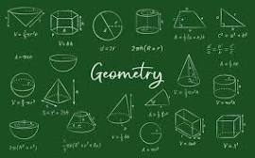

A.20 B.D-Day invasion C.Invasion of Poland D.palindrome E.ssss

**Question 2**

What is a noun?



A.A name of an animal place or thing B.An action word C.A word D.A doing thing E.A doing word

**Question 3**

what is an adjective?

A.an action B.A figure of speech C.a doing word D.a word used instaed of a noun E.a word that qualifies a noun