**Question 1**

A noun

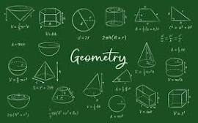

A.ssss B.palindrome C.D-Day invasion D.20 E.Invasion of Poland

**Question 2**

What is a noun?



A.A doing word B.An action word C.A name of an animal place or thing D.A word E.A doing thing

**Question 3**

what is an adjective?

A.A figure of speech B.a word that qualifies a noun C.an action D.a doing word E.a word used instaed of a noun