Faculty of Computing
SLIIT University

SE2030 — Software Engineering
Year 2 Semester 1 (2025)

Lab Sheet 04 — Activity Diagram

Web-Based Food Ordering System

Group ID | 07
Batch Number | Prorata
Topic | Web-Based Food Ordering System

Group Members
No. | Full Name | Student ID
1 | Madushankha P A Y D | IT22029454
2 | Oshada Navindra | IT22079022
3 | [ Full Name ] | [ Student ID ]
4 | Rathnayaka L.P.N.K. | IT22178886
5 | Amantha SAS | IT22133618
6 | Prasanna H.P.G. P | IT22149244
7 | Harishram M. | IT22132178
8 | M.H.M Saajith | IT22156310

1. Member 1 — Customer Registration & Profile Management

Use Case Scenario

Use Case Name | Manage User Profile and Payment
Actor(s) | Customer
Precondition | Customer is registered in the system and logged into the account.
Main Flow | 1. Customer logs into the system. 2. Customer opens the profile section. 3. Customer selects an action: view profile, update profile, manage delivery address, view order history, or proceed to payment. 3a. View Profile: System displays customer details. 3b. Update Profile: Customer edits personal information such as name, email, phone number, or password and saves changes. 3c. Manage Address: Customer adds, edits, or removes a delivery address. 3d. View Order History: System shows previous orders. 3e. Payment Processing: Customer selects a payment method, enters payment details, confirms payment, and the system processes it securely. 4. System saves the changes or payment details. 5. System generates a receipt or invoice and updates payment history.
Alternate Flow | 3b-Alt: If updated profile details are invalid or incomplete, the system shows an error and asks the customer to correct them. 3c-Alt: If address details are incomplete, the system asks the customer to re-enter valid information. 3e-Alt: If payment details are invalid or payment fails, the system displays an error and asks the customer to re-enter details or choose another payment method.
Postcondition | Customer profile is updated successfully, address changes are saved, and payment details and receipt are recorded in the system.

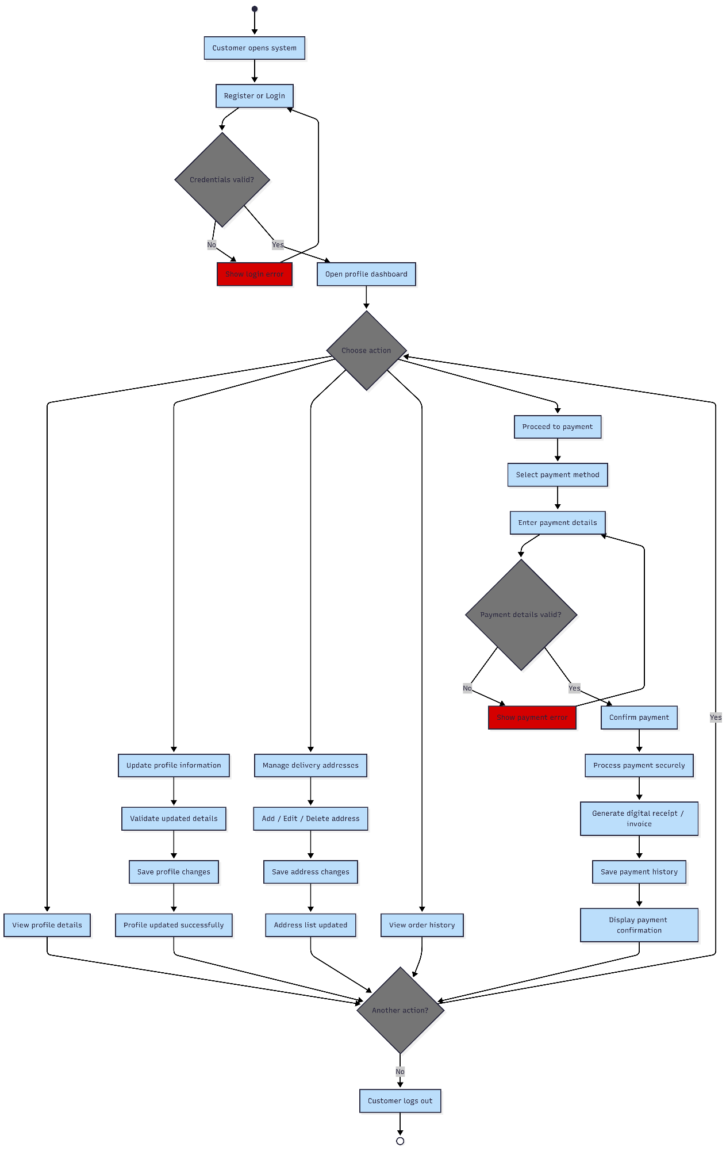
2. Member 2 — Menu Management

Use Case Scenario

Use Case Name | Manage Menu Items
Actor(s) | Admin / Restaurant Owner
Precondition | Admin is logged into the system and the menu management panel is open.
Main Flow | 1. Admin opens the menu management panel. 2. Admin selects an action: Add, Edit, Toggle Availability, or Delete. 3a. Add: Enter name, description, price, category, image and submit. 3b. Edit: Select existing item, update fields, save changes. 3c. Toggle: Switch item status between In Stock and Out of Stock. 3d. Delete: Select item, confirm deletion. 4. System saves changes. Menu updates immediately for customers.
Alternate Flow | 3a-Alt: If required fields are empty or invalid, show error and ask admin to correct. 3d-Alt: If the category still has items, block deletion and notify admin.
Postcondition | The menu is updated and changes are visible to customers immediately.

Activity Diagram
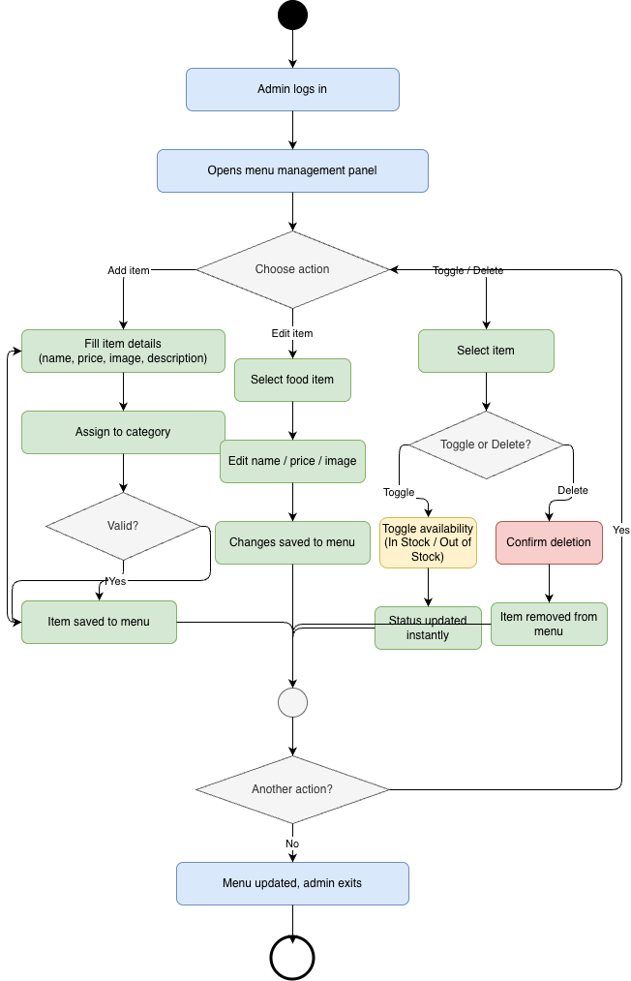

3. Member 3 — Order Placement & Cart Management

Use Case Scenario

Use Case Name | [ Write use case name here ]
Actor(s) | [ Write actor(s) here ]
Precondition | [ Write precondition here ]
Main Flow | [ Write the main flow steps here — Step 1, Step 2, Step 3 ... ]
Alternate Flow | [ Write any alternate or exception flows here ]
Postcondition | [ Write postcondition here ]

Activity Diagram

Activity Diagram — Member 3 (Order Placement & Cart Management)
[ Paste activity diagram image here ]

4. Member 4 — Customer Engagement & Promotion Management

Use Case Scenario

Use Case Name | Customer Engagement & Promotion Management
Actor(s) | Admin / Customer
Precondition | - Customer must be registered and logged into the system  - Customer must have placed/completed an order to submit a review  - Admin must be logged into the system  - Food items and orders must exist in the system
Main Flow | - Customer logs into the system  - Customer selects a food item and submits a rating and review  - System validates and stores the review  - Admin logs into the system and creates or updates a promotion  - Customer applies a promo code during checkout and receives a discount
Alternate Flow | - Customer edits or deletes their existing review  - Admin modifies or deactivates an existing promotion  - Customer views reviews and ratings before placing an order
Postcondition | - Reviews and ratings are stored in the system and visible to other users  - Promotional codes are created/updated and available for use during checkout  - System reflects updated ratings and active promotions

Activity Diagram

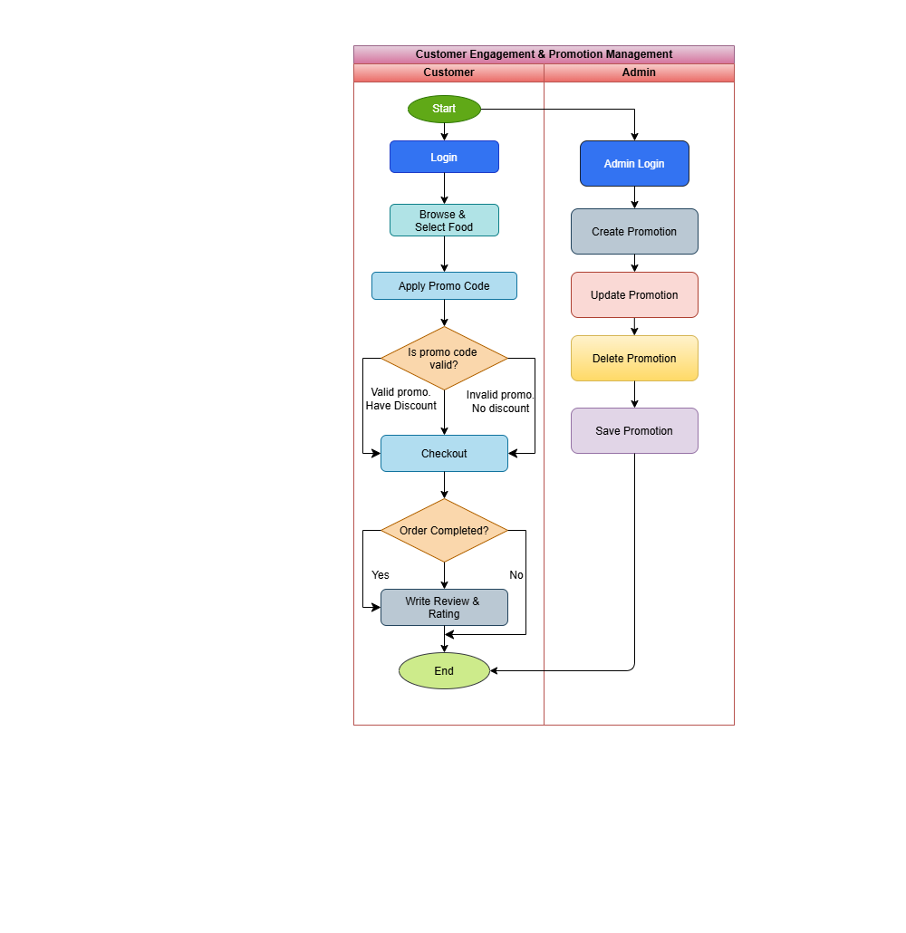

5. Member 5 — Order Tracking & Status Management

Use Case Scenario

Use Case Name | Order Tracking & Status Management
Actor(s) | Customer / Kitchen Staff / Admin
Precondition | Customer has placed an order and the order exists in the system.  Kitchen staff or admin is logged into the system.
Main Flow | - Customer places an order.  - System creates initial order status as “Received”.  - Kitchen staff views incoming orders.  - Kitchen staff updates order status (Preparing → Ready → Out for Delivery → Delivered).  - System updates the order status in real-time.  - Customer views the current order status.  System records each status update in order history.
Alternate Flow | Kitchen staff or admin marks the order as “Cancelled”.  System updates the status and notifies the customer.
Postcondition | Order status is updated successfully and visible to the customer.  Order status history is stored in the system.

Activity Diagram

Activity Diagram — Member 5 (Order Tracking & Status Management)
[ Paste activity diagram image here ]

6. Member 6 — Delivery Management

Use Case Scenario

Use Case Name | Manage Delivery
Actor(s) | Admin / Delivery Person
Precondition | Admin is logged into the system and delivery management panel is open. Orders are available for delivery.
Main Flow | 1. Admin views new confirmed orders.  2. Admin assigns order to a delivery person.  3a. Delivery person accepts the order.  3b. Delivery person picks up the food from the restaurant.  3c. Delivery person updates status to "Out for Delivery".  4. Delivery person delivers the order to the customer.  5. Delivery person marks the order as "Delivered".  6. System updates delivery status and notifies customer.
Alternate Flow | 2a-Alt: If no delivery person is available, system shows "No Rider Available".  3a-Alt: If delivery person rejects the order, admin reassigns it.  4a-Alt: If delivery fails (customer unavailable), mark as "Failed Delivery" and notify admin.
Postcondition | The order is successfully delivered and the delivery status is updated in the system. Customer receives confirmation.

Activity Diagram

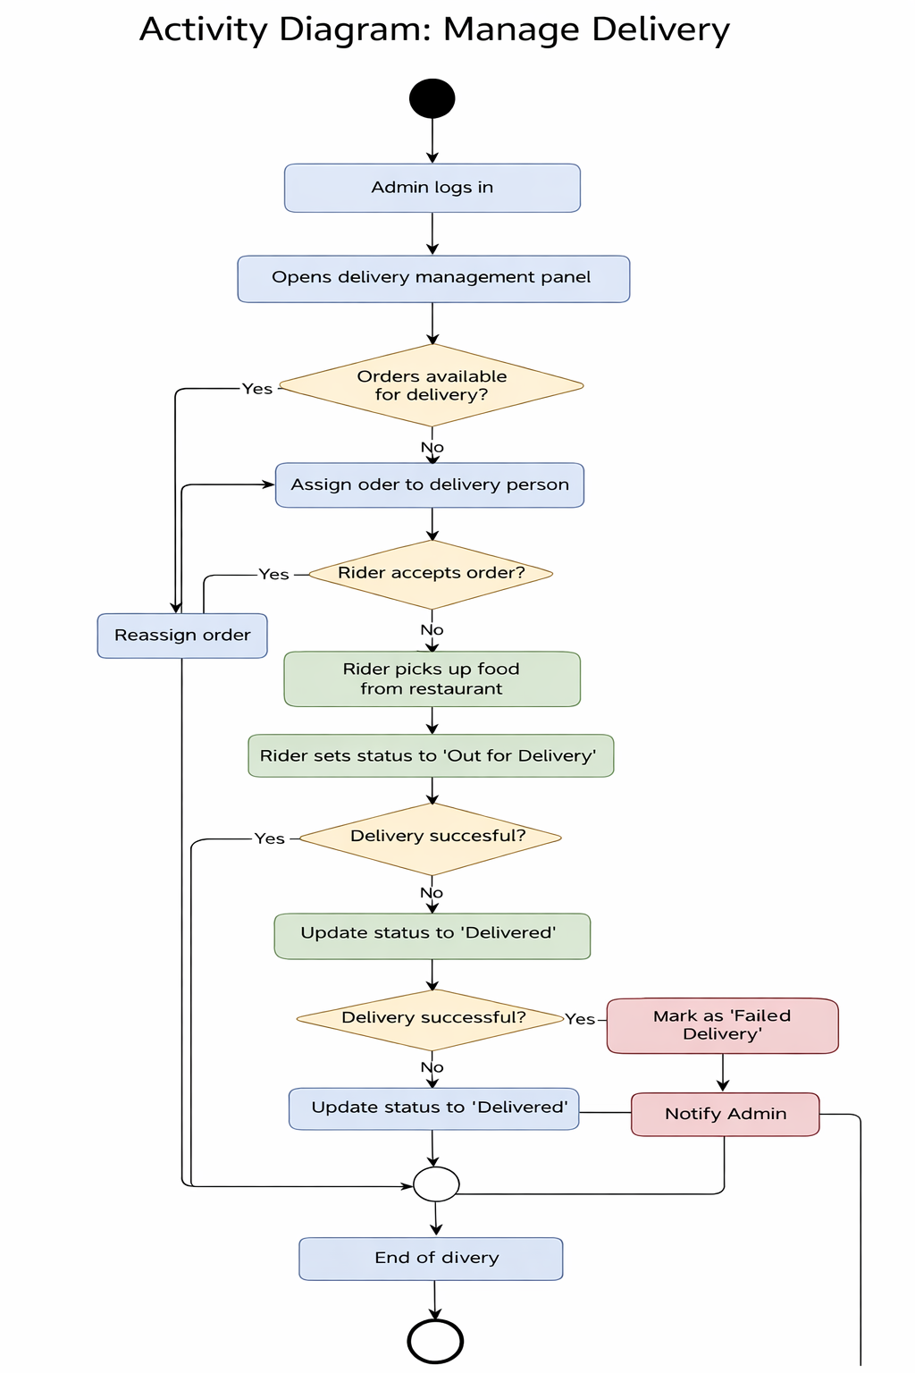

7. Member 7 — Restaurant Analytics & Sales Reporting Management

Use Case Scenario

Use Case Name | Restaurant Analytics & Sales Reporting
Actor(s) | Admin / Restaurant Owner
Precondition | Admin is logged into the system, and order/payment data is available in the database.
Main Flow | STEP 1 - Admin opens the Analytics & Reporting section.  STEP 2 - Admin selects a report type: Daily, Weekly, or Monthly.  STEP 3 - Admin optionally applies filters such as date range, category, or item.  STEP 4 - System retrieves order and payment data from the database.  STEP 5 - System processes and analyzes the data.  STEP 6 - System generates analytics results such as revenue, order count, top-selling items, and peak ordering hours.  STEP 7 - System displays the analytics dashboard with charts and summaries.  STEP 8 - Admin views the report.  STEP 9 - Admin may export the report as PDF or CSV
Alternate Flow | If filters are changed, the system regenerates the report with updated analytics results.
Postcondition | Analytics dashboard is displayed successfully, and the selected report is available for viewing or export.

Activity Diagram

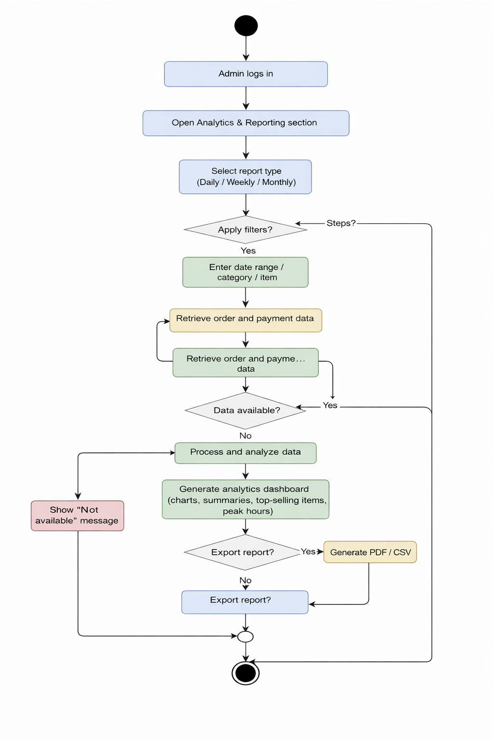
Member 8 — Order History & Reorder Management

Use Case Scenario

Use Case Name | Order History & Reorder
Actor(s) | Customer
Precondition | Customer is logged into the system and has at least one previous completed order stored in the database.
Main Flow | 1. Customer navigates to the “Order History” section. 2. System retrieves and displays a list of previous orders. 3. Customer selects a past order. 4. System shows order details (items, quantity, total price, date). 5. Customer clicks “Reorder”. 6. System adds items to cart. 7. Customer reviews and modifies cart if needed. 8. Customer confirms the order. 9. System processes and saves the new order. 10. Order confirmation is displayed.
Alternate Flow | - Customer edits or removes items before confirming reorder. – Customer cancels reorder process. – Customer filters order history by date or status.
Postcondition | A new order is successfully created based on a previous order and stored in the system.

Activity Diagram

