1. Group Details
Module Code: SE2030
Module Name: SE
Group ID: 07
Project Topic: Web-Based Food Ordering System

Group Members:
Member No | Name | Registration Number
Member 1
Member 2 | Oshada Navindra | IT22079022
Member 3
Member 4
Member 5
Member 6

2. Use Case Diagram

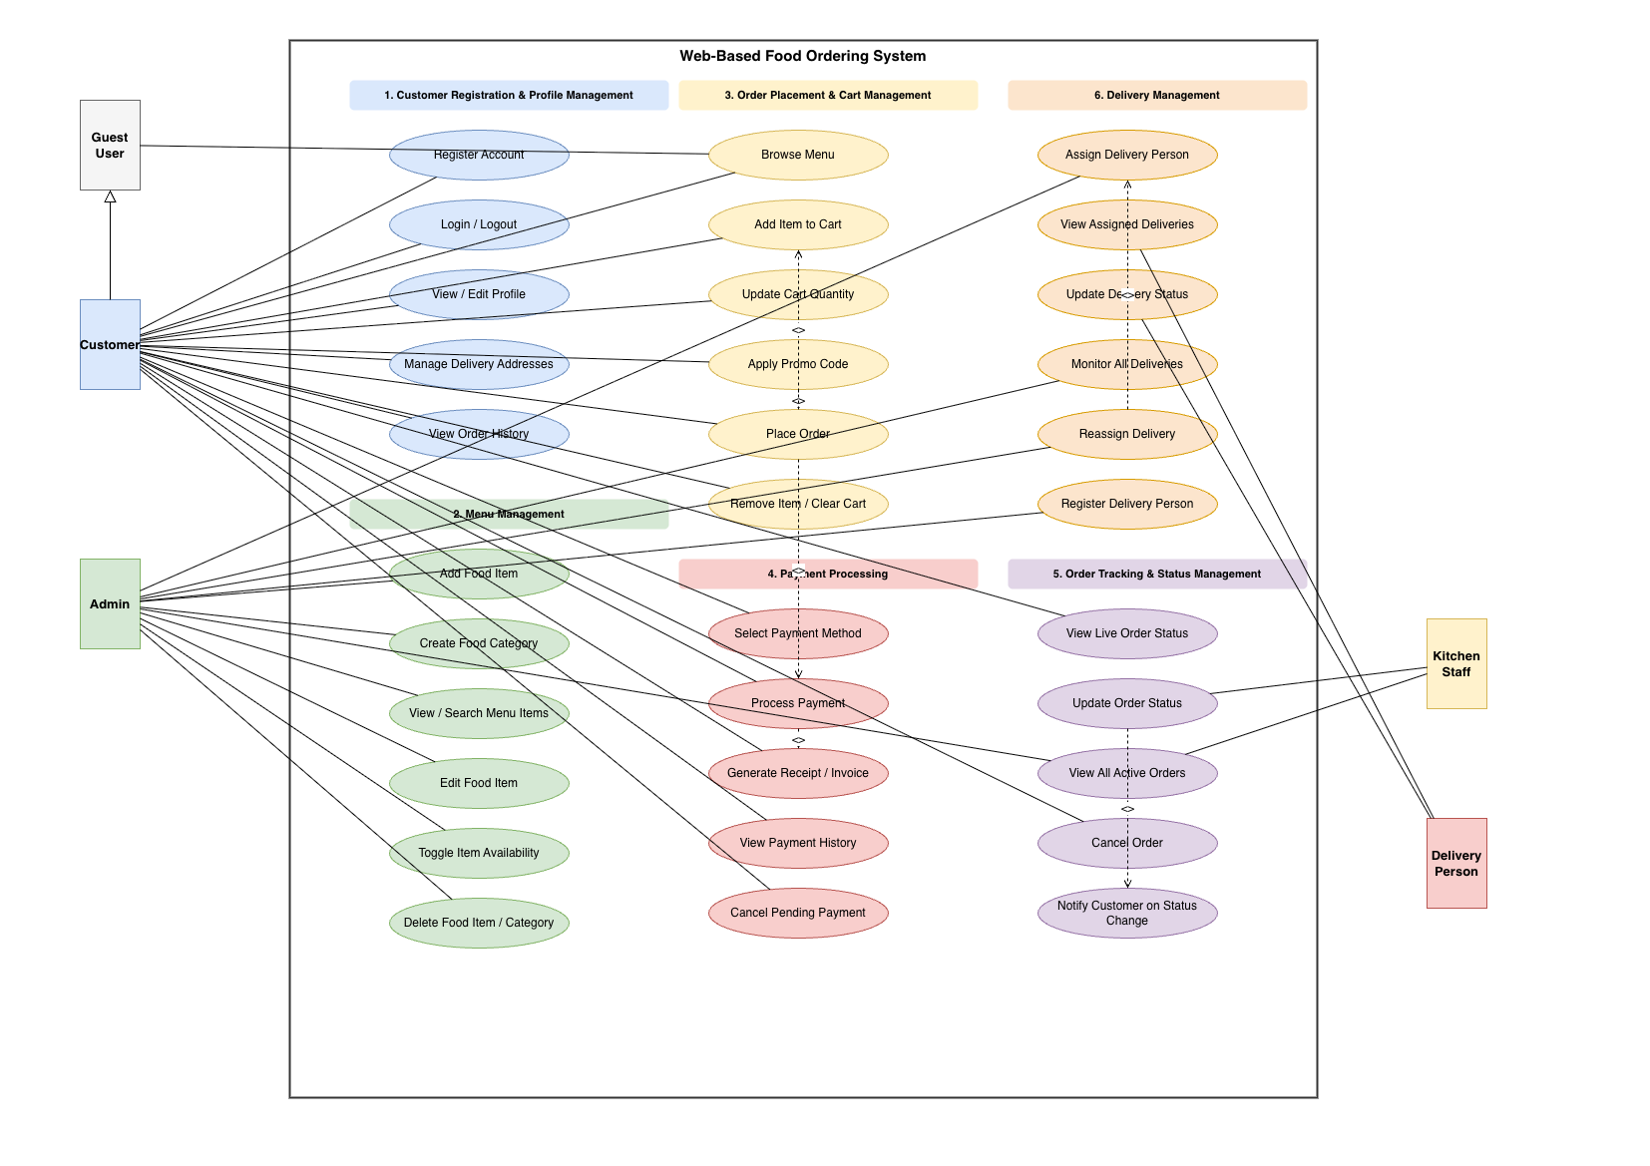

3. Use Case Scenarios

Member 1
Use Case ID:
Use Case Name:
Primary Actor:
Goal:
Preconditions:
Postconditions:
Trigger:
Main Flow:
1.
2.
3.
4.
5.
Alternative Flow:
-
Exception Flow:
-

Member 2
Use Case ID: UC-02
Use Case Name: Menu Management
Primary Actor: Admin / Restaurant Owner
Goal: Maintain the digital menu by adding new food items

Preconditions: 1 Admin is logged into the system
2 At least one category exists

Postconditions: 1 New food item is saved successfully
2 Item is visible on the customer menu

Trigger: Admin clicks 'Add New Item' in Menu Management

Main Flow:
1 Admin navigates to Menu Management section
2 Admin enters item details (name, description, price, category, image)
3 System validates required fields
4 System saves item and sets status to 'In Stock'
5 Item appears on the customer menu

Alternative Flow:
1 Admin marks item as 'Out of Stock'
2 System updates status and hides item from menu

Exception Flow:
1 If required fields are missing, system shows error
2 System prevents saving the item

Member 3
Use Case ID:
Use Case Name:
Primary Actor:
Goal:
Preconditions:
Postconditions:
Trigger:
Main Flow:
1.
2.
3.
4.
5.
Alternative Flow:
-
Exception Flow:
-

Member 4
Use Case ID:
Use Case Name:
Primary Actor:
Goal:
Preconditions:
Postconditions:
Trigger:
Main Flow:
1.
2.
3.
4.
5.
Alternative Flow:
-
Exception Flow:
-

Member 5 - IT22133618

Use Case ID: UC-05
Use Case Name: Order Tracking & Status Management
Primary Actor: Customer / Kitchen Staff / Admin
Goal:
Enable real-time tracking of orders and allow staff to update order status throughout the preparation and delivery process.
Preconditions:
- Customer has successfully placed an order
- Order exists in the system
- Kitchen staff/admin is logged into the system
Postconditions:
- Order status is updated successfully
- Customer can view the latest order status
- Order status history is recorded
Trigger:
Kitchen staff updates order status OR customer views order tracking
Main Flow:
- Customer places an order
- System creates initial status as 'Received'
- Kitchen staff views incoming orders
- Kitchen staff updates order status step-by-step (Preparing → Ready → Out for Delivery → Delivered)
- System updates the status in real-time
- Customer views live order status through the interface
- System logs each status change in order history
Alternative Flow:
- -Kitchen staff marks order as 'Cancelled'
- System updates status accordingly
- Customer is notified about the cancellation
Exception Flow:
- If system fails to update status, an error message is shown
- If order is not found, system displays an error
- System prevents invalid status transitions (e.g., Delivered → Preparing)

Member 6
Use Case ID:
Use Case Name:
Primary Actor:
Goal:
Preconditions:
Postconditions:
Trigger:
Main Flow:
1.
2.
3.
4.
5.
Alternative Flow:
-
Exception Flow:
-

