OBSERVATION
Laboratory Task 1 – Basic Operation of a Spectrum Analyzer

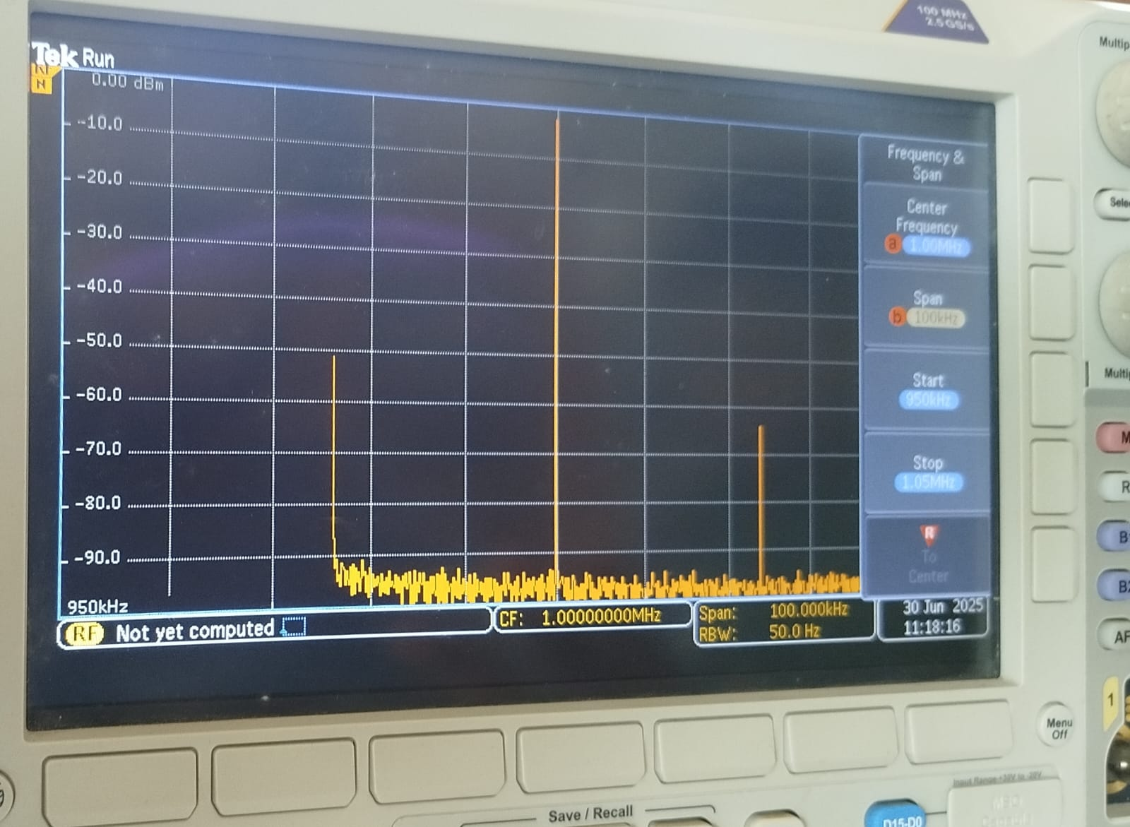
I) Reading Amplitude and Frequency

Figure 02: Observations for 1V peak to peak voltage signal
- Use of the Resolution band width (RBW) setting.

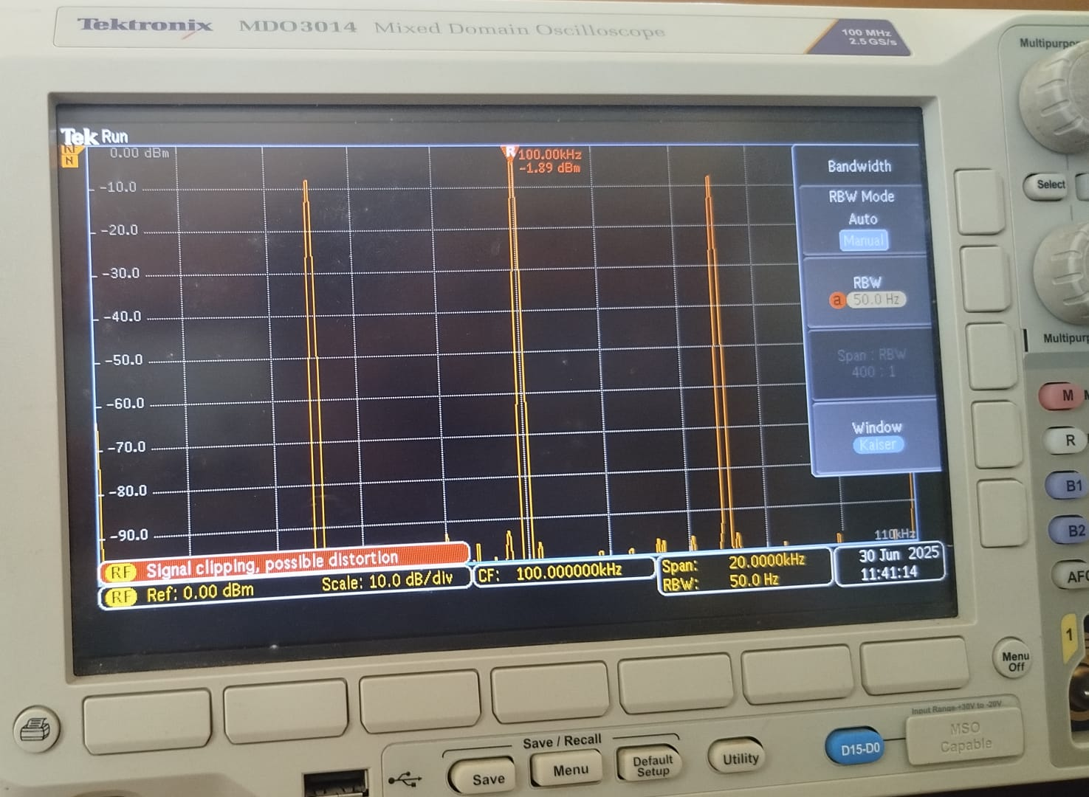

Figure 03: Observations for 50 Hz RBW

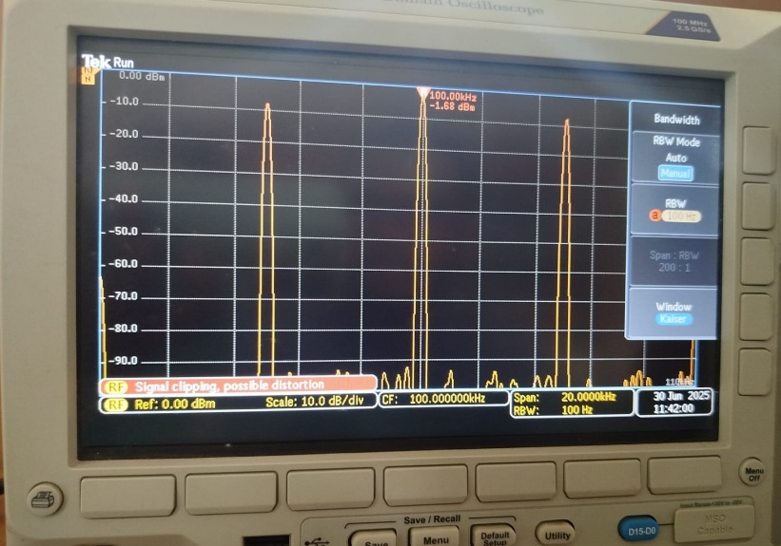
Figure 04: Observations for 100 Hz RBW

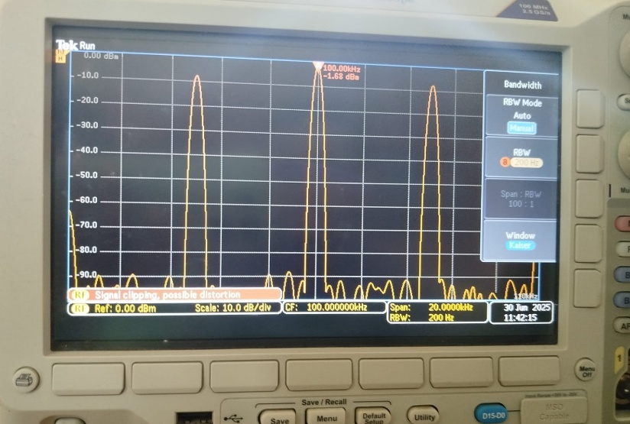
Figure 05: Observations for 200 Hz RBW
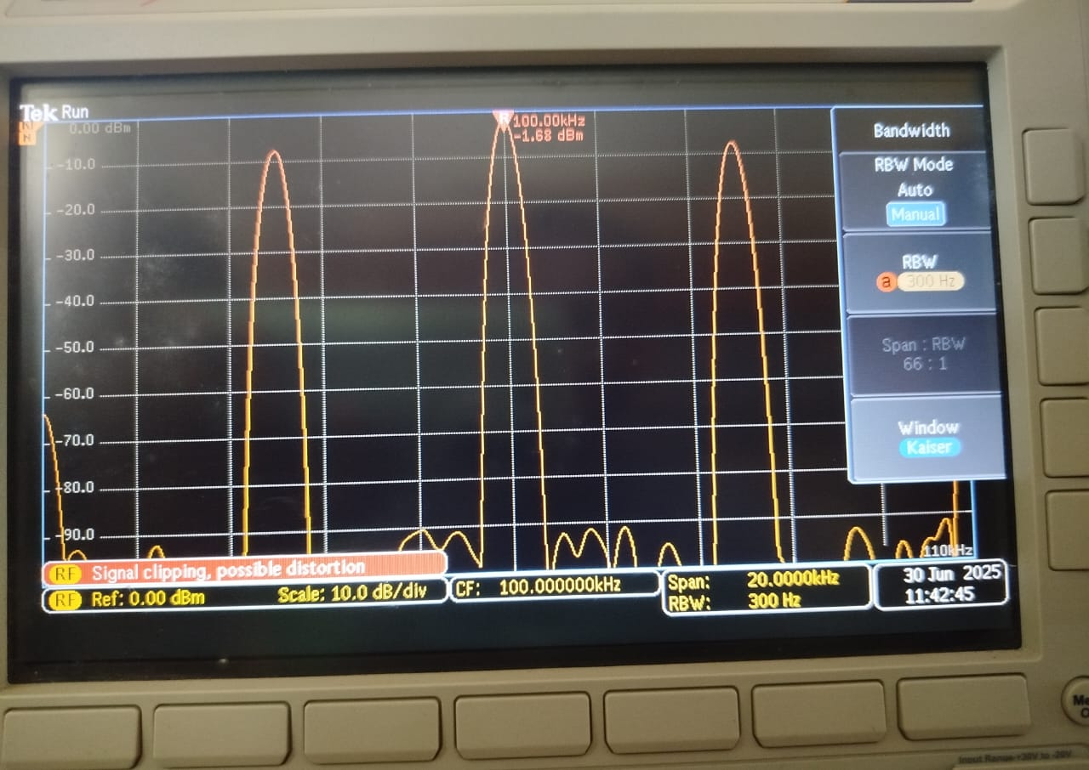
Figure 06: Observations for 300 Hz RBW

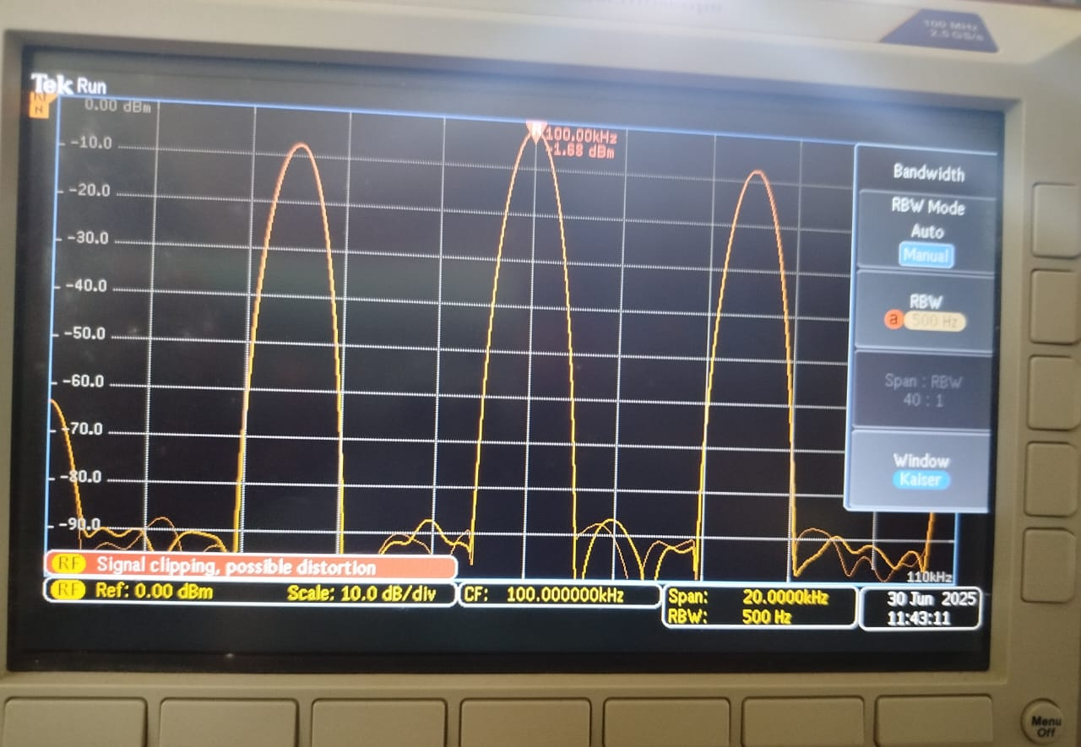
Figure 07: Observations for 500 Hz RBW

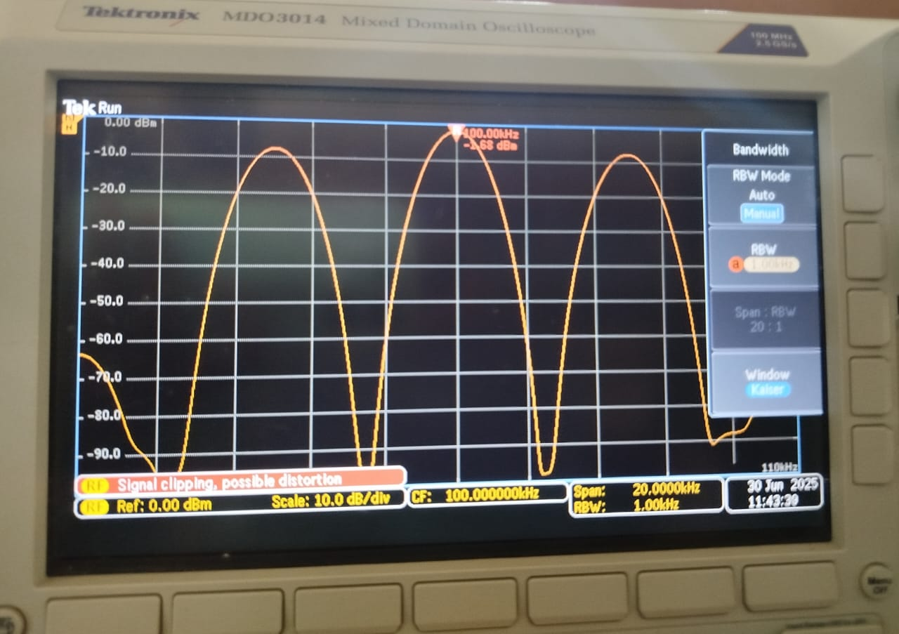

Figure 08: Observations for 1000 Hz RBW

2. Laboratory Task 2 – Time - Frequency Conversion and Frequency Content of Signals.
- Fourier series of a square wave and effect of duty ratio.
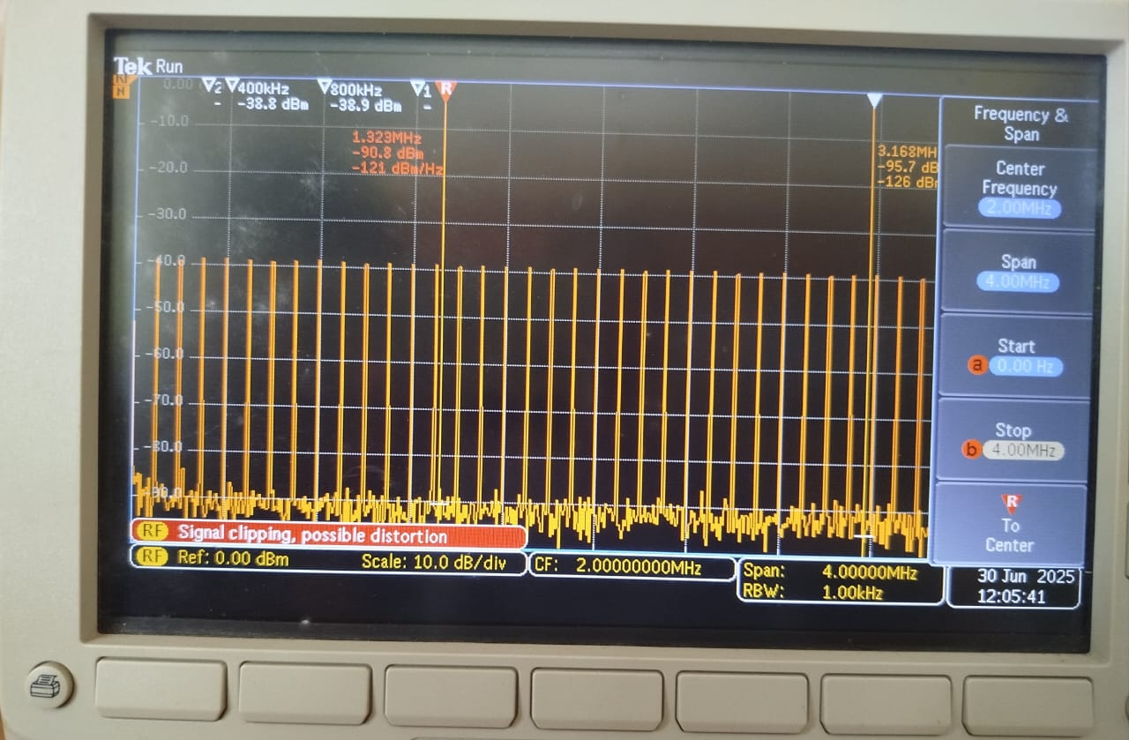

Figure 09: Observations at 100 % duty ratio

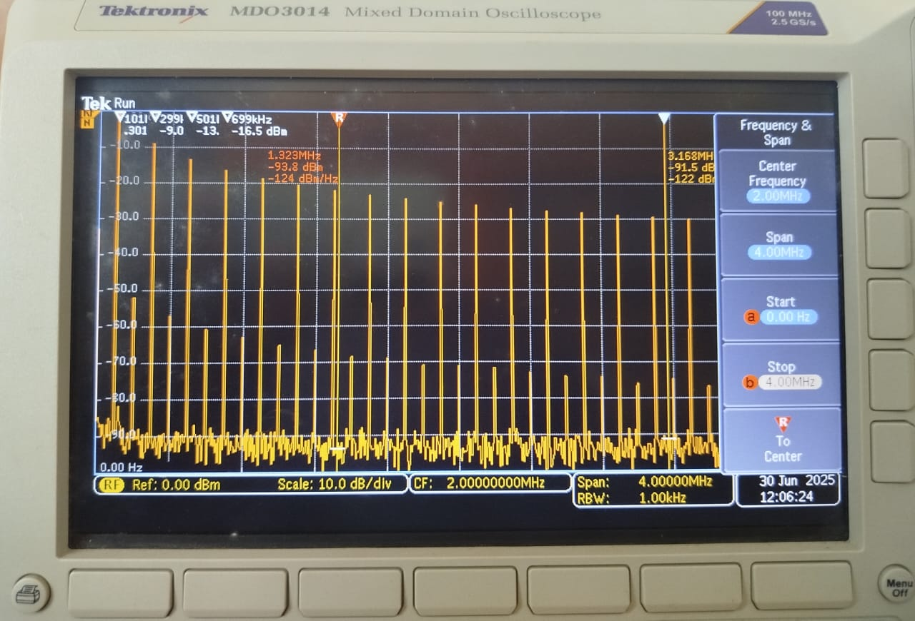
Figure 10: Observations at 50 % duty ratio

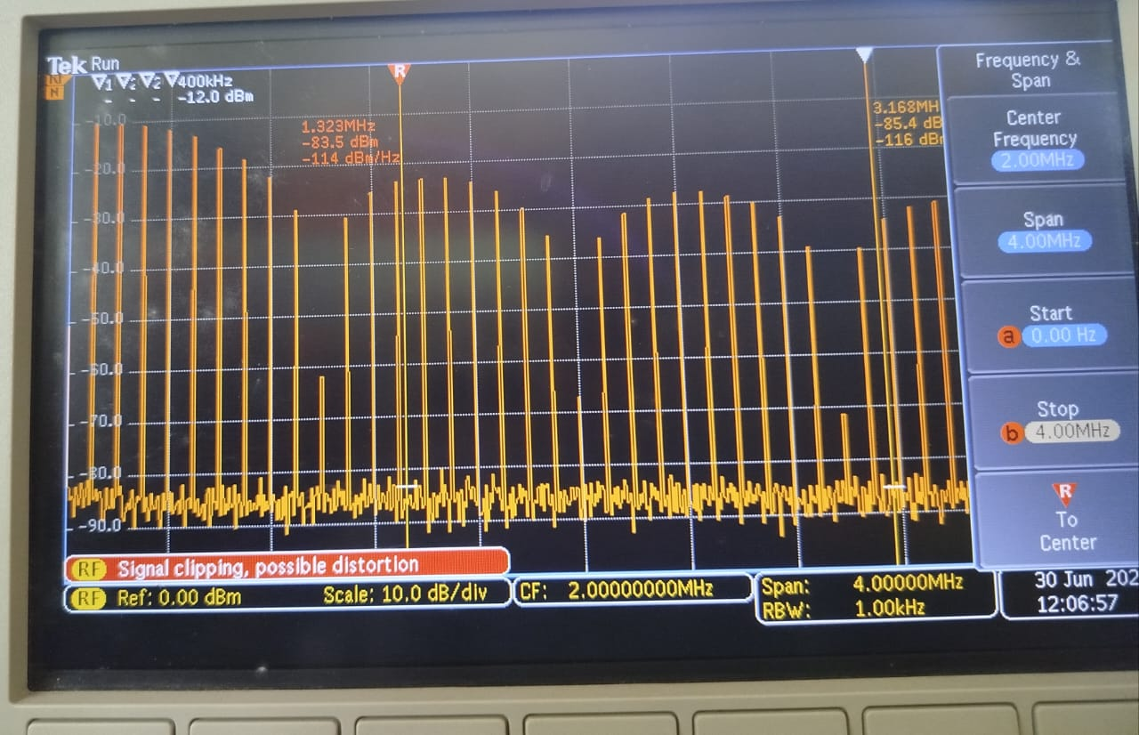
Figure 11: Observations at 10 % duty ratio

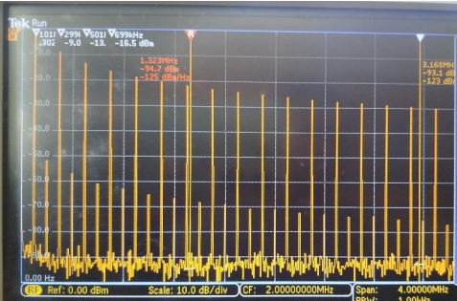

Figure 12: Observations at 50 % duty ratio, 100kHz (10μs)

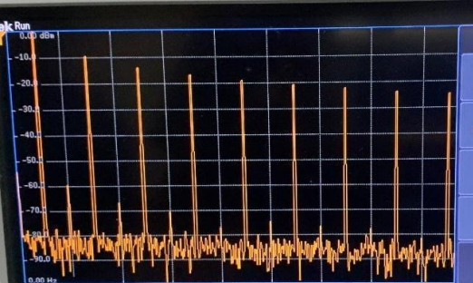

Figure 13: Observations at 50 % duty ratio, 500kHz (2μS)

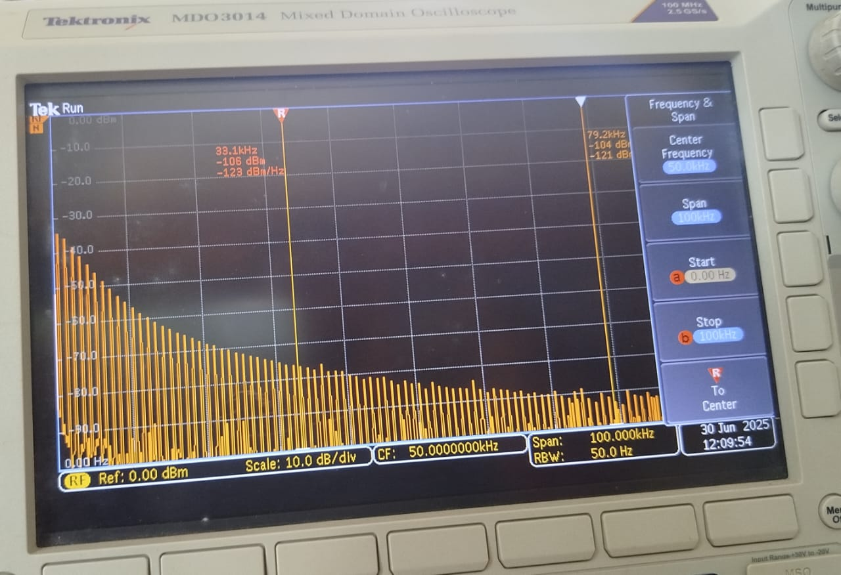
- Fourier series of a Triangular wave.

Figure 14: Observations for the triangular wave

DISCUSSION
Laboratory Task 1 – Basic Operation of a Spectrum Analyzer
- Discussion Question 1 –
Discuss the operation of the FREQ/SPAN and AMPL functions using your knowledge about the spectrum analyzer.
The FREQ/SPAN settings on the spectrum analyzer let me choose the main frequency I want to look at and how wide the frequency range around it should be. It’s like zooming into a specific spot on a map and deciding how far around that spot I want to see. The AMPL functions help set how the signals show up vertically on the screen, adjusting the amplitude reference and scale, making it easier to measure and clearly read signal strengths.

- Discussion Question 2 –
I. Discuss the reason for the difference in the spectrums that you observed for different resolution bandwidth settings.
When changing the resolution bandwidth (RBW), I noticed the shape and clarity of the signals change significantly. With a smaller RBW, signals appeared sharper and clearer, allowing closely spaced signals to be seen separately. With a larger RBW, these signals blended into one another, becoming harder to differentiate clearly.
II. Explain the internal functioning of the RBW settings from the knowledge that you have gained in the discussion.
Internally, the RBW controls how narrow or wide the IF filter window is. A narrower window picks out signals more precisely, giving better frequency resolution but takes more time. A wider window quickly scans frequencies but doesn't clearly separate signals that are close together.
III. Explain the advantages and disadvantages of using a small and large resolution bandwidth using your knowledge about the spectrum analyzer

The advantage of a small RBW is better clarity and more precise measurement, but the disadvantage is slower analysis speed. Conversely, a large RBW is faster and good for quickly scanning wide frequency ranges, but it’s less precise, making signals close to each other hard to distinguish clearly.
Laboratory Task 2 – Time - Frequency Conversion and Frequency Content of Signals.

- Discussion Question 1 –
I. Explain reason for your observation when changing duty ratio.
Changing the duty ratio affected how many harmonics appeared. At a 50% duty cycle, mostly odd harmonics were visible. As I reduced the duty ratio, more harmonics, including even ones, appeared, creating a richer and denser frequency spectrum. Extremely narrow pulses showed even more harmonics across the spectrum.
II. Explain the reason for your observations when changing the frequency of the square wave.
When changing the square wave frequency, I observed that increasing frequency spaced out the harmonics further apart. At lower frequencies, the harmonics appeared closer together, but at higher frequencies, the spectrum was spread out with harmonics clearly separated.

REFERENCES

[1] Department of Electrical and Electronic Engineering, "EE 257 – Signals & Systems: Swept–Tuned Spectrum Analyzer Lab Instruction Sheet," Electrical and Electronic Engineering Dept., 2025.

[2] T. R. Kuphaldt, “Square Wave Signals,” Allaboutcircuits.com, Feb. 12, 2015. https://www.allaboutcircuits.com/textbook/alternating-current/chpt-7/square-wave-signals/

[3] GeeksforGeeks, “Duty Cycle,” GeeksforGeeks, Oct. 17, 2023. https://www.geeksforgeeks.org/electrical-engineering/duty-cycle/

