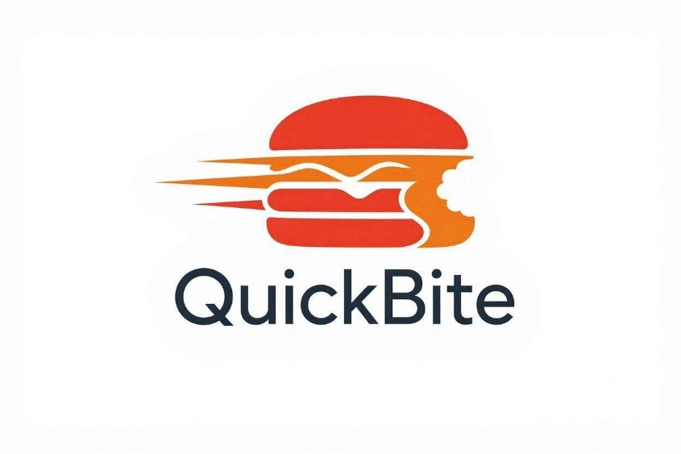
ESOFT UNIVERSITY
BACHELOR OF INFORMATION TECHNOLOGY (HONOURS)
CONTINUOUS ASSESSMENT
CCU1304 – FUNDAMENTALS OF PROGRAMMING

Name: M.W.O.C.Wickramasinghe.
Registration Number: E310875
Module Lecturer: Ms.Thilini.

Design, Implement and Test a Procedural Programming Solution

Introduction

This report presents the QuickBite Food Ordering System, a Python console application designed to automate order calculations, membership discounts, and distance-based delivery fees. The primary objective is to deliver a reliable, crash-free application through robust input validation and error handling.

Table of Contents
1. Problem Analysis. 4
1.1 Introduction 4
1.2 Inputs 4
1.3 Processing 4
1.4 Outputs 5
1.5 Assumptions 5
1.6 Constrains 5
2. Algorithm Design. 6
2.1 Algorithm 6
2.2 Psuedocode 8
2.3 Flowchart 8
4. Program 10
4.1 Constants and Functions. 10
4.2 User Inputs and Data Validation. 11
4.3 Calculations 12
4.4 Generating the Itemized Receipt 13
5. Input Validations 14
5.1 How Input Validation Works in this Program 14
5.1.1 Order Type Validation 14
5.1.2 Number of Items Validation 15
5.1.3 Price per Item Validation 16
5.1.4 Delivery Distance Validation 17
5.1.5 Discount Eligibility Validation 18
6. Testing 20
6.1 Test Plan 20
6.2 Test Cases 21
7. Test Evidence 22
TC01 22
TC02 22
TC03 23
TC04 23
TC05 24
TC06 24
TC07 24
TC08 25
8. Technical Documentation. 25
8.1. Main Functions. 25
1. Validate input () 25
2. Calculate bill () 26
3. Display bill () 26
8.2 Variables Used 26
8.3 Programming Decisions. 27
9. Reflection. 27
9.1 Future Enhancements. 27

1. Problem Analysis.

1.1 Introduction
For QuickBite, there is a need for an automated console billing application to avoid any manual errors and inefficiencies during the process. The billing process will be carried out using the following procedural python program.

1.2 Inputs

Input | Data Type | Description
Customer Name | String | Name of the customer
Order Type | String | Regular, Premium, VIP
Number of Food Items | Integer | Total quantity ordered
Price per Item | Integer | Price of one food item
Delivery distance | Float | Distance in kilometers
Discount eligibility | String | Eligible for promo discount(Y/N)

1.3 Processing
The program performs the following operations:
- Read all user inputs.
- Validate the entered data.
- Calculate Food Subtotal.
Food Subtotal = Number of items * Price per Items
- Calculate delivery charge.
Delivery Charge = Distance * Rs.50
- Check whether free delivery applies.
IF food Subtotal > Rs.5000
Delivery Charge = Rs. 0
- Apply order type discount.

- Calculate Discount Amount
- Calculate Final Amount.
Final Amount = Food Subtotal – Discount + Delivery Charge
- Display the customer bill.

1.4 Outputs
The program displays:
- Customer Name
- Order Type
- Food Subtotal
- Discount Amount
- Price per Item
- Delivery Rate
- Final Payable Amount

1.5 Assumptions
- All prices are entered in Sri Lankan Rupees.
- Customer enters only one order at a time.
- Order type must be Regular, Premium, and VIP.
- Delivery distance is measured in kilometers.
- Discount percentages remain fixed.
- Maximum delivery distance is 20 km.

1.6 Constrains
- Delivery distance cannot exceed 20 km.
- Number of food items must be greater than zero.
- Price per item must be greater than zero.
- Delivery distance cannot be negative.
- Invalid order types are rejected.

Order Type | Discount
Regular | 0%
Premium | 10%
VIP | 20%

- Monetary values are displayed with two decimal places.

2. Algorithm Design.

2.1 Algorithm
Writing the algorithm helped structure business rules and execution flow from inputs to final billing, independent of Python syntax.
- Start the program.
- Define global constants:
- Delivery_Rate = 50
- Free_Delivery_Limit = 5000
- Max_Distance = 20.
- Define Function calculate_disount (order_type, food_subtotal):
  - If order_type is "PREMIUM", return 10% of food_subtotal.
  - Else if order_type is "VIP", return 20% of food_subtotal.
  - Else, return 0.
- Define Function calculate_delivery(food_subtotal, distance):
  - If food_subtotal > Free_Delivery_Limit, Return 0.
  - Else, Return Distance * Delivery_Rate.
- Display main title header.
- Prompt and read customer_name.
- Input Validation Loop for Order Type:
  - Prompt for order_type.
  - Convert to uppercase.
  - If order_type is in ["REGULAR", "PREMIUM", "VIP"], break loop.
  - Else, display error message and repeat.
- Input Validation Loop for Number of Items:
  - If number_of_items > 0, break loop.
  - Else, display error message and repeat.
- Input Validation Loop for Price per Item:
  - If price_per_item > 0, break loop.
  - Else, display error message and repeat.
- Input Validation Loop for Delivery Distance:
  - If 0 <=distance<= 20 km, break loop.
  - Else, display error message and repeat.
- Input Validation Loop for Special Discount:
  - Prompt for eligibility (Y/N).
  - If eligibility is in ["Y", "N"], break loop.
  - Else, display error message and repeat.
- Calculate Costs:
  - food_subtotal = number_of_items * price_per_item
  - discount = Call calculate_discount(order_type, food_subtotal)
  - If eligibility == "Y", add (5% of food_subtotal) to discount
  - delivery_fee = Call calculate_delivery(food_subtotal, distance)
  - total_payable = food_subtotal + delivery_fee - discount
- Display itemized bill formatted to two decimal places.
- End.

2.2 Psuedocode
My pseudocode code connected the entire logical process with the implementation using Python code. The pseudocode helped me to structure my code process earlier, which made it much easier and efficient to do in the end.

Start
Input Customer_Name, Order_Type, Quantity, Unit_Price, Distance
Validate Input
Subtotal = Quantity * Unit_Price
Discount = Calculate_Discount (Order_Type, Subtotal)
Delivery = Calculate_Delivery (Distance, Subtotal)
Total = Subtotal - Discount + Delivery
Print Receipt
End

2.3 Flowchart
These standard symbols for flowcharts have been used to represent the logic in the visual form:
- Terminator: Represent program Start/Stop.
- Input/output: Represent Inputs and Receipt Outputs.
- Process: Perform mathematical computations and Function Call.
- Decision: Checks conditional statements and validation.

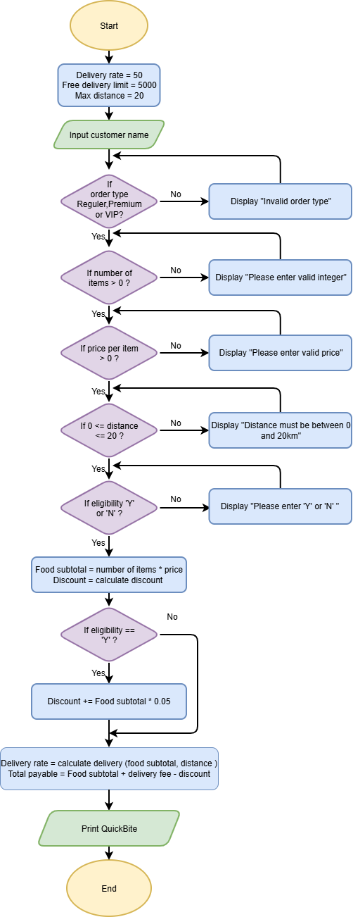

4. Program
Here is the explanation of the QuickBite Python Program logic in simple English, broken down step-by-step:

4.1 Constants and Functions.
Constants (Fixed Values):
- delivery_rate = 50 (Rs. 50 per kilometer)
- free_delivery_limit = 5000 (Free delivery for orders above Rs. 5000)
- max_distance = 20 (Maximum allowable delivery distance is 20 km)
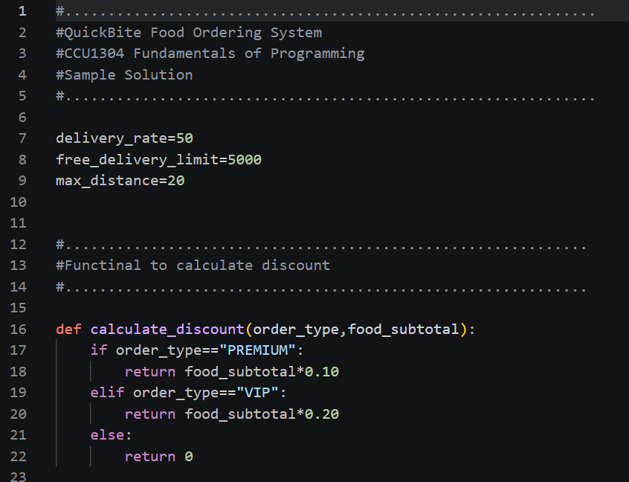

Functions:
- calculate_discount(): Calculates the discount based on the customer category:
  - PREMIUM: 20% discount
  - VIP: 10% discount
  - REGULAR: 0% discount
- calculate_delivery (): Returns 0 if the total order exceeds Rs. 5000; otherwise, calculates Distance * 50.
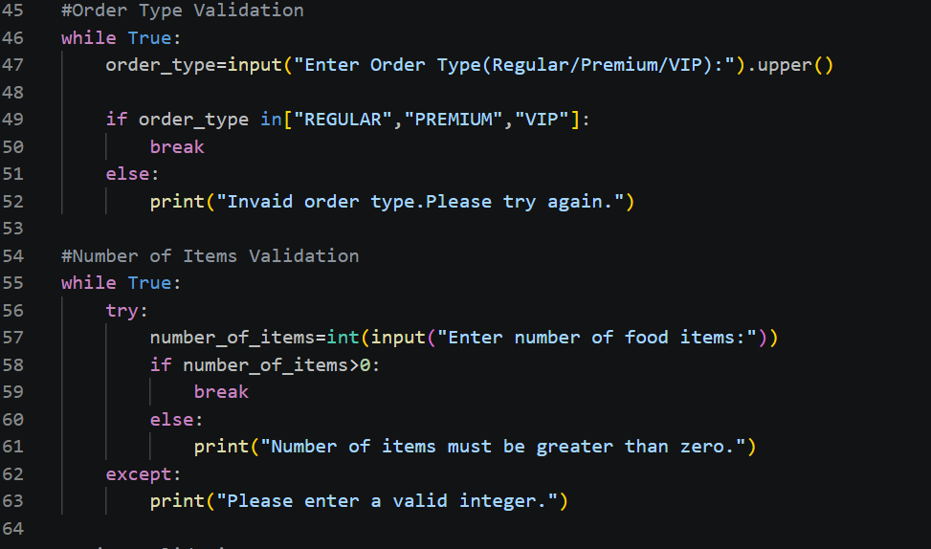

4.2 User Inputs and Data Validation.
The program asks the user for necessary information and uses WHILE loops to prevent invalid inputs:
- Customer Name: Accepts the customer's name.
- Order Type: Validates that the user enters only "REGULAR", "PREMIUM", or "VIP". If invalid, it prompts again.
- Number of Items: Checks that the quantity entered is a number greater than 0.
- Price per Item: Validates that the price is greater than 0.
- Delivery Distance: Ensures the distance is between 0 and 20 km.
- Special Discount Eligibility: Validates input to accept only ‘Y’ or 'N'.

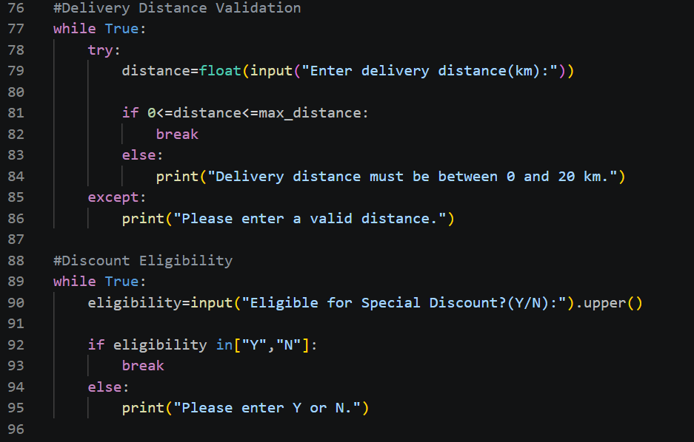

4.3 Calculations
Using the validated input, the program calculates the final bill components:
- Food Subtotal = Number of Items * Price per Item
- Discount = calculate_discount() + (An additional 5% discount if special eligibility is 'Y')
- Delivery Charge = calculate_delivery()
- Total Payable = Food Subtotal + Delivery Charge – Discount

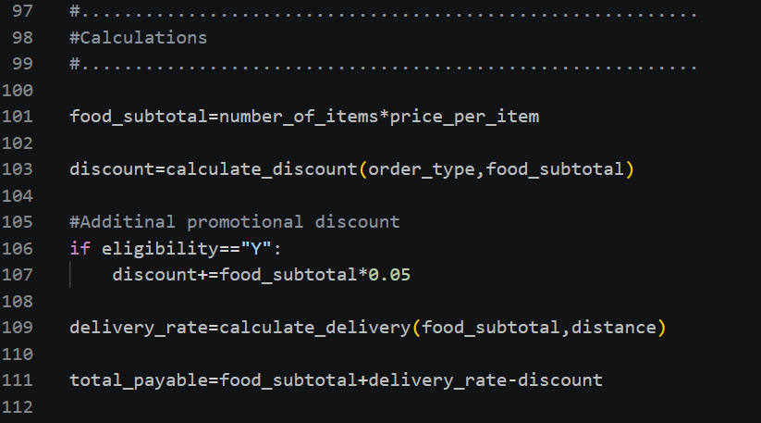

4.4 Generating the Itemized Receipt
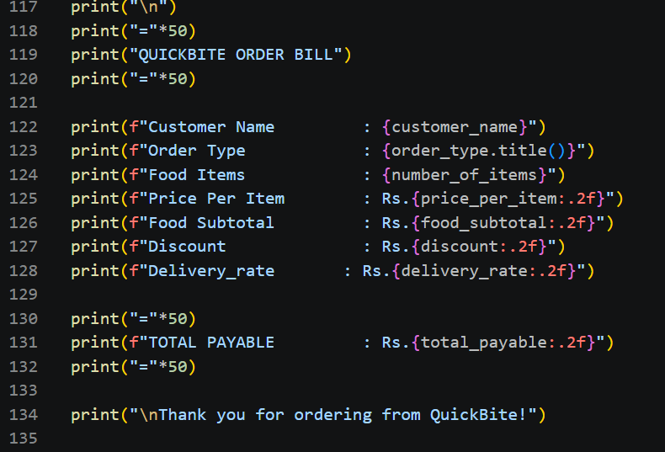
Finally, the program formats all calculated values to two decimal places and displays a clear, detailed bill on the screen.

5. Input Validations
Input Validation is the process of checking the data entered by the user to ensure it is correct, safe, and logical before the program processes it.
If the user enters invalid data, input validation catches the error, displays a helpful message, and asks the user to re-enter the data.

5.1 How Input Validation Works in this Program

5.1.1 Order Type Validation
- The order type must be either REGULAR, PREMIUM, or VIP.
- Converts the input to uppercase using .upper () and checks if it exists in the list of allowed types.

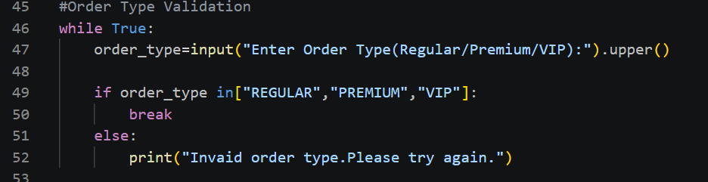

- Correct Case: Accepts only valid order categories: REGULAR, PREMIUM, or VIP (handles both uppercase and lowercase inputs).
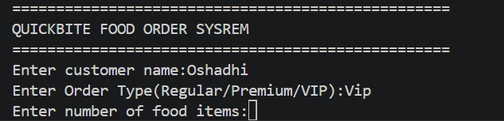

- Error Case: If an unsupported option is entered, the system displays "Invalid order type. Please try again."

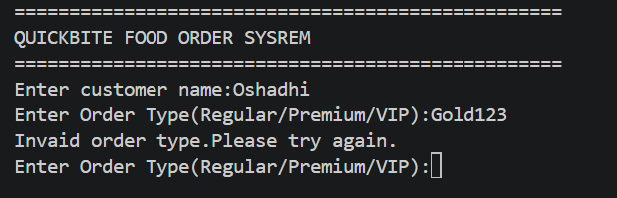

5.1.2 Number of Items Validation
- Uses try-except to prevent program crashes if text is typed instead of a number, and checks if items > 0.
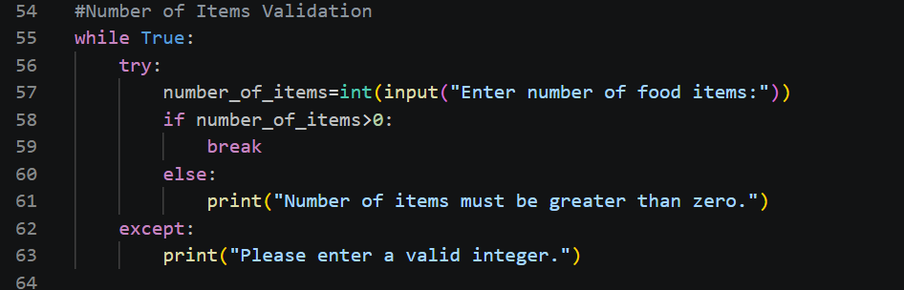

- Correct Case: Accepts any positive whole number greater than 0.
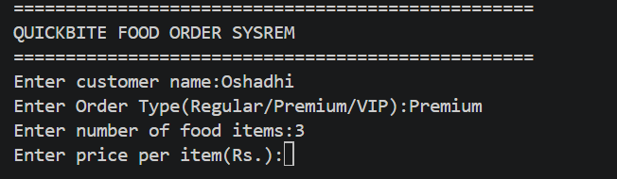

- Error Cases:
- Entering text triggers a Value Error catch block, prompting "Please enter a valid integer".
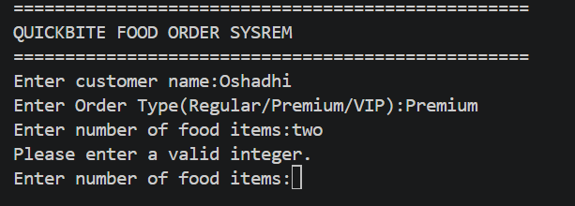

5.1.3 Price per Item Validation
- Uses float () conversion and checks if price > 0.
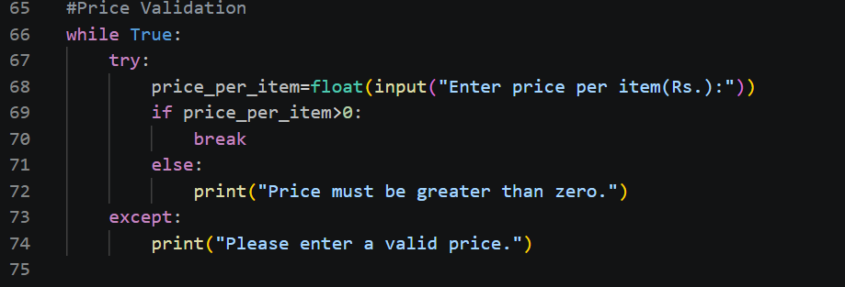

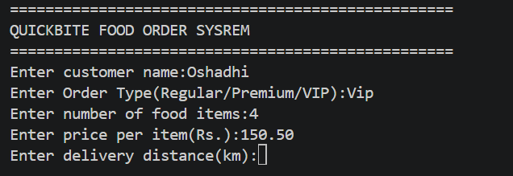
- Correct Case: Accepts positive numeric values including decimals.

- Error Cases:
- Typing letters or symbols is displaying "Please enter a valid price".
- Entering zero or a negative price prompts "Price must be greater than zero".
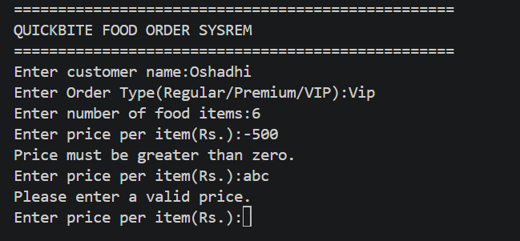

5.1.4 Delivery Distance Validation
- Checks if 0 <=distance<=20.
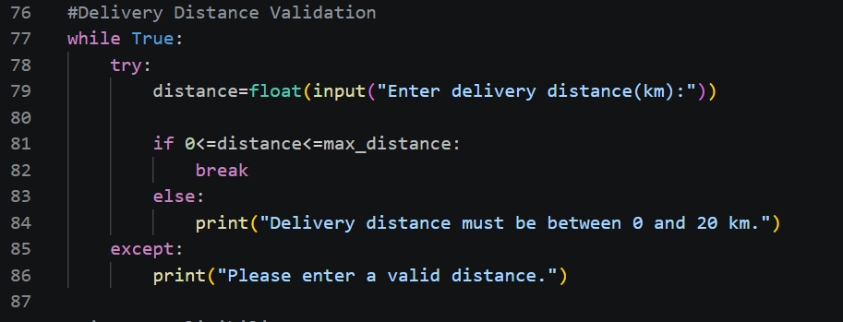

- Correct Case: Accepts values within the allowed range of 0 km to 20 km.

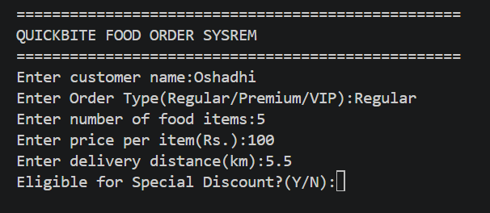

- Error Cases: Entering a value greater than the max distance displays "Distance must be between 0 and 20 km".
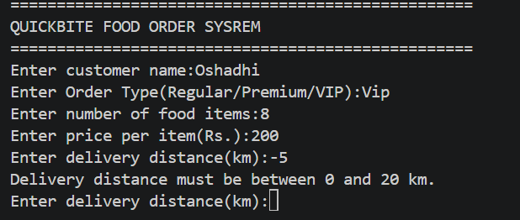

5.1.5 Discount Eligibility Validation
- Validates 'Y' or 'N' inputs after converting to uppercase.
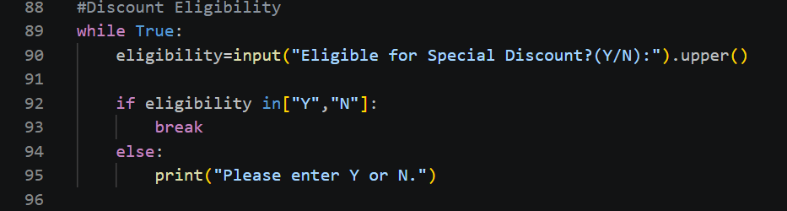

- Correct Case: Accepts either ‘Y’ or ‘N’.
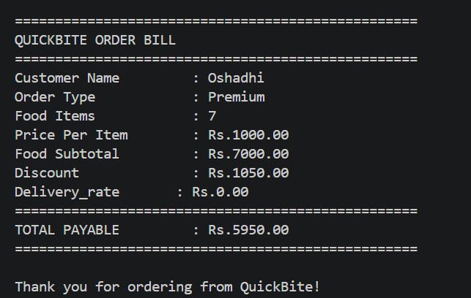

- Error Case: Typing any other character or number displays " Please enter 'Y' or 'N'" and re-prompts the use
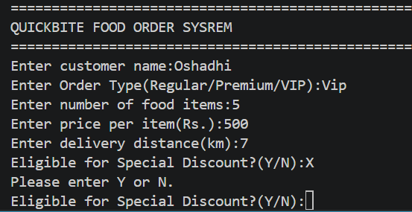

6. Testing

6.1 Test Plan
Testing ensures that QuickBite functions correctly under normal, boundary, and invalid test cases, giving appropriate results and error checking.
Objectives:
- To validate calculations of food costs, delivery charges, and Premium/VIP discounts.
- To ensure that free delivery is given for orders greater than Rs. 5000.
- To validate input validation and invalid data handling.

6.2 Test Cases
Test ID | Test Scenario | Input | Expected Result | Status
TC01 | Normal Regular Order | Regular, 5 items, Rs.500, 5km | Total calculated correctly | Pass
TC02 | Normal Premium Order | Premium, 4 items, Rs.700, 4km | 10% discount applied. | Pass
TC03 | Normal VIP Order | VIP, 5 items, Rs.1000, 3km | 20% discount applied. | Pass
TC04 | Free Delivery | VIP, 6 items, Rs.1000, 8km | Delivery charge = Rs.0 | Pass
TC05 | Boundary Distance | Distance = 20km | Accepted successfully | Pass
TC06 | Invalid Distance | Distance = 25km | Display validation error | Pass
TC07 | Negative Items | Items = -2 | Display validation error | Pass
TC08 | Invalid Order Type | Gold | Display invalid order type message | Pass

7. Test Evidence

TC01
- Normal Regular order output verification.
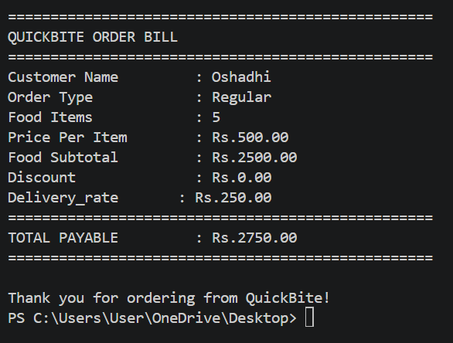

TC02
- Validated 10% discount for Premium membership.
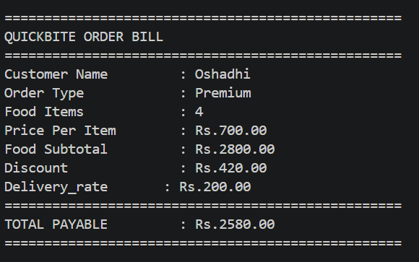

TC03
- Validated 20% discount for VIP membership.
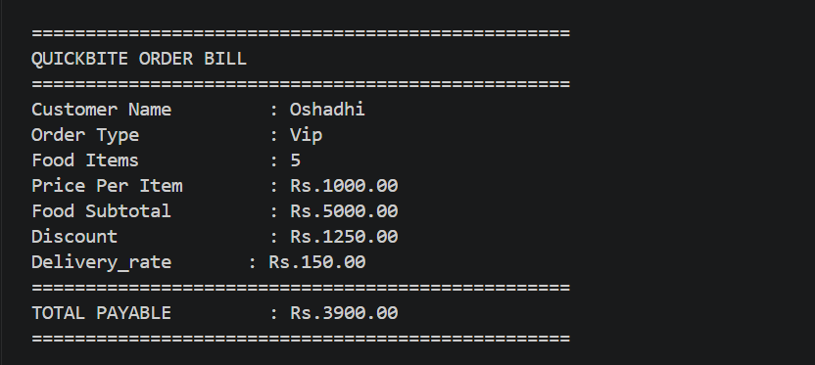

TC04
- Verified free delivery waiver for orders > Rs.5000
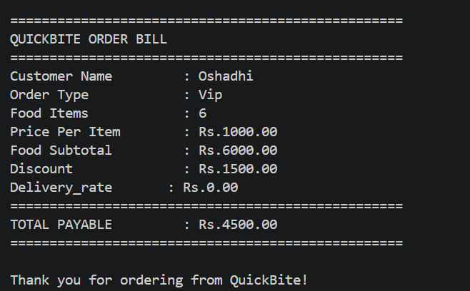

TC05
- Boundary test at 20km maximum delivery range.
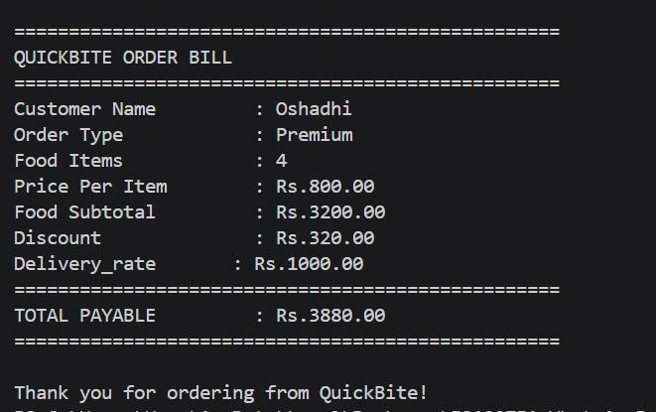

TC06
- Error prompt displayed for invalid distance (>20km).
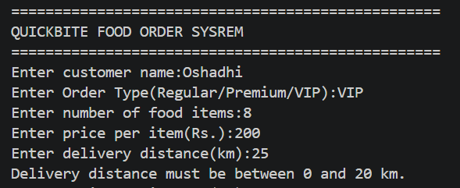

TC07
- Error prompt displayed for negative item quantity.

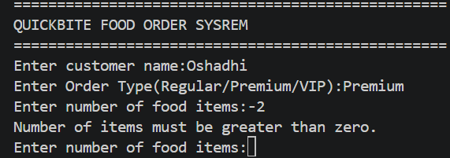

TC08
- Error prompt displayed for invalid order tier.
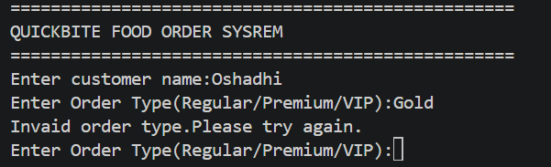

8. Technical Documentation.
QuickBite is built in Python using procedural programming, using modular functions to improve readability, maintainability, and code reuse.

8.1. Main Functions.

1. Validate input ()
This function validates user inputs such as:
- Number of items
- Price per item
- Delivery distance
Invalid entries trigger an error message and prompt the user to retry.

2. Calculate bill ()
This function performs all calculations.
It calculates:
- Food subtotal
- Discount amount
- Delivery charge
- Final payable amount

3. Display bill ()
This function prints the final itemized bill neatly with:
- Customer details
- Food cost
- Delivery charge
- Final total

8.2 Variables Used
Variable | Data Type | Purpose
customer_name | String | Stores customer name
order_type | String | Stores customer category
num_items | Integer | Stores quantity of food items
price_per_item | Float | Stores unit price
distance | Float | Delivery distance
food_total | Float | Total food cost
discount | Float | Discount amount
delivery_charge | Float | Delivery fee
total | Float | Final payable amount

8.3 Programming Decisions.
Key development decisions made the program maintainable and easy to modify:
- Functions: Avoid code repetition.
- Input Validation: Blocks invalid data.
- If-Else Logic: Handles tier discounts.
- Arithmetic Operators: Compute order totals.
- Constants & Clear Naming: Improve readability (e.g., delivery rate of Rs. 50/km).

9. Reflection.

Building QuickBite was a very useful learning process about Python fundamentals such as functions, loops, and validation. The difficulties were mainly in making sure that the discount and delivery conditions were implemented right and also handling the erroneous input via while and try-except.

9.1 Future Enhancements.

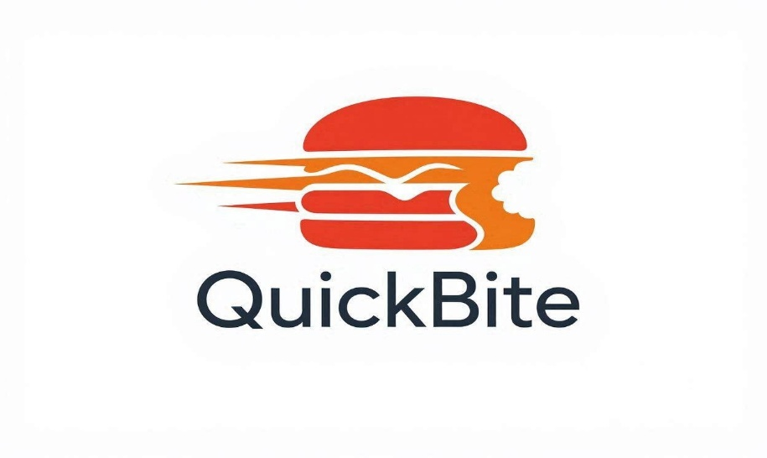
Such enhancements can be considered as GUI development, incorporation of the database with history of orders, payment method expansion, and loyalty reward program.

