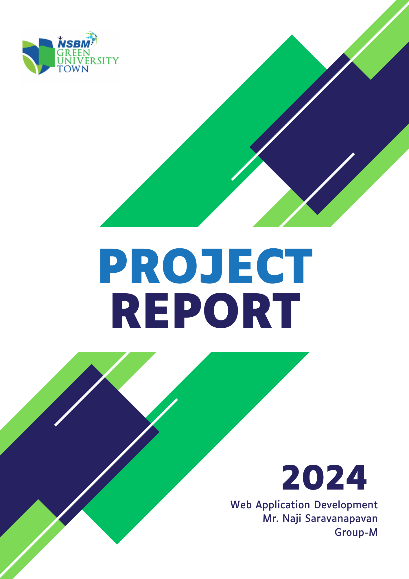

TITLE

# 



### E-Commerce Web Application Development

### (E-Cloth Group-M)

1st Year, 2nd Semester Web Project  
Course: Web Application Development  
Module Leader: Mr. Naji Saravanapavan  
Date: 04/Aug/2024

|  |  |
| --- | --- |
| **Name** | **Student Id** |
| [01] Dissanayake, DMDV | 33041 |
| [02] Charuka, RMD | 33033 |
| [03] Herath, MSSK | 32294 |
| [04] Elkaduwa, RPDB | 32680 |
| [05] Hansamalee, GMA | 32992 |
| [06] Peiris, DAOY | 32595 |
| [07] Methsadi, LLT | 32939 |
| [08] Thennakoon, INB | 32627 |
| [09] Lasith, Kaveesha | 32803 |
| [10] Ransadi, LLT | 32933 |

Acknowledgement

# 

I would like to express my heartfelt gratitude to our university lecturer, Mr. Naji, whose guidance and support were invaluable throughout this project. His insights and encouragement greatly contributed to the successful completion of this report.

I also extend my sincere thanks to my project team members for their hard work and collaboration, as well as to the technical and marketing teams for their dedication and expertise.

Finally, I am grateful to our friends and family for their unwavering support during this endeavor.

Thank you to everyone who played a part in making this project a success.

Abstract

# 

This report examines the development of a new women's clothing website designed to provide an engaging, intuitive, and user-friendly online shopping experience. The project was initiated to create a platform that meets the evolving needs of modern consumers in the women’s fashion industry, emphasizing both aesthetic appeal and functional efficiency.

The report covers key stages of the development process, including market analysis, design conceptualization, and the implementation of user interface (UI) and user experience (UX) best practices. Special attention was given to ensuring the website is mobile-responsive, secure, and optimized for fast performance, addressing the high standards expected by today’s online shoppers.

Additionally, the content strategy was carefully crafted to enhance user engagement, supported by targeted marketing efforts aimed at driving traffic and increasing conversion rates. User testing and iterative feedback played a crucial role in refining the website's features, resulting in a polished, consumer-oriented product.

The report concludes by evaluating the overall success of the project, discussing challenges encountered during development, and providing recommendations for future enhancements and scalability. This project highlights the team’s capability to integrate both creative design and advanced technical solutions into a competitive and functional e-commerce platform tailored to the women’s fashion market

Preface

# 

This report presents the development of a new women’s clothing website, a project inspired by the growing demand for user-friendly and innovative online shopping experiences. As the fashion industry increasingly embraces e-commerce, our goal was to create a platform that seamlessly integrates style, functionality, and technology.

The report chronicles the journey from concept to completion, highlighting the market research, design principles, and technical strategies that guided the project. It showcases the collaborative efforts of our team, whose diverse skills were key to overcoming challenges and achieving our objectives.

Through this project, we sought to build a website that not only serves as a digital storefront but also strengthens brand-consumer relationships. We hope this report provides valuable insights into the process and inspires future endeavors in web development.

CONTENTS

# 

* Acknowledgement 4
* Abstract 5
* Preface 6
* Company Profile 7
* Project Description 8
* Requirement Analysis 10
* Tools Platform Used 15
* SDLC(Software Development Life Cycle) 20
* System Design 25

1. Data Flow Diagrams 28
2. Screen Shots 32

* Testing 35
* Implementation 38
* Maintenance 40
* Future Scope of the project 45
* Conclusion 50