COSMOS COLLEGE OF MANAGEMENT & TECHNOLOGY
(Affiliated to Pokhara University)
Sitapaila, Kathmandu, Nepal


AN ENGINEERING PROJECT REPORT
ON
Digital Clock (MM:SS) Using ATmega32 Microcontroller
Submitted to:
Department of ICT
Bachelor of Engineering in Computer Engineering

Submitted By:
Oshan Bajracharya
Roll No: 230328

Date of Submission:
$1^{th} FEB 2026$

INTRODUCTION
This project focuses on the design and implementation of a digital clock using the ATmega32 microcontroller. The clock displays time in Minutes and Seconds (MM:SS) format using four common cathode 7-segment displays. Embedded systems combine hardware and software to perform specific tasks efficiently. This project demonstrates important embedded system concepts such as port interfacing, multiplexing, and software-based timing.

OBJECTIVE
• To interface multiple 7-segment displays with a microcontroller
• To understand and implement display multiplexing
• To generate accurate time delays using software
• To design a real-time digital clock system
• To gain practical knowledge of embedded C programming

COMPONENTS USED

Atmega32 microcontroller

4 × common cathode 7-segment displays

5V power supply

Connecting wires

8 MHz system clock (internal or external)

CIRCUIT DESCRIPTION
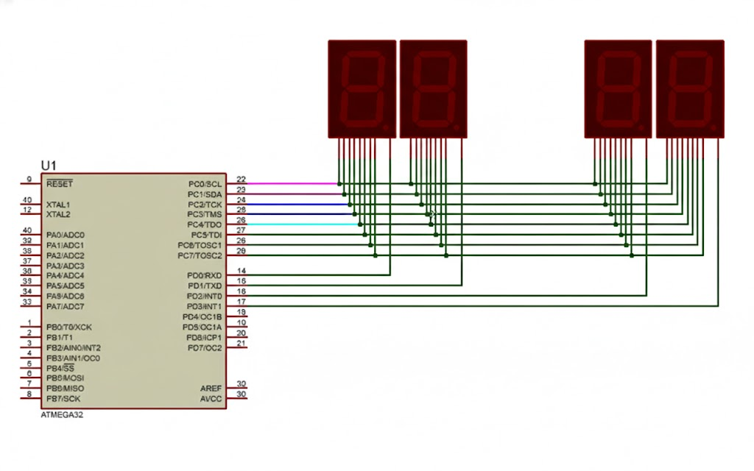

- PortC (PC0–PC7) of the ATmega32 is directly connected to the segment pins (a–g, dp) of all four 7-segment displays.
- PortD pins PD0–PD3 are used as digit select (common cathode) lines.
- Each display is enabled one at a time by controlling PD0–PD3 while segment data is sent through PortC.
- No current-limiting resistors are present in the shown circuit; segments are directly driven from the microcontroller port pins.

WORKING PRINCIPLE
The system uses a lookup table to generate segment patterns for digits 0–9. Multiplexing enables one display at a time with a small delay so that all digits appear continuously ON. The program increments seconds every one-second delay. When seconds reach 60, minutes increment. After 59:59, the clock resets to 00:00.

SOFTWARE DESIGN
The program initializes PORTC and PORTD as outputs. A display function handles digit scanning and refreshing. The main loop splits minutes and seconds into individual digits and displays them continuously. Delay functions create approximate 1-second timing.

ADVANTAGES
• Efficient use of I/O pins
• Low cost and simple hardware
• Good learning model for real-time embedded systems

LIMITATIONS
• Timing accuracy depends on software delay
• No hour display
• No real-time clock module

FUTURE ENHANCEMENTS
• Add RTC module (DS3231)
• Add hour display (HH:MM:SS)
• Add buttons for time setting
• Use timer interrupts instead of delays

CONCLUSION
The digital clock project successfully demonstrates embedded system fundamentals including hardware interfacing, multiplexing, and timing control using the ATmega32 microcontroller. The system accurately displays time in MM:SS format and serves as a strong foundation for more advanced real-time systems.

