- What is DBMS? State advantage of DBMS over file processing system.
A Database Management System (DBMS) is a software system designed to facilitate the creation, management, and administration of databases. It provides an interface for users to define, create, query, update, and manage data.
Advantages of DBMS over File Processing System
- Reduced Data Redundancy: In DBMS, data is centralized and stored in a single database, which minimizes duplication. File processing systems often lead to redundant data storage, which can create inconsistencies.
- Data Consistency: DBMS ensures data consistency with integrity constraints and validations, maintaining uniform data across the database. File processing systems may struggle with maintaining data consistency due to isolated files.
- Data Security: DBMS provides advanced security features like user authentication and access control, ensuring that only authorized users can access and modify data. File systems typically offer limited security features.
- Data Integrity: DBMS maintains data integrity through relational constraints, ensuring accuracy and reliability in data storage and retrieval. File processing systems can have difficulty enforcing data integrity across isolated files.
- Efficient Data Management: DBMS supports multi-user environments, allowing multiple users to access and modify the database concurrently without conflicts. In file processing systems, concurrent access can lead to data corruption.
- Backup and Recovery: DBMS offers automated backup and recovery options, ensuring data protection in case of failures. File processing systems often rely on manual backup processes, which can be error-prone.
- Data Independence: In DBMS, application programs are independent of the data structure, making it easier to modify the schema without affecting applications. File processing systems require program changes when the data structure is altered.
- Improved Data Sharing: DBMS supports data sharing across different applications, enhancing collaboration and data utilization. File systems may make it challenging to share and synchronize data between different applications.
- Better Data Access: DBMS utilizes query languages like SQL, enabling efficient data retrieval and manipulation. File processing systems often involve complex and time-consuming processes to access data.
- Data Centralization: DBMS centralizes data management, removing the need for multiple disparate files and allowing for a unified view of data. File systems often result in fragmented and scattered data storage.

2a) Define the role of relational algebra and its associated basic operators with necessary notations?
Relational Algebra is a formal language for querying and manipulating data in relational databases, providing a theoretical foundation for SQL and other query languages by defining operations like selection, projection, and join to retrieve and transform data., and join to retrieve and transform data.
Basic Operators in Relational Algebra:
- Selection (σ):
  - Role: Selects rows from a relation that satisfy a given condition.
  - Notation: σ_{condition}(Relation)
  - Example: σ_{age > 30}(Employees) retrieves all employees older than 30.
- Projection (π):
  - Role: Projects specified columns of a relation.
  - Notation: π_{column1, column2, ...}(Relation)
  - Example: π_{name, age}(Employees) retrieves only the names and ages of all employees.
- Union (∪):
  - Role: Combines two relations to include all tuples from both, removing duplicates.
  - Notation: Relation1 ∪ Relation2
  - Example: Employees ∪ Managers combines both relations into one.
- Set Difference (−):
  - Role: Retrieves tuples from one relation that are not in another.
  - Notation: Relation1 − Relation2
  - Example: Employees − Managers returns employees who are not managers.
- Cartesian Product (×):
  - Role: Combines tuples of two relations, resulting in all possible pairs of tuples.
  - Notation: Relation1 × Relation2
  - Example: Employees × Departments pairs every employee with every department.
- Intersection (∩):
  - Role: Returns common tuples present in both relations.
  - Notation: Relation1 ∩ Relation2
  - Example: Employees ∩ Managers gives employees who are also managers.
- Join (⋈):
  - Role: Combines related tuples from two relations based on a common attribute.
  - Notation: Relation1 ⋈_{common_attribute} (Relation2)
  - Example: Employees ⋈_ {Employees.DepartmentID = Departments.DepartmentID} Departments joins employees with their respective departments.
2b) Draw an E-R diagram for hospital management system. (Use DOCTOR, PATIENT,HOSPITAL and MEDICAL RECORD Entity)

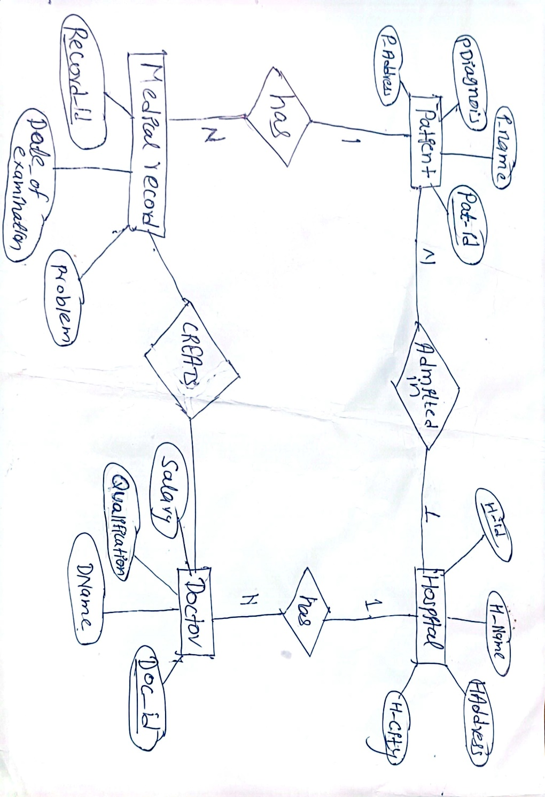

3)Define Normalization and state the advantages of normalization. Normalize database
Employee(emp_id ,emp_name,phone, skill, salary, deptno,dept_name,jobno,job_title) upto 3NF.
Normalization is the process of organizing data in a database to reduce redundancy and improve data integrity by dividing tables into smaller, related ones and establishing relationships between them.
Advantages of Normalization:
- Eliminates Redundancy:
  - Normalization removes duplicate data by splitting tables and creating relationships, which reduces storage needs and minimizes inconsistency risks.
- Improves Data Integrity:
  - By ensuring logical data dependencies, normalization maintains the accuracy and reliability of data through clearly defined relationships among tables.
- Enhances Data Consistency:
  - Updates, inserts, and deletes are more consistent across the database, reducing the chance of anomalies and maintaining uniform data throughout.
Employee
Emp_id | Emp_name | Phone | Skill | Salary | Deptno | Dept_name | Jobno | Job_title

Step 1: First Normal Form (1NF)
In 1NF, we ensure that each column contains atomic (indivisible) values, and each column contains values of a single type. Our table already meets this requirement.

Step 2: Second Normal Form (2NF)
In 2NF, we eliminate partial dependencies, i.e., no non-key attribute should depend on only a part of the primary key. Since emp_id is unique for each employee, we can identify it as the primary key. We split the table into two:
Employee:
Emp_id | Emp_name | Phone | Skill | Salary | Deptno

Department:
Deptno | Dept_name
Job:
Jobno | Job_title

Step 3: Third Normal Form (3NF)
In 3NF, we ensure that no transitive dependency exists, i.e., non-key attributes should not depend on other non-key attributes. This involves further splitting:
Employee:
Emp_id | Emp_name | Phone | Skill | Salary | Deptno | Jobno
Department:
Deptno | Dept_name
Job:
Jobno | Job_title

4) Consider the following relations:
EMP(empno, deptno, ename salary,city)
Write SQL query for the following cases:
- Display employee number and name in an increasing order of salary.
SELECT empno, ename
FROM EMP ORDER
BY salary ASC;

- Display employee name starting with "S" and working in deptno 105
SELECT ename
FROM WHERE ename
LIKE 'S%' AND deptno = 105;
- Delete all employee of department 100.
DELETE FROM EMP
WHERE deptno = 100;

- Display number of employees department wise
SELECT deptno, COUNT(empno)
AS employee_count FROM EMP
GROUP BY deptno;
- Insert the new employee as 500, 102, rohit, 50000, kathmandu.
INSERT INTO EMP (empno, deptno, ename, salary, city)
VALUES (500, 102, 'Rohit', 50000, 'Kathmandu');

4)Write short note on
a)Key
i. Primary Key:
- Definition: A unique identifier for each record in a table. No two rows can have the same primary key value, and it cannot be NULL.
- Purpose: Ensures that each record is unique and can be retrieved easily.
ii. Candidate Key:
- Definition: A set of attributes that uniquely identify a record in a table. There can be multiple candidate keys in a table.
- Purpose: Any candidate key can potentially be chosen as the primary key.
iii. Super Key:
- Definition: A set of one or more attributes that, together, uniquely identify a record in a table. This set might include more attributes than necessary.
- Purpose: Provides an extended combination of attributes for unique identification.
iv. Foreign Key:
- Definition: An attribute or set of attributes that establish a link between the data in two tables. It refers to the primary key in another table.
- Purpose: Enforces referential integrity by ensuring that the value of a foreign key corresponds to an existing primary key in another table.
v. Composite Key:
- Definition: A key that consists of two or more attributes that together uniquely identify a record in a table.
- Purpose: Useful when a single attribute is not sufficient to uniquely identify records.
vi. Alternate Key:
- Definition: A candidate key that was not chosen as the primary key.
- Purpose: Provides a secondary way to uniquely identify records.
vii. Unique Key:
- Definition: An attribute or set of attributes that ensure all values are unique across the records in a table. Similar to a primary key but can accept NULL values.
- Purpose: Ensures unique values without being the main identifier.
b)Integrity Constraints
Integrity constraints are rules applied to database columns to ensure the accuracy and consistency of data. They help maintain the quality and security of data within the database. Here are some key types of integrity constraints:
i. Primary Key Constraint
- Purpose: Ensures that each record in a table is unique and not null.
- Example: PRIMARY KEY (ID)
ii. Foreign Key Constraint
- Purpose: Ensures that the value of a column or set of columns in one table matches the values in a primary key or unique key column of another table.
- Example: FOREIGN KEY (DepartmentID) REFERENCES Departments(ID)
iii. Unique Key Constraint
- Purpose: Ensures that all values in a column or set of columns are unique across the entire table.
- Example: UNIQUE (Email)
iv. Not Null Constraint
- Purpose: Ensures that a column cannot have NULL values.
- Example: NOT NULL
v. Check Constraint
- Purpose: Ensures that values in a column satisfy a specific condition.
- Example: CHECK (Age >= 18)
vi. Default Constraint
- Purpose: Assigns a default value to a column if no value is specified for that column.
- Example: DEFAULT 'N/A'
c) Aggregate functions
Aggregate functions in SQL are powerful tools used to perform calculations on sets of values, returning a single value for each set. They are commonly used in data analysis and reporting. Here are some of the most commonly used aggregate functions:
i. SUM()
- Purpose: Adds up all the values of a specified column.
- Example: SELECT SUM(Salary) FROM Employees;
ii. AVG()
- Purpose: Calculates the average of the values in a specified column.
- Example: SELECT AVG(Salary) FROM Employees;
iii. COUNT()
- Purpose: Counts the number of rows that match a specified criteria.
- Example: SELECT COUNT(*) FROM Employees;
iv. MAX()
- Purpose: Finds the maximum value in a specified column.
- Example: SELECT MAX(Salary) FROM Employees;
v. MIN()
- Purpose: Finds the minimum value in a specified column.
- Example: SELECT MIN(Salary) FROM Employees;
vi. GROUP_CONCAT()
- Purpose: Concatenates values from multiple rows into a single string.
- Example: SELECT GROUP_CONCAT(Name) FROM Employees;

