TITLE :
2-Bit ALU Design in Digital Logic Sim
OBJECTIVE :
- Design and simulate a 2-bit ALU in Digital Logic Sim to perform basic arithmetic and logic operations.
- Ensure efficiency and functional correctness in circuit implementation.
THEORY:
A 2-bit ALU performs arithmetic (addition, subtraction) and logic (AND, OR, XOR) operations on 2-bit binary inputs. It consists of multiplexers, logic gates, adders, and a control unit to execute operations based on control signals.
In Digital Logic Sim, the circuit is built using fundamental components to simulate its functionality before actual hardware implementation. This helps validate the correctness of the design and ensures efficient computation
The 2-bit ALU was successfully designed and simulated in Digital Logic Sim, performing arithmetic and logic operations like addition, subtraction, AND, OR, and XOR. The use of multiplexers and logic gates ensured efficient execution based on control signals. The simulation validated the correctness and functionality of the circuit, confirming its reliability in digital computation.
OBSERVATION :
1.Designing of Arithmetic Unit :
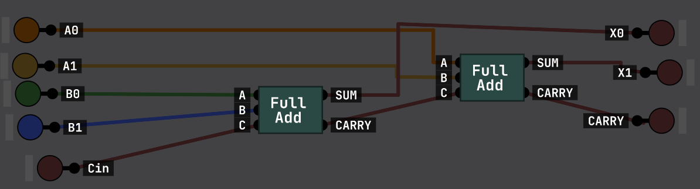
2.Logical Unit
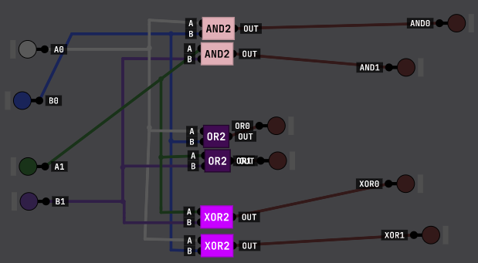

3. 2-bit ALU
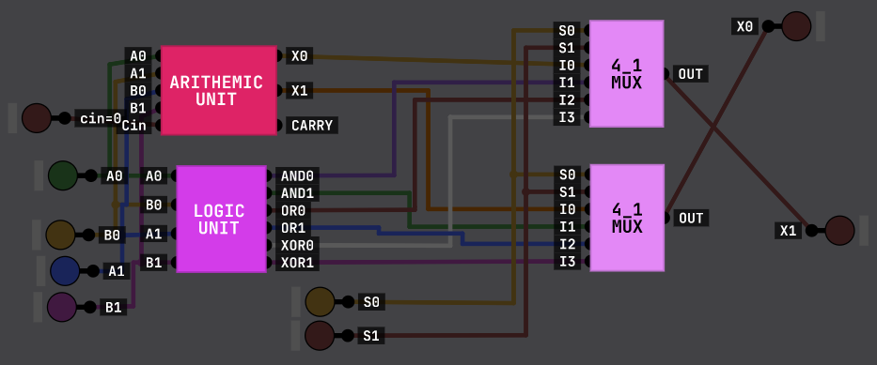

CONCLUSION :
The 2-bit ALU was successfully simulated in Digital Logic Sim, verifying its ability to perform arithmetic and logic operations accurately. The circuit design, utilizing multiplexers and logic gates, functioned as expected, confirming its efficiency and correctness in digital computation.

