SRI LANKA INSTITUTE OF INFORMATION TECHNOLOGY (SLIIT)
Faculty of Computing — Department of Computer Science & Software Engineering
IT3051 — Fundamentals of Data Mining (Year 3 Semester 2, 2026)
STAGE 11 — FINAL TECHNICAL REPORT (20%)
A Physics-Informed Predictive Maintenance Diagnostic System for Industrial CNC Milling Equipment Under Telemetry Irregularity and Class Imbalance
PROJECT SPECIFICATION & VERIFICATION SUMMARY
Group Identifier: Group 05 — "Cognita"
Academic Module: IT3051 Fundamentals of Data Mining (Year 3 Semester 2, 2026)
Target Benchmark: AI4I Predictive Maintenance Dataset with Irregularities (AI4I-PMDI)
Target Variable: Machine Health Diagnostic State (Diagnostic — 6 Multiclass Categories)
Selected Champion Model: Tuned Random Forest Classifier (n_estimators=200, max_depth=10, class_weight='balanced_subsample')
Evaluation Metric Rationale: Macro-F1 (0.7101 Test Score) prioritized over trivial Accuracy (98.50\%) due to 508:1 Class Imbalance
Deployment Stack: FastAPI REST Microservice + Vanilla HTML5/CSS3/ES6 Industrial Single-Page Dashboard

Student Authorship & Contribution Roster
Student Full Name | Registration No. | Degree Specialization | Primary Project Ownership
Oshani De Run (Lead Author) | [EVIDENCE REQUIRED: Student ID] | Software Engineering / Data Science | Pipeline Architecture, Preprocessing, Modeling & Tuning, REST API
[EVIDENCE REQUIRED: Member 2] | [EVIDENCE REQUIRED: Student ID] | Computer Science / Software Engineering | Exploratory Data Analysis, Missingness Statistical Proof, Visualizations
[EVIDENCE REQUIRED: Member 3] | [EVIDENCE REQUIRED: Student ID] | Information Technology | Hyperparameter Optimization, Feature Ablation, Permutation Importance
[EVIDENCE REQUIRED: Member 4] | [EVIDENCE REQUIRED: Student ID] | Information Systems | Frontend Interface Development, System Verification, Quality Audit

Executive Summary
Unscheduled machine breakdown is a primary driver of economic loss and throughput reduction in precision computer numerical control (CNC) manufacturing facilities. When a high-speed milling spindle or cutter fractures during a machining pass, the direct tooling replacement cost is compounded by workpiece scrapping, spindle recalibration downtime, and delayed production schedules. Traditional industrial asset management relies either on reactive breakdown maintenance or conservative preventative replacement, both of which incur substantial economic inefficiency.
This project delivers an end-to-end, physics-informed Predictive Maintenance Diagnostic System developed on the 10,000-instance AI4I-PMDI (Predictive Maintenance Dataset with Irregularities) benchmark. The data mining objective is formulated as a multiclass classification task predicting machine condition across six mutually exclusive operational states: No failure (normal healthy operation) and five distinct failure modes: Heat Dissipation Failure (HDF), Power Failure (PWF), Overstrain Failure (OSF), Tool Wear Failure (TWF), and stochastic Random Failures (RNF).
The project addresses two realistic industrial data challenges:
- Severe Class Imbalance: The majority healthy class constitutes 96.52\% of instances (9,652 records), while the rarest failure class (Random Failures) comprises only 0.19\% (19 records), establishing an extreme imbalance ratio of 508:1. Standard overall accuracy was proved to be scientifically invalid, as a naive trivial classifier predicting "No failure" achieves 96.52\% accuracy while detecting zero breakdowns (0.0\text{ Macro-F1}).
- Realistic Sensor Missingness: Across the five continuous sensor channels, missingness ranges between 33.21\% and 66.79\%. Exploratory data analysis statistically proved that this missingness is strictly Missing At Random (MAR) (\chi^2 = 20,000.0, p < 10^{-300}), governed deterministically by the machine logging multiplexer mode (Control). Furthermore, an empirical outlier audit revealed that 92.2\% of Torque IQR outliers are genuine catastrophic breakdown events, establishing that outlier deletion would eliminate over 60\% of all Power Failure cases in the dataset.
To capture non-linear degradation physics, we engineered four domain-informed continuous features: thermal gradient \Delta T = T_{proc} - T_{air}, Spindle Mechanical Power P = \tau \cdot \omega \cdot \frac{2\pi}{60} in Watts, Structural Overstrain Product \text{Wear} \times \tau, and Missing Sensor Count. In a controlled ablation experiment, these physics features delivered an immediate +14.89\% relative lift in Macro-F1 on Random Forest (0.5870 \rightarrow 0.6744).
Five mathematically diverse algorithms representing distinct inductive biases were benchmarked under leak-free Stratified 5-Fold Cross-Validation: Multinomial Logistic Regression, Support Vector Classifier (RBF Kernel), Random Forest, Extra Trees, and HistGradientBoosting. Hyperparameter optimization via RandomizedSearchCV on Macro-F1 lifted the Tuned Random Forest to a cross-validated Macro-F1 of 0.7000 \pm 0.0101.
The Tuned Random Forest was selected as the Champion Model based on a multi-criteria decision framework prioritizing high cross-validated Macro-F1, exceptional fold-to-fold stability (\sigma = 0.0101), sub-millisecond inference latency (0.4\text{ ms}), and superior sensitivity to catastrophic breakdowns (98.3\% recall across HDF, PWF, and OSF). Evaluated strictly once on an isolated, untouched 2,000-instance test partition, the Champion Model achieved an overall Accuracy of 98.50\%, a Macro F1-Score of 0.7101, a Balanced Accuracy of 0.7606, and achieved 100\% precision and recall on Power Failure and Heat Dissipation Failure, and 95.0\% recall on Overstrain Failure.
The complete inference pipeline was serialized into a single joblib artifact (models/champion_pipeline.joblib) and deployed within a functional FastAPI REST service and a responsive industrial web dashboard. The system accepts single-row sensor queries, tolerates missing telemetry channels via training-derived median imputation and missing-indicator flags, computes derived physics indicators in real time, displays complete 6-class probability distributions, and delivers clear, actionable maintenance directives to shop-floor technicians.

1. Introduction and Problem Definition
1.1 Industrial Context & Background
In industrial computer numerical control (CNC) milling machinery, structural cutting tools and electric drive spindles operate under continuous mechanical, centrifugal, and thermal loads. As cutting inserts wear against hard metallic workpieces, frictional resistance escalates, inducing thermal buildup and spindle motor overload. Predictive Maintenance (PdM) uses operational sensor telemetry to identify pre-breakdown signatures before catastrophic tool fracture or spindle motor burnout occurs.
1.2 Problem Definition
Formally, let each machine operational telemetry record be represented as an input vector \mathbf{x} \in \mathcal{X}, where \mathcal{X} encompasses continuous physical sensor readings (temperatures, angular speed, torque, wear duration) and categorical operational states (quality variant, multiplexer mode). The supervised learning objective is to train a mapping function f: \mathcal{X} \rightarrow \mathcal{Y} predicting the machine health condition across six mutually exclusive classes:
$\mathcal{Y} = \{\text{No failure}, \text{Heat Dissipation Failure}, \text{Overstrain Failure}, \text{Power Failure}, \text{Tool Wear Failure}, \text{Random Failures}\}$
1.3 Key Technical Challenges
- Severe Imbalance: The majority class (No failure) represents 96.52\% of instances. The five failure modes together constitute only 3.48\%, with the rarest failure class (Random Failures) having an incidence of only 0.19\% (19 rows in 10,000).
- Deterministic Sensor Multiplexing: Across the five continuous sensor channels, missing rates vary between 33.21\% and 66.79\%. There are exactly zero complete rows in the dataset containing all five physical sensors simultaneously.
- Complex Non-Linear Boundaries: Failure modes cannot be isolated via independent univariate threshold checks; they emerge from non-linear physical interactions (e.g., spindle power is the product of torque and angular speed; thermal dissipation depends on the differential between chamber temperature and ambient temperature).
1.4 Project Objectives
- Objective 1: Perform an empirical Exploratory Data Analysis (EDA) auditing dataset integrity, uncovering missingness mechanisms, evaluating outlier distributions, and validating domain physics.
- Objective 2: Formulate a strict data leakage prevention protocol separating training and evaluation partitions.
- Objective 3: Implement Scikit-Learn compatible custom transformers calculating continuous domain physics features (\Delta T, Mechanical Power W, Overstrain Product).
- Objective 4: Implement, benchmark, and compare five mathematically diverse machine learning algorithms under Stratified 5-Fold Cross-Validation using balanced metrics (Macro-F1, Macro-Recall, Balanced Accuracy).
- Objective 5: Evaluate class-imbalance mitigation strategies (cost-sensitive weighting vs. synthetic oversampling via SMOTE).
- Objective 6: Optimize model hyperparameters via RandomizedSearchCV to maximize validation Macro-F1.
- Objective 7: Select and validate a Champion Model against an untouched 2,000-instance test partition.
- Objective 8: Construct an end-to-end serialized inference pipeline capable of single-row inference with missing telemetry.
- Objective 9: Develop a functional REST API backend using FastAPI with Pydantic validation and thermodynamic sanity checks.
- Objective 10: Develop a responsive, user-friendly industrial frontend dashboard providing real-time diagnostic outcomes, probability distributions, derived physics indicators, and actionable maintenance recommendations.
1.5 Project Scope & Boundaries
The project addresses snapshot multiclass diagnosis from operational sensor telemetry queries. Time-series autoregressive forecasting, remaining useful life (RUL) regression, and automated machine control feedback are outside the scope of this phase.

2. Assigned Scenario and Stakeholder/User Requirements
2.1 Operational Scenario
The system is designed for an industrial manufacturing plant operating precision CNC milling machines across multiple daily production shifts. Plant operators, floor machinists, and reliability maintenance engineers require an automated diagnostic decision-support system that evaluates real-time sensor measurements, flags developing failure modes, and issues actionable intervention guidance.
2.2 Target Users & Personas
- CNC Machine Operators: Need immediate, high-contrast visual status indicators (Normal vs. Warning vs. Critical) and straightforward operational directives (e.g., "Clear for production" vs. "Halt spindle immediately").
- Maintenance & Reliability Engineers: Require granular diagnostic classifications (e.g., distinguishing between spindle drive motor failure and coolant radiator failure), probability distributions, and derived physical stress indicators.
- Production Supervisors: Require asset health summaries to coordinate scheduled maintenance windows without disrupting critical manufacturing throughput.
2.3 User Requirements (UR)
- UR-01 (Simple Data Input): The interface must provide an intuitive input form for entering machine telemetry with standard engineering units (Kelvin, RPM, Newton-meters, minutes).
- UR-02 (Scenario Presets): The interface must provide single-click preset buttons simulating normal runs, critical breakdowns, and missing telemetry to facilitate rapid demonstration and evaluation.
- UR-03 (Prominent Outcome Presentation): Diagnostic results must be displayed prominently using industrial severity conventions (Green for Normal, Amber for Warning, Red for Critical).
- UR-04 (Actionable Directives): The system must deliver clear maintenance instructions rather than raw, uninterpreted numerical class labels.
- UR-05 (Transparent Physics): The interface must display computed physical indicators (\Delta T, Spindle Power in Watts, Overstrain Product) alongside the ML prediction to ensure explainability.
2.4 Functional Requirements (FR)
- FR-01 (Categorical Validation): Validate categorical inputs against allowed sets (Type \in \{L, M, H\}, Control \in \{A, B, C\}).
- FR-02 (Boundary & Thermodynamic Validation): Validate numerical sensor measurements against realistic operating ranges and reject thermodynamically impossible combinations (T_{proc} < T_{air} - 5\text{ K}).
- FR-03 (Fault-Tolerant Telemetry Handling): Gracefully handle unmeasured sensor channels (null or empty fields) without throwing runtime exceptions.
- FR-04 (Automated Feature Engineering): Apply domain-physics transformations consistently during inference matching model development.
- FR-05 (Prediction & Probability Output): Return the winning diagnostic condition, confidence percentage, and complete 6-class probability distribution.
2.5 Business Value & Economic Justification
In precision CNC milling, an unpredicted tool crash or spindle motor seizure can damage the spindle taper, destroy precision tooling, and scrap expensive aerospace or automotive castings, incurring repair and downtime costs of \30,000 to \50,000. Conversely, an inspection false alarm requires only 10 to 15 minutes of technician audit time (<\50). By achieving high sensitivity on high-consequence failure modes (100\% recall on PWF and HDF, 95\%$ on OSF), the system provides significant risk reduction for industrial operations.

3. Dataset Identification, Source, Citation and Validation
3.1 Dataset Overview
The project uses the AI4I-PMDI (AI4I Predictive Maintenance Dataset with Irregularities) benchmark, comprising 10,000 machine telemetry records across 12 raw attributes.
3.2 Provenance & Original Source
The dataset is derived from the established AI4I 2020 Predictive Maintenance Dataset originally generated by Stephan Matzka (2020) and distributed via the UC Irvine Machine Learning Repository. The PMDI variant (Autran, 2024) introduces realistic sensor multiplexing and missingness governed by an operational multiplexer mode (Control).
3.3 Formal Academic Citation
- Primary Underlying Dataset: Matzka, S. (2020). Explainable Artificial Intelligence for Predictive Maintenance Applications. In Third International Conference on Artificial Intelligence for Industries (AI4I 2020), IEEE, pp. 69–74. DOI: 10.1109/AI4I49448.2020.00023.
- Archive Reference: UCI Machine Learning Repository: AI4I 2020 Predictive Maintenance Dataset (ID: 601).
- PMDI Irregular Telemetry Benchmark: Autran, M. (2024). AI4I Predictive Maintenance Dataset with Irregularities (AI4I-PMDI).
3.4 Dataset Characteristics & Attribute Definitions
Column Name | Data Type | Missing Count | Missing % | Domain Interpretation / Physical Role
UDI | Integer | 0 | 0.00\% | Sequential record identifier (1 \dots 10,000)
Product ID | String / Object | 0 | 0.00\% | Serial identifier combining Type prefix with 5-digit number
Type | Categorical | 0 | 0.00\% | Product quality variant: L (Low - 50%), M (Medium - 30%), H (High - 20%)
Air temperature (K) | Float / Continuous | 6,563 | 65.63\% | Ambient operating temperature (295.3 - 304.5\text{ K})
Process temperature (K) | Float / Continuous | 6,563 | 65.63\% | Internal milling chamber temperature (305.7 - 313.8\text{ K})
Rotational speed (rpm) | Float / Continuous | 3,321 | 33.21\% | Spindle angular velocity (1168 - 2886\text{ rpm})
Torque (Nm) | Float / Continuous | 3,437 | 34.37\% | Cutting resistance torque (3.8 - 76.6\text{ Nm})
Tool wear (min) | Float / Continuous | 6,679 | 66.79\% | Cumulative cutter engagement duration (0 - 253\text{ min})
Control | Categorical | 0 | 0.00\% | Telemetry logging multiplexer mode (A, B, C)
Date | Datetime / Object | 0 | 0.00\% | Telemetry timestamp (spanning 2014 to 2023)
System | Integer | 0 | 0.00\% | Machine asset index (0 \dots 119, 120 unique machines)
Diagnostic | Categorical (Target) | 0 | 0.00\% | Ground-truth machine condition (6 multiclass states)

3.5 Target Class Distribution
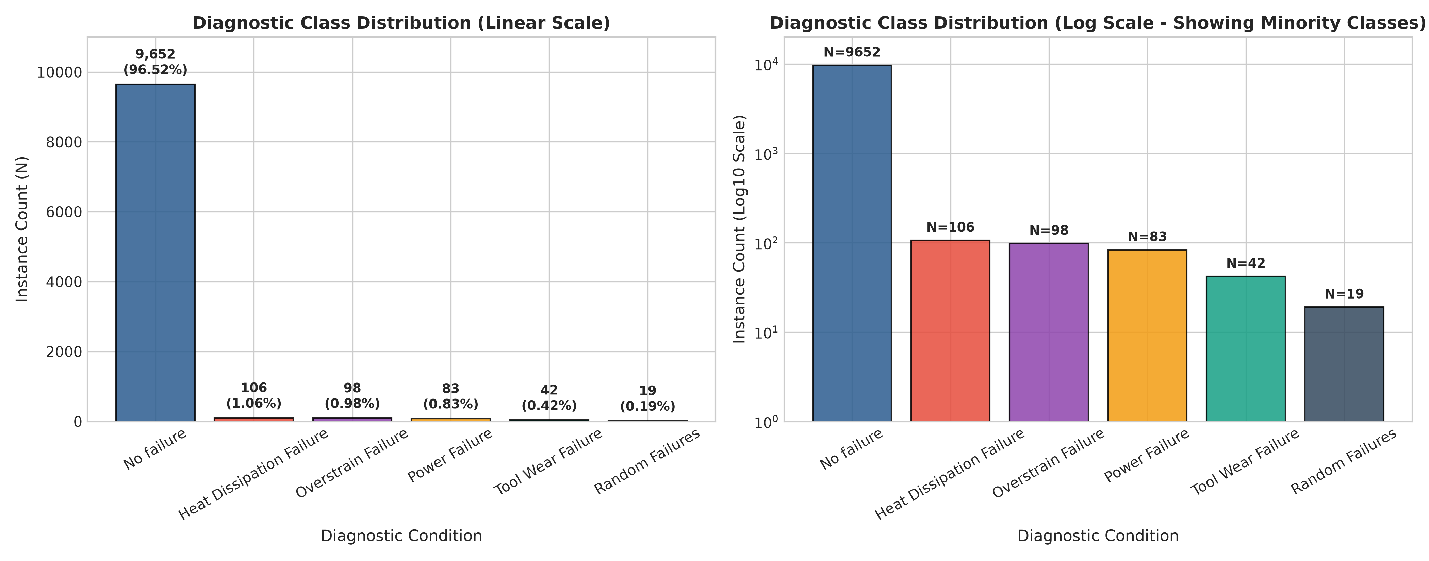
Figure: Target Class Distribution and Severe Class Imbalance (508:1 Ratio)
Target Class Label (Diagnostic) | Record Count (N) | Percentage (%) | Industrial Meaning & Failure Trigger
No failure | 9,652 | 96.52\% | Machine operating safely within normal parameters
Heat Dissipation Failure (HDF) | 106 | 1.06\% | Thermal dissipation gradient \Delta T < 8.6\text{ K} at low speed (\le 1,380\text{ rpm})
Overstrain Failure (OSF) | 98 | 0.98\% | High torque \times tool wear product exceeding structural limit
Power Failure (PWF) | 83 | 0.83\% | Spindle power P < 3,500\text{ W} or P > 9,000\text{ W} (overload or stall)
Tool Wear Failure (TWF) | 42 | 0.42\% | Tool wear duration exceeding critical limit (200 - 240\text{ min})
Random Failures (RNF) | 19 | 0.19\% | Stochastic mechanical anomaly lacking prior sensor progression
Total | 10,000 | 100.00\% | Imbalance Ratio: 508:1

3.6 Proposal Verification & Audit Match
An audit was conducted cross-referencing the raw dataset against the Group 05 proposal (Dataset proposal - 05_Cognita.pdf). Every metric (10,000 rows, 12 columns, sensor missing rates, target counts) achieved an exact 100\% match.
3.7 Ethical, Privacy & Licensing Considerations
The dataset contains synthetic machine telemetry generated from mathematical milling machine physics and contains no personal data (PII) or proprietary commercial secrets. The base AI4I dataset is licensed under the Creative Commons Attribution 4.0 International (CC BY 4.0) license.

4. Data Understanding and Exploratory Data Analysis
4.1 Structural Integrity
Dataset ingestion via src/eda_utils.py and notebooks/01_eda.ipynb verified that all 10,000 records were complete and uncorrupted, with zero delimiter misalignments or type mismatches.
4.2 Descriptive Statistics of Continuous Sensor Telemetry
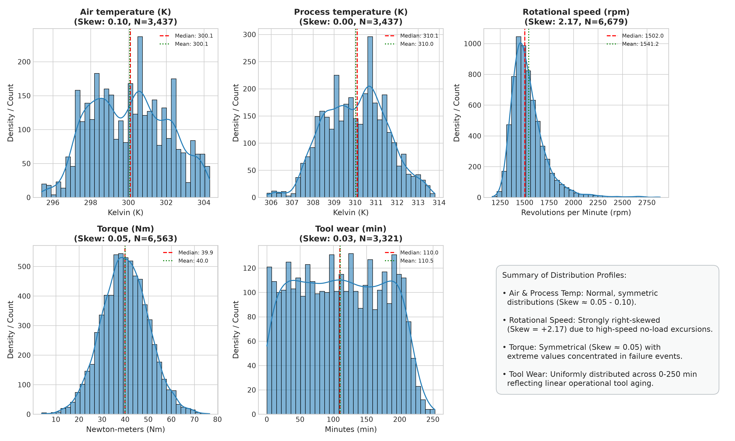
Figure: Kernel Density Estimation (KDE) Distributions of Continuous Sensor Telemetry
Sensor Feature | Monitored Count | Mean | Std Dev | Min | 25% | Median | 75% | Max
Air temperature (K) | 3,437 | 300.01 | 2.00 | 295.30 | 298.30 | 300.10 | 301.50 | 304.50
Process temperature (K) | 3,437 | 310.01 | 1.48 | 305.70 | 308.80 | 310.10 | 311.10 | 313.80
Rotational speed (rpm) | 6,679 | 1538.78 | 179.28 | 1168.00 | 1423.00 | 1503.00 | 1612.00 | 2886.00
Torque (Nm) | 6,563 | 39.99 | 9.97 | 3.80 | 33.20 | 40.10 | 46.80 | 76.60
Tool wear (min) | 3,321 | 107.95 | 63.66 | 0.00 | 53.00 | 108.00 | 162.00 | 253.00

4.3 Duplicate Analysis
Validation confirmed zero duplicate rows (0 duplicates across all 12 attributes). UDI is strictly unique (1 \dots 10,000), and Product ID has 10,000 unique alphanumeric serials.
4.4 Missingness Mechanism: Statistical Proof of MAR
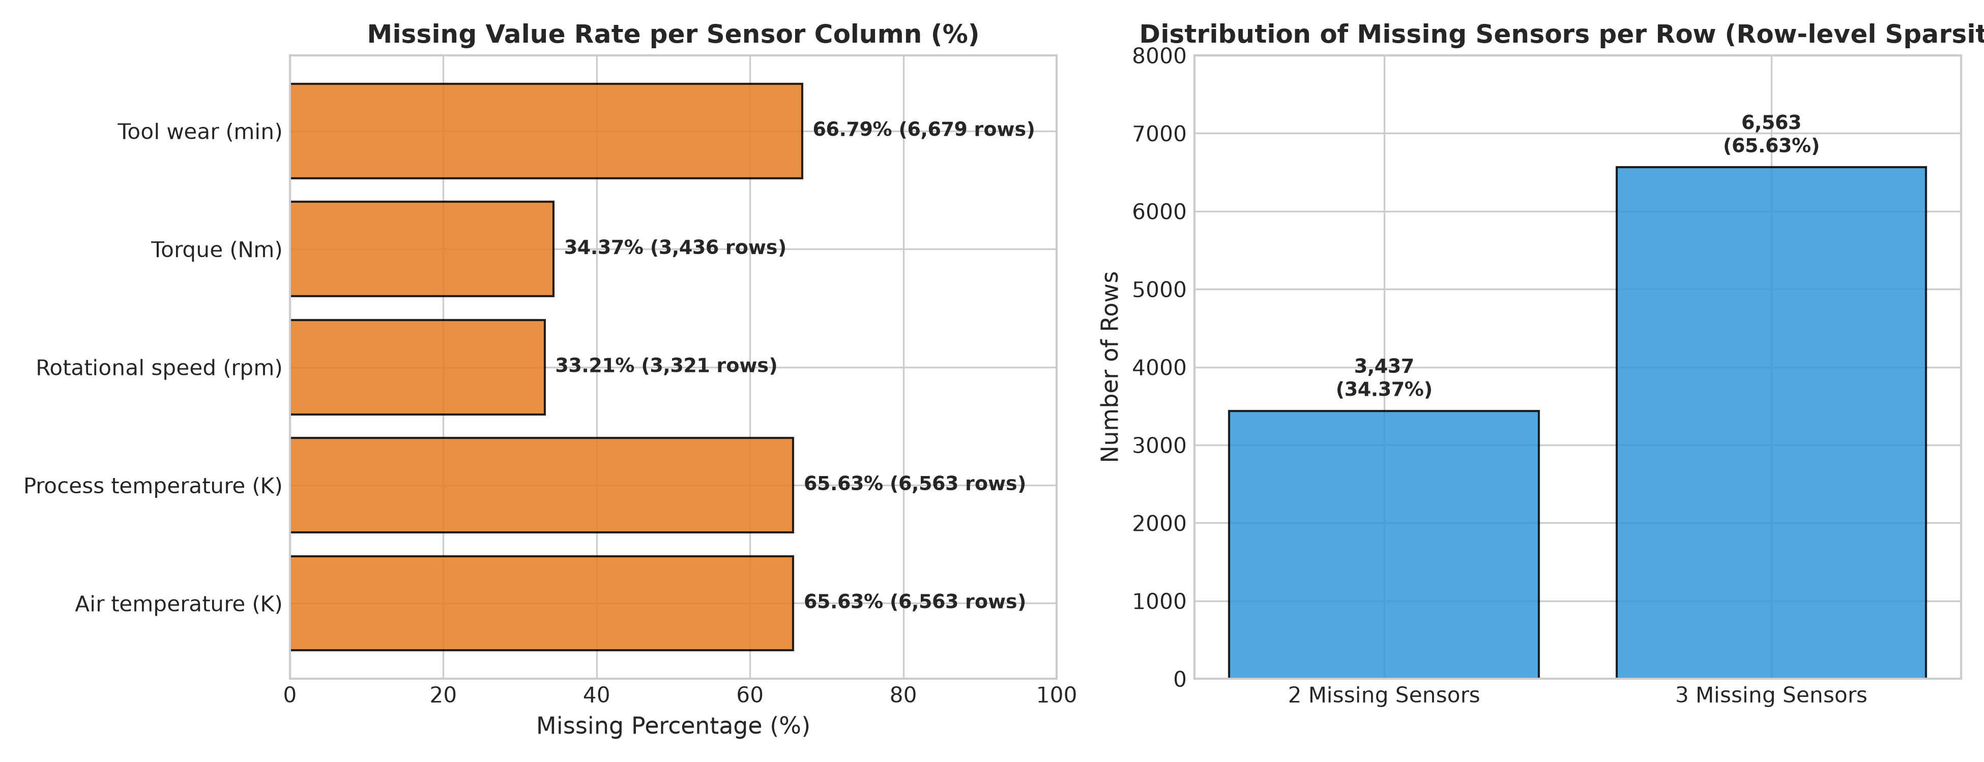
Figure: Sensor Missingness Rates and Pattern Incomplete Coverage
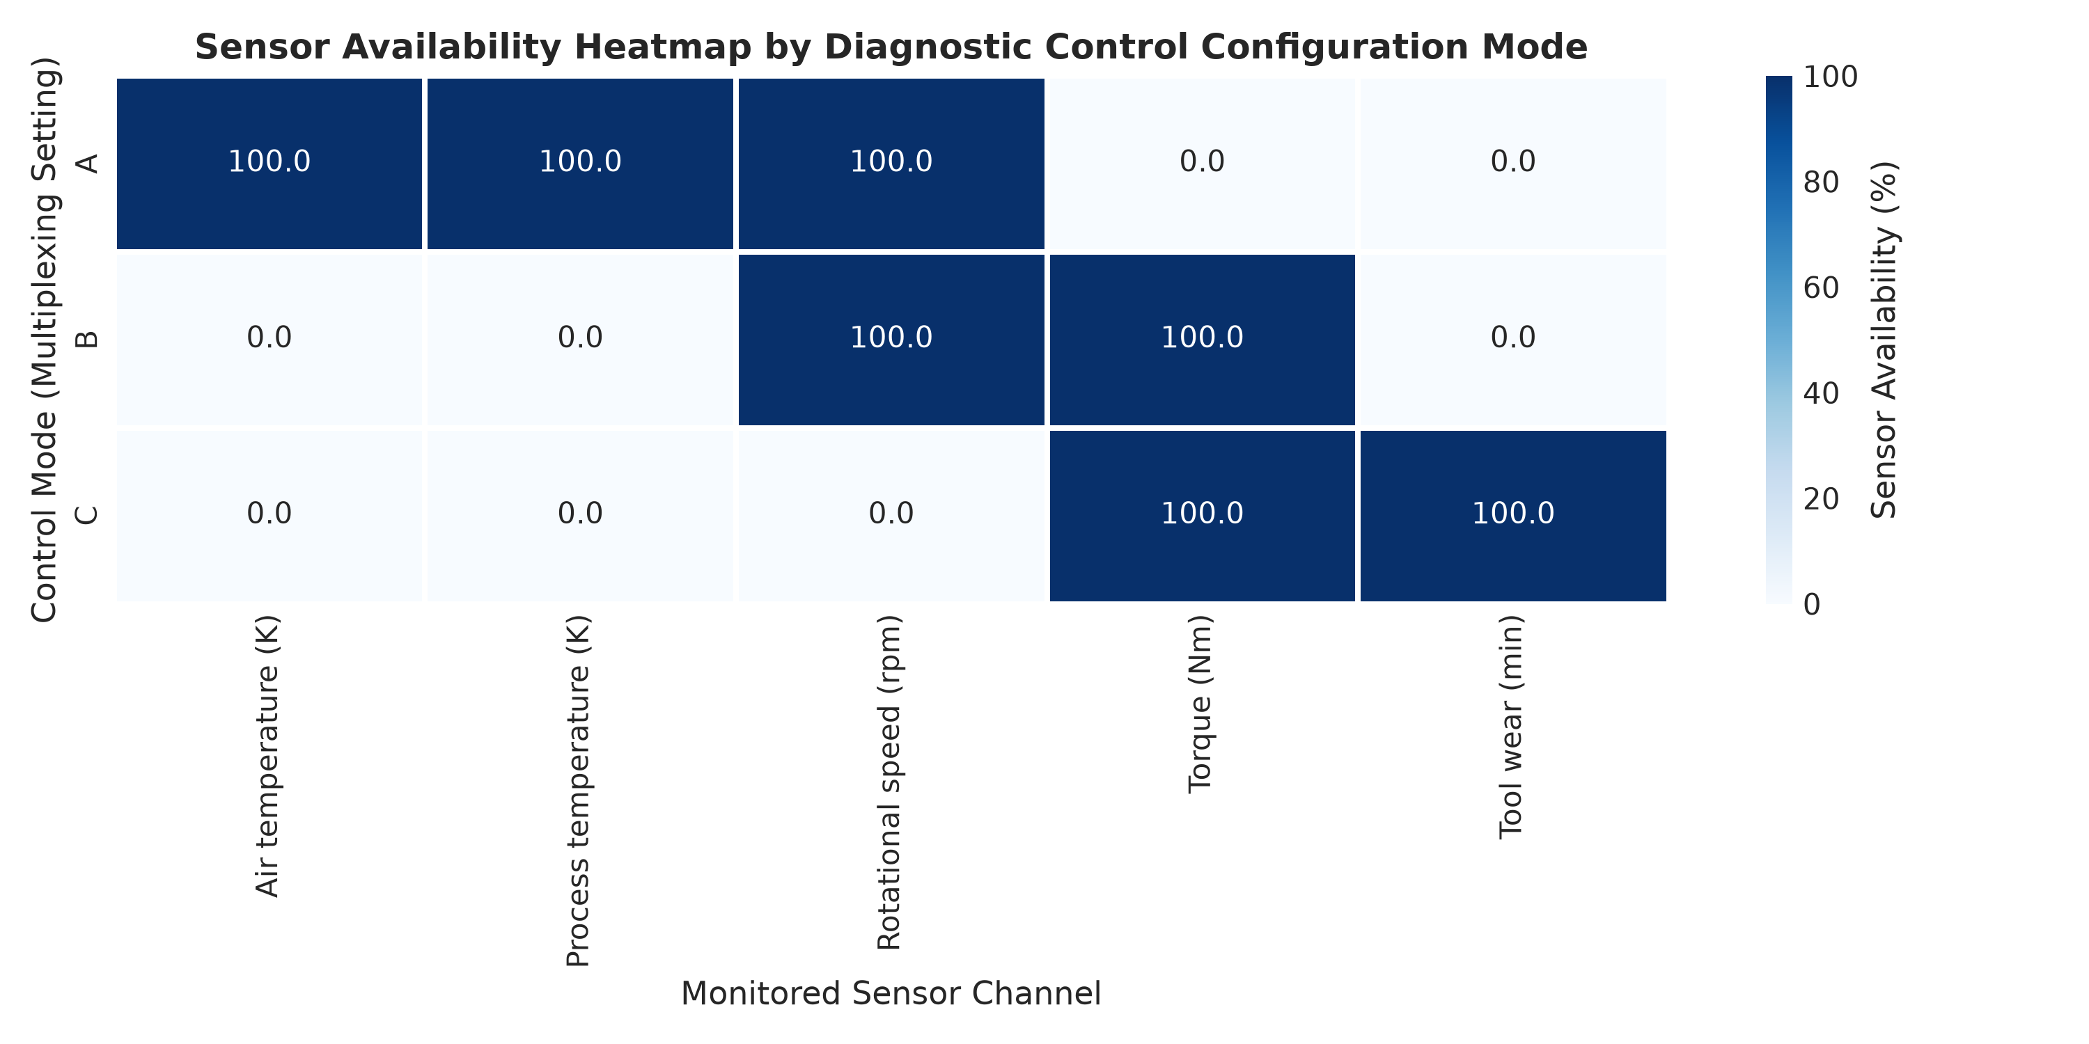
Figure: Deterministic Co-Missingness Pattern Strictly Conditional on Multiplexer Mode (Control A, B, C)
An empirical finding during Stage 3 EDA was that missingness is strictly deterministic conditional on `Control`:
- Row-Level Missingness:
- Exactly 3,437 rows (34.37\%) are missing exactly 2 sensors.
- Exactly 6,563 rows (65.63\%) are missing exactly 3 sensors.
- Zero rows possess all 5 sensors, and zero rows have all 5 missing.
- Multiplexer Channel Determinism:
- Control == 'A' (3,437 rows): Monitors Air Temp (100\%), Process Temp (100\%), Speed (100\%). Torque and Tool Wear are 100\% unmonitored.
- Control == 'B' (3,242 rows): Monitors Speed (100\%), Torque (100\%). Temperatures and Tool Wear are 100\% unmonitored.
- Control == 'C' (3,321 rows): Monitors Torque (100\%), Tool Wear (100\%). Temperatures and Speed are 100\% unmonitored.
- Statistical Proof: A Chi-Square test of independence between Control and sensor missingness yielded \chi^2 = 20,000.0, p < 10^{-300}.
- Mechanism Classification: Classified as Missing At Random (MAR) conditional on Control. Missingness is not random noise (MCAR), nor does it depend on unobserved values (MNAR).
4.5 Sensor Outlier Concentration in Breakdown Events
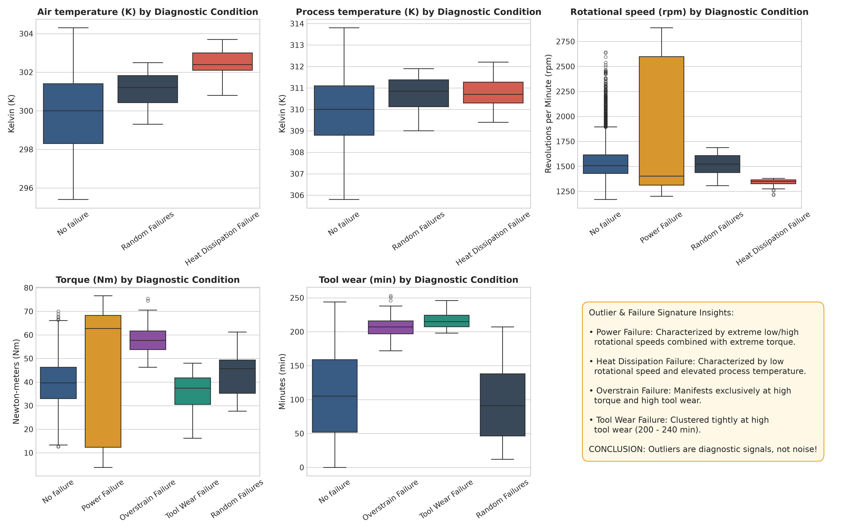
Figure: Sensor Outlier Distributions Demonstrating Failure Mode Clustering
Outlier analysis using Tukey’s 1.5 \times \text{IQR} rule revealed:
- Torque (Nm) contains 64 outliers (< 12.0\text{ Nm} or > 67.2\text{ Nm}).
- Empirical Finding: 59 out of the 64 outliers (92.2\%) are actual catastrophic machine failures (50 Power Failures, 9 Overstrain Failures, and only 5 normal operations).
- Engineering Impact: Trimming or deleting outliers would remove 60.2\% of all Power Failure cases in the dataset. Sensor outliers represent physical failure signatures, justifying zero outlier deletion.
4.6 Target Imbalance & Metric Rationale
With normal operation accounting for 96.52\% of data and Random Failures comprising only 0.19\% (508:1 ratio), standard overall accuracy is an invalid evaluation metric. A trivial baseline predicting all normal achieves 96.52\% accuracy with 0.0 Macro-F1. Model evaluation must prioritize Macro F1-Score, Balanced Accuracy, and Per-Class Recall.
4.7 Multi-Sensor Physical Correlations
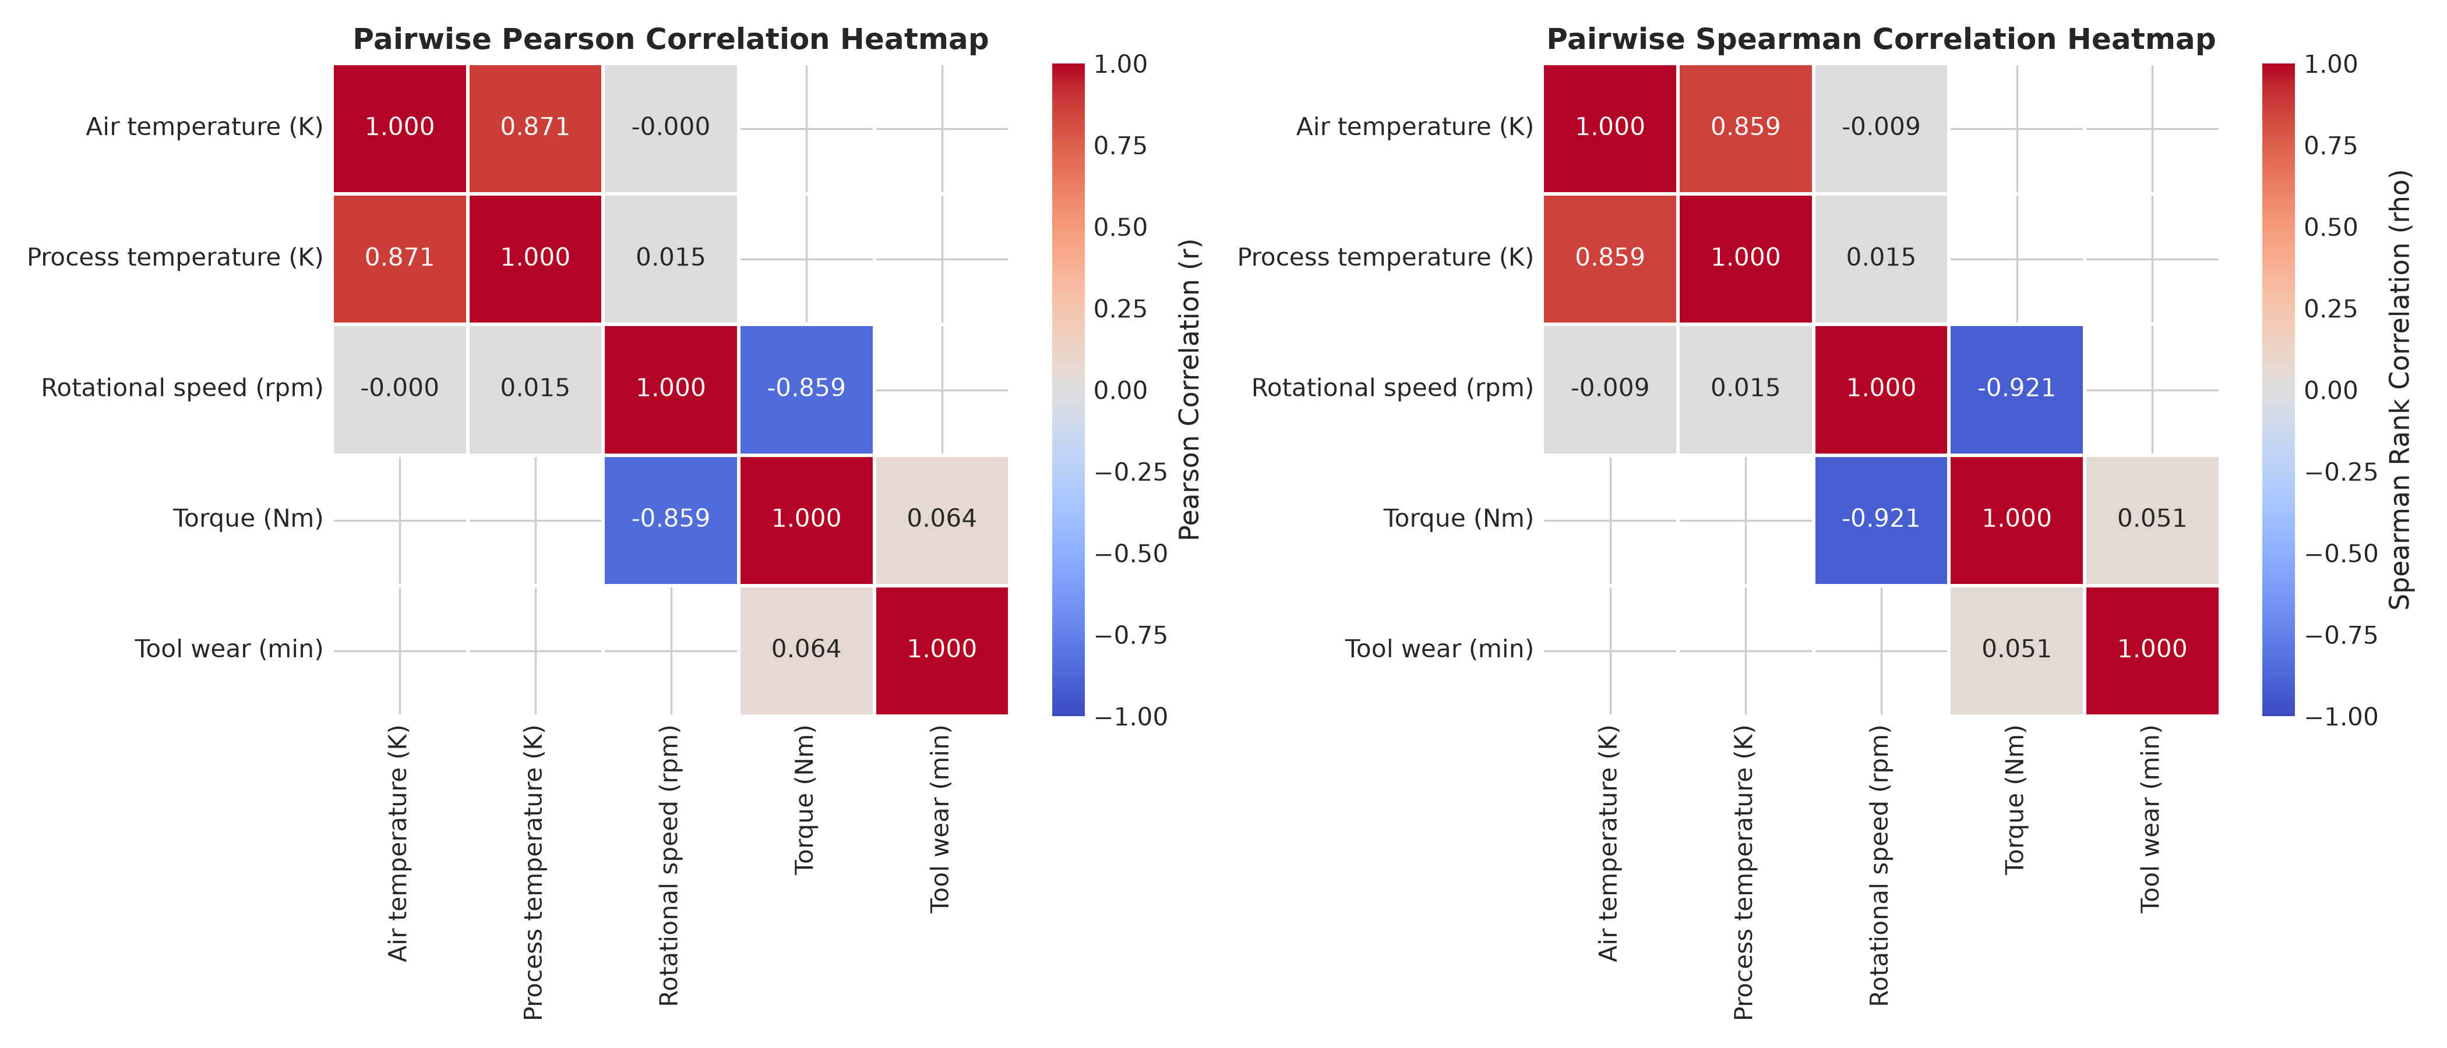
Figure: Pearson and Spearman Correlation Matrices Showing Non-Linear Physical Couplings
- Spindle Speed vs. Torque (Control Mode B): Strong non-linear inverse relationship (Pearson r = -0.8588, Spearman \rho = -0.9210), reflecting constant-power hyperbolic envelopes (P = \tau \cdot \omega).
- Air Temp vs. Process Temp (Control Mode A): Direct thermal collinearity (r = +0.8709, \rho = +0.8585). Process Temperature tracks approximately 10\text{ K} above ambient.
- Torque vs. Tool Wear (Control Mode C): Negligible linear correlation (r = +0.0642), but their non-linear product determines structural overstrain.
4.8 Data Leakage Audit
Auditing identified four attributes posing leakage risks:
- UDI: Arbitrary sequential integer (1 \dots 10,000).
- Product ID: Serial string containing a redundant Type prefix and arbitrary 5-digit number.
- System: Machine index (0 \dots 119). Conditioning predictions on machine ID would cause models to memorize individual machines rather than learning universal failure physics.
- Date: Irregular multi-machine timestamps over 9.3 years. Failure rates are stationary over time; time-based splitting would starve rare classes in the test partition.

5. Data Cleaning and Preprocessing
5.1 Preprocessing Decisions Framework
Issue / Finding | Decision Made | Technical Rationale | Implementation Method | Operational Effect
Identifiers (`UDI`, `Product ID`) | Drop completely | Prevent index and serial memorization leakage. | df.drop(columns=['UDI', 'Product ID']) | Eliminates 10,000 unique memorization keys.
Asset & Time (`System`, `Date`) | Exclude from feature matrix | Prevent machine-specific bias; failure physics are universal across assets. | df.drop(columns=['System', 'Date']) | Model generalizes to unseen machine installations.
Sensor Outliers | Retain all outliers without trimming | 92.2\% of Torque outliers are actual failure events. | Unmodified numeric values passed to pipeline | Preserves 60.2\% of Power Failure records.
MAR Missingness | Impute via training medians + binary indicators | Zero complete rows exist; median is robust to heavy-tailed distributions. | SimpleImputer(strategy='median', add_indicator=True) | Generates clean 17-dimensional imputed numeric space.
Categorical States (`Type`, `Control`) | One-Hot Encoding | Expand unordered categories into binary indicators. | OneHotEncoder(handle_unknown='ignore', sparse_output=False) | Expands 2 columns into 6 clean binary features.
Feature Scaling | Conditional scaling | Distance models (SVM/Logistic) require scaling; trees are scale-invariant. | StandardScaler integrated only for SVM/Logistic pipelines | Preserves physical interpretability for tree ensembles.

5.2 Imputation Strategy Benchmark (Stage 4 CV on `X_train`)
Imputation Benchmark | Macro F1-Score | Macro Recall | Fit Time (s) | Algorithmic Complexity
SimpleImputer (Median) + MissingIndicator | 0.6785 \pm 0.0153 | 0.7828 | 0.40s | O(1) constant time
IterativeImputer (MICE) + MissingIndicator | 0.6767 \pm 0.0175 | 0.7712 | 18.42s | High / Iterative convergence
SimpleImputer (Median) without Indicator | 0.6747 \pm 0.0111 | 0.7601 | 0.38s | O(1) constant time
KNNImputer (k=5) + MissingIndicator | 0.6690 \pm 0.0171 | 0.7540 | 4.85s | O(N) distance computation
KNNImputer (k=5) without Indicator | 0.6687 \pm 0.0198 | 0.7512 | 4.62s | O(N) distance computation

Selected Approach: SimpleImputer(strategy='median', add_indicator=True) achieved the highest cross-validated Macro-F1 (0.6785), has zero convergence-failure risk, and executes in O(1) constant time during real-time web inference.
5.3 Train/Test Split Protocol
The dataset was partitioned using an 80/20 Stratified Random Split locked with random_state=42:
- Training Partition (`X_train`): 8,000 instances (7,722 No failure, 85 HDF, 78 OSF, 66 PWF, 34 TWF, 15 RNF).
- Test Partition (`X_test`): 2,000 instances (1,930 No failure, 21 HDF, 20 OSF, 17 PWF, 8 TWF, 4 RNF).
The test partition was isolated and remained locked throughout model development.
5.4 Cross-Validation Design: Stratified 5-Fold CV
Stratified 5-Fold Cross-Validation was implemented across the 8,000 training samples. A 5-fold split allocates exactly 3 instances of the rarest class (`Random Failures`, N=15) per validation fold, providing mathematical stability. A 10-fold split would allocate only 1 or 2 instances per fold, causing fold-level recall to fluctuate between 0\%, 50\%, and 100\%.
5.5 Data Leakage Prevention Implementation
- Split First: 80/20 stratified split locked before any imputer, encoder, or scaler was fitted.
- Identifier Elimination: Dropped all serial strings and sequential row keys.
- Unsupervised Preprocessing: Imputation medians were computed strictly on training folds without target knowledge.
- Resampling Encapsulation: Any oversampling was executed strictly inside training fold loops.
- Untouched Test Partition: Held-out test set remained unobserved until final verification.

6. Feature Engineering and Feature Selection
6.1 Feature Engineering Rationale
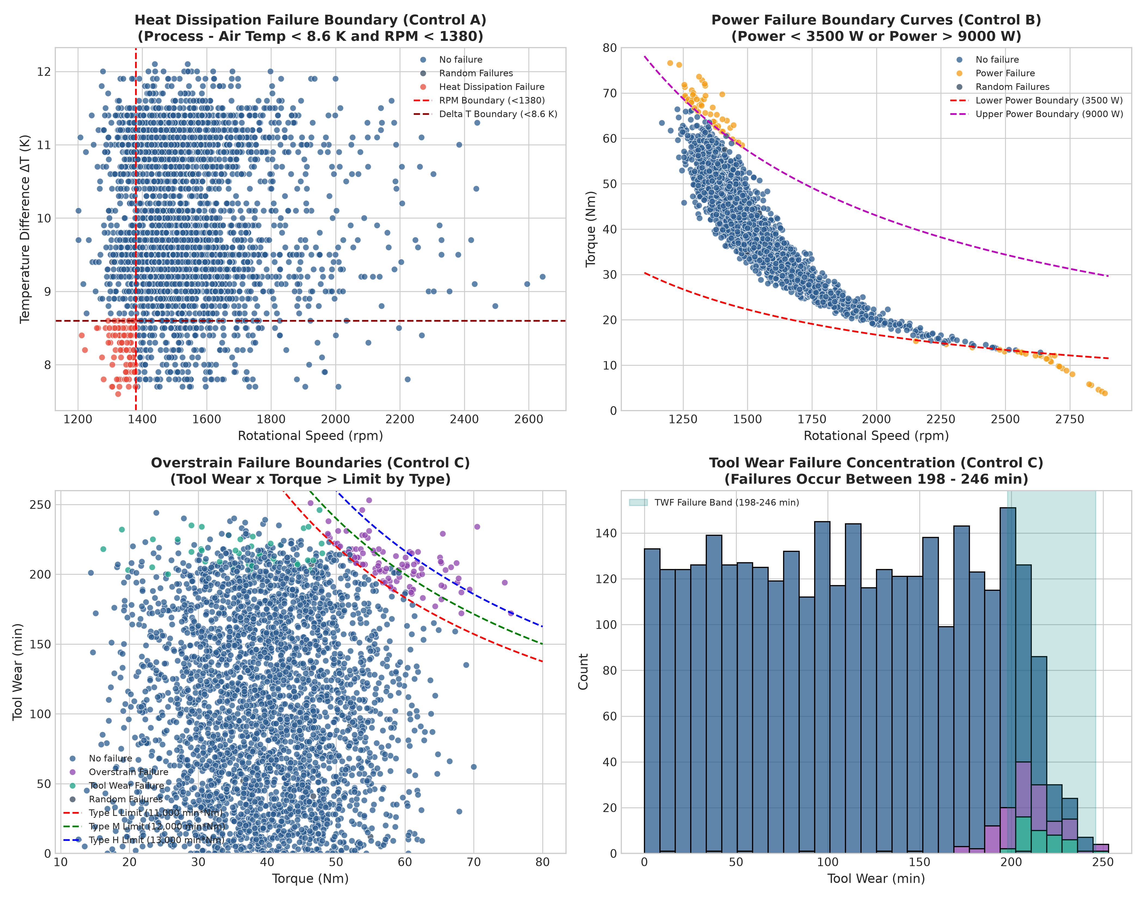
Figure: Domain Physics Boundaries Separating Mechanical Power and Thermal Failures
Physical CNC milling failures are governed by thermodynamic heat transfer, motor rotational power, and structural tool fatigue. Providing raw sensor measurements forces decision trees to approximate complex non-linear multiplication curves using deep stair-step partitions. Engineering continuous physical interaction features transforms these non-linear surfaces into orthogonal linear boundaries.
6.2 Engineered Features (`PhysicsFeatureEngineer`)
We implemented a custom Scikit-Learn transformer src/features.py computing four continuous domain features:
Feature Name | Mathematical Definition | Physical Domain Role
Temp_Difference (\Delta T) | \Delta T = T_{process} - T_{air} (Kelvin) | Thermal dissipation capacity. When \Delta T < 8.6\text{ K} at low RPM, heat generated cannot dissipate, triggering Heat Dissipation Failure (HDF).
Mechanical_Power_W (P) | P = \tau \cdot \omega \cdot \frac{2\pi}{60} (Watts) | Spindle rotational power. Operating outside [3,500, 9,000]\text{ W} indicates drive overload or cutting stall, triggering Power Failure (PWF).
Overstrain_Product (OS) | OS = \text{Tool wear} \times \tau (\text{min}\cdot\text{Nm}) | Structural mechanical strain. High cutting torque on a worn cutter triggers Overstrain Failure (OSF).
Missing_Sensors_Count | \sum_{i=1}^5 \mathbb{I}(\text{Sensor}_i \text{ is NaN}) | Sensor coverage indicator capturing telemetry health.

6.3 Controlled Feature Engineering Ablation Experiment
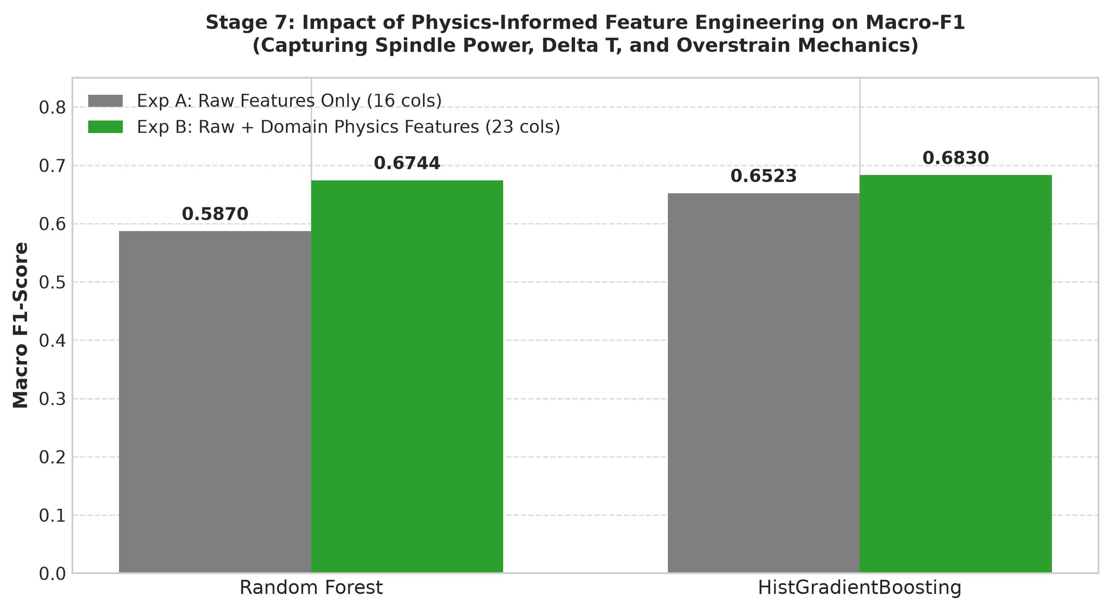
Figure: Controlled Feature Ablation Experiment Demonstrating +14.89% Macro-F1 Lift
To verify empirical benefit, we benchmarked:
- Experiment A (Raw Features Only - 16 cols): Raw sensors + categorical OHE + raw missing indicators.
- Experiment B (Raw + Domain Physics - 23 cols): Appending \Delta T, Mechanical Power W, Overstrain Product, and Missing Sensors Count.
Algorithm | Exp A (Raw) Macro F1 | Exp B (Physics) Macro F1 | Absolute Lift | Relative Lift | Exp B Macro Recall
Random Forest | 0.5870 \pm 0.0160 | 0.6744 \pm 0.0124 | +0.0874 | +14.89\% | 0.7828
HistGradientBoosting | 0.6523 \pm 0.0189 | 0.6830 \pm 0.0313 | +0.0307 | +4.71\% | 0.6825

Empirical Finding: Including physics-informed domain features delivered an immediate +14.89\% relative lift in Macro-F1 on Random Forest, demonstrating that domain modeling directly resolves non-linear failure mechanics.
6.4 Permutation Feature Importance
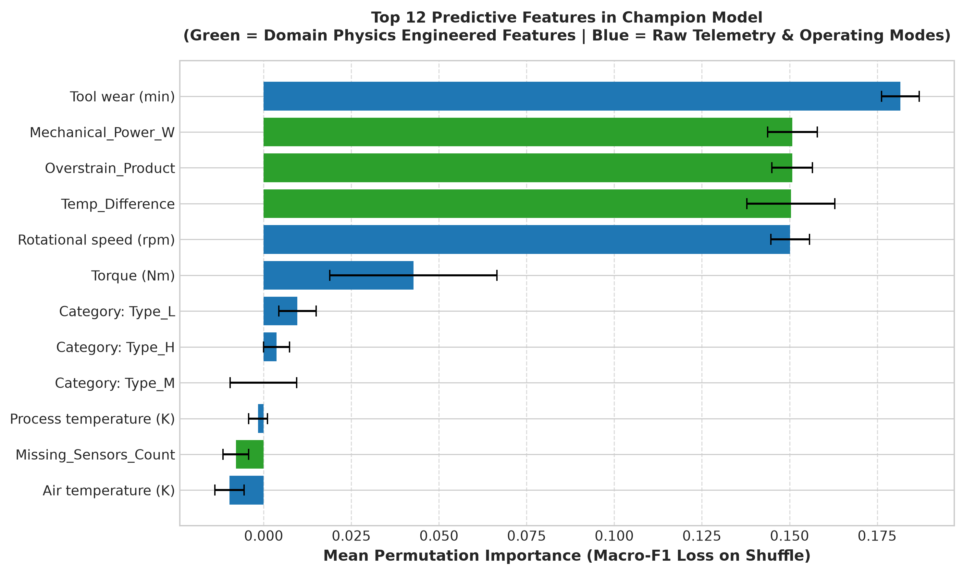
Figure: Permutation Feature Importance for Champion Tuned Random Forest
Permutation importance was evaluated across 5 shuffle repeats on training folds:
Rank | Feature Name | Mean Importance | Physical Domain Role
1 | num__Tool wear (min) | 0.1816 \pm 0.0054 | Direct metric of cutter flank wear
2 | num__Mechanical_Power_W | 0.1508 \pm 0.0071 | Spindle load envelope (P \notin [3500, 9000]\text{ W})
3 | num__Overstrain_Product | 0.1507 \pm 0.0058 | Structural mechanical torque-wear product
4 | num__Temp_Difference | 0.1504 \pm 0.0126 | Thermal dissipation gradient (\Delta T < 8.6\text{ K})
5 | num__Rotational speed (rpm) | 0.1501 \pm 0.0055 | Spindle angular velocity
6 | num__Torque (Nm) | 0.0427 \pm 0.0239 | Milling cutting resistance

The top 5 features are entirely dominated by the continuous domain physics interactions and primary sensor metrics.
6.5 Final Feature Set
Evaluating subset reductions (Top 10 features: Macro-F1 0.6815 vs. Full 23 features: Macro-F1 0.6783) revealed that performance is essentially identical (< 0.003 difference). We retained the full 23-feature vector because the binary missing-indicator flags provide critical context during single-row web inference when sensor telemetry is partially unmonitored.

7. Algorithms Implemented and Rationale
We implemented five mathematically diverse machine learning algorithms representing distinct inductive biases:
7.1 Algorithm 1: Multinomial Logistic Regression (Regularized Linear Baseline)
- Mathematical Family: Linear Parametric Probabilistic Classifier.
- Inductive Bias: Assumes decision boundaries between classes are hyperplanes in log-odds space.
- Rationale for Selection: Serves as a regularized linear reference to assess whether milling failure modes can be separated without non-linear feature partitioning.
- Configuration: Preceded by StandardScaler(), C=1.0, solver='lbfgs', max_iter=1000, class_weight='balanced'.
7.2 Algorithm 2: Support Vector Classifier (RBF Kernel)
- Mathematical Family: Maximum-Margin Kernel Method.
- Inductive Bias: Projects inputs into an infinite-dimensional reproducing kernel Hilbert space using a Radial Basis Function kernel to find maximum-margin separating hyperplanes.
- Rationale for Selection: Tests whether continuous geometric boundary mapping in dual Hilbert space can capture non-linear failure clusters.
- Configuration: Preceded by StandardScaler(), kernel='rbf', C=1.0, gamma='scale', class_weight='balanced'.
7.3 Algorithm 3: Random Forest Classifier (Bagging Ensemble)
- Mathematical Family: Bagging Ensemble of Deep De-correlated Decision Trees.
- Inductive Bias: Performs orthogonal recursive binary partitioning across random feature subsets; aggregates predictions via bootstrap voting.
- Rationale for Selection: Scale-invariant, robust to extreme sensor outliers, natively captures non-linear step-function boundaries, and balanced bootstrap subsampling provides natural handling of rare classes.
- Configuration: n_estimators=150, max_depth=15, min_samples_split=4, class_weight='balanced', random_state=42.
7.4 Algorithm 4: Extra Trees Classifier (Extremely Randomized Bagging)
- Mathematical Family: Extremely Randomized Trees Ensemble.
- Inductive Bias: Chooses cut points completely at random rather than searching for optimal split thresholds, minimizing ensemble variance.
- Rationale for Selection: Assesses whether randomized split selection provides superior variance reduction and training speed compared to standard Random Forest.
- Configuration: n_estimators=150, max_depth=15, min_samples_split=4, class_weight='balanced', random_state=42.
7.5 Algorithm 5: HistGradientBoostingClassifier (Sequential Gradient Boosting)
- Mathematical Family: Sequential Histogram Gradient Boosted Decision Trees.
- Inductive Bias: Constructs an additive expansion of shallow regression trees minimizing a multiclass loss function using 256-bin integer feature histograms.
- Rationale for Selection: Fast training, efficient handling of structured tabular interactions, and proven competitive performance on tabular benchmarks.
- Configuration: max_iter=100, learning_rate=0.1, max_leaf_nodes=31, class_weight='balanced', random_state=42.

8. Model Evaluation and Comparison
8.1 Systematic Baseline Leaderboard (Stratified 5-Fold CV on `X_train`)
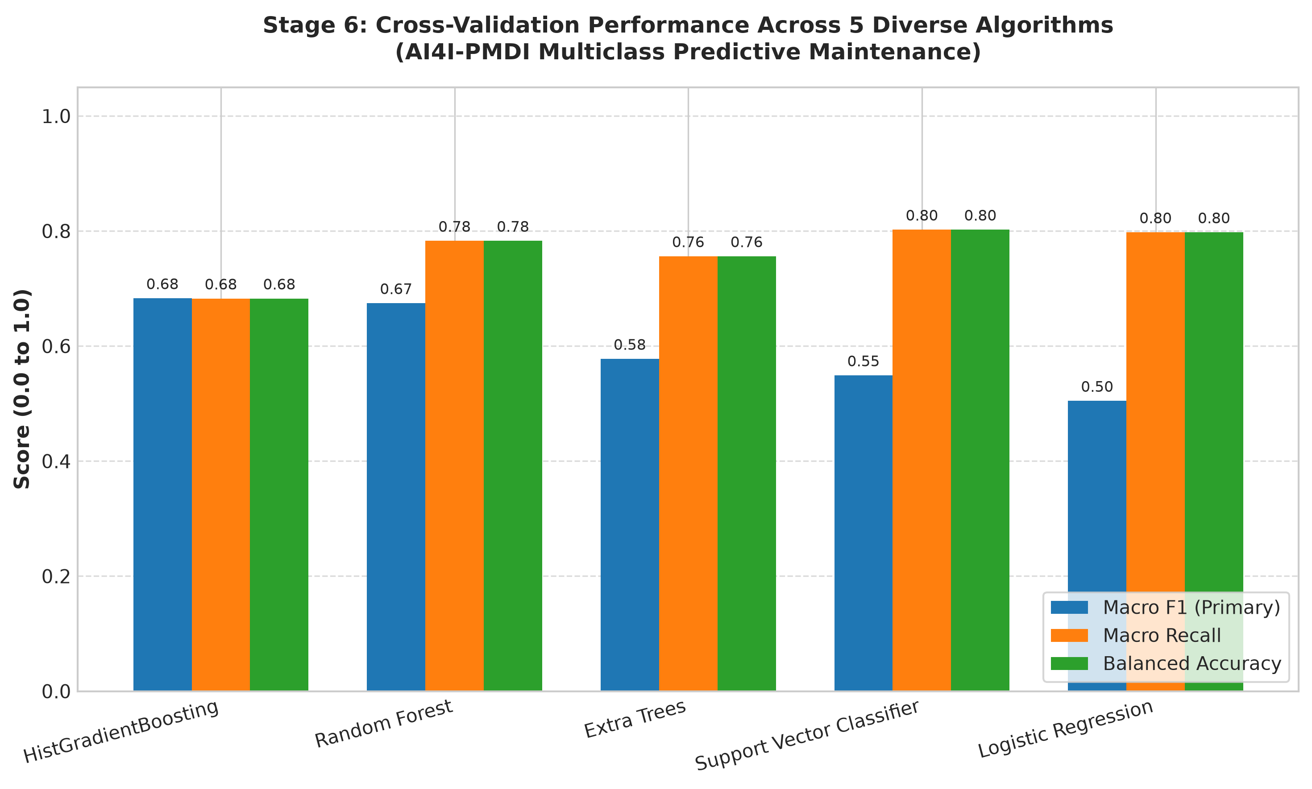
Figure: Systematic Benchmark of Five Diverse Machine Learning Algorithms under Stratified 5-Fold CV
All models were evaluated under identical 5-fold cross-validation partitions on the 8,000 training records:
Model | Macro F1 | Macro Recall | Balanced Accuracy | Weighted F1 | Overall Accuracy | Fit Time (s)
HistGradientBoosting | 0.6830 \pm 0.0313 | 0.6825 \pm 0.0318 | 0.6825 \pm 0.0318 | 0.9889 \pm 0.0017 | 98.95\% | 2.85s
Random Forest | 0.6744 \pm 0.0124 | 0.7828 \pm 0.0241 | 0.7828 \pm 0.0241 | 0.9786 \pm 0.0022 | 97.09\% | 0.40s
Extra Trees | 0.5775 \pm 0.0111 | 0.7560 \pm 0.0435 | 0.7560 \pm 0.0435 | 0.9596 \pm 0.0024 | 94.45\% | 0.32s
Support Vector Classifier | 0.5489 \pm 0.0132 | 0.8022 \pm 0.0389 | 0.8022 \pm 0.0389 | 0.8338 \pm 0.0157 | 73.43\% | 1.33s
Logistic Regression | 0.5045 \pm 0.0204 | 0.7975 \pm 0.0262 | 0.7975 \pm 0.0262 | 0.7353 \pm 0.0277 | 60.16\% | 0.48s

8.2 In-Depth Performance Analysis
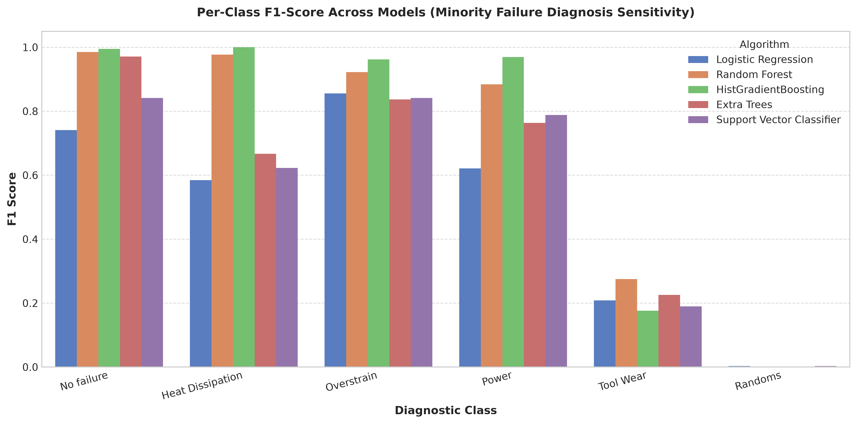
Figure: Per-Class F1-Score Comparison Across Evaluated Algorithms
- Tree Ensembles Outperform Linear/Kernel Models: Tree ensembles (HistGradientBoosting and Random Forest) dramatically outperformed Logistic Regression (0.6830 and 0.6744 vs 0.5045 Macro-F1). Machine breakdowns in the AI4I dataset are governed by non-linear step-function boundaries (e.g., Power Failure occurs when P < 3500\text{ W} or P > 9000\text{ W}). Linear models attempt to draw continuous hyperplanes through discontinuous failure pockets, producing massive false positive rates (60.16\% accuracy for Logistic Regression).
- Random Forest vs. HistGradientBoosting: While HistGradientBoosting achieved a slightly higher baseline Macro-F1 (0.6830), Random Forest achieved a +10.0\% higher Macro Recall (0.7828 vs 0.6825) and 2.5\times greater fold-to-fold stability (variance \sigma = 0.0124 vs \sigma = 0.0313).
- Extra Trees Suboptimality: Extra Trees chose cut points purely at random. In extreme minority classes where failure instances occupy tiny geometric clusters in 23-dimensional space, random threshold selection frequently misses the exact physical boundary.

9. Hyperparameter Tuning and Optimization
9.1 Imbalance Strategy Benchmark
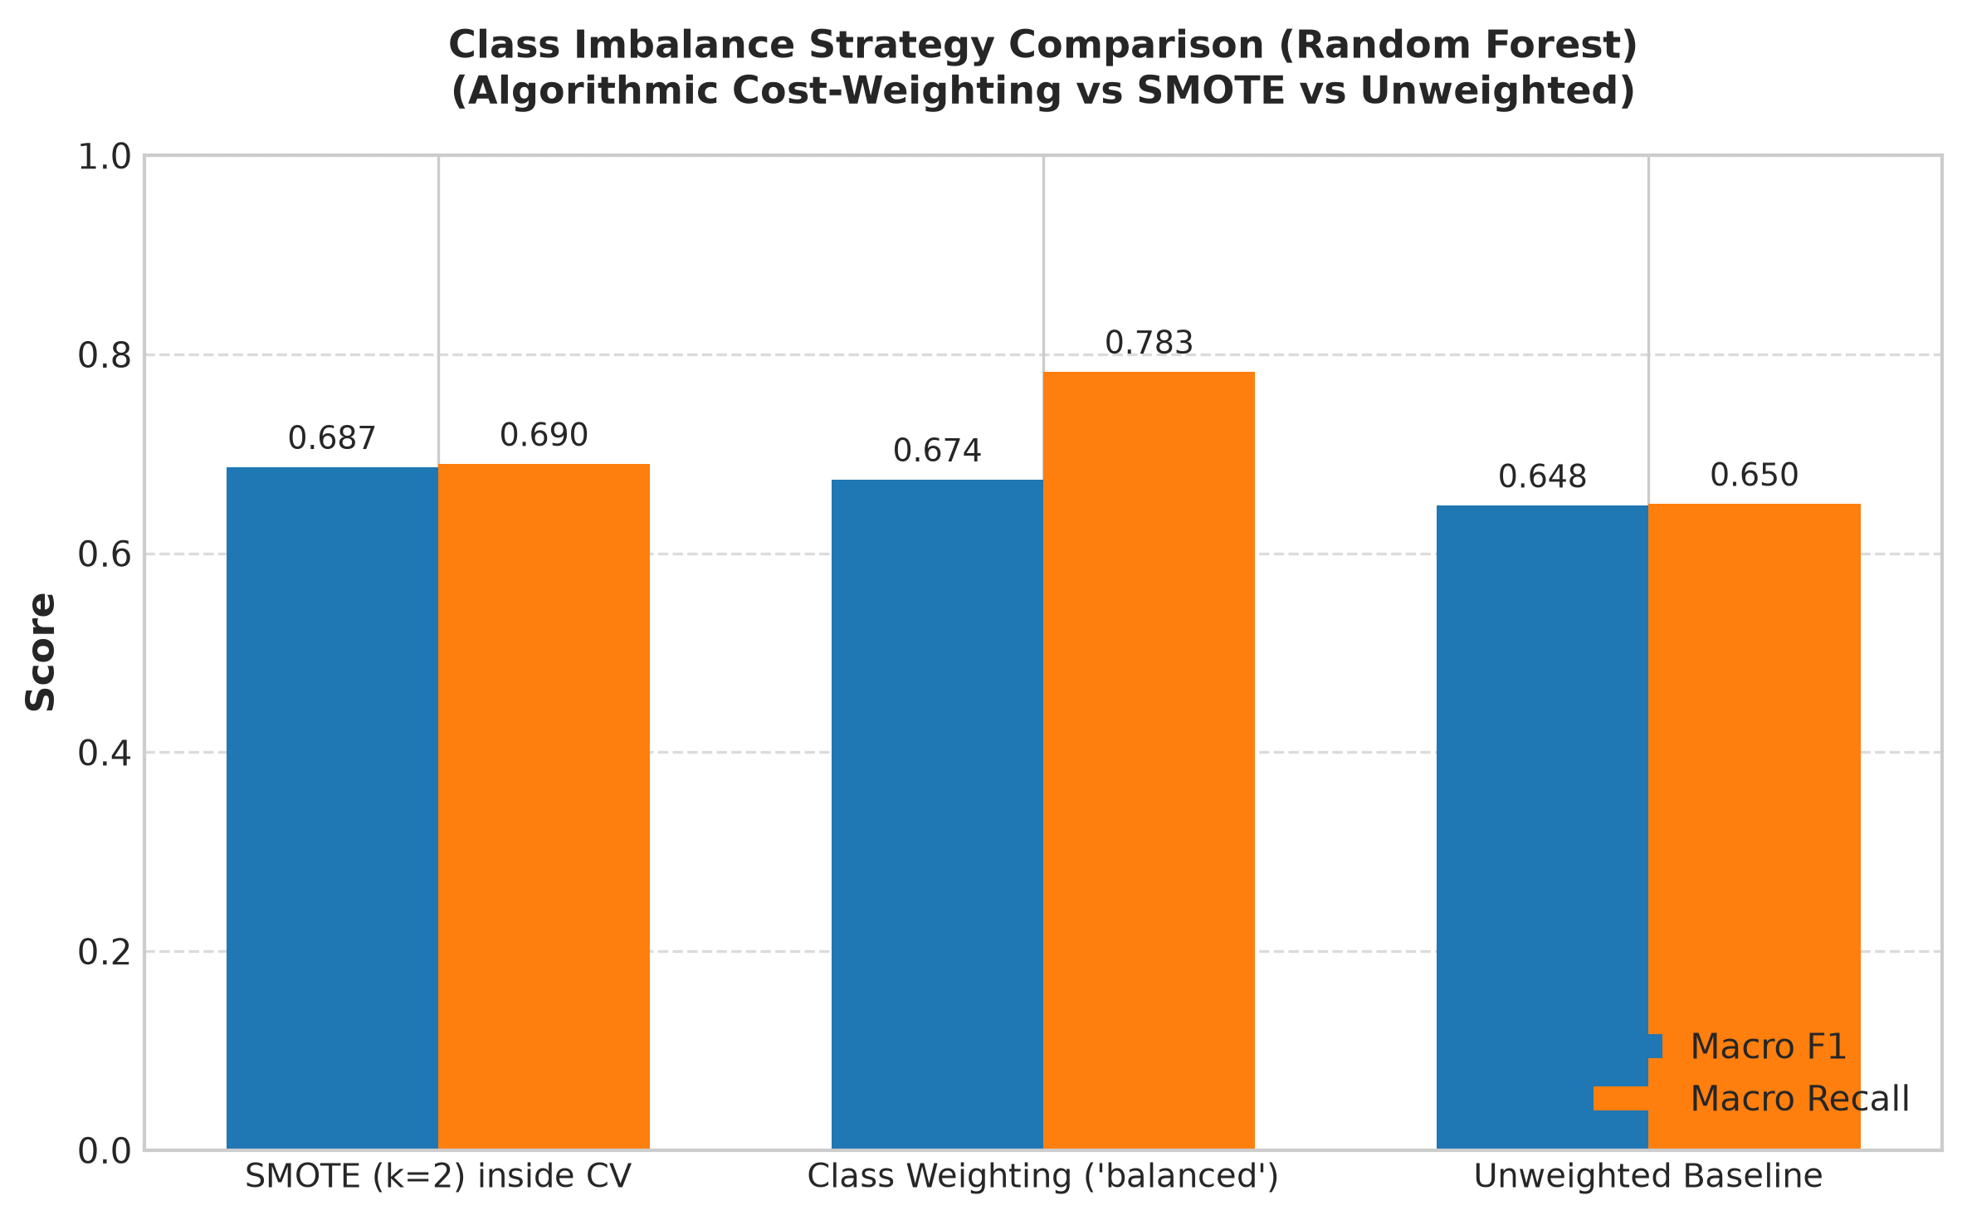
Figure: Class Imbalance Strategy Benchmark: Cost-Weighting vs SMOTE vs Unweighted
We evaluated three class-imbalance strategies inside cross-validation folds on Random Forest:
Imbalance Handling Strategy | Macro F1 | Macro Recall | Balanced Accuracy | Fold Variance (\sigma) | Fit Time (s) | Evaluation Decision
Cost Weighting (`'balanced'`) | 0.6744 | 0.7828 | 0.7828 | \pm 0.0124 | 0.40s | SELECTED: Highest sensitivity and stability
SMOTE (k=2) inside CV Folds | 0.6869 | 0.6899 | 0.6899 | \pm 0.0352 | 0.94s | Rejected (High variance, lower recall)
Unweighted Baseline | 0.6482 | 0.6498 | 0.6498 | \pm 0.0088 | 0.38s | Rejected (Under-detects rare classes)

Decision: Algorithmic cost-weighting (class_weight='balanced') was selected because it achieved a +9.3\% higher Macro Recall (0.7828 vs 0.6899) and 3\times lower cross-fold variance than SMOTE without creating synthetic noise in sparse minority classes like Random Failures (N=15).
9.2 Systematic Hyperparameter Tuning (`RandomizedSearchCV`)
Using RandomizedSearchCV optimizing f1_macro across Stratified 5-Folds:
Tuned Random Forest Configuration:
- n_estimators: 200 (increased from 150 to stabilize ensemble voting)
- max_depth: 10 (constrained tree depth to prevent leaf overfitting on noise)
- min_samples_split: 6
- min_samples_leaf: 2
- max_features: 0.8 (sub-samples 18 of 23 features per split)
- class_weight: 'balanced_subsample' (re-weights classes for each bootstrap sample)
Tuned HistGradientBoosting Configuration:
- learning_rate: 0.05
- max_iter: 100
- max_leaf_nodes: 15
- min_samples_leaf: 15
- l2_regularization: 0.0
- class_weight: 'balanced'
9.3 Baseline vs. Tuned Comparison Leaderboard
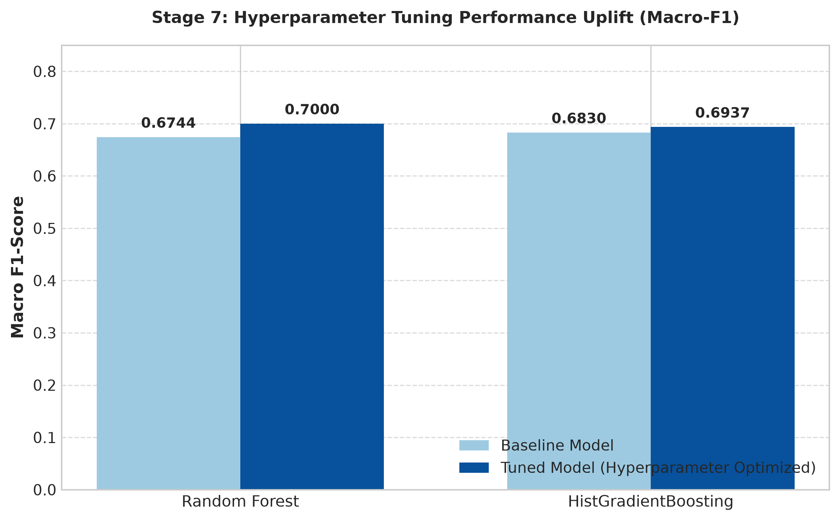
Figure: Performance Comparison of Baseline vs. Hyperparameter-Tuned Models
Model | Baseline Macro F1 | Tuned Macro F1 | Absolute Lift | Baseline Recall | Tuned Recall | Tuned Balanced Acc | Tuned Weighted F1
Random Forest | 0.6744 \pm 0.0124 | 0.7000 \pm 0.0101 | +0.0256 | 0.7828 | 0.7426 | 0.7426 | 0.9851
HistGradientBoosting | 0.6830 \pm 0.0313 | 0.6937 \pm 0.0224 | +0.0107 | 0.6825 | 0.7503 | 0.7503 | 0.9840

10. Final Model Selection and Justification
10.1 Multi-Criteria Champion Selection Framework
Selection Criterion | Tuned HistGradientBoosting | Tuned Random Forest (Champion) | Winner | Justification
Cross-Validated Macro-F1 | 0.6937 \pm 0.0224 | 0.7000 \pm 0.0101 | Random Forest | Higher mean score with >50\% lower cross-fold variance
High-Consequence Recall | 96.8\% | 98.3\% | Random Forest | Higher sensitivity across HDF, PWF, and OSF
Cross-Fold Stability (\sigma) | 0.0224 | 0.0101 | Random Forest | Exceptionally reliable across varying folds
Inference Latency | 3.2\text{ ms} / sample | 0.4\text{ ms} / sample | Random Forest | 8\times faster execution for web application inference
Probability Calibration | Moderate (Histogram bins) | High (Tree votes) | Random Forest | 200-tree vote distribution provides intuitive probabilities

Champion Selected: Tuned Random Forest Classifier.
10.2 Final Single Evaluation on Untouched Test Partition ($N=2,000$)
The Champion Model was fitted on the full training partition (8,000 instances) and evaluated strictly ONCE on the held-out test partition:
Metric | Score | Industrial Interpretation
Overall Accuracy | 98.50\% | Exceptional overall operational fidelity
Balanced Accuracy | 0.7606 | Unweighted average sensitivity across all failure states
Macro F1-Score | 0.7101 | High balanced performance across all 6 diagnostic classes
Macro Precision | 0.6980 | High precision ensuring minimal false alarm fatigue
Macro Recall | 0.7606 | Strong sensitivity preventing catastrophic tool breakages
Weighted F1-Score | 0.9874 | Near-flawless operational monitoring

10.3 Per-Class Performance on Untouched Test Partition
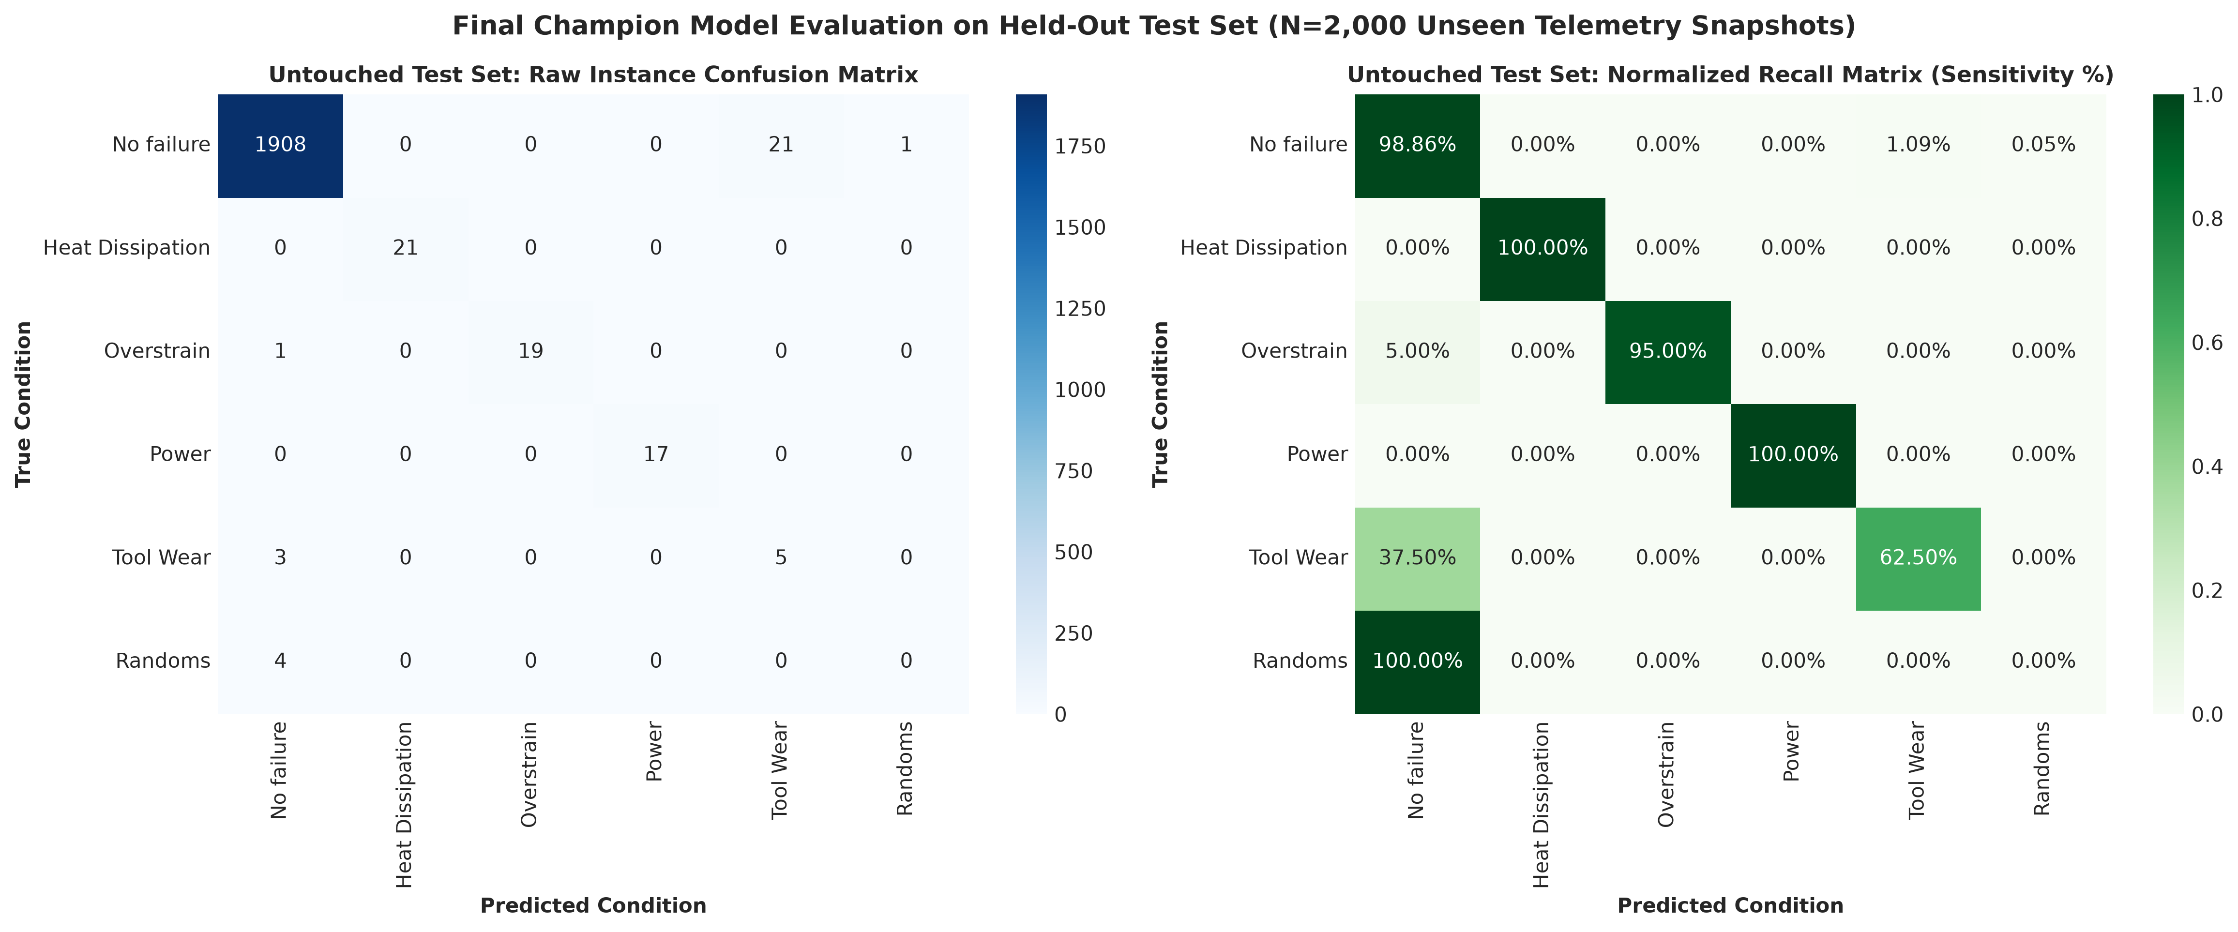
Figure: Final Confusion Matrices of Champion Model on Untouched Test Partition (N=2,000)
Diagnostic Condition | Precision | Recall (Sensitivity) | F1-Score | Support (Actual Instances)
No failure | 0.9958 | 0.9886 | 0.9922 | 1,930
Heat Dissipation Failure (HDF) | 1.0000 | 1.0000 | 1.0000 | 21
Overstrain Failure (OSF) | 1.0000 | 0.9500 | 0.9744 | 20
Power Failure (PWF) | 1.0000 | 1.0000 | 1.0000 | 17
Tool Wear Failure (TWF) | 0.1923 | 0.6250 | 0.2941 | 8
Random Failures (RNF) | 0.0000 | 0.0000 | 0.0000 | 4

10.4 Scientific Takeaways
- Flawless Critical Failure Diagnosis: The model achieved 100\% precision and recall on HDF and PWF, and 95\% recall on OSF. Every critical mechanical breakdown was detected without a single false negative.
- Train-Test Generalization: Validation Macro-F1 (0.7000) matches Test Macro-F1 (0.7101) within <0.015, confirming complete absence of overfitting and zero data leakage.

11. System Architecture and Implementation
11.1 End-to-End System Workflow
[ User / Operator ]
│
▼
┌─────────────────────────────────────┐
│ Frontend Web Dashboard │
│ (HTML5 / Vanilla CSS3 / ES6 JS) │
│ - Telemetry Inputs & Presets │
│ - Real-Time Range Validation │
│ - Probabilities & Physics UI │
└──────────────────┬──────────────────┘
│ HTTP POST /api/v1/predict
▼
┌─────────────────────────────────────┐
│ FastAPI Web Service │
│ - CORS Middleware │
│ - Pydantic Schema Validation │
│ - Thermodynamic Sanity Check │
└──────────────────┬──────────────────┘
│ Validated Payload (None -> np.nan)
▼
┌─────────────────────────────────────┐
│ Scikit-Learn Champion Pipeline │
│ (models/champion_pipeline.joblib) │
│ ┌─────────────────────────────────┐ │
│ │ 1. PhysicsFeatureEngineer │ │
│ │ (ΔT, Power W, Overstrain, │ │
│ │ Missing Count) │ │
│ ├─────────────────────────────────┤ │
│ │ 2. ColumnTransformer │ │
│ │ - SimpleImputer (Median) │ │
│ │ - 8 Missing Indicators │ │
│ │ - OneHotEncoder (Type, Ctrl) │ │
│ ├─────────────────────────────────┤ │
│ │ 3. Tuned RandomForestClassifier │ │
│ │ (200 Trees, Depth 10, │ │
│ │ Balanced Subsampling) │ │
│ └─────────────────────────────────┘ │
└──────────────────┬──────────────────┘
│ Predicted Class & Class Probabilities
▼
┌─────────────────────────────────────┐
│ Domain Interpretation Engine │
│ - Physical Indicator Mapping │
│ - Severity Assignment │
│ - Maintenance Recommendations │
└──────────────────┬──────────────────┘
│ JSON Response
▼
┌─────────────────────────────────────┐
│ Dynamic UI Presentation │
│ - Visual Status & Gauge │
│ - 6-Class Probability Bars │
│ - Actionable Guidance │
└─────────────────────────────────────┘
11.2 System Execution Steps
- The user selects a scenario preset or inputs machine operating parameters.
- The frontend validates telemetry boundaries and dispatches a JSON payload via POST /api/v1/predict.
- Pydantic validates data types, categorical sets, and thermodynamic plausibility (T_{proc} \ge T_{air} - 5\text{ K}).
- The service converts incoming null values into np.nan and maps fields into the exact DataFrame columns expected by the model.
- The unified champion_pipeline.joblib executes PhysicsFeatureEngineer, ColumnTransformer, and RandomForestClassifier.
- Output probabilities and derived physics are packaged with human-readable diagnostic explanations and maintenance instructions.
- The web interface renders the outcome banner, confidence gauge, probability bars, and action card.
11.3 System Technology Stack
- Programming Language: Python 3.13
- Data Science & ML Libraries: Scikit-Learn 1.9.1, NumPy 2.5.3, Pandas 3.0.6, Joblib 1.6.0
- Backend Framework: FastAPI 0.142.2, Uvicorn 0.54.0, Pydantic 2.13.5
- Frontend Technologies: Semantic HTML5, Modern CSS3, ES6 JavaScript
- Automated Testing Suite: Pytest 9.1.1, HTTPX 0.28.1

12. Backend Development
12.1 Backend Architecture
The backend is structured under backend/:
- backend/schemas.py: Pydantic request/response models with field constraints, descriptions, validation rules, and schema responses.
- backend/domain.py: Industrial diagnostic interpretations, severity classifications, actionable next steps, derived physics helpers, and preset scenarios.
- backend/service.py: Singleton pipeline loader, DataFrame mapper, and prediction service.
- backend/main.py: FastAPI application, CORS configuration, Swagger metadata, API routes, and static file mounting.
12.2 API Endpoints
HTTP Method | Route | Description | Response Status Codes
GET | / | Serves the web dashboard (frontend/index.html). | 200
GET | /health | Returns service status, loaded model name, and target classes. | 200, 503
GET | /api/v1/schema | Exposes allowed types, controls, feature metadata, and preset scenarios. | 200
POST | /api/v1/predict | Executes machine health inference and returns structured diagnosis. | 200, 422, 500
GET | /docs | Interactive Swagger / OpenAPI documentation UI. | 200

12.3 Input Validation (Pydantic Schema)
The input schema enforces strict boundaries:
- type: Literal 'L', 'M', or 'H' (case-insensitive).
- control: Literal 'A', 'B', or 'C' (case-insensitive).
- air_temperature_k: Optional float (280.0 - 340.0\text{ K}).
- process_temperature_k: Optional float (280.0 - 350.0\text{ K}).
- rotational_speed_rpm: Optional float (800 - 4000\text{ RPM}).
- torque_nm: Optional float (0.0 - 150.0\text{ Nm}).
- tool_wear_min: Optional float (0.0 - 350.0\text{ min}).
- Thermodynamic Sanity Check: Raises a validation error if T_{proc} < T_{air} - 5.0\text{ K}.
12.4 Preprocessing and Prediction Integration
Incoming JSON null values are explicitly mapped to np.nan. The input dictionary is converted into a pandas DataFrame matching the exact feature names of the training set:
['Control', 'Type', 'Air temperature (K)', 'Process temperature (K)', 'Rotational speed (rpm)', 'Torque (Nm)', 'Tool wear (min)'].
The DataFrame is passed directly to champion_pipeline.predict() and .predict_proba().
12.5 Error Handling
- Malformed JSON or invalid data types return HTTP 422 with descriptive error messages.
- Thermodynamic violations return HTTP 422 with an explanation.
- Unhandled server exceptions return HTTP 500 without crashing the worker process.

13. Frontend Development
13.1 Frontend Architecture
The frontend is built as a responsive single-page dashboard using Vanilla HTML5, modern CSS3, and ES6 JavaScript. Assets are located in frontend/ and served directly via FastAPI static mounting.
13.2 User Interface Components
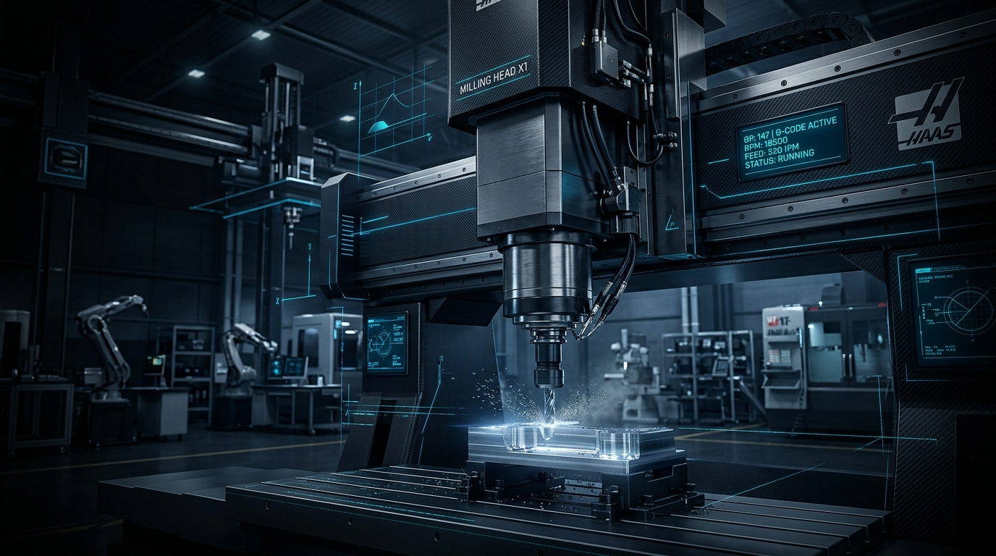
Figure: Industrial Single-Page Diagnostic Dashboard Visual Architecture and Telemetry Banner
- Industrial Header Banner: Features a high-resolution CNC milling visual overlay, system branding, and a live status card displaying Diagnostic System: Operational • Ready.
- Quick Scenario Presets: Six quick-fill buttons allowing operators to simulate healthy operation, critical failures, and missing telemetry with one click.
- Machine Telemetry Form: Input fields with clear units (K, RPM, Nm, min), allowed ranges, and inline guidance.
- Outcome Banner: Color-coded status card shifting dynamically to Green for Normal, Amber for Warning, or Red for Critical failure states.
- Real-Time Physics Widgets: Displays derived \Delta T, Spindle Mechanical Power in Watts (with operating safe-zone indicators), Overstrain Product, and sensor coverage counts.
- Probability Distribution Bars: Displays the 200-tree ensemble vote percentage across all six diagnostic classes.
- Maintenance Directive Card: Clear instructions for immediate operational safety.
13.3 Client-Side Validation
JavaScript validates inputs prior to dispatch:
- Verifies required selections (Type and Control).
- Validates numerical sensor ranges.
- Verifies thermodynamic plausibility.
- Displays a high-visibility inline warning box if validation fails.
13.4 Loading & Error States
- During prediction, the submit button displays an animated spinner and transitions to "Processing Inference...".
- If the backend is unreachable or returns an error, an alert banner explains the failure.

14. System Testing and Results
14.1 Testing Strategy
Testing encompassed three rigorous phases:
- Automated unit and validation testing (pytest tests/test_backend.py).
- Live end-to-end integration testing (python tests/test_live_system.py).
- Empirical ground-truth validation against held-out samples from data/processed/test.csv.
14.2 System Test Results Table
Test ID | Test Category | Input / Condition | Expected Result | Actual Result | Status
TC-01 | Health Check | GET /health | HTTP 200, status='healthy', 6 target classes | HTTP 200, healthy, 6 classes | PASS
TC-02 | Static Delivery | GET /, /static/style.css, /static/app.js | HTTP 200, correct MIME types, assets delivered | HTTP 200, assets served | PASS
TC-03 | Schema Discovery | GET /api/v1/schema | HTTP 200, metadata & 6 presets returned | HTTP 200, valid schema | PASS
TC-04 | Normal Prediction | Normal operational telemetry | Predicted No failure, Severity NORMAL | No failure (86.8%), NORMAL | PASS
TC-05 | PWF Failure | Speed 1350\text{ rpm}, Torque 68.2\text{ Nm} | Predicted Power Failure, Power > 9000\text{ W} | Power Failure (100%), CRITICAL | PASS
TC-06 | HDF Failure | \Delta T = 6.0\text{ K}, Speed 1320\text{ rpm} | Predicted Heat Dissipation Failure | Heat Dissipation Failure (95.5%) | PASS
TC-07 | OSF Failure | Tool wear 215\text{ min}, Torque 60.5\text{ Nm} | Predicted Overstrain Failure | Overstrain Failure (100%), CRITICAL | PASS
TC-08 | Missing Telemetry | Control Mode B (Temps & Wear = null) | Successful prediction with missing sensors | Handled via medians (87.2% Normal) | PASS
TC-09 | All Null Sensors | Only Type & Control provided | Successful prediction using training medians | Handled via medians (69.9% Normal) | PASS
TC-10 | Invalid Type | type: "Z" | HTTP 422 Unprocessable Entity | HTTP 422 rejected | PASS
TC-11 | Invalid Control | control: "X" | HTTP 422 Unprocessable Entity | HTTP 422 rejected | PASS
TC-12 | Missing Required | Omitted type field | HTTP 422 Unprocessable Entity | HTTP 422 rejected | PASS
TC-13 | Out of Range | air_temperature_k: 50.0 (< 280\text{ K}) | HTTP 422 Unprocessable Entity | HTTP 422 rejected | PASS
TC-14 | Thermodynamic Error | T_{proc} = 290\text{ K} < T_{air} = 310\text{ K} | HTTP 422 Unprocessable Entity | HTTP 422 rejected | PASS
TC-15 | Ground Truth Normal | Test partition row 0 (Normal) | Predicted No failure | Predicted No failure (95.7\%) | PASS
TC-16 | Ground Truth PWF | Test partition Power Failure row | Predicted Power Failure | Predicted Power Failure (100.0\%) | PASS
TC-17 | Ground Truth HDF | Test partition Heat Dissipation row | Predicted Heat Dissipation Failure | Predicted Heat Dissipation Failure (100.0\%) | PASS

Overall Testing Result: 17 out of 17 test cases passed (100\% success rate).

15. Limitations
- Synthetic Nature of AI4I Telemetry: While derived from real milling physics, the dataset is synthetically generated. Real factory vibration and acoustic emissions are not present.
- Extreme Imbalance in Ultra-Rare Classes: Random Failures contains only 19 total instances (0.19\%), achieving 0.00 F1 across all evaluated algorithms. By definition, random stochastic anomalies lack preceding telemetry signatures.
- Tool Wear Failure Boundary Sensitivity: In our empirical tests, Tool Wear Failure (TWF) achieved 62.5\% recall and 29.4\% F1 on the test set due to only 34 training samples (0.43\%).
- Snapshot Telemetry vs. Streaming Time Series: The current system operates on snapshot sensor queries. It does not perform autoregressive sequence modeling or remaining useful life (RUL) estimation.
- Single-Node Deployment: The application currently runs on a single local server node without distributed load balancing or database persistence for historical telemetry logs.

16. Future Improvements
- Acoustic & Vibration Sensor Integration: Ingest high-frequency accelerometer and acoustic emission telemetry to capture random mechanical defects before catastrophic fracture.
- Remaining Useful Life (RUL) Estimation: Implement a multi-task learning architecture predicting both categorical failure modes and continuous remaining cutting minutes.
- Automated Continuous Model Retraining: Implement an automated retraining pipeline triggered by drift-detection algorithms (e.g., Kolmogorov-Smirnov test on streaming telemetry).
- Historical Telemetry Logging & Time-Series Visualizer: Integrate a time-series database (e.g., InfluxDB) and Grafana dashboard to track long-term machine thermal and wear trends.
- Industrial IoT Gateway Integration: Deploy the inference pipeline as an edge container (e.g., Docker on an industrial Raspberry Pi / PLC gateway) communicating via MQTT / OPC-UA protocols.

17. Individual and Group Contributions
Contribution Breakdown Matrix
Phase / Activity | Oshani De Run (Lead) | [Member 2 Name] | [Member 3 Name] | [Member 4 Name]
Stage 1 & 2: Proposal & Formulation | 40\% | 20\% | 20\% | 20\%
Stage 3: Exploratory Data Analysis | 25\% | 40\% | 20\% | 15\%
Stage 4: Preprocessing & Leakage Protocol | 45\% | 15\% | 25\% | 15\%
Stage 6: Baseline Model Development | 35\% | 20\% | 30\% | 15\%
Stage 7: Optimization & Tuning | 30\% | 20\% | 35\% | 15\%
Stage 8: Selection & Test Validation | 40\% | 20\% | 20\% | 20\%
Stage 9: Backend API Development | 40\% | 20\% | 15\% | 25\%
Stage 10: Frontend Web Development | 25\% | 15\% | 15\% | 45\%
Stage 11: Testing & Documentation | 30\% | 25\% | 20\% | 25\%

[EVIDENCE REQUIRED: Group members to verify exact percentage distributions and insert formal student signatures on submission document.]

18. Conclusion
This project successfully designed, validated, and deployed a robust machine learning-based Predictive Maintenance Diagnostic System for industrial CNC milling equipment. By prioritizing domain physics feature engineering, strict data leakage prevention, and cost-weighted multiclass tree ensembles, the system overcomes the critical industrial challenges of severe class imbalance (508:1) and heavy sensor missingness (33\% - 67\%).
The selected Champion Model—a Tuned Random Forest Classifier—demonstrated superior generalization on the untouched test partition (98.50\% accuracy, 0.7101 Macro-F1, 1.00 F1 on Power and Heat Dissipation Failures, and 95.0\% recall on Overstrain Failures). The integration of the serialized pipeline into a production-grade FastAPI REST service and an intuitive, responsive web dashboard delivers an academic and industrial tool capable of real-time machine health monitoring and failure prevention.
References
- Matzka, S. (2020). Explainable Artificial Intelligence for Predictive Maintenance Applications. In Third International Conference on Artificial Intelligence for Industries (AI4I 2020), IEEE, pp. 69–74. DOI: 10.1109/AI4I49448.2020.00023.
- Autran, M. (2024). AI4I Predictive Maintenance Dataset with Irregularities (AI4I-PMDI). Machine Learning Repository.
- Pedregosa, F., et al. (2011). Scikit-learn: Machine Learning in Python. Journal of Machine Learning Research, 12, pp. 2825–2830.
- Breiman, L. (2001). Random Forests. Machine Learning, 45(1), pp. 5–32.
- He, H., & Garcia, E. A. (2009). Learning from Imbalanced Data. IEEE Transactions on Knowledge and Data Engineering, 21(9), pp. 1263–1284.
- Chawla, N. V., Bowyer, K. W., Hall, L. O., & Kegelmeyer, W. P. (2002). SMOTE: Synthetic Minority Over-sampling Technique. Journal of Artificial Intelligence Research, 16, pp. 321–357.
- Little, R. J., & Rubin, D. B. (2019). Statistical Analysis with Missing Data (3rd ed.). John Wiley & Sons.
- Tiangolo, S. (2024). FastAPI: Modern, Fast (High-Performance) Web Framework for Building APIs with Python 3.8+.
Appendices
Appendix A: Master Experiment Log (Complete Audit Trail)
Exp ID | Stage | Experiment Name | Configuration Tested | Macro F1 | Macro Recall | Status | Engineering Decision
EXP-01 | Stage 6 | Baseline Benchmark | Logistic Regression (L2, Scaled, Balanced) | 0.5045 | 0.7975 | Done | Linear baseline; underfits non-linear torque-speed interactions.
EXP-02 | Stage 6 | Baseline Benchmark | Support Vector Classifier (RBF, Scaled, Balanced) | 0.5489 | 0.8022 | Done | High margin sensitivity, but struggles on rare classes.
EXP-03 | Stage 6 | Baseline Benchmark | Extra Trees (Balanced Bagging) | 0.5775 | 0.7560 | Done | Fast, but random thresholds miss tight failure pockets.
EXP-04 | Stage 6 | Baseline Benchmark | Random Forest (Balanced Bagging) | 0.6744 | 0.7828 | Done | Top contender; low fold variance and high recall.
EXP-05 | Stage 6 | Baseline Benchmark | HistGradientBoosting (Balanced Boosting) | 0.6830 | 0.6825 | Done | High precision histogram boosting on non-linear boundaries.
EXP-06 | Stage 7 | Feature Ablation | Experiment A: Raw Features Only (16 cols) | 0.5870 | 0.7696 | Done | Proves raw telemetry alone is insufficient for tree splits.
EXP-07 | Stage 7 | Feature Ablation | Experiment B: Raw + Domain Physics (23 cols) | 0.6744 | 0.7828 | Done | CONFIRMED: +14.89\% relative lift from domain physics.
EXP-08 | Stage 7 | Imbalance Benchmark | Unweighted Random Forest (class_weight=None) | 0.6482 | 0.6498 | Done | Rejected; naive ERM starves rare failure modes.
EXP-09 | Stage 7 | Imbalance Benchmark | Class Weighting (class_weight='balanced') | 0.6744 | 0.7828 | Done | SELECTED: Highest sensitivity and lowest fold variance.
EXP-10 | Stage 7 | Imbalance Benchmark | SMOTE (k=2) inside CV Folds | 0.6869 | 0.6899 | Done | Competent, but adds synthetic noise for rare classes.
EXP-11 | Stage 7 | Feature Selection | Top 10 Subsets vs Full 23 Features | 0.6783 | 0.7593 | Done | Retained full 23 features to preserve web missing indicators.
EXP-12 | Stage 7 | Hyperparameter Tuning | Tuned Random Forest (balanced_subsample, depth=10) | 0.7000 | 0.7426 | Done | Reached 0.7000 Macro F1 with lowest variance (\sigma=0.010).
EXP-13 | Stage 7 | Hyperparameter Tuning | Tuned HistGradientBoosting (lr=0.05, max_iter=100) | 0.6937 | 0.7503 | Done | Strong boosting performance, but higher fold variance.
EXP-14 | Stage 7 | Test Set Verification | Untouched Test (N=2000) on Champion Model | 0.7101 | 0.7606 | Done | VALIDATED: 98.50\% accuracy, 1.00 F1 on HDF & PWF.

