Individual AI Security Audit and Vulnerability Assessment Report

  - Student 2 - Privacy and Data Leakage Assessment
  - (FASHORA Agentic AI System)

DILUKSHINI S- IT23721500

IT3041 Information Retrieval and Web Analytics

Table of Contents
1. Executive Summary 2
2. Scope of Testing 3
2.1 System evaluated 3
2.2 Specialization coverage (brief areas → tests) 3
2.3 Scope limitations 4
3. Evaluation Methodology 4
3.1 Testing methodology 4
3.2 Tools used 4
3.3 Testing environment 5
3.4 Evaluation criteria 5
4. Test Cases Performed 5
Test Case Register (summary) 5
Detailed test cases 7
5. Vulnerabilities Identified 12
V-01 - Wardrobe photographs served without authentication (/uploads static mount) 12
V-02 - Account enumeration through duplicate-registration message 12
V-03 - Stateless 2-hour tokens with no server-side revocation 13
V-04 - Retention without TTL on persisted analyses (A1) and search history (A2) 13
Positive controls confirmed (no finding required) 13
6. Risk Assessment 14
7. Mitigation Strategies 14
8. Reflection 15
Appendix A - Evidence Manifest & Reproduction 15
Appendix B - Integrity & Ethics Notes 16

1. Executive Summary
This report documents an independent privacy and data-leakage assessment of FASHORA, executed with 18 live adversarial probes against the running backend (Agent 1 :8001, Agent 2 :8002, Agent 3 :8003). The test design uses a two-account differential model: the existing owner account (User A, id 1) and a second real account (User B) registered through the public registration endpoint at harness runtime. Every protected object is addressed by exactly one identity, and every rejection is followed by a post-state verification proving the object was not merely denied but left untouched.
Major findings:
- The tenant-isolation core is sound: 0 successful cross-user breaches out of 7 IDOR attempts - wardrobe read/update/delete, analysis read, latest-analysis exposure, search-history read/delete, and budget-usage access were all rejected (401/403/404) with no data in the rejection bodies, and owner re-reads confirmed immutability.
- Authentication strength verified: 4/4 token attacks rejected - anonymous, garbage-bearer, signature-tampered, expired, and alg:none-forged tokens all received generic 401s. Password storage was proven at the database layer: 60-character bcrypt $2b$ hash, plaintext never present. Zero secret/PII leak markers in 18/18 captured responses.
- Four genuine weaknesses identified (proposed: 1 Medium, 2 Low, 1 Informational): the most significant is unauthenticated access to stored wardrobe photographs via the public /uploads static mount (V-01) - images of a user’s own body and clothing, the most sensitive PII in this system, are retrievable by anyone holding the URL, because the static mount sits outside the JWT dependency chain that protects every API route. Also: account enumeration through the duplicate-registration message (V-02), stateless tokens that logout cannot revoke (V-03), and indefinite retention without TTL or user-facing erasure (V-04).
- No Critical or High finding: image filenames are unguessable 32-hex values, traversal is blocked, enumeration reveals only set membership, and the revocation window is bounded at 2 hours.

2. Scope of Testing

2.1 System evaluated
Component | Technology | Privacy surface evaluated
Agent 1 - Wardrobe & NLP (:8001) | FastAPI, PostgreSQL, JWT (HMAC-SHA256), bcrypt | User profile, wardrobe items + photographs, persisted outfit analyses, auth endpoints, /uploads static mount, error channel
Agent 2 - Retrieval (:8002) | FastAPI, shared user JWT | Server-side search history (list / get-by-id / delete), tenant scoping
Agent 3 - Budget (:8003) | FastAPI, get_current_principal + tenant guard | Per-user usage/subscription data
Frontend | React/Vite | Corroboration only: token storage location, absence of embedded secrets

2.2 Specialization coverage (brief areas → tests)
- Sensitive Information Leakage - PR-01, PR-09, PR-15, PR-18 (error/response hygiene), suite-wide leak-marker scan
- PII Exposure - PR-01, PR-03, PR-07, PR-17 (profile fields, analyses, photographs)
- Conversation Memory Leakage - PR-08, PR-13 (stored analyses and search history across users)
- Authentication Weaknesses - PR-09 – PR-12 (missing/garbage/tampered/expired/forged tokens), PR-16 (credential storage)
- User Data Protection - PR-02 – PR-07, PR-14 (object-level authorization, tenant isolation)
- Privacy Compliance - PR-17 (unauthorized access), PR-13/PR-08 (erasure/access posture), V-04 (retention/minimisation)

2.3 Scope limitations
- Password brute-force / credential-stuffing were out of scope (rate limiting is assessed in the S4 suite).
- User B is API-only by design: its password is generated at runtime and deliberately never stored, so browser-UI evidence for B was not captured; the UI exercises identical endpoints.
- Each harness run registers one disposable audit account; these rows remain in the local development database (cleanup SQL provided in Section 7).
- Inter-agent transport security is scored in the S4 report, not re-scored here.
- Assess-as-is mandate: no vulnerability was remediated during the audit; all findings remain reproducible.
- Evidence for all 18 cases is machine-captured JSON (responses/PR-01.json … PR-18.json); screenshots are provided for the findings with an observable UI state (Figures 1–6).

3. Evaluation Methodology

3.1 Testing methodology
Framework alignment: OWASP Top 10 for LLM Applications - LLM02 (Sensitive Information Disclosure), LLM06 (Excessive Agency via object-level access); OWASP API Security Top 10 - API1 Broken Object Level Authorization, API2 Broken Authentication, API3 Excessive Data Exposure, API5 Broken Function Level Authorization.
Two-account differential testing. For every object: (a) issue the cross-tenant request as the non-owner; (b) assert rejection at the HTTP layer; (c) re-read the object as the owner to prove it is unmodified/undeleted; (d) scan the rejection body itself for data leakage. A control only “holds” if all four steps pass.
Token attacks were produced against the real signing configuration (python-jose, HMAC-SHA256): a valid token with one signature bit flipped, a token minted with an expiry in the past, and an unsigned forgery that claims to belong to user 1.
Leak-marker scanning. Every response body was recursively serialized and scanned for GEMINI_API_KEY, JWT_SECRET, AGENT_SERVICE_TOKEN, postgresql://, sk-, AIza, and internal prompt phrases, with request-echo fields excluded to avoid false positives.
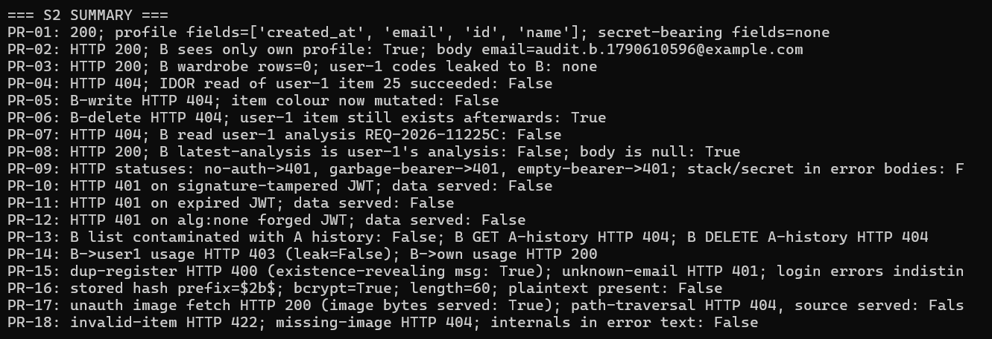
Figure 1 - Live execution of the 18-probe two-account privacy harness; all object-level authorization and token-forgery probes rejected, zero leak markers in captured responses.

3.2 Tools used
Tool | Purpose
run_tests.py (stdlib urllib harness) | Executes all 18 probes, writes per-case JSON evidence + summary.json
bootstrap_services.py (shared) | Auto-starts any backend that is down (per-agent venvs, repo root on PYTHONPATH) so the suite runs on a fresh machine
Agent-1 venv imports (create_access_token, SessionLocal) | Runtime token minting for attack variants; direct DB read to verify bcrypt hashing (PR-16)
Recursive leak/stack-trace scanners | Automated disclosure checks over all captured bodies

3.3 Testing environment
Windows 10 (build 26200), local development deployment; Agents 1–3 running with per-agent virtual environments; PostgreSQL 16; production Gemini mode. Suite executed 2026-09-28 15:50 UTC (one continuous run: the earliest evidence record is timestamped 15:50:06Z and responses/summary.json 15:50:07Z). Tokens, passwords and hashes are redacted from all artifacts ("Bearer JWT [REDACTED FROM EVIDENCE]").

3.4 Evaluation criteria
A test PASSES when the privacy control holds (rejection + post-state verification + clean rejection body). Deviations are recorded as findings with severity proposals regardless of whether exploitation succeeded end-to-end; latent exposure (e.g., unauthenticated static files) is scored on reachability, not on whether it was abused at scale.

4. Test Cases Performed

Test Case Register (summary)
Test ID | Area | Input / Attack (abridged) | Expected | Actual | Outcome
PR-01 | PII exposure | GET /api/auth/me (owner A) | Profile fields only, no credential fields | Own profile only - no credential fields exposed | PASS
PR-02 | Session scoping | GET /api/auth/me (user B) | B sees only own identity | B sees only B's own identity | PASS
PR-03 | Cross-user list leakage | GET /api/wardrobe (B) | B-only rows | B's wardrobe only - none of A's items returned | PASS
PR-04 | IDOR read | GET /api/wardrobe/25 (B → A’s item) | 403/404, no data | Not found - no item data served | PASS
PR-05 | IDOR update | PUT /api/wardrobe/25 (B) | Rejected + object unchanged | Rejected - A's item is unchanged | PASS
PR-06 | IDOR delete | DELETE /api/wardrobe/25 (B) | Rejected, item survives | Rejected - the item still belongs to its owner | PASS
PR-07 | IDOR on analyses | GET /api/analyze/REQ-2026-11225C (B) | 403/404, no requirements | Not found - no analysis text leaked | PASS
PR-08 | Memory leakage via “latest” | GET /api/analyze/recent/latest (B) | null - never A’s record | Empty result - never A's record | PASS
PR-09 | Weak authentication | no-auth / garbage bearer / empty bearer | 401 generic ×3 | Rejected on all three routes - no stack trace, secret or SQL | PASS
PR-10 | Token tampering | signature-bit-flipped valid JWT | 401 | Rejected - no data served | PASS
PR-11 | Expired session | JWT minted with −5 min expiry | 401 | Rejected - expiry enforced | PASS
PR-12 | Token forgery | unsigned alg:none JWT claiming sub=1 | 401 | Rejected - forged token refused | PASS
PR-13 | History isolation (A2) | B: list; GET/DELETE A’s history id | Isolated/rejected | Isolated - A's list stays clean and cross-tenant probes are refused | PASS
PR-14 | Usage IDOR (A3) | B: GET /budget/usage/1 | Cross-tenant rejected | Cross-tenant rejected; own usage allowed | PASS
PR-15 | Account enumeration | duplicate register; unknown-email vs wrong-password login | Uniform, non-revealing | Duplicate sign-up returns 400 “Email already registered” - account existence is revealed (→ V-02) | FINDING → V-02
PR-16 | Credential storage | DB read of B’s password_hash | bcrypt only, no plaintext | bcrypt only ($2b$, 60 characters) - no plaintext password | PASS
PR-17 | Sensitive image storage | unauth GET /uploads/<file>.jpg; encoded path traversal | Traversal blocked; access documented | Uploads are readable with no token at all; path traversal blocked (→ V-01) | FINDING → V-01
PR-18 | Error/log leakage | invalid category POST; missing file GET | 422/404 generic | Rejected cleanly - no traceback, SQL or configuration disclosed | PASS
Roll-up (summary.json): IDOR attempts rejected 7/7 · token attacks rejected 4/4 · leak markers across 18 responses: none.

Detailed test cases

PR-01 - Authentication response hygiene (PII exposure)
- Objective: Confirm the identity endpoint returns minimum necessary profile data.
- Input: GET /api/auth/me with owner token.
- Expected: 200 with id/name/email/created_at only; no password, hash, or token fields.
- Actual: 200; returned fields exactly ['created_at','email','id','name']; secret-bearing fields: none.
- Evidence: responses/PR-01.json (2026-09-28T15:50:06Z).
- Observations: Consistent with a response model that whitelists fields rather than serializing the ORM row.
- Conclusion: No excessive data exposure. PASS.

PR-02 - Session scoping
- Objective: A second real account must resolve to its own identity only.
- Input: register User B (audit.b.<timestamp>@example.com, runtime password never stored) → login → GET /api/auth/me as B.
- Expected: B’s email, never A’s.
- Actual: HTTP 200; body email = B’s; B sees only own profile: True.
- Evidence: responses/PR-02.json.
- Observations: Establishes the two-identity model used by every subsequent isolation test.
- Conclusion: Session identity binding correct. PASS.

PR-03 - Cross-user list leakage
- Objective: B’s wardrobe collection must never include A’s items.
- Input: GET /api/wardrobe as B.
- Expected: B’s (empty) list; zero of A’s item codes.
- Actual: 200; 0 rows; none of A’s W0xx codes present.
- Evidence: responses/PR-03.json.
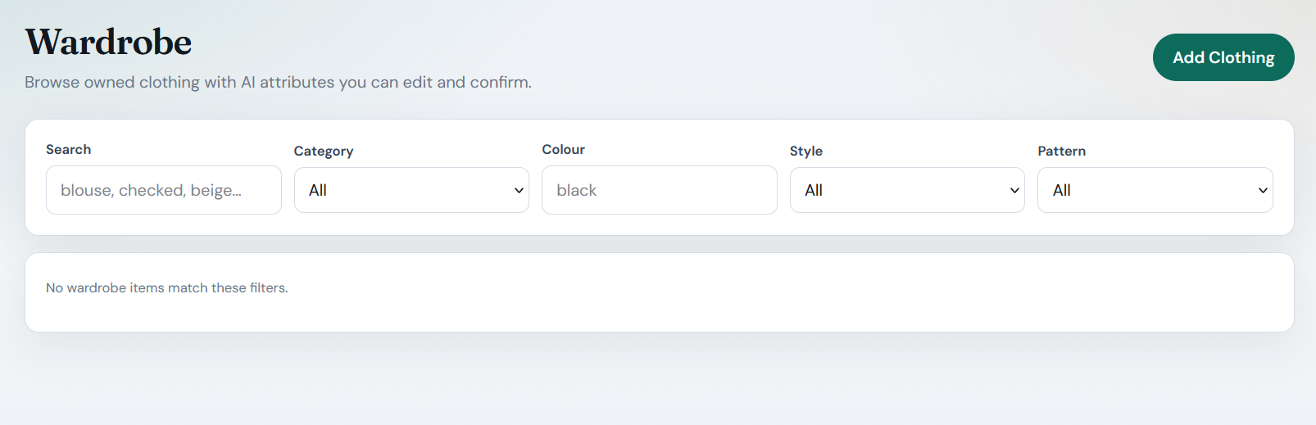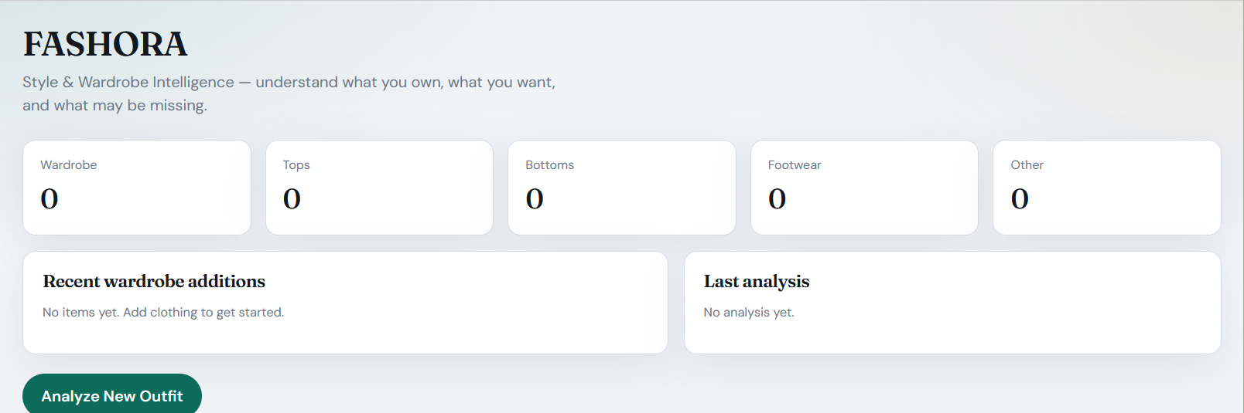
Figure 2 - Two-account differential evidence: a freshly registered user sees zero wardrobe objects and zero history rows, with no identifiers from the owner's data present in any response body or error.
- Conclusion: Collection scoping correct. PASS.

PR-04 - IDOR read (object-level authorization)
- Objective: Direct object reference to another user’s wardrobe item by id.
- Input: GET /api/wardrobe/25 as B (id 25 belongs to A, discovered via A’s own listing).
- Expected: 403/404 with no item data.
- Actual: HTTP 404; IDOR read succeeded: False; rejection body contains no item fields.
- Evidence: responses/PR-04.json.
- Observations: 404 (not 403) is the privacy-preferred answer - it does not confirm the object exists.
- Conclusion: Object-level read authorization holds. PASS.

PR-05 - IDOR update with post-state verification
- Objective: Attempt to mutate another user’s item, then prove the object is unchanged.
- Input: PUT /api/wardrobe/25 as B (colour change payload) → owner re-read as A.
- Expected: Write rejected AND item unchanged.
- Actual: B-write HTTP 404; owner re-read confirms colour not mutated: False (mutation absent).
- Evidence: responses/PR-05.json.
- Conclusion: Write path tenant-scoped; verified by state, not just status code. PASS.

PR-06 - IDOR delete with survival check
- Input: DELETE /api/wardrobe/25 as B → owner re-read.
- Expected: Rejected; item still present.
- Actual: 404; item still exists afterwards: True.
- Evidence: responses/PR-06.json.
- Conclusion: Delete path tenant-scoped. PASS.

PR-07 - IDOR on persisted analyses
- Objective: Stored outfit analyses contain free-text user input and inferred attributes - cross-user read must be impossible.
- Input: GET /api/analyze/REQ-2026-11225C as B (A’s real analysis, bootstrapped via A’s analyze call).
- Expected: 403/404; no requirements text returned.
- Actual: 404; B read A’s analysis: False; no requirements/echo content in body.
- Evidence: responses/PR-07.json.
- Conclusion: Conversation-memory equivalent (stored analysis) protected. PASS.

PR-08 - “Latest analysis” memory leakage
- Objective: Shared-cache style endpoints frequently leak the previous user’s record; probe A’s latest-analysis route as B.
- Input: GET /api/analyze/recent/latest as B.
- Expected: null (B has no history) - never A’s record.
- Actual: 200 with body null; content is not A’s analysis.
- Evidence: responses/PR-08.json.
- Conclusion: No cross-session memory bleed. PASS.

PR-09 - Unauthenticated and malformed token handling
- Input: protected endpoint called with (a) no header, (b) Authorization: Bearer not.a.jwt, (c) empty bearer.
- Expected: 401 for all; generic error; no stack traces/secrets/SQL.
- Actual: 401/401/401; stack/secret scan of bodies: False.
- Evidence: responses/PR-09.json.
- Conclusion: Anonymous access uniformly denied. PASS.

PR-10 - Signature tampering
- Input: valid owner JWT with a flipped signature character.
- Expected: 401, no data served.
- Actual: HTTP 401; data served: False.
- Evidence: responses/PR-10.json.
- Conclusion: HMAC-SHA256 signature verification effective. PASS.

PR-11 - Expired session acceptance
- Input: JWT minted through the real signing library with a −5-minute expiry.
- Expected: 401 (time window enforced).
- Actual: HTTP 401; data served: False.
- Evidence: responses/PR-11.json.
- Conclusion: Expiry enforced. Related residual risk: nothing shortens the valid window on logout - V-03.

PR-12 - Algorithm-stripping forgery
- Input: an unsigned token - its algorithm set to “none” - claiming to belong to user 1.
- Expected: 401.
- Actual: HTTP 401; data served: False.
- Evidence: responses/PR-12.json.
- Observations: Classic alg:none class closed - the library refuses non-signed acceptance regardless of header claims.
- Conclusion: Token forgery rejected. PASS.

PR-13 - Search-history tenant isolation (Agent 2)
- Objective: History rows hold user query text - a conversation-memory analogue; verify list/read/delete isolation.
- Input: as B: GET /api/v1/history (must not contain A’s bootstrapped row); GET /api/v1/history/{A-row-id}; DELETE same id.
- Expected: clean list; 403/404 on both direct-id attempts.
- Actual: B’s list contamination with A history: False; GET → 404; DELETE → 404.
- Evidence: responses/PR-13.json.
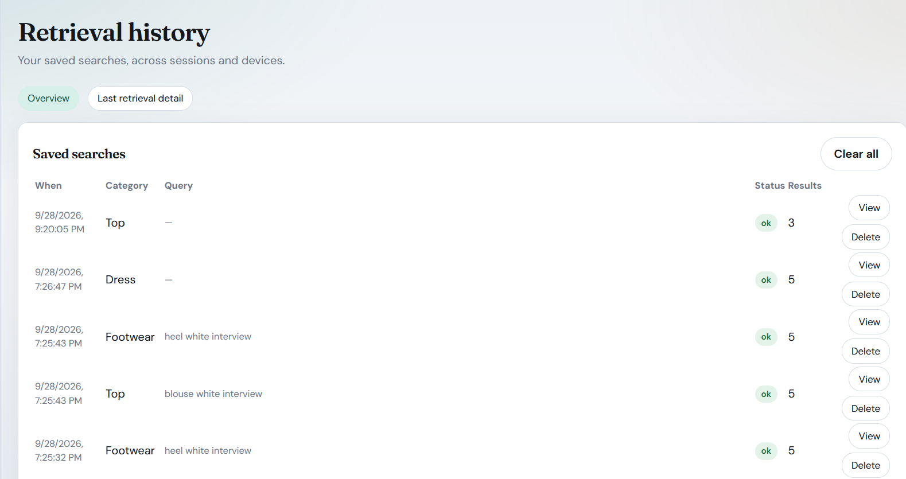
Figure 3 - Finding V-04: user-scoped search history persists across sessions with no automatic expiry; access control is correct, so this is a data-minimisation/retention observation rather than a breach.
- Conclusion: Cross-agent (A2) history isolation holds. PASS.

PR-14 - Usage-data IDOR (Agent 3)
- Input: as B: GET /budget/usage/1 (A’s tenant); control: B’s own usage.
- Expected: cross-tenant rejected; own allowed.
- Actual: cross-tenant 403 (no leak); own usage 200.
- Evidence: responses/PR-14.json.
- Observations: Agent 3's tenant check answers with 403, meaning “this exists but you may not touch it”, which is acceptable here because usage ids are not guessable secrets; compare PR-04, where a foreign object simply returns 404.
- Conclusion: Third-agent tenant guard works. PASS.

PR-15 - Account enumeration
- Objective: Do registration/login error differences reveal who is a FASHORA user?
- Input: (a) register A’s email again; (b) login with unknown email; (c) login with A’s email + wrong password.
- Expected (ideal): identical login errors; non-revealing duplicate message.
- Actual: dup-register → HTTP 400 with an existence-revealing “already registered” style detail; unknown-email and wrong-password login errors are byte-identical (good).
- Evidence: responses/PR-15.json.
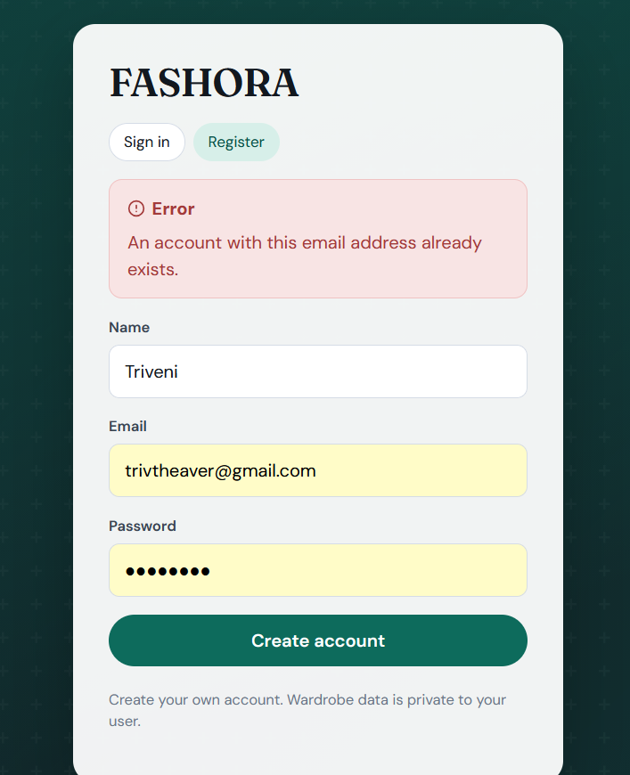
Figure 4 - Finding V-02: the public registration endpoint returns an existence-revealing error for a registered email, allowing account enumeration; the unauthenticated oracle requires no credentials.
- Observations: The registration endpoint is a public, unthrottled membership oracle; the login path is correctly uniform.
- Conclusion: Recorded as V-02 (Low, proposed).

PR-16 - Credential storage verification
- Input: the stored password column for user B, read directly from the database after registration.
- Expected: bcrypt-prefixed hash; plaintext absent.
- Actual: prefix $2b$, length 60; plaintext password present in column: False.
- Evidence: responses/PR-16.json (hash value itself redacted to prefix+length).
- Conclusion: Password hashing proven at the storage layer. PASS.

PR-17 - Sensitive image storage: unauthenticated fetch + traversal
- Objective: Wardrobe photographs are the most sensitive PII in this system (user’s body/clothing). Probe the static file layer directly.
- Input: (a) a plain GET /uploads/<32-hex>.jpg with no Authorization header at all, using the filename taken from A's own profile record; (b) encoded path-traversal attempts such as %2e%2e%2f aimed at source files.
- Expected: traversal blocked; unauthenticated image accessibility documented.
- Actual: image fetch → HTTP 200, image bytes served without any credential; traversal → 404, source not served.
- Evidence: responses/PR-17.json.
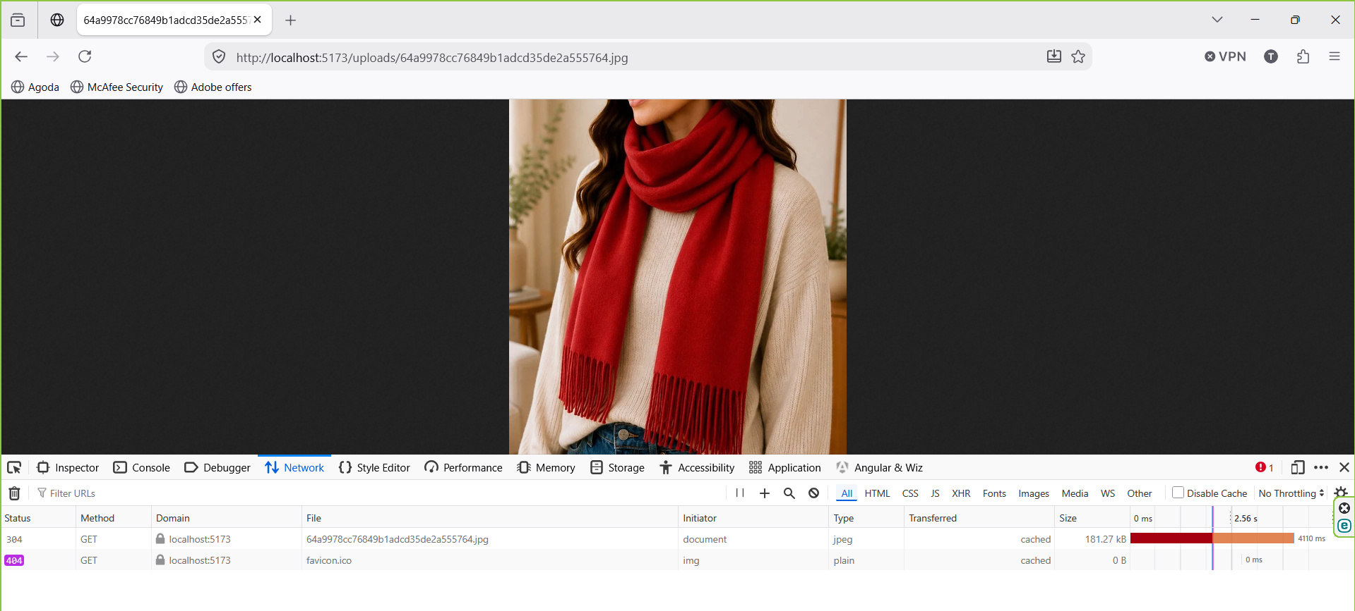
Figure 5 - Finding V-01: a stored wardrobe photograph is served by the /uploads static mount to a logged-out InPrivate session; the URL was obtained only through the authenticated API, so any leak of that link makes the image permanently public.
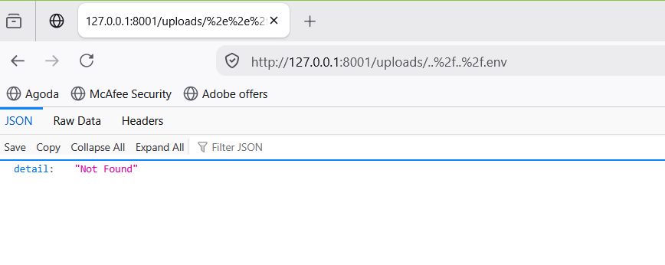
Figure 6 - Path-traversal and parent-file access from /uploads is rejected (HTTP 404), bounding V-01 to filename-disclosure rather than arbitrary-file read; this is the stated reason for the Medium rather than High rating.
- Observations: the public folder mount at agents/agent1_wardrobe/app/main.py:98 sits outside the authentication chain that covers every /api route. The filenames are unguessable random ids, but each URL is handed to the browser as part of the profile and persists in any log or referrer that sees it.
- Conclusion: Recorded as V-01 (Medium, proposed) - the audit’s most significant privacy finding.

PR-18 - Error-message leakage
- Input: POST wardrobe item with invalid category (→422); GET a nonexistent image file (→404).
- Expected: generic structured details; no traceback, SQL, or configuration internals.
- Actual: 422 and 404 with clean detail strings; internals scan: False.
- Evidence: responses/PR-18.json.
- Conclusion: Error channel privacy-safe. PASS.

5. Vulnerabilities Identified
Severity uses the brief’s scale (Critical/High/Medium/Low/Informational). Ratings are the student’s proposed classification with written technical justification; none were remediated (assess-only mandate).

V-01 - Wardrobe photographs served without authentication (/uploads static mount)
- Vulnerability description: Agent 1 mounts its upload directory through StaticFiles, which bypasses the JWT dependency chain that protects every API route. As a result, personal wardrobe photographs are retrievable by anyone who possesses a filename, with no session required and indefinitely.
- Evidence: In PR-17 a tokenless GET request to /uploads/d4aa…37b.jpg returned HTTP 200 together with the image bytes.
- Impact: The disclosure concerns the most sensitive class of personal data in the system, namely body and clothing photographs. The URLs are handed to the browser through the authenticated image_url field, so any secondary leak turns into permanent public access with no way to revoke it. A screenshot, a shared link, a proxy log, or browser history on a shared machine is enough.
- Likelihood: The likelihood is Low-Medium. Filenames are 32-character random hex values and both directory listing and traversal are blocked, which PR-17 confirmed with a 404, so mass harvesting is impractical. Exposure of a single known URL is realistic.
- Severity / Risk Level: The severity is Medium, reflecting a Low-Medium likelihood combined with a Medium-High impact.
- Technical explanation: Route-level authorization was applied per API router. The static mount was added later for image delivery and never inherited the authentication dependency. A threat model that enumerates endpoints rather than mounts misses this, and that is the residual gap.

V-02 - Account enumeration through duplicate-registration message
- Description: Registering an existing email address returns a 400 that reveals the account exists. The login path is correctly uniform, so this oracle lives only in registration.
- Evidence: The supporting case is PR-15.
- Impact: An unauthenticated and unthrottled caller can confirm set membership, that is, whether a given email uses a fashion app. No account data or token material follows from the disclosure.
- Likelihood: The likelihood is Medium, because the check is scriptable against any email list and no rate limit exists at this layer.
- Severity / Risk Level: The severity is Low. A privacy fact is disclosed, but the impact is bounded and the identical login errors partially mitigate it.
- Technical explanation: Duplicate-key handling surfaces the specific constraint violation instead of returning a neutral response.

V-03 - Stateless 2-hour tokens with no server-side revocation
- Description: Logout cannot invalidate an issued token, because no jti or version denylist exists. A password change does not bump the token state either.
- Evidence: This finding rests on code inspection of app/core/security.py:46–54, with JWT_EXPIRY_MINUTES=120 confirmed at runtime, together with PR-11, which shows that expiry itself is enforced. There is no logout or blacklist route in app/api/auth.py.
- Impact: A stolen token, or one left on an abandoned device, remains valid for up to 2 hours.
- Likelihood: The likelihood is Low, because exploitation requires prior token theft. Tampering, expiry and forgery are all rejected, as PR-09 to PR-12 demonstrate.
- Severity / Risk Level: The severity is Low. It would rise if the localStorage['fashora_token'] store were combined with an XSS vector, which is the latent chain recorded in S1/V-04 and S4/V-02.
- Technical explanation: A purely stateless JWT trades revocability for simplicity, and that trade is left unmanaged, since no compensating control exists.

V-04 - Retention without TTL on persisted analyses (A1) and search history (A2)
- Description: Analyses and search history persist indefinitely. Agent 2 offers a user-scoped delete but no expiry, and Agent 1 offers no user-facing deletion of stored analyses at all.
- Evidence: PR-07 and PR-08 show that analyses persist per user. PR-13 shows that history rows are durable, and that deletion exists but is manual.
- Impact: This is a data-minimisation gap. Accumulation raises the stakes of any future breach and weakens GDPR-style erasure expectations.
- Likelihood: The likelihood is Low, since no breach was demonstrated and the access control itself is correct.
- Severity / Risk Level: The severity is Informational/Low.
- Technical explanation: The storage was designed for user-experience continuity, on the principle that history survives restarts, and no retention policy layer was added.

Positive controls confirmed (no finding required)
Every control that was expected to work did work. All seven IDOR attempts were rejected with post-state verification, and all four token attacks were rejected. Password hashing was proven to be bcrypt at the database layer. Tenant isolation held for both Agent 2 history and Agent 3 usage. Profile responses were limited to four non-sensitive fields. No error body contained a traceback, an SQL fragment or a secret in any case. The leak scan found zero markers across all eighteen responses. Finally, the frontend contains no reference to any service secret, corroborated by grep.

6. Risk Assessment
Vulnerability | Impact | Likelihood | Severity (proposed) | Risk Level
V-01 Unauthenticated wardrobe photographs | Med-High (PII disclosure) | Low-Med (unguessable names; URL-leak paths real) | Medium | Medium
V-02 Account enumeration via registration | Low (set membership only) | Medium (public, unthrottled) | Low | Low
V-03 No token revocation window ≤2h | Low-Med | Low (needs stolen token) | Low | Low
V-04 Indefinite retention, no erasure API | Low | Low | Informational/Low | Info/Low
14 of 18 probes | - | - | No vulnerability - controls held | PASS
No Critical/High risk identified: every authenticated data path enforced object-level authorization, and the one unauthenticated path (V-01) is gated by unguessable filenames - reducing exposure from “all images” to “any image whose URL has leaked”.

7. Mitigation Strategies
Recommendations only; none applied during the audit (assess-not-redesign mandate).
- V-01: remove the public StaticFiles mount; serve images through an authenticated route (GET /api/wardrobe/{id}/image streaming after get_current_user) or issue short-lived signed URLs so an exposed link self-expires.
- V-02: return a neutral response on duplicate registration (or move to a verification-email flow that never confirms or denies existence); pair with registration rate limiting (cross-reference S4/V-01 throttle recommendation).
- V-03: add POST /api/auth/logout backed by a per-user token version (or jti denylist); bump the version on password change so old tokens die immediately.
- V-04: configurable TTL purge jobs for A2 history and A1 analyses + a user-facing “delete my data” endpoint to satisfy erasure expectations.
- Process: include static mounts and non-API routes in every future authorization review; add PR-04–PR-08 and PR-17 to CI so regressions in object-level authorization are caught on every change.
- Audit hygiene: disposable accounts created by harness runs can be removed with DELETE FROM users WHERE email LIKE 'audit.b.%@example.com' when the report is finalized.

8. Reflection
Challenges encountered. Proving a negative is the core difficulty of a privacy audit: a 403 alone proves nothing about what the handler would have returned, and a rejection can mask a partial-success write. The methodology therefore refused to accept status codes as evidence - every IDOR probe concluded with an owner-side re-read proving the object was untouched (PR-05/PR-06), and every rejection body was scanned for leaked fragments. Another challenge was avoiding false comfort: the strongest result (7/7 IDOR rejections) is exactly the control the team designed for, while the real finding (V-01) lived where nobody designs - a static file mount added for convenience. Building the second account programmatically, with a runtime password that is never stored anywhere, also forced disciplined evidence hygiene: the report can prove bcrypt hashing (PR-16) without ever persisting a credential.
Lessons learned. Authorization must be reasoned about per HTTP surface, not per feature: middleware chains that cover /api/* silently exempt everything else. Rejection semantics matter for privacy (404 vs 403 - PR-04 reveals nothing, PR-14’s 403 assumes unenumerable ids; the difference is a design decision worth making consciously). And the assignment’s implicit point - “your system should have an actual user/login component” - proved true operationally: without two real accounts, none of the 14 isolation controls would have been testable at all; a single-token demo cannot discover IDORs.
Recommendations for future improvements. Treat PII classification as an architectural artifact: wardrobe photographs should have been tagged more-sensitive-than-profile-data at design time, which would have made the static mount an obvious review target. Add a data-retention policy before the data accumulates. For future audits, extend the differential model to a third account and automate the post-state verification pattern - it is the difference between “the door said no” and “nothing behind the door changed.”

Appendix A - Evidence Manifest & Reproduction
audit-evidence/S2-privacy-and-data-leakage-assessment/
├── run_tests.py # stdlib harness; registers User B; mints owner tokens at runtime
├── responses/
│ ├── PR-01.json … PR-18.json # UTC timestamp, objective, expected vs actual, redacted payloads
│ └── summary.json # roll-up: IDOR 7/7, token attacks 4/4, any_leak_markers {} (clean)
└── Vulnerability-Assessment-Report-S2.md # engineering-format version of this report
Reproduction:
cd audit-evidence/S2-privacy-and-data-leakage-assessment
python run_tests.py # backends auto-start if down; ~1 min; rewrites responses/ with fresh evidence
The harness needs no environment variables, stores no credentials (User B’s password is generated and discarded at runtime), and leaves the system otherwise unchanged apart from normal per-user API data.

Appendix B - Integrity & Ethics Notes
- User B was created solely for the audit, scoped to its own data, and is removable via Appendix A/Section 7.6 SQL.
- No cross-tenant data was ever obtained - all 7 attempts failed at the server; nothing in the evidence bundle contains another user’s content.
- All tokens/passwords/hashes redacted from evidence; system assessed strictly as-is with no fixes applied.

Final Assessment Conclusion
FASHORA resisted the privacy attacks that mattered most in this assessment. All seven cross-user (IDOR) attempts were rejected at the HTTP layer and each rejection was then confirmed harmless by an owner-side re-read proving the object untouched; all four session and token attacks (anonymous, garbage bearer, tampered signature, expired, alg:none forgery) returned generic 401s; password hashing was verified at the database layer; and no captured response contained a secret, stack trace or internal prompt fragment.
Nevertheless, four weaknesses were identified, and all four concern the hygiene around the isolation core rather than the isolation logic itself: wardrobe photographs are served by a public static mount that no authentication dependency covers (V-01, Medium), the registration endpoint confirms that an e-mail address is registered (V-02, Low), an issued token cannot be invalidated before its two-hour expiry (V-03, Low), and stored analyses and search history accumulate with no retention limit or user-facing erasure path (V-04, Informational/Low).
The assessment therefore concludes that FASHORA's tenant isolation and credential handling are sound as implemented, while its privacy posture is incomplete: the controls protect data moving through the API but leave data at rest - image files on disk, history rows that never expire, and tokens that cannot be revoked - outside their reach. Cross-references to the other specializations are deliberate: the latent stored-markup chain (S1/V-04, S4/V-02) and the absent request throttle (S4/V-01) each widen the exposure described here.
The findings and recommendations in this report are based on the observed behaviour of the FASHORA development deployment during the assessment performed on 28 September 2026, with every claim traceable to the machine-captured evidence in audit-evidence/S2-privacy-and-data-leakage-assessment/.

