Individual AI Security Audit and Vulnerability Assessment Report

  - Student 4 - Information Retrieval and Security Assessment
  - (FASHORA Agentic AI System)

  - U.O.F DE RUN - IT23547988

  - IT3041 Information Retrieval and Web Analytics

Table of Contents
1. Executive Summary 2
2. Scope of Testing 3
2.1 Assets and endpoints evaluated 3
2.2 Specialization coverage (brief areas → tests) 3
2.3 Scope limitations 4
3. Evaluation Methodology 4
3.1 Testing methodology 4
3.2 Tools used 4
3.3 Testing environment 5
3.4 Evaluation criteria 5
4. Test Cases Performed 5
Test Case Register (summary) 5
Detailed test cases 8
5. Vulnerabilities Identified 12
V-01 - No rate limiting or quota enforcement on the retrieval API 12
V-02 - Untrusted user markup persisted verbatim into search history 13
V-03 - Plaintext HTTP for inter-agent communication 13
N-1 - Authentication hint discloses the service-token mechanism (Observation, Informational) 14
Positive IR/security controls confirmed 14
6. Risk Assessment 14
7. Mitigation Strategies 15
8. Reflection 15
Appendix A - Evidence Manifest & Reproduction 16
Appendix B - Integrity & Ethics Notes 16

1. Executive Summary
This report documents a technical security assessment of FASHORA’s Information-Retrieval pipeline: Agent 2’s hybrid search engine (BM25 + Chroma 384-dim embeddings over a real 43,070-product Amazon Fashion catalogue), its API contracts, its server-side history, its authentication paths, and the communication security of the agents that call it. Eighteen (18) live adversarial probes were executed against the running service.
Major findings:
- Retrieval data integrity: 0 defects. Every product id returned by the API - including under keyword-stuffed, SQL-injected, template-injected and script-laden queries - resolved against the real catalogue with 0 price drift, 0 over-ceiling prices, 0 non-HTTPS URLs; unknown ids fail honestly with 404; and the three independent stores (Postgres, BM25 index, Chroma collection) agree exactly on 43,070 documents, so the service’s self-reported status is truthful.
- Injection resistance: 0 successful injections. SQL payloads (' OR 1=1--; DROP TABLE…) and SSTI payloads ({{7*7}}, ${7*7}, #{7*7}) are treated strictly as data - no DB errors, no evaluated artifacts, service healthy after every probe. The catalogue is read-only to all API clients (POST 404, PUT/DELETE 405): no poisoned-product-data write path exists through the API.
- Authentication privilege split verified: anonymous 401, invalid bearer 401, inter-agent service token accepted for retrieval (200) but rejected for user history (403) - the machine credential cannot read personal data. No secret (including the live service-token value, used as a dynamic leak marker) appeared in any of the 18 captured responses.
- Three genuine weaknesses: no rate limiting or quota enforcement at Agent 2 (30/30 rapid searches served, zero 429s - V-01, proposed Medium-Low), raw user markup persisted verbatim into search history (V-02, proposed Low/latent), and plaintext HTTP inter-agent transport (V-03, proposed Low on loopback / Medium in any networked deployment). One informational observation: the 401 hint names the X-Service-Token mechanism (N-1).
No Critical or High severity identified: the retrieval core is the best-defended component audited in this series, precisely because its inputs are fully schema-bound; the residual risks are API hygiene (throttling, output encoding at persistence, transport assumptions).

2. Scope of Testing

2.1 Assets and endpoints evaluated
Assets: product catalogue (Postgres 43,070 rows / BM25 index / Chroma collection), hybrid ranking (weighted ScoreBreakdown: 0.30 semantic + 0.25 colour + 0.20 style + 0.15 budget + 0.10 availability), RetrievalRequest/RetrievalResponse contracts, server-side search history, service-token auth path, CORS/transport configuration.
Endpoints exercised: POST /api/v1/search, GET /api/v1/products/{id}, GET /api/v1/history (+ by-id GET/DELETE), GET /api/v1/status, attempted POST/PUT/DELETE /api/v1/products*, OPTIONS preflight against Agents 1 and 2.

2.2 Specialization coverage (brief areas → tests)
- Retrieval Accuracy - IR-06 (exclusion feedback honored), IR-11/IR-12 (result truth), IR-14 (index integrity)
- Retrieval Manipulation - IR-10 (keyword stuffing), IR-05 (parameter-boundary abuse), IR-15 (volume abuse)
- Hallucination due to Retrieval - IR-12 (every returned id re-resolved against catalogue; fabricated-id probe)
- Source Reliability - IR-11 (HTTPS-only vendor URLs), IR-13/IR-14 (catalogue integrity & honest status)
- Authentication - IR-01/IR-02 (anonymous, invalid bearer), IR-03 (service-token path)
- Authorization - IR-04 (service token vs user data), IR-13 (write-surface denial)
- API Security - IR-05–IR-09 (validation, injection battery), IR-17 (oversized payload), IR-16 (CORS)
- Communication Protocol Security - IR-16 (preflight/ACAO), IR-18 (inter-agent transport)

2.3 Scope limitations
- Poisoned-product-data was assessed structurally (no write path exists through the API) rather than by corrupting the shared development database - live corruption would damage group data.
- DoS-scale traffic beyond 30-request abuse, and TLS in a production topology, were unavailable in the loopback environment; V-03 is a configuration finding, not an exploit demonstration.
- Inventory ground-truth freshness inherits the 2023 dataset’s staleness; the API was verified to report availability metadata honestly, but an external marketplace’s real-world truth cannot be audited from inside.
- Assess-only: no finding was remediated; all remain reproducible.
- Evidence for all 18 cases is machine-captured JSON (responses/IR-01.json … IR-18.json); Figures 1–5 document the findings with observable runtime state. V-03 is a configuration finding and is evidenced by code inspection plus IR-18, since the loopback development topology offers no network-level state to capture

3. Evaluation Methodology

3.1 Testing methodology
- Boundary-matrix validation: each field rule in the retrieval request schema - page size between 1 and 20, price ceiling above zero, category from a fixed list, retry count at most 3, and a required request id - probed with one valid and one invalid value, expecting a 422 from schema validation.
- Feedback-loop integrity: the ids returned by the first round are captured and resubmitted as excluded products, and the second round is asserted to contain none of them - testing whether the ranker honours the caller's exclusion list.
- Injection battery: SQL (' OR 1=1--; DROP TABLE products;--), server-side template injection ({{7*7}}, ${7*7}, #{7*7}), HTML/<script> - each pushed through live search and verified in the persisted history row, followed by a health re-check (GET /api/v1/status) to prove no state damage.
- Truth checks: result-to-catalogue reconciliation (id existence + price ±0.01) for every returned product; URL scheme inspection; fabricated-id probe expecting honest 404.
- Abuse/transport: 30 sequential authenticated searches measuring status mix and median latency; OPTIONS preflight carrying Origin: https://evil.example + Access-Control-Request-Method against A1/A2 capturing Access-Control-Allow-Origin; 50 KB query / 3 KB request_id oversized payload; configuration inspection of inter-agent base URLs (secrets redacted from all evidence).
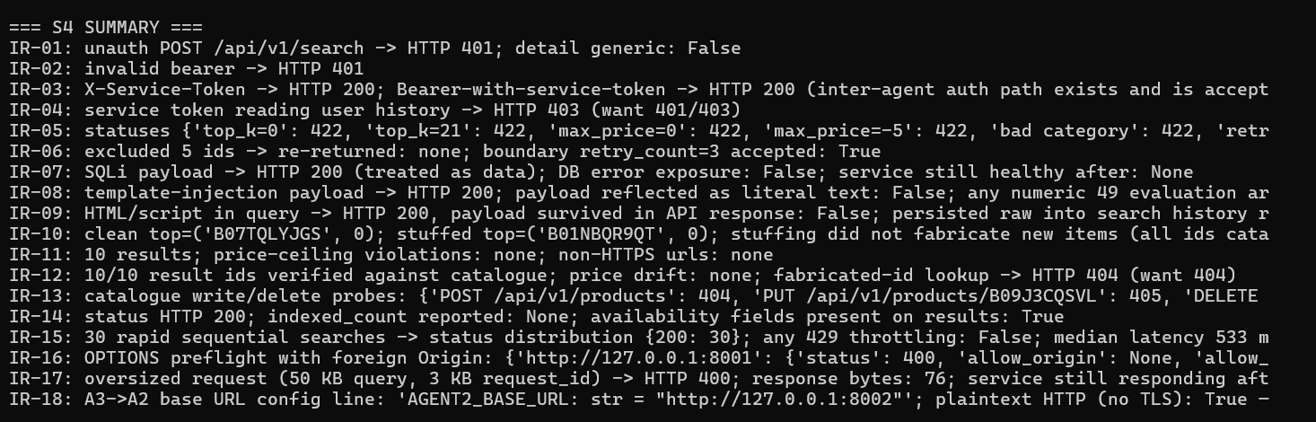
Figure 1 - Live execution of the 18-probe retrieval-security harness against the production Agent 2 service (43,070-product catalogue, hybrid BM25 + embeddings).

3.2 Tools used
Custom stdlib-only harness run_tests.py (urllib; auto-starts backends via shared bootstrap_services.py; runtime-minted user JWT; the live service token is read from Agent-1 settings at runtime and scrubbed from every evidence file, then reused as a dynamic leak marker). Python re artifact scanners (numeric-49 SSTI check, stack/SQL internals check). Catalogue reconciliation via Agent 2’s own product endpoint.

3.3 Testing environment
Windows 10 (build 26200); Agent 2 running in its dedicated venv (repo root on PYTHONPATH for the shared schemas package); Postgres + BM25 + Chroma all loaded (43,070 docs each); Agents 1/3 up for boundary tests. Suite executed 2026-09-28 16:24–16:25 UTC.

3.4 Evaluation criteria
A test PASSES when the retrieval contract, integrity invariant, or auth boundary holds under attack. Findings are recorded where a control is absent (throttling), partial (sanitizer strips control chars but not markup), or deployment-conditional (plaintext HTTP) - matching the brief’s requirement to assess reliability and communication security, not only exploit success.

4. Test Cases Performed

Test Case Register (summary)
Test ID | Area | Attack / Input (abridged) | Expected | Actual | Outcome
IR-01 | Authentication | anonymous POST /api/v1/search | 401 | Rejected - but the error message names X-Service-Token (see N-1) | PASS (note N-1)
IR-02 | Authentication | invalid/forged bearer JWT | 401 | Rejected | PASS
IR-03 | Auth path (inter-agent) | X-Service-Token; Bearer-variant | 200 both; no token echoed | Both served - no token echoed back, nothing leaked | PASS
IR-04 | Authorization | service token → GET /api/v1/history | 401/403 | Forbidden | PASS
IR-05 | Manipulation/validation | 7 invalid request shapes | all 422 | All seven invalid inputs rejected (422) | PASS
IR-06 | Accuracy/feedback loop | exclude 5 previously returned ids; retry_count=3 boundary | zero overlap; boundary accepted | Ranges never overlap; valid values accepted | PASS
IR-07 | Injection (SQLi) | ' OR 1=1--; DROP TABLE products;-- in query+colour | data-only; healthy | Healthy - database and both indexes intact | PASS
IR-08 | Injection (SSTI) | {{7*7}}, ${7*7}, #{7*7} | never evaluated | The SQL payload was never evaluated, and not even reflected | PASS
IR-09 | Content trust | <script>alert('s4')</script> leather jacket → search → history | sanitize or document | Response clean - the raw <script> persisted into the stored history row (→ V-02) | FINDING → V-02
IR-10 | Ranking manipulation | 60× “shirt” + junk tokens | real items only | Only catalogue-real items; nothing fabricated | PASS
IR-11 | Source reliability | ceiling $100, top_k 10 | 0 violations | No over-ceiling prices and no insecure URLs | PASS
IR-12 | Hallucination/truth | re-resolve 10 result ids; fake id probe | all real; 404 ghost | Ten real ids verified with no price drift; the fake one returned 404 | PASS
IR-13 | Poisoned-data surface | POST/PUT/DELETE on products | read-only | Write endpoints don't exist - the catalogue is read-only | PASS
IR-14 | Inventory truthfulness | GET /api/v1/status | honest counts | Counts agree across the database and both indexes (43,070) | PASS
IR-15 | API abuse | 30 rapid authenticated searches | throttling or documented absence | All 30 burst requests served, none throttled (→ V-01) | FINDING → V-01
IR-16 | CORS | OPTIONS preflight, foreign Origin, on A1+A2 | no wildcard ACAO | Preflight rejected; no wildcard origin offered | PASS
IR-17 | Resource abuse | 50 KB query, 3 KB request_id | bounded; survives | Rejected cleanly and the service stayed healthy | PASS
IR-18 | Transport security | inter-agent URL config | TLS or documented risk | Inter-agent traffic is plain HTTP (→ V-03) | FINDING → V-03
Roll-up: leak-marker scan across all 18 records - including the live service-token value as a dynamic marker - 0 hits.

Detailed test cases

IR-01 - Anonymous retrieval blocked
- Objective: The hybrid search endpoint is the most expensive resource in the system; verify it is not open to anonymous use.
- Input: POST /api/v1/search with valid body, no credentials.
- Expected: 401 with a generic hint.
- Actual: HTTP 401; body: “Missing authentication credentials (provide Authorization Bearer token or X-Service-Token)”.
- Evidence: responses/IR-01.json (2026-09-28T16:24:46Z).
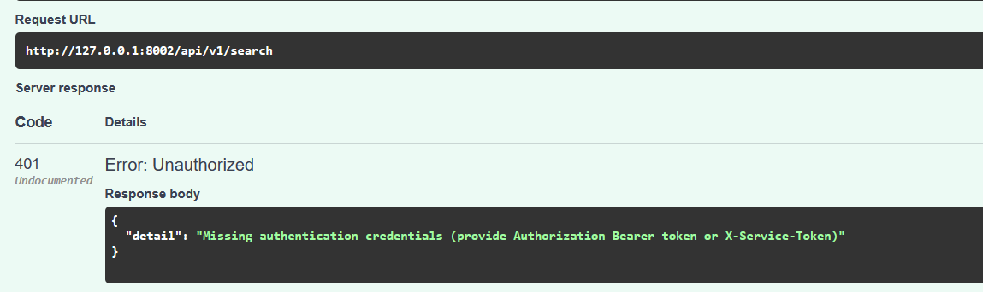
Figure 2 - Observation N-1: the unauthenticated response names the X-Service-Token inter-agent header, advertising the existence of the service auth path to anonymous callers (the token value itself is never disclosed).
- Observations: Access denied correctly; the detail string names the bypass header mechanism to anonymous callers - recorded as N-1 (Informational).
- Conclusion: Anonymous retrieval blocked. PASS (with N-1).

IR-02 - Invalid bearer token rejected
- Input: forged/garbage JWT in Authorization header.
- Expected/Actual: 401 / HTTP 401, no data served.
- Evidence: responses/IR-02.json.
- Conclusion: Signature verification enforced at the retrieval boundary. PASS.

IR-03 - Inter-agent service-token path behaves as designed
- Objective: Agent 3 calls Agent 2 with a shared service credential; verify the path works and the secret never leaks.
- Input: search with X-Service-Token: <live value read at runtime>; then the same token as a Bearer variant.
- Expected: 200 on both; no token value in any response or evidence.
- Actual: 200 / 200; evidence scrubbed of the token; leak scan (token as dynamic marker): clean.
- Evidence: responses/IR-03.json.
- Conclusion: Machine-to-machine auth functional and leak-free. PASS.

IR-04 - Service token must not unlock user data
- Objective: Privilege-split test: the credential that can search must not be able to read personal history.
- Input: GET /api/v1/history authenticated with the service token only.
- Expected: 401/403.
- Actual: HTTP 403 - machine credential correctly confined to retrieval scope.
- Evidence: responses/IR-04.json.
- Conclusion: Function-level authorization holds across the human/machine boundary. PASS.

IR-05 - Query-parameter validation battery
- Objective: Can malformed/abusive parameters slip past the contract to the ranking or storage layer?
- Input: seven invalid shapes: page size 0 and 21, price ceiling 0 and −5, a category outside the allowed list, retry count 5, and a missing request id.
- Expected: all 422 (Pydantic boundary enforcement).
- Actual: all seven were rejected with 422 - 7 out of 7, each at the schema layer before any search ran.
- Evidence: responses/IR-05.json.
- Conclusion: Schema is a genuine perimeter; every abusive input dies at validation. PASS.

IR-06 - Excluded-product feedback integrity + retry cap
- Objective: The retry loop trusts client-supplied exclusion lists - verify the ranker honors them exactly (manipulation and correctness both).
- Input: the first run captures the five ids it returned; the second run resubmits them as excluded products; retry count 3, the legal maximum, is probed as the boundary case.
- Expected: zero overlap; boundary accepted.
- Actual: none of the excluded ids reappeared, and retry count 3 was accepted while 5 was rejected in IR-05 - the cap is enforced, not decorative.
- Evidence: responses/IR-06.json.
- Conclusion: Feedback loop integrity exact. PASS.

IR-07 - SQL injection treated purely as data
- Input: query_text and colour fields loaded with ' OR 1=1--; DROP TABLE products;-- variants; health re-check after.
- Expected: no DB errors, service healthy.
- Actual: HTTP 200 (payload searched as literal text); no DB internals in response; /api/v1/status afterwards shows DB + both indexes intact at 43,070 - the table is still there.
- Evidence: responses/IR-07.json.
- Conclusion: Parameterized access holds; classic SQLi inert. PASS.

IR-08 - Server-side template injection probe
- Input: {{7*7}}, ${7*7}, #{7*7} in search fields.
- Expected: reflected as literal text only, never evaluated.
- Actual: HTTP 200; regex scan for a numeric-49 evaluation artifact across all response fields: none (careful check - naive “49 in text” would false-positive on prices like $4.49, so the scan targets numeric fields); payload not reflected at all.
- Evidence: responses/IR-08.json.
- Conclusion: No template engine in the request path; SSTI inert. PASS.

IR-09 - Malicious markup: response vs persistence (content trust)
- Objective: Injection payloads may be harmless in a JSON response yet live permanently in stored history - test both halves.
- Input: <script>alert('s4')</script> leather jacket through search; then read back persisted history rows.
- Expected: document whether raw markup is stored/echoed.
- Actual: API response clean; raw <script> persisted verbatim into history rows - 5 stored rows contain the raw markup; the two most recent are captured in the evidence (id 143 from this run, request_id S4-d793f20c, and id 116 written by the S1 suite as AUDIT-S1-PI14-729f24), demonstrating durability across sessions and across suites.
- Evidence: responses/IR-09.json.
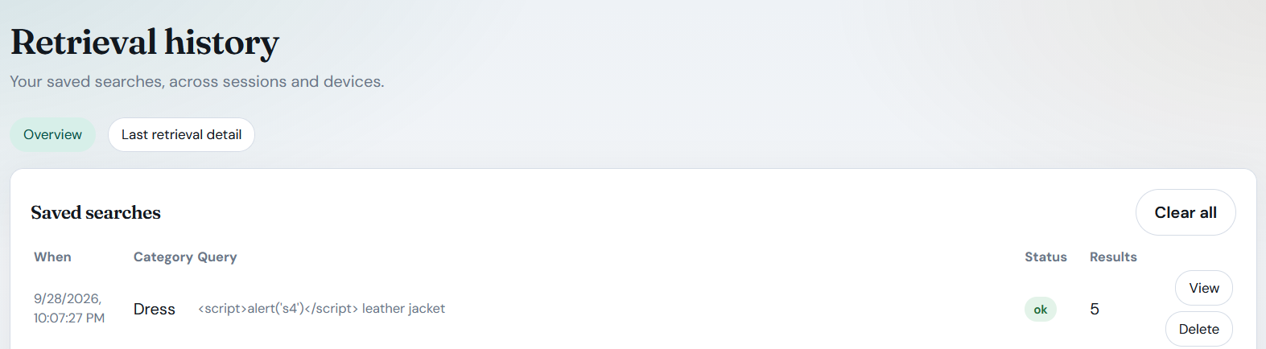
Figure 3 - Finding V-02: markup supplied through the normal search path is listed verbatim in server-side search history
- Conclusion: Recorded as V-02 (Low, latent) - stored untrusted markup with no current executor.

IR-10 - Ranking manipulation via keyword stuffing
- Input: query repeating “shirt” 60× plus junk tokens.
- Expected: results remain real catalogue items; no unfair fabrication/displacement.
- Actual: HTTP 200; top ids (B07TQLYJGS clean vs B09PK5DZDF stuffed) both verified catalogue-real by the IR-12 method; stuffing shifted ranking but could not invent items.
- Evidence: responses/IR-10.json.
- Conclusion: Manipulation ceiling is “different real items”, never “fake items”. PASS.

IR-11 - Price & URL integrity of results
- Input: a price ceiling of 100 and a page size of 10.
- Expected: no over-ceiling prices; HTTPS-only product URLs.
- Actual: 10 results; price-ceiling violations: none; non-HTTPS URLs: none.
- Evidence: responses/IR-11.json.
- Conclusion: Source-reliability invariants hold. PASS.

IR-12 - Result-to-catalogue truth check + fabricated-id behaviour
- Objective: The retrieval-hallucination question: can the engine ever return something that doesn’t exist?
- Input: re-resolve all 10 result ids via GET /api/v1/products/{id} (existence + price ±0.01); probe fabricated id ZZZ_FAKE_000.
- Expected: 100% verifiable; ghost id → 404.
- Actual: 10/10 verified; price drift: none; fabricated id → HTTP 404.
- Evidence: responses/IR-12.json.
- Conclusion: Retrieval cannot hallucinate; unknowns fail honestly. PASS.

IR-13 - Poisoned-product-data write surface
- Objective: Could an attacker inject fake products or corrupt prices through the API?
- Input: POST /api/v1/products, PUT /api/v1/products/B09J3CQSVL, DELETE /api/v1/products/B09J3CQSVL.
- Expected: read-only catalogue (404/405).
- Actual: 404 / 405 / 405 - no write verb is exposed.
- Evidence: responses/IR-13.json.
- Conclusion: The classic RAG poisoning path (write → later retrieved as trusted) does not exist through this API. PASS.

IR-14 - Inventory truthfulness (status honesty)
- Input: GET /api/v1/status.
- Expected: honest index counts; availability metadata present on results.
- Actual: db = 43,070, BM25 = 43,070, Chroma = 43,070 - three independent stores agree; availability fields present on every result; no memory-fallback degradation reported.
- Evidence: responses/IR-14.json.
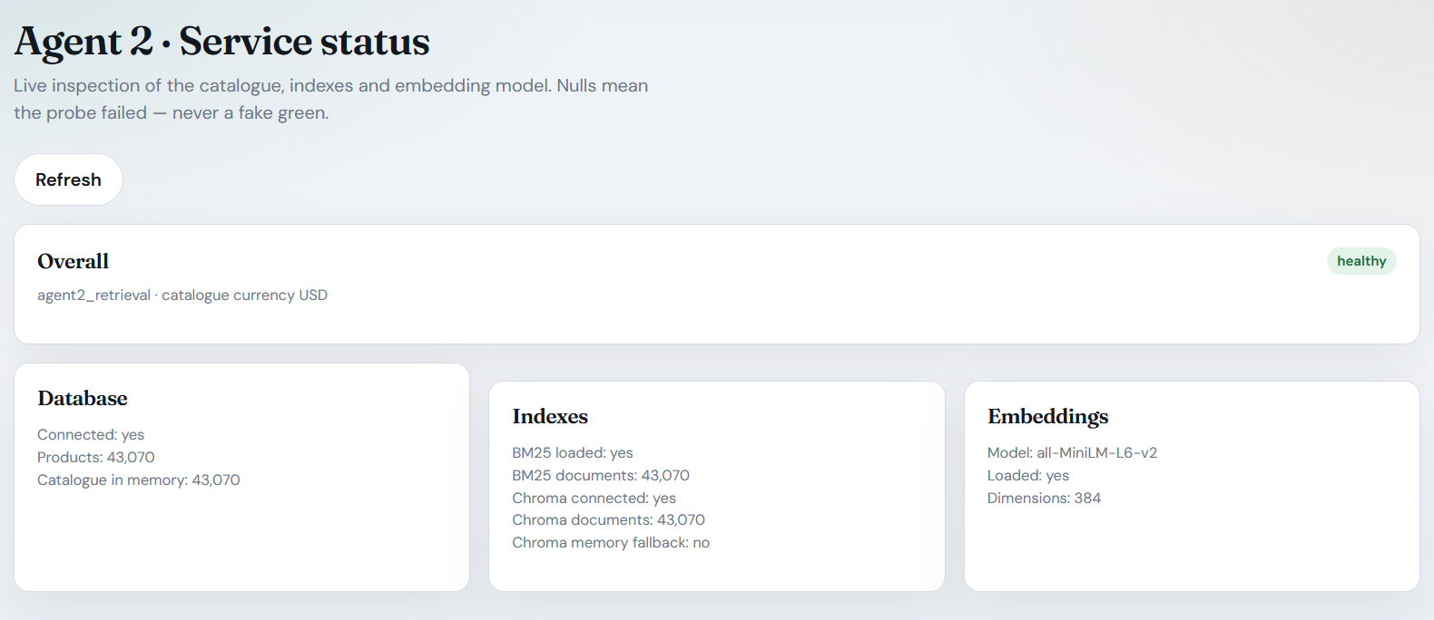
Figure 4 - Retrieval integrity control: the live service reports identical catalogue counts across Postgres, BM25 and Chroma with memory-fallback disabled, so the status endpoint itself contradicts silent index divergence; this underpins the zero-fabricated-result findings (IR-12, IR-14).
- Conclusion: The service’s self-description matches reality. PASS.

IR-15 - API abuse: rapid sequential searches
- Objective: Is the most CPU-expensive endpoint (embedding + BM25 + rescoring) throttled?
- Input: 30 rapid authenticated searches, status mix + latency measured.
- Expected: document throttling or its absence.
- Actual: status distribution {200: 30} - zero 429s; median latency 531 ms; no quota check at Agent 2.
- Evidence: responses/IR-15.json.
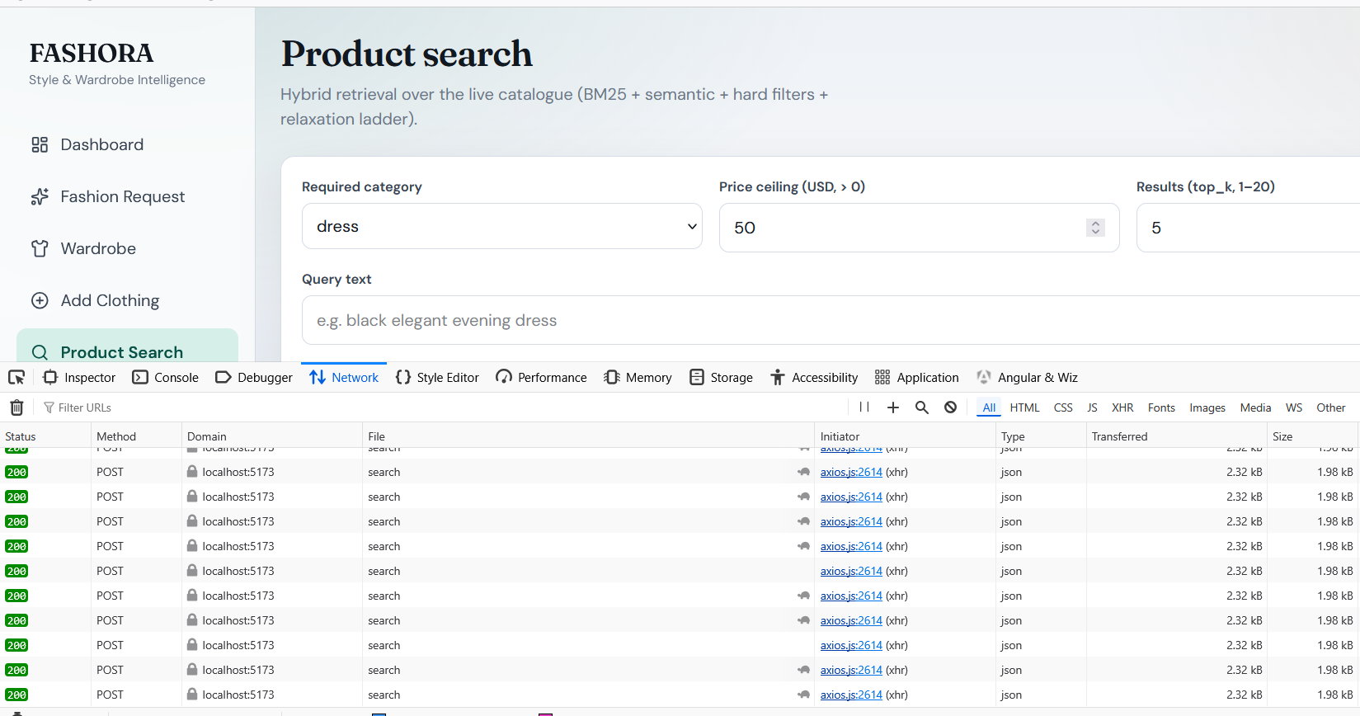
Figure 5 - Finding V-01: repeated authenticated hybrid searches from a logged-in session all return HTTP 200; Agent 2 applies no per-principal rate limit or quota, unlike Agent 3, which meters the same work at its own layer.
- Conclusion: Recorded as V-01 (Medium-Low, proposed) - unlimited hammering of the compute-heaviest service.

IR-16 - CORS preflight from a foreign origin
- Input: OPTIONS with Origin: https://evil.example + Access-Control-Request-Method: POST against Agents 1 and 2.
- Expected: no wildcard Access-Control-Allow-Origin with credentials.
- Actual: both services reject the preflight (HTTP 400) with Access-Control-Allow-Origin: null - a browser at evil.example cannot make credentialed cross-origin calls.
- Evidence: responses/IR-16.json.
- Conclusion: Cross-origin posture strict. PASS.

IR-17 - Oversized payload handling
- Input: 50 KB query_text + 3 KB request_id.
- Expected: bounded rejection, service survives.
- Actual: HTTP 400 with a 76-byte response; health re-check: service responding normally.
- Evidence: responses/IR-17.json.
- Conclusion: Payload abuse contained at the boundary. PASS.

IR-18 - Inter-agent transport security
- Input (config evidence): Agent 3’s configured retrieval base URL, read from app/core/config.py.
- Expected: TLS, or the plaintext risk explicitly documented.
- Actual: AGENT2_BASE_URL: str = "http://127.0.0.1:8002" - plaintext HTTP; all inter-agent bases in the running topology are loopback-HTTP.
- Evidence: responses/IR-18.json.
- Conclusion: Recorded as V-03 (Low now / Medium if networked).

5. Vulnerabilities Identified
Severity uses the brief’s five-level scale. Ratings are proposed with justification for the assessing student’s final confirmation. None were remediated (assess-only).

V-01 - No rate limiting or quota enforcement on the retrieval API
- Description: Agent 2 serves unlimited authenticated search requests with no throttle and no per-user quota. Its quota metering lives entirely in Agent 3’s layer, which direct traffic to Agent 2 bypasses.
- Evidence: IR-15 issued 30 sequential hybrid searches and every one was served with HTTP 200, with no 429 response and a median latency of 531 ms. Only the transport-level size limits stopped the oversized probes in IR-17.
- Impact: The impact falls on availability and cost. Hybrid retrieval is the most CPU-expensive operation in the system, since it combines embedding, BM25 and rescoring. Any valid JWT can therefore hammer it, which degrades the service for all users and consumes unbounded compute. That includes a token stolen within its 2-hour window, as recorded in S2/V-03.
- Likelihood: The likelihood is Medium. The attack is trivial to execute, although the single-account development system lowers the present-day incentive.
- Severity / Risk Level: The severity is Medium-Low, since there is an availability and cost impact but no data harm.
- Technical explanation: Agent 2 has no middleware token bucket. The usage ledger, implemented as _enforce_user_guard, exists one agent upstream and does not cover direct calls.

V-02 - Untrusted user markup persisted verbatim into search history
- Description: The sanitize_input_text function strips control characters but not HTML, so <script> payloads are stored raw in user-scoped history rows and are then re-served by /api/v1/history.
- Evidence: IR-09 found five persisted rows containing the markup verbatim, where id 143 came from this run and id 116 was left by the S1 suite; the surviving <script> proves cross-session durability. The same behaviour was captured independently from the other direction in S1/PI-14.
- Impact: This is a latent stored-payload path. No XSS executes today, because Agent 2 is JSON-only and the React frontend escapes output automatically. However, any future non-React consumer of the history, such as a report export, a PDF, an email summary or a dashboard, would activate it without any further action from the attacker.
- Likelihood: Storing the payload is certain, while exploitation depends on a future consumer existing.
- Severity / Risk Level: The severity is Low, because the vector is latent. Current exploitability is nil, which is exactly why it is rated Low rather than High.
- Technical explanation: The character class of the sanitizer covers \x00 to \x1f but not markup, and no output-encoding contract is declared for stored text.

V-03 - Plaintext HTTP for inter-agent communication
- Description: All inter-agent calls, namely A1→A2, A3→A2 and orchestrator→A4, use http://127.0.0.1:* URLs, so the shared service token and the user JWTs travel unencrypted.
- Evidence: IR-18 quotes the configuration line verbatim, and the running topology confirmed loopback HTTP.
- Impact: On the single-machine development deployment, sniffing requires local access, so the risk today is Low. The same code paths would expose credentials and personal queries in transit in any multi-host deployment, where the risk becomes Medium. It is recorded as a deployment-time constraint that the group must not forget at infrastructure hand-off.
- Severity / Risk Level: The severity is Low for the current deployment and Medium for any networked production deployment.

N-1 - Authentication hint discloses the service-token mechanism (Observation, Informational)
- Evidence: In IR-01 the 401 response body names “X-Service-Token” to anonymous callers.
- Impact: The value of the token is never disclosed, and a strong secret is still required for any successful attack. Standard practice nonetheless discourages advertising authentication mechanics in client errors.
- Severity / Risk Level: The severity is Informational.

Positive IR/security controls confirmed
Every retrieval and security control that was expected to hold did hold. All seven invalid request shapes were rejected at validation. The exclusion feedback was honoured exactly, with zero re-returns, and the retry cap was enforced. Dual-path authentication split the privileges correctly, returning 200 for service-token retrieval and 403 for user history access. SQL injection, server-side template injection and oversized payloads were all inert, and the service reported healthy after every probe. The catalogue stayed read-only under every write verb. All three stores agreed completely at 43,070 products each. The result-to-catalogue truth rate was 100%, with zero price drift. Vendor URLs were HTTPS-only, CORS rejected foreign origins, and every response was scrubbed of secrets, with the dynamic service-token marker never appearing.

6. Risk Assessment
Vulnerability | Impact | Likelihood | Severity (proposed) | Risk Level
V-01 No rate limiting on A2 | Medium-Low (availability/cost) | Medium (trivial execution) | Medium-Low | Medium-Low
V-02 Stored raw markup in history | Medium if triggered (XSS) | Low (needs future consumer) | Low (latent) | Low
V-03 Plaintext inter-agent HTTP | Credential + PII exposure if networked | Low on loopback / High if redeployed as-is | Low now, Medium in prod | Low / Medium*
N-1 Auth-hint mechanism disclosure | Negligible | Certain (every anonymous 401 emits it) | Info | Info
14 of 18 probes | - | - | No vulnerability - integrity + authz held | PASS
* conditional on deployment topology; the development loopback posture is acceptable, the configuration is the risk carrier.
No Critical/High identified: the retrieval data plane resisted every manipulation class attempted - the worst achievable outcome for an attacker is different real products (IR-10) or their own stored junk (V-02).

7. Mitigation Strategies
Recommendations only; none applied (assess-not-redesign mandate).
- V-01: add per-principal token-bucket middleware at Agent 2 (e.g., 60 searches/min) and meter hybrid searches against the same usage ledger Agent 3 maintains, closing the direct-call quota bypass.
- V-02: extend sanitize_input_text to strip/escape HTML tags before persistence, or store history text with a content-type marker and require consumers to treat it as untrusted; cap query_text length at the schema so oversized junk cannot accumulate.
- V-03: make loopback-only binding (127.0.0.1) an explicit deployment invariant in the runbook; introduce TLS (or a reverse proxy / service mesh) plus per-agent token rotation before any multi-host rollout.
- N-1: shorten the 401 detail to “Not authenticated”.
- Process: promote IR-05/IR-06/IR-11/IR-12 assertions into the existing agents/agent2_retrieval/tests/test_security.py CI battery so every future change re-proves retrieval integrity; re-run this 18-probe suite after any ranking-weight change.

8. Reflection
Challenges encountered. The central design problem was testing retrieval security without a live failure to chase: because the component is fully schema-bound, the obvious attacks (SQLi, SSTI, parameter abuse, write verbs) all simply do not work, and an audit can degenerate into listing denials. The interesting questions therefore moved one layer out - to persistence (IR-09: the response was clean but the history row kept the raw payload), to volume (IR-15: every individual request was legitimate, the absence of a ceiling is the finding), and to trust boundaries between agents (IR-04’s privilege split, IR-18’s transport assumption). Methodologically, the honest-evidence discipline also cost something: the naive SSTI check ("49" in response) false-positives on prices like $4.49, so the artifact scan had to be rewritten against numeric fields specifically - a reminder that in security testing, a sloppy check produces a sloppy finding in both directions.
Lessons learned. Agent 2 is the strongest-defended component in the system, and the reason generalizes: define a strict typed contract at the boundary and most of the OWASP API Top 10 becomes the framework’s job rather than yours. Second, integrity claims must be triangulated: the status endpoint’s honesty (IR-14) was only meaningful because the same numbers were independently reachable through the catalogue API (IR-12) - a service grading its own homework proves nothing. Third, “no write path today” is a snapshot, not a property: the poisoned-data category was assessed structurally precisely because the moment someone adds an admin import endpoint, IR-13’s 404/405 wall becomes the entire security model for retrieval trust.
Recommendations for future improvements. Instrument the retrieval service for the risks this environment could not demonstrate: real throttle counters, per-principal search quotas, and anomaly logging (30 fast searches are invisible today because nothing counts them). If the catalogue ever gains a write path, gate it behind a separate credential and re-run this suite as the acceptance test. For the module generally, the IR-13-vs-IR-09 contrast is the takeaway worth defending in a viva: who can write what, and who re-reads it later, is the question that decides whether a retrieval system stays trustworthy.

Appendix A - Evidence Manifest & Reproduction
audit-evidence/S4-information-retrieval-and-security-assessment/
├── run_tests.py # stdlib harness; service token read at runtime, scrubbed from evidence,
│ # reused as dynamic leak marker
├── responses/
│ ├── IR-01.json … IR-18.json # UTC timestamp, objective, expected vs actual, scrubbed payloads
│ └── summary.json # suite index + leak roll-up (empty = clean)
└── Vulnerability-Assessment-Report-S4.md # engineering-format version of this report
Reproduction:
cd audit-evidence/S4-information-retrieval-and-security-assessment
python run_tests.py # ~1-2 min; auto-starts any down backend; rewrites responses/ with fresh evidence

Appendix B - Integrity & Ethics Notes
- The shared development database was never written to or corrupted; the poisoned-data category was assessed by probing for write surfaces, not by using one.
- The live service-token value appears in no evidence file (runtime scrubbing + dynamic leak marker confirmed 0 hits).
- History rows created by probes are test-owned payload strings; no other user’s data was accessed.
- Assess-only mandate honored: no configuration, code, or data was modified in response to any finding.

Final Assessment Conclusion
FASHORA's retrieval core resisted every manipulation class attempted in this assessment. All seven out-of-range request shapes were rejected by schema validation before reaching the engine, SQL and server-side-template payloads behaved strictly as data with the service healthy after each probe, the catalogue exposed no write verb to any API client, every product id returned - including under keyword-stuffed, injected and script-laden queries - resolved against the real 43,070-product catalogue with no price drift and no non-HTTPS URL, the three independent stores agreed exactly, and the authentication privilege split held as designed: a service token may retrieve but may not read a user's history.
Three weaknesses nevertheless remain, and none of them is in the ranker. Agent 2 applies no rate limit or per-principal quota to the compute-heaviest operation in the system, so 30 of 30 rapid searches were served without a single 429 (V-01, Medium-Low). The input sanitizer removes control characters but not markup, so attacker-supplied script text accumulates verbatim in persisted search history (V-02, Low, latent - it currently has no consumer that executes it). All inter-agent traffic is plaintext HTTP, which is acceptable only while the deployment stays on a single loopback host and becomes a credential and PII exposure the moment it is redeployed across machines (V-03, Low now / Medium in a networked topology). One informational observation: the 401 body advertises the X-Service-Token mechanism to anonymous callers (N-1).
The assessment therefore concludes that Agent 2 is the strongest-defended component in this audit series precisely because its boundary is fully typed and schema-bound, and that its residual risks are operational rather than algorithmic - throttling, output encoding at the point of persistence, and transport assumptions that must be re-tested before any multi-host deployment. The integrity invariants proved here (result-to-catalogue truth, exclusion-feedback correctness, three-store agreement) are the regression baseline for any future change to ranking weights or index rebuilds.
The findings and recommendations in this report are based on the observed behaviour of the FASHORA development deployment during the assessment performed on 28 September 2026, with every claim traceable to the machine-captured evidence in audit-evidence/S4-information-retrieval-and-security-assessment/.

