DATA ASSOCIATE PROGRAMME
PROJECT PROPOSAL
Purpose: Use this template to explain what your team plans to build or investigate, why it matters, how you intend to approach it, and how you will complete it within the programme. Keep the proposal realistic and specific enough for mentors to understand your intended direction.
1. Team
Note: Maximum of 3 members. If your team requires 4 members, it will be evaluated by the DAP core team on case-by-case basis. Include your current commitments so that the project scope can be assessed realistically.
No. | Name | Year of Study | Course / Degree | Previous Experience / Technical Background | Commitments (Winter + Term 2) | Individual Learning Objective
1 | Teo Mou Kai | 2 | Computer Science | CS stuff + CS50 AI
2
3
2. Group Learning Objectives
Note: State 2-4 shared objectives. Where possible, make them concrete and measurable (e.g., complete an end-to-end ML workflow, deploy a working prototype, or build intuition in a specific ML area).
Enter the team's shared learning objectives here.
3. Mentor Preference
Note: List any mentor pairs you have already consulted and/or your top mentor choices.
Preference | Mentor Names | Reason / Relevant Expertise
1
2
3

4. Project Idea
Project Title | Mood Playlist
4.1 Problem Statement & Motivation
Note: Explain the problem or opportunity, why it matters, and what motivated the team to pursue it. Frame the problem in a way that can be investigated or addressed using data.
What problem are you trying to solve? Why is it meaningful or relevant?

4.2 Project Description / Proposed Approach
Note: Describe what you intend to build or analyse, the expected workflow, and the main output or deliverable. Keep this at a high level; detailed implementation decisions can change later.
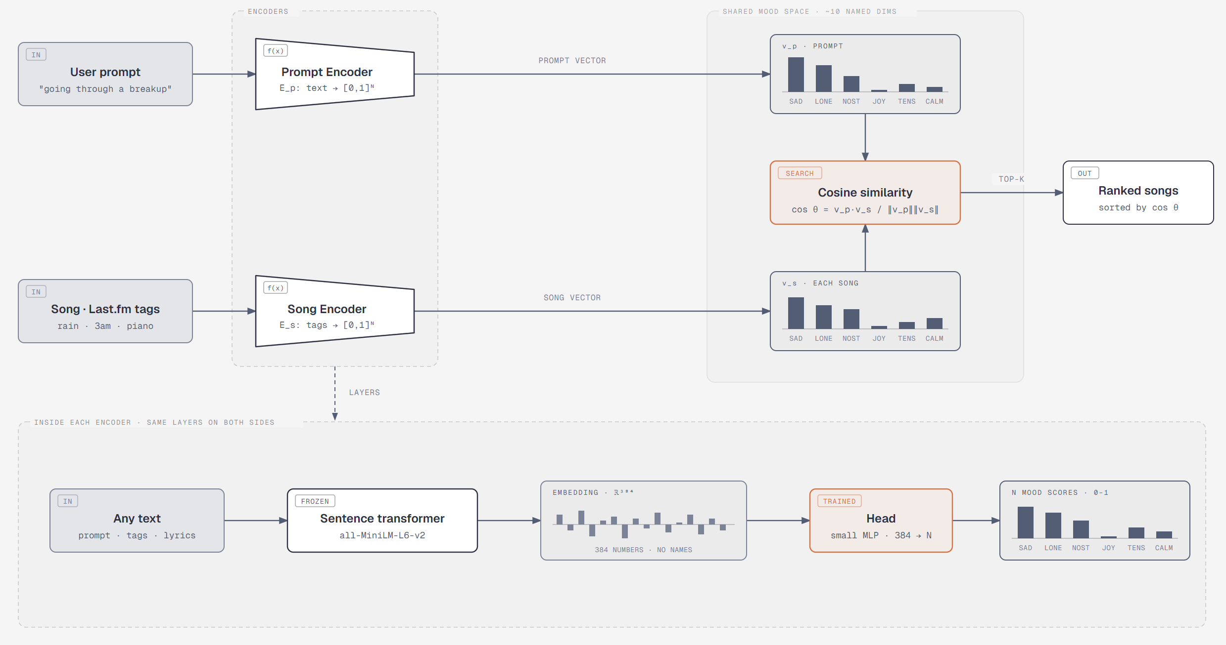
A dual-encoder system. Both the prompt and each song are turned into a vector of scores over the same named mood dimensions (e.g. sadness, nostalgia, tension, joy), then compared with cosine similarity.

- Both encoders are a pretrained sentence transformer + a small trained head that outputs N named mood scores.
- Prompt Encoder: trained on EmpatheticDialogues situations, with their 32 moods mapped onto our dimensions. GoEmotions is a second, larger source.
- Song Encoder: reads each song's Last.fm tags (fetched with track.getTopTags). It is trained on MuSe songs, labelled with the dimension of their MuSe seed mood word. The seed and its synonyms are removed from the input, so the model has to learn which other tags go with each mood ("rain, 3am, piano" → sadness) instead of copying the answer.
- Named dimensions: the two sides line up by design, so no prompt-song paired data is needed.
- Labels: MuSe seeds (song side) and EmpatheticDialogues emotions (prompt side), both chosen by people.

4.3 Key Research Question(s)
Note: Write 1-3 questions that your project should be able to answer by the end of the programme.
e.g., “Can publicly available data be used to quantify ...?”
4.4 Intended Users / Beneficiaries & Expected Value
Stakeholder / User | How they may use or benefit from the project
5. Machine Learning Techniques Required
Note: You do not need to be overly technical at this stage. If you are unsure of the exact model or algorithm, describe the type of analysis or capability you think may be needed (e.g., regression, classification, clustering, recommendation, NLP, computer vision, time-series forecasting, geospatial analysis).
- NLP: pretrained sentence-embedding transformers for prompts and song tags.
- Transfer learning: heads
- Multi-label classification: predicting N mood scores per input, trained from single positive labels ("this dimension is high").
- Retrieval: cosine similarity search over vectors, ranked results.
- Evaluation: precision@k, per-dimension accuracy, calibration between the two encoders, comparison with a valence × energy baseline, human check on PMEmo, small listening study.
- Optional: weak supervision with an LLM (Jev); clustering of tag embeddings for dimension discovery; audio CNNs on mel-spectrograms; contrastive learning (CLAP).

6. Research Done
Note: Share relevant links and give a short description of what each source is about and how it informs your project idea. Sources may include papers, articles, existing products, tutorials, API documentation, or similar projects.
No. | Link / Source | What the research is about | How it informs your project
1 | MuSe | 90,001 songs, one or more of 276 AllMusic mood words each. Spotify IDs for 68%. | Milestone 1: named dimensions  Milestone 2: Song catalogue and seed labels for the song model
2 | Last.fm API | Free-text user-given tags with weights for any song | Milestone 2: Full tags for MuSe and PMEmo songs: the song model's input
3 | EmpatheticDialogues | 24,850 first-person conversations about an emotion | Milestone 1: named dimensions  Milestone 3: Prompt Encoder training and testing
4
7. Datasets / Data Sources to be Used
Note: List the datasets, APIs, or data sources you expect to use. If a source is tentative, indicate that clearly. Consider whether the data is accessible, sufficiently complete, and appropriate for your intended use.
No. | Dataset / API / Source | Link / Access Method | Key Information Available | Planned Usage in Project
1
2
3
4
8. Initial EDA / Preliminary Exploration
Note: If you have already explored the data, share a notebook, repository, screenshots, or brief findings.
Notebook / Repository / Link | Key observations, feasibility checks, or early findings

9. Project Milestones
Note: Define 4 major milestones that take the project from initial validation to final completion. Each milestone should have clear tasks and a success criterion / deliverable so that the team and mentors can tell when it is complete.
Milestone | Main Goals / Tasks | Success Criteria / Key Deliverable | Target Completion
Milestone 1
Milestone 2
Milestone 3
Milestone 4
Suggested progression (adapt as needed): data collection / preprocessing → feature engineering / model development → validation / prototype → final refinement, deployment, and showcase.
10. Key Risks, Dependencies & Scope Considerations
Note: Identify anything that could materially affect delivery, such as API limits, data availability, compute requirements, external approvals, or an overly ambitious scope. Include a simple mitigation where possible.
Risk / Dependency | Potential Impact | Mitigation / Fallback

11. Project Plan
Note: Plan realistically and front-load important work where possible. Aim to have Milestone 2 completed by around Week 5 of Term 2. Earlier weeks should be more concrete; later weeks may remain broader if details are not yet known.
Week / Period | Main Goals / Planned Work | Milestone / Deliverable | Team Notes (availability, exams, etc.) | DAP / Mentor Notes
Proposal / Pre-programme
Winter - Week 1
Winter - Week 2
Winter - Week 3
Winter - Week 4
Sem 2 - Week 1
Sem 2 - Week 2
Sem 2 - Week 3
Sem 2 - Week 4
Sem 2 - Week 5
Sem 2 - Weeks 6
Sem 2 - Weeks 7
Hack Day | Mid-Term presentation
Sem 2 - Weeks 8
Sem 2 - Weeks 9
Sem 2 - Weeks 10
Sem 2 - Weeks 11
Final Showcase / Wrap-up | Final presentation

