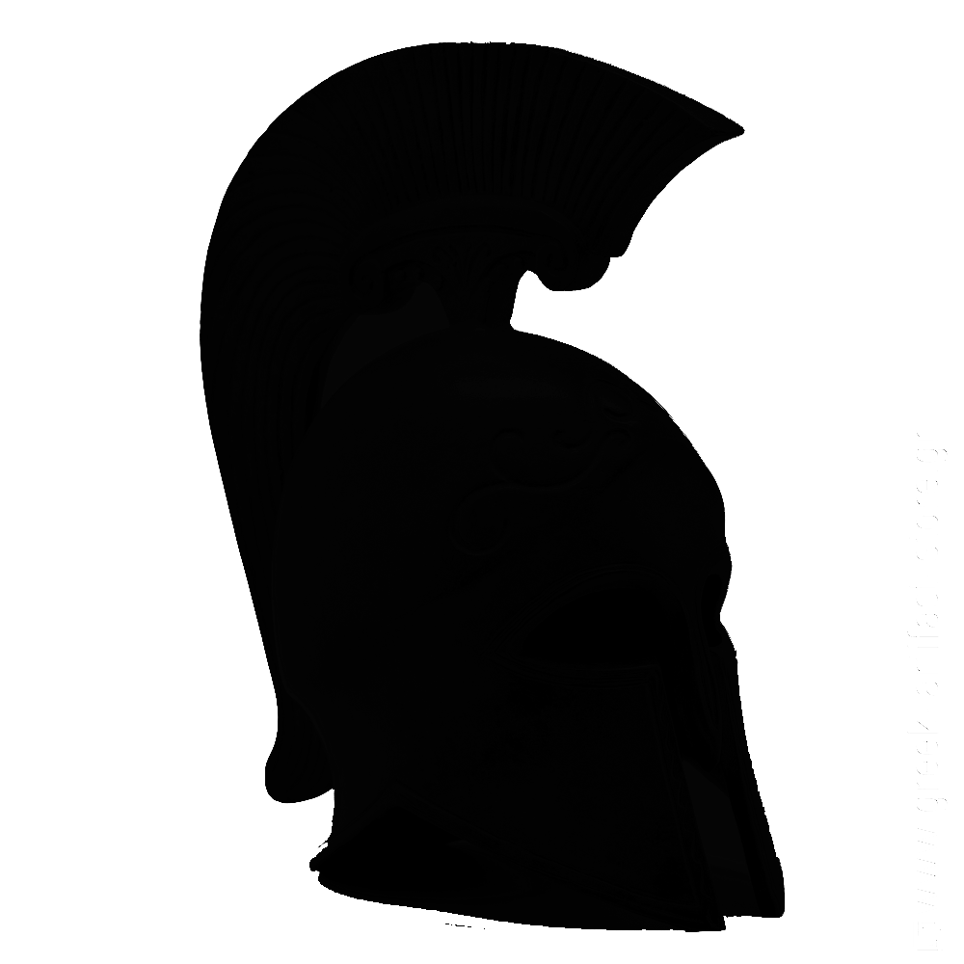

Deimos

For Windows, Macintosh, Linux and Xbox

Rating: Pegi 12+ ESRB T

Ship date: TBD

Story and Gameplay

**Game story:**

The hunter’s wife, child and entire village are murdered by rampaging monsters. It is up to the hunter to take bounties from the mysterious pandora and uncover the reason why the monsters are running wild through the world. The hunter must go to a variety of different environments to track down the commanders of the different monster types and collect proof of death. Along the way, the hunter collects clues as to the identity of the fabled dark lord. To defeat him will require mastery of 4 different weapons. Can the hunter uncover the mystery and avenge his family?

**Gameplay:**

In Deimos, the player takes control of the Hunter, a man who has lost everything and now must hunt monsters. The player must take advantage of the different weapons found throughout the world to correctly find the weak points of each monster. Goatmen are weak to everything, Harpies are weak to ranged attacks but are difficult to hit with any other weapon. Hydras are weak to spears which are able to find their fragile heart but being attacked anywhere else just causes the heads to regrow. Finally, Cyclopes have a thick hide which protects them from everything but the most savage hammer blows. The player must also complete tricky platforming sections in each level to first obtain the respective weapons. The game takes around 2-4 hours to complete but a knowledgeable player should be able to complete it even faster. Upgrades to running, jumping and climbing can be bought from pandora with the rewards from each hunt.

**Elevator pitch:**

Monster hunter meets Metroid

Game Flow

**Player growth:**

The hunter: The hunter starts with a sword and Greek styled armour. Throughout the game the hunter finds weapons which target a specific monster’s weakness. The player can buy upgrades for their weapons at Pandora as well as customize their cosmetic armor.

The player can also buy abilities from pandora such as a dash, double jump, climbing claws to make traversing levels easier and also to find secrets in each level. The secrets the player can find provide no player growth but will unlock extras in the menu, providing additional objectives throughout the levels.

Upgrades are bought with currency earned from completing monster hunts, the player can collect trophies from lesser monsters to receive gold or trophies from boss monsters to receive a large amount of gold.

Gold can also be found scattered around each level.

The game can be completed without upgrades for additional challenge.

Character and controls

The player is in control of the Hunter for the entire game. The player can walk left or right, jump, attack, guard, sprint, switch weapons and control the camera.

**Controls KB/M + Xbox Gamepad**

Move left/right: (A/D) (Left stick)

Jump: (Spacebar) (A button)

Attack: (X) (Right Bumper)

Guard: (Z) (Left Bumper)

Sprint: (Shift) (Left Trigger)

Switch weapon: (Q/E) (Directional pad left/right)

Camera: (Mouse) (Right stick)

Dialog controls: (LMB/RMB)(A/B)

Pause menu: (Esc) (Start)

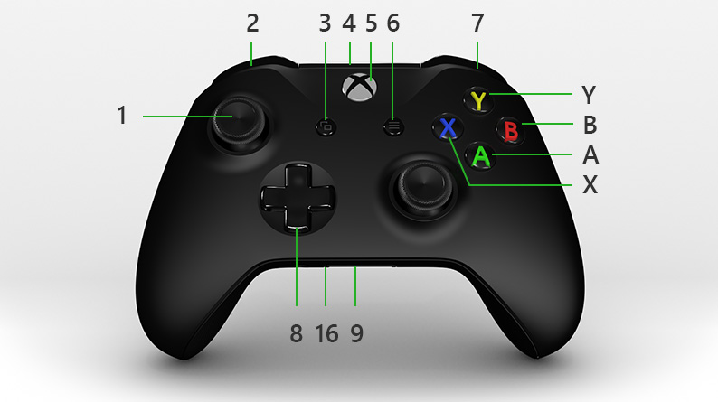

Gameplay and Features

**Gameplay:**

The gameplay of Deimos consists of platforming, attacking enemies, exploration and light puzzle solving. A large part of the gameplay is finding out how to exploit the enemy’s weakness and using the correct weapon for the job.

The game is broken up into 3 distinct worlds with self contained enemies to help the player learn their strategies and a final separate world which combines the enemies and platforming styles from each location into a more difficult version.

Pottery minigame: Throughout the game you find pottery shards which can be used in a pottery fixing minigame where you have to line up the shards like a jigsaw puzzle to repair the pottery.

**Features:**

On Xbox or with Xbox controller, the controller rumbles at certain points in the game such as during rock falls, earthquakes, volcanic eruptions, stumbles, etc.

With internet connection, you can see where other players have died ala the dark souls/bloodborne series. Which will help the player by warning them what not to do.

Game World

Deimos is set in a version of the Greek heroic age and thus the locations are inspired by locations around Greece.

**Locations**

Home: This is the hunter’s home and village. The background is picturesque and contains rolling wheat fields alongside olive groves. This area should evoke feelings of calm to contrast the other areas of the game. This area should also feel lonely as breezes roll over the empty fields. This area is also the main hub where the player can buy upgrades and cosmetics.

Mountains: This area is rocky and barren and parallels the Greek highlands of Arcadia. Arrows stick out of long dead piles of bones, scavenging birds fly away as the hunter passes. The silence is broken by raptorial birds screeching far above. Observant players can see the dark lord’s lair far in the background

Swamps: Swamp gas rises from stagnant pools, this area parallels the swamps around lake Lerna in which Heracles slew the Lernean hydra. Logs float in the murky water and serpents slither through the muck.

Volcano: The sky is darkened and stained red by ash billowing from the volcano. This area is parallels the island of Santorini. Statues to the god Hephaestus and broken pillars line the walls of the caldera. The hunter coughs and covers his face when the player idles here.

Dark lord’s lair: This area is a standard evil lair, carved into the side of a cliff there is a permanent storm surrounding it. Rain effects are present on the ground as the player approaches the entrance. Inside, braziers of blue fire illuminate evil carvings on the walls, chains hang down from the ceiling in the foreground, wails from prisoners can be heard.

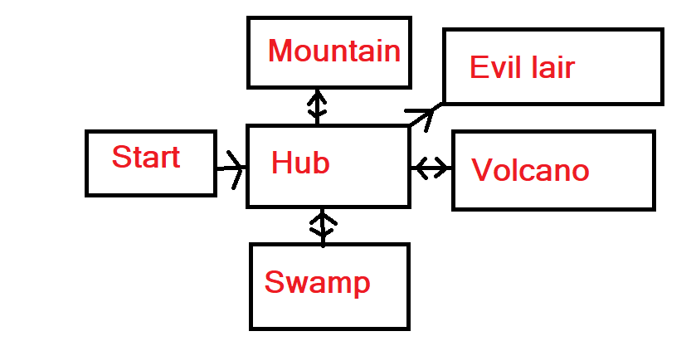

Interface

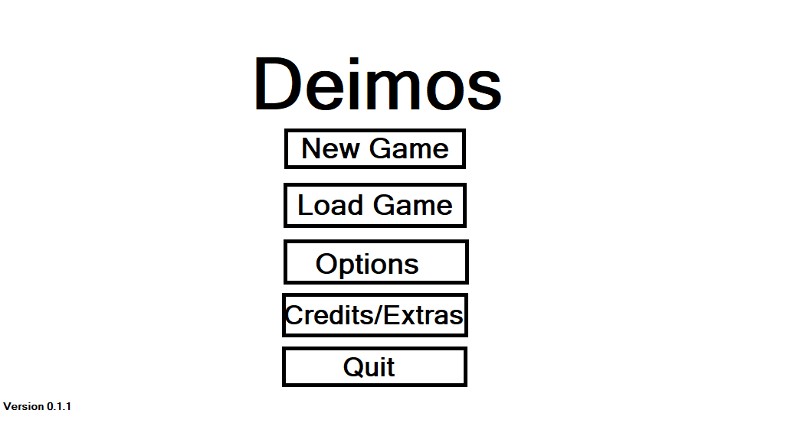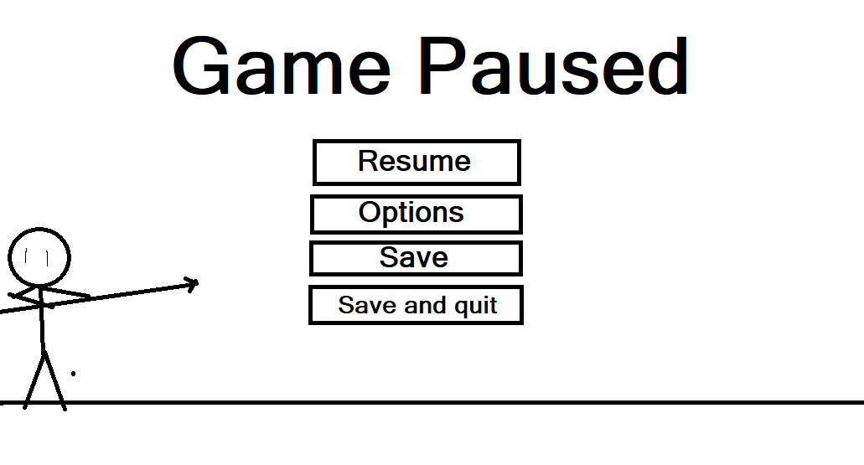

Mechanics and Powerups

**Mechanics:**

* Platforming
* Hacking and slashing
* Looting bodies
* Shop mechanics
* Pottery minigame

**Powerups:**

* Gold which is used to buy upgrades.
* Unique drops which can be traded for upgrades
* Healing potions
* Invulnerability potions
* Speed potions

Enemies and bosses

**Enemies:**

Goatman: this enemy has the legs and head of a goat with the torso of a man. The goatman will walk back and forth until he reaches an obstacle or the end of a platform. If the play comes within his range, he will start moving towards the player and attacking with a sword. His attacks can be blocked and he only takes a few hits to kill.

Harpy: The Harpy is a birdlike creature with the chest and face of a woman but the wings and legs of a hawk or eagle. This enemy will fly around and swoop down at the player, avoiding melee weapons. The harpy can be defeated with a sword but it is very difficult to hit, so the player is encouraged to use the bow, however the bow is slow to reload so the player should avoid fighting many harpies at once.

Hydra: The hydra appears as a serpent rising out of the water. The spear will track towards the hydra’s heart and kill it. Getting too close to the hydra can be dangerous so the spears reach should be used to the player’s advantage.

Cyclops: These are giant humanoids with a singular eye who work the forges around the volcano, forging weapons and armour for the dark lord’s armies. Their thick hide repels any attacks made by slashing or piercing weapons. The hammer stuns them long enough to get a killing blow,

**Bosses:**

The Siren: A giant harpy with additional abilities. Throughout the fight the siren will stay above the ground making melee impossible. The siren will swoop down occasionally to attack the player. The siren will also drop flammable pots which can be shot in mid-air to light the harpy on fire and force her to land.

The Lernaen Hydra: A massive beast with several heads that poke out of holes in the ground. The player will have to attack the heads in a specific order to reveal the creature’s heart. The hydra will spit acid projectiles at the player which must be jumped over or dodged.

Polyphemus: A giant cyclops which appears in the background of the screen and attacks by slamming fists onto the battlefield. The player must force his head to fall forward by skipping sections of column into his hands.

The Dark Lord: This boss combines the other bosses abilities and uses them in different ways.

Cutscenes and bonus materials

**Cutscenes:**

Deimos will have cutscenes using in game assets after each successful hunt. As well as 2 ending cutscenes animated in adobe animate. The in game cutscenes can be distinguished from normal gameplay by a vignetting effect as well as a border.

**Bonus material:**

Bonus materials will include a future expansion pack as downloadable content adding post game content to one of the endings in which you continue hunting down new monster types and receive new upgrades and weapons. As well as:

* Full soundtrack
* 10 wallpapers
* Xbox/Windows Avatars
* Timed speedrun mode
* Daily challenge maps
* New story snippets