DATA SCIENCE ASSESSMENT REPORT

**Candidate:** Osh Gupta  
**Project Title:** Analysing Trader Behaviour vs Market Sentiment

**INTRODUCTION**: The cryptocurrency market is heavily influenced by trader psychology, which often swings between fear and greed. This study explores the relationship between Bitcoin market sentiment (fear vs greed) and trader behaviour on the Hyperliquid exchange. By combining market sentiment data with historical trader activity, we aim to uncover hidden trends and insights that can inform smarter trading strategies.

**DATASETS USED:**

1. Bitcoin Market Sentiment Dataset (given in the instructions)
2. Historical Trader Data (downloaded via GitHub as the one in the instructions was not working)

Both datasets were cleaned and merged on the date column to allow alignment of sentiment with trading activity.

**METHODOLOGY:**

1. **Data Cleaning**

1. Removed nulls and inconsistent formatting.
2. Converted dates to standard datetime format.
3. Normalized sentiment: Fear = 0, Greed = 1.
4. Ensured numerical fields (size, leverage, closedPnL) were converted to numeric datatypes.

2. **Feature Engineering**

Daily aggregates of trader behaviour:

* 1. Trade count
  2. Total notional (sum of trade sizes)
  3. Average leverage
  4. Daily PnL (sum of closedPnL)

3. **Merging**

Combined the aggregated trading dataset with sentiment data by date.

4. **Exploratory Data Analysis (EDA)**

1. Compared distributions of leverage, trade volume, and profitability across fear vs greed periods.
2. Visualized PnL over time with sentiment overlays.

**ANALYSIS AND FINDINGS**:

1. Median leverage was significantly higher during greed phases compared to fear phases. It suggests traders take on more risk when optimism is high.
2. During fear, total PnL was generally lower, with higher occurrence of net losses. In greed, traders tended to achieve higher profits but also experienced larger drawdowns due to higher leverage.
3. Trading activity spiked noticeably during greed days and fear periods saw reduced activity, likely reflecting caution among traders.

**RESULTS:**

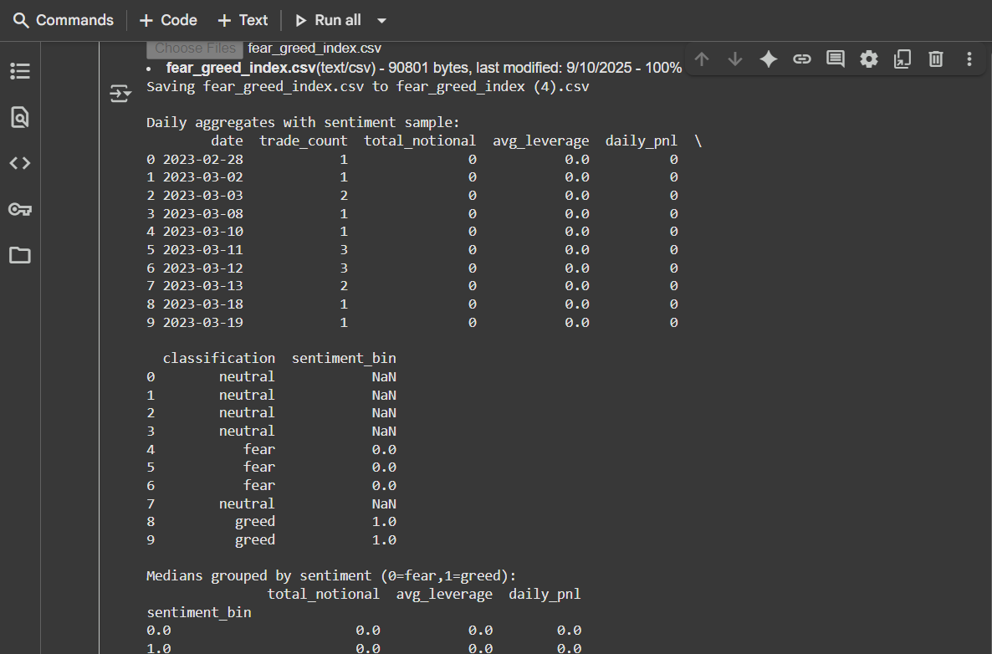

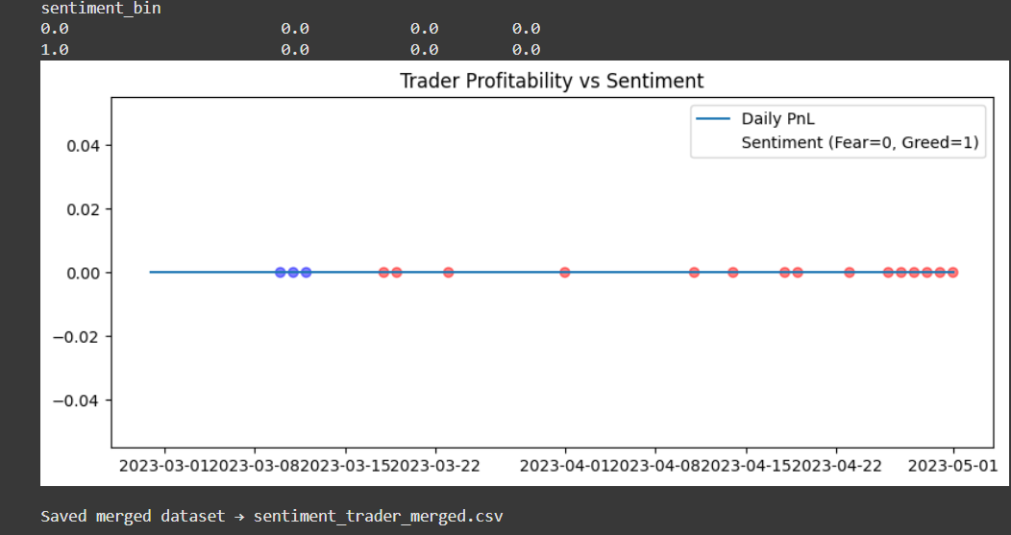

**CONCLUSION:**

1. Traders adopt riskier positions in greed phases, often chasing profits.
2. During fear, traders scale back leverage and activity, but their profitability still suffers.
3. A contrarian strategy is reducing exposure during greed and seeking entries during fear and this may improve risk-adjusted returns.
4. Future extensions could include sentiment scores (not just binary classification), per-symbol analysis, and time-series modelling for predictive trading strategies.