Thank you for choosing "wopShow" another WPfeed.com theme. Here are some stuff you need to adjust before using this theme. We tried to make things easy for you.

First thing

Under Appearance tab, choose "wopShow".
Make sure you have the two basic categories, first one should be called "video" and the second one should be called "blog". You can open new categories or open one and change the default "uncategorized" category.

Posting
Basic fact you should remember – when choosing "video" category for a post, you will have a video player box on the page, which means you need to embed video. When choosing a "blog" category, you will not see the video box.

When posting a video, choose the "video" category and not the "blog" one (the video player box will not be visible on "blog" posts).

Two custom fields are required:
Embed – paste the embed code you got from the video website you chose. Preferred video size is 660px X 370px.
Thumb – upload a thumbnail for the videos carousel container on the right side of the video player. The size should be 95px X 54px. Copy the file URL from the upload image panel. Paste it to the custom field.
hp_image - upload a thumbnail for the blog posts displayed on the homepage. The size should be 157px X 157px. Copy the file URL from the upload image panel. Paste it to the custom field.

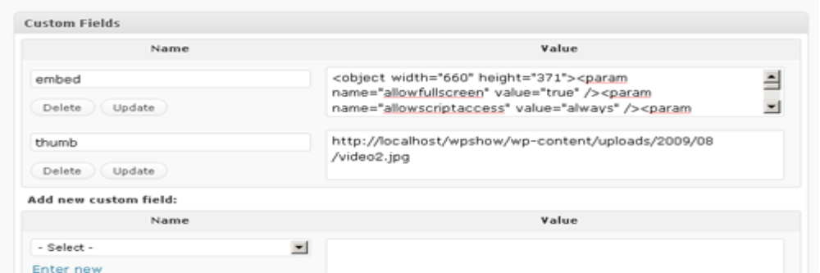

Regular posts should always be categorized as "blog", all the rest of the categories are also OK, but just don't choose the "Video" category this time.

Widgets
On the sidebar you can add widgets from the admin area. You can add as many widgets as you like. The first two widgets are built in, search and categories.

Sharing
Every video has share links near its description, you can share the video on facebook, twitter and Google buzz.

ENJOY!!!

