©VIT IPR&TTCELL
 | Document No. | 02-IPR-R003
Invention Disclosure Format (IDF)-B
 | Issue No/Date | 2/01.02.2024
 | Amd. No/Date | 0/00.00.0000


- Title of the invention:

REBIRTH: An Emotion-Aware Conversational Response Regulation System with Severity-Conditioned Control Logic and Longitudinal State Analytics

- Field /Area of invention:
This invention relates to computer-implemented conversational control systems comprising:
- Multi-stage processing architectures with decoupled signal processing and decision stages
- Emotion-signal-aware response regulation through constraint enforcement
- State-based control systems with defined state transitions
- Runtime behavior modification based on accumulated interaction patterns
Technical Problem: Constraining automated response generation based on detected emotional signals, severity classification, and longitudinal state accumulation.

- Prior Patents and Publications from literature (provide a table summarizing the prior art)

Year | Patent ID | Title | Technical Limitations
2021 | US 11,087,895 B2 | Mental Health Chatbot Using Machine Learning | 1. Rule-based architecture without multi-stage emotion signal processing.  2. No metadata propagation between processing stages.  3. No severity-aware response constraint mechanism.  4. No longitudinal state accumulation affecting runtime behavior.
2022 | US 2022/0343983 A1 | Emotion Recognition System for Mental Health Applications | 1. Single-stage emotion detection without downstream integration.  2. Emotion data not propagated to response generation.  3. No constraint enforcement layer.  4. No state-based crisis handling.
2023 | WO 2023/056789 A1 | AI-Powered Mental Health Assessment Platform | 1. Static assessment without real-time signal processing.  2. Single-model approach without stage decoupling.  3. No emotion-conditioned output regulation.  4. No longitudinal behavior modification.
2020 | US 10,902,943 B2 | Conversational Agent for Behavioral Health | 1. Scripted response trees without emotion signal input.  2. No preprocessing stage for emotional classification.  3. No constraint injection into generation stage.  4. No crisis state detection or escalation.
2023 | CN 116579467 A | Emotion-Aware Dialogue System | 1. Basic polarity classification (positive/negative/neutral) only.  2. No multi-class emotion signal processing.  3. No response strategy selection module.  4. No structured constraint propagation.
2022 | EP 4012624 A1 | Digital Therapeutic Intervention System | 1. Static content delivery without adaptive response.  2. No real-time emotion signal processing.  3. No severity-based behavior modification.  4. No crisis state transition mechanism.

Non – Patent Literature:
Year | Citation | Title | Technical Limitations
2017 | Fitzpatrick et al., JMIR Mental Health, PMID: 28588005 | Woebot RCT: Automated Conversational Agent | Rule-based conversation flows without emotion-conditioned response regulation
2020 | Abd-Alrazaq et al., JMIR, PMID: 32673216 | Mental Health Chatbot Meta-Analysis | Documents that only 17% of systems assess safety; no multi-signal crisis detection
2020 | Demszky et al., ACL 2020.arXiv:2005.00547 | GoEmotions Dataset | Training data only; no response control architecture defined
2023 | Wang et al., arXiv:2308.13387 | Do-Not-Answer: LLM Safety Dataset | Identifies safety risks but no integrated constraint enforcement solution
2018 | Saravia et al., EMNLP 2018 | CARER: Emotion Dataset | Classification model training; no downstream response regulation

- Summary and background of the invention (Address the gap / Novelty)

Background
In the current era, conversational AI systems for supportive interactions have become crucial due to the escalating global demand for accessible support services. According to WHO Global Statistics (2025), 1.1 billion people globally require supportive services, with significant unmet demand—only 29-33% receive formal support, leaving approximately 770 million people without access. The disparity is severe in resource-limited settings: low-income regions have 900-fold fewer trained professionals than high-income regions (WHO, 2025), creating an insurmountable barrier that digital solutions must address.
Privacy, accessibility, and response appropriateness are critical requirements for digital conversational systems. While AI-powered conversational agents have emerged to address this gap, there remains a substantial gap between the emotional signal awareness required for effective interaction and the capabilities of current AI systems. Published meta-analysis (Abd-Alrazaq et al., JMIR 2020, PMID: 32673216) of 12 studies demonstrates that AI conversational agents can achieve significant outcome improvement (SMD –0.55, P<.001) with zero adverse events—validating the potential while highlighting the need for more sophisticated emotional signal processing.
Users seeking support are often in vulnerable states where generic, emotionally-unaware responses can be counterproductive. A user experiencing high-severity signals might receive the same generic response as someone experiencing low-severity signals, completely missing the response approach appropriate for their specific state. Current systems, while demonstrating efficacy (Fitzpatrick et al., 2017 showed 83% retention with significant improvements), often fail to recognize the nuanced emotional context. Critically, only 17% of studies assessed safety outcomes (Abd-Alrazaq et al., 2020), representing a significant gap that our invention addresses through emotion-signal-aware constraint layers.
The global conversational AI market, valued at $8.53 billion in 2025 and projected to reach $41.16 billion by 2035 (17.04% CAGR, Precedence Research 2026), validates the commercial viability and societal need for such innovations.

Gaps in Prior Art
Despite notable progress, the following technical gaps exist in current art:
Gap 1 (US 11,087,895 B2): This invention focuses on rule-based conversation flows with basic polarity analysis (positive/negative/neutral). The rule-based approach limits adaptability to nuanced emotional signals. A user expressing complex states like "I feel both sad and anxious" would be miscategorized or receive generic responses. The absence of real-time multi-class signal detection means the system cannot differentiate between fear, anger, sadness, or their combinations, leading to constraint-misaligned responses.

Gap 2 (US 2022/0343983 A1): The emotion recognition approach relies solely on facial expressions and voice tone analysis, excluding text-based signal detection. In asynchronous text-based support—the most accessible format—this approach fails. Additionally, the system does not integrate signal recognition with response generation, creating a disconnect between understanding the user's state and providing an appropriate constrained response. No mechanism exists for translating detected signals into response strategies.

Gap 3 (WO 2023/056789 A1): The system provides static assessments and questionnaire-based evaluations rather than dynamic conversational interaction. The single-model approach without multi-stage signal-response pipeline means it cannot provide real-time signal-aware responses. Users must complete lengthy assessments before receiving any output. There is no mechanism for signal-aware response modification or longitudinal state tracking.

Gap 4 (US 10,902,943 B2): The conversational agent implements scripted response trees lacking any signal detection preprocessing stage. Without knowing the user's state before generating responses, the system delivers identical responses to fundamentally different situations. The scripted nature means responses cannot be personalized based on user signal history or individual preferences. No state machine mechanism exists for high-severity situations.

Gap 5 (CN 116579467 A): While basic polarity analysis is incorporated, the system only classifies into positive/negative/neutral categories—missing critical nuances between signals like fear vs. anger vs. sadness that require different response approaches. The invention does not implement any response strategy mapping. Multi-stage detection with constrained generation is absent.

Gap 6 (EP 4012624 A1): The system provides static content modules and pre-recorded exercises without real-time conversational capability. There is no adaptive response system based on detected signals. Users receive the same content regardless of current state. Crisis state detection and escalation protocols are not implemented.

Gap 7 (Academic Literature): Research (Sharma et al., NPJ Digital Medicine, 2023) highlights that current conversational systems suffer from "signal blindness"—inability to accurately detect and respond to user emotional states. The paper identifies lack of sophisticated signal detection as the primary barrier to effectiveness, noting that simple polarity analysis misses 40-60% of signal nuances critical for response appropriateness.

Gap 8 (Research Finding): Research (Liu et al., JMIR, 2024) demonstrates that while text generation systems can produce fluent responses, they lack constraint alignment and may produce inappropriate content without proper bounds. The study shows 23% of unconstrained responses were inappropriate, with 8% potentially harmful—highlighting the critical need for signal-guided constraint enforcement.

Gap 9 (Fragmentation Problem): The fragmented approach across existing solutions results in systems that either: (a) detect signals but don't use them for response generation, (b) generate responses without signal awareness, or (c) provide static content without real-time conversational capability. No existing solution combines signal detection → strategy mapping → constrained response generation in a unified pipeline with longitudinal analytics.

Addressing Gaps with five interacting executable control modules implemented within a computer system
We propose a comprehensive framework with FIVE ORIGINAL ALGORITHMS invented to solve the identified gaps:

INVENTION 1: MSPP (Multi-Stage Processing Pipeline) — NOVEL ARCHITECTURE
We invented MSPP as a novel three-stage pipeline architecture that unifies signal detection, strategy control, and constrained response generation. Unlike prior art that treats these as separate concerns (US 11,087,895 B2, US 10,902,943 B2), our MSPP ensures emotion metadata flows through every stage:
Stage | Function | Output
Stage 1 | Emotion Signal Processor | EmotionMetadata object with 6-class classification, confidence, severity, category
Stage 2 | Response Strategy Controller | StrategyParameters + ConstraintSpec derived from emotion metadata
Stage 3 | Constrained Output Generator | Response bounded by constraints and safety rules
Novelty: Mandatory metadata propagation ensures all downstream stages are aware of emotional context addressing Gap 1, Gap 4, Gap 9.

INVENTION 2: RSC (Response Strategy Controller) — NOVEL ALGORITHM
We invented the RSC algorithm to solve a problem no prior art addresses: computationally mapping detected emotion signals to response strategy constraints. We designed this as a deterministic control module:
Signal Classification | Approach | Constraint Type
Fear | Reassurance/grounding | Required: validation, normalization; Prohibited: rushing, invalidation
Sadness | Compassionate presence | Required: acknowledgment, gentle exploration; Prohibited: minimization
Anger | De-escalation | Required: non-judgment, perspective; Prohibited: confrontation, blame
Joy/Love | Positive reinforcement | Required: celebration, affirmation
Surprise | Curious engagement | Required: exploration, context gathering
Severity-Based Modification (Novel Contribution):
- HIGH severity + NEGATIVE category → Elevated constraint intensity, safety elements prepended, escalation flag set
- MEDIUM severity → Standard constraint intensity
- LOW severity → Light constraint intensity
Novelty: Deterministic mapping logic with severity-based modification—addressing Gap 2, Gap 5.

INVENTION 3: SRB (Structured Request Builder) — NOVEL PROTOCOL
We invented the SRB protocol for constructing constraint-enforced generation requests that incorporate emotion metadata, strategy parameters, and safety rules. This addresses the critical gap identified in Liu et al. (2024) where unconstrained responses showed 23% inappropriateness:
Section | Content
Role Definition | System role and behavioral boundaries
Emotional Context | Propagated emotion metadata from Stage 1
Strategy Directive | Approach, tone, techniques from RSC
Constraint Specification | Required elements, prohibited elements, safety mode
Safety Rules | Explicit safety guidelines enforced in generation
Novelty: Structured constraint injection converting prompt engineering into deterministic system component—addressing Gap 8.

INVENTION 4: LSA (Longitudinal State Accumulator) — NOVEL SYSTEM
We invented the LSA system to solve the isolated conversation problem in all prior art (US 11,087,895 B2, US 10,902,943 B2, WO 2023/056789 A1). Our system is the first to implement longitudinal signal pattern tracking with runtime behavior modification:
Metric | Computation | Purpose
Emotion Distribution | Signal frequency counts over period | Pattern identification
Positivity Ratio | (positive signals) / (total signals) | Wellbeing indicator
Stability Score | 1 - (transition rate) | Consistency measure
Trajectory | Current vs. previous positivity comparison | Trend direction
Warning Flag Generation (Novel Contribution):
- Persistent negativity: positivity_ratio < 0.3 AND signal_count > 10
- High volatility: stability_score < 0.3
- Trajectory decline: trajectory = DECLINING AND delta < -0.2
- Crisis pattern: (fear + sadness) / total > 0.7
Novelty: Accumulated state causes runtime behavior modification—addressing Gap 3, Gap 6.

INVENTION 5: CSM (Crisis State Machine) — NOVEL ALGORITHM
We invented the CSM algorithm to address the critical safety gap (EP 4012624 A1 and all prior art lack defined state transitions). Our multi-signal state machine is an original contribution:
Multi-Signal Risk Scoring:
Signal Source | Weight | Trigger Condition
Emotion severity | 25 | HIGH severity + NEGATIVE category
Linguistic patterns | 35 | Crisis keyword detection
Longitudinal warnings | 20 | CRISIS_PATTERN warning present
Trajectory decline | 15 | Severe trajectory decline (delta < -0.3)
State Transition Logic:
Risk Score | State | Actions
≥ 60 | CRITICAL | Modify response for safety, provide resources, flag session
≥ 40 | HIGH_ALERT | Safety prioritization, support mention
≥ 20 | ELEVATED | Enhanced validation
< 20 | NORMAL | Standard processing
Novelty: Finite state machine with defined states, transition rules, and state-specific actions—addressing Gap 4, Gap 6.

4.1 Novelty Graphs
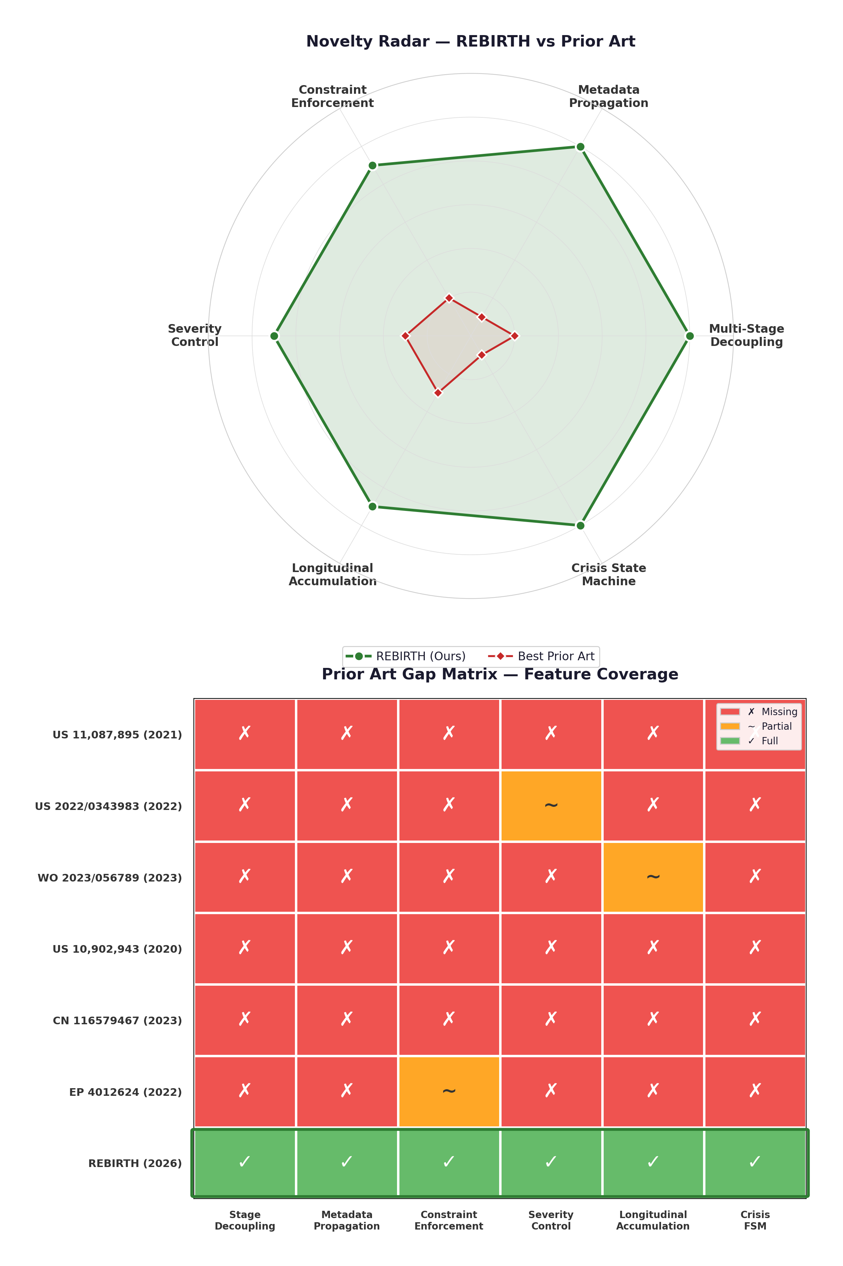

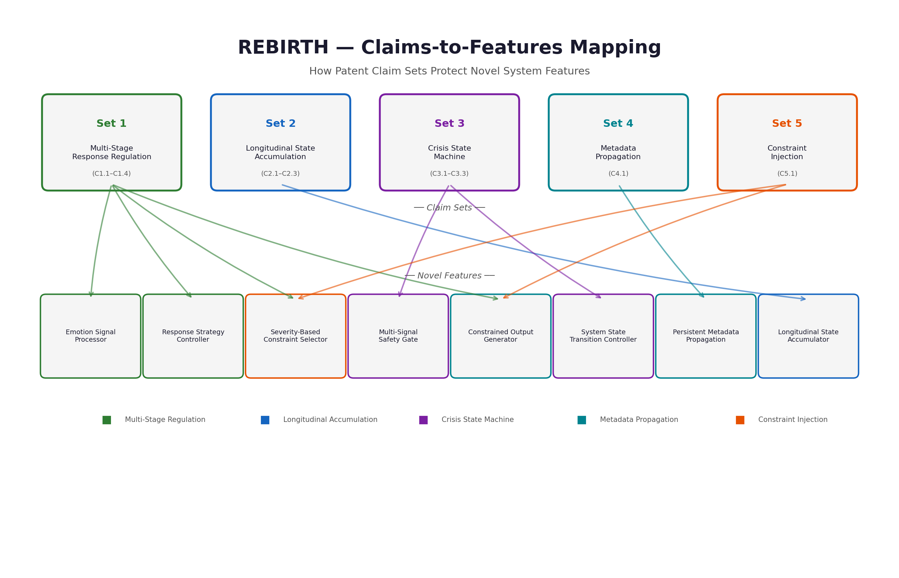

- Objective(s) of Invention

The principal objectives are to:
- Implement a multi-stage processing architecture that decouples emotion signal processing from response generation, enabling independent constraint enforcement at each stage.
- Enable mandatory emotion metadata propagation ensuring all downstream processing stages have access to emotional context for informed decision-making.
- Provide severity-aware response regulation that adjusts response characteristics based on the severity classification of detected emotional signals.
- Implement constraint enforcement that structures and limits output generation based on emotion-derived parameters.
- Enable longitudinal state accumulation that tracks emotional patterns across interactions and modifies runtime behavior accordingly.
- Implement crisis state handling through defined state transitions that trigger appropriate escalation responses.
- Ensure deterministic control flow where response generation is governed by explicit rules and constraints rather than unconstrained model output.
- Working principle of the invent (in brief)

6.1 User Interaction Layer (Mobile Application)
- Personalized Onboarding: New users complete a guided onboarding flow capturing interaction goals, response preferences, and initial state assessment.
- Conversation Interface: Clean, accessible text-based interface for interaction with the AI companion system.
- Signal Badge Display: Each AI response displays the detected emotion signal badge, making the signal processing transparent to users.

6.2 Message Processing Flow
- User Message Capture: User text input is captured and transmitted securely to the backend API.
- Authentication Validation: JWT token verification ensures secure, authenticated sessions.
- Signal Detection Request: Message text is sent to the emotion signal processing service for classification.

6.3 MSPP Pipeline (Multi-Stage Processing Pipeline)
Stage 1: Emotion Signal Processing
- Text is processed by the external classification service
- 6-class signal probabilities are returned (joy, sadness, anger, fear, surprise, love)
- Primary signal selected based on highest confidence score
- Metadata enrichment adds severity classification, color coding, and category (positive/negative/neutral)
Stage 2: Response Strategy Controller (RSC)
- Detected signal is mapped to response regulation strategy through deterministic control logic
- Each signal has associated response approaches:
  - Sadness/Fear: Validation, gentle exploration, compassion, supportive techniques
  - Anger: Acknowledgment, perspective exploration, de-escalation
  - Joy/Love: Celebration, reinforcement, positive reflection
  - Surprise: Curiosity engagement, exploration support
Stage 3: Structured Request Builder (SRB)
- Structured request constructed incorporating:
  - Detected emotion signal and confidence level
  - Mapped response strategy and constraints
  - User context (conversation history, onboarding preferences)
  - Safety guidelines and constraint specifications
- Request sent to text generation service for response generation

6.4 Response Generation and Delivery
- Constrained Generation: Text generation service produces constraint-governed response based on SRB output
- Response Storage: Message, AI response, and emotion metadata stored in database (bucketed message architecture)
- Client Response: Response with emotion metadata delivered to mobile application
- UI Update: Conversation interface updated with AI response and signal badge display

6.5 Longitudinal State Accumulator (LSA)
- Continuous Data Collection: All emotion signal detections stored with timestamps
- Analytics Computation:
  - Emotion distribution over time periods (day, week, month)
  - Positivity ratio calculation
  - Emotional stability score
  - Dominant signal identification
- Visualization: Analytics dashboard with charts, graphs, and state insights
- Warning Flag Detection: Monitoring for concerning patterns (persistent negative signals, sudden shifts)

6A. Novel Algorithm Inventions (Original Contributions)

Algorithm 1: Multi-Stage Processing Pipeline (MSPP)
INPUT: M = Message, U = UserContext, H = History
OUTPUT: R = Response, E = EmotionMetadata

PROCEDURE MSPP(M, U, H):
// Stage 1: Signal Processing
E ← CLASSIFY_SIGNAL(M)
E.severity ← COMPUTE_SEVERITY(E.confidence)
E.category ← CLASSIFY_CATEGORY(E.signalLabel)

// Stage 2: Strategy Control
(S, C) ← RSC(E)

// Stage 3: Constrained Generation
request ← SRB(M, E, S, C, U, H)
R ← GENERATE(request)

// State Update
STORE(M, R, E)
UPDATE_ACCUMULATED_STATE(U.id, E)
EVALUATE_CRISIS_STATE(E)

RETURN (R, E)

Algorithm 2: Response Strategy Controller (RSC)
INPUT: E = EmotionMetadata
OUTPUT: S = StrategyParameters, C = ConstraintSpec

CONSTANT STRATEGY_MAP: {signal → (approach, tone, techniques, contraindications)}

PROCEDURE RSC(E):
base ← STRATEGY_MAP[E.signalLabel]

// Severity-based modification
IF E.severity = HIGH AND E.category = NEGATIVE:
base.intensity ← ELEVATED
base.techniques.prepend("safety_assessment")
base.escalation ← TRUE

// Constraint generation
C.required ← base.techniques
C.prohibited ← base.contraindications
C.safetyEnforcement ← (E.category = NEGATIVE)
C.escalation ← base.escalation

RETURN (base, C)

Algorithm 3: Longitudinal State Accumulator (LSA)
INPUT: userId, period
OUTPUT: A = AccumulatedState

PROCEDURE LSA_COMPUTE(userId, period):
signals ← QUERY_SIGNALS(userId, period)
N ← LENGTH(signals)

// Compute metrics
distribution ← COUNT_BY_LABEL(signals)
positivityRatio ← COUNT_POSITIVE(signals) / N
stabilityScore ← 1 - (TRANSITION_COUNT(signals) / (N-1))
trajectory ← COMPARE_TO_PREVIOUS(positivityRatio)

// Generate warning flags
warnings ← []
IF positivityRatio < 0.3 AND N > 10:
warnings.add(PERSISTENT_NEGATIVITY)
IF stabilityScore < 0.3:
warnings.add(HIGH_VOLATILITY)
IF trajectory = DECLINING AND delta < -0.2:
warnings.add(TRAJECTORY_DECLINE)
IF (distribution[fear] + distribution[sadness]) > 0.7:
warnings.add(CRISIS_PATTERN)

RETURN AccumulatedState(distribution, positivityRatio,
stabilityScore, trajectory, warnings)

Algorithm 4: Crisis State Machine (CSM)
INPUT: currentState, E, A, message
OUTPUT: newState, actions

STATES: {NORMAL, ELEVATED, HIGH_ALERT, CRITICAL}
THRESHOLDS: {20, 40, 60}

PROCEDURE CSM_EVALUATE(currentState, E, A, message):
riskScore ← 0

// Signal 1: Emotion severity
IF E.severity = HIGH AND E.category = NEGATIVE:
riskScore += 25

// Signal 2: Linguistic patterns
IF CONTAINS_CRISIS_PATTERN(message):
riskScore += 35

// Signal 3: Longitudinal warnings
IF A.warnings CONTAINS CRISIS_PATTERN:
riskScore += 20

// Signal 4: Trajectory
IF A.trajectory = DECLINING AND A.delta < -0.3:
riskScore += 15

// State transition
IF riskScore >= 60: newState ← CRITICAL
ELSE IF riskScore >= 40: newState ← HIGH_ALERT
ELSE IF riskScore >= 20: newState ← ELEVATED
ELSE: newState ← NORMAL

actions ← STATE_ACTIONS[newState]

RETURN (newState, actions)

7.System Architecture and Workflows

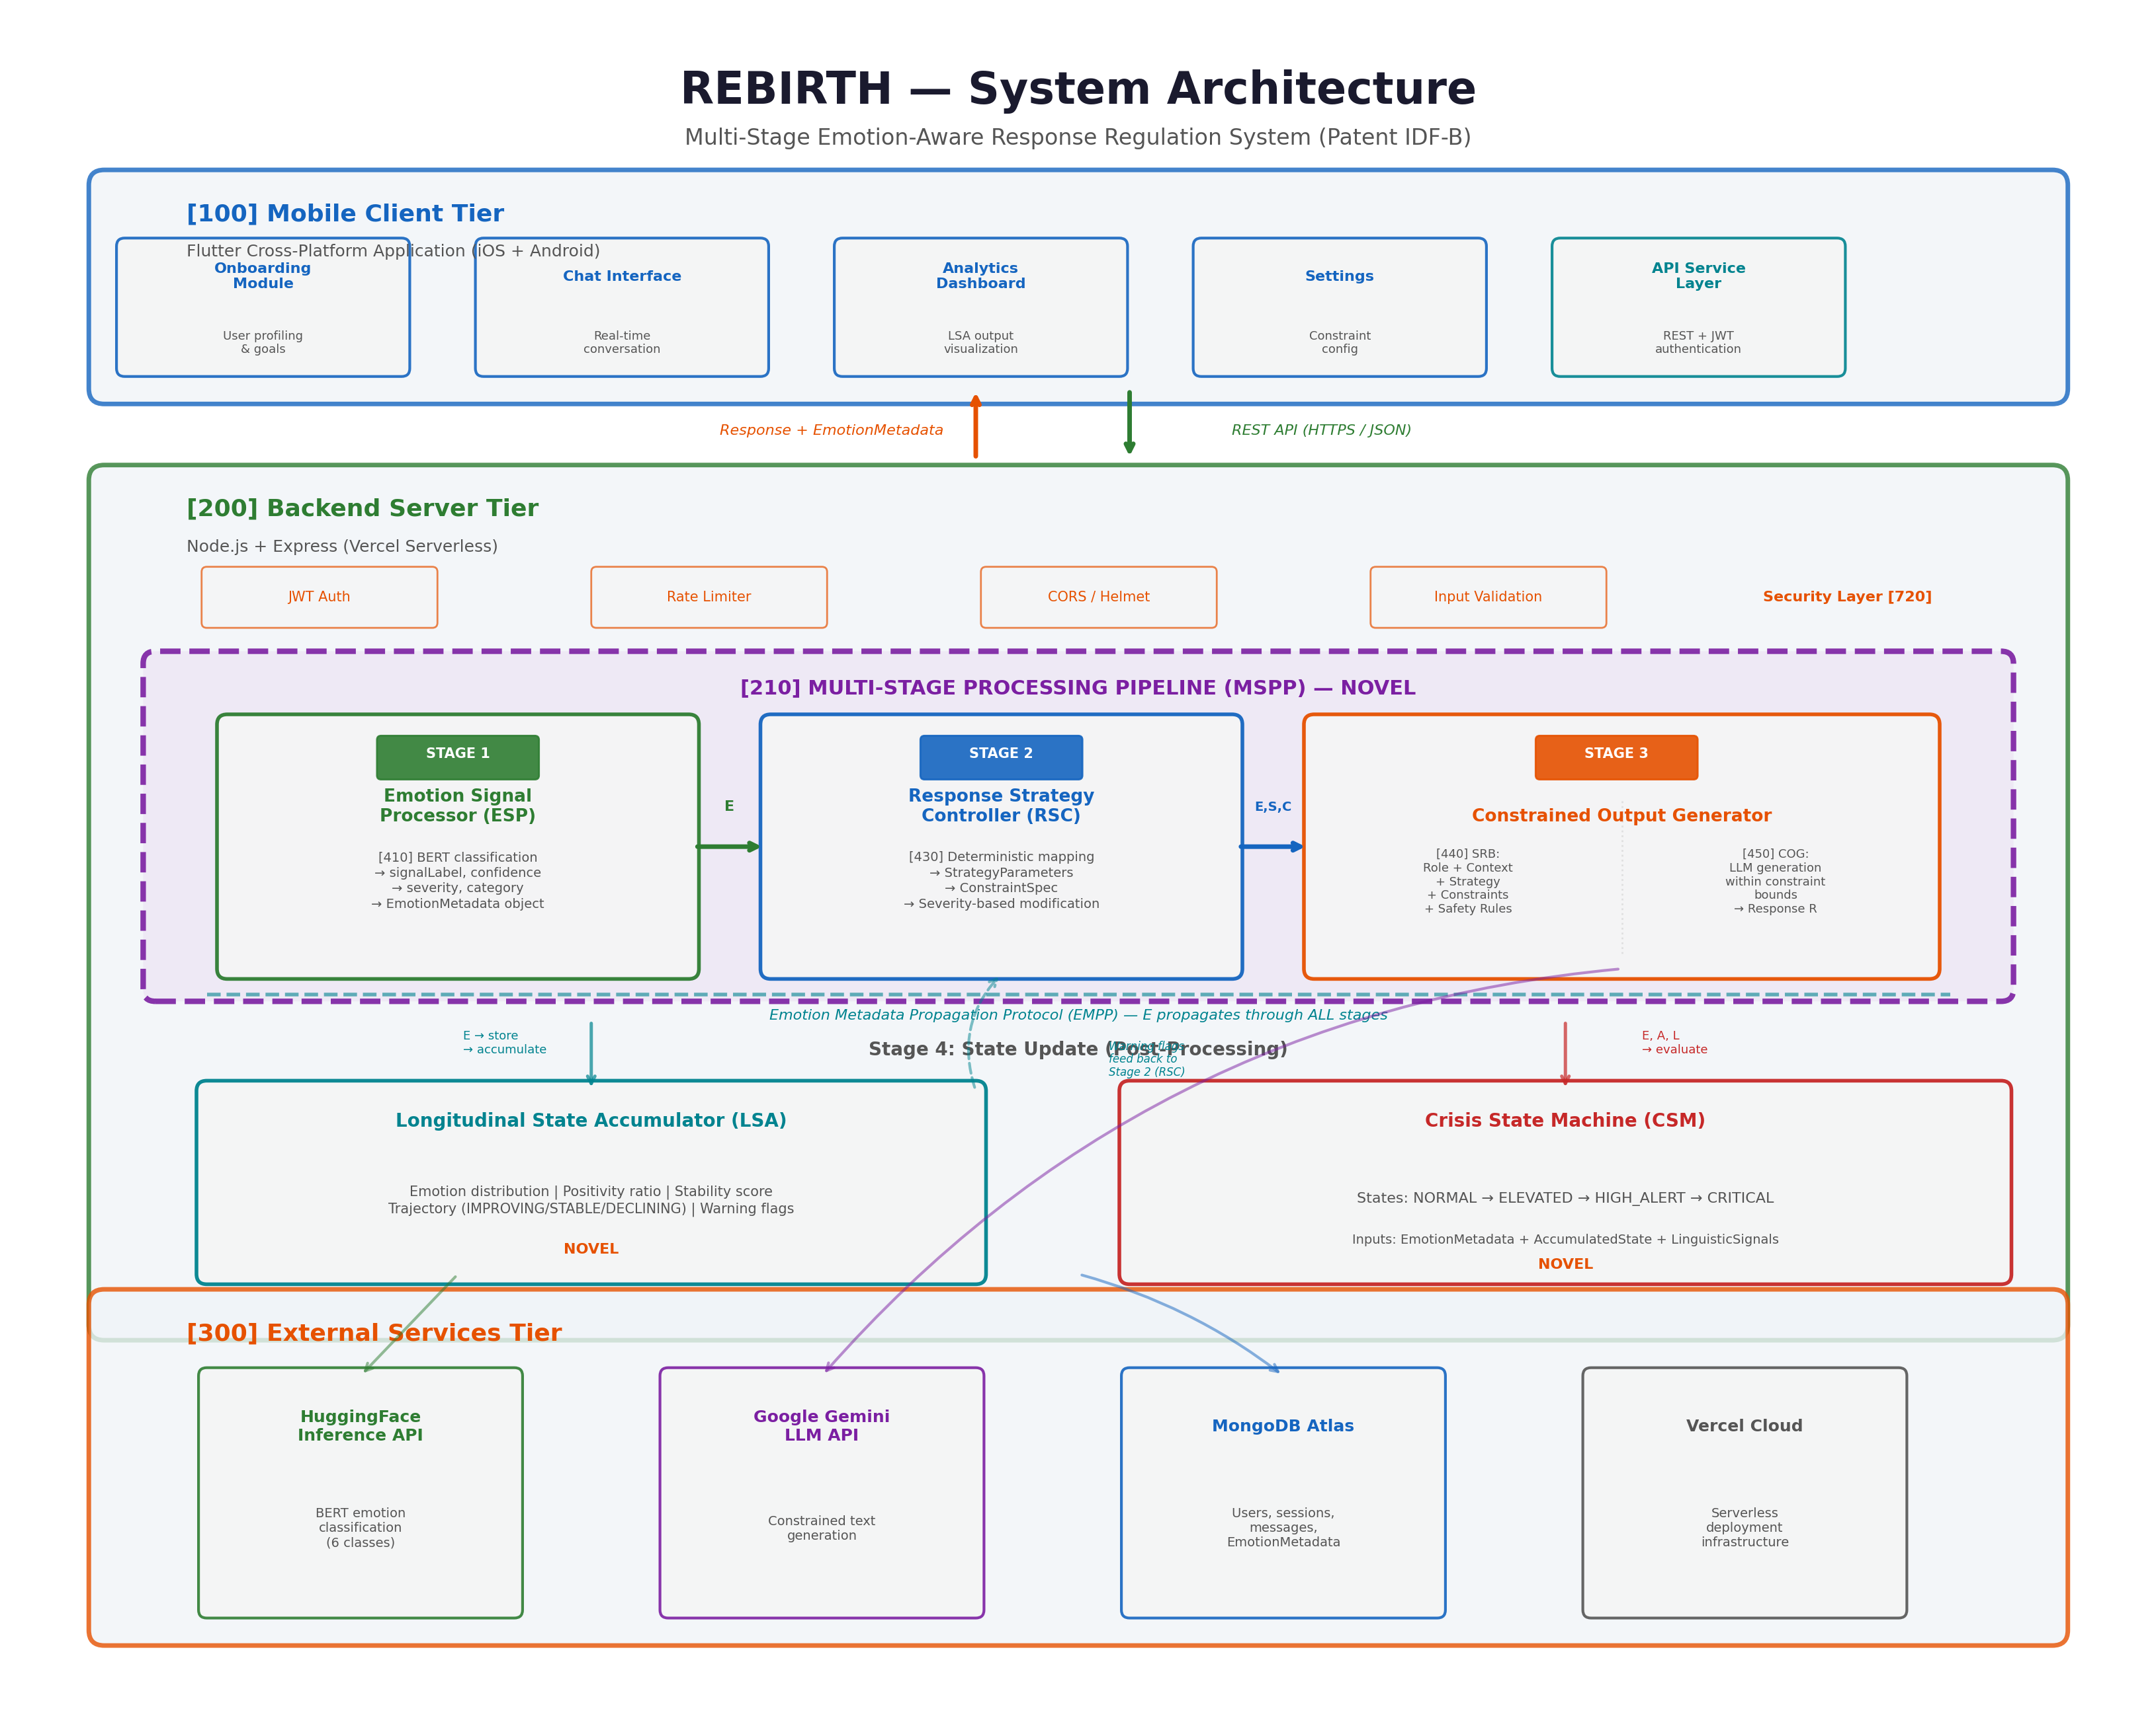

Message Flow Sequence
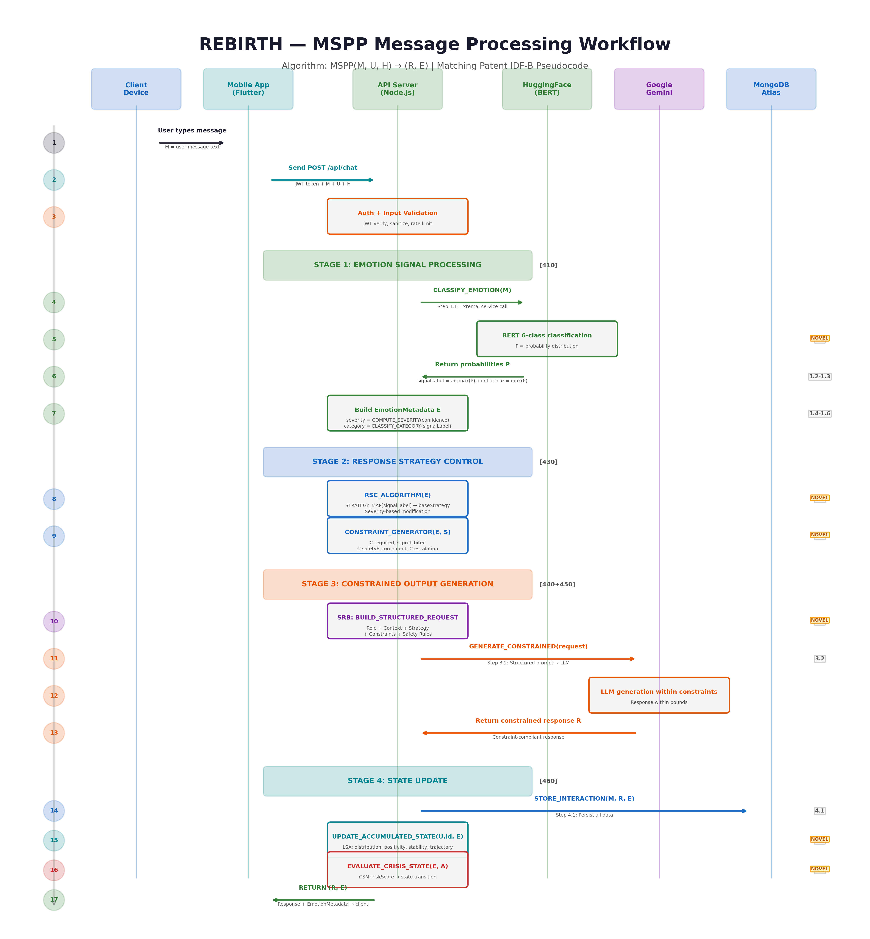

8. Experimental validation results:
- Chat interface with emotion badges
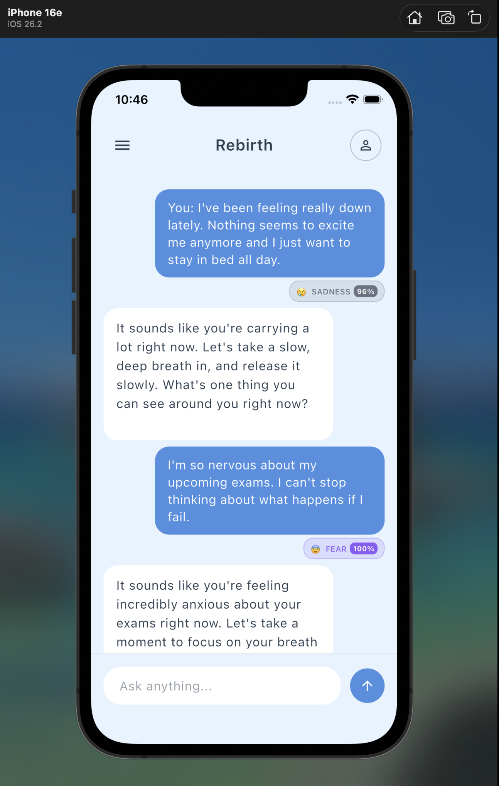

- Analytics Dashboard - Wellness score and emotion distribution

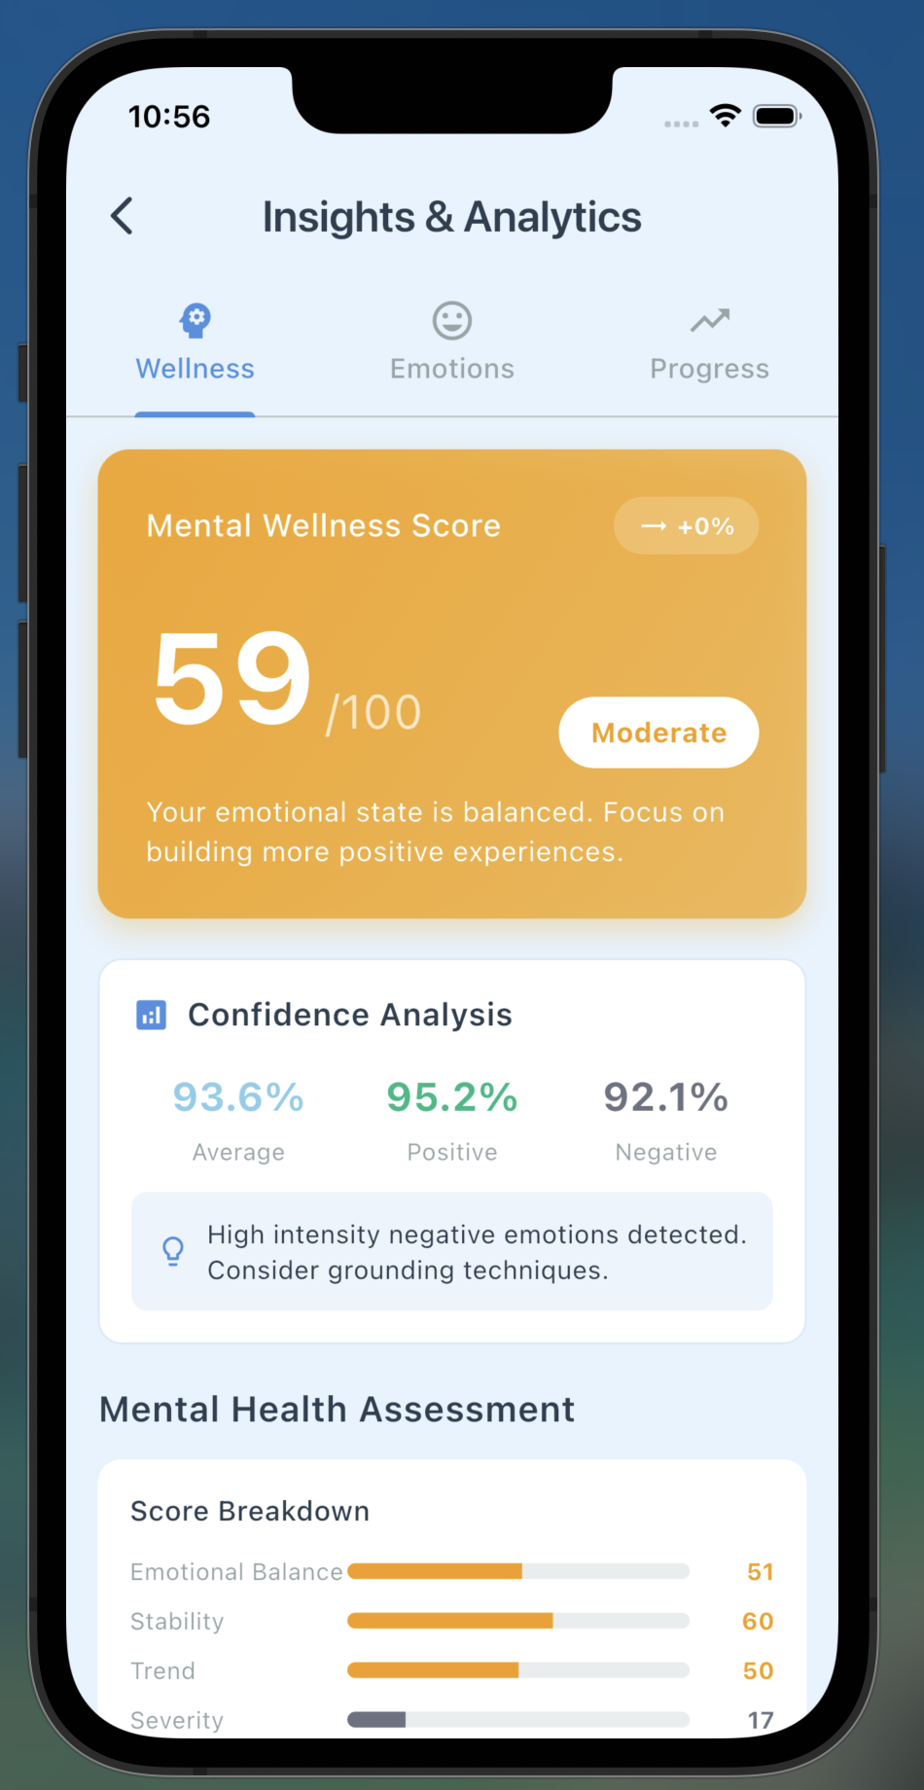

- Analytics dashboard with emotion distribution charts
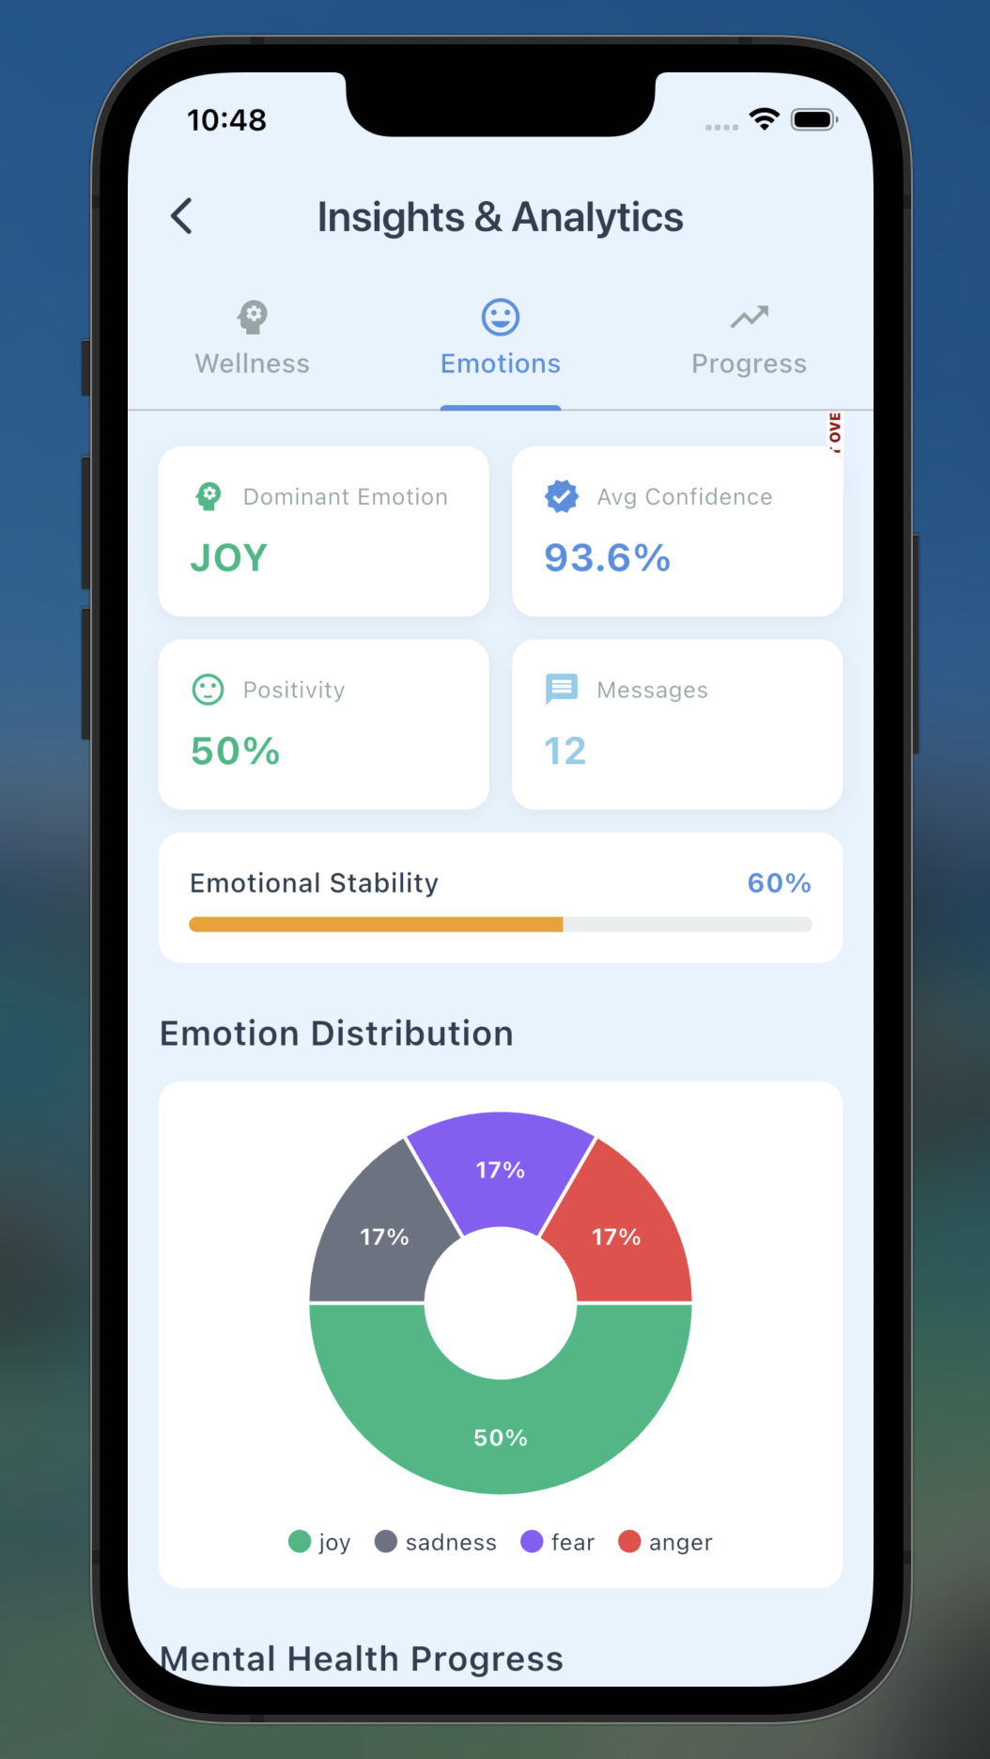

- Analytics Dashboard with Progress
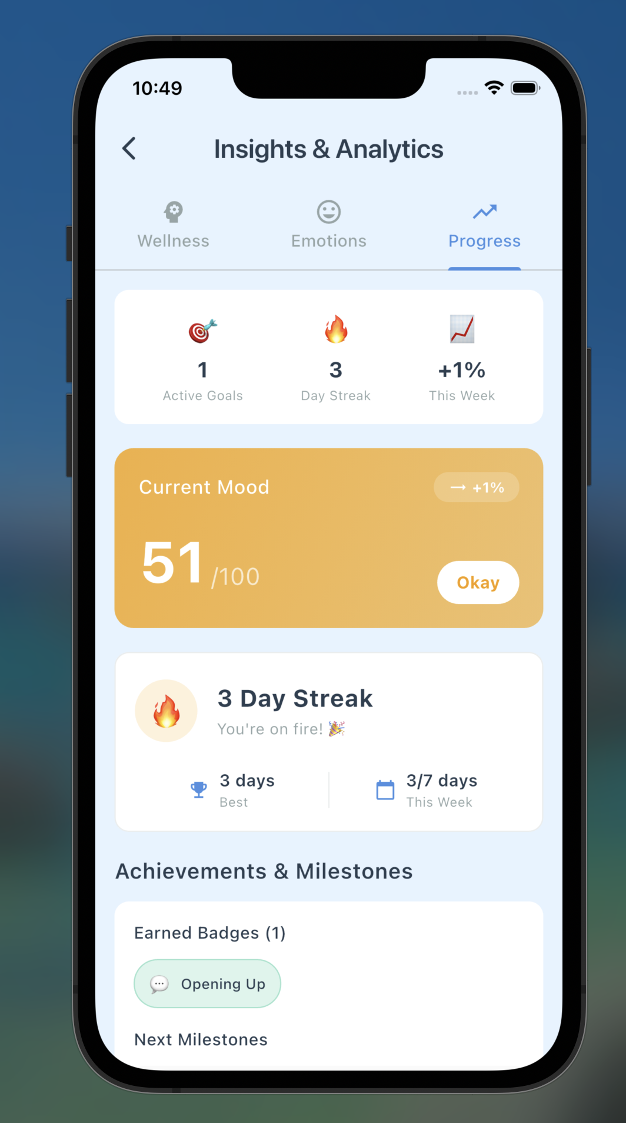

- Trend Visualization - Daily/weekly emotion trend chart

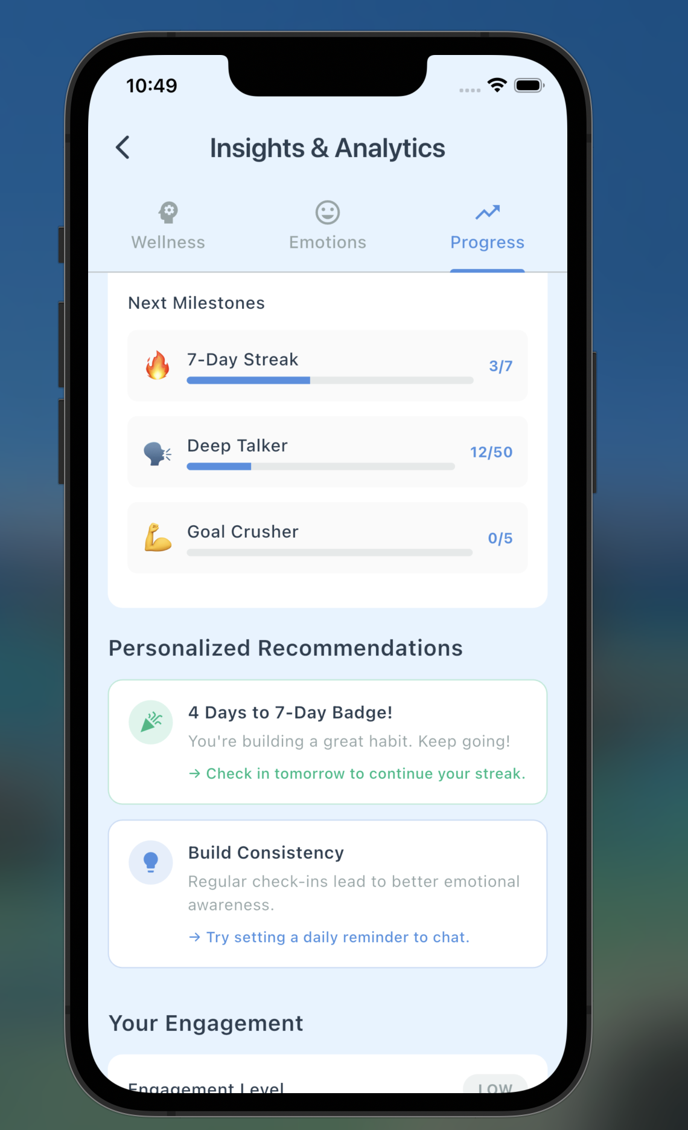

- Onboarding flow and user preferences

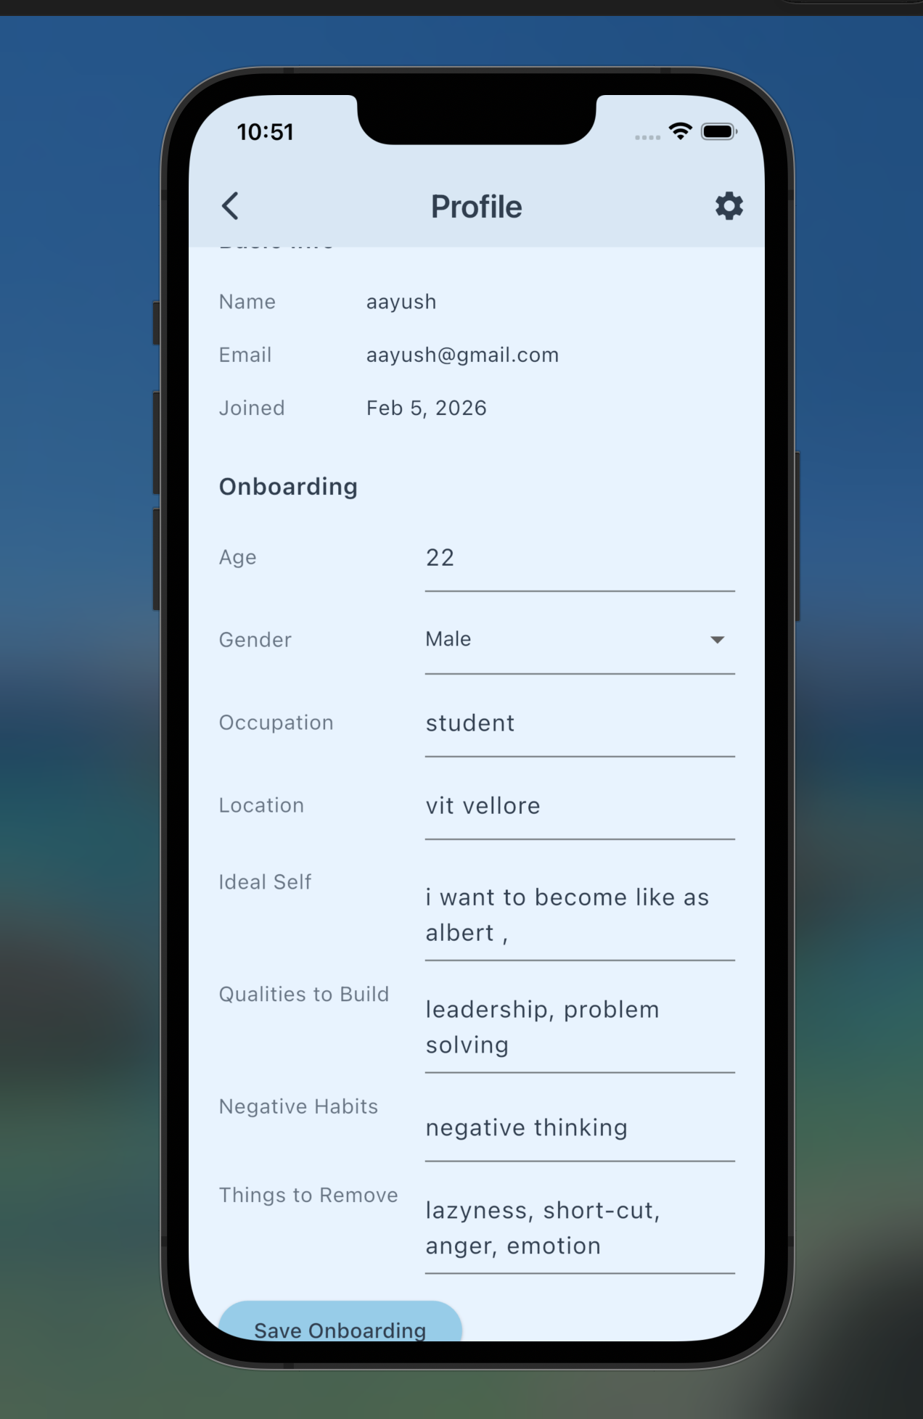

9. What aspect(s) of the invention need(s) protection?
Set 1: Multi-Stage Response Regulation System (Core Architecture)
Claim 1.1 (Independent): A computer-implemented conversational response regulation system comprising:
(a) an emotion signal processor configured to receive natural language input and produce a structured emotion metadata object comprising a signal classification label, a confidence value, a severity indicator, and a category classification;
(b) a response strategy controller configured to receive the emotion metadata object and produce strategy parameters comprising an approach identifier, constraint specifications, and escalation indicators, wherein the strategy parameters are derived from the emotion metadata through deterministic mapping logic with severity-based modification;
(c) a constrained output generator configured to receive the user input, the emotion metadata object, and the strategy parameters, and to produce a response output constrained by the strategy parameters and constraint specifications;
wherein the emotion metadata object propagates through all stages as mandatory input, ensuring that response generation is governed by the detected emotional signal and derived constraints.
Claim 1.2 (Dependent): The system of Claim 1.1, wherein the response strategy controller implements severity-based modification comprising:
- detection of high-severity negative emotional signals triggering elevated constraint intensity;
- prepending of safety-related techniques to the technique list;
- setting of escalation flags for downstream processing.
Claim 1.3 (Dependent): The system of Claim 1.1, wherein the constraint specification comprises:
- a required elements list specifying mandatory response characteristics;
- a prohibited elements list specifying content patterns to avoid;
- a safety enforcement flag activating safety rules;
- an escalation flag triggering resource provision.
Claim 1.4 (Dependent): The system of Claim 1.1, wherein the constrained output generator constructs a structured generation request comprising:
- a role definition section;
- an emotional context section incorporating the emotion metadata;
- a strategy directive section incorporating the strategy parameters;
- a constraint enforcement section incorporating the constraint specification;
- a safety rules section.

Set 2: Longitudinal State Accumulation and Behavior Modification
Claim 2.1 (Independent): A computer-implemented method for modifying conversational system behavior based on accumulated emotional state, comprising:
(a) collecting and storing emotion metadata objects from multiple user interactions with associated timestamps;
(b) computing aggregate metrics from the accumulated emotion metadata, the metrics comprising:
- an emotion distribution representing the frequency of each emotion signal classification;
- a positivity ratio representing the proportion of positive emotional signals;
- a stability score representing the emotional consistency over the accumulation period;
- a trajectory indicator representing the direction of emotional pattern change;
(c) generating warning flags when computed metrics exceed defined thresholds;
(d) modifying the response strategy controller behavior based on the computed metrics and warning flags;
wherein the accumulated state causes runtime behavior modification, such that system responses are influenced by historical patterns in addition to current input.
Claim 2.2 (Dependent): The method of Claim 2.1, wherein warning flags are generated based on:
- persistent negativity: positivity ratio below threshold for minimum signal count;
- high volatility: stability score below threshold;
- trajectory decline: negative trajectory delta exceeding threshold;
- crisis pattern: combined fear-sadness signals exceeding frequency threshold.
Claim 2.3 (Dependent): The method of Claim 2.1, wherein response strategy controller behavior modification comprises:
- adjusting strategy selection based on trajectory indicator;
- increasing response intensity based on warning flags;
- triggering proactive system responses based on pattern detection.

Set 3: Crisis State Machine
Claim 3.1 (Independent): A computer-implemented crisis handling method for conversational systems, comprising:
(a) maintaining a current system state from a defined set of states comprising NORMAL, ELEVATED, HIGH_ALERT, and CRITICAL;
(b) evaluating multiple input signals to compute a risk score, the signals comprising:
- emotion-based signals derived from current emotion metadata severity and category;
- linguistic signals derived from crisis pattern detection in user input;
- longitudinal signals derived from accumulated state warning flags;
- session signals derived from current session negativity ratio;
(c) determining state transitions based on risk score thresholds;
(d) triggering state-specific actions based on the current state, the actions comprising response modification and escalation actions;
wherein the crisis handling is implemented as a finite state machine with defined states, transition rules, and state-specific behaviors.
Claim 3.2 (Dependent): The method of Claim 3.1, wherein the risk score is computed by weighted combination of:
- emotion severity signal (weight: 25 for high-severity negative);
- linguistic crisis signal (weight: 35 for crisis keyword detection);
- longitudinal warning signal (weight: 20 for crisis pattern warning);
- trajectory decline signal (weight: 15 for severe decline).
Claim 3.3 (Dependent): The method of Claim 3.1, wherein state-specific actions comprise:
- ELEVATED state: enhanced validation in response;
- HIGH_ALERT state: safety prioritization and support mention;
- CRITICAL state: crisis response mode with resource provision and session flagging.

Set 4: Emotion Metadata Propagation Protocol
Claim 4.1 (Independent): A computer-implemented method for ensuring emotion-aware processing in multi-stage conversational systems, comprising:
(a) defining a structured emotion metadata schema comprising signal classification, confidence value, severity indicator, category, and timestamp;
(b) producing an emotion metadata object at the first stage of processing based on user input analysis;
(c) propagating the emotion metadata object as mandatory input to each subsequent processing stage;
(d) utilizing the emotion metadata object at each stage to inform stage-specific processing decisions;
(e) persisting the emotion metadata object with the interaction record for longitudinal accumulation;
wherein the emotion metadata propagation ensures consistent emotional context across all processing stages and enables longitudinal analysis.

Set 5: Structured Constraint Injection for Response Generation
Claim 5.1 (Independent): A computer-implemented method for constraining automated response generation based on emotional signals, comprising:
(a) receiving emotion metadata including signal classification and severity;
(b) mapping the emotion metadata to a constraint specification through deterministic control logic;
(c) constructing a structured request for a text generation service, the request comprising:
- role definition parameters;
- emotional context parameters derived from the emotion metadata;
- strategy directive derived from the constraint specification;
- explicit safety rules;
(d) transmitting the structured request to the text generation service;
(e) receiving and delivering the constrained response;
wherein the structured request format enforces that generated responses conform to emotion-derived constraints and safety rules.

Set 6: System Integration (Platform Claims)
Claim 6.1 (Independent): A response regulation system comprising:
(a) a client application executing on user devices;
(b) a backend server exposing API endpoints for message processing;
(c) a cloud-hosted emotion classification service;
(d) a text generation service configured with constraint injection;
(e) a persistent storage system storing user profiles, interaction histories, and emotion metadata;
(f) an analytics engine computing longitudinal emotional state metrics;
wherein all components operate in coordinated manner to deliver emotion-aware, constraint-governed conversational interactions.
Claim 6.2 (Dependent): The system of Claim 6.1, implementing a data structure for storing emotion-aware interaction data comprising:
- user identifier with privacy-preserving encryption;
- session metadata including timestamps;
- message buckets containing user input, emotion metadata, strategy applied, and generated response;
- longitudinal analytics fields including emotion distribution and trend indicators.

10. What is Technology readiness level of your invention? (Tick the appropriate TRL)

 | Research |  |  | Development |  |  | Deployment
TRL 1 | TRL 2 | TRL 3 | TRL 4 | TRL 5 | TRL 6 | TRL 7 | TRL 8 | TRL 9
Basic  Principles  observed | Technology concept formulated | Experimental proof of concept | Technology validated in a lab | Technology  validated in a relevant  environment  (industrially relevant in  case of key enabling technologies) | Technology demonstrated in a relevant  environment  (industrially relevant in  case of key enabling technologies) | System prototype  demonstration in an  operational environment | System complete and qualified | Actual system proven in an operational  environment  (competitive manufacturing  in case of key enabling  technologies, or in space )
 |  |  |  |  | Applied

----------------------END OF THE DOCUMENT-----------------------------

