WIREFRAMES & UX DESIGN
MARKETLENS — MARKETING DECISION INTELLIGENCE PLATFORM

Prepared By:
Oshin Mankar
Business Analyst
Version: 1.0
Status: Draft
Classification: Internal – Portfolio Project

TABLE OF CONTENTS
1. Section 1 – UX Objective
2. Section 2 – Information Architecture
3. Section 3 – Key User Flow
4. Section 4 – Key Screens
Screen 01 — Dashboard
Screen 02 — Campaigns / Data
Screen 03 — AI Intelligence
Screen 04 — Recommendations
Screen 05 — Reports
5. Section 5 – Design Principles
6. Section 6 – Important UX States
7. Section 7 – Responsive Design
8. Section 8 – Accessibility & Usability
9. Section 9 – Wireframe Set
01 — Dashboard
02 — Campaigns / Data
03 — AI Intelligence
04 — Recommendations
05 — Reports
10. Section 10 – Design Outcome

Section 1 – UX Objective
The UX is designed around one primary principle:
Principle: Reduce the time between seeing a marketing problem and deciding what to do about it.
The interface therefore follows a progressive workflow:
Overview → Investigate → Understand → Act → Report
Section 2 – Information Architecture
The platform is organized into five primary modules, each with focused sub-areas:
Dashboard
– KPIs
– Trends
– Campaign Performance
– AI Insights

Campaigns / Data
– Upload Dataset
– Data Validation
– Data Preview
– Dataset History

AI Intelligence
– AI Analysis
– Campaign Questions
– Comparisons
– Performance Diagnosis

Recommendations
– High Priority
– Medium Priority
– Low Priority
– Recommendation Status

Reports
– Report Configuration
– Performance Summary
– AI Insights
– Recommendations
– Export

Section 3 – Key User Flow
Primary Flow

Upload Dataset
▼
Validate Data
▼
View Dashboard
▼
Identify Performance Issue
▼
Ask AI / Explore Analysis
▼
Receive Diagnosis
▼
Review Recommendation
▼
Take Action
▼
Generate Report

This is the main experience the product is designed around.
Section 4 – Key Screens
Screen 01 — Dashboard
Purpose: Give the user an immediate understanding of account performance.
Main Components
- Total Spend
- Total Revenue
- Blended ROAS
- Total Conversions
- Revenue vs Spend trend
- Campaign performance table
- AI Insights panel
- Attention indicators
UX Principle
Show the most important information first. The user should not need to navigate through multiple pages just to understand whether performance is improving or declining.
Screen 02 — Campaigns / Data
Purpose: Give users control over the data powering the analysis.
Main Components
- Dataset upload
- Validation status
- Data quality warnings
- Data preview
- Dataset history
- Active dataset indicator
UX Principle
Make data quality visible before analysis begins. This prevents users from blindly trusting AI-generated insights based on incomplete data.
Screen 03 — AI Intelligence
Purpose: Allow users to investigate campaign performance using natural language.
Main Components
- AI conversation area
- Suggested questions
- Campaign context
- Performance highlights
- Campaign quick reference
- User query input
Example Questions
- “Why is Competitor Conquest underperforming?”
- “Which campaign should receive more budget?”
- “Compare Meta and Google performance.”
UX Principle
AI should explain the data, not simply produce an answer.
Screen 04 — Recommendations
Purpose: Convert analysis into actionable decisions.
Main Components
- Priority
- Recommendation
- Campaign
- Supporting KPIs
- Analysis / rationale
- Expected impact
- Action status
Available Actions
- Mark Complete | Mark in Review | Dismiss
UX Principle
Every recommendation should answer: what should I do, why should I do it, and what could be the impact?
Screen 05 — Reports
Purpose: Turn platform analysis into a shareable business output.
Main Components
- Reporting period
- Campaign selection
- Report type
- Executive summary
- KPI summary
- Campaign performance
- AI insights
- Recommendations
- PDF export
UX Principle
The report should be decision-ready, not simply a data dump.
Section 5 – Design Principles
01 — Decision-first: Prioritize information that helps users make decisions.
02 — Explainable AI: AI insights should show the metrics and reasoning behind conclusions.
03 — Progressive disclosure: Show high-level insights first and allow users to explore deeper details when required.
04 — Actionability: Insights should lead naturally to recommendations and next steps.
05 — Data transparency: Clearly indicate the dataset being analyzed and surface data-quality issues.
06 — Consistency: Use consistent KPI cards, status indicators, priority labels, tables and interaction patterns across modules.
Section 6 – Important UX States
The design accounts for the following states, not just the happy path:
- Loading
- Empty dataset
- Successful upload
- Validation warning
- Validation error
- AI processing
- AI response
- No recommendations
- Pending recommendation
- Completed recommendation
- Report generated
- Export/download
Section 7 – Responsive Design
The platform is primarily designed for desktop use because marketing analysts typically work with large datasets, tables, multiple KPIs, charts, and AI analysis.
Responsive layouts should adapt for:
Desktop → Tablet → Mobile
On smaller screens:
- KPI cards stack
- Tables become horizontally scrollable
- AI panel becomes full width
- Side navigation becomes collapsible
- Report sections stack vertically
Section 8 – Accessibility & Usability
The design should maintain:
- Clear visual hierarchy
- Readable typography
- Sufficient color contrast
- Status indicators using both color and text/icons
- Consistent button behavior
- Clear labels for interactive elements
- Keyboard-friendly interaction where applicable
Section 9 – Wireframe Set
The following screens show the platform's core workflow as implemented.
01 — Dashboard
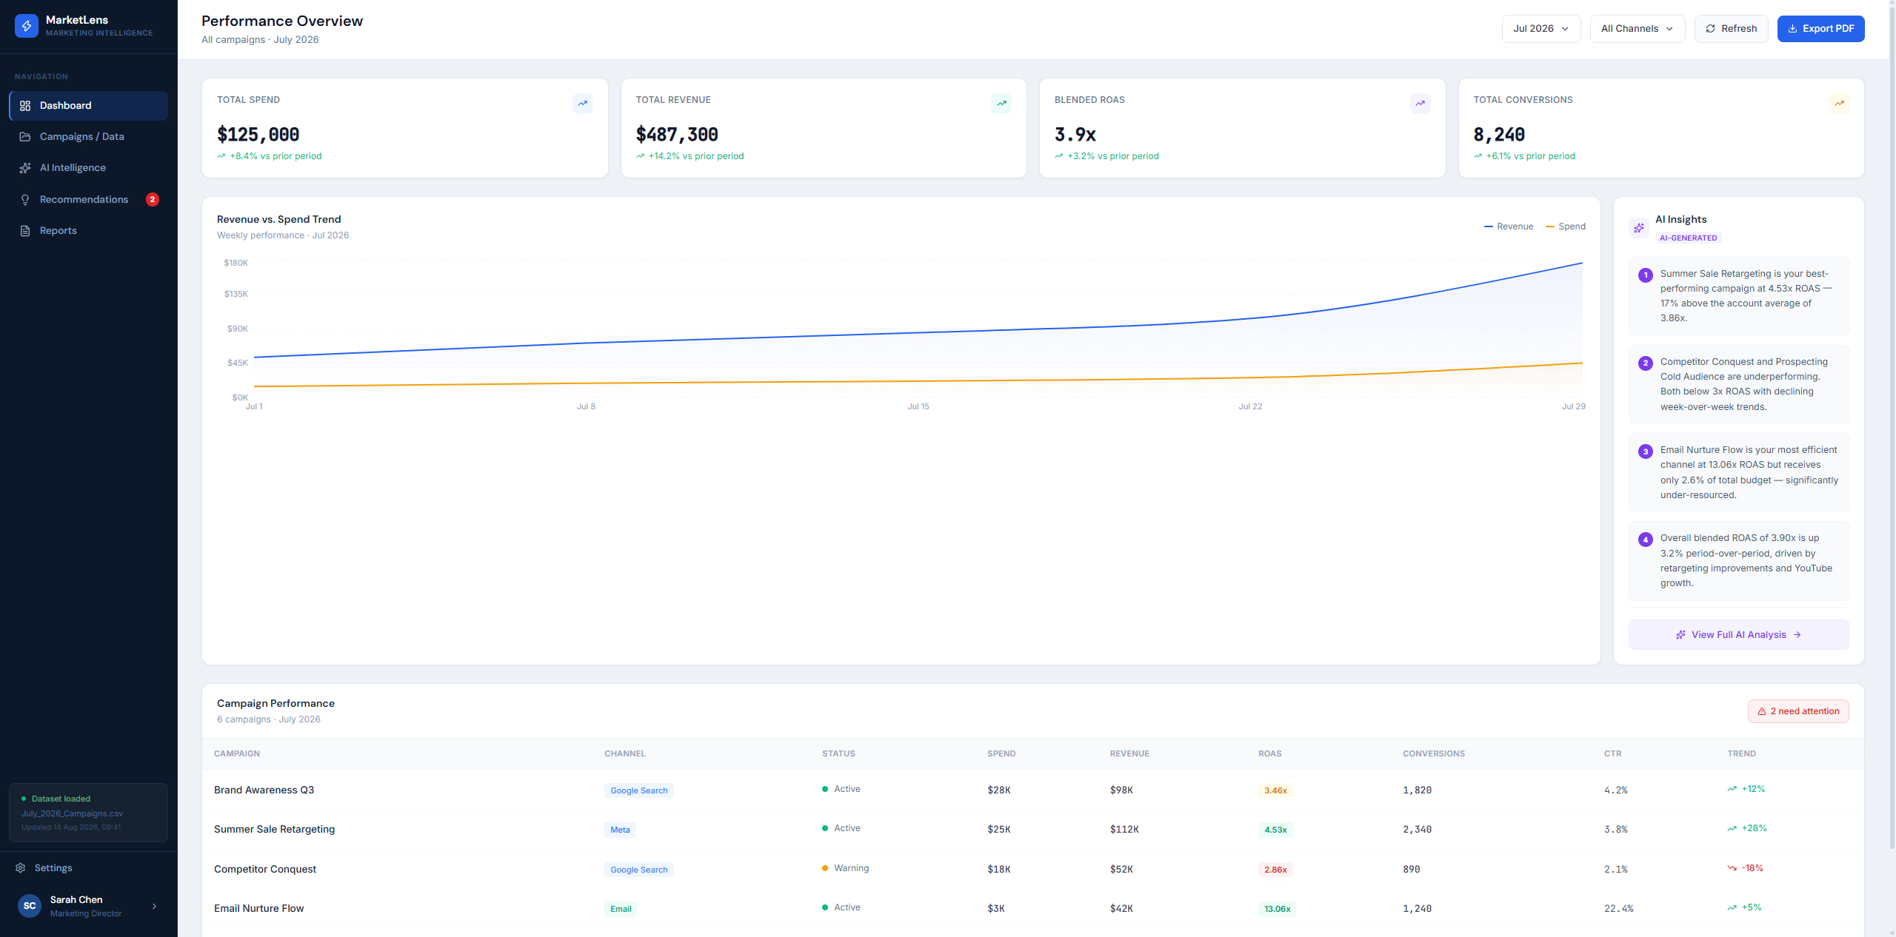
Gives users an immediate, single-glance view of account performance and AI-flagged issues.
02 — Campaigns / Data
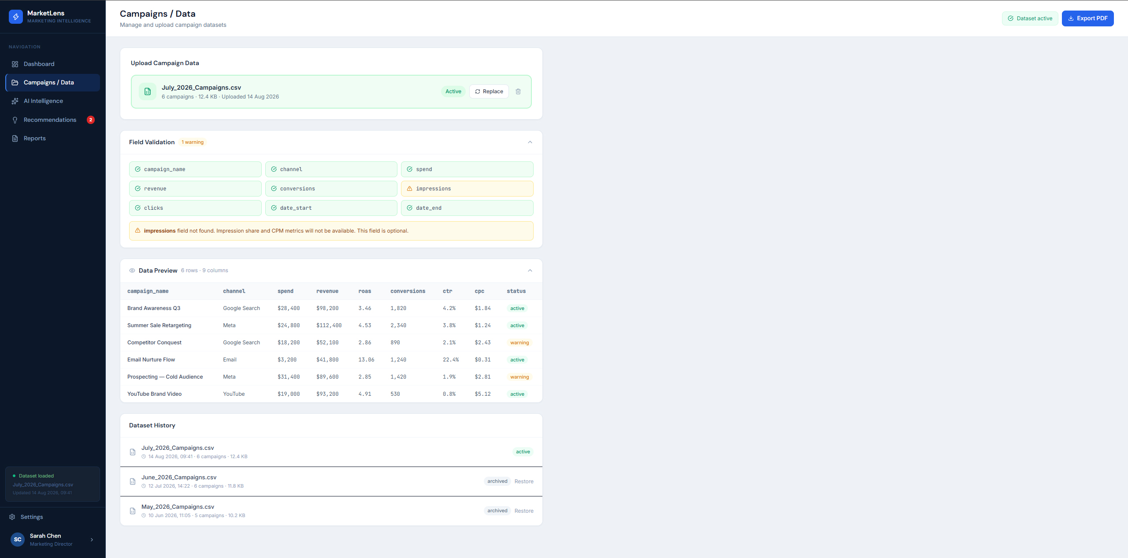
Lets users upload, validate, and monitor the quality of campaign data before it feeds the analysis.
03 — AI Intelligence
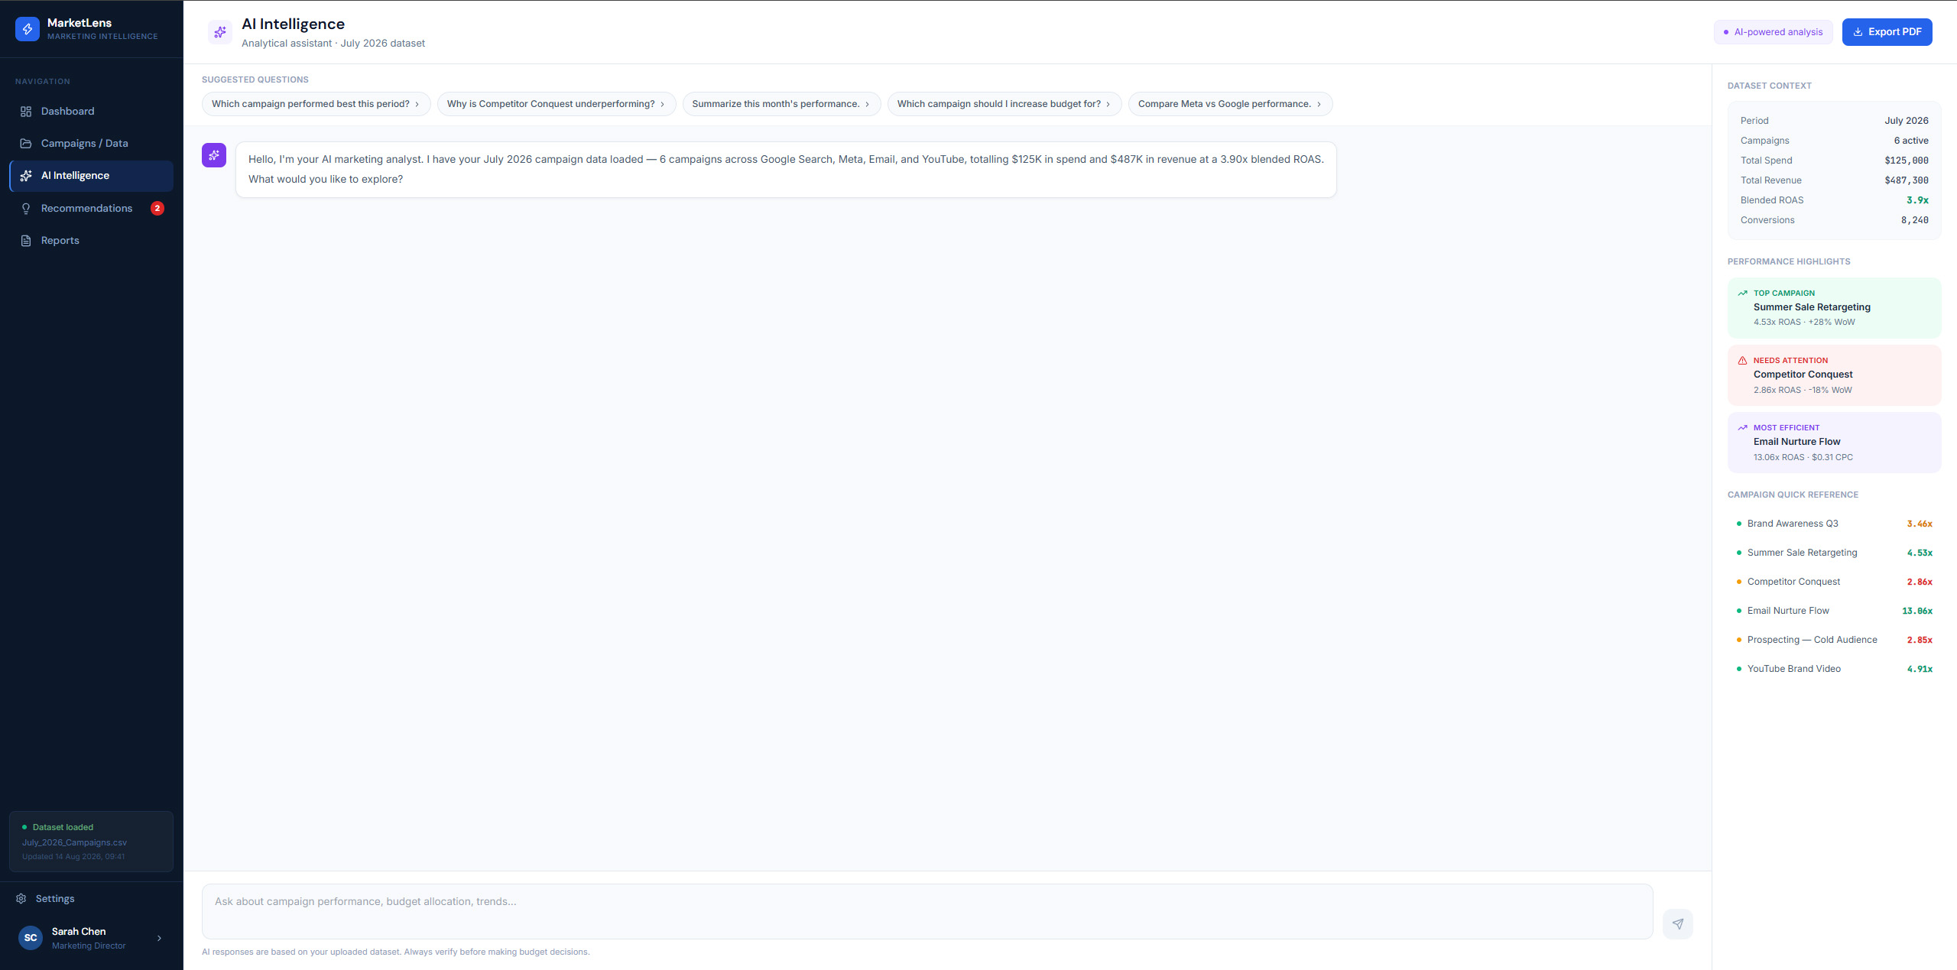
Lets users investigate campaign performance conversationally and see the reasoning behind each answer.
04 — Recommendations
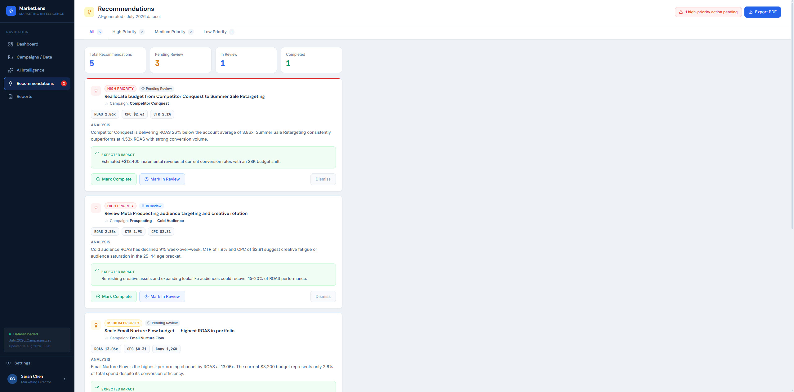
Converts AI analysis into prioritized, actionable next steps with supporting rationale and expected impact.
05 — Reports
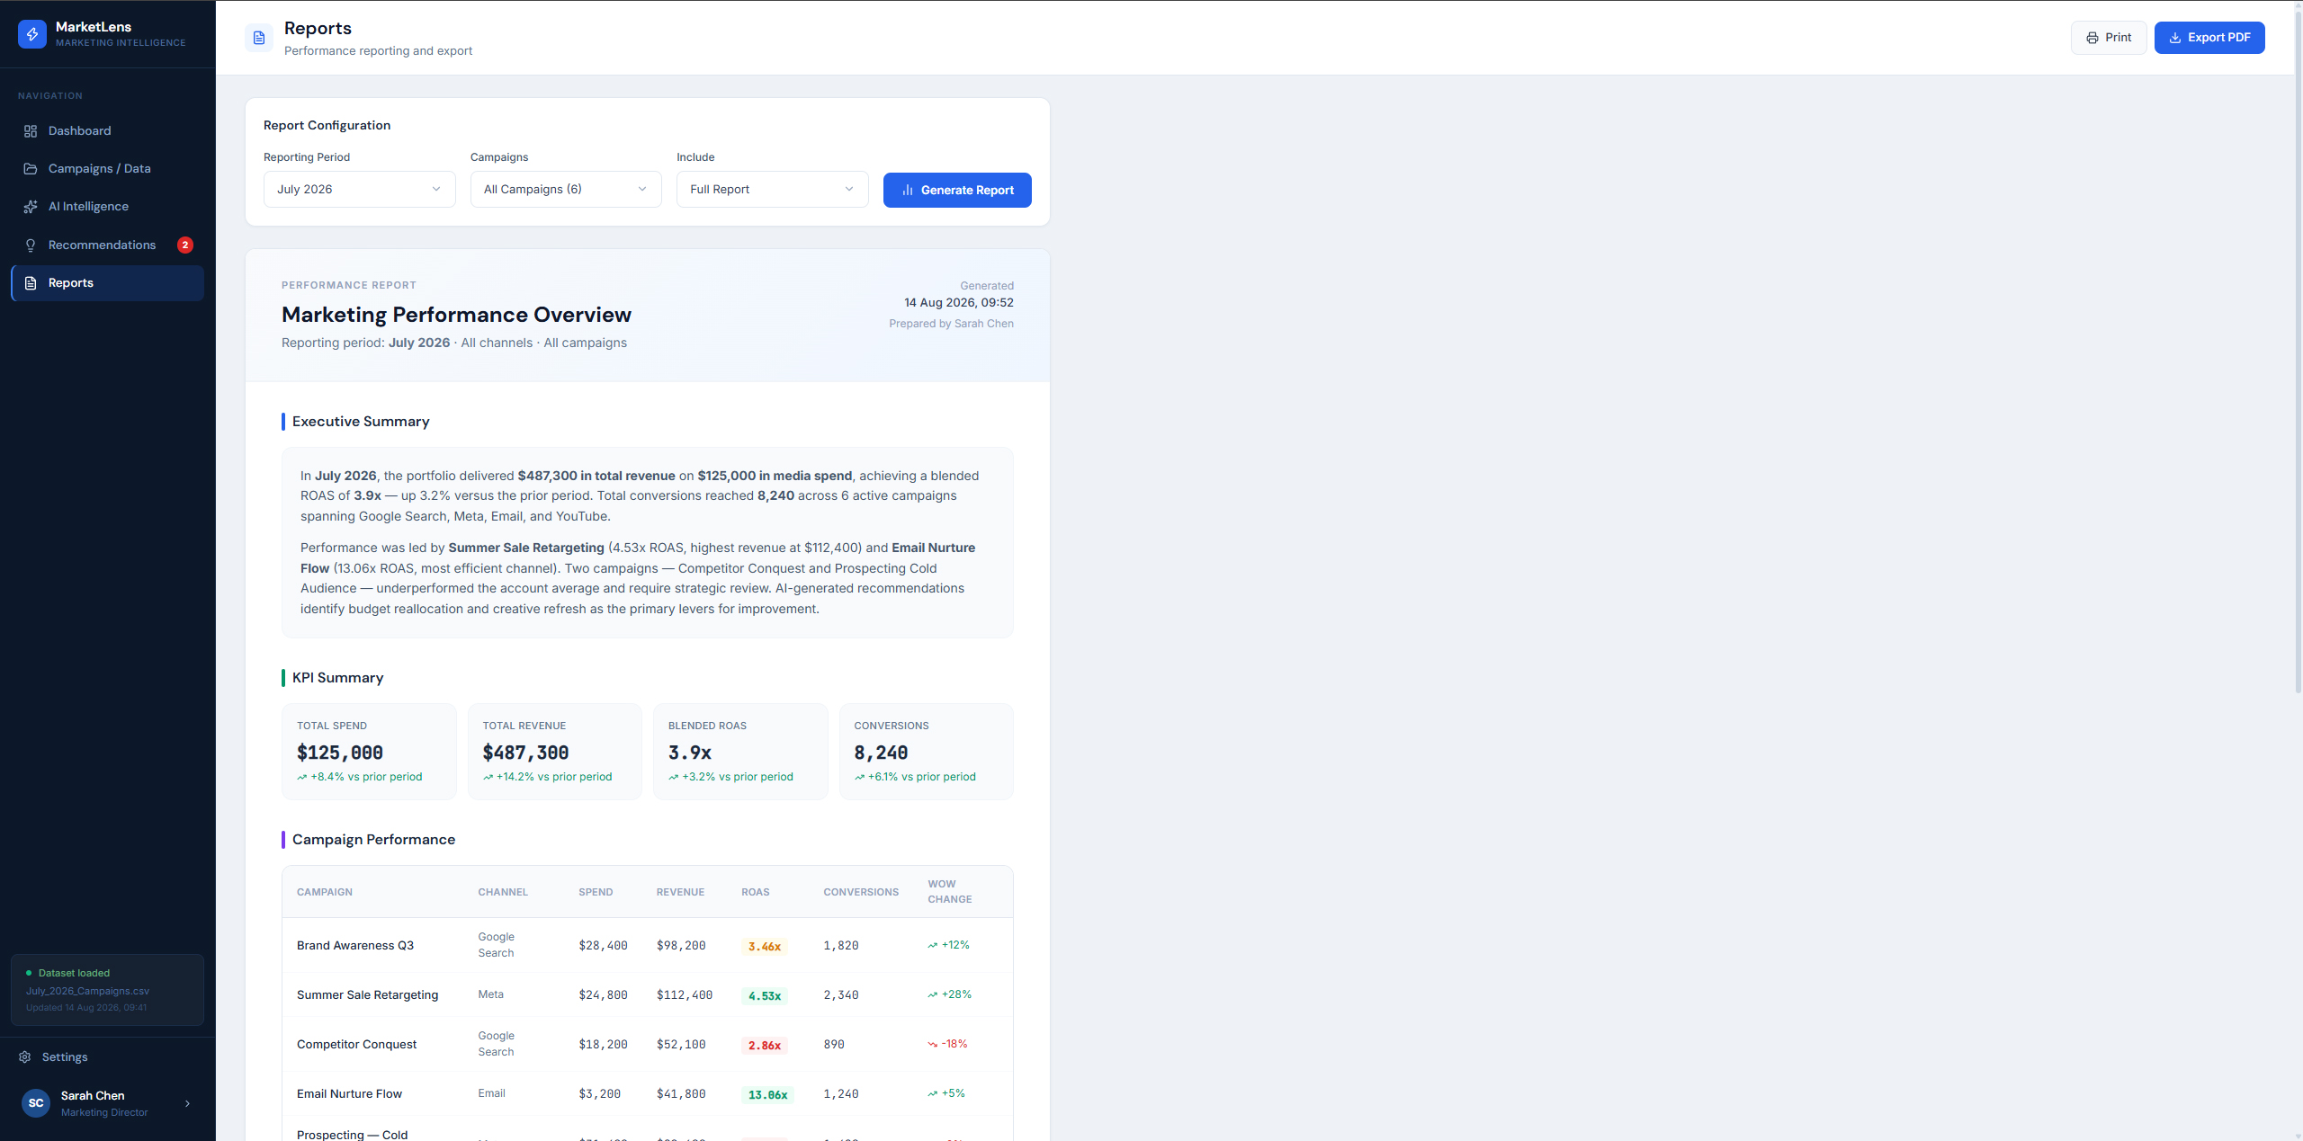
Turns platform analysis into a decision-ready, exportable performance report.
Section 10 – Design Outcome
The UX connects the five modules into one continuous decision-making workflow:
DATA → SIGNALS → INSIGHT → DIAGNOSIS → RECOMMENDATION → DECISION
The goal is to reduce fragmented analysis across spreadsheets, dashboards and separate AI tools by bringing performance understanding and next-step recommendations into one workflow.

