AMS Supply and Property Management System
AMS Supplies (office portal) and AMS StockWatch (AMS admin)
System Diagrams and Process Descriptions
IPO • Context Diagram • Use Case Diagram • Process Flowchart • System Architecture
Asset Management Section
Department of Education – National Capital Region
October 2026
Contents
1. System Overview
2. Input–Process–Output (IPO) Diagram
3. Context Diagram
4. Use Case Diagram
5. Process Flowchart
6. System Architecture
7. Process Descriptions: AMS Supplies (Offices)
8. Process Descriptions: AMS StockWatch (AMS Staff)

1. System Overview
The AMS Supply and Property Management System replaces paper-based supply requests and manual stock records of the Asset Management Section (AMS). It has two websites that share one database:
Website | Used by | Purpose
AMS Supplies | Regional Office units (office accounts) | Browse supplies, request them through a Requisition and Issue Slip (RIS), follow each request, print the RIS, view the office's APP-CSE, suggest new supplies.
AMS StockWatch | AMS staff and the Super Admin | Approve and release requisitions, manage stock and the catalog, upload APP-CSE, produce the RSMI and stock cards, keep the property register and property documents, manage accounts and settings.

Every request is checked against two limits: the stock in the AMS stockroom and the office's Annual Procurement Plan for Common-Use Supplies and Equipment (APP-CSE). When AMS releases items, the system deducts the stock, records the quantity used against the office's APP-CSE, saves the scanned signed RIS, and updates the stock card and the monthly Report of Supplies and Materials Issued (RSMI) automatically.
The system is hosted online on MonsterASP.NET. Offices open it in any web browser at asset-shop.runasp.net (AMS Supplies) and AMS staff at ams-stockwatch.runasp.net (AMS StockWatch), over secure HTTPS, from the office or anywhere with internet.

2. Input–Process–Output (IPO) Diagram
The IPO diagram shows what goes into the system, what the system does with it, and what comes out.
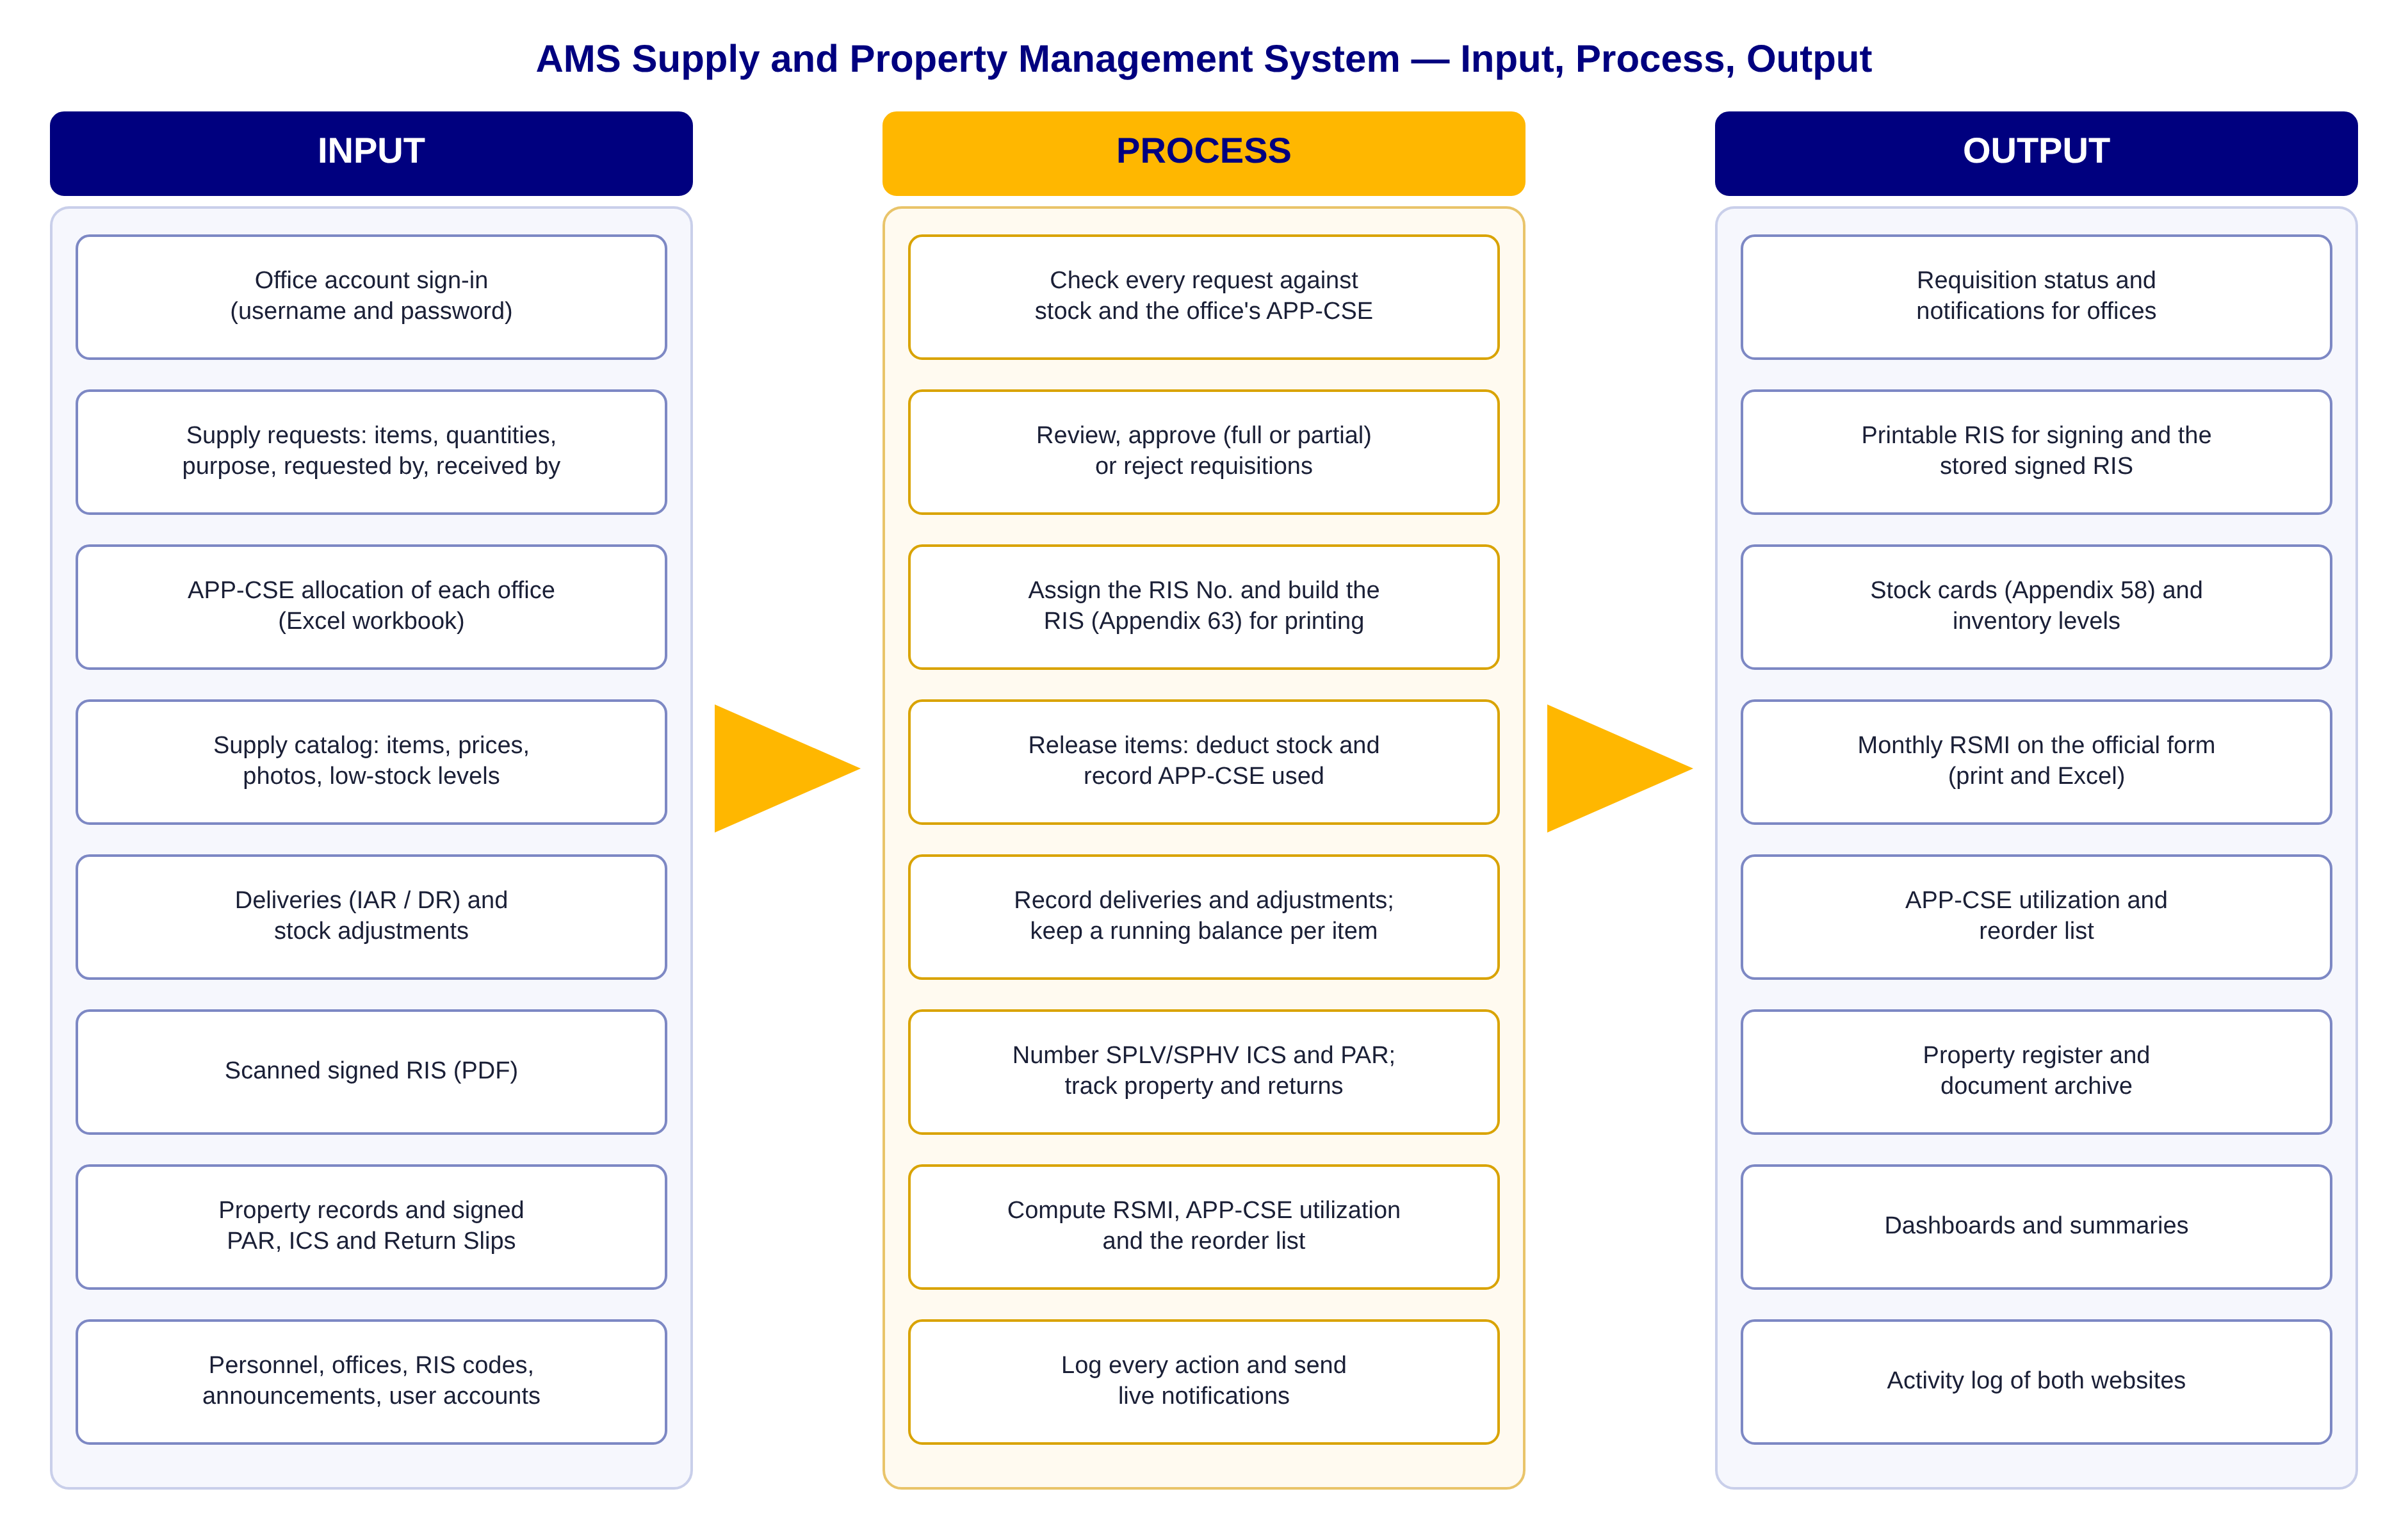
Figure 1. Input–Process–Output diagram
Input. Offices supply their requests (items, quantities, purpose and the people who request and receive). AMS staff supply the catalog, the APP-CSE of every office, deliveries and stock corrections, the scanned signed RIS, and property records and documents.
Process. The system checks requests against stock and APP-CSE, lets AMS approve, partly approve or reject them, numbers and builds the RIS, deducts stock on release, keeps a running balance per item, numbers SPLV/SPHV ICS and PAR, and computes the reports. Every action is logged.
Output. Offices get status updates, a printable RIS and the signed copy. AMS gets stock cards, inventory levels, the monthly RSMI, APP-CSE utilization, a reorder list, the property register, dashboards and the activity log.

3. Context Diagram
The context diagram (Level 0 data flow diagram) shows the whole system as a single process and the people and offices that exchange data with it.
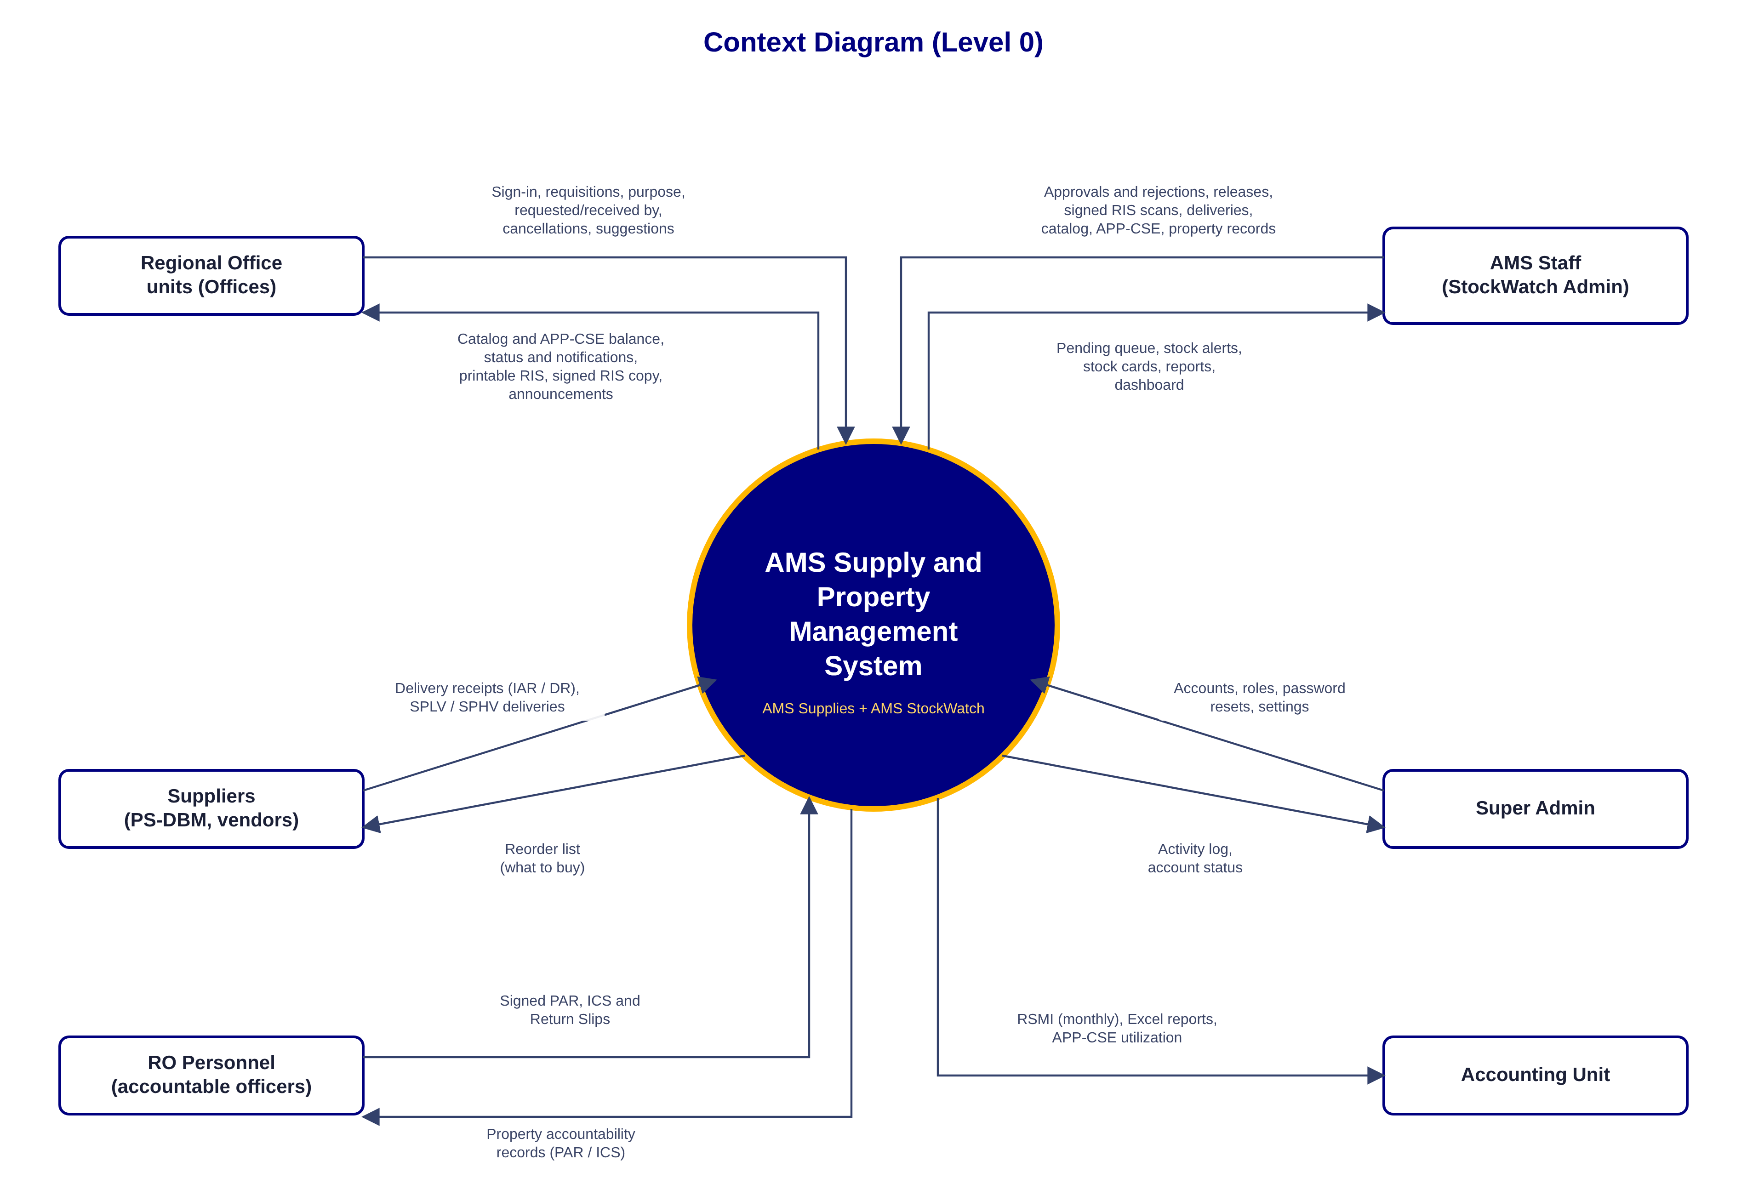
Figure 2. Context diagram
External entity | Sends to the system | Receives from the system
Regional Office units | Sign-in, requisitions, purpose, requested by and received by, cancellations, supply suggestions | Catalog and APP-CSE balance, requisition status and notifications, printable RIS, signed RIS copy, announcements
AMS Staff | Approvals and rejections, releases and signed RIS scans, deliveries, catalog, APP-CSE, property records | Pending queue, stock alerts, stock cards, reports, dashboard
Super Admin | User accounts, roles, password resets, settings | Activity log, account status
Suppliers (PS-DBM, vendors) | Delivery receipts (IAR / DR), SPLV and SPHV deliveries | Reorder list (what to buy)
RO Personnel | Signed PAR, ICS and Return Slips | Property accountability records
Accounting Unit | — | Monthly RSMI, Excel reports, APP-CSE utilization

4. Use Case Diagram
The use case diagram shows who uses the system and what each of them can do. The left group is AMS Supplies; the right group is AMS StockWatch.
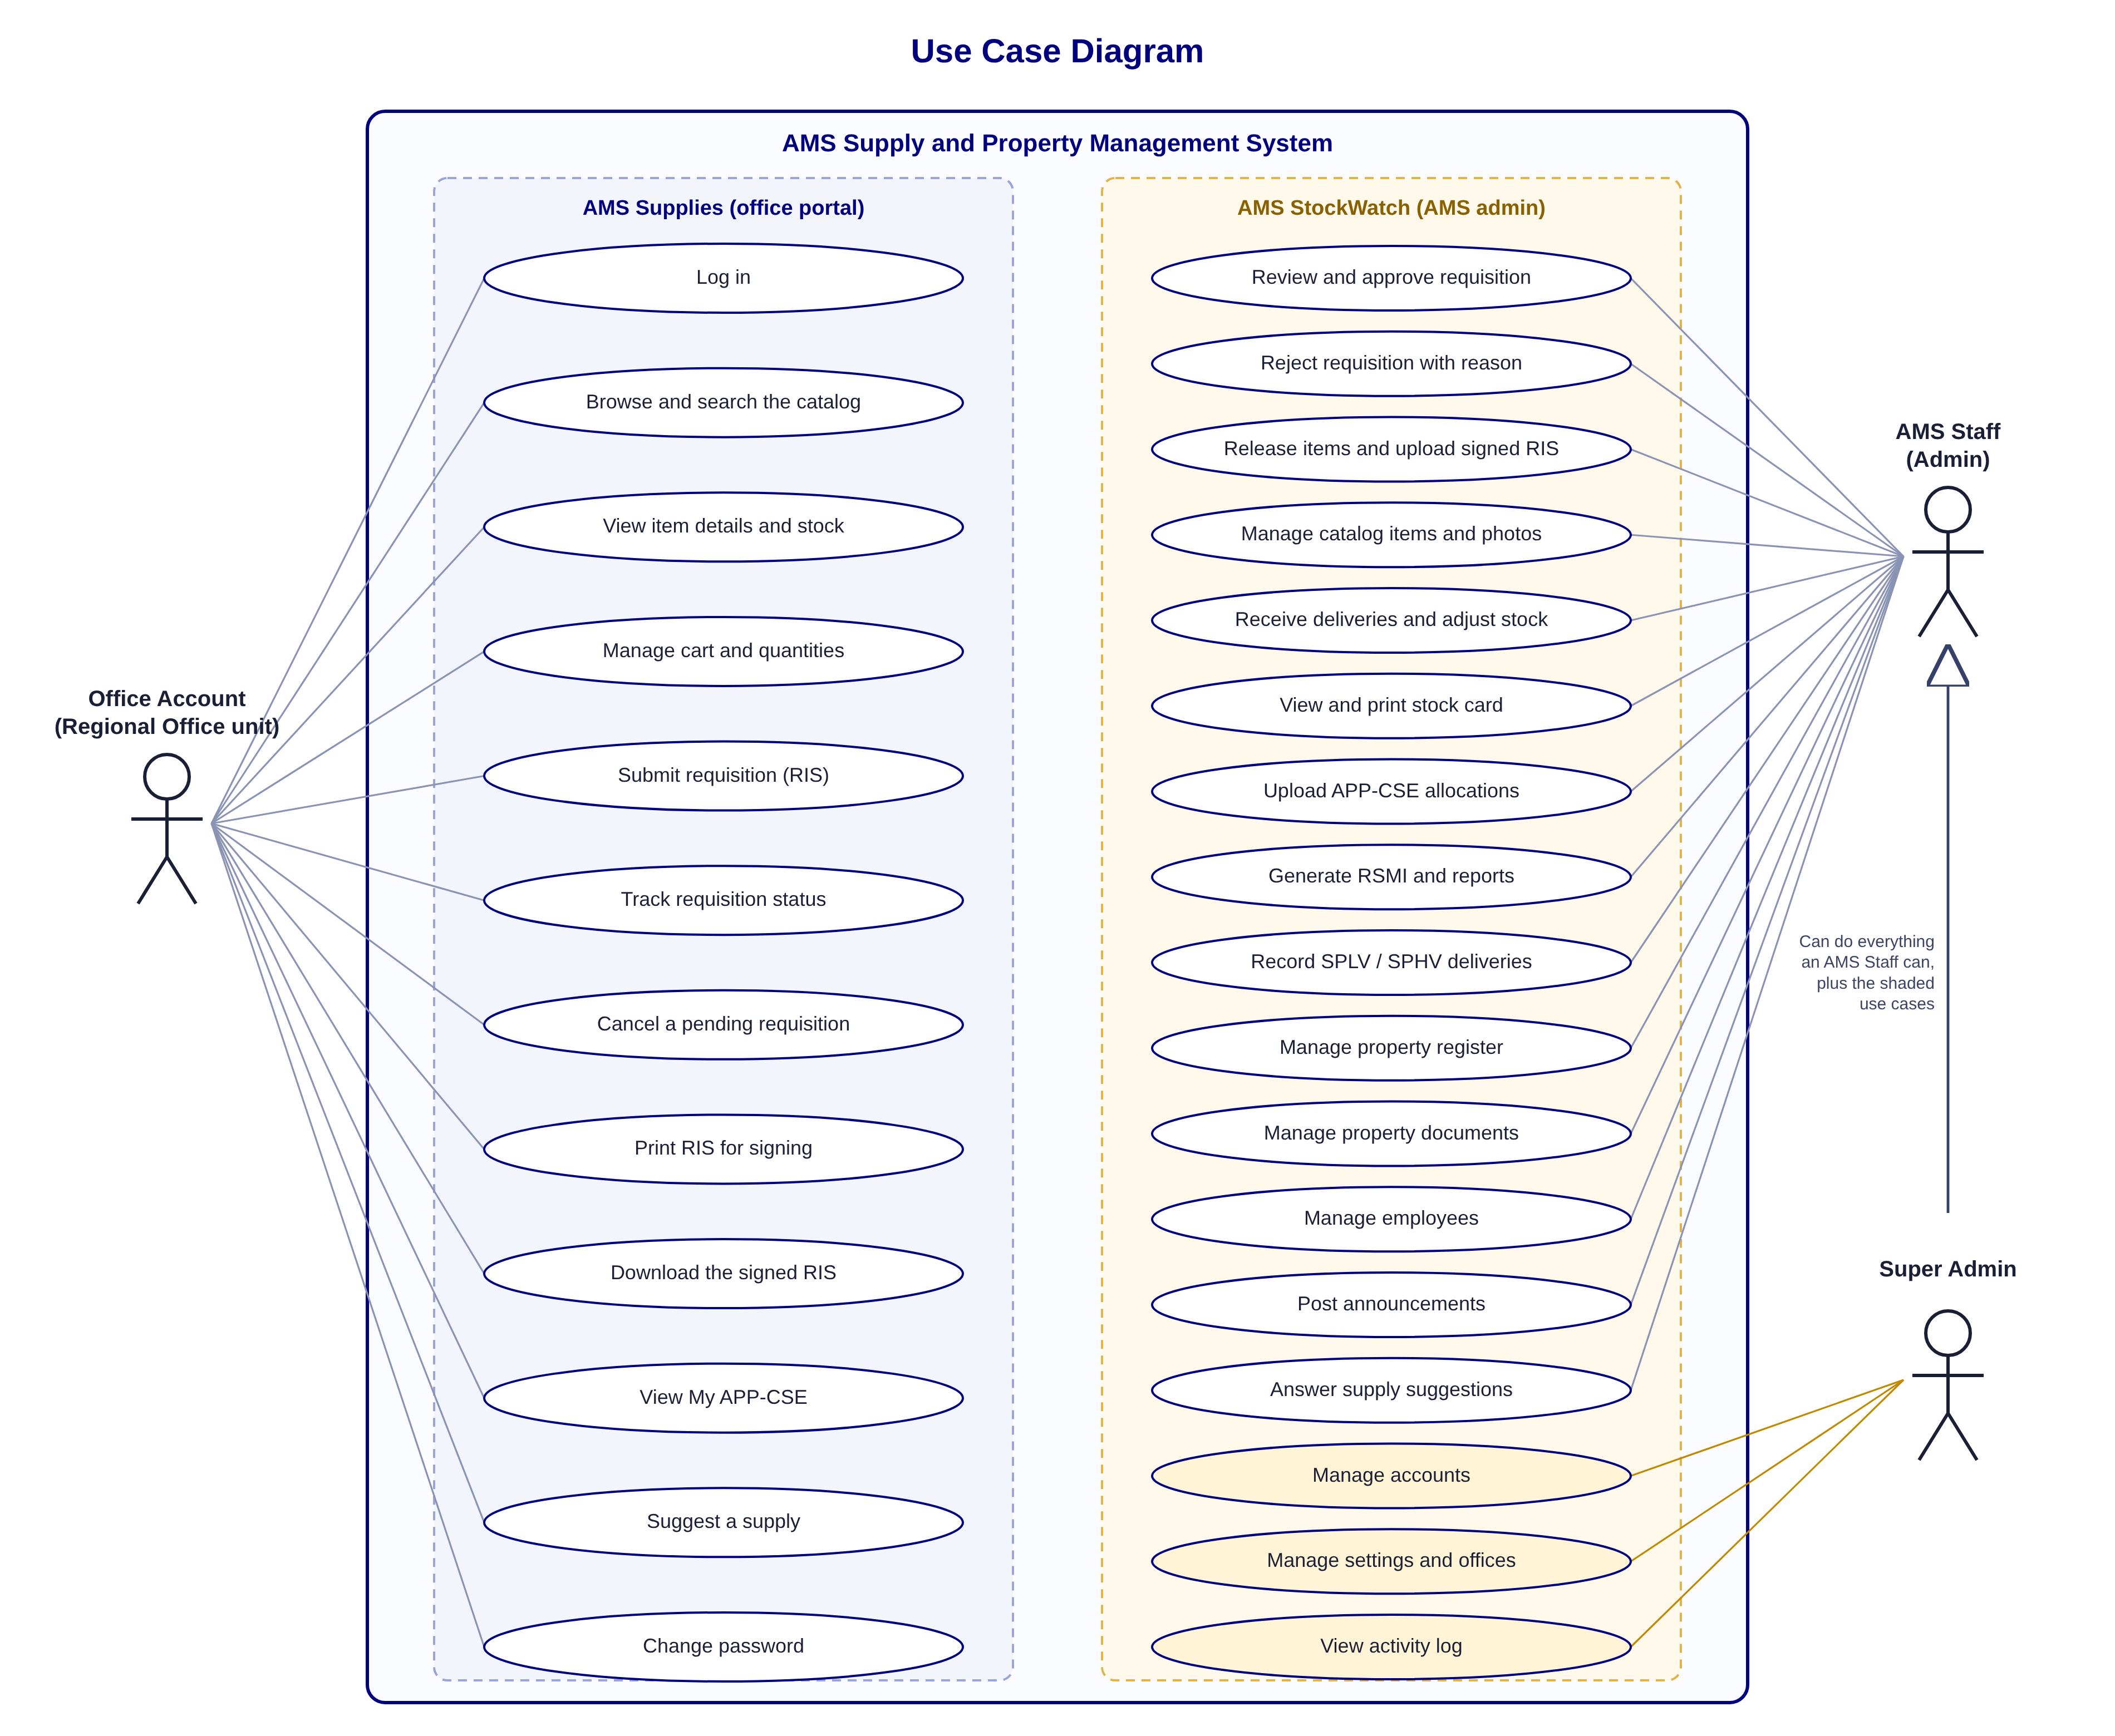
Figure 3. Use case diagram

Actors
- Office Account: one account per Regional Office unit. Requests supplies for the office and follows its requisitions in AMS Supplies.
- AMS Staff (Admin): reviews, approves and releases requisitions and keeps stock, catalog, APP-CSE, reports and property records in AMS StockWatch.
- Super Admin: can do everything an AMS Staff can, and also manages user accounts, settings and offices, and views the activity log.

5. Process Flowchart
The flowchart follows one requisition from the office's request to the release of the items. Each column shows who does the step.
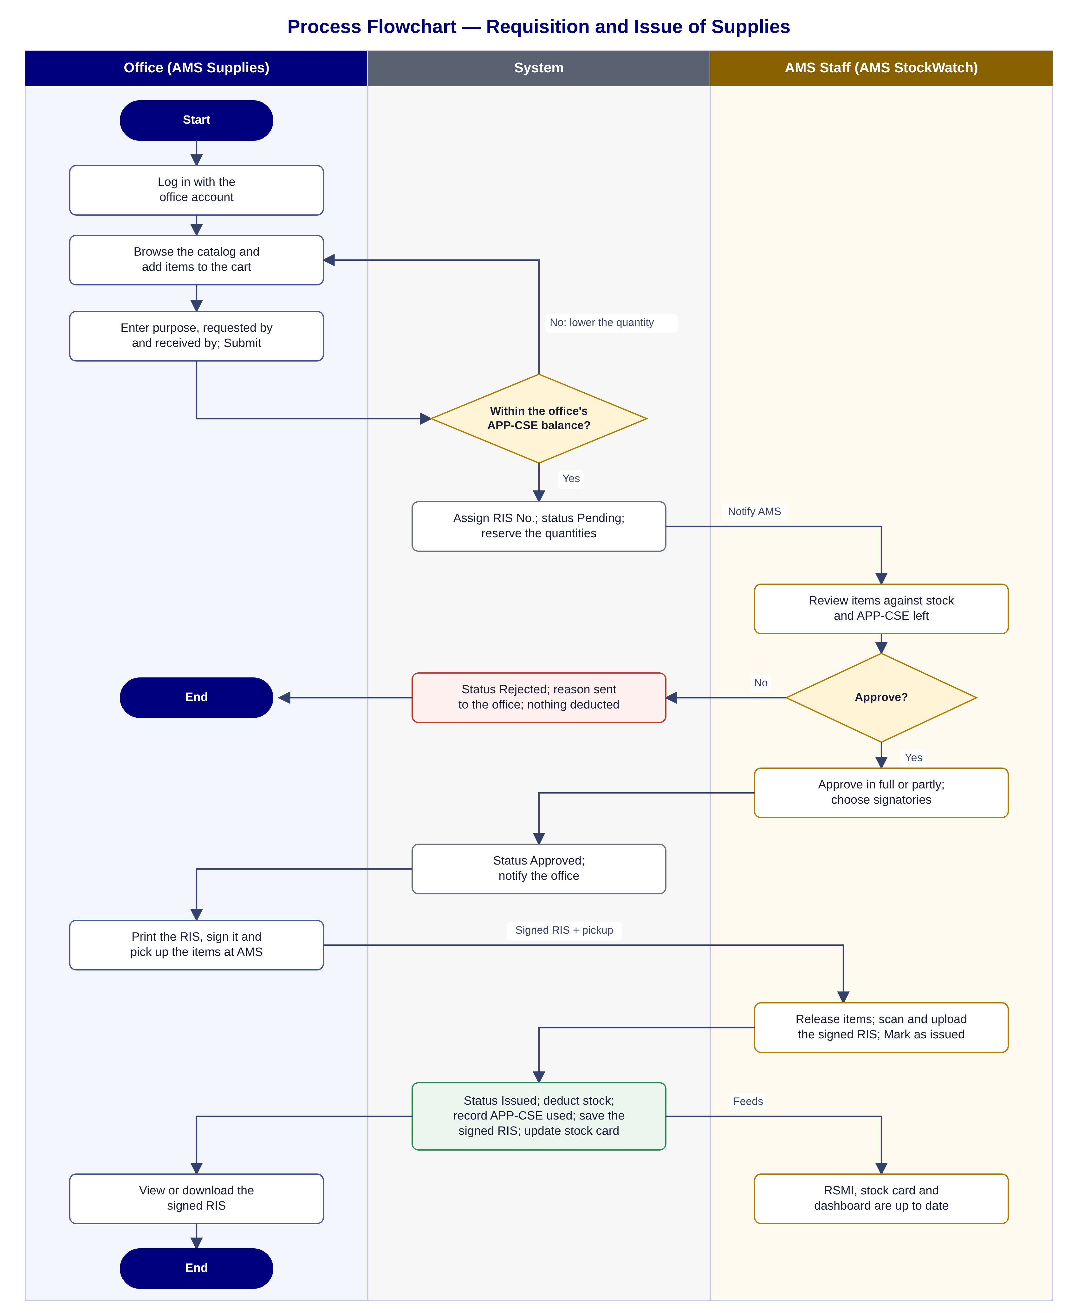
Figure 4. Process flowchart: requisition and issue of supplies

Steps of the flowchart
- The office logs in to AMS Supplies, adds items to the cart, enters the purpose, the person requesting and the person who will receive the items, and submits.
- The system checks each quantity against the office's remaining APP-CSE. If a quantity is too high, the office lowers it before it can submit.
- The system assigns the RIS No., sets the status to Pending approval, reserves the quantities from the office's APP-CSE and notifies AMS.
- AMS staff review the requisition in AMS StockWatch against the stock and the APP-CSE left.
- If AMS rejects it, the reason is sent to the office and nothing is deducted. The process ends.
- If AMS approves it (in full or partly, with remarks), the status becomes Approved and the office is notified.
- The office prints the RIS, signs it and picks up the items at AMS.
- AMS releases the items, scans and uploads the signed RIS and marks the requisition as issued.
- The system sets the status to Issued, deducts the stock, records the quantity used against the APP-CSE, saves the signed RIS and updates the stock card, the RSMI and the dashboard.
- The office can view or download the signed RIS at any time.

6. System Architecture
The system is hosted on MonsterASP.NET, a cloud hosting service for ASP.NET applications. Users need only a web browser and an internet connection; nothing is installed on their computers.
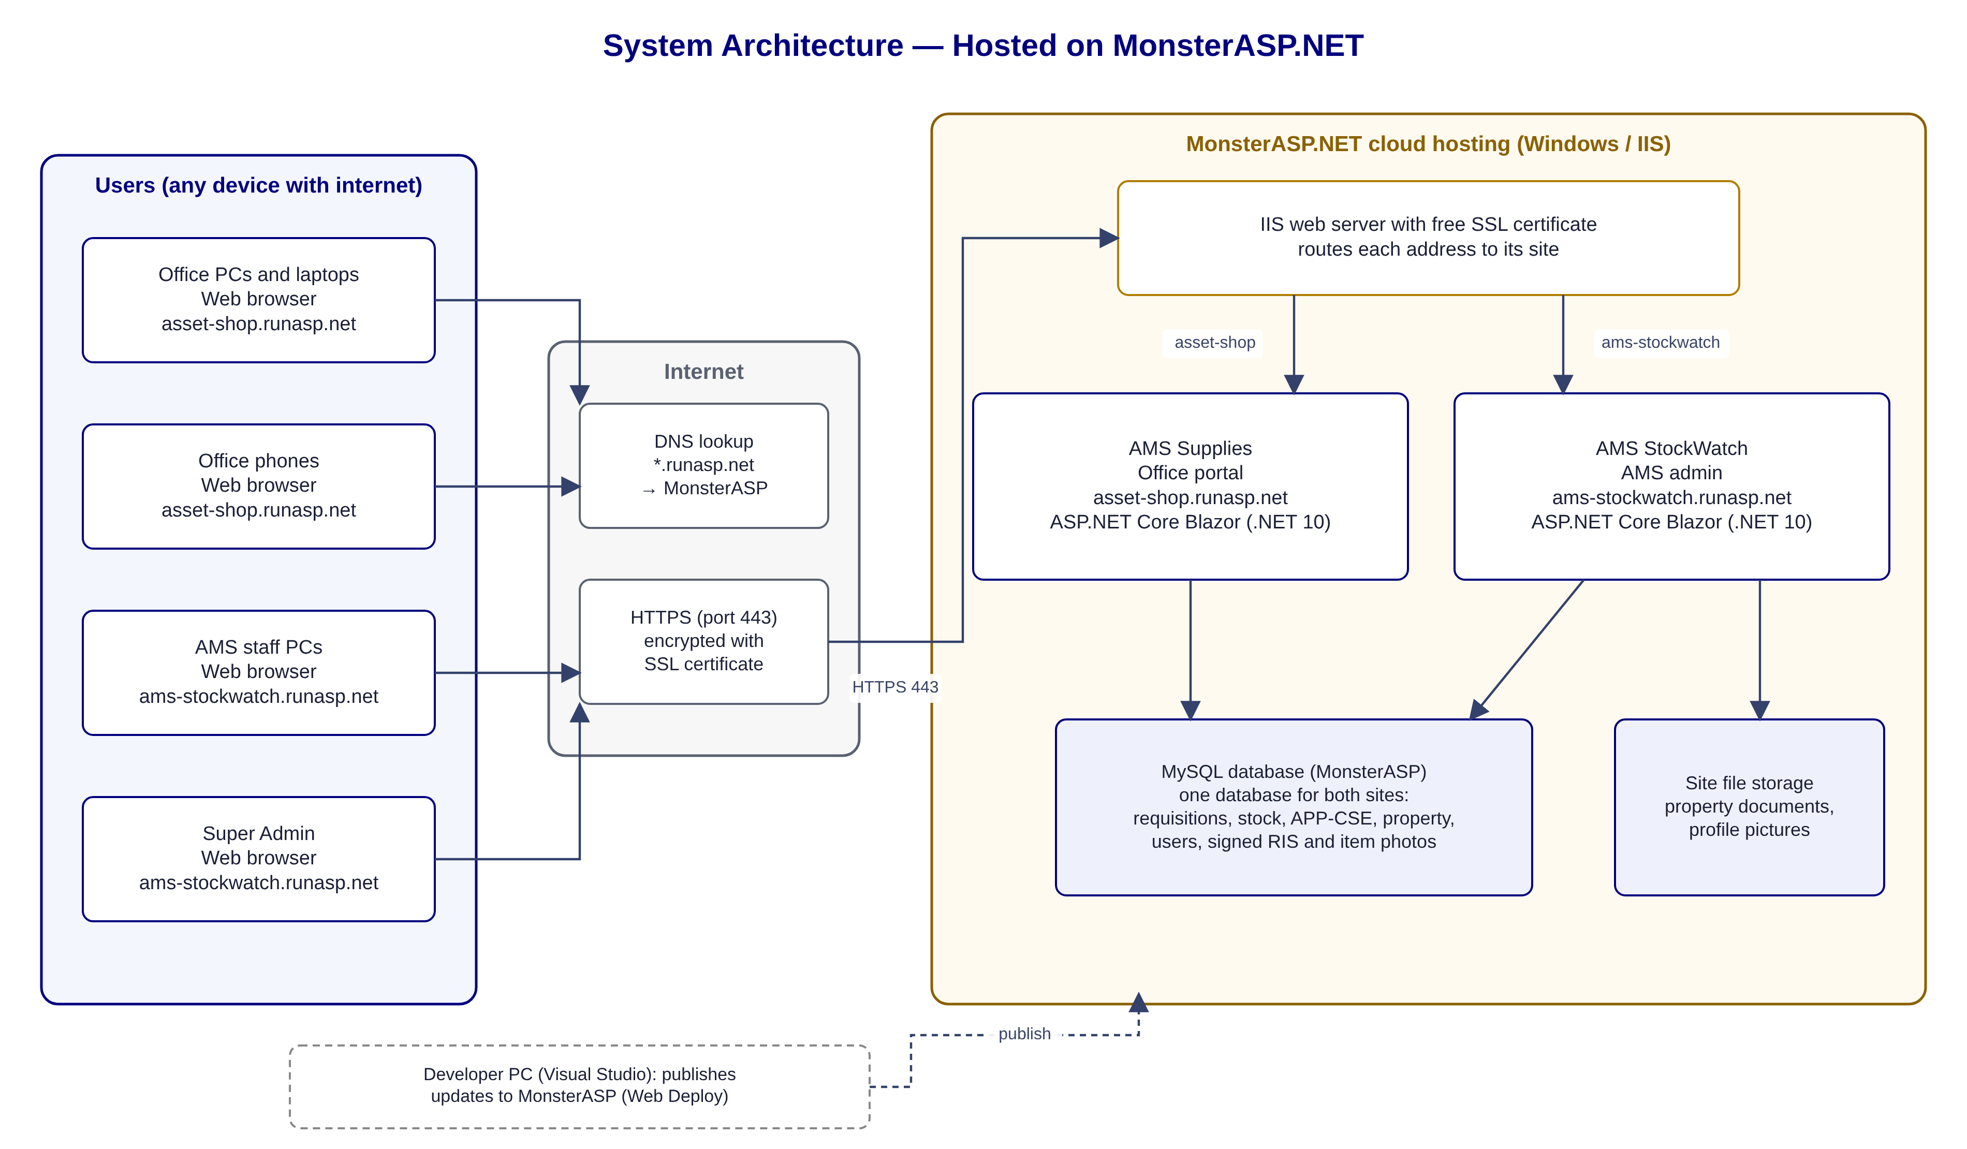
Figure 5. System architecture
Component | Role
Web browser (any PC, laptop or phone with internet) | Opens asset-shop.runasp.net (AMS Supplies) or ams-stockwatch.runasp.net (AMS StockWatch).
Internet and DNS | The runasp.net addresses point to the MonsterASP.NET servers; all traffic is encrypted with HTTPS.
MonsterASP.NET hosting (Windows, IIS) | Runs both websites, provides their SSL certificates and sends each address to its site.
AMS Supplies (asset-shop.runasp.net) | ASP.NET Core Blazor application (.NET 10) for offices.
AMS StockWatch (ams-stockwatch.runasp.net) | ASP.NET Core Blazor application (.NET 10) for AMS staff.
MySQL database (MonsterASP) | One database shared by both sites: requisitions, stock movements, APP-CSE, catalog and item photos, signed RIS, property, users and the activity log.
Site file storage | Scanned property documents (PAR, ICS, Return Slips) and profile pictures, kept in the StockWatch site's storage folder.
Developer PC (Visual Studio) | Publishes updates of both applications to MonsterASP.NET.

7. Process Descriptions: AMS Supplies (Offices)
AMS Supplies is the website offices use to request supplies from AMS. Address: https://asset-shop.runasp.net

7.1 Log in and browse supplies
Purpose: Find the supplies AMS keeps in stock and see how much the office can still request.
- Open AMS Supplies. The catalog of supplies can be viewed even before logging in.
- Click Log in and enter the office username and password.
- After logging in, every item shows the office's APP-CSE total, the quantity requested to date and what remains.
- Search by item name, specification or stock number, or filter by category and stock level.
- Click an item to see its details, the stock in the AMS stockroom and the office's APP-CSE balance.

7.2 Request supplies (cart and RIS)
Purpose: Prepare and send a Requisition and Issue Slip to AMS.
- Choose the quantity in the item details and click Add to cart, or click Add to cart on the item card to add one unit.
- Open the cart. Change quantities or remove items; the system does not allow more than the remaining APP-CSE.
- Type the purpose of the requisition.
- Choose who requests the items (Requested by) and who will pick them up (Received by).
- Check the RIS preview on the right; it updates as you edit.
- Click Submit requisition and confirm. The RIS No. is assigned and AMS is notified.

7.3 Track a requisition and print the RIS
Purpose: Follow each requisition and print the approved RIS for signing.
- Open My requests to see every requisition of the office and its status: Pending approval, Ready for release, Issued, Rejected or Cancelled.
- Filter the list by status and open a requisition to see its timeline and history.
- While it is still pending, the office can cancel it.
- When AMS approves it, make sure Received by is chosen, then click Print RIS for signing. Only the RIS is printed, on A4.
- Sign the RIS and bring it to AMS when picking up the items.

7.4 View the signed RIS after issuance
Purpose: Keep a copy of the signed RIS for the office's records.
- When AMS releases the items, the requisition shows Issued.
- Open it to view the signed RIS that AMS scanned.
- Click Download signed RIS (PDF) to save a copy.
- To request the same items again, click Request these items again; they are added back to the cart.

7.5 View the office's APP-CSE
Purpose: See the office's yearly plan per item.
- Open My APP-CSE.
- Each item shows the quantity per quarter, the yearly total, the quantity issued, the quantity pending and what remains.
- Filter the list by item or stock number, or print it.

7.6 Suggest a supply
Purpose: Ask AMS to carry an item that is not in the catalog.
- Click Suggest a supply at the bottom of any page.
- Enter the item name, its description, why the office needs it and the estimated quantity per year.
- Click Send suggestion and confirm.
- Follow AMS's answer under My requests › My supply suggestions.

7.7 Read announcements
Purpose: Know about AMS notices such as schedule changes.
- Announcements posted by AMS appear at the top of every page while they are active.
- They show the level (Information, Important or Urgent), the message and when it was posted.

7.8 Help, What's new, dark mode and password
Purpose: Get answers and adjust the account.
- Open Help for answers to common questions; use the search box to find a topic.
- Open What's new to see the latest updates to AMS Supplies.
- Use the moon button to switch between light and dark mode.
- Open the account menu to change the office's password.

7.9 Use on a phone
Purpose: Request and follow supplies from a phone.
- Open asset-shop.runasp.net in the phone's browser.
- The catalog, cart, My requests and My APP-CSE adjust to the phone screen.

8. Process Descriptions: AMS StockWatch (AMS Staff)
AMS StockWatch is the website AMS staff use to manage requisitions, stock, reports and property. Address: https://ams-stockwatch.runasp.net

8.1 Sign in and dashboard
Purpose: See what needs attention today.
- Open AMS StockWatch and sign in with the AMS staff account.
- The dashboard shows requisitions waiting for approval, items low on stock or out of stock, the most requested supplies, property summaries and requisition monitoring.
- Click any item or panel to go to its page.

8.2 Review and approve a requisition
Purpose: Decide what AMS can issue.
- Open Supplies › Requisitions and click Review on a pending requisition.
- For each line, check the quantity requested, the stock available and the office's APP-CSE left.
- Lower a quantity if needed and add a remark (for example, partial issue).
- Choose the Approved by and Issued by signatories.
- Click Approve and confirm. The office is notified that the RIS is ready for printing.

8.3 Reject a requisition
Purpose: Return a requisition that cannot be served.
- Open the pending requisition and click Reject.
- Type the reason; the office sees it in AMS Supplies.
- Confirm. Nothing is deducted from stock or from the office's APP-CSE.

8.4 Release items
Purpose: Issue the items and file the signed RIS.
- When the office picks up the items, open the approved requisition.
- Confirm who received the items, the AMS staff who issued them and the date released.
- Attach the scanned RIS with all four signatures (PDF).
- Click Mark as issued and confirm. The stock and the office's APP-CSE are updated and the signed RIS is saved for both AMS and the office.

8.5 Answer supply suggestions
Purpose: Respond to items offices asked AMS to carry.
- Open Supplies › Suggestions and click Review.
- Set the status: Under review, Added to catalog, For next APP or Declined.
- Write a reply and save. The office sees it under My supply suggestions.

8.6 Add a catalog item
Purpose: Make a new supply available to offices.
- Open Supplies › Catalog and click Add item.
- Enter the stock number, item name, specifications, unit, unit price, low-stock level, category and supplier. Mark it perishable if it has an expiration date.
- Save, then add a photo so offices can recognize the item.
- The item appears in AMS Supplies right away. Items can be edited or hidden later.

8.7 Receive deliveries, adjust stock and print the stock card
Purpose: Keep the warehouse count correct.
- Open Supplies › Inventory and click Receive delivery.
- Enter the IAR or delivery receipt number, the date received and remarks, then add each item with its quantity and unit cost. Confirm to add them to stock.
- For corrections after a physical count, click Adjust stock, choose the item, add to or remove from stock, enter the quantity and the reason, and save.
- Click Stock card on any item to see every receipt, issue and adjustment with the running balance.
- Click Print to print the stock card on the official Appendix 58 form, or Excel to download it.

8.8 Upload the APP-CSE
Purpose: Load each office's yearly plan.
- Open Supplies › APP-CSE and choose the fiscal year.
- Click Download Excel for the template, or use the Regional Office's APP-CSE workbook.
- Upload the file. The system checks every row and shows what is new, changed or has errors.
- Click Import if everything is correct. Choose an office to view its allocation, issued quantity and remaining balance.

8.9 Reports and RSMI
Purpose: Produce the monthly report and planning lists.
- Open Supplies › Reports and choose the month.
- The RSMI tab lists every item issued in the month. Click Generate RSMI for the official form.
- Each office and day gets one RIS No. (month-day-office code, for example 09-01-001), and the NO. is year-month-page (for example 2026-09-0001). Print it or download it to Excel.
- APP-CSE utilization shows how much of its plan each office has used.
- The reorder list shows items at or below their low-stock level, with a suggested order.

8.10 SPLV and SPHV deliveries
Purpose: Record semi-expendable property delivered to AMS.
- Open Records › SPLV and SPHV and click New delivery.
- Choose SPLV or SPHV, the date delivered, the DR or invoice number and the supplier.
- Optionally choose end users by office or by person.
- Add each item with its unit, quantity and unit price. ICS or PAR numbers are assigned automatically from the unit price.
- Save and assign numbers. The delivery can be viewed or exported to Excel or PDF.

8.11 Property register
Purpose: Keep a list of every PPE and semi-expendable property.
- Open Records › Property register.
- Filter by status (Serviceable, For Repair, For Disposal and others), office, classification or type.
- Click Add property and enter the property number, type, description, classification, status, quantity, unit cost, date acquired, office and accountable person.
- Save. Edit an entry when its status or accountable person changes.

8.12 Property documents
Purpose: File signed PAR, ICS and Return Slips.
- Open Records › Property documents and click Upload document.
- Choose the office, the RO personnel and the document type (PAR, ICS or Return Slip).
- Pick the date it was signed from the calendar and attach the scanned PDF, then upload.
- When property is returned, turn on the Returned switch on its PAR or ICS. The Return Slip upload opens with the fields filled in; choose the date signed, attach the PDF and upload.
- The PAR or ICS then shows Returned with the date of the Return Slip.

8.13 Employees
Purpose: Keep the list of Regional Office personnel.
- Open Records › Employees and click Add employee.
- Choose the office and enter the full name and position.
- Save. The person can now be chosen on RIS and property documents.

8.14 Announcements
Purpose: Notify every office.
- Open Administration › Announcements and click New announcement.
- Enter the title and message, choose the importance (Information, Important or Urgent) and set when it shows and until when.
- Post it. Offices see it at the top of every page in AMS Supplies.

8.15 Accounts and activity log (Super Admin)
Purpose: Manage who can sign in and review what happened.
- Open Administration › Accounts and click Add account.
- Choose the account type and office, enter the account name, username and email, and generate a temporary password. Give it to the person privately.
- Use Reset password when someone forgets theirs, and Deactivate to block an account.
- Open Activity log to see sign-ins, approvals, issuances, changes and deletions on both websites, filtered by account, type or date.

8.16 Settings and profile
Purpose: Set what is printed on forms and manage your own account.
- Open Administration › Settings to set the entity name, fund cluster, default signatories and default low-stock level printed on the RIS.
- In the Offices table, set each office's RIS code (used in the RSMI), the APP-CSE it uses (for example, LRPO uses ESSD's) and whether it can request supplies.
- Open My profile to change your display name, email, profile picture and password.
- Use the moon button to switch between light and dark mode.

