COVER PAGE

* Themed: Movies from your childhood
* Words to sneak in:
  + Minion
  + Despicable me
  + Do you banana
  + Faster than fast. I am lightning
  + To infinity and beyond
  + Fish are friends, not food.

# Abstract

* Write this last. What is the topic of this report, what did you do, and what are the main results and recommendations?
* The reason the analysis was carried out (intro)
* The key details of the methods
* Main results (with numbers)
* Main conclusions (interpretations of results)

# Introduction

Purple Minions Ltd is manufacturing robot cookies for use in spying and infiltration operations. The assembly line consists of a robotic arm mounted on a cart that moves back and forth along a rail system. The construction of each cookie takes two tasks 100mm apart, each task requiring 2 seconds to complete. This report will show the process of optimising PID control gains to meet the following design specifications:

The goal of this report is to provide Purple Minions Ltd with PID control gains that will increase manufacturing throughput of the cookie robots to maximise the number of assemblies achieved per hour.

# Methods

The key steps to finding the optimal gains for the assembly line cart were research, simulation, and testing.

## Research

The first step was to research the problem. The behaviour on the cart can be modelled as a spring mass damper (SMD) system, assuming the system is linear time-invariant. The cart uses a proportional, integral, derivative (PID) controller to provide voltage to the motor. Using the provided cart equation of motion (EOM) and the design specifications, design regions for pole locations were found. These regions show the values the poles of the system must have to produce stable behaviour. Using the equation for a controller in series with the plant, equations for P, PD, PI, and PID control were produced. By choosing KP, KI, and KD gains that fit within the pole location regions, initial guesses for the simulation step were chosen.

## Simulation

The simulation step utilized MATLAB to find graphical models of the car displacement given a single unit step input. This step input is a reproduction of a displacement error input into the real cart. The simulation gave a graphical representation of the cart behaviour. Using the initial guesses, the gains for each simulation (P, PD, PI, PID) were refined to produce behaviour that best fit the design specifications. These gains were recorded and used in the testing lab.

## Testing

The testing step tested the simulated gains on a real-world model of the cart system. Gains were applied to the controller via a GUI. A 100mm displacement step was imparted on the cart via the GUI, and the actual displacement of the cart was recorded by the motor encoder. This data was recorded and saved to a MATLAB file along with the cart velocity and voltage. Using the real world data, calculations were made to find whether the cart still met the design specifications.

# Results

## 1st Lab Tests

### P Control

Gains: KP = 100, KI = 0, KD = 0.

Figure 1 shows that P control produced high oscillatory behaviour and poor steady state error rejection.

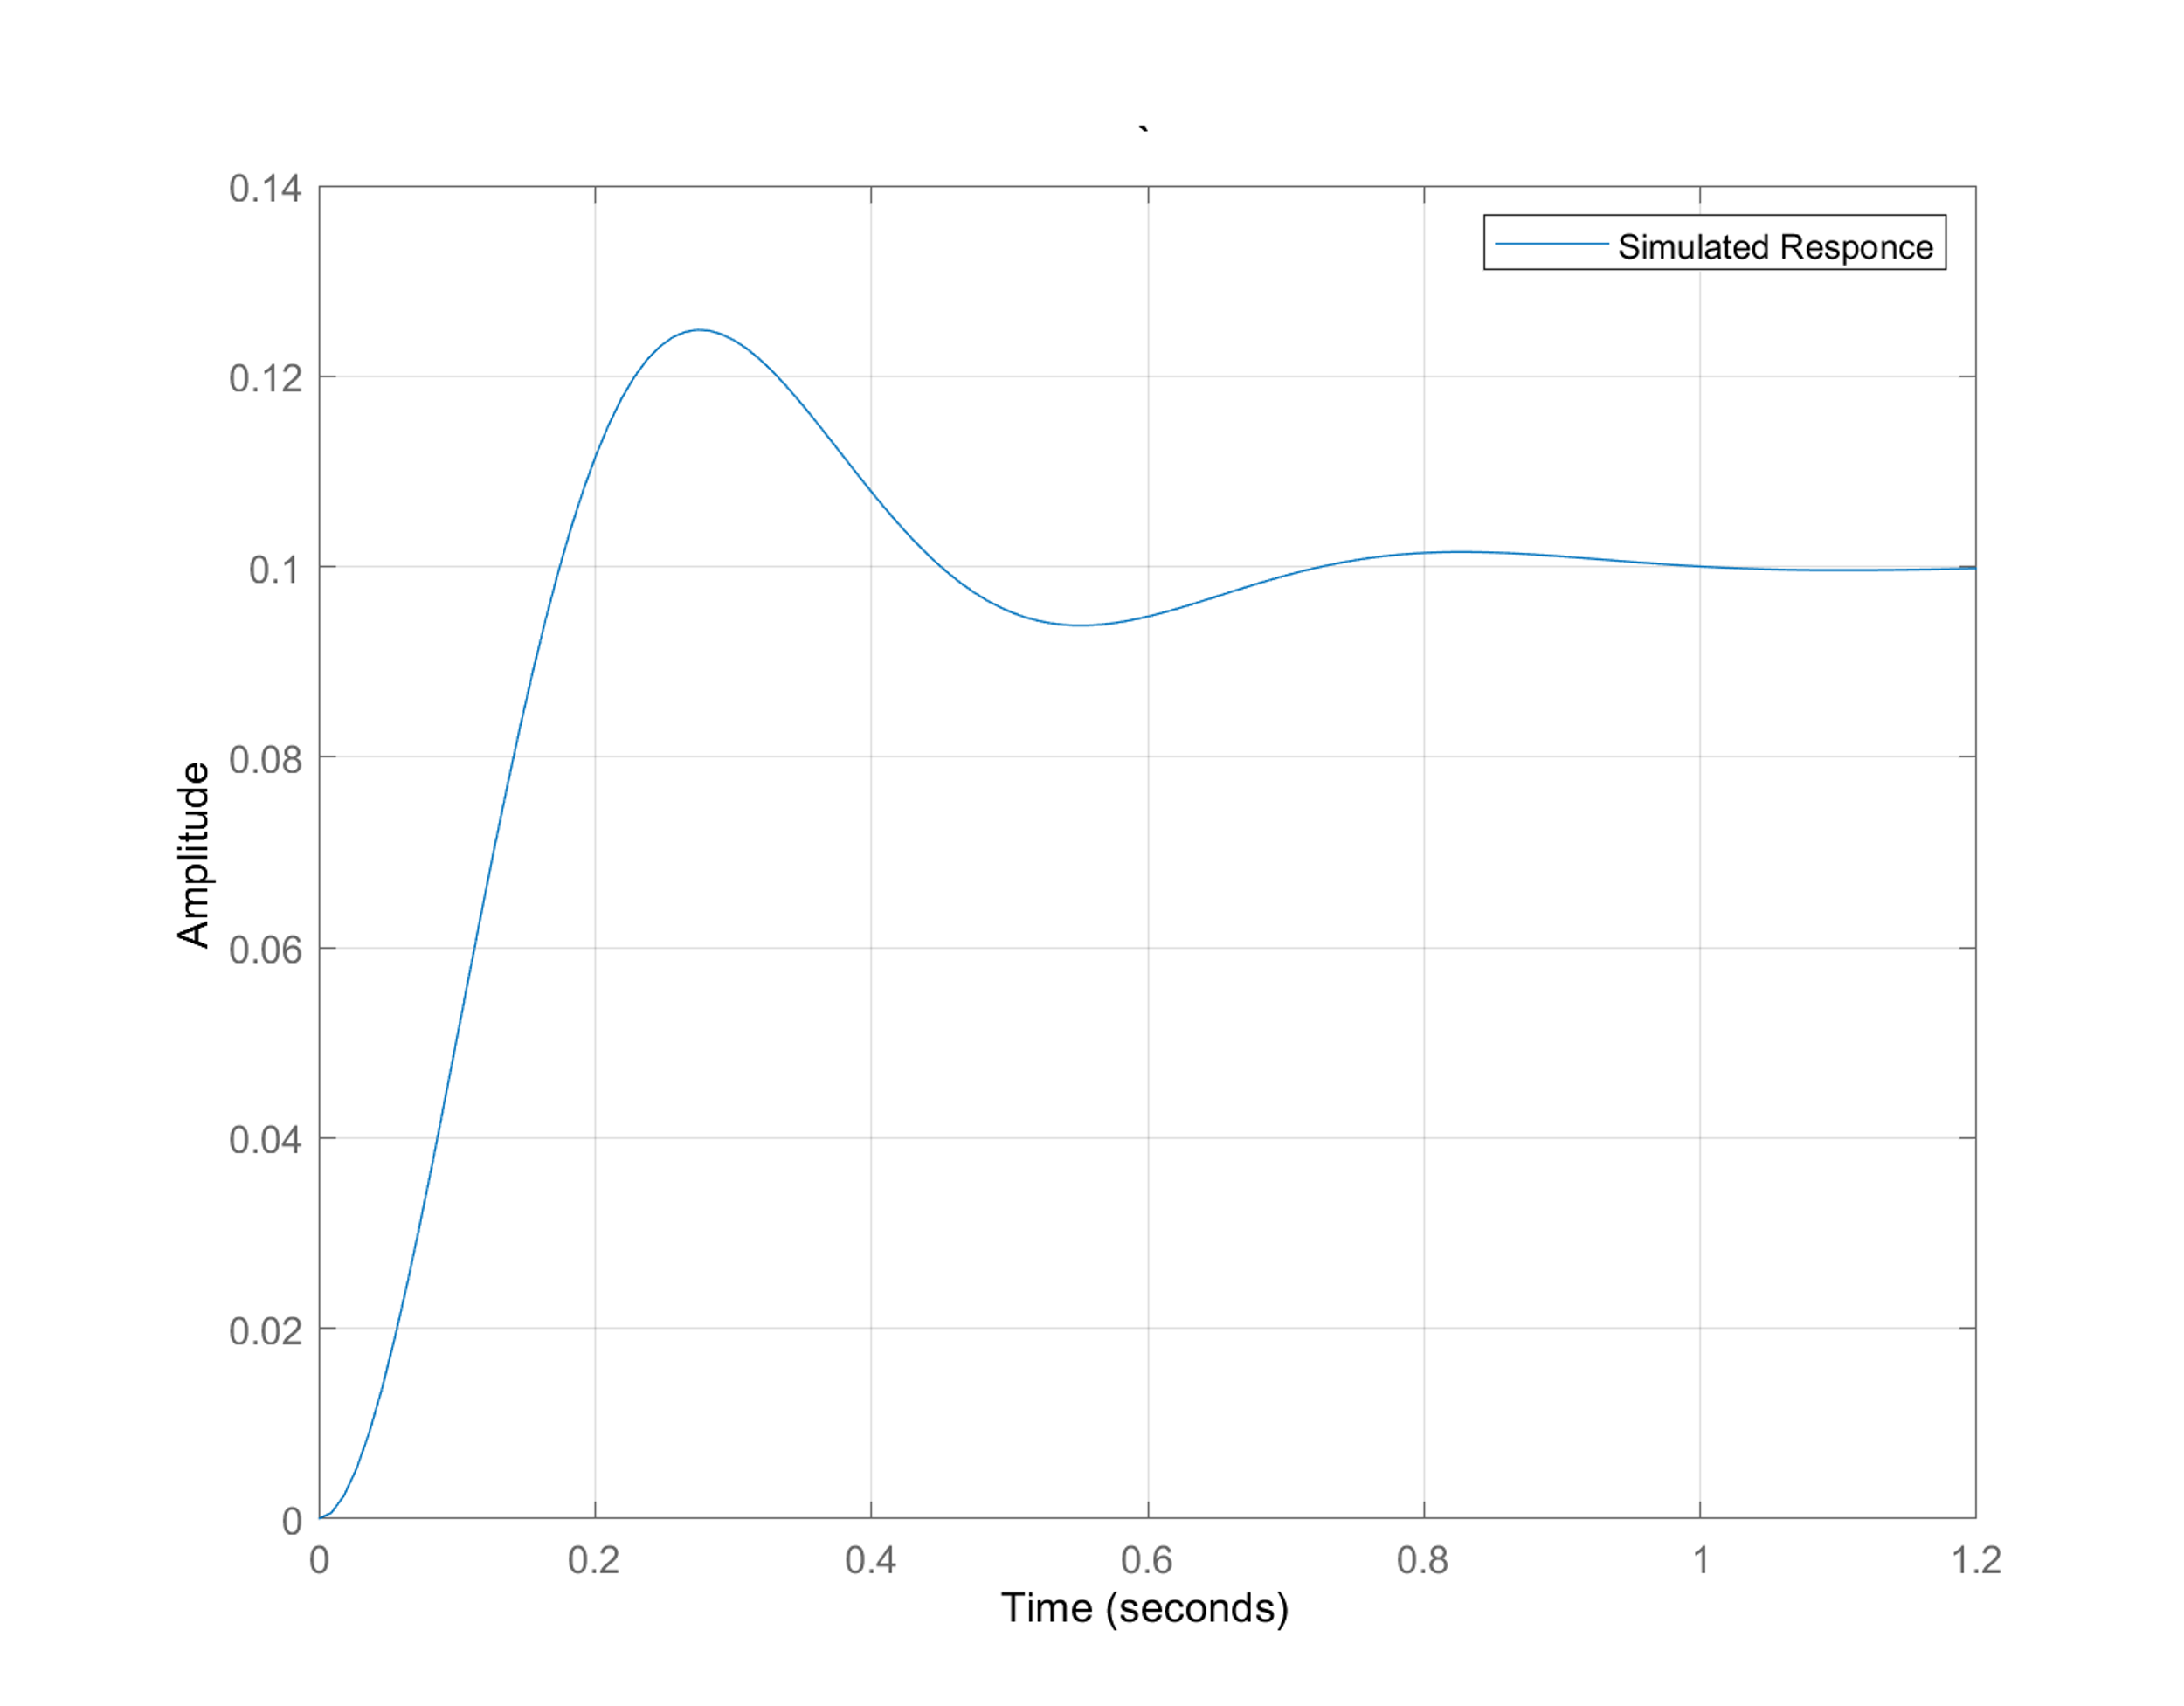 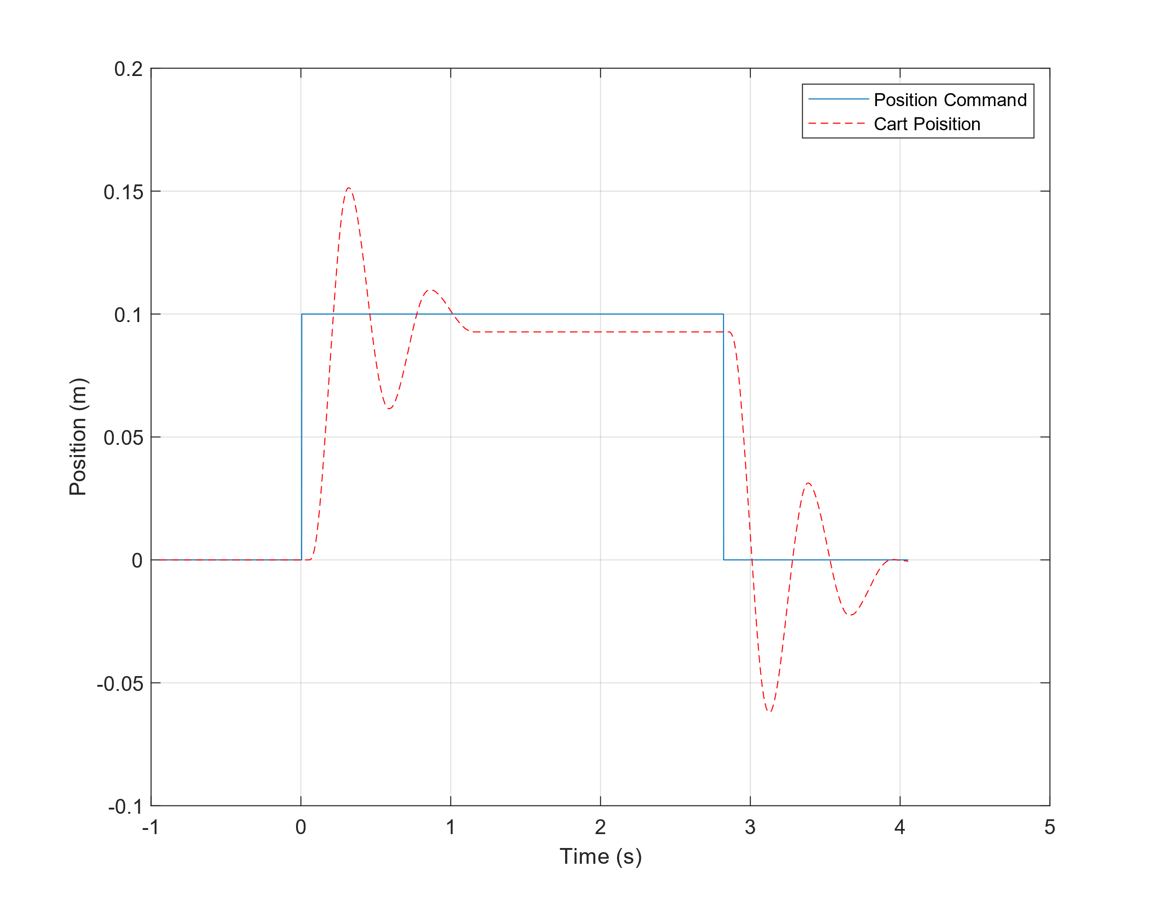

**Figure 1: Left: P Control Simulated response. Right: P Control Real response.**

### PD Control

Gains: KP = 100, KI = 0, KD = 50

Figure 2 shows how larger values of KD produce erratic behaviour.

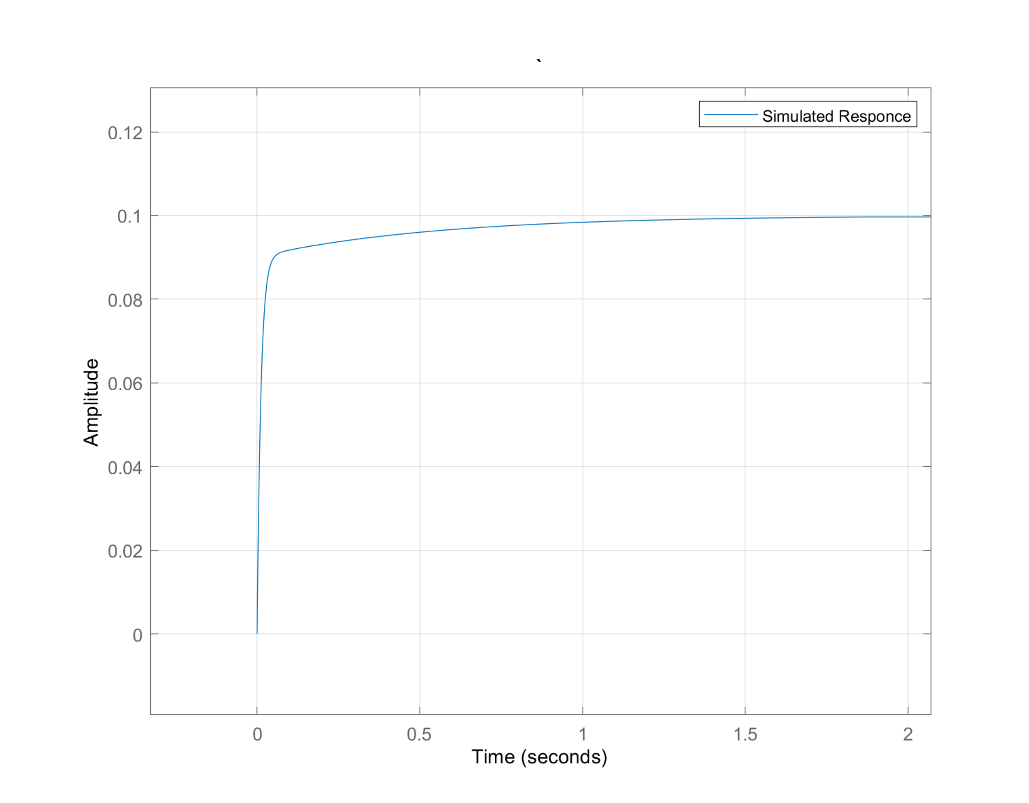 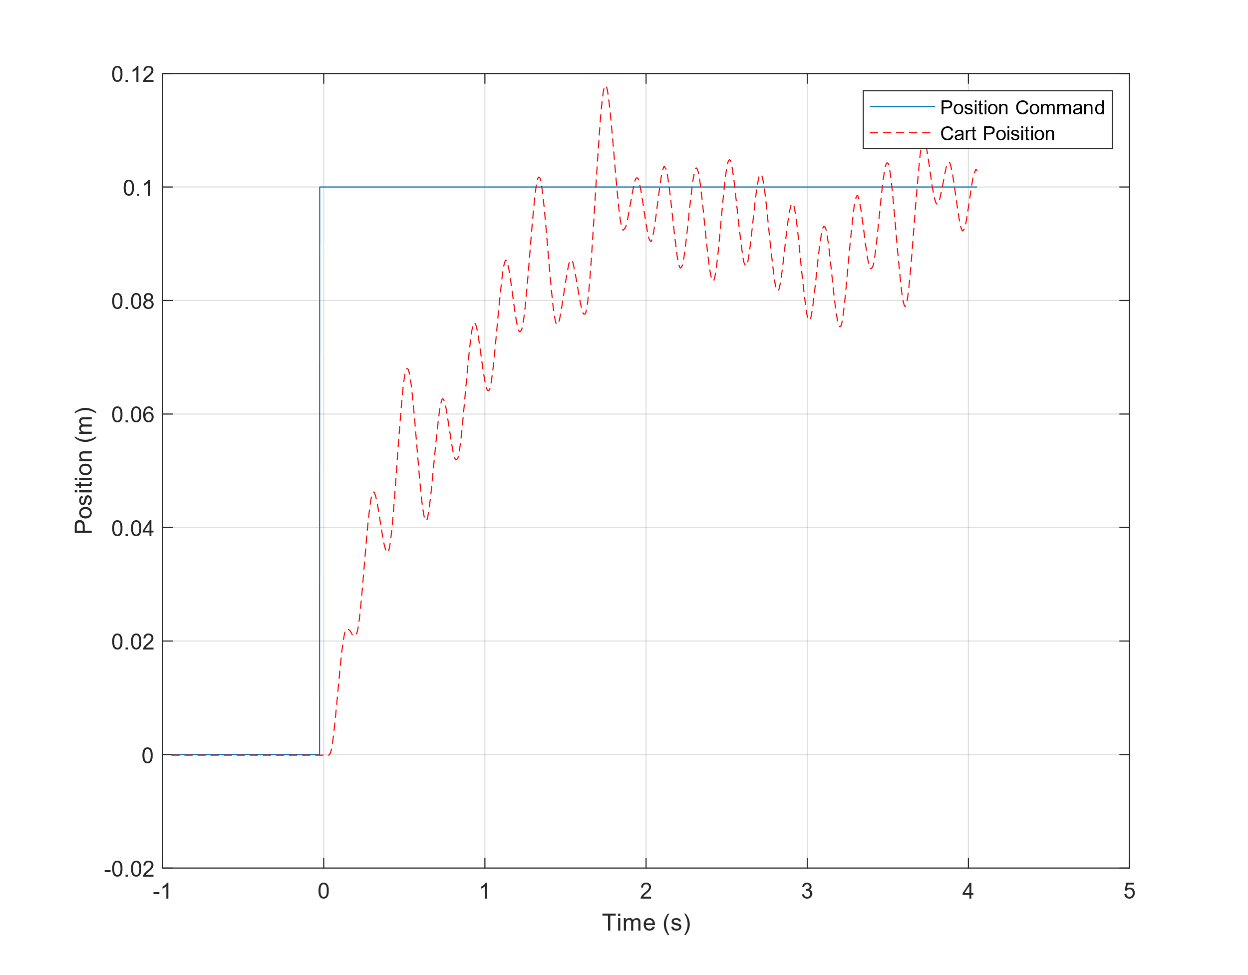

**Figure 2: Left: PD Control Simulated response. Right: PD Control Real response.**

### 

### PI Control

Gains: KP = 75, KI = 200, KD = 0

Figure 3 shows that PI control high levels of oscillation.

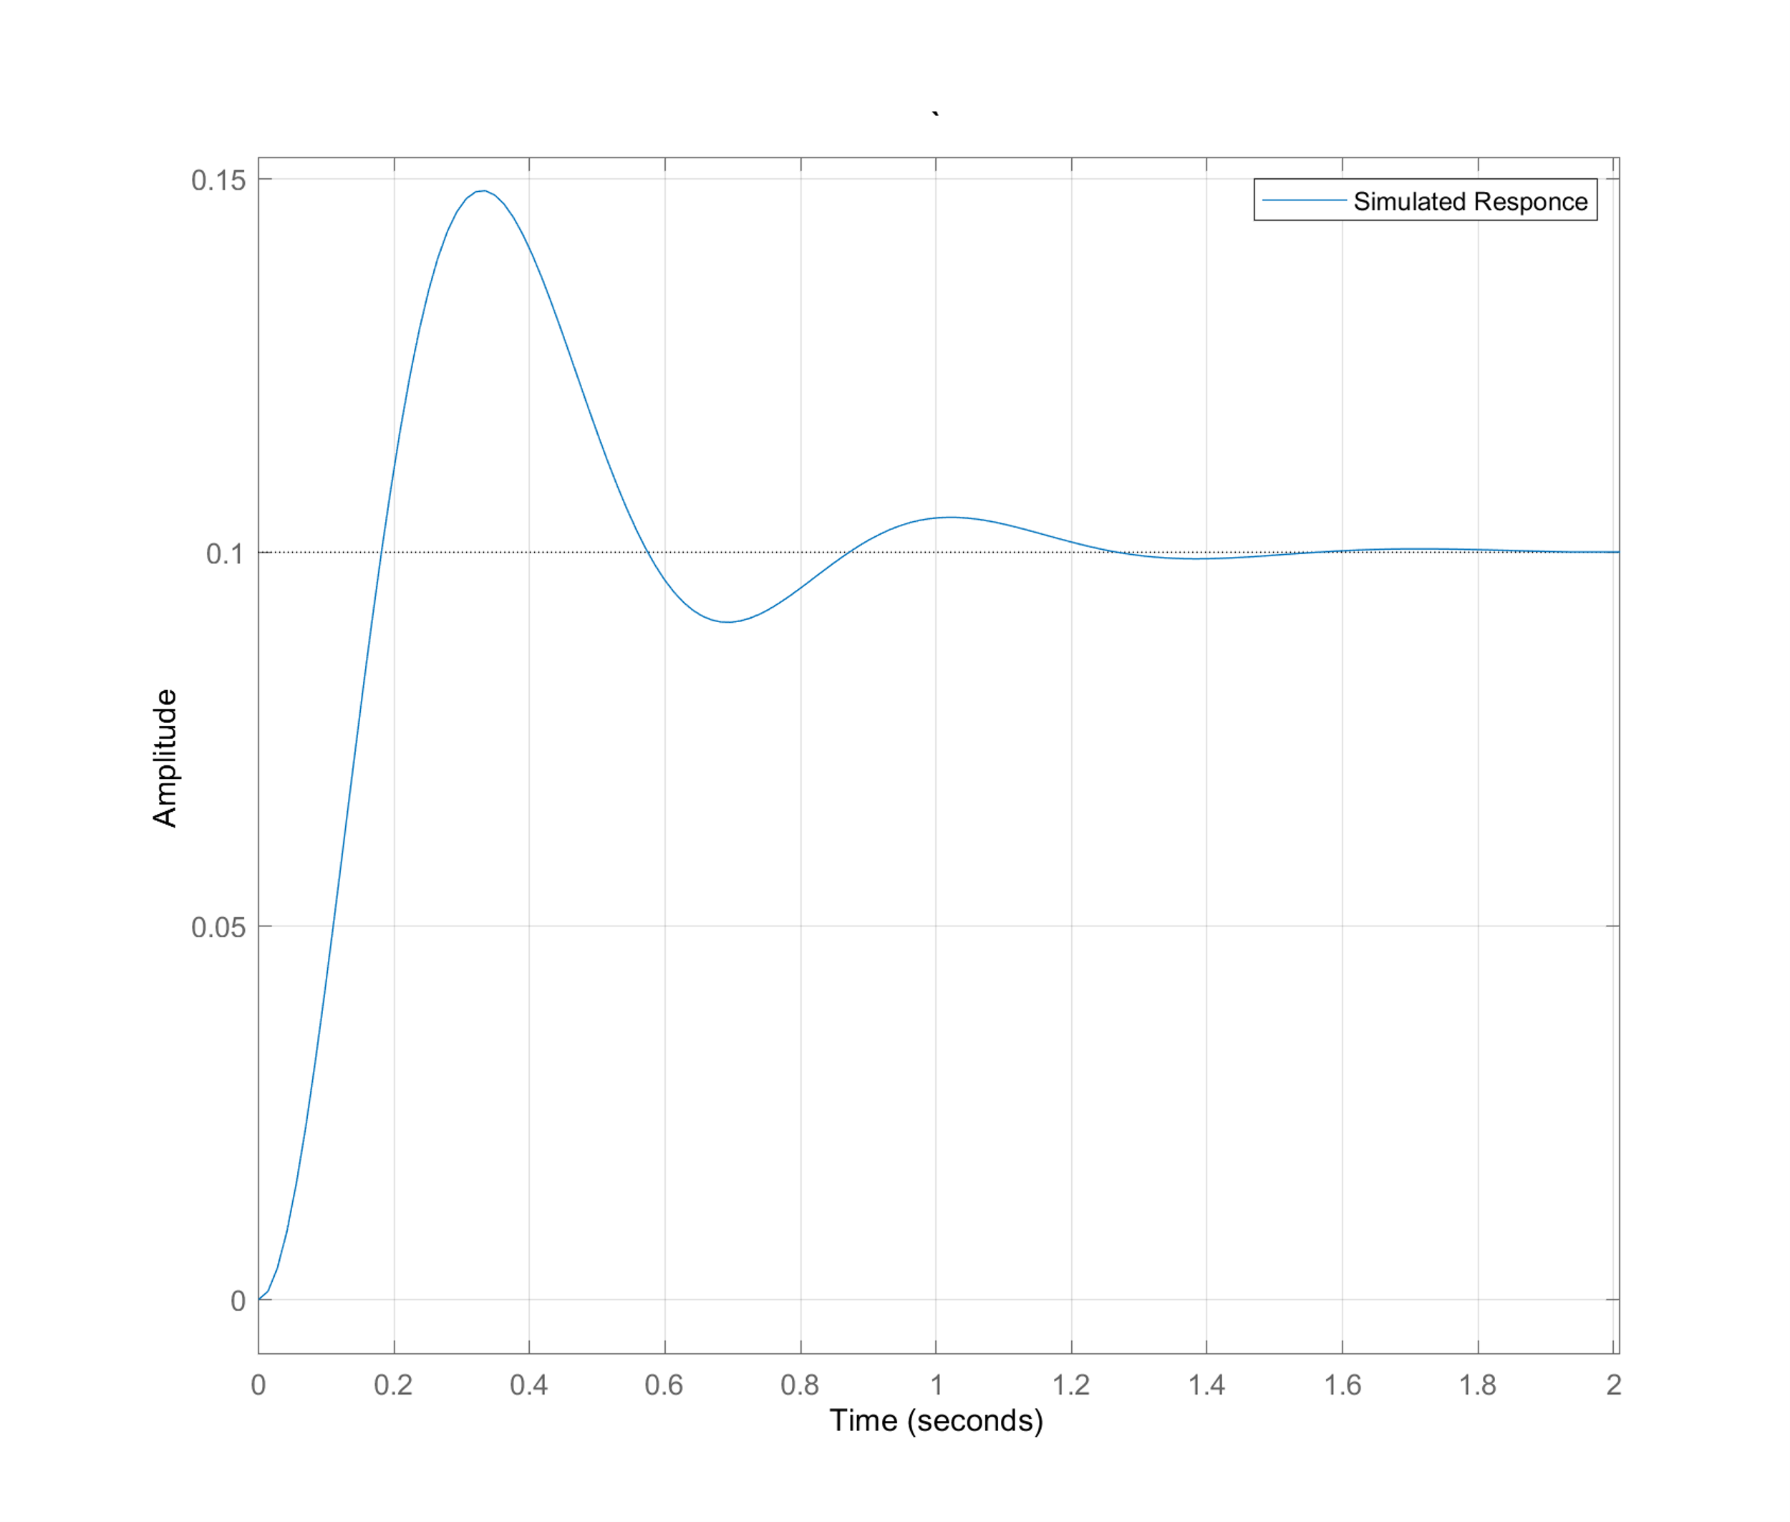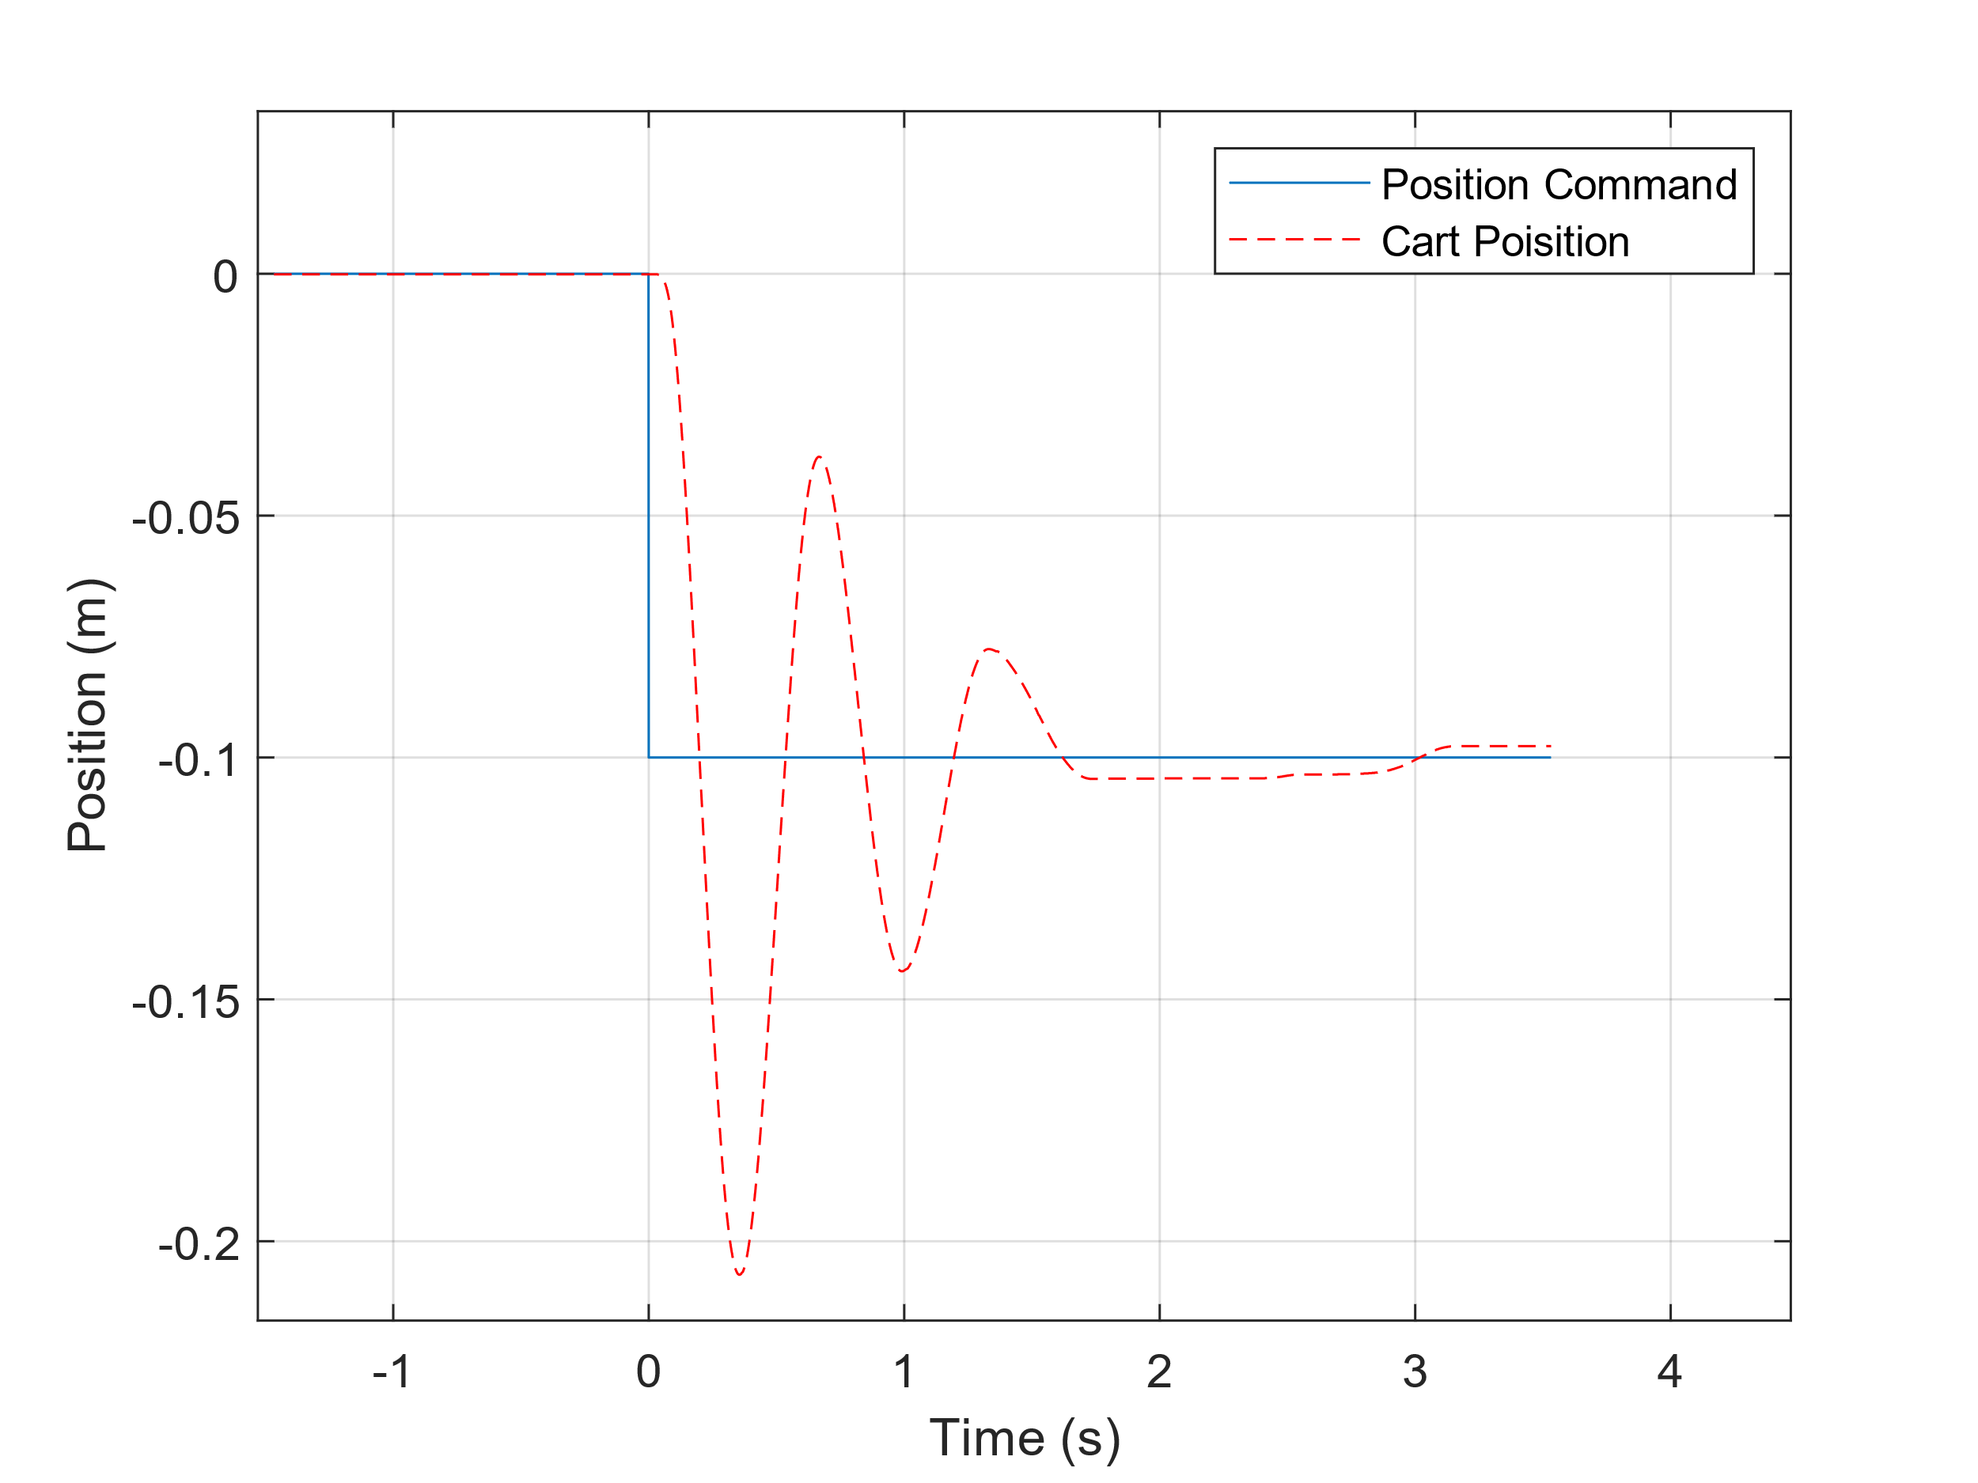

**Figure 3: Left: PI Control Simulated response. Right: PI Control Real response.**

### PID Control

Gains: KP = 50, KI = 200, KD = 5

Figure 4 shows how the dynamics of the simulated response do not exactly match the real dynamics of the cart.

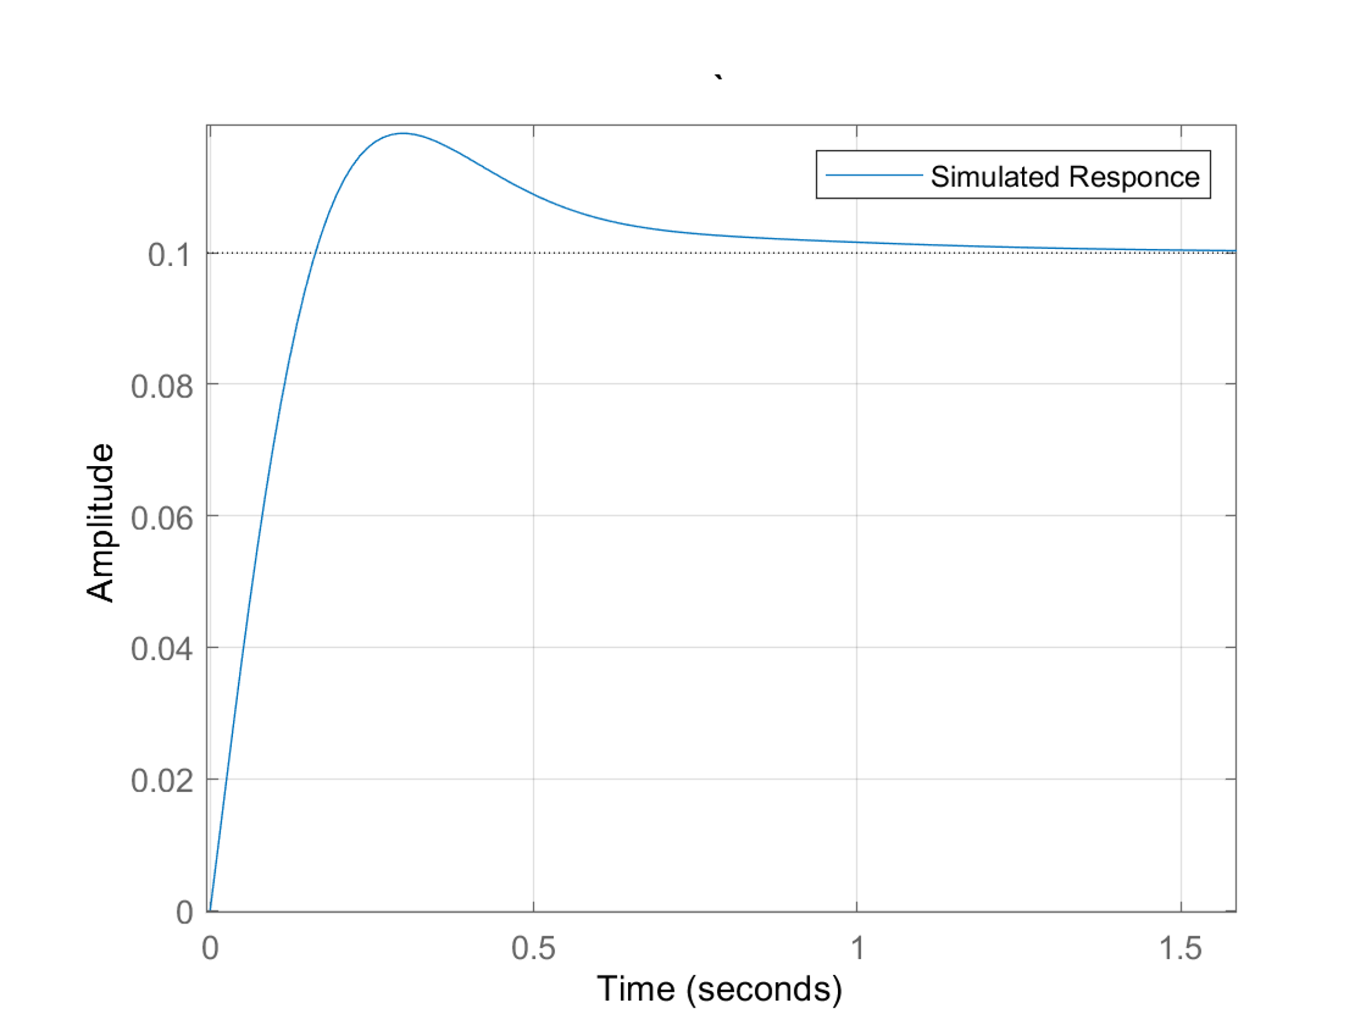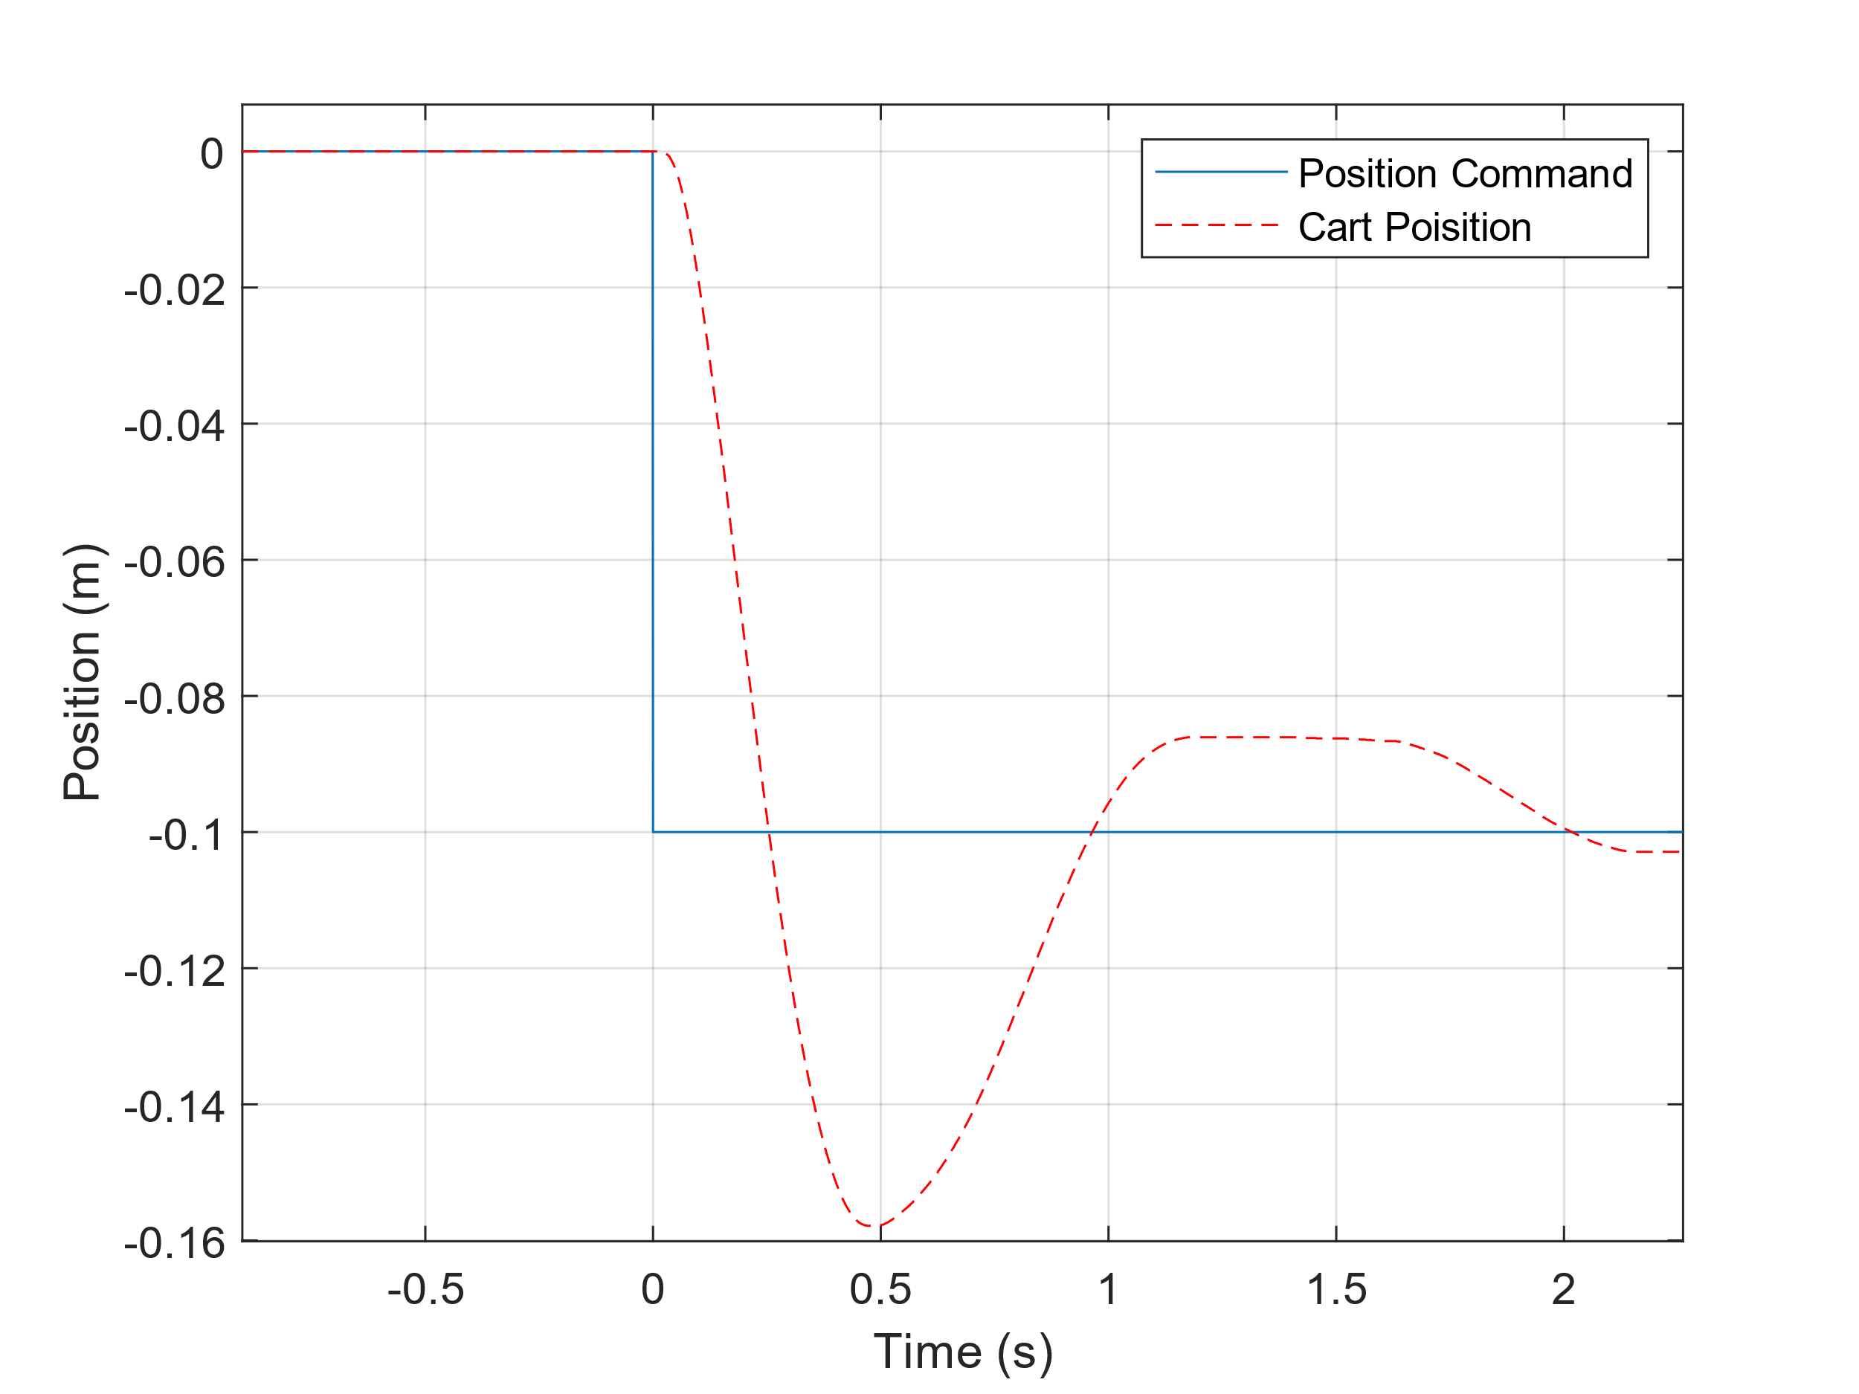

**Figure 4: Left: PID Control Simulated response. Right: PID Control Real response.**

## 2nd Lab Tests

### Optimal Gains

In the second round of testing, the results and insights from the first tests were used to estimate the best gains for the real cart. Minor adjustments were made to the gains during the lab tests to find the best fitting gains. These gains were found to be: KP = 118, KI = 4, KD = 9

Figure 5 shows the results of these adjustments. Table 1 shows compares the results of the gains to the design specifications Purple Minions Ltd.

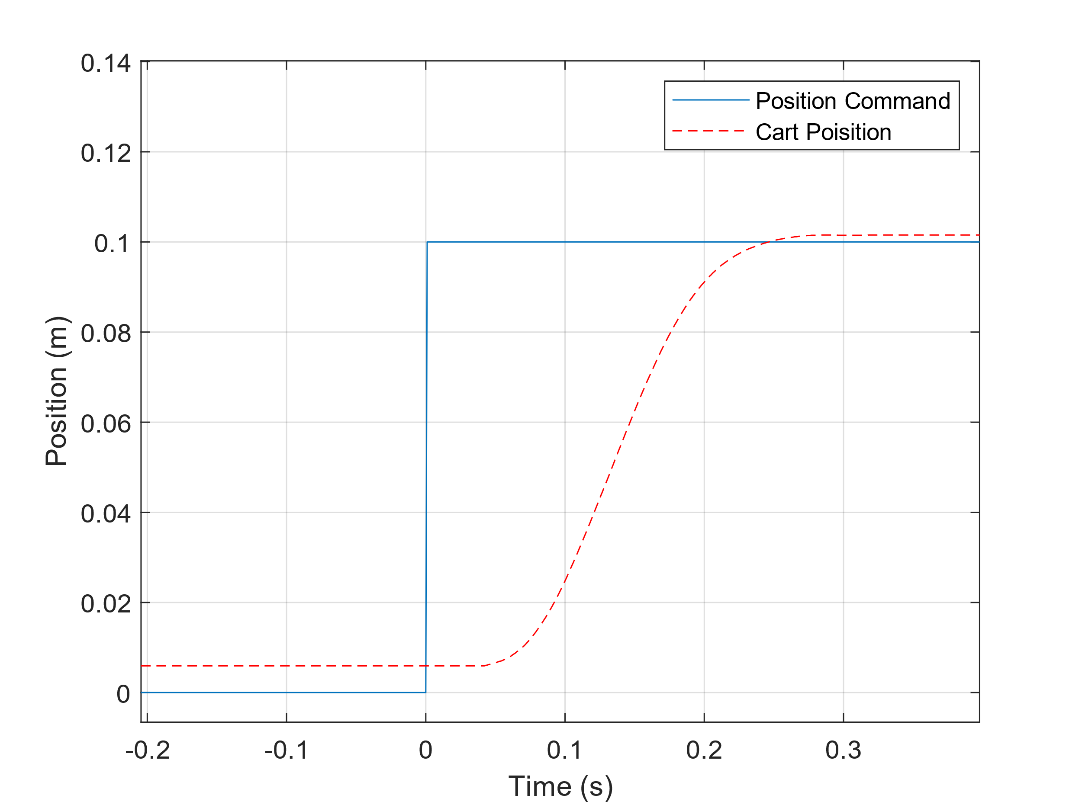

**Figure 5: Optimal PID Gain Response**

**Table 1: Required Specifications to Gain Results**

|  |  |  |  |
| --- | --- | --- | --- |
|  | Required Specifications | Calculated Specifications | Achieved? |
| Overshoot | < 30% | 5% | Yes |
| Damping Ratio | > 0.1 | 0.7 | Yes |
| Steady State Error | < 0.1 mm | 1.5 mm | No |
| Rise Time | < 0.5 sec | 0.2 sec | Yes |
| Settle Time | N/A | 0.3 sec |  |

### Assemblies Per Hour

With each robot taking 2 tasks at 2 seconds each, plus the settle time of the system for each task:

:

# Discussion

## PID control

A PID controller uses proportional, integral, and derivative gains to alter the dynamics of a system. In respect to controlling the volage into the motor, proportion control acts as a spring; higher KP results in larger voltage values, results in higher motor speed. This means proportional control has the most impact on the rise time of the system. This can be in the figure 5 where a large value of KP resulted in a rise time within the design specifications.

Derivative control acts like a damper, reducing the overshoot of a system by acting on the rate of change of the system error. This can be seen in difference between the simulated respond of the P controller (Figure 2 Left), and the simulated response of the PD controller (Figure 1 Left). The P controller oscillated, while the PD controller does not. Derivative control has the most effect on the settle time of the system.

Integral does not act like a physical component but adds new dynamics to the system. KI acts on the sum of the error and takes time to build up and effect on the system. Integral control reduces the steady state error of the system. This can be seen in Figure 3. After the system seems to have reached a steady state, the integral control worked to bring the cart closer to the required displacement.

## Difference Between Simulated and Real Results

The simulated results operated on the assumption that the system was linear time-invariant. This is not true to the real world and is the cause of most of the differences between the simulated and real results. The real-world system is a non-linear system. One cause of this is friction. The friction of the system is caused by a changing wire belt length, friction between the carts wheels and the rails, and friction between the gears in the motor. An example of friction affecting the system can be seen in figure 4, where the simulated results show a smooth reduction in steady state error, while the real results have a jump past the required displacement. This is due the controller not being able to overcome the static friction of the system.

Another difference between the simulated and real results can be seen in Figure 2. A derivate gain of 50 was simulated as a smooth transition, but the real cart produced erratic borderline unstable behaviour. This was unexpected as the chosen gains did not account for the real-world controller calculating the derivative as discrete values. This could be improved by increasing the polling rate of the controller, to approximate closer to continuous derivatives, or by decreasing the KD value.

# Conclusions and Recommendations

The optimal gains for the Purple Minions Ltd manufacturing plant are KP = 118, KI = 4, KD = 9. The large P gain increases the speed of the system, and the D and I gains control the overshoot and settle time of the system. Purple Minions Ltd can manufacture 782 cookie robots per hour.