# C:\Users\user\AppData\Local\Microsoft\Windows\INetCache\Content.MSO\94C856CD.tmp

# DevOps2019 Mid Test Questions

Answer all the questions below.

Name: Oshri Baruch

Date: 06/12/2019

## C:\Users\user\AppData\Local\Microsoft\Windows\INetCache\Content.MSO\66C54A08.tmp

## Q1 Linux Basics

1. Name at least two distributions of Linux

**Answer:** Ubuntu , RHEL

1. What is the difference between using **>** and **>>** to write into files? What is **2>** ?

**Answer:** the first is overwrite the file and the second add to the bottom, the 2> write error to the file

1. Explain the commands: **which**, **touch**, **gzip**

**Answer:** which - shows details on a file, touch – create file, gzip - archiving utilities

1. What is the command to search all the files in **/etc** that are older than 2 days?

**Answer:** find /etc -mtime -2-print

1. What is **~** referring to in Linux Shell?

**Answer:** this home directory of the user how login

1. What is **.** and **..** referring to in Linux?

**Answer:** one dot ( . ) refer to the folder the user is in now, two dot ( .. ) refer to the parent folder

1. What does a dot in the beginning of a file mean? For example **.ssh** ?  
   **Answer:** It’s meaning to source the file – its execute it.
2. What is the .**bashrc** file and what is it used for? Give at least one example. Explain what is the difference between ~/.bashrc and /etc/bashrc

**Answer:** the bashrc executed by bash for non-login shells. The difference is ~/.bashrc personal initialization file and /etc/bashrc its global

1. What is a link in Linux? Explain the difference between a hard-link and a soft-link (also known as symbolic link)

**Answer**: link is a connection between a file name and the actual data on the disk Hard links are for files in one partition basically you cannot link to a file on different partition unlike symbolic links. But if the real copy is deleted the symbolic link will not work, unlike hard links .

1. How would you change a permission to a file to be read only for the user who created it and for its group? (there may be more than one solution, you can write as many as you know)

**Answer:** chmod u+g=r

1. How would you change a **password** for a user?

**Answer:** sudo passwd username

1. What is the command you would use to install **vim** package without being asked any questions by the installer?

**Answer:** yes | apt-get install vim

1. How would you move between edit and command mode in VIM?

**Answer:** By pressing Esc key

1. What is the command to start a service, to stop a service, and to check its status? Use for example the service **sshd**

**Answer:** service sshd start, service sshd stop, service sshd restart

1. How would you create a **sudo entry** for a user? How would you create a password-less **sudo** entry for this user?

**Answer:** I define a schedule for my script by adding it to crontab file – by running crontab -l. And I define a password-less by running sudo commend at fixed time .

## C:\Users\user\AppData\Local\Microsoft\Windows\INetCache\Content.MSO\A8B22556.tmp

## Q2 Cron

1. What is cron?

**Answer:** cron allows Linux users to run commands or scripts at a given date and time.

1. Write a cron job that will run **/home/user1/test.sh** every Sunday at 5 minutes past midnight

**Answer:** 5 * * * 0 /home/ user1/test.sh >> /home/user1/output.txt

## C:\Users\user\AppData\Local\Microsoft\Windows\INetCache\Content.MSO\47EEF3D4.tmp

## Q3 Process Management

1. How would you list all the processes running that their name contains **elevation**?

**Answer:** ps -ef | grep elevation

1. What is the variable **$$** standing for? What is **$?**, and what is **$#**

**Answer:**

$# - all arguments were passed to the Bash script.

$? - exit status of the most recently run process.

$$ - process ID of the current script.

1. What command you would use to see the memory available in your system?

**Answer:** df -h

1. How would you kill a process?

**Answer**: kill $PID , kill ( -2, -15, -9) $PID

1. How would you create a process that cannot be killed with signal INT? How would you kill a process which refuses to be killed?

**Answer:** trap ‘echo “SIGINT caught!”’ SIGINT – AND we sand instead SIGKILL

1. How would you run a command (can be **sleep 100** for example) in the background? How would you list all the commands in the background? How to send a command to the foreground?

**Answer:** with the & char we run command in background, jobs for list, fg for foreground

## C:\Users\user\AppData\Local\Microsoft\Windows\INetCache\Content.MSO\BED88D02.tmp

## Q4 User management

1. What command would you use to check what user you are currently logged in to?

**Answer:** whoami

1. How would you check the **id** of a user?

**Answer:** id

1. What is the command to create a new user with the name of **test_user**? Will it have a new home directory? How to make sure it will?

**Answer:** useradd -m test_user

1. What is the command to add the **test_user** to the group **sudo**?

**Answer:** sudo adduser test_user sudo

1. What is the command to change the password of user **test_user**?

**Answer:** sudo passwd test_user

1. What is the command to **delete** user **test_user**?

**Answer:** sudo userdel -r test_user



## Q5 Disk Management

1. What is the command to list all the filesystems on your Linux system?

**Answer:** df -h

1. What is the command used to check disk usage of files and directories? How would you check the size of your home directory?

**Answer:** df -hT /

1. Describe the steps to add a new disk to Virtual Machine running Ubuntu

**Answer:**

so in the beginning the disk is just chunk of data, and with fdisk command you will see all the files system that you have on your machine also with fdisk you connect and set a new file system on new disk , then you define partitions as you wont on that device , and you connect it to your files tree . The most common filesystems in Linux are ext[1 – 4].

1. Explain what **SWAP** is and what it is used for. Describe the steps to add a SWAP file into a Linux system.

**Answer:** a swap is another unit to help the machine to manage her memory, it’s a part of you disk and its less fester but more chip **.**

The step is define a file as a swap with the commend mkswap and active by swapon /swapfile and to add it to the file /etc/fstab

1. What is the **/etc/fstab** file? When will you use it?

**Answer**: it’s the file that make it permanent



## Q6 Networking

1. How would you list all the network interfaces in your system?

**Answer:** netstat -i

1. How would you check your connection to a specific address, say 10.0.2.150?

**Answer:** ping10.0.2.150

1. How would you listen (sniff) to all the network traffic from **port 80** going through a specific network interface **enp0s3**?

**Answer:** tcpdump enp0a3 port 80

1. What is port **80**? What is port **22**?

**Answer:** 80 – http, 22 - ssh

1. How would you open a Secure Shell Connection to **192.168.1.2** with username **user1** using your Linux terminal? How would you do it using your Windows?

**Answer:** both is - ssh [user1@192.168.1.2](mailto:user1@192.168.1.2) ,



## Q7 Scripting

1. - Write a script named **find_files.sh** (you can use either bash or python) that gets two arguments - a name of a **directory** and a **word**.

* The script will print the name of all the files in that directory (and sub-directories) that contain that word (their actual content, not their name).
* The script should check that the input is valid, and print errors accordingly
* The script should take care of return codes according it success or failure to run
* Be sure to document your code (comments).
* Try to keep your script simple.

Example:

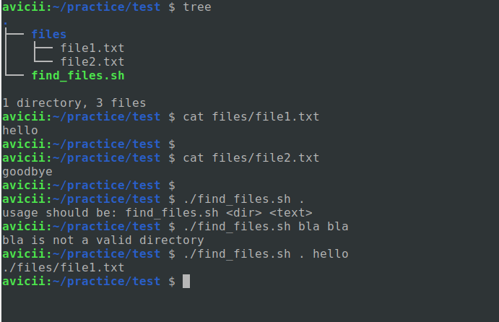

**Answer:**

1. - Write a python script with the name **first_occur.py** that will get a string as an argument and print out a dictionary, the keys will be the characters and the values will be the first occurrence of each character in the string (an example will follow).

* Make sure to check arguments and print errors of bad usage.
* Add comment to explain you script.
* Try to keep it simple.

Example:

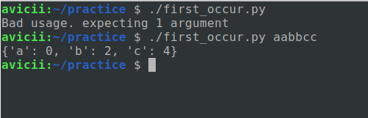

**Answer:**

## C:\Users\user\AppData\Local\Microsoft\Windows\INetCache\Content.MSO\32B617AC.tmp

## Q8 GIT

1. Create a git repository with the name **devops2019-midtest**. Make sure it’s public.
2. Copy the scripts **find_files.sh** and **first_occur.py** from the scripting section into the repository.
3. Create an **Initial Commit**, and another commit (can be anything).
4. Create a branch with the name **test_branch** in it make another commit, and then merge it to the master branch. Delete **test_branch** after merging it.
5. Push all the changes to the remote repository of your **github** account
6. Write down the link to the repo here:

**Answer:**

When done save the doc file and send it by Slack.

Good luck!