

Department of Computer Science

COMP4200 - Introduction to Graduation Project

Making A Change Through Boycott

**Project No:**

5

**Supervised By:**

Dr. Samer Al-Zein

**Prepared By**

Osid Abu Al-Rub (1183096)

Hamzeh Hawwash (1180470)

Hashem Abu Al-Teen (1172660)

# Abstract

Nowadays, a lot of people can find themselves at a disadvantage facing a higher company or person, and usually have no effective ways of going against them except for boycotting, which can be considered as the best way to demand changes in a non-violent way. There are a lot of examples of successful boycotts that have happened over the years, such as the Iranian Tobacco Boycott in 1891, and the boycott that China did against the Japanese products in the May fourth movement. So, the examples are endless, but not nearly enough people consider boycotting as an option of resistance. And if they consider it, it’s still a tremendous task to find people who also want to support and join the boycott, and also finding the products that align with one's belief is very difficult. Making the process of spreading the news about the boycott and getting new people introduced to the movement/boycott a whole lot more complicated. This is why we’ve created this project. In this project, we developed a mobile application that will make it easier for people to discover, participate, and make a change. They can also have the news about a boycott be concentrated in one place via the campaigns that the application provides, which are groups of like-minded people who are also passionate about the same movement. Finally, the application helps the users to determine if a product supports their boycott/campaign or not.

# Table of Contents

## Contents

Abstract I

Table of Contents II

Contents II

List of Figures VI

List of Tables VIII

Chapter 1: Introduction 1

1.1) Overview 1

1.2) Aims and Objectives 2

1.3) Motivation 2

1.4) Technologies Used 2

1.5) Report Structure 3

Chapter 2: Background Information 4

2.1) Adobe XD 4

Repeat Grid 5

Components 6

2.2) React-Native 7

React Native Under the Hood 8

Advantages of React Native 8

Cons of React Native 9

Javascript Syntax Extension (JSX) 10

2.3) Node JS 11

Non-thread Blocking 11

Event Loop 11

2.4) Typescript 12

2.5) MySQL 13

2.6) Barcodes 14

How barcodes work 14

Types of Barcodes 14

3.1) Similar apps 16

3.1.1) Buycott – Barcode Scanner Vote 16

Pros of Buycott 19

Cons of Buycott 19

Differences 20

3.1.2) QR and Barcode scanner 21

Features 21

Differences 24

3.1.3) Facebook 24

Differences 27

3.1.4) Summary of features 28

3.2) Literature Review 30

3.2.1) Does boycotting actually work? 30

What is boycotting? 30

Outcomes of boycotting 30

Successful boycotts 31

Conclusion 31

3.2.2) What is the purpose of using Facebook? 31

3.2.3) Why do people participate in boycotts 32

Chapter 4: System Analysis 34

4.1) Use case diagram 34

4.2) User-system requirements 35

4.3) Class Diagram 40

4.4) Activity Diagrams 41

4.4.1) Creating account activity 42

4.4.2) scanning the product activity 43

4.5) Sequence Diagrams 43

4.5.1) Scanning a product 44

4.5.2) Filtering 44

4.6) Software architecture 45

Chapter 5: System Design 47

5.1) User Interface: 47

5.1.1) Sign in Interface 47

5.1.2) Sign Up Interface 49

5.1.3) Feed Interface 50

5.1.4) Sidebar Interface 51

5.1.5) Post Interface 52

5.1.6) Search Interface 53

Chapter 6: Conclusion & Work Plan 54

6.1) Conclusion 54

6.2) Work Plan 54

References 55

# List of Figures

Figure 1: Adobe XD UI 4

Figure 2: Copy of Design 5

Figure 3: Horizontal and Vertical Alignment 6

Figure 4: Main and Instance Components. 7

Figure 5: How React Native Works 8

Figure 6: React Native Advantages 9

Figure 7: JSX Example 10

Figure 8: The Event Loop 12

Figure 9: Vin Diagram of Typescript 13

Figure 10: MySQL Logo 14

Figure 11: Types of Barcodes 15

Figure 12: Explore and Join Campaigns 16

Figure 13: Suggest a Product 17

Figure 14: Scanning a Product 18

Figure 15 Trending Campaigns and Recent Actions 19

Figure 16: Slow Loading and Errors 20

Figure 17: Main Page 21

Figure 18: Favorite Scans 22

Figure 19: Create Code 23

Figure 20: History View 24

Figure 21: Screenshot of a Post 25

Figure 22: Screenshot of a Facebook Profile 26

Figure 23: Screenshot of a Group Post 27

Figure 24: Boycott Motivations 32

Figure 25: Use Case Diagram 35

Figure 26: Class Diagram 41

Figure 27: Create Account Activity Diagram 42

Figure 28: Scan Product Activity Diagram 43

Figure 29: Scanning a Product 44

Figure 30: Filtering Campaigns 45

Figure 31: Software Architecture 46

Figure 32: Sign in Interface 48

Figure 33: Sign Up Interface 49

Figure 34: Feed Interface 50

Figure 35: Sidebar Interface 51

Figure 36: Post Interface 52

Figure 37: Search by Filter 53

# List of Tables

Table 1: Feature comparisons 29

Table 2: User Requirements 36

Table 3: Work Plan Table 54

# Chapter 1: Introduction

## 1.1) Overview

Mobile applications are quickly becoming more omnipresent, used anywhere and everywhere, making it easier to connect to people and share news between them, which is why we believe, if executed successfully, we can use this power to assist people in making, participating, and sharing a better future via boycotts. An Example of a boycott of products occurred and started on October 22, 2020, when the Arab community got together and decided to boycott French products, because of their constant disrespectful behavior towards the prophet Mohammed**ﷺ** . They urged the French government to apologize and claim that no offense was meant to take place­ [1].

So, how does our application work? And how does it help people with boycotts? The user starts by signing in/registering into our application using his preferred email, in addition to some extra personal info when registering. After that the user can choose between viewing ongoing boycotts, creating one themselves, or participating in existing boycotts. The user is also able to share boycotts and movements to other social media apps like Facebook or Twitter. Furthermore, the user can participate in something called campaigns, which are (put lightly) a community of like-minded people. These communities grow people closer to their cause and makes it really easy for them to always be up to date about anything that they support or care about. Additionally, the user can scan a barcode to view the product’s info and any boycotts related to it, which is useful for the user to know if the product is good for their campaign or not. On top of that, the user can view campaigns/boycotts from all over the world, not just in his/her country. Which is good for people who are trying to enlighten themselves about world issues.

The application is not meant to be a social media app, it’s meant to give people the ability to make their voices heard, and give them the ability to represent themselves and overshadow their governments.

## 1.2) Aims and Objectives

The motivation and objective of this application is to make people’s voices heard, to give the ability for humans with kind hearts and enlightened minds to make the change they want to do around the world without the need to be physically there. Ultimately, our aim is to be the stepping stone for the public to know occupation state products and boycott it in specific, and the other products in general.

## 1.3) Motivation

The program is needed because social media apps take a lot of time out of people’s days, and they don’t focus on change, they instead focus on wasting, consuming, and monetizing people’s time. And that’s not the case in our application, our motivation is to give the space for exploration in the short term, and focus mainly on actions in the long term.

What you should expect is a simple application that delivers people’s voices and identifies unwanted products from occupation state specifically, and from any other oppressing voice generally. This is needed because it’s very difficult for people to identify what products harm their causes/beliefs.

## 1.4) Technologies Used

Many technologies can be used to build such an application like this one. But considering the timeframe and scalability aspects, the following technologies are considered to be the best fit for our cause and goals:

* **Adobe XD:** A UI/UX design tool that is vector-based.
* **React Native:** write Javascript for android, IOS, and web from a single codebase.
* **Nodejs:** It’s a way for the developer to write and run Javascript on the server-side
* **Typescript:** A superset of Javascript that builds upon it by giving you types.
* **MySQL:** Relational database management system built on structured query language.

## 1.5) Report Structure

The incoming structure for the report is simple, chapter two will mainly focus on the background information for the project/application. This means we dive deeper into the technologies used and so on. Chapter three will take a look at some related work that is kind of similar to what we are trying to do. Chapter four will be about system analysis, so diagrams, and user-system requirements. Chapter five will be the system design of the application. Finally, chapter six will be the conclusion of all the work and complexities we faced during the development.

# Chapter 2: Background Information

## 2.1) Adobe XD

It is a design tool that is vector-based, which means the output is an artwork that is made of lines, points, and curves, and not pixels. And this gives us the ability to zoom in or out as much as we want without losing the quality of the artwork. Adobe XD can be used to create simple UI like smartwatch apps to fully-fledged websites [2].

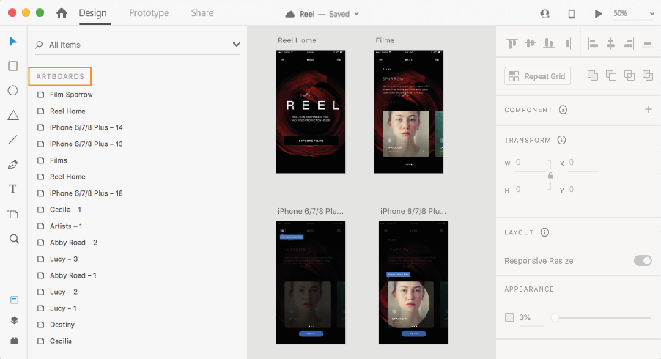

Figure 1: Adobe XD UI

As shown in **Figure 1,** this is the general user interface of Adobe XD. It’s very beginner-friendly and isn’t cluttered as one might expect.

Adobe XD was first introduced in 2015, as a saving grace for all those designers who were using photoshop and adobe illustrator for their designs. Adobe XD came with a lot of features that were not existent before, like prototypes, animations, components, plugins, responsive resizing, and repeat grid. And these are just a few of the Adobe XD features [3].

To dive deeper, we will look at two main features of adobe xd, which are repeat grid and components.

### Repeat Grid

It allows you to create copies of your design and easily rearrange them in a 2D grid using a simple grid. Then you are able to change the horizontal and vertical margins between these copies easily.

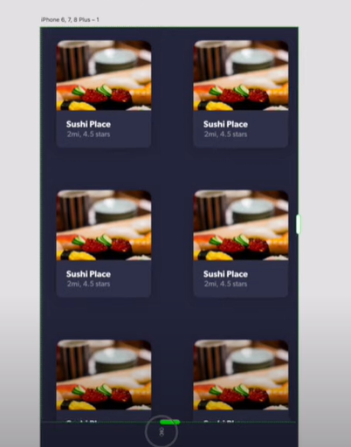

Figure 2: Copy of Design

As shown in **Figure 2**, the designer can easily drag the layout and create infinite copies of their design. And the design is automatically sorted into a grid.

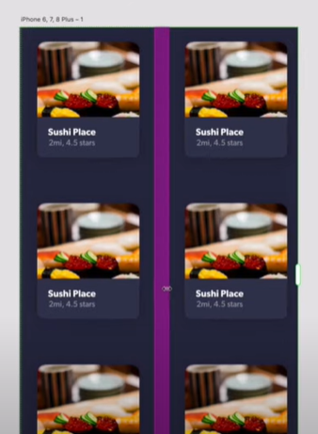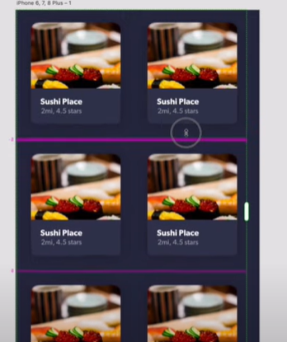\

Figure 3: Horizontal and Vertical Alignment

As shown in **Figure 3**, aligning the created copies vertically and horizontally can be done very easily thanks to adobe XD repeat grid feature.

### Components

A component is a reusable element that functions on two logics, main and instance. An instance is a duplicate of the main component**.** The modifications made to the main element are mirrored to all the instances, but the instances can be independently modified without reflecting the modification on the main.

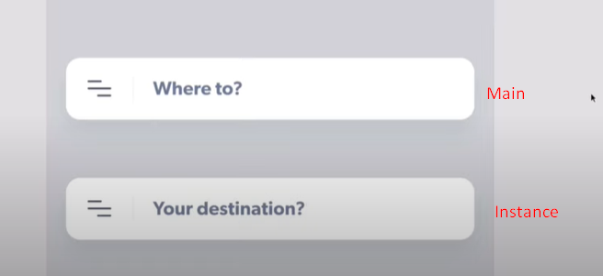

Figure 4: Main and Instance Components.

As shown in **Figure 4,** we have a main and an instance component. If we make the icon on the left in the main component bold, then automatically the icon in the instance will also become bold.

Moreover, all components have states in Adobe XD, which are basically variations of the component. So, for example, if we have a button, this button can have three states, idle, hovered, and clicked. And they all link back to the same main component but with different states.

## 2.2) React-Native

React-Native is a famous mobile application framework built on Javascript that allows you to build android and IOS apps simultaneously. React-Native was invented and implemented by Facebook as an open-source framework in 2015, and it became one of the most famous frameworks used for mobile application development. Before react-native, developers used to wrap their Javascript-based application with something called a “webview” to be able to deploy them as mobile apps to mobile devices. That worked, but it was still hard to a make a website give the native feel of a mobile application, the developers also had to write the code every time for each new system they wanted to deploy on. So at least twice for IOS and android [4].

And that’s how react native was born, the developers can change the code in one place, and then it is automatically compiled and shipped to both the app store and the play store, resolving the biggest headache and creating the era of “Learn once, use many” [5].

### React Native Under the Hood

React native works in a really special way, it allows the developers to work on apps by creating Javascript threads that understand Javascript code. This means it makes a bridge between the app and the platform that the application is targeting. This bridge takes advantage of the library and transforms the components hierarchy to mobile device views. For example, toggling a toggle would be translated into an event that Javascript can handle, after that, via the messages between native platforms and Javascript code, the react native bridges translate native events into something that react-native components can understand and make sense of [6].

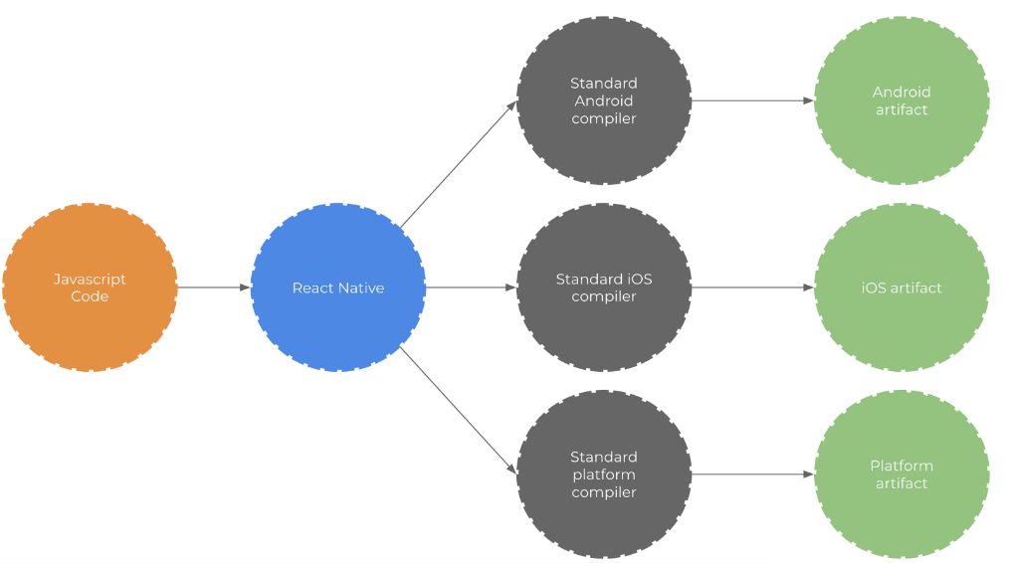

Figure 5: How React Native Works

As shown in **Figure 5,** the developer writes Javascript code, which is then (based on the platform) is converted accordingly via the bridge (the blue circle). For example, if we had a button, react native bridge will connect the button to the android button or IOS button based on the platform [7].

### Advantages of React Native

Here are some (and not all) of the advantages of react-native:

* **React native is community-driven:** Facebook made react native in 2013 actually, but made it officially open source in 2015. This allowed a flood of skilled and talented developers from around the world to join in and add to this already amazing library. This also created a bond between the react-native community and react-native itself, in return, this makes it really easy to find help online when using react-native.
* **Optimal code reuse and cost-saving:** in react native, you can use the same code for android, ios, and any other platform. Which are a huge time and cost saver for any developer/business.
* **Live reload:** If you had two screens, one has the code and the other has the emulator for your work. You can immediately see the changes you made to your code without the need to close and reopen the emulator. Which is such a beautiful thing.
* **Strong performance:** react native is made and tuned for mobile environments because it makes use of the GPU and not only the CPU.

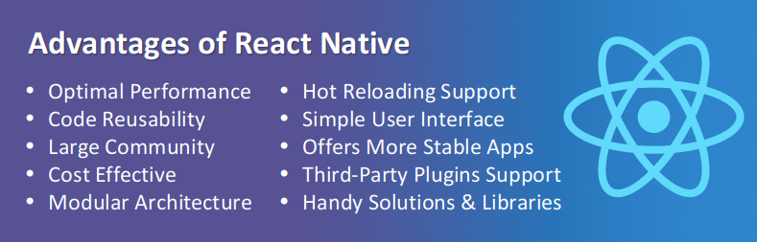

Figure 6: React Native Advantages

As shown in **Figure 6,** react-native has countless advantages, some of them are already mentioned above but more can be seen in the figure [8].

### Cons of React Native

It’s not all rainbows and sunshine in react native land, there are also some cons and they are as follows:

* **Hard to debug:** since it’s a cross-platform library, sometimes bugs can occur on one platform but not the other, which makes it hard to determine if it’s the result of the code or the platform itself.
* **Hard to determine UI:** transitions and animations can get quite tedious if the developer has a lot of them because he needs to be careful that these animations align with the standard for the platform.
* **Still immature:** react native is still new, which means that every update has some major changes usually. And sometimes, this makes it hard to adapt.

### Javascript Syntax Extension (JSX)

React native is written in JSX, it’s simply Javascript script functions that are sugar-coated to make it easier for the developer to use and read. It uses a syntax similar to HTML, with opening and closing tags, but at the end plain Javascript functions that are executed at runtime [9].

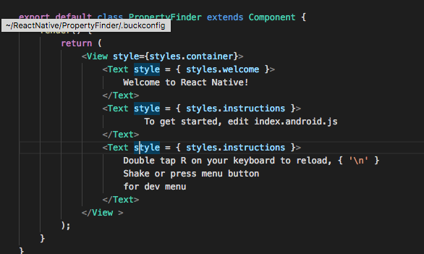

Figure 7: JSX Example

As shown in **Figure 7,** this is a simple example of the react-native syntax. **View and Text** are the JSX tags.

## 2.3) Node JS

A lot of big companies use Nodejs to build their applications, like LinkedIn, Netflix Uber, Trello, and many more. Even though the technology is still relatively new (released in 2009) it is bringing a lot of developers and corporate businesses in because of its amazing features. Additionally, any developer who is familiar with Javascript will not have a problem with picking it up.

NodeJS is an open-source, runtime environment for running Javascript code independent of the browser. Its use in the web is often to build backend services or application programming interfaces (APIs for short). Nodejs is perfect for implementing scalable, data concentrated, and instantaneous backend services that back up our application. Furthermore, the technology is non-thread blocking and it presents the event loop construct [10].

### Non-thread Blocking

This is what node is mostly famous for, non-thread blocking means that there are no worries of deadlocks because all processes are done asynchronously. Even though Javascript is single-threaded, Nodejs still manages to provide great performance for I/O operations with nearly no blockage.

### Event Loop

Node presents and utilizes an event loop; the event loop is what allows and enables nodes to perform non-blocking tasks (even though javascript is single-threaded) by delegating tasks to the system kernel when possible. And since modern-day kernels are multi-threaded, they can handle multiple tasks simultaneously without any issues.

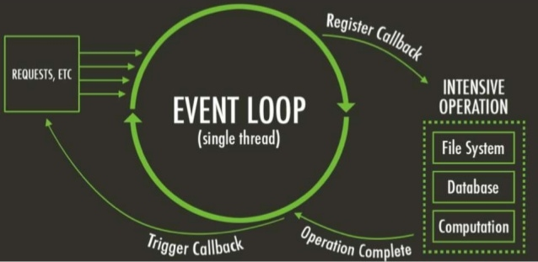

Figure 8: The Event Loop

As shown in **Figure 8,** the event loop can be looked at as an infinite loop. The **register callback** part is where the event loop delegates work to system kernels. And when the **operation is complete**, the system kernels give the event loop the result. Which then fires the **trigger callback** step, and this basically does any required operations to the returned data.

## 2.4) Typescript

Javascript became the known scripting language for the web over time, but the problem with current Javascript is that it’s not made for current, modern, large web applications. Why? Because it is really hard to scale an application that is made without any kind of type checking during development, which results in messy, huge bugs after deployment.

In comes typescript, to put it lightly and simply, it is a superset of Javascript that provides static types and is compiled to plain Javascript, so it can run in the browsers. Why do we need static types though? For many reasons, but some of them include avoiding null and undefined values that the developer won’t be aware of without the help of a compiler, giving the developer the ability to refactor the code more easily whilst being aware of any breaking changes, and finally, depending on external documentation or someone’s brain to memorize return values is no longer needed [11].

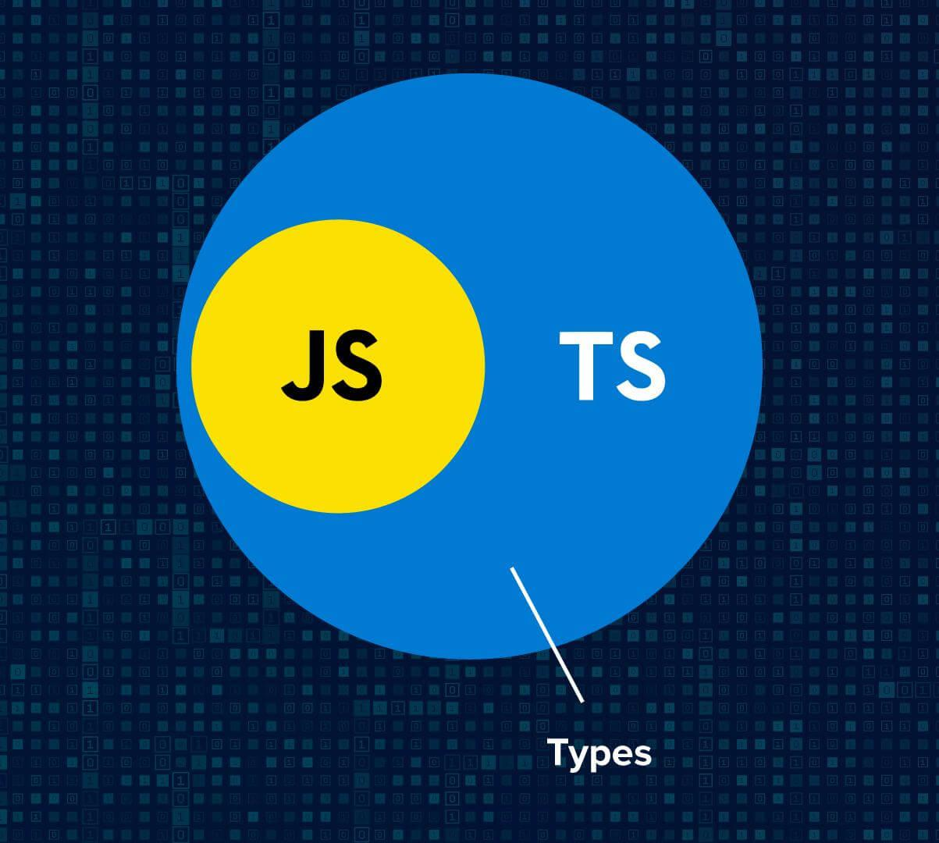

Figure 9: Vin Diagram of Typescript

As shown in **Figure 9,** all typescript does is add types to Javascript. Making it easy to develop and ensuring that fewer bugs arise after deployment.

## 2.5) MySQL

A database management system is a program that communicates with the end-user, software applications, and database to engulf and inspect data. The type of data stored in a database management system can be numbers, strings, dates, images, etc. MySQL is a relational database management system. It is powered by oracle, is open-source, works on many platforms, provides very good connectivity, is scalable, provides data migration, and many more features. It also uses a structure that allows the users of the database management system to identify and access data that has relation(s) with another piece of data in the database [12].



Figure 10: MySQL Logo

As shown in **Figure 10,** this is the MySQL logo. Fun fact, the dolphin represents the performance, power, and precision of MySQL, and its name is Sakila [13].

## 2.6) Barcodes

A barcode is made of several black and white bars that can be scanned using a scanner called a barcode scanner. Usually, barcodes are used to identify products in a fast, optimal way. In other words, it is a machine-readable portrayal of characters and numbers. It can be found on basically any product that one buys these days.

### How barcodes work

In a nutshell, a barcode encodes info, turning it into a visual pattern, which can be read using a barcode scanner. The black and white bars represent various characters that follow an algorithm for that specific type of barcode [14].

### Types of Barcodes

1. One-dimensional barcode: usually contains information like product type, size, and color
2. Two-dimensional barcode: is more complex than the one-dimensional type, and can contain more info, like text, inventory levels, and even an image of the product!

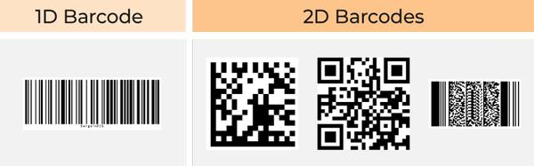

Figure 11: Types of Barcodes

As shown in **Figure 11,** 2D barcodes are more complex with shapes, but we only care about 1D barcodes. Because most products have 1D barcodes

Chapter 3: Related Work

The More we know about the product, the better product we can deliver. In this chapter, to know the product better, we researched the product and looked at related content. This chapter can be split into two sections, sections 3.1 and 3.2.

Section 3.1 talks about three applications similar to ours, and sheds light on their pros and cons, in addition to a summary of all the features, which will show how they differ from our app. In section 3.2, we research and summarize three papers related to our app, which will help us know the app better.

## 3.1) Similar apps

### 3.1.1) Buycott – Barcode Scanner Vote

The application was released in 2013 with more than one million downloads on google play. It helps its users to make changes and get unbiased information about the products by using a barcode scanner. Features in the application include:

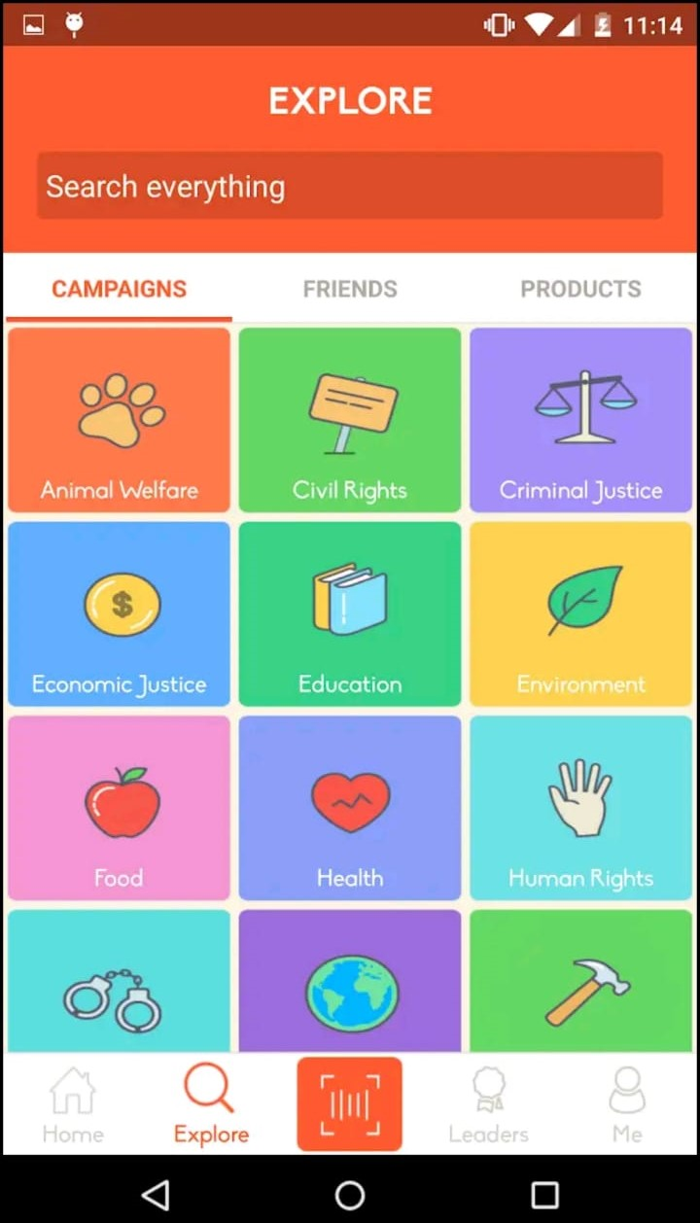

Figure 12: Explore and Join Campaigns

As shown in **Figure 12,** the application allows you to look up and interact with multiple categories. These categories are static and don’t change over time, which restricts the user experience in the long term.

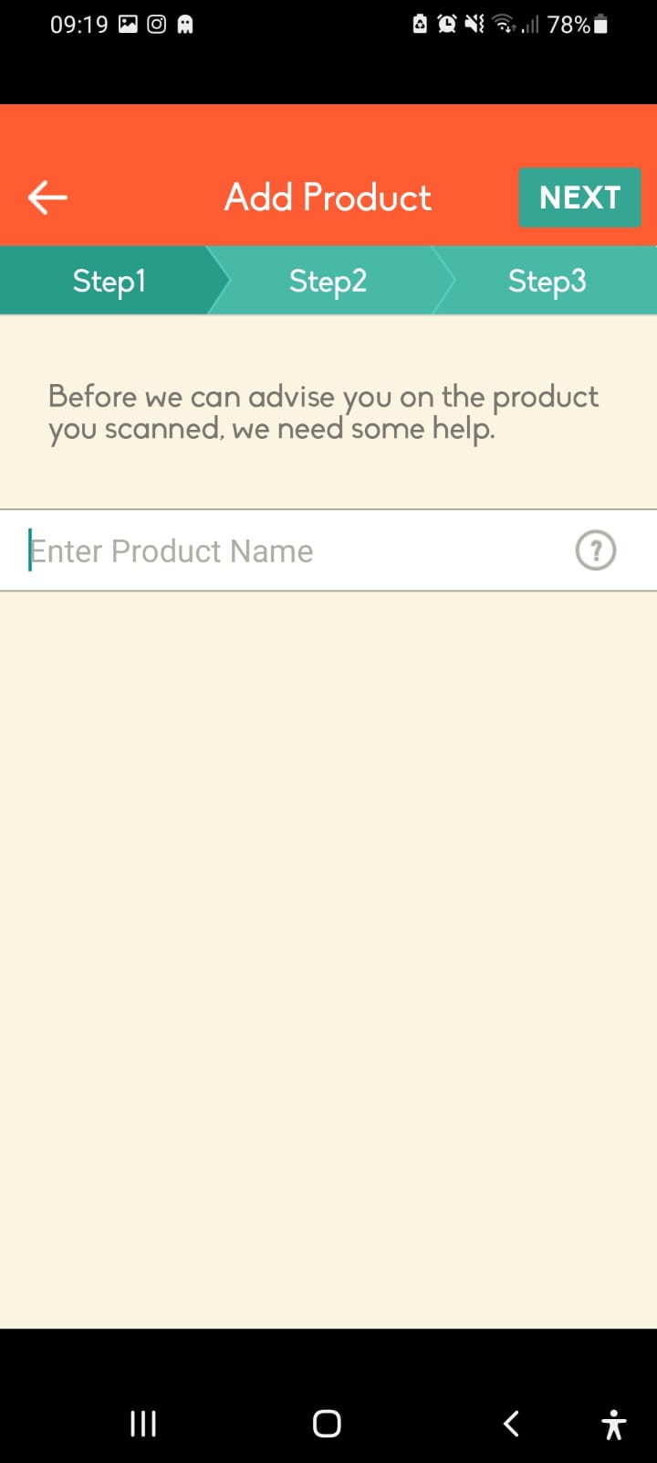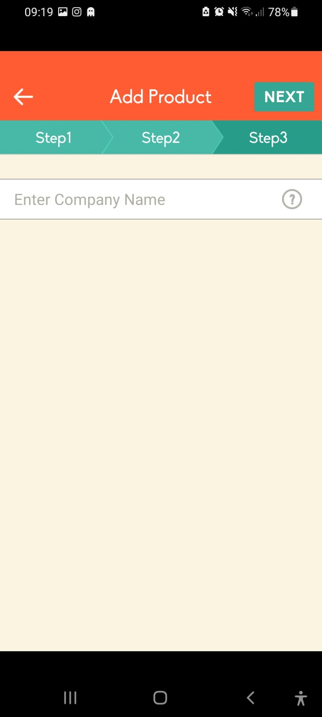

Figure 13: Suggest a Product

As shown in **Figure 13,** This is a three-step process that allows the user to firstly enter a product name, enter the product’s picture, and finally enter the parent company of the product. So that the maintainers of the app can add the product to their database.

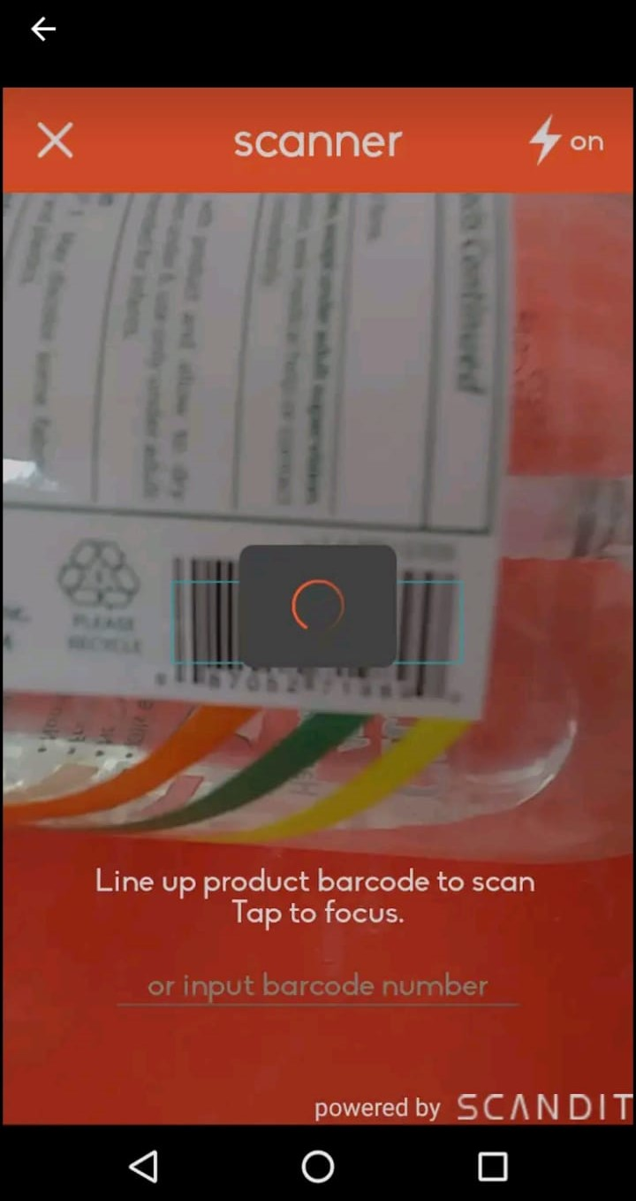

Figure 14: Scanning a Product

As shown in **Figure 14,** the user has the ability to scan barcodes and get information about the product. The application also suggests alternatives for the product (sometimes), shows what campaigns/movements conflict with the product, and it also shows information about the company that made the product

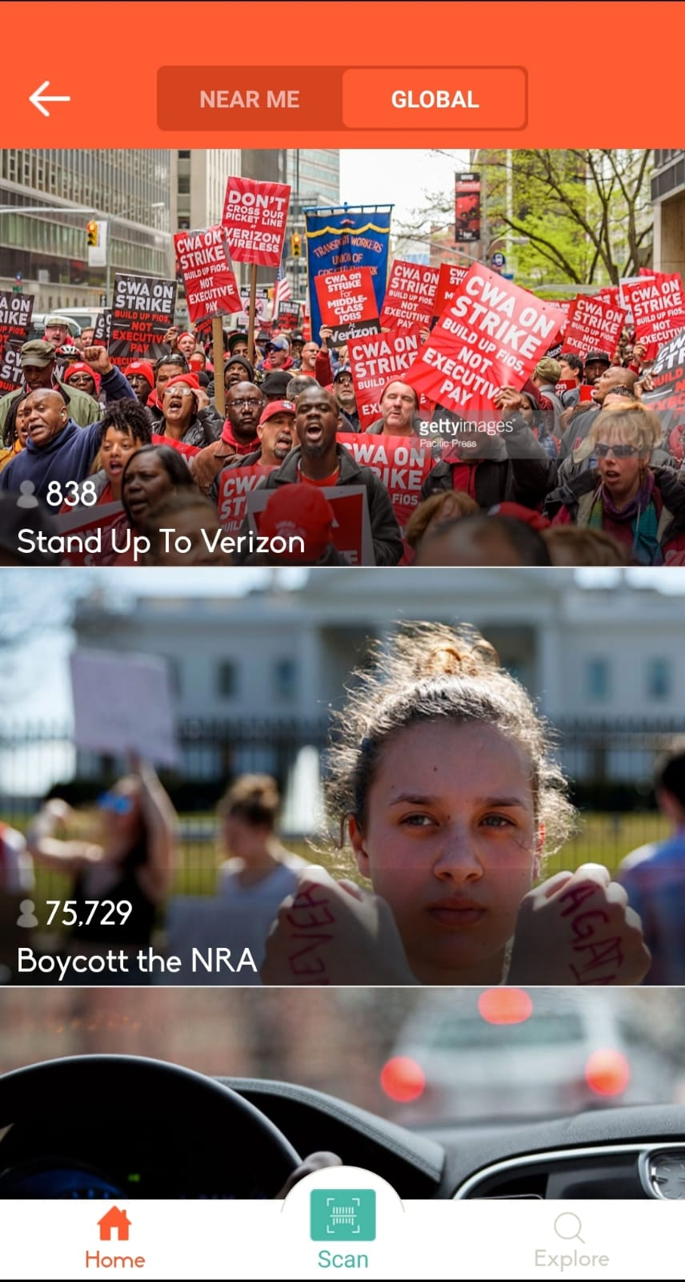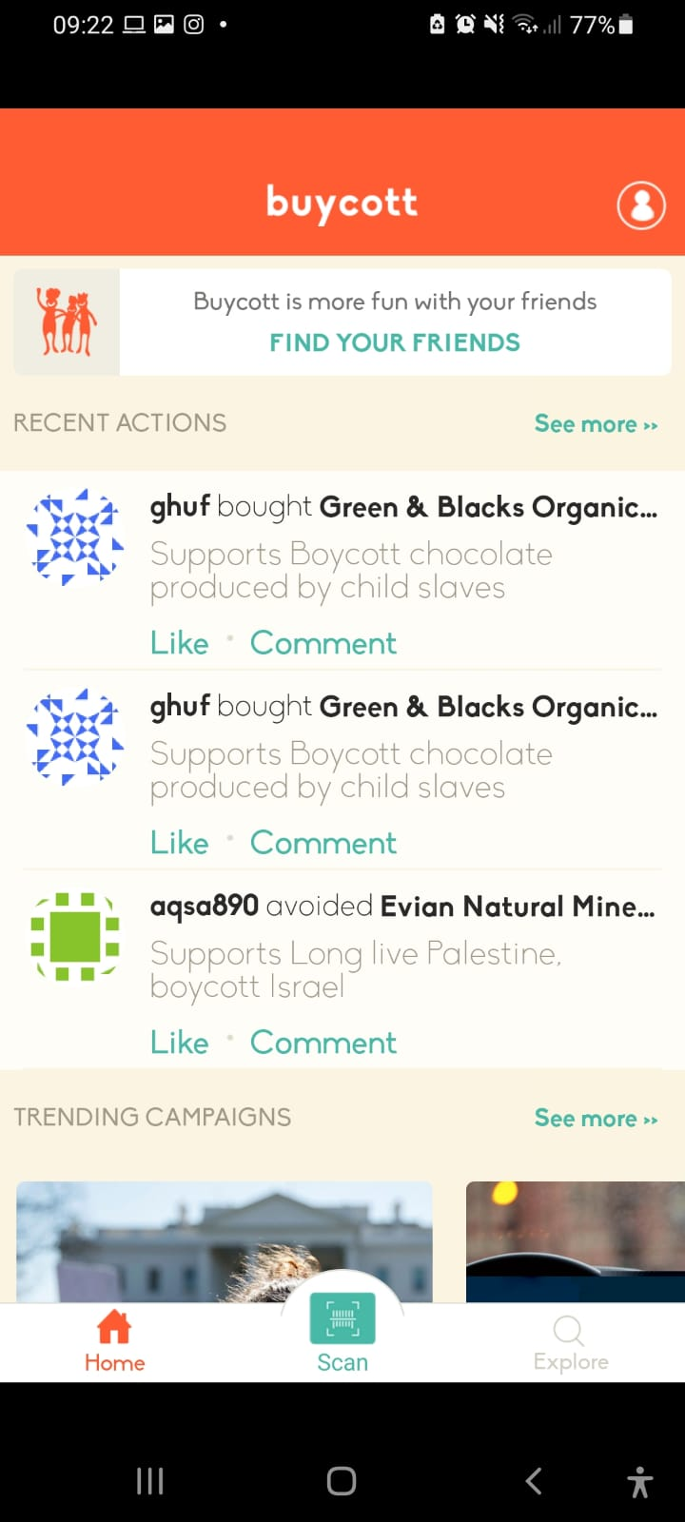

Figure 15 Trending Campaigns and Recent Actions

As shown in **Figure 15,** the application shows some trending campaigns, it also shows recent actions/campaigns near the user’s location.

### Pros of Buycott

There is a lot of pros and good things about this application, like the fact that it is the first of its kind, it also has had a very large audience in the past, and finally, the application has a very large database that contains a lot of products and their parent companies.

### Cons of Buycott

Buycott is not a perfect application, it is full of flaws, no updates have been pushed to the application since 2016, their API costs money for developers to use, it is a social media app in disguise, and last but not least, it is full of errors and unexpected crashes.

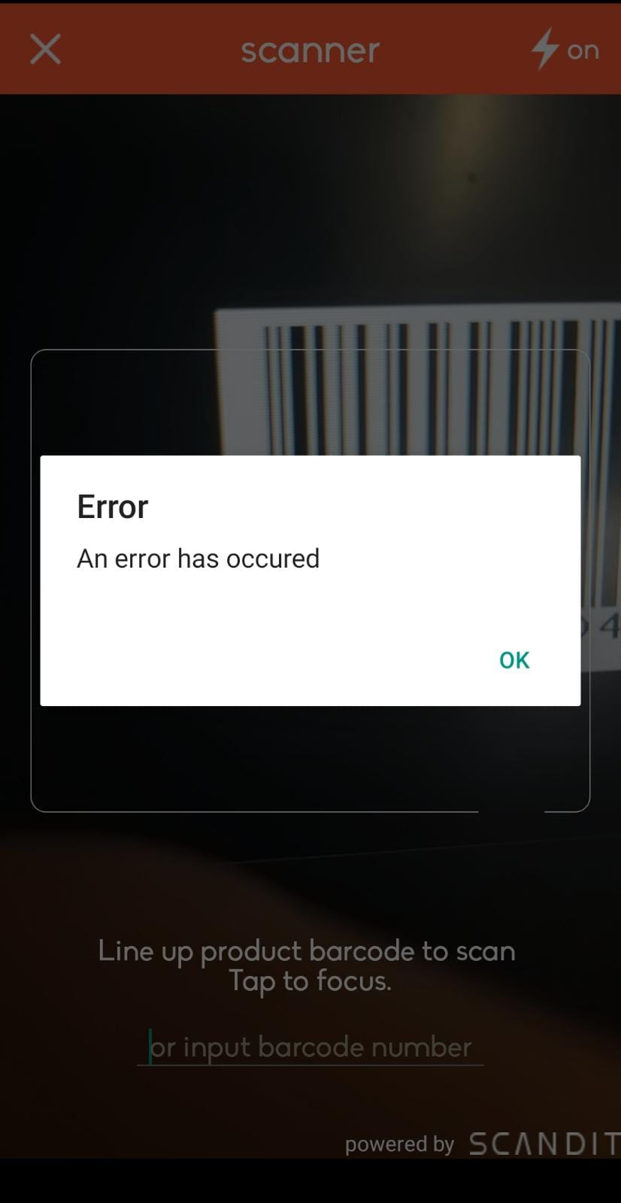

Figure 16: Slow Loading and Errors

As shown in **Figure 16,** the application most of the time crashes whilst trying to scan barcodes and it takes a lot of time to load campaigns and categories related to these campaigns.

### Differences

These are some of the differences between our app and buycott:

* Our app will have constant updates
* It will not have as many errors
* Our application will be built on the community for the community

### 3.1.2) QR and Barcode scanner

QR & Barcode Scanner is a mobile application that allows the user to scan and open QR codes, in addition to scanning barcodes. The application is simple and goes straight to the point, what it does is scan barcodes and QR codes. That’s it.

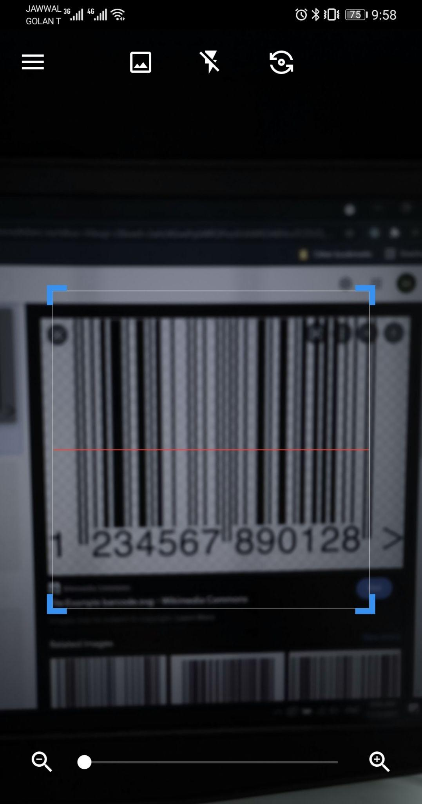

Figure 17: Main Page

As shown in **Figure 17**, the app starts with its main page, the main page contains the camera for scanning, it also contains three icons on the top, two of which are used to flip the camera and use the flash, and one to save the scanned image to the phone. The main page also contains an icon used to open the sidebar, which contains the rest of the app’s features, such as accessing the scans history and the QR creation feature.

### Features

* **Scanning QR codes:** the app uses the phone’s camera to locate and scan QR codes, after the scanning was completed successfully, it moves the user to a new page containing the QR code’s link, in addition to an icon for opening it, and icon to share it, and an icon to copy the link.
* **Scanning barcodes:** the app uses the phone’s camera to locate and scan barcodes, after the scanning was completed successfully, it moves the user to a new page containing the barcode number, in addition to an icon to web search the barcode, and icon to share it, and icon to copy it, and an icon that takes you to Amazon and searches for the product with the matching barcode for the user to buy if found.
* **A history with previous scans:** the app will have a page containing a list of all previous scans and their info.
* **Create a QR:** the app will allow the user to create a new QR code with various info, such as a URL, contact, email, SMS, location, and much more.
* **A favorite section:** the app will have a page contacting the favorite scans which were saved by the user.

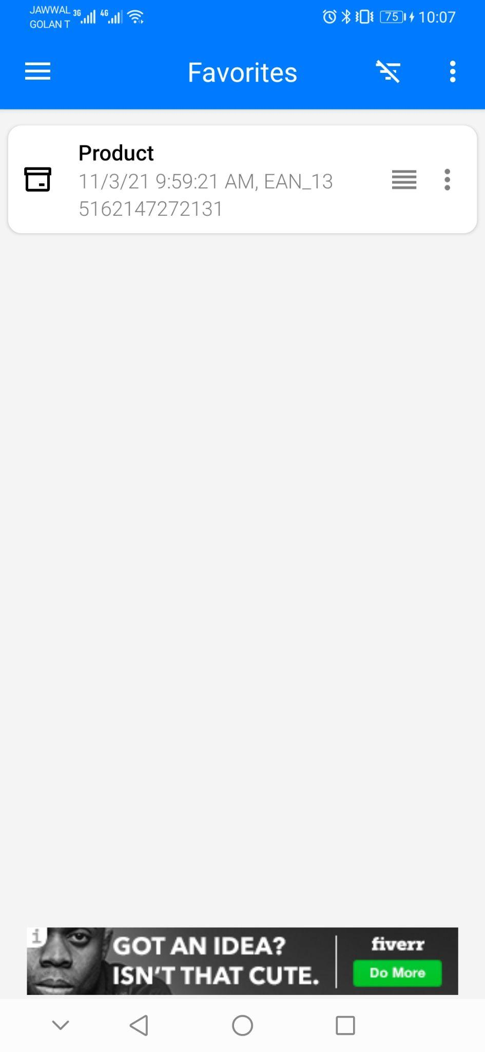

Figure 18: Favorite Scans

As shown in **Figure 18,** the application gives the user the ability to save favorite scans that the user has done in the past.

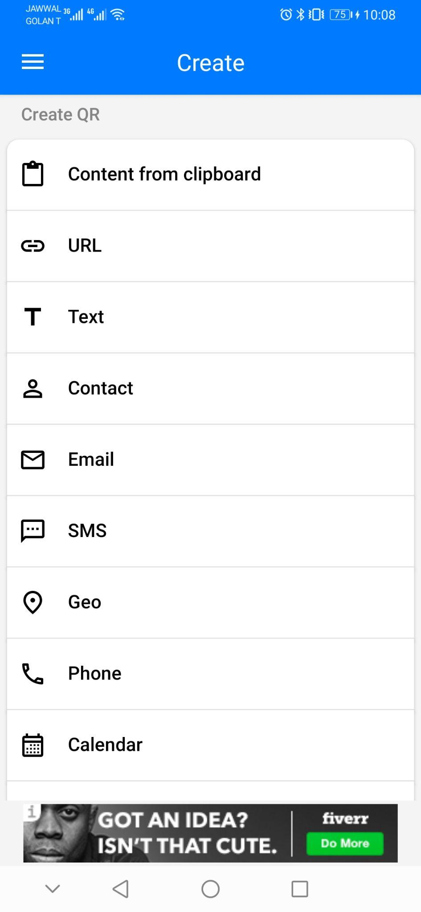

Figure 19: Create Code

As shown in **Figure 19,** the application gives the user the ability to create their own QR codes for their own personal usage.

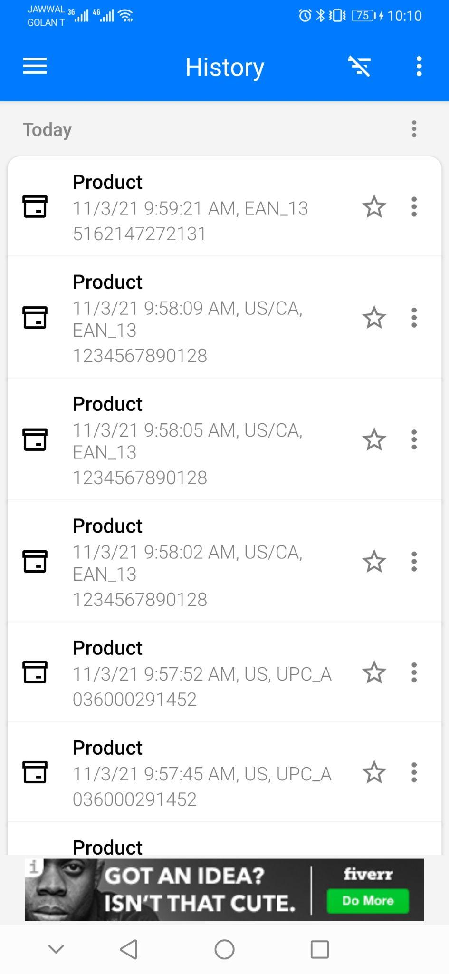

Figure 20: History View

As shown in **Figure 20,** the user can view their past scans via the history view.

### Differences

Our app differs from the QR & Barcode Scanner in different areas summarized below:

* Instead of only showing the barcode number, our app will have the ability to fetch the products info and display them.
* Our app will have a community that will help in adding info to the barcode database.
* Our app will have the ability to load a barcode picture from the phone’s local storage and scan it.

### 3.1.3) Facebook

Facebook is a social networking website that was founded and created by Mark Zuckerberg to connect with his college friends in 2004. By 2006, Facebook became a social networking platform for anyone above the age of thirteen. It gives the users the ability to create accounts and sign into them, then start viewing posts from all over the world. It also allows users to join groups to talk, chat, and view posts from people. Users can also share their thoughts and ideas via stories, which are temporary posts that are visible for twenty-four hours only. Finally, Facebook allows advertisers to pay and put advertisements on Facebook, and it integrates that with the data collection it does about users to show them specific advertisements about things they want.

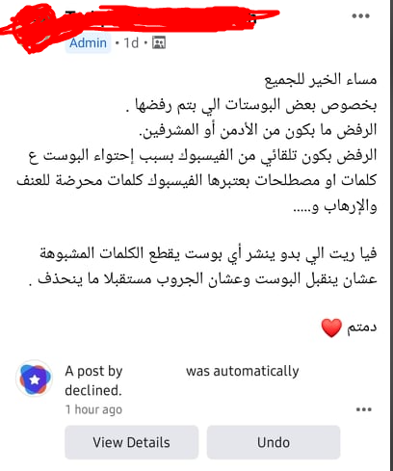

Figure 21: Screenshot of a Post

As shown in **Figure 21,** a post was taken from Facebook group. Coincidentally, the owner of the post is complaining/warning other members of posting any controversial topics in their posts, because Facebook is striking them down.

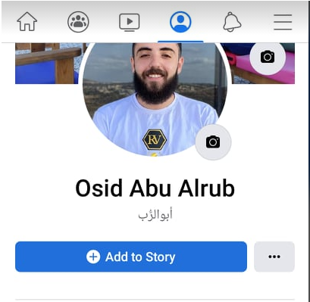

Figure 22: Screenshot of a Facebook Profile

As shown in **Figure 22,** Facebook gives the user the ability to create their own profile and visit other people’s profiles. A profile includes a profile picture plus some possible functionalities for the owner of the account. In this case, these functionalities are adding a story (which is a picture or a video that is available for 24 hours only) or changing the profile picture.

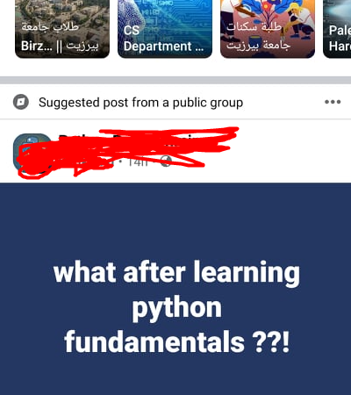

Figure 23: Screenshot of a Group Post

As shown in **Figure 23,** a post that exists on a private programming group, the post here is mainly educational. It is also posted in a group that includes programmers from all over the world.

### Differences

Even though Facebook is really old, it still has issues (other than silencing voices). Some problems include the following:

* **Privacy:** Teens can often forget that what they post on Facebook is public, and unless their personal profiles are set to hidden/private, any user can enter and view the information of their profiles. Usually, teens post a lot of personal information online like images, videos, or telephone numbers
* **Predators:** A lot of times predators and other bad people target young people on Facebook. Due to the fact that its nature pushes adding and meeting new people online, which leaves a lot of young people vulnerable.
* **Cyberbullying:** Facebook provides bullies with a new way and method to bully people online. They can now send repeated bad messages to people and hurt their feelings, and sometimes lead these people (who are bullied) to become depressed and have suicidal thoughts.

### 3.1.4) Summary of features

As shown, the apps above provide some smart features like the ability to socialize on Facebook, the ability to read QR codes from the QR scanning app, and the ability to create campaigns in Buycott. But they also lack some primary features like:

* Privacy
* Ability to express and share opinions freely
* Listening to feedback
* Focused action
* Constant updates
* No bugs
* Responsive and modern
* Built on community
* Image processing

All of the above features and more are going to be included in our application.

The following table summarizes the differences between our app and the mentioned apps:

Table 1: Feature comparisons

|  |  |  |  |  |
| --- | --- | --- | --- | --- |
|  | Facebook | QR & Barcode | Buycott | Our App |
| Ability to fully express opinions | No | No | Yes | Yes |
| Privacy | No | No | No | Yes |
| Used to socialize and learn | Yes | No | No | Yes |
| QR scanning | No | Yes | Yes | Yes |
| Scanning from local storage | No | No | No | Yes |
| Constant Updates | Yes | No | No | Yes |
| Listen To Feedback | No | No | No | Yes |
| Built on the community for the community | No | No | No | Yes |

## 3.2) Literature Review

### 3.2.1) Does boycotting actually work?

### What is boycotting?

Whenever an employee or a consumer finds themselves disadvantaged negotiating against a higher company or person, usually the best choice of action is to boycott. Boycotting is when a person or a group decides to refuse to engage in all transactions involving products of a target company [15].

Boycotting is a non-violent, voluntary, and intentional way that involves refusing to deal with a certain product or target, meaning that the boycotters rely solely on moral persuasion.

### Outcomes of boycotting

Boycotts grow more popular by the second, as social media has made it easier to share and participate in boycott activities. A recent survey that surveyed a little over a thousand people showed that 38% of the people are currently boycotting something [16], but do they really work? “With a few exceptions, most threats to boycott do not impact the cash register, they are, however, a powerful means to pressure companies to take action”, said the vice president of Cone Communications.

To see whether boycotting actually works, we can take the Nestle boycott as an example, the boycott started in the 1970 and 80 when the company was accused of aggressive marketing of breast milk substitutes, which when mixed with non-suitable dirty water in poor countries, would not be good for consumption.

The boycott joined a lot of people and has been on-again-off since then, and although there were some claims that there were similar practices, the boycott resulted in much stricter legislations of how the company operates. Now whether that can be considered as a success depends purely on the motivation of the people participating, if the reason behind the boycott was to crush and damage the company financially, then clearly it didn’t work, but if the reason was to hold the company accountable of their actions, and spread the word, then it was a success.

### Successful boycotts

- 2021 - July

Ben & Jerry’s, one of the most successful ice cream brands, has stopped selling its product in all illegal settlements. The boycott was done by Palestinian human rights activists nearly 10 years ago. The company shared “We believe it is inconsistent with our values for Ben & Jerry’s ice cream to be sold in the Occupied Palestinian Territory”, said Ben & Jerry’s establishment [17].

- 2018 - September

Burberry, an iconic British luxury brand, has stopped using fur and angora, after a long-running campaign started by PETA. The campaign has been running for over a decade and methods such as dozens of protests outside Burberry stores and sending thousands of emails [18].

### Conclusion

In conclusion, boycotts do not, on average, harm the target financially, but that doesn’t necessarily mean that they’re useless, as we’ve seen several examples of successful boycotts that held companies accountable for their actions.

### 3.2.2) What is the purpose of using Facebook?

Facebook has the poke feature, which allows the users to offer opening greetings to other Facebook users, and provides room for meeting new people. As for Facebook usage, among the Facebook users, Hargittai noted that the usage of Facebook differs depending on the user's ethnicity, gender, race, and upbringing. Also, women use it more than men. Moreover, Mexican users are less likely to use Facebook than White people. And for users from Italy, they rated groups and games as the most important features in Facebook. But for Greek, these features were less important. And finally, United Kingdom users rated groups as the most important thing in Facebook [19].

Studies also showed that extroverts are more likely to use Facebook as a socializing tool, but introverts tend to use Facebook for other purposes. Like only viewing posts (not interacting with them) and using it to get up to date with the news around the world. Also, users with more open-mindedness are more likely to experience a lot of the personal information section features than users with lower levels of open-mindedness to experience.

Finally, people who had more active friends on Facebook seemed to have higher self-worth and self-esteem. In contrast to people who had inactive/no friends on Facebook, who showed a lack of self-confidence and self-worth.

### 3.2.3) Why do people participate in boycotts

The researchers collected data by an online petition posted on a virtual community and they collected data of 50,000 consumers that signed to participate in the boycott of Canadian Seafood. The following table shows the stated boycott motivations in a random sample of 1200 boycott pledges [20].

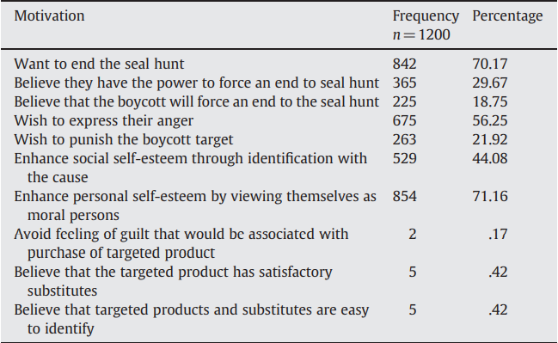

Figure 24: Boycott Motivations

As shown in **Figure 24,** the results of the research show that most of the consumers participating in the boycott do so because they want the bad policies and behaviors to stop. A high number of participants think that it is their responsibility to use their materialistic votes to make the change. Also, about a fifth of the participants have no doubts that the boycott will enforce the entity that’s being boycotted to change its conduct.

The results also show that more than half of the participants are motivated by their anger. A majority of the participants are motivated to participate because they want to see themselves as moral individuals. It also shows the participants are not motivated by feelings of guilt.

# 

# Chapter 4: System Analysis

This chapter presents the analysis model for the mobile app. It will include a use case diagram, sequence diagram, user and system requirements, and some other diagrams.

The diagrams are needed to showcase and simplify the process that the application is built upon, and the user-system requirements are needed to clarify what are the features exactly and how they are going to be used with details.

## 4.1) Use case diagram

The user's actions with the system represented as an illustrative portrayal/depiction, known as a use-case diagram. It also shows system actors, which are the various kinds of users that the application has.

The use case diagram below shows the most important operations that can be done by a user. It also shows all the actors that the system has, which are User, Admin, Campaign Manager, Location Services, and Social Media Services.

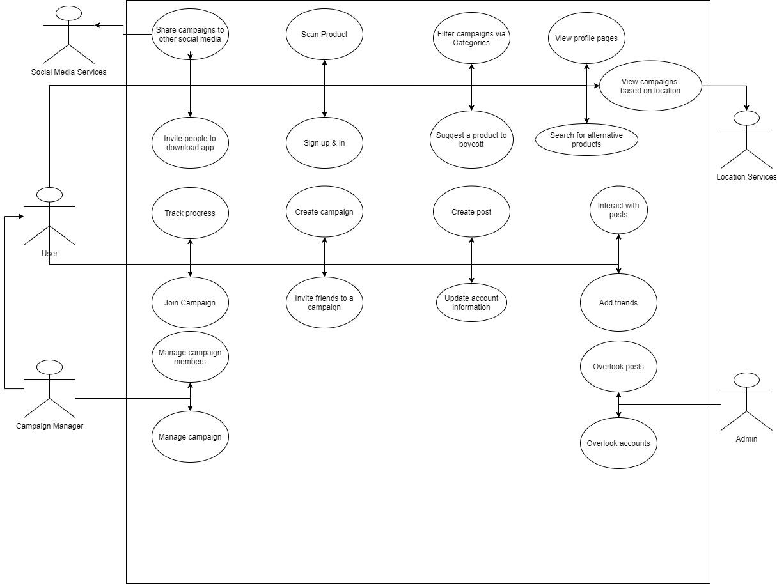

Figure 25: Use Case Diagram [1]

## 4.2) User-system requirements

user needs, also known as user requirements, represents how the user interacts with the system. For example, what actions the users must be able to do when navigating the system. On the other hand, System requirements are the core ingredient and factor that the developers use to implement the system. These are the typical must and shall sentences that illustrate what the system must do and shall do.

Table 2: User Requirements

|  |  |
| --- | --- |
|  | **Requirement** |
| **1** | **The user creates an account or logs in if he has an account** |
| **2** | **The user scans a product’s barcode** |
| **3** | **The user has the ability to share campaigns to other social media apps** |
| **4** | **The user can create campaigns** |
| **5** | **The user can join campaigns** |
| **6** | **The user should have the ability to search and filter campaigns based on categories** |

**UR1 The user creates an account or logs in if he has an account.**

**SR1-1** User opens the application and clicks register

**SR1-2** User fills required information (username, email, password, confirmation

password, gender). Username and email must be:

1. Unique

password must be:

1. At least 5 characters long
2. Contain one number
3. Contain one uppercase character.

**SR1-3** user clicks create account, one of the following can happen

1. User creates an account successfully, and he is logged into the system with the created account
2. Email or username is already taken, in that case, we inform the user and ask him if the email/username for the already existing account belongs to him, if yes, we direct him to the login page

**UR2 The user scans a product’s barcode**

**SR2-1** The user opens the barcode scanner in the application and points the camera at the barcode

**SR2-2** Barcode should be scanned within 5 to 10 seconds max

**SR2-3** If the product is recognized, then the user is redirected to a new page with more details about the product. The page should include

1. Name of product
2. Details about the product
3. Number of campaigns that the product aligns with
4. Number of campaigns that the product has a conflict with
5. Closest place that sells the product

**SR2-4** If the product is not found, the user is redirected to a page where he can add the name of the product, where he found it, and add a brief description. Then submit it.

**SR2-5** If the user submits the form successfully, an email will be sent to him thanking him for his contributions. He is also redirected to the barcode scanner page/view

1. If the user tries to close the page without submitting the form, a prompt will show asking him if he is sure of his decision
   1. If yes => the user is taken back to the barcode scanner
   2. If no => user stays in the form

**UR3 The user has the ability to share campaigns to other social media apps**

**SR3-1** Campaign homepage will have an arrow to share the campaign

**SR3-2** When the user clicks on the arrow, a modal will slide from below and it gives the user multiple social media options to share to

**SR3-3** When the user chooses a social media app, the user will be redirected to that app with a text template that is ready to just be posted/shared.

**SR3-4** If the user backs out (AKA doesn’t choose an app), then the modal just closes.

**UR4 The user can create campaigns**

**SR4-1** User is at the main screen and clicks “create campaign button”, and he is directed to create campaign form.

**SR4-2** The form includes the following required fields:

1. Name of the campaign
2. Categories that this campaign belongs to (at least 2)
3. Description of campaign
4. Who can join the campaign:
   1. Anyone
   2. Friends and friends of friends
   3. Friends only
   4. No one
5. Is the campaign invite-only?

The form also includes the following optional fields:

1. Invite friends’ checkbox
   1. If it's checked, upon creation, a notification will be sent to friends of this user telling them to join the campaign if they want to.

The form will also have three buttons:

1. Create a campaign button
2. Clear all fields button
3. “X” icon in the top right corner

**SR4-3** When the user clicks “create campaign” the campaign will be created and the user will be taken to the homepage of the campaign

**SR4-4** If the user didn’t click the “create campaign” button and instead decides to back out, the data he entered will be cached so that he can continue later.

**UR5 The user can join campaigns**

**SR5-1** For public campaigns, users can find them on the homepage or via invite by friends

**SR5-2** When the user clicks on a campaign to view it, he will see an overview of the campaign. The overview will contain:

1. Title
2. Number of members
3. Is it trending?
   1. If the number of members joining in the past week is more than 50% of the number of current members AND the number of members is more than 1000 => then the campaign is trending.
   2. How many people joined in the last week compared to other campaigns (most successful 3)
4. Categories
5. View more button
6. Join button

**SR5-3** If the user clicks the join button, then he will be a member of the campaign successfully.

**SR5-4** If the user clicks the “View More” button, he will be directed to the homepage of the campaign, where he can learn more about the campaign and see posts.

**SR5-5** He will have a join button at the bottom of the screen so he can join the campaign if he likes it.

**SR5-6** If the user clicks the join button, the process in **SR5-3** steps.

**UR6 The user should have the ability to search and filter campaigns based on categories**

**SR6-1** The user will have an icon at the top of his screen, if he clicks on it, an input field will appear

**SR6-2** The input field will have a mini dropdown on the left, when the dropdown is clicked it will show 2 options for filtering:

1. By Name
2. By Category

**SR6-3** If the user chooses to filter by name, then the text he writes in the input field will result in a campaign that contains the entered text.

**SR6-4** If the user chooses to filter by a category, then the campaigns he will get as a result of filtering must contain the category the user filtered for.

**SR6-5** If no campaigns match the value the user is searching for, a text “No Campaigns That Match Your Search” exists. Also, an option for him to create a campaign that matches his search will be given to him.

## 4.3) Class Diagram

This diagram will be representing the main classes of which the application consists of, it shows each class and its relationship to the other classes, in addition to some of the attributes and methods it handles. So, in conclusion, class diagrams include class names, class attributes, and class methods. And its main purpose is to show and simplify the roles and relations between a group of objects in the system.

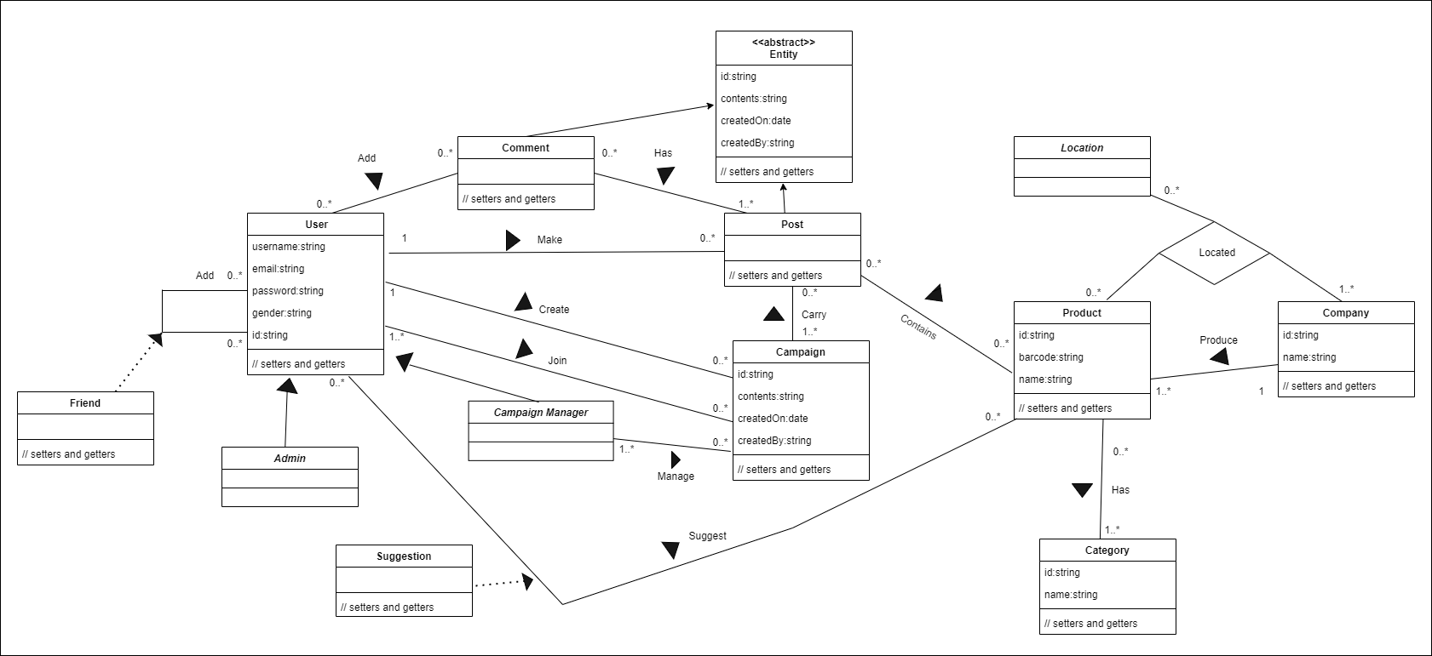

Figure 26: Class Diagram [2]

## 4.4) Activity Diagrams

Activity diagrams are used to describe a process in the system. This process can span over multiple use cases, which means activity diagrams have a one-to-many relationship with the written use cases. It is important due to the fact that an activity diagram helps the programmers and developers to comprehend and see the workings of the application from a high-level point of view. Furthermore, it helps them to find out limitations, conditions, and the corresponding events.

### 4.4.1) Creating account activity

This diagram shows how the account can be created by the user, and how the app behaves based on the user's actions. The activity goes as the following:

User fills the info and clicks on the create account button, the app then checks if it exists, if it does, it redirects the user to the login page then validates it, if it's not, it validates it, then takes it to the login page.

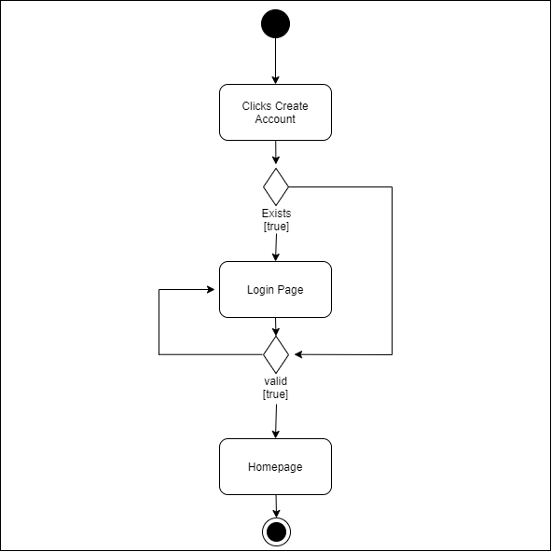

Figure 27: Create Account Activity Diagram [3]

### 4.4.2) scanning the product activity

This diagram shows how the product scanning works, and how the app behaves depending on the output information. The activity goes as the following:

The users scan a barcode using the built-in camera, if the product exists in the app’s database, the app redirects the user to the products page, if the product was not found in the database, the app will direct the user to the product suggestion page, where he can register the product in the database, the re-directs the user to the home page.

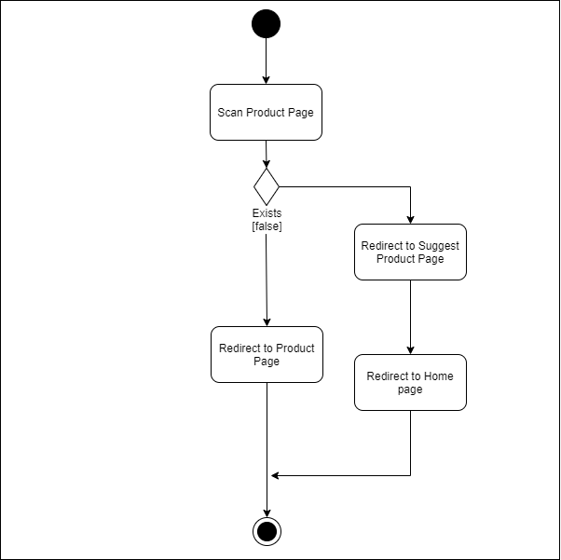

Figure 28: Scan Product Activity Diagram [4]

## 4.5) Sequence Diagrams

Sequence Diagrams show how certain tasks are performed between users and the system, these tasks can be repetitive, simple, or complex. The goal is to depict the use case in a visual format. Sequence diagrams help the developer understand use cases and how they operate. The Model-View-Controller pattern was followed in creating the sequence diagrams. This pattern is used to split up application concerns.

### 4.5.1) Scanning a product

This sequence diagram shows how the users interact with the app to scan a product using the app’s built-in scanner.

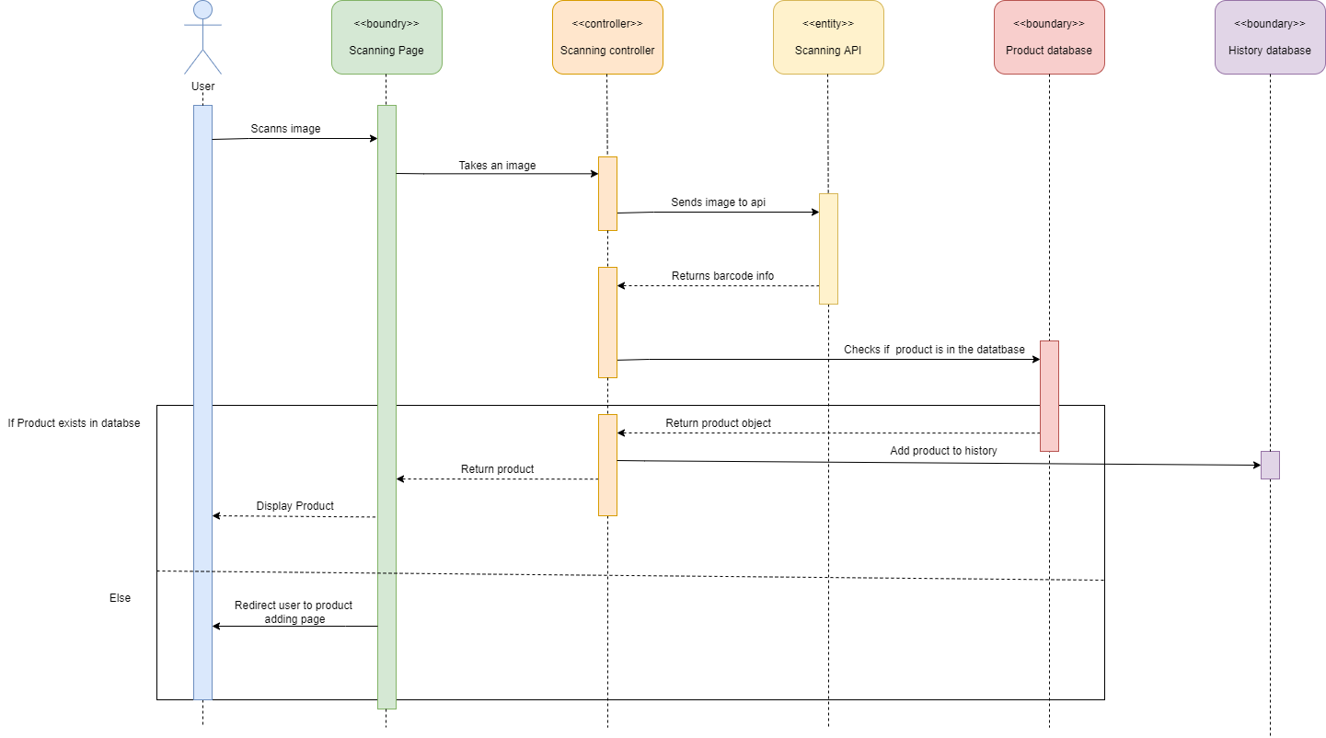

Figure 29: Scanning a Product

### 4.5.2) Filtering

This sequence diagram shows how the users interact with the app to filter the campaigns and how it works.

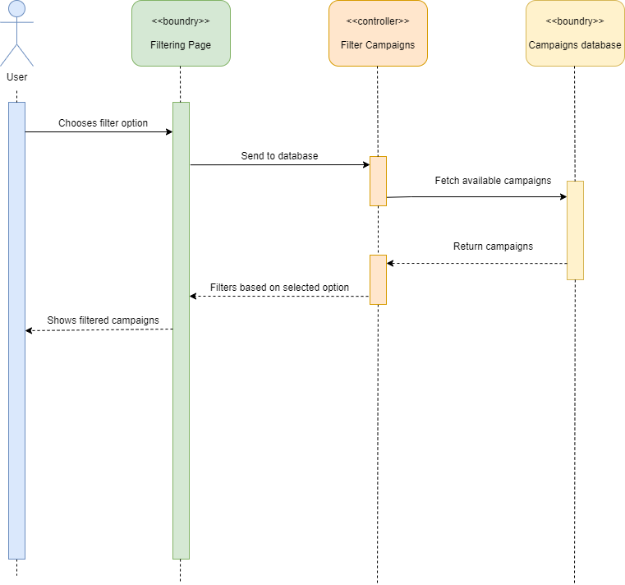

Figure 30: Filtering Campaigns

## 4.6) Software architecture

The application architecture diagram is a high-level diagram that shows the application basic structure, it consists of the following:

* **Client-side application:** the frontend layer to which the user has access to see and use. It consists of the following layers:
  1. **UI layer** is the components the user sees and interacts with.
  2. **Service access layer:** handles the requests and calls to the server-side.
  3. **Application logic layer:** controls the data fetched from the server and vice-versa, and performs all the operations on that data.
* **The server-side application:** this part of the application happens behind the scene on the server and users don’t have access to, and it consists of the following layers:
  1. **REST APIs:** the interface of the server-side of the application to the service access layer in the client-side, and it is the only communication between the client-side and the server-side and the database.
  2. **Data access layer:** holds the connection and configuration to connect to the database.
  3. **Database:** where all the data of the users and campaigns and other data is stored.

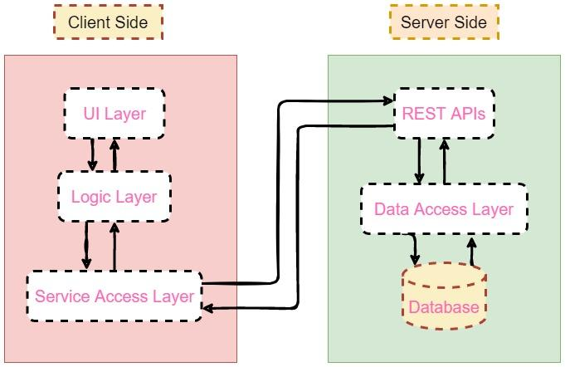

Figure 31: Software Architecture

# Chapter 5: System Design

This chapter is all about user interfaces. It will showcase some of the user interfaces that the app will have. All of the user interfaces here were made with Adobe XD, we were able to leverage repetition grids and components features that are in Adobe XD to make the process of creating the user interfaces much easier. Also, the export feature allowed us to extract the create interfaces with ease and high quality.

## 5.1) User Interface:

### 5.1.1) Sign in Interface

The sign-in interface is where the user will be able to log into the app using his private username and password, the interface consists of two text fields, one for the email, and the other for the password, there’s also a sign-up button at the bottom in case the user has not signed up.

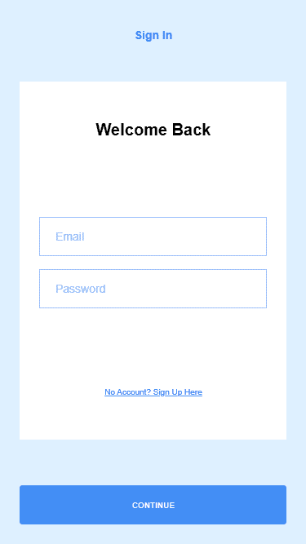

Figure 32: Sign in Interface

### 

### 5.1.2) Sign Up Interface

The sign-up interface is where the user usually creates an account in the app, the interface consists of 4 text fields, a full name, an email, a password, and a confirmation for the password.

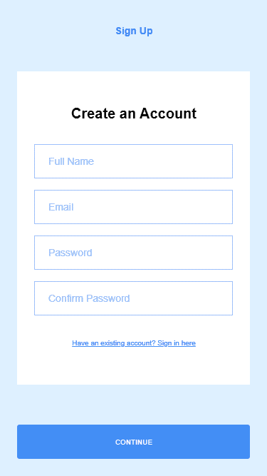

Figure 33: Sign Up Interface

### 5.1.3) Feed Interface

In the feed interface, the user is presented with a continuous collection of a smaller version of a post, which works similar to a recycler view, the interface consists of the feed header, the post, and the reaction buttons for each post.

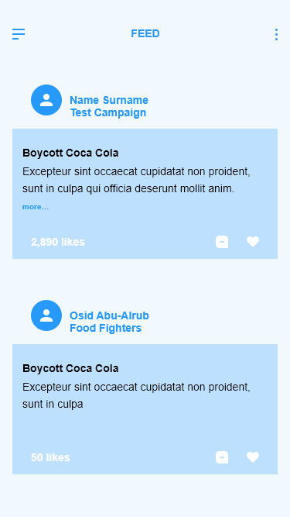

Figure 34: Feed Interface

### 5.1.4) Sidebar Interface

The sidebar interface allows the user to access different features and interfaces more easily, it consists of the user’s info at the top, followed by home, scan, search, messages, and settings buttons

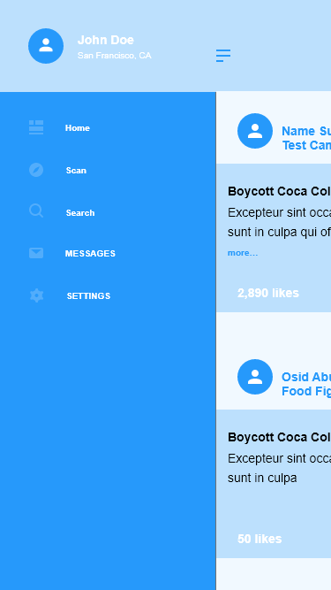

Figure 35: Sidebar Interface

### 5.1.5) Post Interface

The post interface is where the user can share his opinions, it consists of the post’s header, followed by the body of the post, in addition to the issue date and the number of participants following the campaign

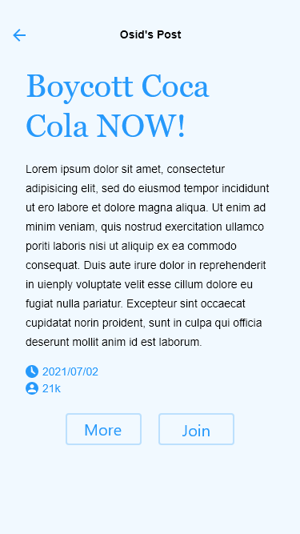

Figure 36: Post Interface

### 5.1.6) Search Interface

In the search interface, the user can search for campaigns with multiple filters that can be applied via a dropdown.

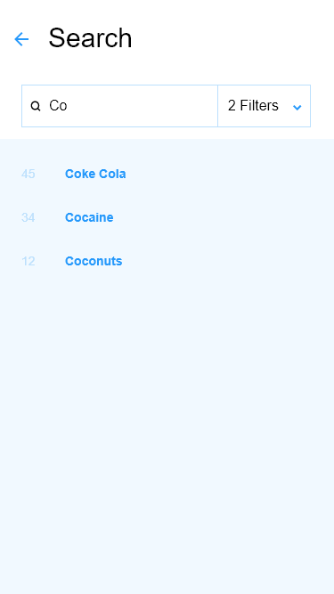

Figure 37: Search by Filter

# Chapter 6: Conclusion & Work Plan

## 6.1) Conclusion

Boycotting is the way to change for people. The main idea of this report, project, and application is to help ordinary people fight without a weapon or violence. To make their voices heard all across the world by their doings. To affect big and whole economies with simple actions. One human can’t change anything alone, but a group of humans can do wonders to the world.

As for the technologies used for this project (React Native, Typescript, Nodejs, etc..), it was all new technologies to us. We’ve never used it before. So, we had to learn everything from scratch, apply, and integrate the technologies together as we go, which added a big complexity to our workflow.

## 6.2) Work Plan

Table 3: Work Plan Table

|  |  |  |
| --- | --- | --- |
|  | Goals | Time |
| 1 | Review Report & Requirements | One Week |
| 2 | Frontend Code & Testing | Four Weeks |
| 3 | Backend Code & Testing | Six Weeks |
| 4 | Integration & Testing | Three Weeks |
| 5 | E2E Testing | Two Weeks |

# References

[1] France 24, “France urges Arab countries to stop boycott of French products,” 25 10 2020 [online]. Available: <https://www.france24.com/en/middle-east/20201025-france-calls-on-arab-countries-to-stop-boycott-of-french-products>

[2] VIVID IMAGE, “what is a Vector Image,” 2022 [online]. Available: <https://vimm.com/what-is-a-vector-image/>

[3] Adobe xd, “Adobe xd features,” 2022 [online]. Available: <https://www.adobe.com/products/xd/features.html>

[4] React Native, “react native guide,” 2022 [online]. Available: <https://reactnative.dev/>

[5] techahead, “the history of React Native: Facebook’s Open-Source App Development Framework,” 17 9 2020 [online]. Available: <https://www.techaheadcorp.com/blog/history-of-react-native/>

[6] Digitalya, “How React Native Works” 2021 [online]. Available: <https://digitalya.co/blog/how-react-native-works/>

[7] medium, “React-native bridge for noobs,” 29 8 2020 [online] Available: <https://medium.com/@jagdeepak009/react-native-bridge-for-noobs-b997de25ca46>

[8] C4LCUL4T0R, “5 key advantages of react native,” 4 12 2017 [online]. Available: <https://icapps.com/blog/5-advantages-react-native>

[9] react js, “Introducing JSX,” 2022 [online]. Available: <https://reactjs.org/docs/introducing-jsx.html>

[10] node js, “About Node JS,” 2021 [online]. Available: <https://nodejs.org/en/about/>

[11] Serokell, “Why You Should Choose Typescript Over Javascript,” 18 7 2020 [online]. Available: <https://serokell.io/blog/why-typescript>

[12] MySQL, “Why MySQL,” 2022 [online]. Available: <https://www.mysql.com/>

[13] MySQL, “History of MySQL,” 25 2 2022 [online]. Available: [https://dev.mysql.com/doc/refman/8.0/en/history.html](https://dev.mysql.com/doc/refman/8.0/en/history.html%23:~:text=The%20name%20of%20the%20MySQL,(formerly%20Swaziland)%2C%20Africa.)

[14] denso-wave, “what is a barcode,” 2022 [online]. Available: <https://www.denso-wave.com/en/adcd/fundamental/barcode/barcode/index.html>

[15] wekipedia, “What is boycotting,” 10 1 2006 [online]. Available: <https://en.wikipedia.org/wiki/Nestl%C3%A9_boycott>

[16] ethical consumer, “History of Successful Boycotts,” 6 1 2022 [online]. Available: <https://www.ethicalconsumer.org/ethicalcampaigns/boycotts/history-successful-boycotts>

[17] Ben & Jerry’s, “Ben & Jerry’s Will End Sales of Our Ice Cream in the Occupied Palestinian Territory,” 19 7 2021 [online]. Available: <https://www.benjerry.com/about-us/media-center/opt-statement>

[18] PETAUK, “VICTORY! Burberry Bans Fur and Angora,” 6 9 2018 [online]. Available: <https://www.peta.org.uk/blog/victory-burberry-bans-fur-and-angora/>

[19] NCBI, “Why Do People Use Facebook,” 26 11 2006 [online]. Available: <https://www.ncbi.nlm.nih.gov/pmc/articles/PMC3335399/>

[20] ScienceDirect, “What motivates consumers to participate in boycotts: Lessons from the ongoing Canadian seafood boycott” 1 2011 [online]. Available: <https://www.sciencedirect.com/science/article/pii/S014829630900318X>

1. ) Find the diagram online: [Flowchart Maker & Online Diagram Software](https://viewer.diagrams.net/?tags=%7B%7D&highlight=0000ff&edit=_blank&layers=1&nav=1&title=Use-Case-Diagram.drawio#R7VxZd9o4FP41PNLjfXkkkC6ZZiY9dJqkL3OELcCtsRxZEOivH8kbxhaGJNhyEvqQWtfCtj59uouW21OHi%2FUnDML5NXKh31Mkd91TRz1FkU1Jo%2F8xySaRmIqdCGbYc9NKW8HY%2BwNToZRKl54Lo52KBCGfeOGu0EFBAB2yIwMYo8fdalPk7741BDNYEYwd4Felt55L5onUUsyt%2FDP0ZvPszbKRtm8BssppS6I5cNFjQaRe9tQhRogkV4)
2. ) Class diagram: <https://drive.google.com/file/d/1j-UUvpaGFXrt7BJhi29F9e1AV-6ytDzG/view?usp=sharing>
3. Diagram link: <https://drive.google.com/file/d/1juJTWUNmTWBm6ip1LenNvvx4Waxybugf/view?usp=sharing>
4. Diagram link: <https://drive.google.com/file/d/18_WxnDYYPyyGy6mbYLOdJQzHt6EORynk/view?usp=sharing>