Install taab on Android
A screenshot guide for beta testers
Follow these steps to download and install the taab beta from Google Drive. The screenshots show the exact sequence on one Android phone; yours may look slightly different.
Open the taab Android beta download folder

1 Open the menu beside taab apk
Open the download folder on your Android phone. Find taab.apk and tap the three dots beside the file name, as highlighted in the left screenshot.

2 Tap Download
In the file menu, tap Download, as highlighted in the right screenshot. Wait until the download finishes. If a generic browser download prompt appears, confirm the source and file before deciding to continue.
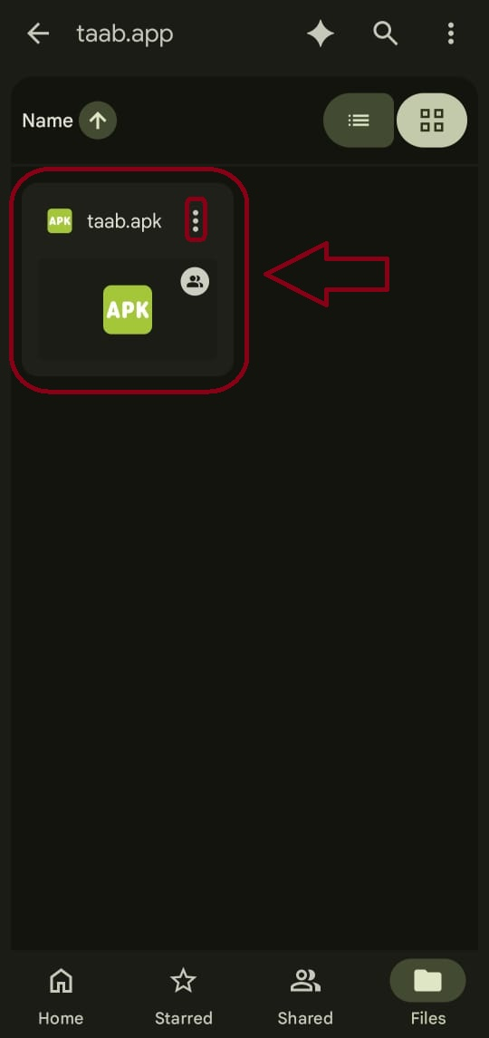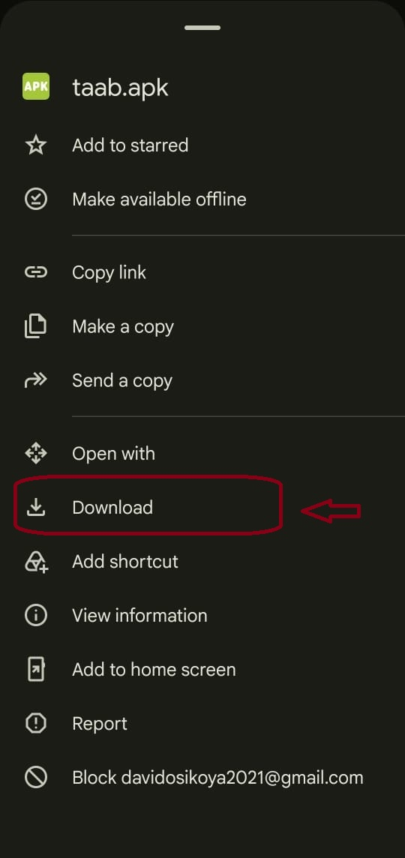
Left Find taab.apk and open its menu Right Choose Download

Open the downloaded file

3 Find taab apk in Downloads
Open Files or My Files on your phone, then open Downloads. Tap taab.apk. The screenshot shows a 123 MB file; the size and date can change with a newer beta.
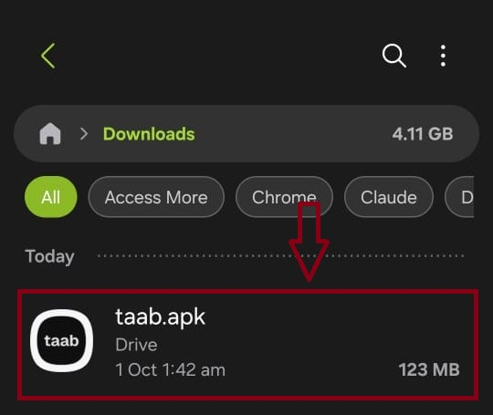
Tap the downloaded taab.apk file

4 Tap Install
Check that the app name shown is taab, then tap Install. If your phone asks you to allow installation from this source first, tap Settings, enable Allow from this source for the app opening the APK, then return and tap Install.
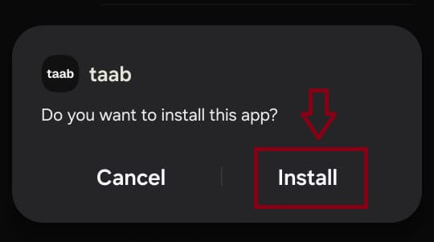
Confirm the app name and tap Install

Understand the Play Protect prompt
You may see the message shown below: Play Protect has not seen an app from this developer before and says it may be unsafe. This describes an unfamiliar developer; it does not verify that this APK is safe.

5 Read the message and tap More details
Read the full warning. If it matches the unfamiliar developer message shown here and you downloaded the intended taab.apk from the linked folder, tap More details to see the available options.

6 Decide whether to tap Install anyway
If you trust the source and choose to proceed with this beta despite the warning, tap Install anyway, as shown on the right. Wait for installation to finish. You can also stop here and use taab in your browser.
Keep Google Play Protect enabled. If a different message reports malware, harmful behaviour or data theft, stop and contact taab support. These instructions apply only to the unfamiliar developer prompt pictured below.
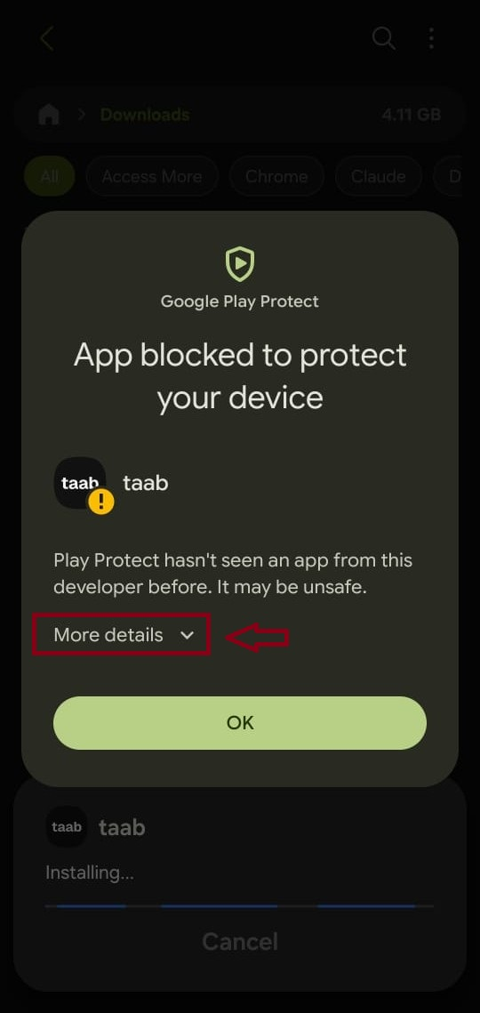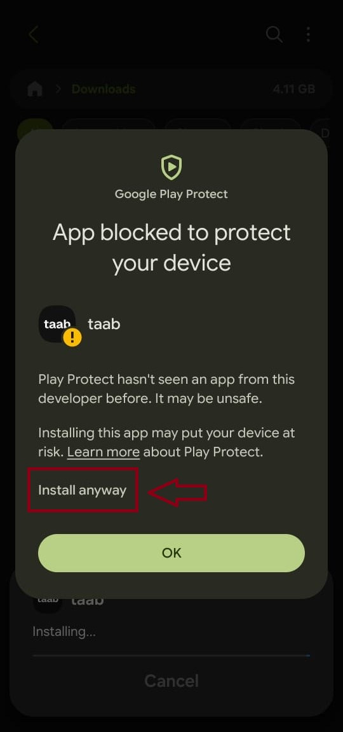
Left Read the warning and open More details Right Optional Install anyway choice

Open taab and start testing

7 Open the app
When installation finishes, tap Open. If you do not see that button, find taab on your home screen or in your app list and tap it.
The welcome screen below means you have reached the app. Tap Next to go through the introduction, or Skip to move past it. Then follow the prompts to create an account or sign in.
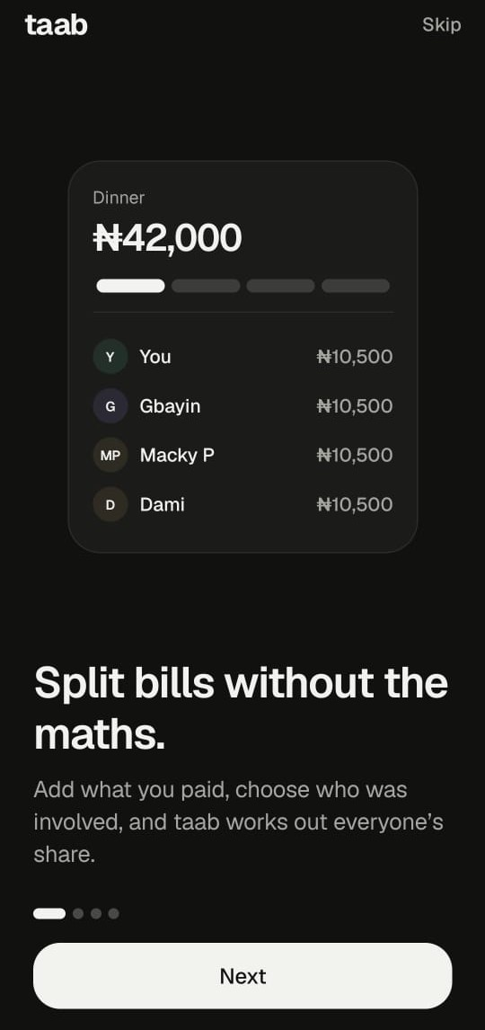
The taab welcome screen after installation

Try your first shared expense
Create a group with people you know and add a shared expense. Send feedback through the beta feedback option in the app.

Help updates and the web version

If you cannot download or install
Folder asks for access: contact taab support so the Drive sharing settings can be checked. If you opened the link inside another app, try opening it in your normal browser or the Drive app.
File will not open or says App not installed: check that the download finished and that your phone has free storage. Download again if the file is incomplete. If the error continues, send the exact message to support.
No Install anyway option or installation is blocked: use the web version and contact support. Button names vary, and some phones or work profiles do not allow APK installation. Do not disable Play Protect to follow this guide.
App does not open or sign in: check your internet connection and try again. If it still fails, send your phone model, Android version and the error message to support.

After installation
If you enabled Allow from this source, turn that permission off again in Settings under Install unknown apps for the source app. This does not uninstall taab.

Get a newer beta
When a new beta is announced, return to the same Drive folder and download the latest APK. Follow the steps again and choose Update if offered. If Android reports a conflict, contact support before uninstalling your existing app.

Use taab in your browser
Android users can use the web version instead of installing the APK. iPhone users should use the web version; an APK does not install on iOS.
Open taab in your browser

Ask for help or send feedback
Use the beta feedback option in taab or email taabsupport@gmail.com. Tell us which step failed and include a screenshot if possible. Hide passwords, sign in codes and personal information before sharing screenshots.

About the warning
Google recommends keeping Play Protect on. Its checks and scan results may differ between devices and app versions.
Read Google Help on Play Protect

