

UNIT INFORMATION
COURSE – (LEADING TO) | BSC(HONS) IN SOFTWARE ENGINEERING
UNIT NAME | OBJECT ORIENTED DESIGN PATTERNS II
UNIT ID | JIAT/OODP II
ASSIGNMENT ID | JIAT/OODP II /EX/01
STUDENT INFORMATION
STUDENT NAME | A.P.L OSINI NAVODA LIYANAGE
NIC | 200380111705
STUDENT ID | 2025/2026/BCU/SE/I1/245
BATCH | 2025/2026/BCU/SE/Intake1
BRANCH | GAMPAHA

Acknowledgements
The OODP II lectures and practical exercises provided the foundation for this project. The supplied class notes helped establish the responsibilities and relationships used in the five pattern implementations. The Java and Jakarta documentation supported the integration of these classes with a working web application.

Abstract
SmartCity360 is a Java web application for managing city infrastructure and resident service requests. It combines a city hierarchy, energy-meter message processing, complaint handling, streetlight records and a small policy language in one application. Residents can submit and follow their own complaints, while staff work within the responsibilities and city access assigned to their accounts.
The project applies Decorator to meter-message processing, Composite to city zones, Chain of Responsibility to complaint routing, Flyweight to shared lamp configurations and Interpreter to policy expressions. PostgreSQL stores application records, and Jakarta REST resources expose controlled operations to the browser. The implementation is packaged as a Maven WAR and deployed on Payara Community 7 using Java 21.
The pattern review passed 33 focused Java tests. The complete Java suite passed 67 tests, and a separate live complaint journey passed 42 checks, including isolation between two residents. These results support the implemented behavior within the tested local environment. Device commands and observations are simulated; the project is not connected to municipal hardware.
Contents
Acknowledgements 2
Abstract 2
1 Introduction 5
1.1 Project overview 5
1.2 Problem statement 5
1.3 Objectives 5
1.4 Scope and boundaries 5
2 Background and specification 6
2.1 Technology choices 6
2.2 Functional requirements 6
2.3 Roles and access 7
2.4 Quality requirements and constraints 7
3 System design 8
3.1 Architecture 8
3.2 Persistent data model 8
3.3 Interface design 9
4 Part A Dynamic security wrappers 11
A1. Pattern identification and justification (3 marks) 11
A2. Flexible, layered enhancement (4 marks) 11
A3. Long-term reuse and extensibility (8 marks) 12
5 Part B Hierarchical smart zones 15
B1. Pattern identification and justification (3 marks) 15
B2. UML class diagram and mechanism (4 marks) 15
B3. Support for large and growing infrastructure (8 marks) 16
6 Part C Complaint escalation 18
C1. Pattern identification and justification (3 marks) 18
C2. Decoupling request handling (4 marks) 18
C3. Flexibility and traceability: benefits and drawbacks (8 marks) 19
7 Part D Efficient streetlights 22
D1. Pattern identification and justification (3 marks) 22
D2. Intrinsic and extrinsic state (4 marks) 22
D3. Effect at tens of thousands of lights (8 marks) 23
8 Part E City policy language 25
E1. Pattern identification and justification (3 marks) 25
E2. UML class diagram and mechanism (4 marks) 26
E3. Suitability for rule updates and extensibility (8 marks) 27
9 Implementation and operation 30
9.1 Project organization 30
9.2 Representative working code 30
9.3 Running the project 31
9.4 Using the main workflows 31
9.5 Data and operational safeguards 33
10 Testing and results 34
10.1 Verification approach 34
10.2 Requirement-based test cases 34
10.3 Live complaint journey 35
10.4 Interface verification 35
10.5 Verification limits 36
11 Evaluation and conclusion 37
11.1 Achievement of objectives 37
11.2 Limitations and future work 37
11.3 Conclusion 37
References 38

1 Introduction

1.1 Project overview
A city service request often relates to a physical location, a responsible team and a history of decisions. SmartCity360 keeps these elements together. A resident reports an issue, the system routes it according to severity, and staff record progress and public replies. The same city workspace contains building usage, streetlights and policies so that each feature has a clear place in the city structure.

1.2 Problem statement
The assessment presents five design problems: adding optional processing layers without changing a meter stream, applying operations across a hierarchy, passing complaints between responsible authorities, avoiding repeated streetlight configuration objects and interpreting rules that change at runtime. Solving these with large conditional blocks or duplicated classes would make later changes harder to trace. Each part therefore uses one pattern whose structure matches the problem.

1.3 Objectives
The objectives are to implement all five scenarios in one working Java application; preserve records between requests; enforce account, city and complaint-owner restrictions; provide usable forms and records pages; and demonstrate the pattern mechanisms with executable code, diagrams and evidence. The selected patterns follow the structures taught in the supplied class notes (Object Oriented Design Patterns - II, n.d.).

1.4 Scope and boundaries
The application includes five roles, resident registration, profile details, complaint allocation and reopening, a city hierarchy, saved meter readings, streetlight configuration sharing, policy evaluation and complaint reports. The five active sample cities are Colombo, Kandy, Galle, Jaffna and Kurunegala. Their records are fictional examples used to demonstrate the application. They are not measurements or decisions from real municipal authorities.
The system does not provide physical device control, verified email delivery, payments, geographic navigation or live sensor feeds. Saved notifications, complete maintenance history and a full audit of every policy edit are not implemented. These boundaries prevent the report from treating planned enhancements as working features.

2 Background and specification

2.1 Technology choices
Java 21 implements the domain logic and patterns. Jakarta EE 11 provides the application platform on Payara Community 7. Jakarta REST supplies resource-based HTTP endpoints, while Jakarta Persistence maps entities to PostgreSQL records (Eclipse Foundation, n.d.-a; Eclipse Foundation, n.d.-b). Maven produces the WAR. The interface uses HTML, Tailwind CSS and plain JavaScript. Spring Boot is not used.
This structure keeps the small pattern classes separate from web requests and storage. For example, a comparison expression can be tested without a database, while the policy service handles authorization, saved revisions and transactions. IntelliJ IDEA Ultimate is used to develop the Maven project.

2.2 Functional requirements
Area | Implemented behavior
Accounts | Resident registration, sign-in/out, profile details and photo, staff access management.
City zones | City, district, street and building hierarchy; recorded usage totals and simulated power control.
Meter streams | Optional credential checking, GZIP compression and AES-GCM encryption; saved reading inspection and recovery.
Complaints | Severity routing, employee allocation, public messages, private notes, resolution and reviewed reopening.
Streetlights | Lamp specification catalogue, individual locations/states and pooled configuration demonstration.
Policies | Text rules, syntax validation, saved revisions, observation evaluation and result snapshots.
Reports | Accessible complaint filters, charts, totals and a printable view.

2.3 Roles and access
Role | Responsibility
Resident | Submit complaints; read and follow up own cases; request reopening; manage own profile.
Local staff | Work on local-tier cases and permitted operational records in the assigned city.
Supervisor | Review local and supervisor-tier work; allocate eligible staff; review reopening requests.
City manager | Review city-wide complaints and manage city policies within assigned scope.
System administrator | Manage accounts and city access; administer authorized cross-city records. Does not submit resident complaints.

Navigation reflects these roles, but Java also checks permissions on requests. Hiding a button is not the authorization boundary. Resident case ownership is checked independently of the URL, and a staff role does not grant access to another city.

2.4 Quality requirements and constraints
Correctness requires that displayed totals agree with saved records, invalid writes leave data unchanged and old edits are rejected rather than silently overwriting newer values. Usability requires readable light and dark themes, a responsive sidebar, separate forms and meaningful errors. Maintainability requires clear resource, service, entity and pattern responsibilities. These qualities are tested within the local environment; no production throughput or availability guarantee is claimed.

3 System design

3.1 Architecture
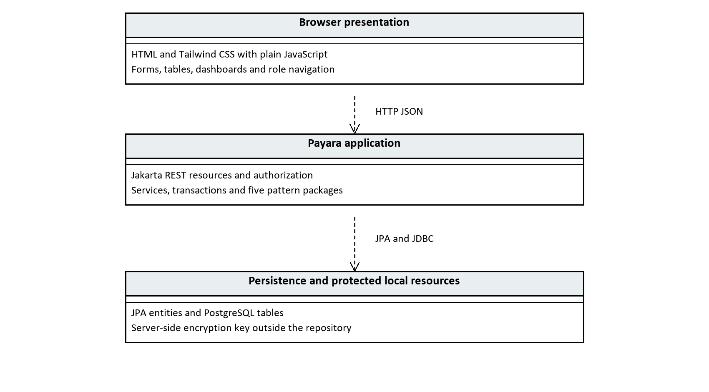
Figure 1 Application layers and request flow
The browser sends JSON requests to Jakarta REST resources under /api. Resources validate the request shape and apply access restrictions. Services perform business operations and use JPA transactions where required. Pattern objects carry out the relevant domain behavior. PostgreSQL stores entities and histories. The encryption key is retained outside the repository and is not included in screenshots or this document.
The pattern class diagrams use standard UML notation: a hollow triangle points to the parent class or interface, with a solid line for inheritance and a dashed line for interface realization. A filled diamond marks owned Composite children. Plain lines denote stored associations, while dashed open arrows denote dependencies. Italics identify abstract classes and operations. Only relevant members are shown; ellipses abbreviate omitted parameters.

3.2 Persistent data model
Table | Purpose and main relationship
city | Root city record.
zone | District/street/building, linked to city and optional parent zone.
app_user | Role, profile and account status; staff may be linked to a city.
account_event | Actor, target account and administration action.
complaint | City, optional zone, owner, severity, state and optional employee assignment.
complaint_event | Ordered case events linked to complaint and actor.
meter | Registered device linked to a building.
meter_reading | Saved reading and processing flags/payload linked to meter.
lamp_specification | Reusable immutable lamp configuration.
streetlight | Individual pole linked to city, street and specification.
policy | City rule text, category, meaning, revision and active state.
policy_evaluation | Saved observations, outcome and original rule snapshot linked to policy/zone.

The Composite tree and database tree have different responsibilities. Database rows preserve the hierarchy between requests; the Java component objects expose uniform operations. Likewise, a specification foreign key reduces stored duplication, but the Flyweight mechanism additionally reuses the same Java object from a pool.

3.3 Interface design
Every role has Dashboard and Profile entries. Other entries depend on permission. On desktop the sidebar can collapse to an icon rail; on narrow screens it becomes a drawer. Light and dark themes share coordinated green accents, and the chosen theme is remembered. Tables remain records views, while add/edit operations open separately. Routine navigation and refresh actions stay quiet; errors and relevant saved-form outcomes receive feedback.
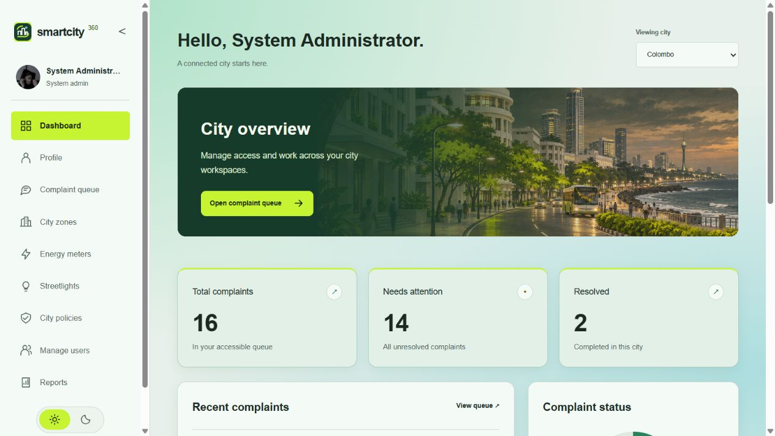
Figure 2 Current administrator dashboard and complaint summary
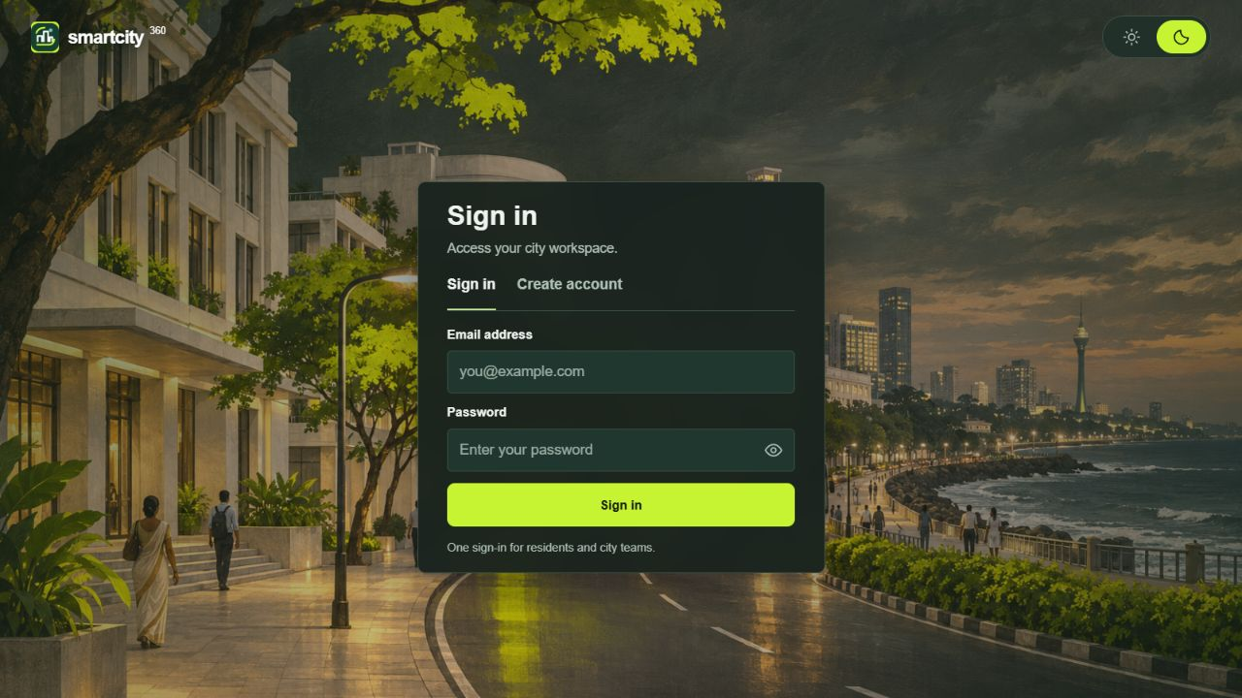
Figure 3 Shared sign-in screen

4 Part A Dynamic security wrappers

A1. Pattern identification and justification (3 marks)
Question: Identify and justify the most suitable design pattern for this requirement.
The Decorator pattern adds authentication, compression and encryption to a meter message without changing its base component. All components implement MeterStream, which exposes encode() and decode(). PlainMeterStream copies the original bytes; a decorator holds another MeterStream, delegates work to it and adds one responsibility.
This follows the wrapping structure taught in the supplied class notes, where a base item gains additional behavior through wrappers (Object Oriented Design Patterns - II, n.d., PDF pp. 2-5). SmartCity360 adapts that structure to a sequence of bounded meter messages. Java cryptography and compression APIs provide the actual transformations; those APIs are supporting technology, not additional selected design patterns.
Decorator fits better than creating a subclass for every feature combination. Three optional features give eight combinations. The same base and three wrappers support all eight, selected at runtime by the page's checkboxes.

A2. Flexible, layered enhancement (4 marks)
Question: Explain how the pattern supports flexible and layered enhancements to object functionality.
MeterService creates a fresh component chain for each submission. With all options selected, its structure is:
AuthenticationDecorator(EncryptionDecorator(CompressionDecorator(PlainMeterStream)))
The outer authentication wrapper first checks the supplied meter credential. It delegates to encryption, which asks its inner compression wrapper to process the base message. Compression produces GZIP bytes; encryption then transforms those bytes. The resulting order is credential check to base message to compression to encryption.
Recovery uses the same saved layer flags. Authentication checks the current meter credential; encryption decrypts; compression expands the message; the base returns the recovered bytes. The service verifies that the original and recovered bytes match before saving a reading and replacing its building's usage total. Failure leaves both reading history and building usage unchanged.
Authentication means checking a randomly generated credential issued for that registered meter. The database stores its SHA-256 hash; the plaintext credential is returned only when issued or replaced. Java's MessageDigest supplies the digest operation (Oracle, n.d.-b). This is a meter credential check, not user login.
Encryption uses Java Cipher with AES-GCM, a 256-bit key, a fresh random 12-byte nonce and a 128-bit authentication tag. GCM validates its tag during decryption; Java's documentation emphasizes that IVs must not be reused with the same key (Oracle, n.d.-a). The nonce travels with the ciphertext. The private key remains in the local Payara domain, outside the repository and database.
Compression uses Java's GZIP streams (Oracle, n.d.-c). Recovery limits expanded data to 64 KiB. Base64 is only the printable representation of processed bytes; it is not encryption.
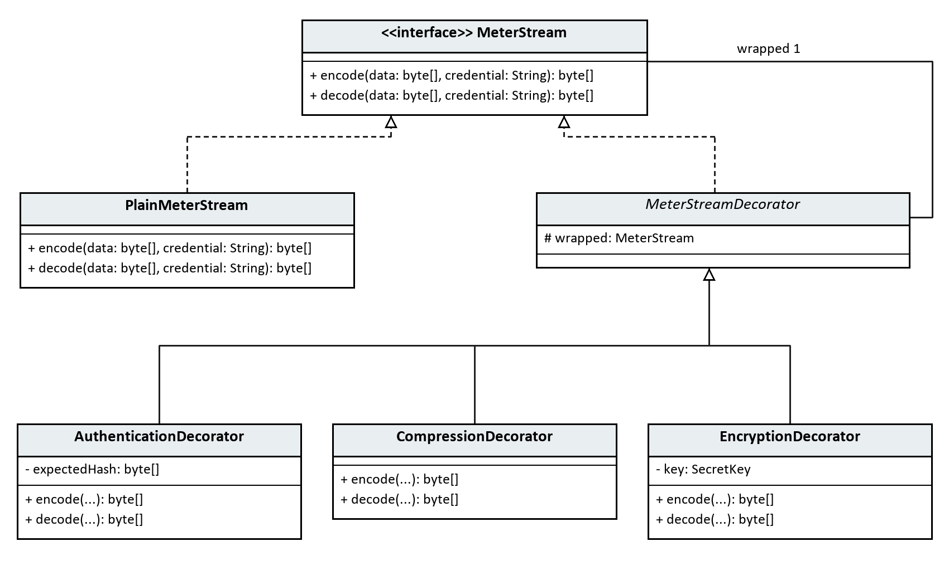
Figure 4 A UML class relationships for the implemented pattern

A3. Long-term reuse and extensibility (8 marks)
Question: Evaluate the long-term benefits of this pattern in terms of reusability and system extensibility.
One responsibility per wrapper. Authentication, compression and encryption can be understood and tested separately. The base component does not change when an option is switched on. The service and browser use the common operation rather than knowing transformation implementation details.
Runtime composition. A new request can select different options without rebuilding Java. The seven Decorator unit tests include all eight combinations, Unicode byte recovery, incorrect credentials, wrong keys, corrupted data, fresh nonces, compression behavior and bounded decompression. These tests protect the common contract when a wrapper changes.
Reuse across messages. The same pattern can process a different bounded meter-message format because transformations work on bytes. Domain validation and the decision to update a building remain in MeterService, not in the encryption or compression classes. An additional logging or validation wrapper could be introduced without editing PlainMeterStream; it would still need its own tests and deliberate placement in the chain.
Ordering matters. Decorators are composable but not interchangeable in arbitrary order. Compressing ciphertext is usually ineffective, while authenticating only after expensive work wastes effort on invalid requests. This implementation fixes the supported transformation order and varies which layers are present. Stored flags let recovery rebuild that same order; any future algorithm/format changes should add explicit format versioning rather than assume old payloads use the newest scheme.
Costs are measurable. Every wrapper adds work and can allocate another byte array. GZIP and encryption headers/tags may outweigh savings on small readings. In the browser demonstration, an 86-byte message became 131 encoded bytes with all layers enabled, before Base64 expansion. The interface reports that increase. The compression unit test proves reduction for repetitive test data, but the project does not claim all readings become smaller or that high-volume throughput has been benchmarked.
Keys and credentials have lifecycles. The domain key survives application redeployment and server restart. Losing it prevents recovery of encrypted historical payloads, so private backups must include both the database and key. If encrypted records already exist and the key is missing, the service refuses to create a replacement silently. Meter credential replacement is separate: it invalidates the old credential and uses the new one for later checks, including recovery of earlier authenticated readings. Key rotation across multiple retained encryption keys is not implemented.
Security boundaries must remain clear. Selecting authentication off intentionally skips that meter wrapper for the assignment demonstration. Application login, role restrictions and city scope are independently enforced by the current backend. Payload encryption does not hide stored usage metadata or protect the browser-to-server HTTP connection. Production transport would still require HTTPS; Decorator does not replace account authorization.
Integration without double counting. An accepted message replaces the building's current usage total; the Composite then calculates district/city totals. Historical messages remain available for inspection and recovery but are not all summed. The current product assumes manually entered totals for a common reporting period. It is a local meter-message simulation, not a continuous connection to physical meters or a historical billing system.
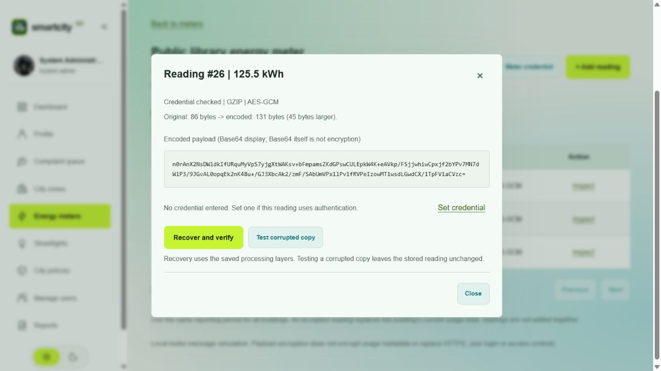
Figure 5 Saved meter payload with authentication, GZIP and AES-GCM processing
The current reading shown above contains 86 original bytes and 131 encoded bytes. This example demonstrates that compression and encryption overhead can make a small message larger. The saved layer flags are used again when recovering its original content.

5 Part B Hierarchical smart zones

B1. Pattern identification and justification (3 marks)
Question: Identify the most appropriate design pattern to model such a structure.
The Composite design pattern represents the SmartCity360 hierarchy: a city contains districts, a district contains streets, and a street contains buildings. A building is an individual item (a leaf), while the other levels are groups (composites).
Both implement the same operations through ZoneComponent: getUsageKwh() reports recorded energy use and setPower(boolean) changes simulated power. A caller can therefore issue an operation to one building or to an entire district using the same method. A group delegates the operation to its children, recursively, until the buildings are reached.
This follows the component/composite/leaf structure taught through the file-and-folder example in the supplied class notes (Object Oriented Design Patterns - II, n.d., PDF pp. 5-9). SmartCity360 adapts the roles to city infrastructure; the Java implementation and persistence integration are project-specific.

B2. UML class diagram and mechanism (4 marks)
Question: Provide a UML class diagram to demonstrate the selected design pattern’s mechanism.
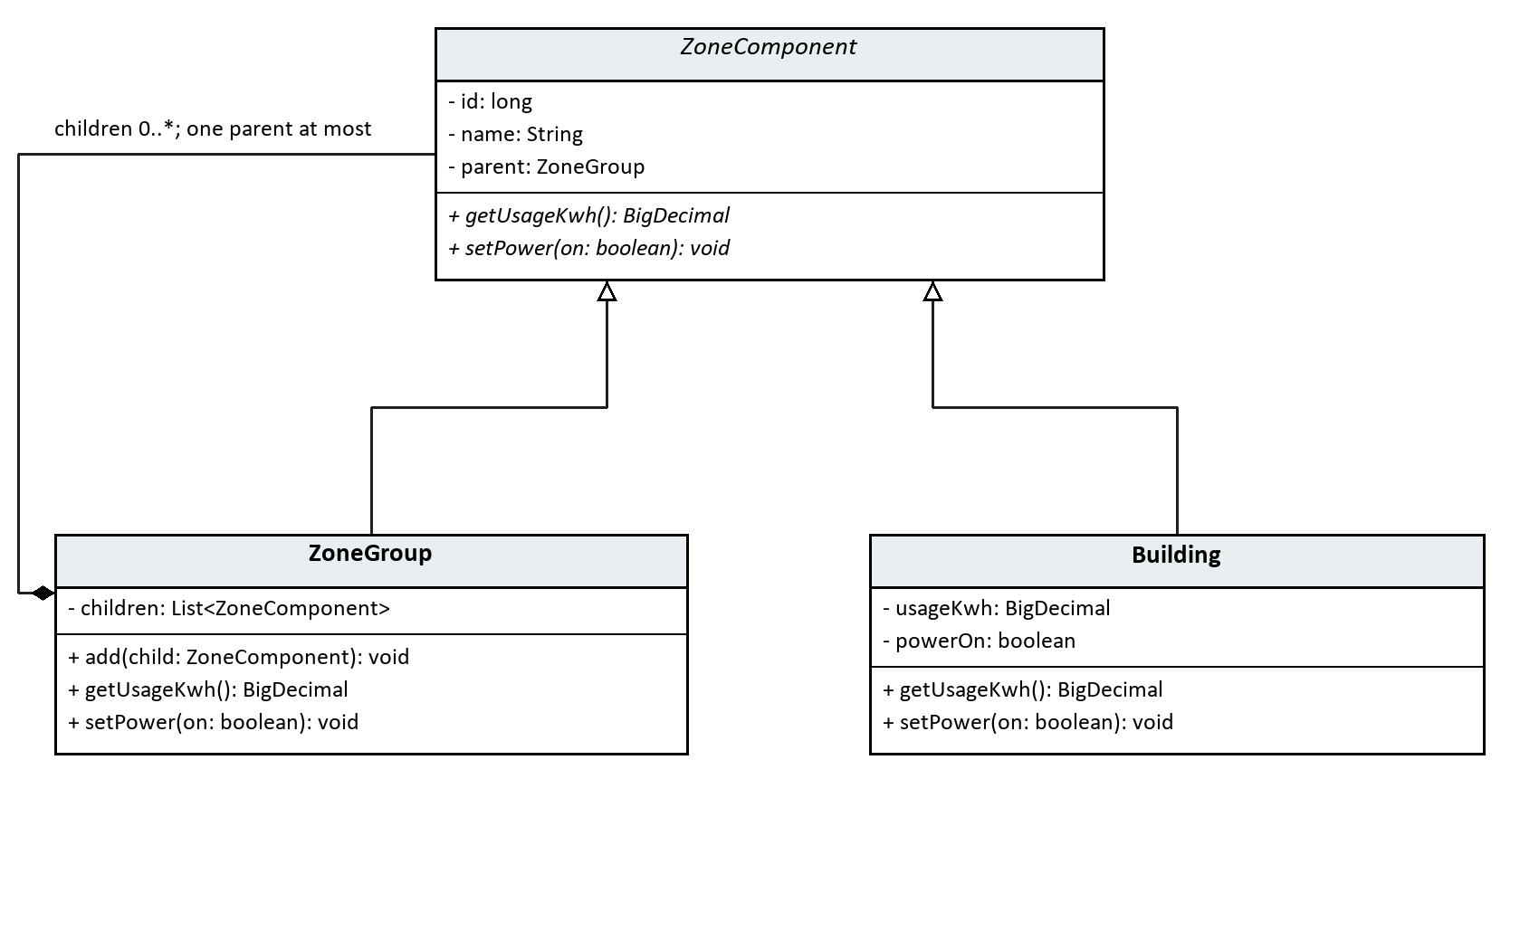
Figure 6 B UML class relationships for the implemented pattern
ZoneGroup represents CITY, DISTRICT and STREET using ZoneType; separate classes are unnecessary because these levels use the same aggregation and delegation behavior. Building represents BUILDING and stores the leaf state. The strict type order prevents cycles, and attachTo() prevents a component instance from belonging to two parents. The root city has no parent.
For example, Library records 12.125 kWh and Clinic records 7.875 kWh under Lake Road. Community Hall records 5 kWh in a different district. The first district totals 20 kWh; the city totals 25 kWh. Calling setPower(false) on the first district turns off Library and Clinic while Community Hall remains on. The city's power state becomes MIXED. The recorded total remains 25 kWh because switching off power does not undo earlier consumption.
The web request follows this path:
1. The browser sends the selected zone and requested state to ZoneResource. 2. ZoneService loads the city's stored hierarchy and builds the Composite objects. 3. The service invokes setPower() on the selected ZoneComponent. 4. A ZoneGroup passes the call to its children; a Building changes its own state. 5. The service saves the resulting building states in one JPA transaction and returns updated totals.
ZoneEntity is a database mapping, not another design pattern. It keeps JPA details out of the small pattern classes. PostgreSQL stores each district/street/building with its city and parent IDs; the city itself uses the existing City record. Root commands use a null zone ID, so city and zone numeric IDs cannot be confused.

B3. Support for large and growing infrastructure (8 marks)
Question: Discuss its usefulness for managing a large and growing city infrastructure.
Uniform client code. The service calls the same operation regardless of whether the target is a leaf or a group. Adding buildings to a street does not require a new power-control method. The same recursion handles the expanded tree.
Local responsibility. A building manages its own reading and simulated state. A group aggregates or delegates. This keeps the core logic small and independently testable, and avoids duplicating loops for city, district and street levels.
Controlled growth. New districts, streets and buildings are stored as records without recompiling the application. The present hierarchy deliberately permits four fixed levels. Adding a new kind of level would require changing ZoneType, validation, database constraints and the interface; it is not claimed to be configuration-only.
Correctness. Decimal totals use BigDecimal. The API rejects negative or over-precision readings and cross-city parents/commands. Each mutation locks the city row and uses one transaction, so simultaneous operations on the same city are serialized. Empty groups return zero usage and an EMPTY power state. These choices make invalid or ambiguous states visible.
Costs and limitations. A recursive operation visits the selected subtree, so its core cost grows linearly with the number of descendants. The current service loads and reconstructs the whole city even for a single-building update, and returns the full tree. Memory, response size and page rendering therefore grow with city size. The row lock also means writes to one city wait for each other. This is suitable for the assessed demonstration but has not been load-tested for a real municipal deployment.
For larger deployments, measure the actual bottleneck before introducing subtree loading, lazy UI expansion, cached aggregate totals or asynchronous commands. Caching needs invalidation when readings change; asynchronous commands need progress/failure records and cannot claim immediate success. Real devices may be offline or fail mid-command, unlike the current transactional simulation. Composite provides the structure for delegation; it does not solve those operational issues itself.
Readings represent manually entered totals for a common reporting period. Saved meter-reading history and authentication are implemented. Explicit reporting-period records and physical meter ingestion remain outside the current implementation. Group totals must not be described as live telemetry or calculated by summing every historical reading.
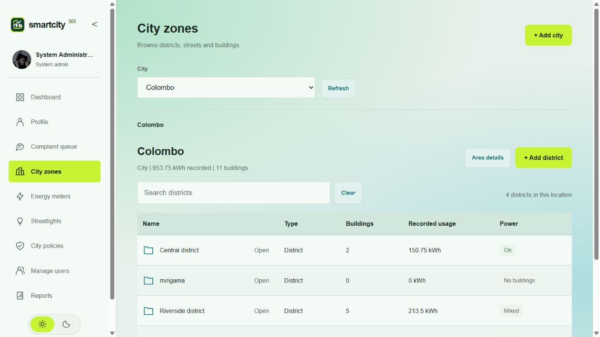
Figure 7 City hierarchy with usage and power summaries

6 Part C Complaint escalation

C1. Pattern identification and justification (3 marks)
Question: Identify the most appropriate pattern to handle dynamic escalation paths.
Chain of Responsibility is appropriate for severity-dependent complaint escalation. The sender passes a complaint to the first handler, which either accepts it or forwards it to its successor. The sender does not need to choose the final responsible authority.
SmartCity360 uses this chain:
LocalStaffHandler to SupervisorHandler to CityManagerHandler
Local staff accept LOW complaints. A supervisor can accept LOW or MEDIUM complaints, but normally receives only those forwarded by local staff. The city manager can accept all supported severities and normally receives HIGH complaints. Processing stops at the first accepting handler. This follows the handler/successor structure in the supplied class notes (Object Oriented Design Patterns - II, n.d., PDF pp. 17-20).
Severity thresholds are project business rules, not rules mandated by the design pattern. The interface describes them clearly so a demonstration user can choose the appropriate level.

C2. Decoupling request handling (4 marks)
Question: Explain how this pattern enables decoupled request handling.
The browser sends complaint details and severity to ComplaintResource. ComplaintService validates the request and invokes first.handle(severity) through the abstract ComplaintHandler type. It does not use a severity switch to select the final team.
Each concrete handler supplies canHandle() and its authority. The base class implements the common accept-or-forward algorithm using its next reference. The returned RoutingResult contains the assigned authority and an immutable list of handler visits. The service saves the complaint and those visits in PostgreSQL.
For a MEDIUM complaint:
1. Local staff cannot accept it and record FORWARDED. 2. The supervisor accepts it and records ASSIGNED. 3. The city manager is not visited.
The browser and REST endpoint are independent of the chain's length and order. Wiring is centralized in ComplaintService; replacing the first handler with a supervisor can model a period when local staff are unavailable. A unit test proves the same caller still works with this alternative chain. This configuration currently changes in Java and requires rebuilding/redeploying; a runtime chain editor is not implemented.
Assignment is distinct from completion. A routed complaint starts as ASSIGNED; a demo operator records IN_PROGRESS and then RESOLVED with mandatory notes. Resolved complaints can be reopened to IN_PROGRESS. Raising severity on an unresolved complaint routes it through the chain again, returns it to ASSIGNED for the new team, and preserves earlier history.
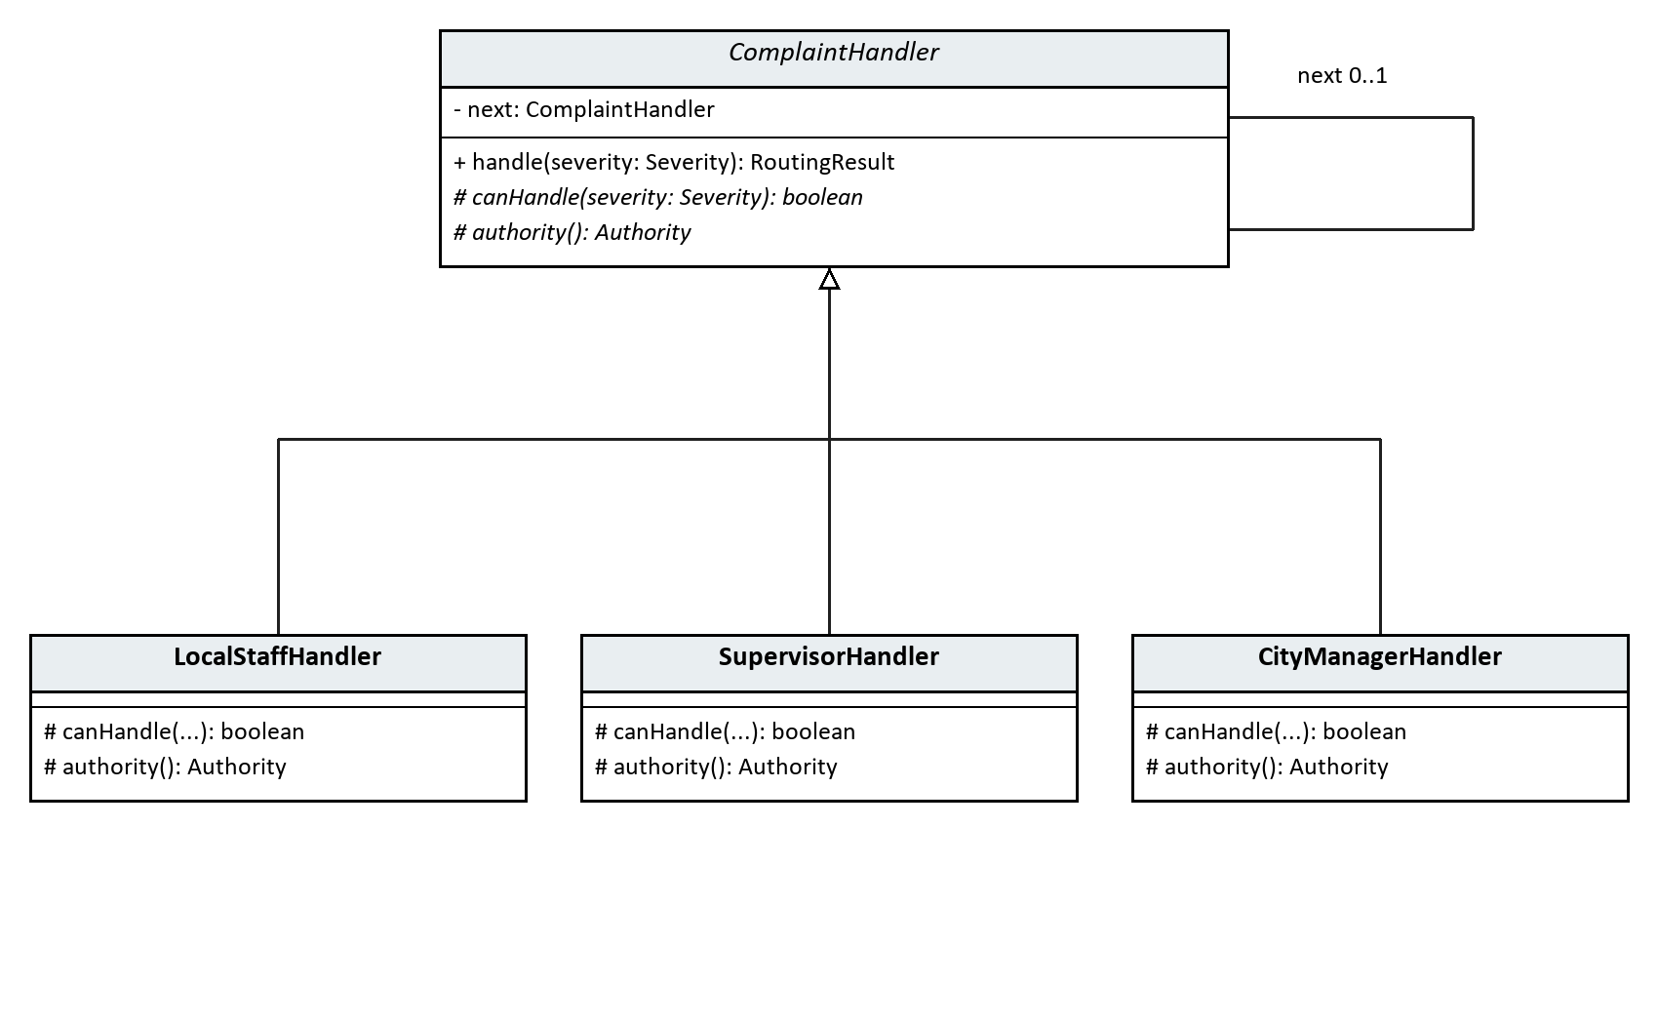
Figure 8 C UML class relationships for the implemented pattern

C3. Flexibility and traceability: benefits and drawbacks (8 marks)
Question: Evaluate its benefits and drawbacks in terms of flexibility and traceability.
Flexible responsibility. Each handler owns its acceptance rule. A new specialist handler can be inserted in the chain without changing the complaint submission endpoint. Chain wiring still needs deliberate review, and supporting authority labels/database constraints must be updated if a new authority is introduced. Extensibility does not mean every change is automatic.
Reduced coupling. The service knows the first handler and the common operation rather than choosing a specific team for each request. Common forwarding logic is implemented once. The six pure Java tests exercise handler behavior without needing Payara or PostgreSQL.
Visible decisions. History records submission, each forwarded/accepted step, severity escalation, work updates and reopening. The page shows both the current team and the earlier route. When severity changes, the old events remain; they are not replaced with the latest route. This supports explanation during a viva and helps users understand why a team received the complaint.
Explicit failure handling. A chain can end without a handler accepting the request. ComplaintHandler returns an UNHANDLED step with no assigned authority rather than silently dropping the request. The service can persist this as UNASSIGNED. The normal three-handler chain covers all three supported severities; the unhandled case is tested using a shortened chain. Repairing an intentionally incomplete chain or adding manual authority assignment remains an administrative extension, not an existing screen.
Order dependence. The first accepting handler wins. Placing the manager first would send every complaint to the manager and bypass local staff. A very broad acceptance rule could similarly hide later handlers. Tests for all three severities are therefore necessary after changing the chain.
Processing and storage costs. Routing visits at most the handlers up to the accepting one, so cost grows with chain length. The present chain contains three handlers. Every visit also creates a stored event. The application flushes events individually to guarantee their generated IDs follow handling order; they still belong to one transaction. This adds database work, but avoids misleading history ordering. No high-volume benchmark has been performed, and the current queue loads all complaints for a city before browser filtering. Pagination/index usage and retention would need attention as data grows.
Traceability needs supporting design. The pattern alone does not provide persistent history, transactions, authorization or timestamps. SmartCity360 adds JPA/PostgreSQL persistence, ordered events and work notes. The application database role can insert/read history but cannot update/delete it. Current actions record authenticated users; role, city and ownership checks protect access, and resident responses omit private staff notes. This is not a cryptographically tamper-proof audit: a database administrator can still change records.
Concurrent changes. Mutations lock and refresh the complaint record and check the version supplied by the browser. A stale window receives HTTP 409 and must refresh. A live test with two concurrent updates showed one accepted change and one conflict, with only one work-history event. Complaint and history changes commit together, avoiding a status change with a missing explanation.
The chain selects an authority role. A separate, permission-checked service can allocate an eligible named employee. Real notification delivery is not implemented. The application demonstrates local complaint handling without claiming integration with a municipality.
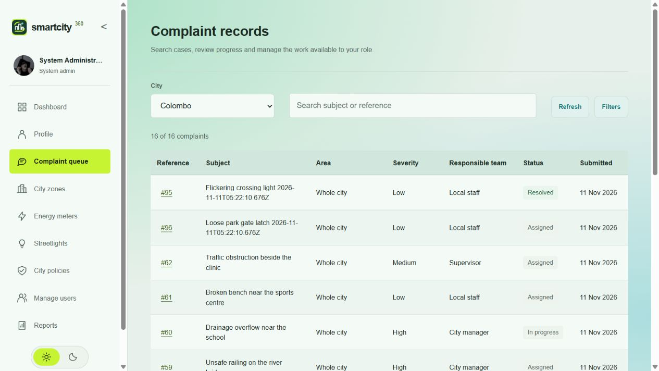
Figure 9 Current complaint queue with severity, authority and work status

7 Part D Efficient streetlights

D1. Pattern identification and justification (3 marks)
Question: Identify and justify the pattern that best optimizes resource use in this scenario.
The Flyweight pattern reduces duplicated intrinsic state when a city has many streetlights with relatively few lamp configurations. SmartCity360 shares one immutable LampSpecification per combination of model, rated watts and light colour. Individual lights retain their own location and operating state.
This applies the sharing approach taught in the supplied class notes (Object Oriented Design Patterns - II, n.d., PDF pp. 20-25). The LampSpecificationFactory is the pool/factory role within Flyweight, not an additional selected design pattern. It returns an existing specification when the configuration already exists and creates one otherwise.
For example, two lights on different streets can both reference the same CityLED 40 specification. Switching one light off changes that light's context, leaving the other light on. Copying a specification for every lamp would repeat the same model, wattage and colour state without adding information.

D2. Intrinsic and extrinsic state (4 marks)
Question: Explain how this pattern handles shared (intrinsic) and unique (extrinsic) properties.
The service loads an inventory page, resolves each specification through the application-scoped pool and constructs an individual context for each row. It counts shared objects by identity, so identical values alone do not establish the reported sharing. ConcurrentHashMap.computeIfAbsent protects pool lookup/creation when requests run concurrently. Specifications expose no mutation methods.
StreetLight.getRatedLoadWatts() passes its power and fault values to LampSpecification.ratedLoadWatts(powerOn, faulty). Thus shared behavior uses the current context without saving that context inside the shared object. The calculation returns rated watts only when the light is on and healthy. This is a stated simulation assumption, not measured power or energy consumption.
Changing one light's configuration updates its specification reference in storage. A newly reconstructed context refers to the selected pooled object; other lights continue to use their previous specification. Shared configurations are not edited in place.
PostgreSQL stores one lamp_specification row per unique configuration, referenced by multiple streetlight rows. That reduces stored duplication, while the Java pool separately provides runtime object sharing. A foreign key alone would not prove a Flyweight implementation. After application restart, the pool is reconstructed from requested persisted configurations.
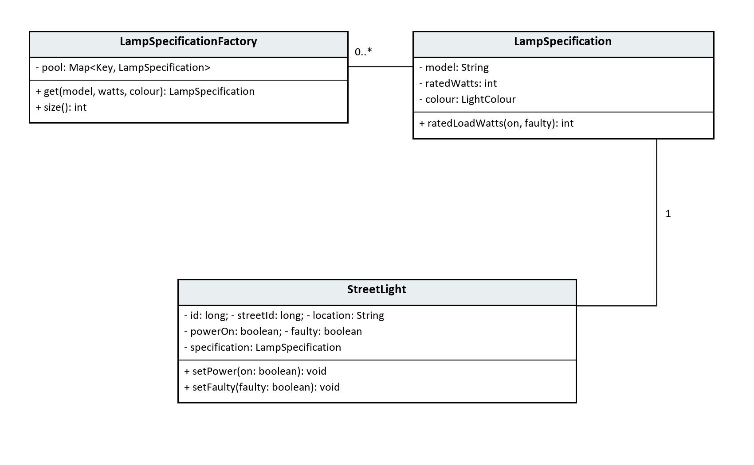
Figure 10 D UML class relationships for the implemented pattern

D3. Effect at tens of thousands of lights (8 marks)
Question: Analyze the performance impact when scaling to tens of thousands of similar objects.
Let N be the number of lights and K the number of distinct specifications. Without sharing, each light can require its own specification object, giving N specification instances. Flyweight reduces those instances to K while retaining N independent light contexts. It is most useful when K is much smaller than N.
An illustrative storage model is N x (E + I) without sharing, compared with N x (E + R) + K x I + pool overhead with sharing. Here E represents individual context state, I intrinsic specification state and R a shared reference. This explains the tradeoff; it is not a measured byte count. Real JVM memory also depends on headers, alignment, map entries, strings and temporary allocations.

Performance implications and limits
Fewer repeated specification objects can reduce retained intrinsic state and repeated object creation. Immutable sharing also avoids synchronizing edits to the shared data. Pool lookup and map storage add overhead, however, and each light still needs its own context. If nearly every light has a unique configuration, K approaches N and the benefit shrinks; the pool can cost more than it saves.
The live inventory loads bounded pages: 25 lights in the UI and at most 100 per API page. City-wide counts and rated-load totals are calculated by database queries. This avoids constructing every light merely to display one page, but the in-memory 100,000-light demonstration does not prove database throughput for 100,000 persisted rows.
The application pool retains requested configurations until restart/redeployment and currently has no eviction. A large number of unique configurations therefore increases its memory use. Database uniqueness and immutable specifications preserve reuse; concurrency tests verify that simultaneous requests for one configuration obtain the same pooled identity. The demonstration is bounded and serialized to limit simultaneous temporary allocations.
This implementation simulates power commands and fault state. It does not connect to physical lamps, estimate energy over time or retain maintenance history. Current application role and city restrictions are enforced separately from Flyweight; this is not a production-security certification.
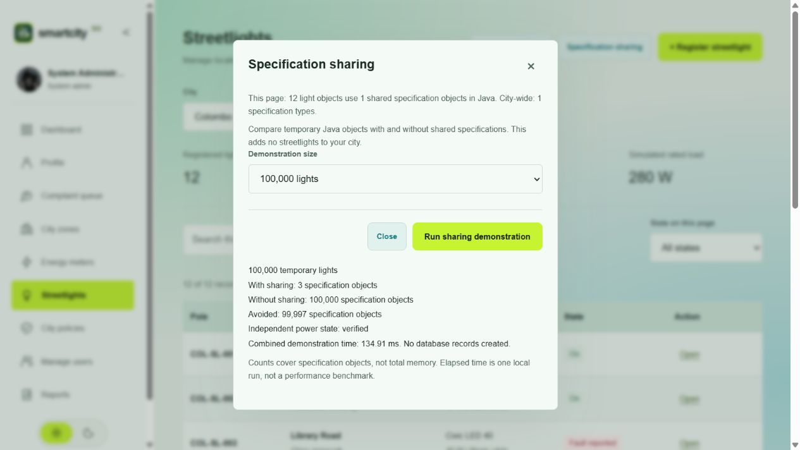
Figure 11 Isolated specification-sharing demonstration
The 100,000-light test uses three shared specification identities instead of 100,000 independent specifications. The 99,997 avoided specification instances are an object-count result, not a measured byte saving. The contexts remain separate. The demonstration creates no database streetlights, and elapsed time includes both shared and unshared allocations.

8 Part E City policy language

E1. Pattern identification and justification (3 marks)
Question: Identify the most appropriate design pattern for interpreting this rule language.
The Interpreter pattern fits SmartCity360's small policy language. It represents a rule as expression objects, with a common interpret(context) operation. Terminal expressions evaluate individual comparisons, while nonterminal expressions combine other expressions using AND, OR and NOT.
The supplied class notes introduce an Expression interface, terminal expressions and a nonterminal expression that combines two child expressions (Object Oriented Design Patterns - II, n.d., PDF pp. 25-27). Their arithmetic example is adapted here to boolean city policies. The parser translates user-entered text into those objects; the Java expression classes perform the actual interpretation.
For example, noise > 65 AND (hour >= 22 OR hour < 6) describes a fictional overnight noise violation. It becomes an AndExpression with a noise comparison on its left and an OrExpression for the two hour comparisons on its right. A PolicyContext supplies the observed values. A result of true is interpreted using the policy's saved meaning, because a noise rule may describe a violation while a parking rule may describe permission.
This makes supported policy edits data changes: an administrator can change 65 to 75, save the text and evaluate the revised rule without changing or recompiling Java classes.

E2. UML class diagram and mechanism (4 marks)
Question: Provide a UML class diagram to demonstrate the selected design pattern’s mechanism.
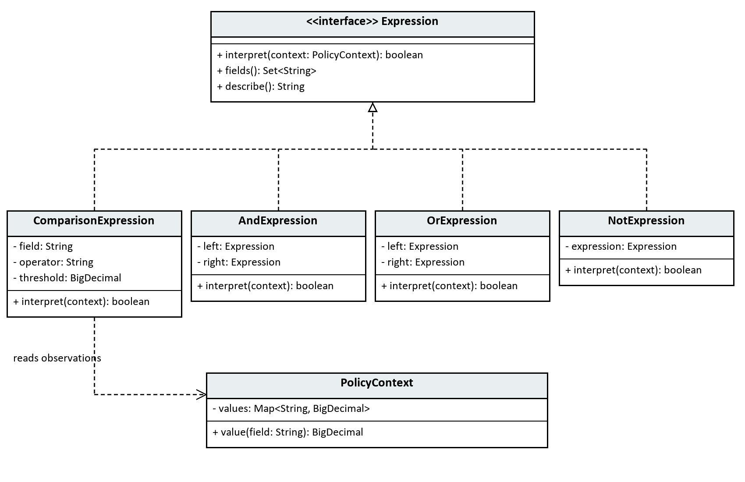
Figure 12 E UML class relationships for the implemented pattern

Execution sequence
1. The browser sends a policy expression to the Jakarta REST resource. Java validates syntax when saving; an optional syntax-check action also returns explicit grouping and required fields without saving anything. 2. PolicyParser tokenizes the text and builds the tree. Its grammar applies NOT before AND before OR, with parentheses overriding grouping. Unknown fields, malformed comparisons and leftover tokens produce errors with character positions. 3. On evaluation, PolicyService loads the saved policy and checks its city, active flag and submitted edit version. The observation zone must belong to that city. 4. PolicyContext validates numeric values. Parsed.evaluate() checks every field referenced anywhere in the tree before calling the root. Missing input cannot be hidden by a short-circuited boolean branch. 5. Each comparison reads its field and compares it with its threshold using BigDecimal. Nonterminal expressions recursively combine boolean results. describe() displays the actual parsed grouping, not a separate interpretation of the user's text. 6. The service saves the result with a snapshot of the rule, meaning, revision, observations, zone and evaluation timestamp. These operations occur within a transaction.
The pattern remains visible in ordinary Java classes. REST transport, a bounded recursive-descent parser, JPA and PostgreSQL support the application; they are not additional selected patterns for this question.

E3. Suitability for rule updates and extensibility (8 marks)
Question: Critically assess the pattern’s suitability for rule updates and extensibility.

Strengths
The expression tree separates the grammar's meaning from the interface and persistence code. Existing expressions can be recombined and their thresholds edited without adding a Java subclass for each city policy. The same comparison class serves noise, hour and parking-duration checks. Parentheses and boolean operators allow more useful rules than a fixed list of form checkboxes.
Each node has a small, testable responsibility. Comparison tests check exact boundaries, while combination tests check precedence and negation. Decimal comparison avoids equality surprises from trailing zeros. Immutable expression nodes and contexts avoid accidental state changes while interpreting a rule; each parse uses a fresh parser instance.
Saved evaluation snapshots make rule changes explainable. For example, the browser used 70 dB at hour 23: a 65 dB threshold produced a violation at revision 1, while changing the threshold to 75 dB produced no violation at revision 2. The earlier result still displayed the 65 dB rule and original observation. This provides traceability for evaluated rules rather than retroactively applying the latest text to every result.
The UI stops evaluation while its draft has unsaved changes, and the server independently checks the requested saved version. City-level transactional locking serializes competing edits/evaluations; a stale request returns 409. Inactive rules retain their history while rejecting new evaluations.

Extensibility and tradeoffs
Changing a threshold or combining existing comparisons is a runtime update. Adding a genuinely new language feature is a software change. A new numeric field needs context validation, parser recognition, observation input, persistence mapping and tests. A new boolean operator needs an expression implementation, grammar/precedence changes and tests. Dates, units, functions or arithmetic would require more substantial grammar and type design. Interpreter does not make arbitrary language extensions automatic.
For a small grammar, the classes are easy to follow in a viva. As a language grows, the number of node types, parser cases and interactions can become difficult to maintain. Users may also write syntactically valid rules with the wrong meaning. Explicit grouping, a clear true-result meaning, examples and boundary tests help, but do not replace policy review.
Parsing allocates an expression tree for each operation, and recursive interpretation visits relevant nodes. Boolean operators can short-circuit evaluation, but the application deliberately validates all required observations first. Parsing is currently repeated instead of cached. A future cache would need keys including policy revision and language version to avoid using outdated rules. No large-policy throughput benchmark has been performed.
Resource limits keep this implementation bounded: 1,000 source characters, 200 tokens, 20 nested groups/negations and 20 characters per numeric literal. The language accepts only known numeric fields and explicit operators; it has no script execution, external calls or loops. These restrictions are part of making a small, explainable DSL, not proof of complete production security. Current application role and city access checks are implemented separately from the interpreter.
The observations are manual demonstration data: noise 0-200 dB with up to three decimal places, whole hours 0-23, and whole parking minutes 0-10080. Overnight windows use an OR expression. The language does not handle minutes within an hour, time zones, calendars, holidays or continuous sensing. A result is recorded for one selected zone; it does not automatically switch devices, issue penalties or establish legal compliance.
History preserves evaluated revisions and their inputs, but is not a complete audit log of every policy edit. An intermediate rule that is edited again before evaluation has no separate historical snapshot. Similarly, future changes to language semantics would need an explicit language-version strategy; the current implementation does not migrate or replay old rules automatically.
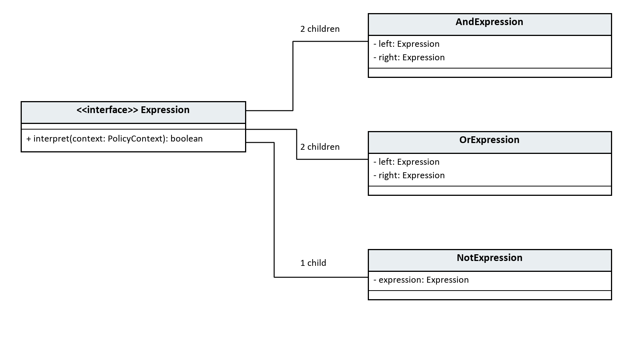
Figure 13 Recursive child references held by nonterminal expressions
Each child is itself an Expression, so logical expressions can contain other logical expressions or terminal comparisons. The implementation has two fields for AND/OR and one for NOT. The interface realization relationships are shown in the preceding class diagram.
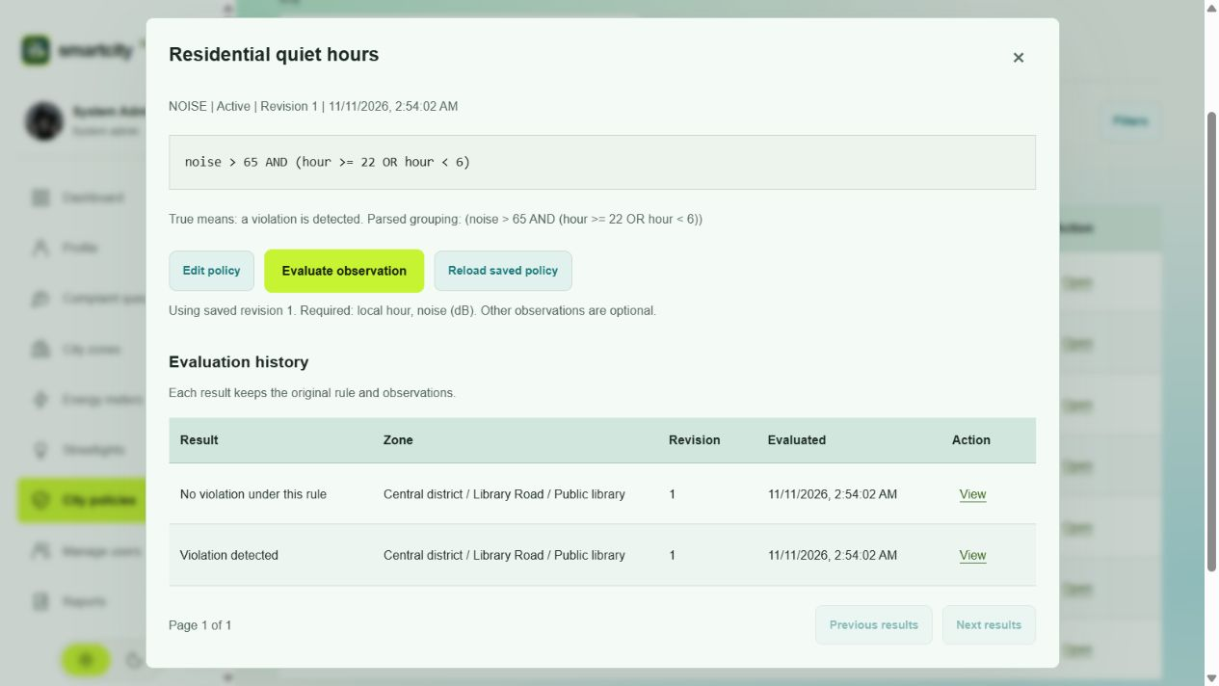
Figure 14 A saved rule with true and false evaluation results

9 Implementation and operation

9.1 Project organization
Location | Responsibility
pattern/decorator, composite, chain, flyweight, interpreter | Small Java classes that implement the five assessed mechanisms.
resource and service packages | HTTP operations, validation, authorization and business transactions.
entity and security packages | Persistence mappings, account/session handling and access checks.
src/main/webapp | HTML, local styles, JavaScript, icons and application images.
database | Ordered additive schema scripts.
scripts and src/test/java | Setup helpers, repeatable sample setup and automated verification.

9.2 Representative working code
The excerpts below are taken from the implementation. They show the key mechanism for each part; full classes and error handling remain in the submitted source project.

Decorator assembly
if (compress) stream = new CompressionDecorator(stream);
if (encrypt) {
long encryptedCount = em.createQuery("SELECT COUNT(r) FROM MeterReading r WHERE r.encrypted = true", Long.class).getSingleResult();
stream = new EncryptionDecorator(stream, keyStore.key(encryptedCount == 0));
}
if (auth) stream = new AuthenticationDecorator(stream, HexFormat.of().parseHex(meter.getCredentialHash()));
return stream;
}
Source: service/MeterService.java

Composite delegation
@Override public void setPower(boolean on) {
for (ZoneComponent child : children) child.setPower(on);
}
Source: pattern/composite/ZoneGroup.java

Complaint forwarding
RoutingResult downstream = next.handle(severity);
var steps = new ArrayList<RoutingResult.Step>();
steps.add(new RoutingResult.Step(authority(), "FORWARDED"));
steps.addAll(downstream.steps());
return new RoutingResult(downstream.assignedTo(), steps);
Source: pattern/chain/ComplaintHandler.java

Flyweight pool lookup
Key key = new Key(model.strip(), watts, Objects.requireNonNull(colour));
return pool.computeIfAbsent(key, value -> new LampSpecification(value.model(), value.watts(), value.colour()));
Source: pattern/flyweight/LampSpecificationFactory.java

Interpreter evaluation
public record Parsed(Expression root) {
public boolean evaluate(PolicyContext context) { context.require(root.fields()); return root.interpret(context); }
}
Source: pattern/interpreter/PolicyParser.java

9.3 Running the project
Open the Maven project in IntelliJ IDEA Ultimate and select JDK 21. PostgreSQL must be started before Payara. The project uses a dedicated Payara domain, HTTP port 9080 and application context /smartcity360. The local launcher builds the WAR and deploys it; it is not a Java Application main class.
From the project terminal, run powershell.exe -NoProfile -ExecutionPolicy Bypass -File .\scripts\run-local.ps1. The launcher uses the configured local tool paths and cached Maven dependencies. A new machine must first install the documented tools, configure database credentials and apply the ordered migrations; the local launcher is not a substitute for first-time setup.
Open http://localhost:9080/smartcity360/login.html. Use an authorized local account. Public registration creates a Resident account; it cannot grant a staff role. Credentials and the encryption key must not be copied into the report, source repository or public screenshots.

9.4 Using the main workflows
A resident chooses a city and submits a complaint. LOW routes to local staff, MEDIUM to a supervisor and HIGH to a city manager. Authorized staff open the case, allocate a suitable employee when permitted, start work and record a resolution. Public replies are visible to the resident; private notes are not. A resident may request reopening, after which a supervisor or higher authority records approval or rejection with an explanation.
For meter processing, select a building meter and enter a reading with the required credential and chosen layers. The saved-reading inspector shows the processing flags, payload size and recovery controls. For streetlights, select an existing specification or create one with appropriate permission, then register an individual location. Policy operations are separate: save a valid rule, enter observations and inspect the saved outcome and revision.
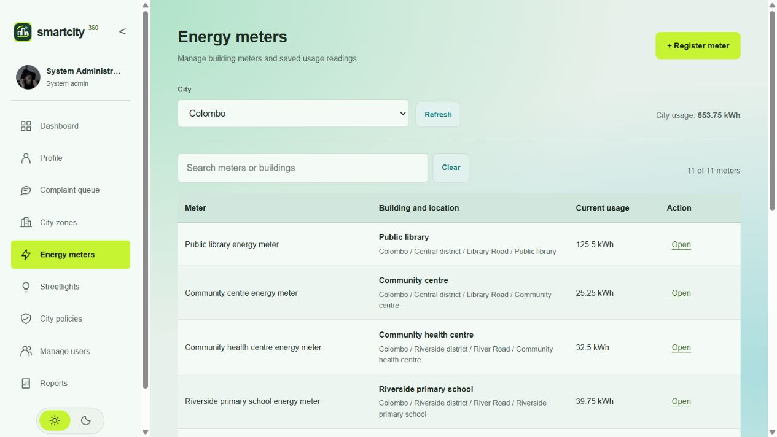
Figure 15 Registered meters linked to building locations
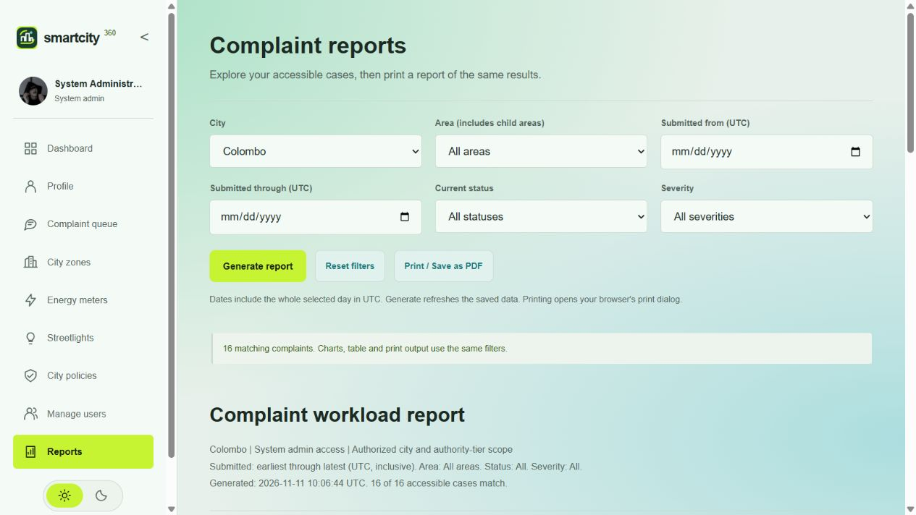
Figure 16 Complaint reporting with filters and saved-data summaries

9.5 Data and operational safeguards
Sample loaders add named records to the five existing cities and skip matching examples on repeat runs. The expanded setup provided ten buildings and meters per city, twelve streetlights, at least six policies and twelve complaint examples, before later manual additions. Screenshots reflect the current database and may therefore show larger counts. New meter observations are recorded at their actual creation time and must not be described as a long-term energy trend.
Many writes use a saved version to detect conflicting updates. A stale request is rejected and the user must reload before retrying. Invalid meter credentials or corrupted payloads do not create an accepted reading. Backups must include the database and protected encryption key; losing the key prevents recovery of old encrypted payloads.

10 Testing and results

10.1 Verification approach
Testing combines pure pattern tests, service/security tests, live HTTP checks against the local database and browser inspection. These levels answer different questions. A unit test can prove that a Composite operation leaves a sibling unchanged, but it cannot by itself prove that a browser form sends the correct request. Similarly, a screenshot documents visible state but does not prove authorization against a modified URL.
Verification | Observed result | Scope
Java suite | 67 passed; no failures/errors/skips | Patterns, account security, allocation, profile validation and mocked complaint service behavior.
Pattern-only review | 33 passed | Decorator 7; Composite 5; Chain 6; Flyweight 6; Interpreter 9.
Current-role API checks | 106 passed | Five roles, city scope, module access, reporting and ownership fixture.
Live complaint journey | 42 passed | Writes, two resident owners, allocation, messages, stale updates, reopening and persistence after sign-in.
Client checks | 21 passed | Alerts, session behavior, report calculations and city navigation.

The pattern-only review was executed on 11 November 2026 using mvn -B -o -Dtest=MeterStreamTest,ZoneCompositeTest,ComplaintHandlerTest,StreetLightTest,PolicyParserTest test. The full suite was run with mvn -B -o test. Test totals are separate suites and must not be added together as if all cases were unique.

10.2 Requirement-based test cases
Case | Expected behavior | Observed evidence
A layer combinations | All eight supported selections recover original bytes. | Passed in MeterStreamTest.
A tampering | Corrupted encrypted content and wrong keys are rejected. | Passed in MeterStreamTest.
B subtree command | Selected district changes; sibling district remains unchanged. | Passed in ZoneCompositeTest.
C routing | Each severity reaches the correct authority in order. | Passed in ComplaintHandlerTest.
C ownership | A resident cannot read or write another resident case. | Both directions passed in live journey.
C privacy | Private staff note does not appear in resident detail. | Passed in live journey.
D sharing | Matching configurations use the same object identity. | Passed, including concurrent lookups and 100,000 contexts.
E language | Precedence, parentheses and boundaries evaluate correctly. | Passed in PolicyParserTest.
E invalid input | Malformed rules, missing fields and excessive complexity are rejected. | Passed in PolicyParserTest.
Reports | Status-filter totals match accessible underlying cases. | Passed in client and live role checks.

10.3 Live complaint journey
Two different residents submitted separate cases. Requests in both directions to read the other case returned not-found responses, and neither queue included the other owner’s case. Attempts to message or request reopening on the other case were rejected. A resident could not perform a staff status update. A supervisor allocated an eligible local employee, who posted a public reply and recorded private work notes.
The test then resolved the case, submitted a resident reopening request, rejected it with an explanation, submitted a clarified request and approved it. Local staff were denied the review operation. After the final repair and resolution, a fresh sign-in still returned the resolved state. Cases 95 and 96 were retained for inspection. This is live complaint verification, not a claim that every write operation in every module was retested.

10.4 Interface verification
Current screenshots were captured from the running application on 11 November 2026. Desktop dashboards and complaint tables were checked in both themes. At a 390 by 844 viewport, cards stacked vertically and the complaint page did not overflow horizontally; wide tables stayed inside their scrollable container. The sidebar drawer and remembered theme switch were exercised. Refreshing records did not produce an unnecessary success popup.

10.5 Verification limits
The evidence does not establish production load capacity, physical sensor reliability or legal policy correctness. Complete native print/PDF output, every dialog in every role, clean setup on a second machine and full live write regression for all modules remain outside the latest checks. Earlier module and restart results are retained in the project verification notes, but are not presented here as freshly rerun tests.

11 Evaluation and conclusion

11.1 Achievement of objectives
The five assessment scenarios are implemented in one Java web application. Each pattern addresses a distinct change point: optional meter layers, hierarchy traversal, authority routing, shared configuration and runtime rule interpretation. The application adds persistent records and access checks around these mechanisms without treating the pattern classes as the whole system.
The most useful integration is the relationship between meter readings and zone totals. An accepted reading changes one building total, and Composite reports the aggregate. Complaint history makes the authority chain visible, while policy snapshots show which expression produced a result. These links make the design demonstrable through ordinary application tasks.

11.2 Limitations and future work
The hierarchy service reconstructs a city tree and can become expensive for very large cities. Complaint queues are filtered in the browser over accessible records. Lamp specifications stay in the application pool until restart, so many unique configurations increase memory usage. Policy expressions are parsed for each operation and have a deliberately small grammar. These are explicit design limits rather than claims of unlimited scalability.
Useful future work includes saved notifications, maintenance assignments and repair history, historical reporting periods, complete policy edit auditing and larger operational reports. Builder and Visitor could support future report construction and hierarchy reporting if their structures are justified by those features. They are not claimed as implemented patterns in this submission.

11.3 Conclusion
SmartCity360 provides a working setting for the five selected design patterns. The implementation, current interface evidence and recorded tests show how each mechanism solves its assigned scenario. The project also shows the boundary between a pattern and the surrounding engineering work: persistence, authorization, validation, concurrency and usability must still be designed explicitly.

References
Eclipse Foundation (n.d.-a) Jakarta RESTful Web Services 4.0. Available at: https://jakarta.ee/specifications/restful-ws/4.0/ (Accessed: 11 November 2026).
Eclipse Foundation (n.d.-b) Jakarta Persistence 3.2. Available at: https://jakarta.ee/specifications/persistence/3.2/ (Accessed: 11 November 2026).
Java Institute for Advanced Technology (n.d.) Object Oriented Design Patterns II Final Assessment. Assessment JIAT/OODP II/EX/01. Supplied assessment brief.
Object Oriented Design Patterns - II (n.d.) Class lecture notes supplied for OODP II. Decorator pp. 2-5; Composite pp. 5-9; Chain of Responsibility pp. 17-20; Flyweight pp. 20-25; Interpreter pp. 25-27. Author and publication date are not stated in the supplied copy.
Oracle (n.d.-a) Cipher. Java SE 21 API documentation. Available at: https://docs.oracle.com/en/java/javase/21/docs/api/java.base/javax/crypto/Cipher.html (Accessed: 11 November 2026).
Oracle (n.d.-b) MessageDigest. Java SE 21 API documentation. Available at: https://docs.oracle.com/en/java/javase/21/docs/api/java.base/java/security/MessageDigest.html (Accessed: 11 November 2026).
Oracle (n.d.-c) GZIPInputStream. Java SE 21 API documentation. Available at: https://docs.oracle.com/en/java/javase/21/docs/api/java.base/java/util/zip/GZIPInputStream.html (Accessed: 11 November 2026).
RasheedaIdusara (n.d.) Object-Oriented-Design-Pattern-2. Class practical examples. Available at: https://github.com/RasheedaIdusara/Object-Oriented-Design-Pattern-2 (Consulted during project planning).
OODP II NOTE (n.d.) Supplementary class notes supplied with the project brief. Available at: https://troubled-angle-969.notion.site/OODP-II-NOTE-4078f56485818074a628e98e5aff02e0 (Supplied course reference).
The class materials were used to understand pattern roles and relationships. The diagrams in this report represent the SmartCity360 classes and were redrawn for this implementation. Screenshots show the local application and fictional sample records. Java API references support the cryptographic and compression operations; they do not replace the pattern explanations.

