PHISHING ANALYSIS

Submitted by

Rishikesh M

FLOW OF EMAIL

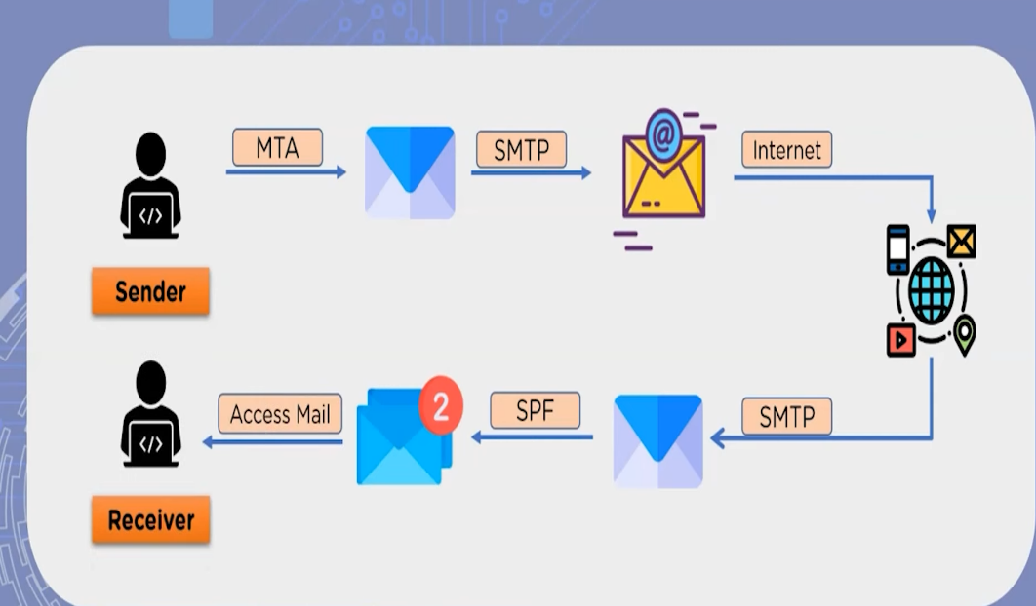

How to check email header?

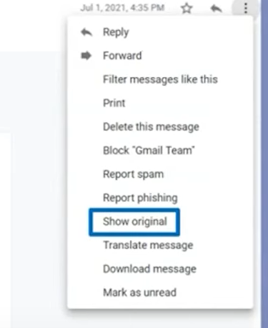

EXAMPLE 1 [Simple Analysis]

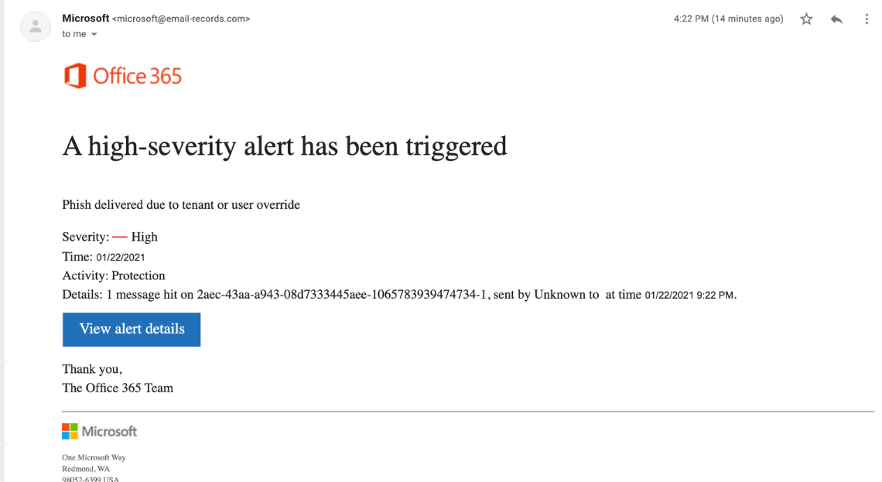

By looking at the sender’s address, it is clear that the received mail is not from Microsoft.org. This can be confirmed by checking online to see the original mailing address of Microsoft.

Before clicking any button on the mail received, always check where the link takes the user by placing the mouse over the button.

EXAMPLE 2 [Header Analysis]

The email header analyzer is an efficient utility that enables users to check for the credibility of emails received. The header present in sample-email.txt file was analyzed online using <https://mxtoolbox.com/EmailHeaders.aspx>

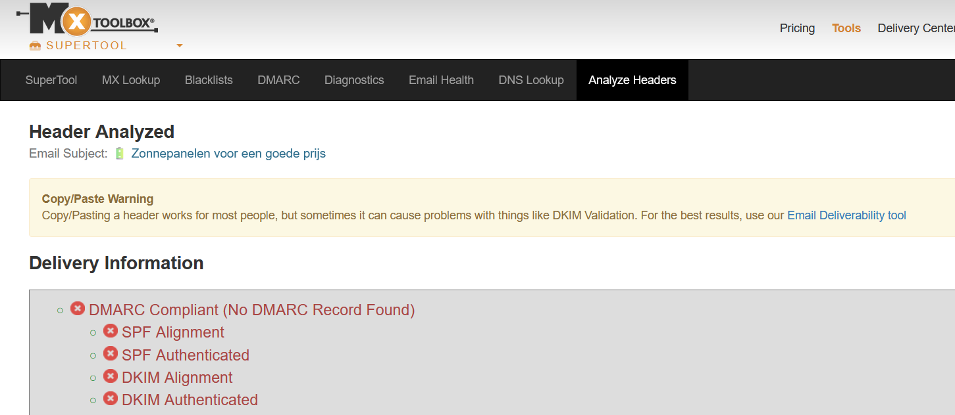

This revealed that the given email is not valid and contains phishing attacks to lure the naïve user.

REFERENCES

<https://github.com/rf-peixoto/phishing_pot/blob/main/email/sample-100.eml>

<https://mxtoolbox.com/EmailHeaders.aspx>

<https://www.youtube.com/watch?v=3wwaYc_Yuhc>