FIREWALL ANALYSIS

Submitted by

Rishikesh M

START FIREWALL

Operating sytem: Windows 11 23H2

Use the Start menu on Windows to search Windows Defender Firewall with Advanced Security to open up the firewall.

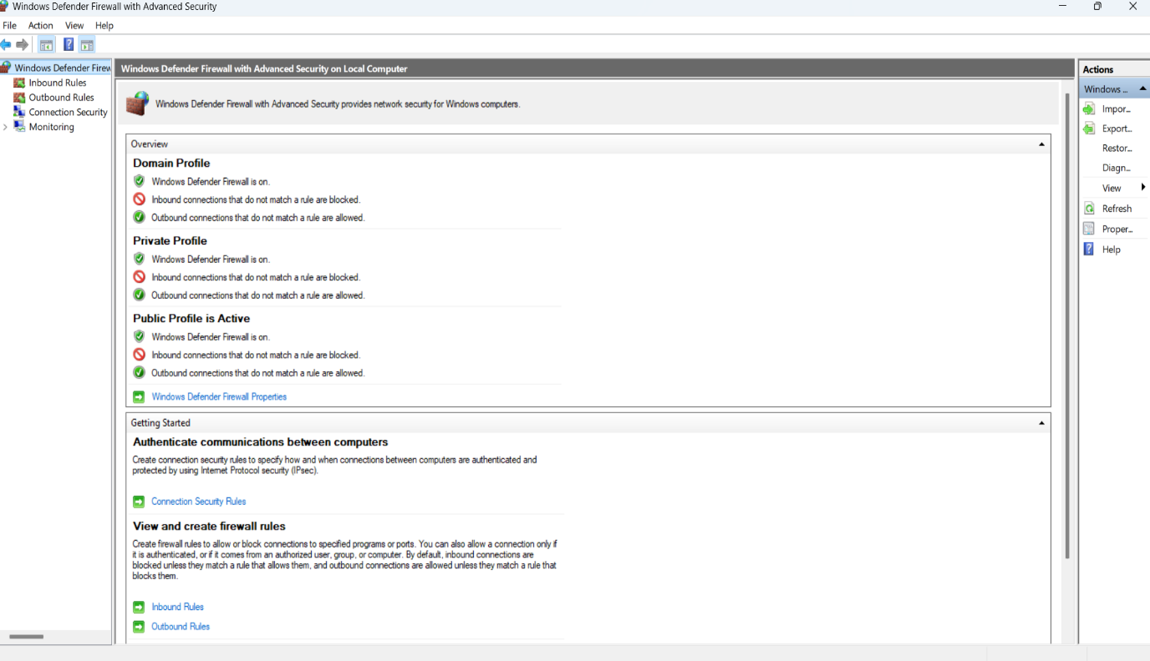

INCOMING RULES

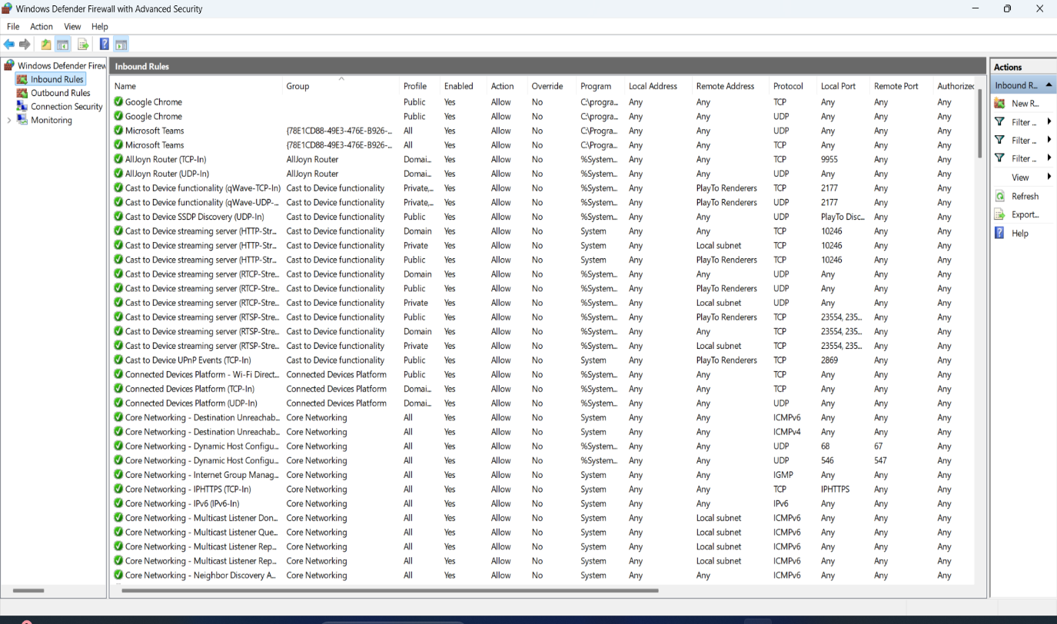

OUTBOUND RULES

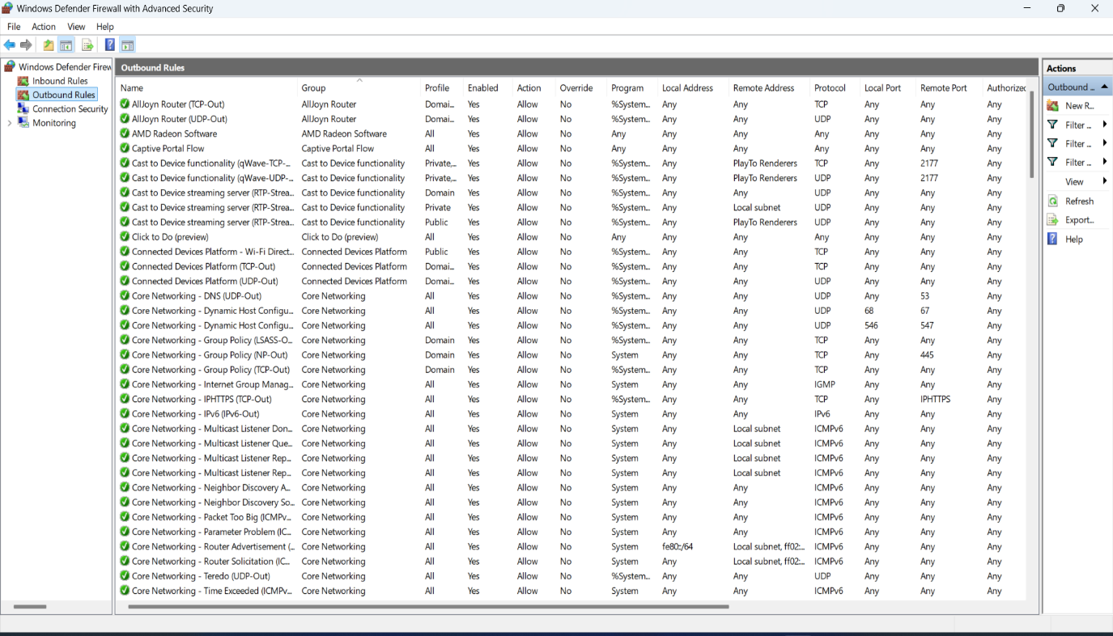

CREATING RULE TO BLOCK OUTBOUND TELNET

Select the new rule option in the right side pane of the outbound rules to create a new rule -> Select Custom rule.

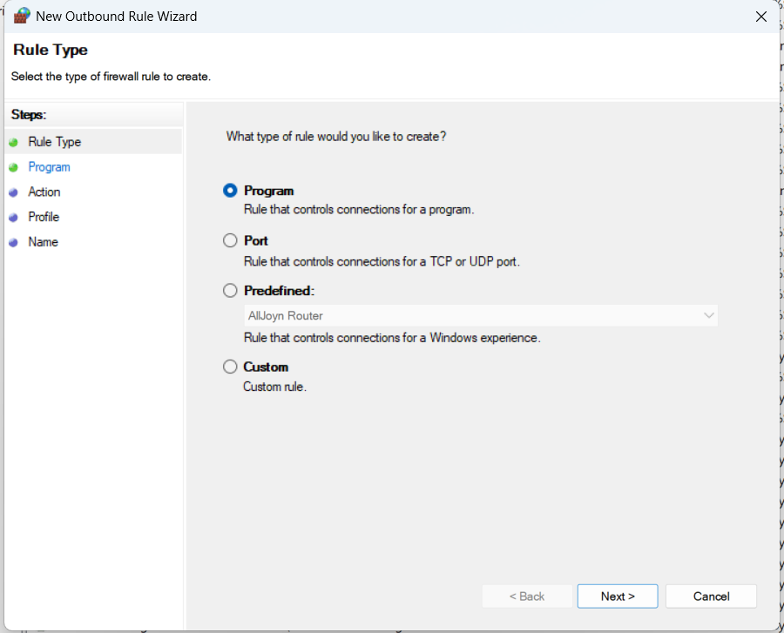

Click on all programs -> specific ports -> type port 23 -> Next.

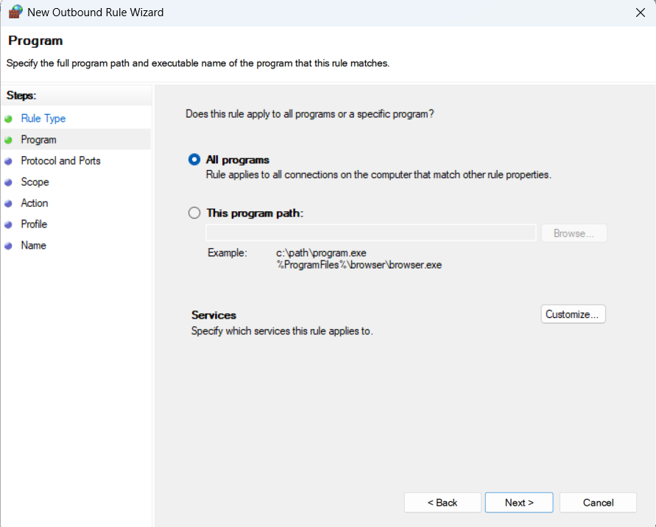

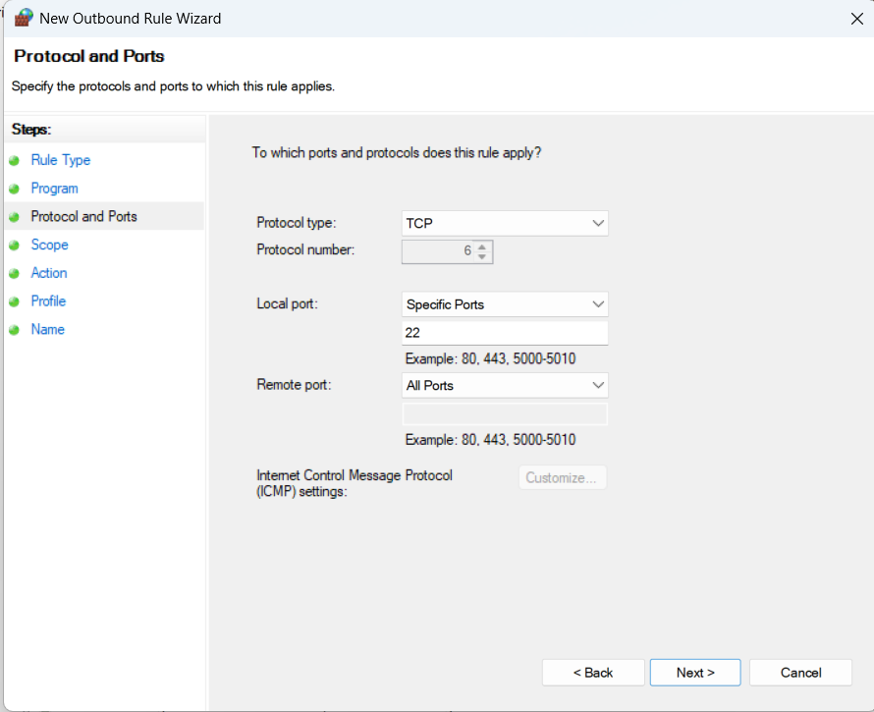

Under action, select **Block the connection** ->Select required domains -> Next.

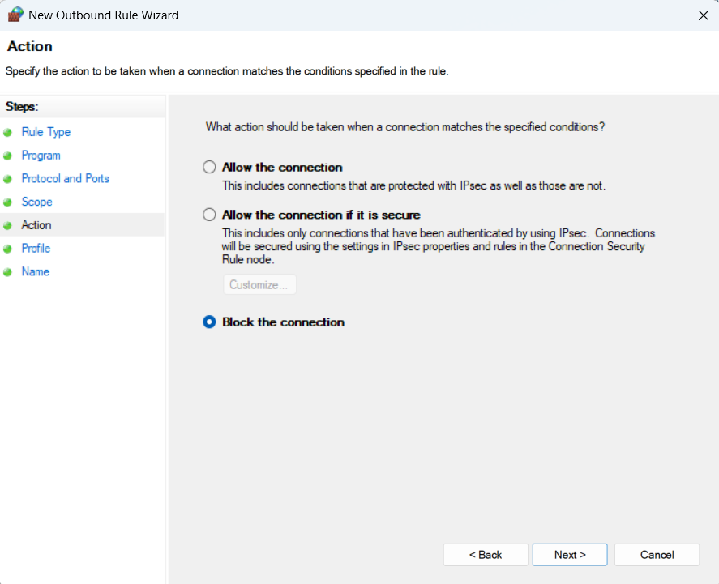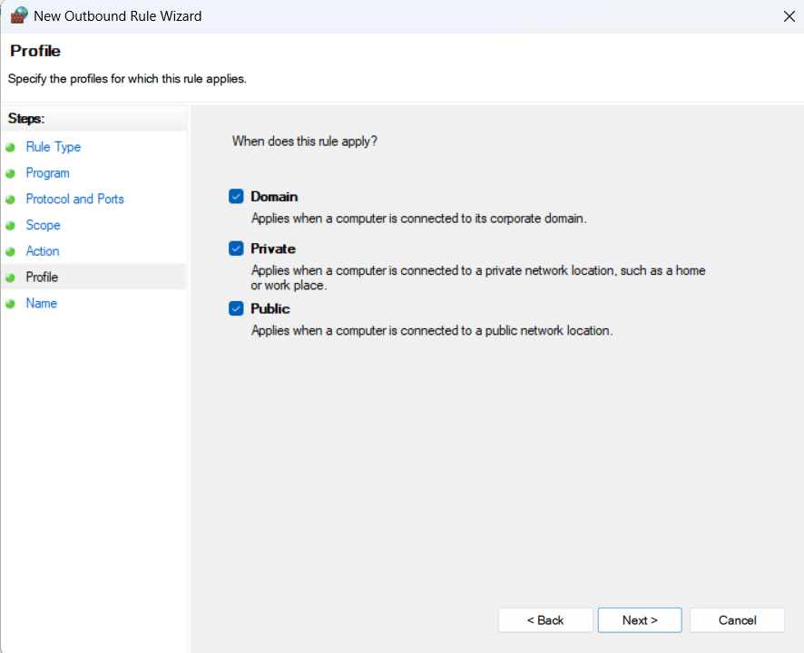

Give the rule a name and description if needed.

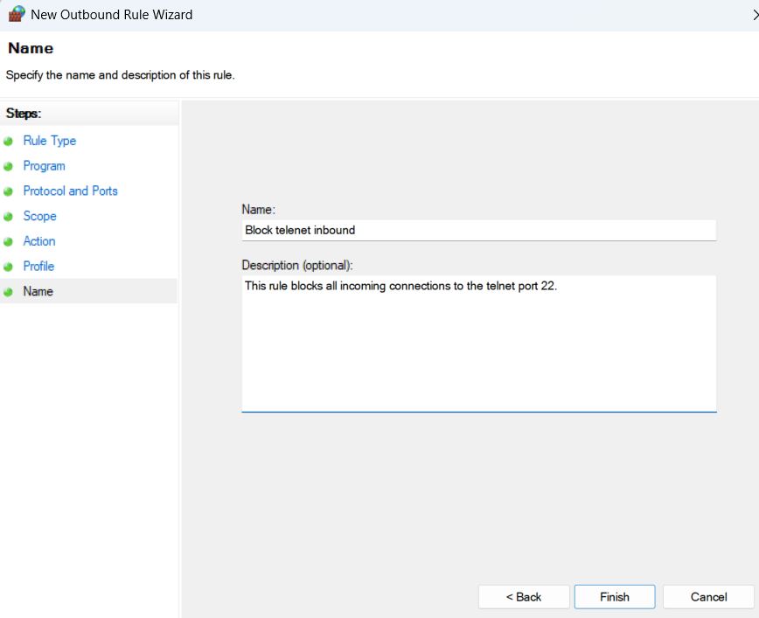

Attempting to connect to telnet via mobile phone terminal or another remote server is not working because of the created rule.

RESTORE TO ORIGINAL STATE

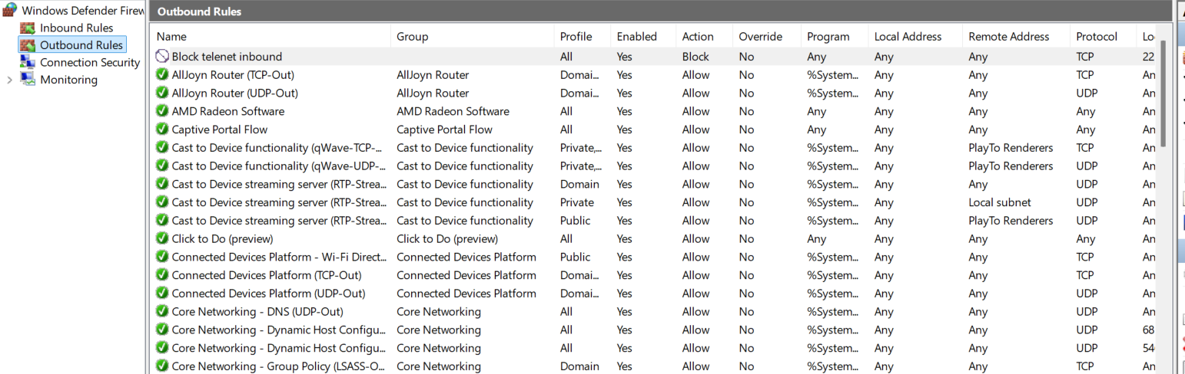

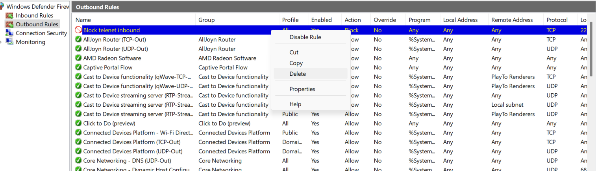

SUMMARY

The firewall acts as a layer of protection to protect our systems against unauthorized access of data or intrusion by attackers. There are various inbound and outbound rules which help in the easy filter of incoming and outgoing internet traffic. Firewalls work on a kind of match system where the traffic is matched against the rules present and it determines whether a certain traffic packet should be allowed or restricted.

REFERENCES

<https://www.geeksforgeeks.org/computer-networks/introduction-of-firewall-in-computer-network/>

<https://superuser.com/questions/1679873/firewall-blocked-port-telnet-23>