ROLE OF VPN ANALYSIS

Submitted by  
  
Rishikesh M

# VPN USED

VPN: ProtonVPN  
Operating System: Windows 11 23H2

# Downloading Proton VPN

Download the VPN from the official website of the corresponding service.

# 

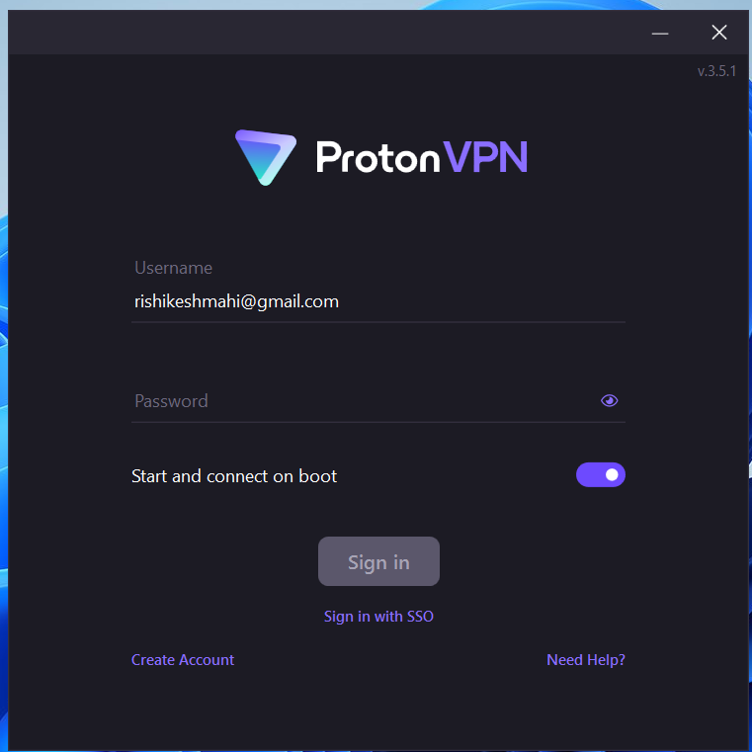

# CONNECT TO VPN

Select a server from the available list and change your ip address using the vpn.

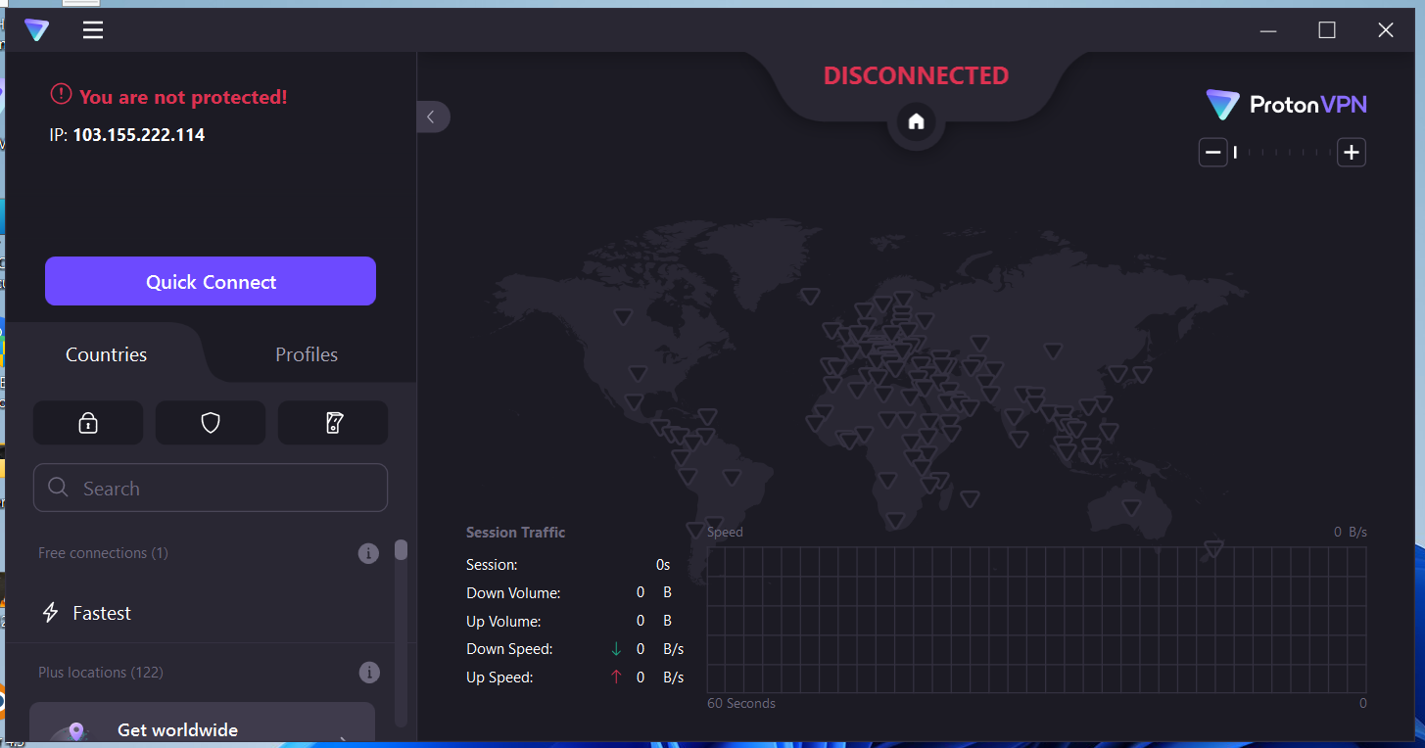

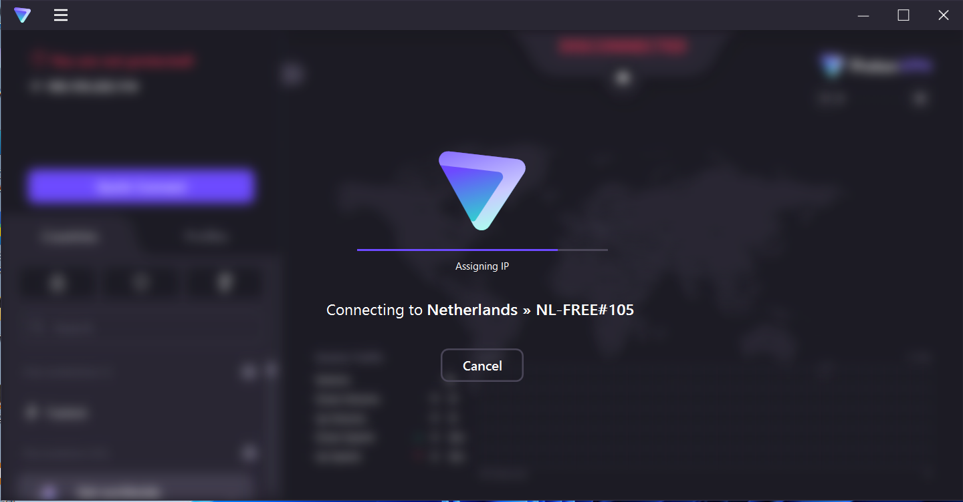

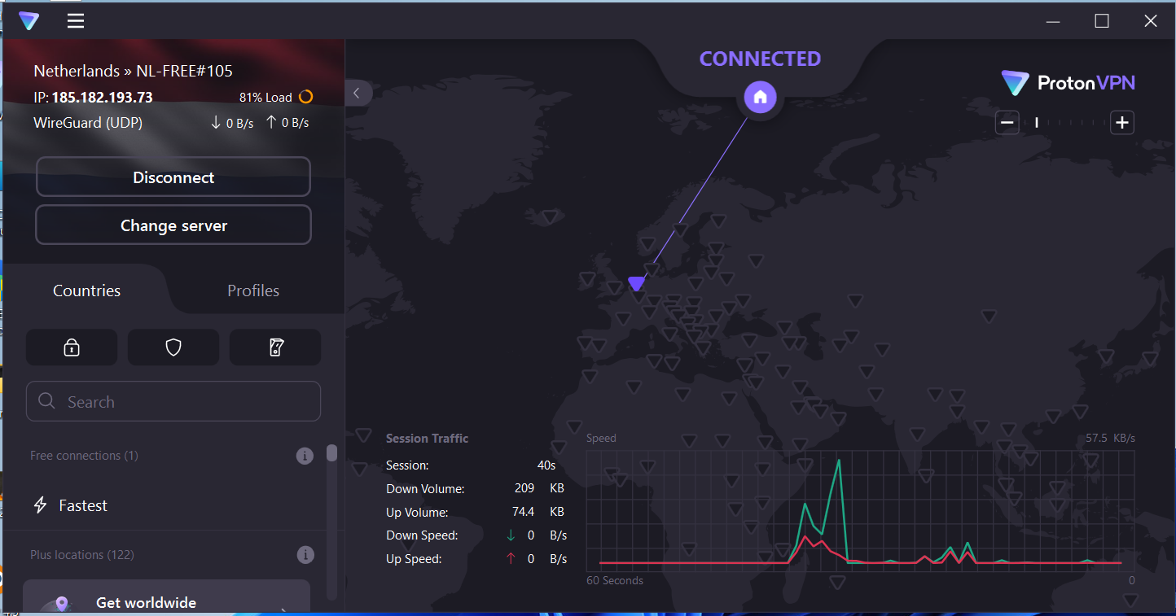

# CHECK FOR PROPER WORKING OF VPN

Before connecting to vpn, the output of whatismyipaddress is:

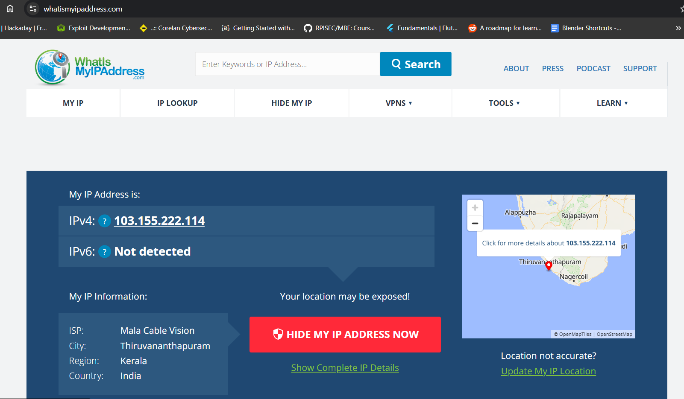

After connecting to vpn, whatismyipaddress reflects the change in ip address:

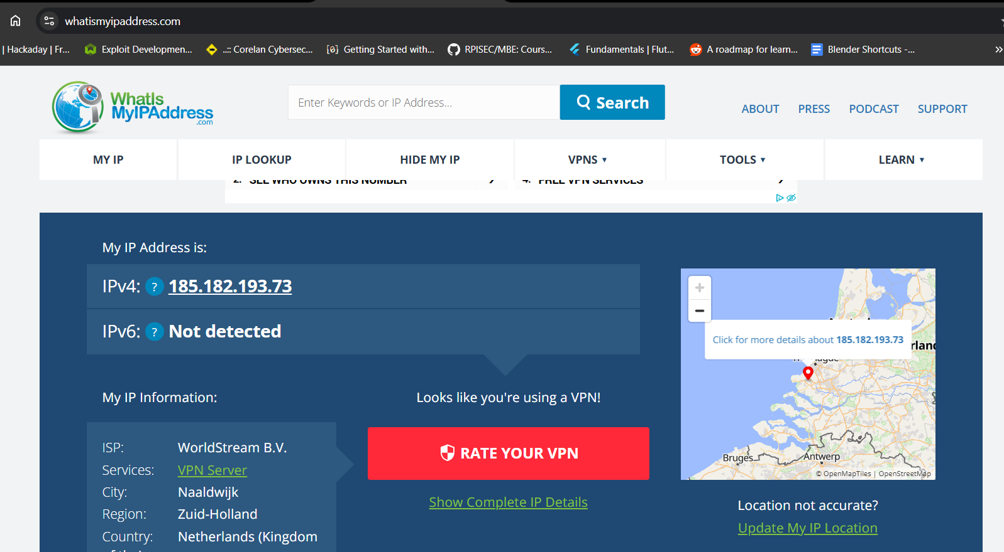

# CHANGE IN INTERNET SPEED

Before connecting to vpn, there was greater speeds compared to the speeds after connecting to vpn.

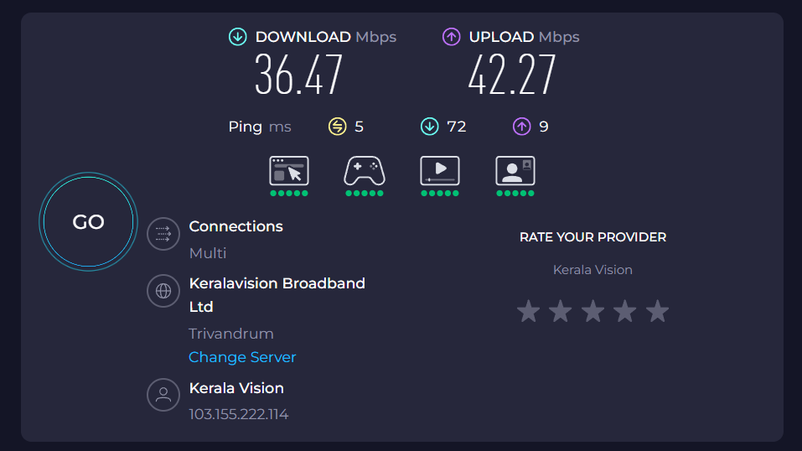

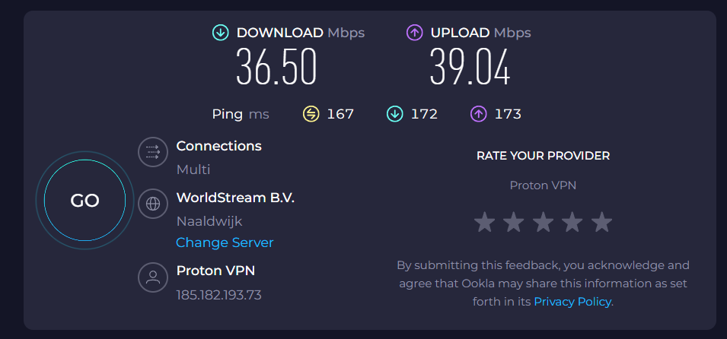

# SUMMARY

A VPN (Virtual Private Network) helps protect your privacy online by hiding your IP address and encrypting your internet traffic. It’s great for staying secure on public Wi-Fi, accessing region-locked content, and keeping your browsing private from ISPs. However, it’s not perfect—VPNs can slow down your connection, aren’t completely anonymous, and some websites may block them. Also, in certain countries, using a VPN can be restricted or even illegal. So while VPNs are a powerful tool for online security, they should be used with awareness and a trusted provider. It keeps your online activity private, secures your data on public Wi-Fi, and lets you access content that might be blocked in your region. It’s like a privacy shield for your internet. But it’s not flawless. VPNs can slow down your connection, some sites might block them, and not all VPN providers are trustworthy. Plus, in a few countries, using one might get you in trouble. So, while VPNs are super useful, it’s important to choose a good one and use it wisely.

# REFERENCES

<https://protonvpn.com/pricing>

<https://whatismyipaddress.com/>

<https://www.cloudflare.com/learning/access-management/vpn-security/>