professional practice in it

By Oskar Ciebień and David Newman.

Table of Contents

Introduction 2

System Requirements 2

Technology and the Reasons Why 2

Implementation and Design 3

Asset design 3

Database Design and Implementation 6

Architecture of the Game 7

The Game 7

Scenes 7

Code 7

Highscore table 7

Database Connection 7

Conclusions 8

References 9

# Introduction

This is a joint team project of Oskar Ciebień and David Newman for Professional Practice in IT, the project will be the creation of a matching card or memory game where the user must flip over cards 2 at a time and try to match each flipped card the game will be called Super Memory Turbo Game, our objectives will be to make a playable version of this game where the user will gain score points as they match cards and at the end of the game or level the score the user achieved will be entered into the high score table with their name, have that high score link to database and then be store inside that database, allow the score to be retrieved from the database and be displayed to the user to show them who has scored the highest.

# System Requirements

a specification of the project, what the user requires

Unity? Not sure what to put here.

A computer

# Technology and the Reasons Why

For the project we were originally planned to used Unity for the game and MySQL for the database, due to issues with the newest version of Unity and MySQL we instead looked into other databases and ended up going with SQLite, Unity is a cross platform video game engine it can be used to create 2d and 3d games and has wide use with many companies using the engine to make video games. For the graphics design in Unity we used GIMP 2.0 to create each of the assets used in the game.

# Implementation and Design

## Asset design

The first thing we did with Super Memory Turbo game was to create the assets for the game as we could then start working on the coding inside unity and the database. First some concept artwork was done to give us an idea what we should go for with the design of the menu and the design of the cards. The concept art for both cards and menu was done on paper with ink and pens, then it was recreated in GIMP 2.0 using layers we were able to create 9 different cards in one file without having to recreate the whole design each time.

1.Start Menu Concept Art

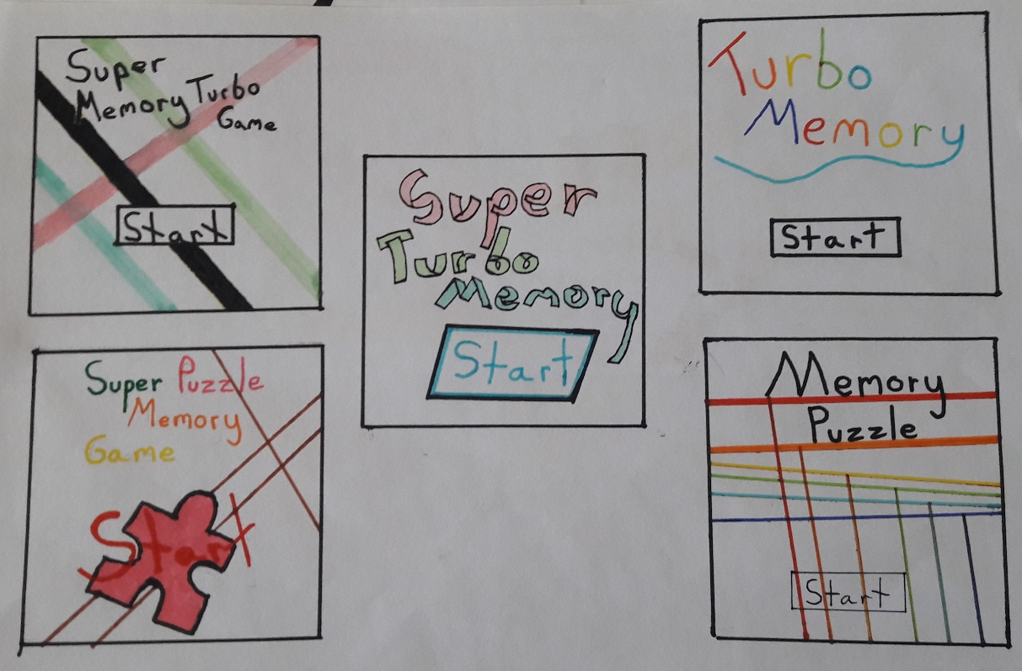

The start menu concept was based on simple colours and lines, its to grab the user interest and attention, we ended up going with this design as it matched our requirements and gave a nostalgic aesthetic 90s feel.

2.Finished Menu Screen Design

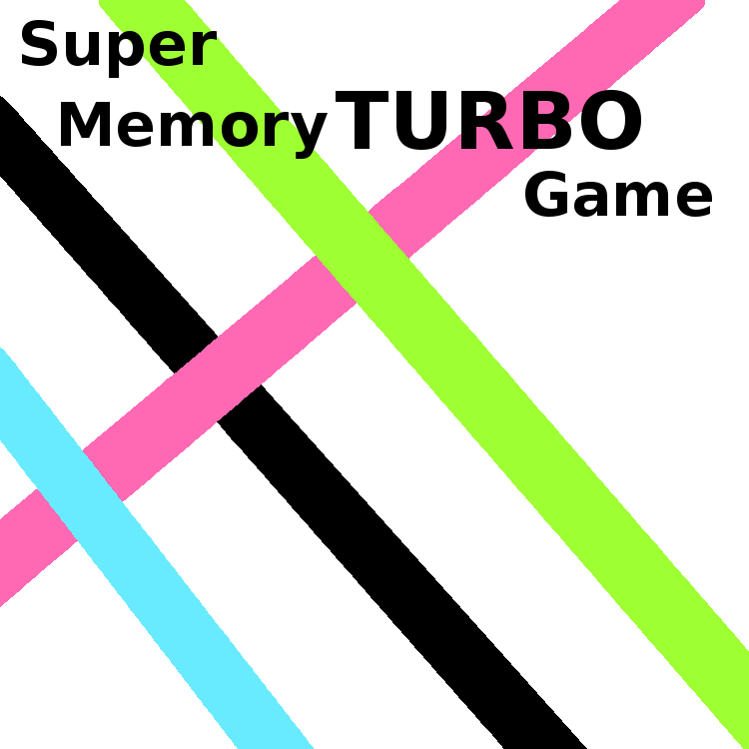

Next was the concept design for the cards that will be flipped during the game. With this we tried to make the object in the card stand out as much as we could so the user could not be confused as to what they are seen on screen, as such with went with a simple design again out of all the concept designs that we had.

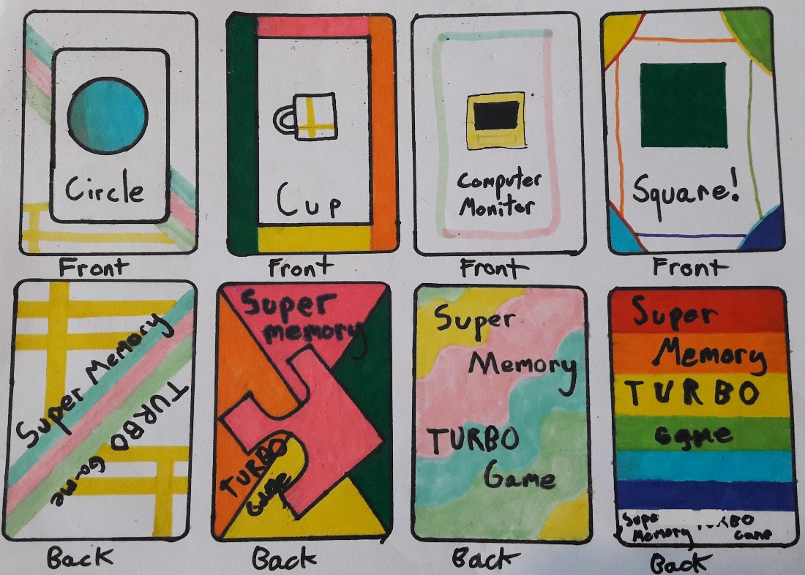 3. Concept Design for Matching Cards

As we wanted the game to have an overall connected design and theme, we went with cards that matched the start menu in design. We use 9 cards in total in the game each with a different shape that the user must match.

4. Back of Card. 5. Front of Card.



## Database Design and Implementation

Originally we were going to use MySQL but due to conflicting problems with the newest version of Unity we had to go with a different database, so for the database we used SQLite which was just what we needed for the project, DB Browser was used to create the Database.

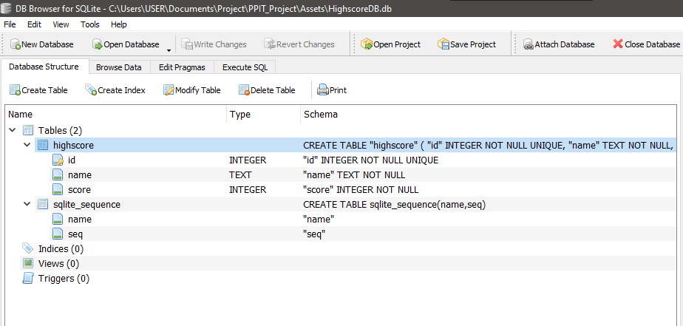

The database is made up of a table called highscore, inside the table with have 3 columns id, name and score, id is a unique integer, name is text and can’t be null and score is an int and can’t be null. The database is designed so that in the game when the user gets a highscore there name and score will be stored in this database.

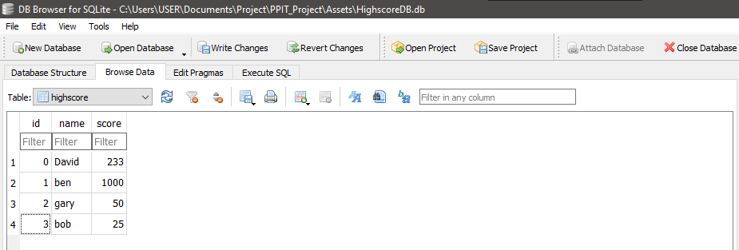

Example of user stored data in the database, the data will be retrieved from the database and showing to the user in game as a highscore table. The user will be able to enter a custom name but not enter a score.

# Architecture of the Game

## The Game

Talk about game

## Scenes

Talk about sences maybe?

## Code

Talk about code?

## Highscore table

The highscore table the player views at the end of the game is created using Unity UI with scripts and coding, the user can view the highscores that have being achieved so far and add there own name to the highscore table using an input box.

## Database Connection

The database connects to the highscore table using scripts and prefab of the scores, when the user gets to the end screen they can put in there name which is then saved with there score in the highscore database.

# Conclusions

In conclusion (will write this after you add the game bit)

# References

Creation of Database and Highscore and linking them together.

<https://www.youtube.com/playlist?list=PLX-uZVK_0K_7NmsYfe2BTOk_IamWC2kU3>

List of headings

Design Methodology Applied

Software Development Life Cycle

Limitations and Known Bugs

Testing Plans

Recommendations for Future Development