|  |  |
| --- | --- |
| **Topic** | Java Language Fundamentals I |
| **Document Name** | JAVA-EX-01 |
|  |  |

|  |  |  |  |
| --- | --- | --- | --- |
| **Document Difficulty Level** | | | |
| **Beginner** | **Junior** | **Senior** | **Expert** |
| ■ | □ | □ | □ |

# Document History

|  |  |  |  |
| --- | --- | --- | --- |
| Date | Author | Ver | Comments |
| 20.06.2018 | Yasin KILINÇ | 1.0 | Initial Draft |

# Java Language Fundamentals I

## Exercise JAVA-EX-01:

**Definiton :** Write a Java program that prints out all prime numbers between 1 and 20.

**Sample Output :**

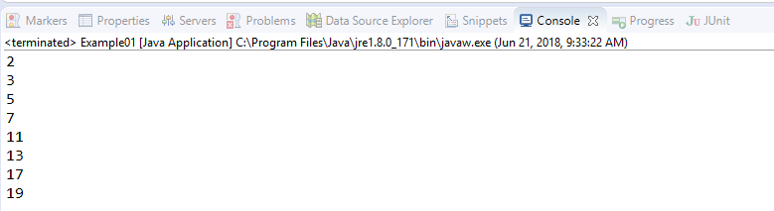

**Objectives** : To learn basic Java language data types,conditional claueses(IF THEN ELSE), loops(FOR, WHILE) and some mathematical functions(MOD).

## Solution of JAVA-EX-01:

For solution of example, please send your answer to your supervisor.