|  |  |
| --- | --- |
| **Topic** | Oracle SQL Language Fundamentals I |
| **Document Name** | PLSQL01-EX-07 |
|  |  |

|  |  |  |  |
| --- | --- | --- | --- |
| **Document Difficulty Level** | | | |
| **Beginner** | **Junior** | **Senior** | **Expert** |
| □ | ■ | □ | □ |

# Document History

|  |  |  |  |
| --- | --- | --- | --- |
| Date | Author | Ver | Comments |
| 03.10.2013 | Erman İbrişim | 1.0 | Initial Draft |

# Oracle SQL Language Fundamentals I

## Exercise PLSQL01-EX-07:

**Definiton :** Create a report that displays department id, first name, salary and rank of employee’s salary in own department. (Please use HR.EMPLOYEES table)

**Sample Output :**

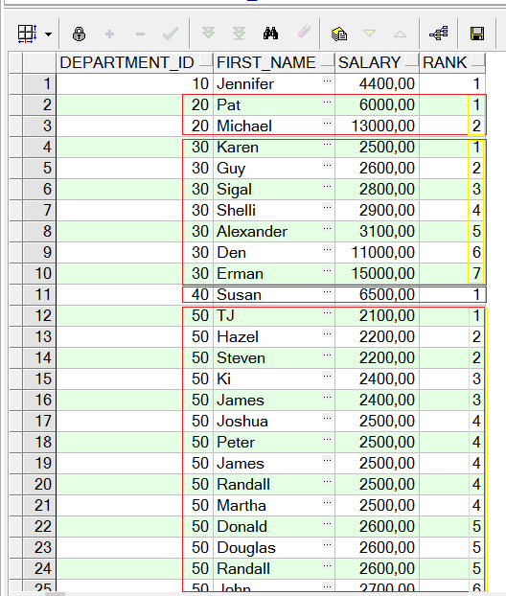

**Objectives** : To learn some SQL functions like OVER, DENSE_RANK.

**Keywords:** OVER(partition by ... order by ...)

## Solution of PLSQL01-EX-07:

For solution of example, please send your answer to your supervisor.