|  |  |
| --- | --- |
| **Topic** | Oracle SQL,PL-SQL Examples |
| **Document Name** | Exercise - 04 |
|  |  |

|  |  |  |  |
| --- | --- | --- | --- |
| **Document Difficulty Level** | | | |
| **Beginner** | **Junior** | **Senior** | **Expert** |
| ■ | □ | □ | □ |

# Document History

|  |  |  |  |
| --- | --- | --- | --- |
| Date | Author | Ver | Comments |
| 02.10.2013 | Ufuk Armağan Özgür | 1.0 | Initial Draft |

# Oracle SQL,PL-SQL Exercises

## Exercise -12:

**Definiton**

Write PL-SQL procedures that make following processes ;

* Find the employee who have biggest salary in company and return his/her id,name,salary.
* Convert this employee’s salary as a dollar. (Note that if there are one more employee with same salary and this salary is biggest salary, procedure will get one of them without error.)

**Sample Output**

Assume that your table will be like this;

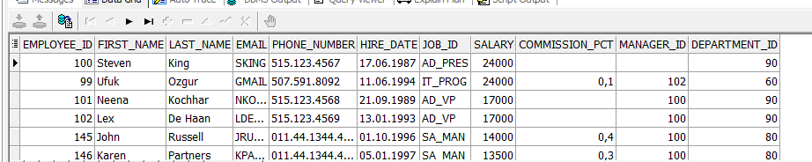

After running this procedures;

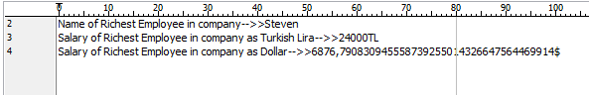

**Objectives** : To learn create , call a procedure , and processes with parameters in PL-SQL. Learn Oracle Analytic Functions.

**Exercise Keywords:** CREATE OR REPLACE PROCEDURE , IN , OUT , ROW_NUMBER(), %TYPE