|  |  |
| --- | --- |
| **Topic** | Oracle SQL , PL-SQL Examples |
| **Document Name** | Exercise-05 |
|  |  |

|  |  |  |  |
| --- | --- | --- | --- |
| **Document Difficulty Level** | | | |
| **Beginner** | **Junior** | **Senior** | **Expert** |
| ■ | □ | □ | □ |

# Document History

|  |  |  |  |
| --- | --- | --- | --- |
| Date | Author | Ver | Comments |
| 15.06.2017 | Ufuk Armağan Özgür | 1.0 | Initial Draft |

# Oracle SQL , PL-SQL Examples

## Exercise-13

**Definiton**

Write a PL-SQL procedure that make following process;

* Take one of the employee who have biggest salary in company from employees table and write his/her some informations to a file.

**Sample Output :**

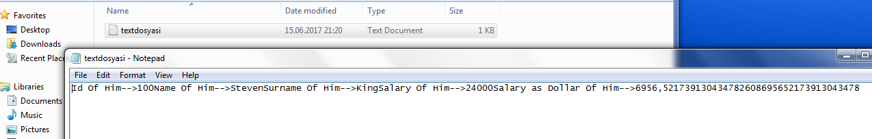

**Objectives** : To learn create and write data into file.

**Exercise Keywords:** CREATE DIRECTORY , UTL_FILE , FOPEN , FCLOSE