|  |  |
| --- | --- |
| **Topic** | Oracle SQL,PL-SQL Examples |
| **Document Name** | Exercise-06 |
|  |  |

|  |  |  |  |
| --- | --- | --- | --- |
| **Document Difficulty Level** | | | |
| **Beginner** | **Junior** | **Senior** | **Expert** |
| ■ | □ | □ | □ |

# Document History

|  |  |  |  |
| --- | --- | --- | --- |
| Date | Author | Ver | Comments |
| 16.06.2017 | Ufuk Armağan Özgür | 1.0 | Initial Draft |

# Oracle SQL Language Fundamentals I

## Exercise 14:

**Definiton**

Write a PL/SQL package that include one package named “utility\_employees\_package” . This package should consist of one procedure should do that write id , name , surname , department name of all emloyees to file and file must consist number of total rows.

**Sample Output**

**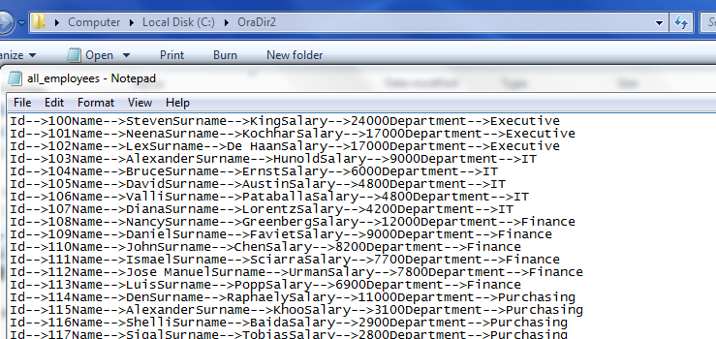**

**C:\Users\7213\Desktop\package_ss2.png**

**Objectives** : To learn cursor concept and packages.

**Exercise Keywords:** PACKAGE, PACKAGE BODY , CURSOR , FETCH