|  |  |
| --- | --- |
| **Topic** | PL/SQL Language Fundamentals I |
| **Document Name** | PLSQL01-EX-02 |
|  |  |

|  |  |  |  |
| --- | --- | --- | --- |
| **Document Difficulty Level** | | | |
| **Beginner** | **Junior** | **Senior** | **Expert** |
| ■ | □ | □ | □ |

# Document History

|  |  |  |  |
| --- | --- | --- | --- |
| Date | Author | Ver | Comments |
| 14.06.2013  03.10.2013 | Mennan Tekbir  Erman İbrişim | 1.0  1.1 | Initial Draft  Sample Output Added |

# PL/SQL Language Fundamentals I

## Exercise PLSQL01-EX-02:

**Definiton :** Write a PL/SQL program that extracts a structured text into meaningful pieces. Be careful to the sample input and output.

**Sample Input :** Name1:ERMAN, Surname1:İbriŞiM. Name2:MUstAFA, Surname2:Demir.

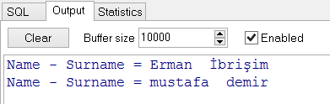

**Objectives** : To learn PL/SQL language string manipulations and some string functions like INITCAP(), LOWER().

## Solution of PLSQL01-EX-02:

For solution of example, please send your answer to your supervisor.