|  |  |
| --- | --- |
| **Topic** | SQL Language Fundamentals I |
| **Document Name** | PLSQL01-EX-03 |
|  |  |

|  |  |  |  |
| --- | --- | --- | --- |
| **Document Difficulty Level** | | | |
| **Beginner** | **Junior** | **Senior** | **Expert** |
| ■ | □ | □ | □ |

# Document History

|  |  |  |  |
| --- | --- | --- | --- |
| Date | Author | Ver | Comments |
| 14.06.2013  03.10.2013 | Mennan Tekbir  Erman ibrişim | 1.0  1.1 | Initial Draft  Sample Output Added |

# SQL Language Fundamentals I

## Exercise PLSQL01-EX-03:

**Definiton :** Write a PL/SQL program that prints out all first and last names from HR.EMPLOYEES table.

**Sample Output :**

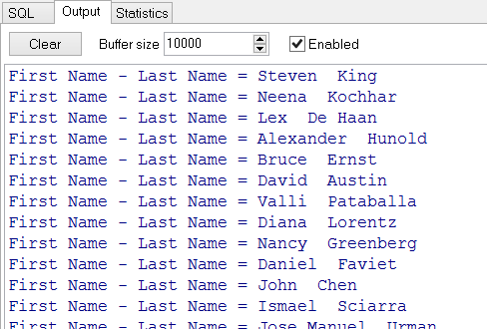

**Objectives** : To learn SQL data retrive metods(Explicit/Implicit Cursors)

## Solution of PLSQL01-EX-03:

For solution of example, please send your answer to your supervisor.