МИНИСТЕРСТВО НАУКИ И ВЫСШЕГО ОБРАЗОВАНИЯ РОССИЙСКОЙ ФЕДЕРАЦИИ

федеральное государственное автономное образовательное учреждение высшего образования

«САНКТ-ПЕТЕРБУРГСКИЙ ГОСУДАРСТВЕННЫЙ УНИВЕРСИТЕТ АЭРОКОСМИЧЕСКОГО ПРИБОРОСТРОЕНИЯ»

КАФЕДРА №  43

ОТЧЕТ

ЗАЩИЩЕН С ОЦЕНКОЙ

ПРЕПОДАВАТЕЛЬ

### Старший преподаватель                                                               Путилова Н. В.

должность, уч. Степень, звание   подпись, дата                    инициалы, фамилия

ОТЧЕТ О ЛАБОРАТОРНОЙ РАБОТЕ №6

[Разработка SQL запросов:](https://pro.guap.ru/inside/student/tasks/129276) запросы с подзапросами

по курсу: ПРОЕКТИРОВАНИЕ БАЗ ДАННЫХ

РАБОТУ ВЫПОЛНИЛ

СТУДЕНТ ГР. 4136                                                                        Бобрович Н. С.

                                                                         подпись, дата                      инициалы, фамилия

Санкт-Петербург 2023

Вариант 3:

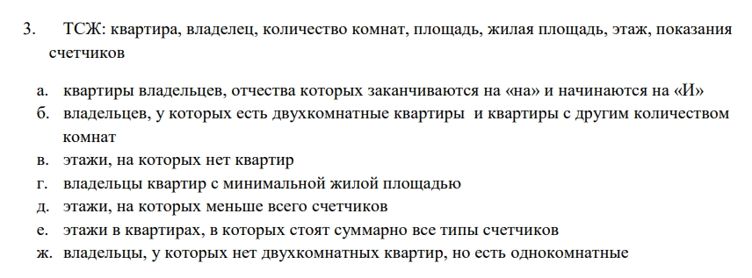

Физическая модель БД:

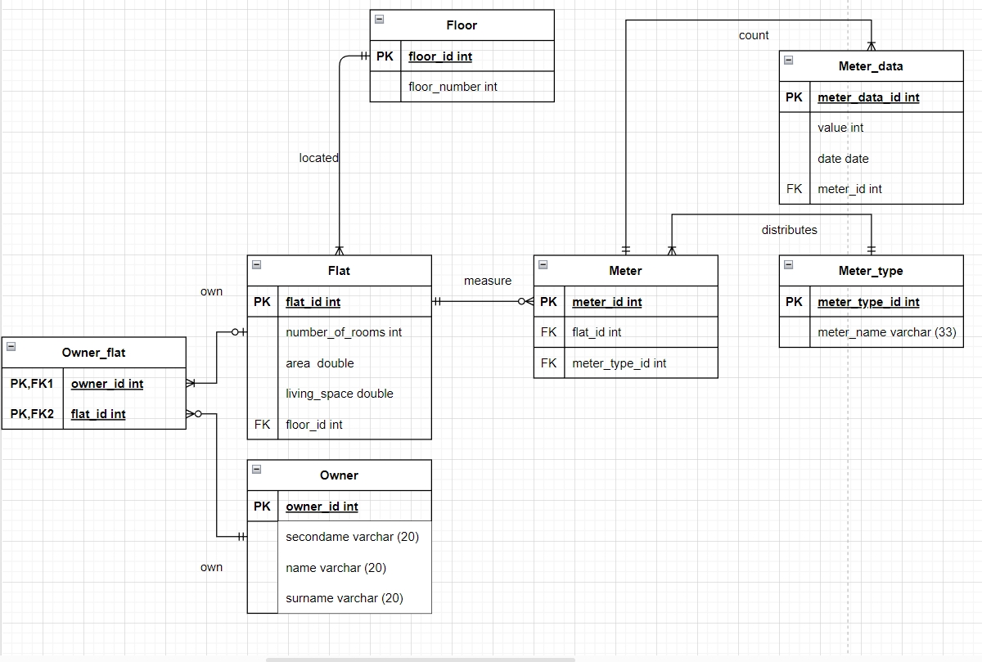

Текст запросов:

USE BD1;

#6

ЗАПРОС Г)

SELECT O.*

FROM owner AS O

LEFT JOIN owner_flat AS O_F ON O.owner_id = O_F.owner_id

LEFT JOIN flat AS F ON F.flat_id = O_F.flat_id WHERE living_space = (SELECT MIN(living_space) FROM flat);

SELECT O.*

FROM owner AS O

LEFT JOIN owner_flat AS O_F ON O.owner_id = O_F.owner_id

LEFT JOIN flat AS F ON F.flat_id = O_F.flat_id WHERE living_space <= ALL (SELECT (living_space) FROM flat);

ЗАПРОС Д)

select FLO.floor_id, COUNT(M.meter_id)

from floor AS FLO

join flat AS FLA on FLO.floor_id = FLA.floor_id

LEFT JOIN meter AS M ON FLA.flat_id = M.flat_id

group by FLA.floor_id

HAVING COUNT(M.meter_id) = (

SELECT MIN(t.c) FROM (

SELECT COUNT(*) AS c

FROM flat AS FLA

LEFT JOIN meter AS M ON FLA.flat_id = M.flat_id

GROUP BY M.meter_id

) t

);

ВАРИАЦИИ ЗАПРОСА Е)

select FLO.floor_id, COUNT(DISTINCT M_T.meter_type_id)

from floor AS FLO

join flat AS FLA on FLO.floor_id = FLA.floor_id

JOIN meter AS M ON FLA.flat_id = M.flat_id

left join meter_type AS M_T ON m.meter_type_id = m_t.meter_type_id

group by FLO.floor_id

HAVING COUNT(DISTINCT M_T.meter_type_id) = (

SELECT COUNT(meter_type_id) AS c FROM meter_type

);

Select floor.*

from floor

where not exists

(select * from meter_type

where not exists

(Select * from floor as FLO

join flat as FLA on FLO.floor_id = FLA.floor_id

JOIN meter AS M ON FLA.flat_id = M.flat_id

where FLO.floor_id = floor.floor_id and meter_type.meter_type_id = M.meter_type_id));

ВАРИАЦИИ ЗАПРОСА Ж)

SELECT O.*

FROM owner AS O

JOIN owner_flat AS O_F ON O.owner_id = O_F.owner_id

JOIN flat AS F ON F.flat_id = O_F.flat_id

WHERE F.number_of_rooms = 1 AND O.owner_id NOT IN

(SELECT O.owner_id

FROM owner AS O

JOIN owner_flat AS O_F ON O.owner_id = O_F.owner_id

JOIN flat AS F ON F.flat_id = O_F.flat_id

WHERE F.number_of_rooms = 2);

/*

SELECT O.*

FROM owner AS O

JOIN owner_flat AS O_F ON O.owner_id = O_F.owner_id

JOIN flat AS F ON F.flat_id = O_F.flat_id

WHERE F.number_of_rooms = 1 EXCEPT

SELECT O.*

FROM owner AS O

JOIN owner_flat AS O_F ON O.owner_id = O_F.owner_id

JOIN flat AS F ON F.flat_id = O_F.flat_id

WHERE F.number_of_rooms = 2;

*/

SELECT O.*

FROM owner AS O

JOIN owner_flat AS O_F ON O.owner_id = O_F.owner_id

JOIN flat AS F ON F.flat_id = O_F.flat_id

LEFT JOIN

(SELECT O.*

FROM owner AS O

JOIN owner_flat AS O_F ON O.owner_id = O_F.owner_id

JOIN flat AS F ON F.flat_id = O_F.flat_id

WHERE F.number_of_rooms = 2

)q ON O.owner_id = q.owner_id

WHERE F.number_of_rooms = 1 AND q.owner_id IS NULL;

Наборы данных, возвращаемые запросами:

