МИНИСТЕРСТВО НАУКИ И ВЫСШЕГО ОБРАЗОВАНИЯ РОССИЙСКОЙ ФЕДЕРАЦИИ

федеральное государственное автономное образовательное учреждение высшего образования

«САНКТ-ПЕТЕРБУРГСКИЙ ГОСУДАРСТВЕННЫЙ УНИВЕРСИТЕТ АЭРОКОСМИЧЕСКОГО ПРИБОРОСТРОЕНИЯ»

КАФЕДРА №  43

ОТЧЕТ

ЗАЩИЩЕН С ОЦЕНКОЙ

ПРЕПОДАВАТЕЛЬ

### Старший преподаватель                                                               Путилова Н. В.

должность, уч. Степень, звание   подпись, дата                    инициалы, фамилия

ОТЧЕТ О ЛАБОРАТОРНОЙ РАБОТЕ №7

Хранимые процедуры

по курсу: ПРОЕКТИРОВАНИЕ БАЗ ДАННЫХ

РАБОТУ ВЫПОЛНИЛ

СТУДЕНТ ГР. 4136                                                                        Бобрович Н. С.

                                                                         подпись, дата                      инициалы, фамилия

Санкт-Петербург 2023

Вариант 3:

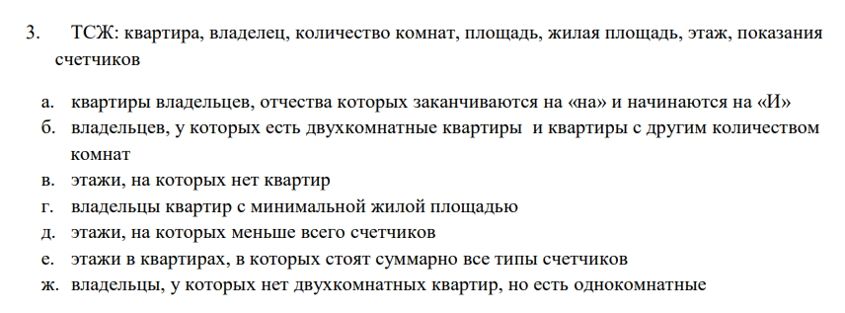

Физическая модель БД:

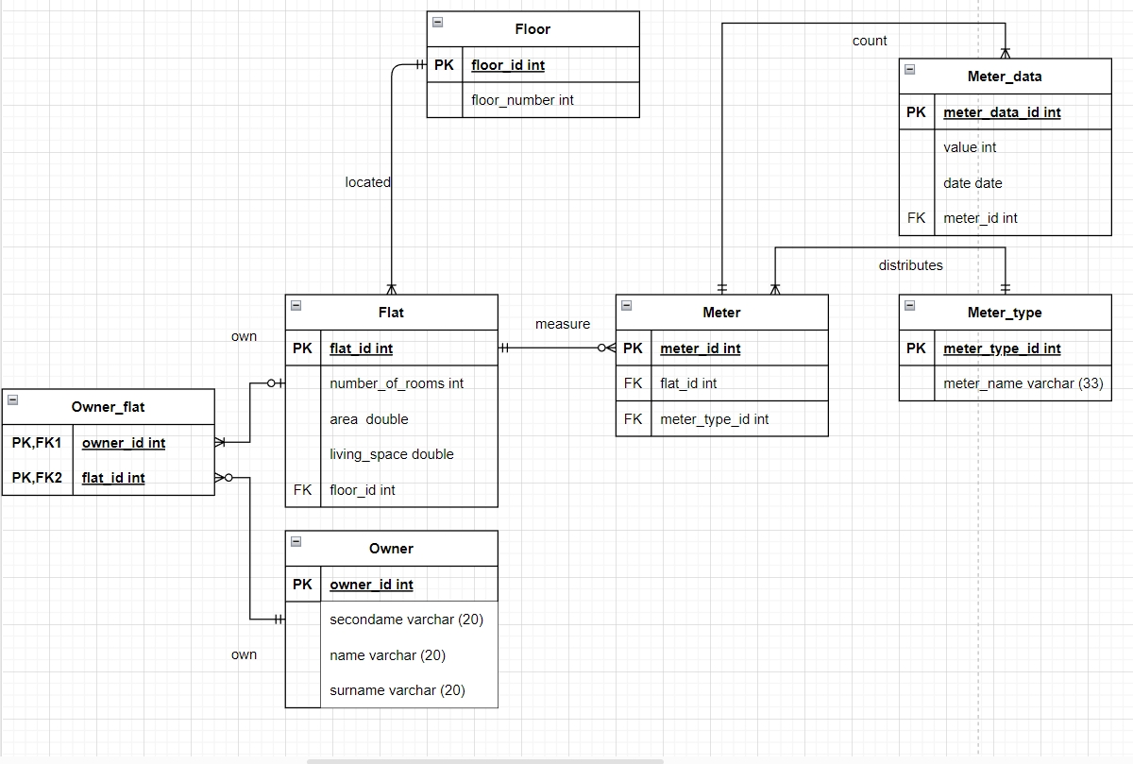

Назначение, тексты ХП и их вызовов:

Создание ХП:

**Процедура вставки с пополнением справочника.**

delimiter //

CREATE PROCEDURE p1 (floor_number_ INT, number_of_rooms_ INT, area_ DECIMAL(18,2), living_space_ DECIMAL(18,2))

BEGIN

declare floor_id_new int;

declare flat_id_new int;

if exists (select * from floor where floor_number = floor_number_)

then select floor_id into floor_id_new from floor where floor_number = floor_number_;

else begin

set floor_id_new = (select ifnull (max (floor_id) + 1,0) from floor);

INSERT INTO floor (floor_id, floor_number) VALUES (floor_id_new, floor_number_);

end;

end if;

set flat_id_new = ( select ifnull(max(flat_id)+1,0) from flat);

insert into flat (flat_id, number_of_rooms, area, living_space, floor_id)

VALUES (flat_id_new, number_of_rooms_, area_, living_space_,floor_id_new);

END;//

delimiter ;

**Процедура удаления с очисткой справочника.**

delimiter //

create procedure p2(flat_id_del int)

BEGIN

declare floor_id_del int;

select floor_id into floor_id_del from flat where flat_id = flat_id_del;

delete from flat where flat_id = flat_id_del;

if not exists(select * from flat where floor_id = floor_id_del)

then delete from floor where floor_id = floor_id_del;

end if;

END;//

delimiter ;

**Процедура каскадного удаления.**

delimiter //

create procedure p3(floor_id_del int)

BEGIN

#delete from meter_data where meter_id in

#(select meter_id from meter where flat_id in

#(select flat_id from flat where floor_id = floor_id_del));

DELETE meter_data

FROM meter_data

JOIN meter ON meter_data.meter_id = meter.meter_id

JOIN flat ON meter.flat_id = flat.flat_id

WHERE flat.floor_id = floor_id_del;

delete from meter where flat_id in

(select flat_id from flat where floor_id = floor_id_del);

delete from owner_flat where flat_id in

(select flat_id from flat where floor_id = floor_id_del);

delete from flat where floor_id = floor_id_del;

delete from floor where floor_id = floor_id_del;

END;//

delimiter ;**Процедура вычисления и возврат значения агрегатной функции.**

delimiter //

create procedure p4(out cnt_floor int)

BEGIN

select ifnull(count(floor_id),0) into cnt_floor from floor;

END;//

delimiter ;

delimiter //

create function p4_1() returns int NOT DETERMINISTIC

BEGIN

declare cnt_floor int DEFAULT 0;

set cnt_floor = (select ifnull(count(floor_id),0) from floor);

return cnt_floor;

END;//

delimiter ;

**Формирование статистики во временной таблице.**

delimiter //

create procedure p5()

BEGIN

create temporary table if not exists owner_stat

(

id_stat int auto_increment primary key,

flat_id int,

count_owner int,

count_owner_avg double default 0,

diff_cnt_avg double default 0

);

insert into owner_stat (flat_id, count_owner)

select flat.flat_id, count(owner_id) as count_owner from flat

left join owner_flat on flat.flat_id = owner_flat.flat_id group by flat.flat_id;

update owner_stat set count_owner_avg =

(select avg(count_owner) from

(select flat.flat_id, count(owner_id) as count_owner from flat

left join owner_flat on flat.flat_id = owner_flat.flat_id group by flat.flat_id)q);

update owner_stat set diff_cnt_avg = count_owner - count_owner_avg;

select * from owner_stat;

select avg (diff_cnt_avg * diff_cnt_avg) from owner_stat;

drop table owner_stat;

END;//

delimiter ;

Вызовы ХП (соответственно их созданию):

call p1 (3, 5, 70.33, 68.11);

call p2 (5);

call p3 (4);

call p4(@cnt);

select @cnt;

select p4_1();

call p5 ();

Наборы данных, возвращаемые ХП:

До добавления:

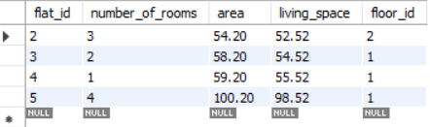

После:

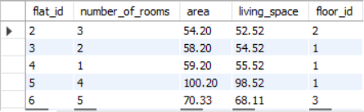

До удаления:



После:

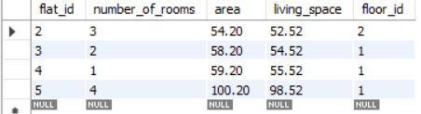

До каскадного удаления:

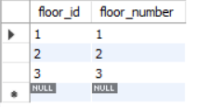

После:

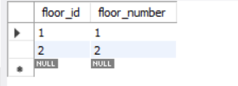

Результаты ХП 4:

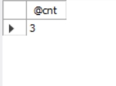

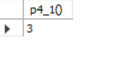

Результаты ХП 5:

