.МИНИСТЕРСТВО НАУКИ И ВЫСШЕГО ОБРАЗОВАНИЯ РОССИЙСКОЙ ФЕДЕРАЦИИ

федеральное государственное автономное образовательное учреждение высшего образования

«САНКТ-ПЕТЕРБУРГСКИЙ ГОСУДАРСТВЕННЫЙ УНИВЕРСИТЕТ АЭРОКОСМИЧЕСКОГО ПРИБОРОСТРОЕНИЯ»

КАФЕДРА №  43

ОТЧЁТ

ЗАЩИЩЁН С ОЦЕНКОЙ

ПРЕПОДАВАТЕЛЬ

### Старший преподаватель                                                               Путилова Н. В.

должность, уч. Степень, звание   подпись, дата                    инициалы, фамилия

ОТЧЁТ О ЛАБОРАТОРНОЙ РАБОТЕ №9

Объектно-реляционные базы данных. Проектирование и создание.

по курсу: ПРОЕКТИРОВАНИЕ БАЗ ДАННЫХ

РАБОТУ ВЫПОЛНИЛ

СТУДЕНТ ГР. 4136                                                                        Бобрович Н. С.

                                                                         подпись, дата                      инициалы, фамилия

Санкт-Петербург 2024

**Вариант 3:**

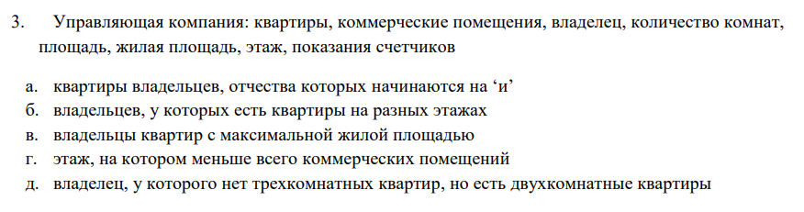

**Физическая модель БД:**

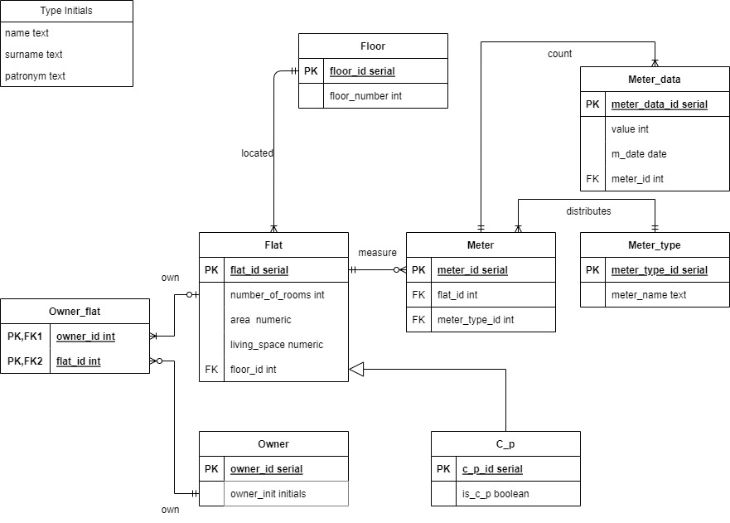

Скрипт создания БД: (с выводом)

**Создание таблиц и триггеров для их корректного заполнения:**

--CREATE DATABASE db_1;

CREATE TABLE floor(

floor_id SERIAL NOT NULL PRIMARY KEY,

floor_number int

);

CREATE TABLE flat(

flat_id SERIAL NOT NULL PRIMARY KEY,

number_of_rooms int check(number_of_rooms > 0),

area numeric check(area > 0),

living_space numeric check(living_space > 0),

floor_id int,

foreign key (floor_id) references floor(floor_id) on delete cascade on update cascade

);

CREATE TABLE c_p (

primary key (flat_id),

foreign key (floor_id) references floor(floor_id) on delete cascade on update cascade,

is_c_p boolean

) INHERITS (flat);

CREATE TYPE initials AS (

surname varchar(55),

name varchar(55),

patronym varchar(55)

);

CREATE TABLE owner(

owner_id SERIAL NOT NULL PRIMARY KEY,

owner_init initials

);

CREATE TABLE owner_flat(

owner_flat_id SERIAL NOT NULL PRIMARY KEY,

owner_id int,

flat_id int,

foreign key (owner_id) references owner(owner_id) on delete restrict on update restrict

);

CREATE OR REPLACE FUNCTION check_flat_exists_on_create()

RETURNS TRIGGER AS $$

BEGIN

IF NOT EXISTS (SELECT 1 FROM flat WHERE flat_id = NEW.flat_id) THEN

RAISE EXCEPTION 'flat with id % does not exist', NEW.flat_id;

END IF;

RETURN NEW;

END;

$$ LANGUAGE plpgsql;

CREATE TRIGGER owner_flat_check_flat_exists_on_create

BEFORE INSERT ON owner_flat

FOR EACH ROW

EXECUTE FUNCTION check_flat_exists_on_create();

CREATE OR REPLACE FUNCTION check_flat_exists_on_update()

RETURNS TRIGGER AS $$

BEGIN

IF EXISTS (SELECT 1 FROM owner_flat WHERE flat_id = OLD.flat_id) THEN

RAISE EXCEPTION 'flat with id % сannot be updated because of owner_flat', OLD.flat_id;

END IF;

RETURN OLD;

END;

$$ LANGUAGE plpgsql;

CREATE TRIGGER owner_flat_check_flat_exists_on_update

BEFORE UPDATE ON flat

FOR EACH ROW

EXECUTE FUNCTION check_flat_exists_on_update();

CREATE OR REPLACE FUNCTION check_flat_exists_on_delete()

RETURNS TRIGGER AS $$

BEGIN

IF EXISTS (SELECT 1 FROM owner_flat WHERE flat_id = OLD.flat_id) THEN

RAISE EXCEPTION 'flat with id % сannot be deleted because of owner_flat', OLD.flat_id;

END IF;

RETURN OLD;

END;

$$ LANGUAGE plpgsql;

CREATE TRIGGER owner_flat_check_flat_exists_on_delete

BEFORE DELETE ON flat

FOR EACH ROW

EXECUTE FUNCTION check_flat_exists_on_delete();

CREATE TABLE meter_type(

meter_type_id SERIAL NOT NULL PRIMARY KEY,

meter_name varchar(55)

);

CREATE TABLE meter(

meter_id SERIAL NOT NULL PRIMARY KEY,

flat_id int,

meter_type_id int,

foreign key (meter_type_id) references meter_type(meter_type_id) on delete restrict on update restrict

);

CREATE OR REPLACE FUNCTION check_flat_exists_on_create()

RETURNS TRIGGER AS $$

BEGIN

IF NOT EXISTS (SELECT 1 FROM flat WHERE flat_id = NEW.flat_id) THEN

RAISE EXCEPTION 'flat with id % does not exist', NEW.flat_id;

END IF;

RETURN NEW;

END;

$$ LANGUAGE plpgsql;

CREATE TRIGGER meter_check_flat_exists_on_create

BEFORE INSERT ON meter

FOR EACH ROW

EXECUTE FUNCTION check_flat_exists_on_create();

CREATE OR REPLACE FUNCTION check_flat_exists_on_update()

RETURNS TRIGGER AS $$

BEGIN

IF EXISTS (SELECT 1 FROM meter WHERE flat_id = OLD.flat_id) THEN

RAISE EXCEPTION 'flat with id % сannot be updated because of meter', OLD.flat_id;

END IF;

RETURN OLD;

END;

$$ LANGUAGE plpgsql;

CREATE TRIGGER meter_check_flat_exists_on_update

BEFORE UPDATE ON flat

FOR EACH ROW

EXECUTE FUNCTION check_flat_exists_on_update();

CREATE OR REPLACE FUNCTION check_flat_exists_on_delete()

RETURNS TRIGGER AS $$

BEGIN

IF EXISTS (SELECT 1 FROM meter WHERE flat_id = OLD.flat_id) THEN

RAISE EXCEPTION 'flat with id % сannot be deleted because of meter', OLD.flat_id;

END IF;

RETURN OLD;

END;

$$ LANGUAGE plpgsql;

CREATE TRIGGER meter_check_flat_exists_on_delete

BEFORE DELETE ON flat

FOR EACH ROW

EXECUTE FUNCTION check_flat_exists_on_delete();

CREATE TABLE meter_data(

meter_data_id SERIAL NOT NULL PRIMARY KEY,

value int,

m_date date,

meter_id int,

foreign key (meter_id) references meter(meter_id) on delete cascade on update cascade

);