МИНИСТЕРСТВО НАУКИ И ВЫСШЕГО ОБРАЗОВАНИЯ РОССИЙСКОЙ ФЕДЕРАЦИИ

федеральное государственное автономное образовательное учреждение высшего образования

«САНКТ-ПЕТЕРБУРГСКИЙ ГОСУДАРСТВЕННЫЙ УНИВЕРСИТЕТ АЭРОКОСМИЧЕСКОГО ПРИБОРОСТРОЕНИЯ»

КАФЕДРА № 43

ОТЧЕТ   
ЗАЩИЩЕН С ОЦЕНКОЙ

ПРЕПОДАВАТЕЛЬ

|  |  |  |  |  |
| --- | --- | --- | --- | --- |
| Доцент |  |  |  | В. Ю. Скобцов |
| должность, уч. степень, звание |  | подпись, дата |  | инициалы, фамилия |

|  |
| --- |
| ОТЧЕТ О ЛАБОРАТОРНОЙ РАБОТЕ №3 |
| классификация табличных данных на основе нейросетевых моделей |
| по курсу: интеллектуальный анализ данных на основе методов машинного обучения |
|  |
|  |

РАБОТУ ВЫПОЛНИЛА

|  |  |  |  |  |  |
| --- | --- | --- | --- | --- | --- |
| СТУДЕНТ гр. № | 4136 |  |  |  | Н.С. Бобрович |
|  |  |  | подпись, дата |  | инициалы, фамилия |

Санкт-Петербург 2024

1. **Цель работы**

Необходимо выполнить классификационный анализ данных по указанному целевому признаку

**Вариант 1:**

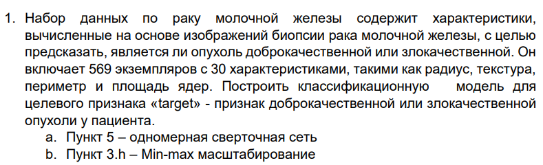

1. **Ход работы**

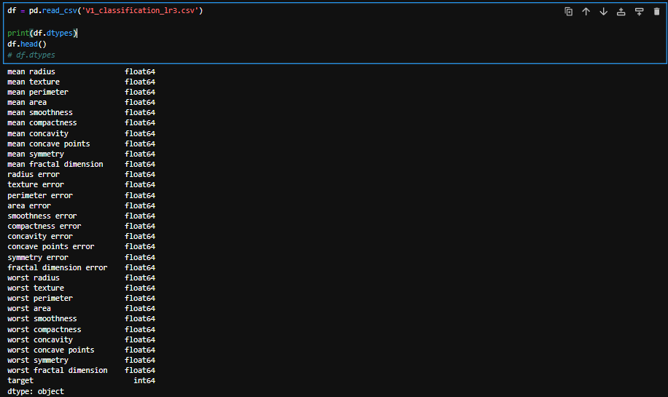

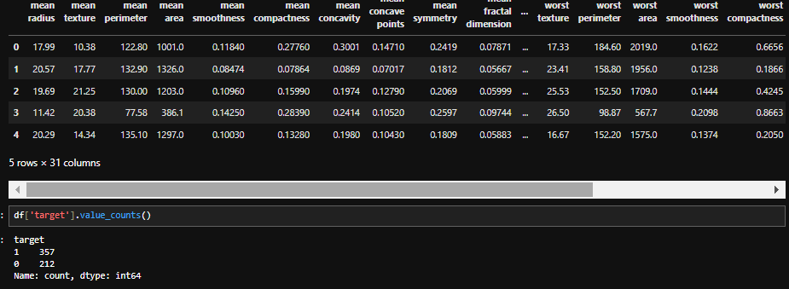

Выполним анализ корреляционной зависимости для целевого признака (target)

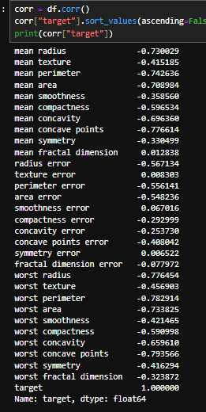

Построим гистограммы распределения и плотнотей и зависимостей признаков

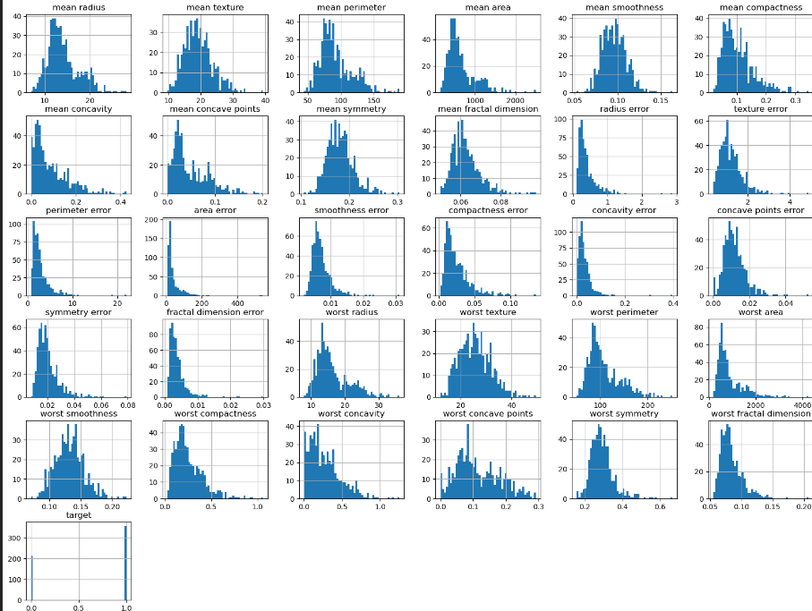

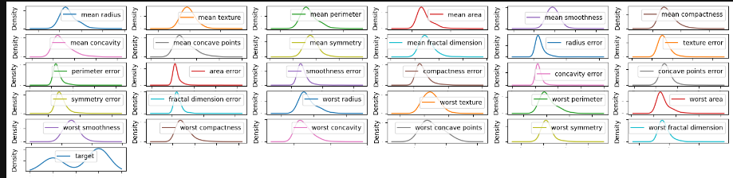

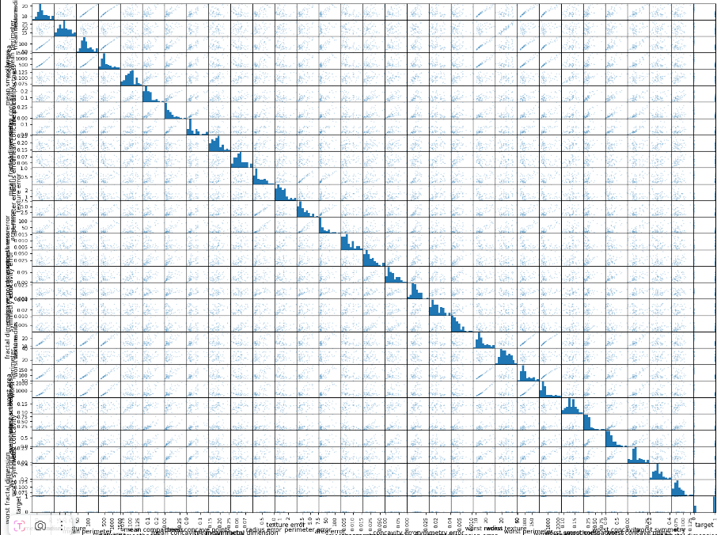

Как можно заметить, признаки нормально распределены

Разделим данные на входные и выходные значения

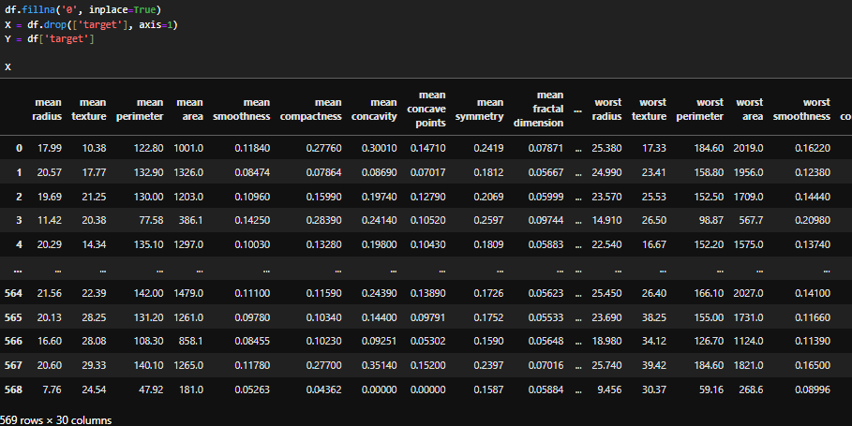

Создадим набор с дополнительным признаком, представляющим собой сумму части негативных величин

X_extra = X

Y_extra = Y

X_extra["worst"] = X_extra["worst smoothness"] + X_extra["worst concavity"] + X_extra["worst concave points"] + X_extra["worst fractal dimension"]

X_with_new_atribbute = df.drop(['target'], axis=1)

Y_with_new_atribbute = df['target']

Используем масштабирование для обоих наборов данных.

scaler = MinMaxScaler(feature_range = (0, 1))

X_scaled = scaler.fit_transform(X)

Y = np.array(Y)

Y = Y.reshape(-1, Y.shape[0])

Y_scaled = Y

X_with_new_atribbute_scaled = scaler.fit_transform(X_with_new_atribbute)

Y_with_new_atribbute = np.array(Y_with_new_atribbute)

Y_with_new_atribbute = Y_with_new_atribbute.reshape(-1, Y_with_new_atribbute.shape[0])

Y_with_new_atribbute_scaled = Y_with_new_atribbute

Разобъём выборку на обучающую, тестовую и валидационную в отношении 60/20/20 %

X_train, X_test, Y_train, Y_test = train_test_split(X_scaled, Y_scaled, test_size=0.4, random_state=42)

X_test, X_dev, Y_test, Y_dev = train_test_split(X_test, Y_test, test_size=0.5, random_state=42)

Создадим одномерную сверточная сеть и полносвязную модель для последующего обучения

model_dense = Sequential()

model_dense.add(Input(shape=(X_train.shape[1],)))

model_dense.add(Dense(128, activation='relu'))

model_dense.add(Dense(64, activation='relu'))

model_dense.add(Dense(1, activation='sigmoid'))

model = Sequential()

model.add(Input(shape=(1, X_train.shape[1])))

model.add(Conv1D(filters=128, kernel_size=3, activation='relu', padding='same'))

model.add(MaxPooling1D(pool_size=1))

model.add(Conv1D(filters=64, kernel_size=3, activation='relu', padding='same'))

model.add(MaxPooling1D(pool_size=1))

model.add(Flatten())

model.add(Dense(64, activation='relu'))

model.add(Dense(1, activation='sigmoid'))

X_train, X_test, Y_train, Y_test = train_test_split(X_with_new_atribbute_scaled, Y_with_new_atribbute_scaled, test_size=0.4, random_state=32)

X_test, X_dev, Y_test, Y_dev = train_test_split(X_test, Y_test, test_size=0.5, random_state=32)

model_dense_2 = Sequential()

model_dense_2.add(Input(shape=(X_train.shape[1],)))

model_dense_2.add(Dense(128, activation='relu'))

model_dense_2.add(Dense(64, activation='relu'))

model_dense_2.add(Dense(1, activation='sigmoid'))

model_2 = Sequential()

model_2.add(Input(shape=(1, X_train.shape[1])))

model_2.add(Conv1D(filters=128, kernel_size=3, activation='relu', padding='same'))

model_2.add(MaxPooling1D(pool_size=1))

model_2.add(Conv1D(filters=64, kernel_size=3, activation='relu', padding='same'))

model_2.add(MaxPooling1D(pool_size=1))

model_2.add(Flatten())

model_2.add(Dense(64, activation='relu'))

model_2.add(Dense(1, activation='sigmoid'))

X_train, X_test, Y_train, Y_test = train_test_split(X_scaled, Y_scaled, test_size=0.4, random_state=42)

X_test, X_dev, Y_test, Y_dev = train_test_split(X_test, Y_test, test_size=0.5, random_state=42)

labels = [0, 1]

X_test.shape

model_dense.compile(optimizer='adam', loss='binary_crossentropy', metrics=['accuracy'])

history = model_dense.fit(X_train, Y_train, epochs=50, batch_size=32, verbose=0, validation_data=(X_dev, Y_dev))

mse = model_dense.evaluate(X_test, Y_test)

predicted = model_dense.predict(X_test)

predicted_classes = (predicted > 0.5).astype(int)

print(f'Dense, stand mse: {mse[0]}, balansed accurancy: {balanced_accuracy_score(Y_test, predicted_classes)}')

model.compile(optimizer='adam', loss='binary_crossentropy', metrics=['accuracy'])

history = model.fit(np.reshape(X_train, (X_train.shape[0], 1, X_train.shape[1])), Y_train, epochs=50, batch_size=32, verbose=0, validation_data=(np.reshape(X_dev, (X_dev.shape[0], 1, X_dev.shape[1])), Y_dev))

mse = model.evaluate(np.reshape(X_test, (X_test.shape[0], 1, X_test.shape[1])), Y_test)

predicted = model.predict(np.reshape(X_test, (X_test.shape[0], 1, X_test.shape[1])))

predicted_classes = (predicted > 0.5).astype(int)

print(f'Conv, stand mse: {mse[0]}, balanced accurancy: {balanced_accuracy_score(Y_test, predicted_classes)}')

X_train, X_test, Y_train, Y_test = train_test_split(X_with_new_atribbute_scaled, Y_with_new_atribbute_scaled, test_size=0.4, random_state=42)

X_test, X_dev, Y_test, Y_dev = train_test_split(X_test, Y_test, test_size=0.5, random_state=42)

model_dense_2.compile(optimizer='adam', loss='binary_crossentropy', metrics=['accuracy'])

history = model_dense_2.fit(X_train, Y_train, epochs=50, batch_size=32, verbose=0, validation_data=(X_dev, Y_dev))

mse = model_dense_2.evaluate(X_test, Y_test)

predicted = model_dense_2.predict(X_test)

predicted_classes = (predicted > 0.5).astype(int)

print(f'Dense, stand, extra mse: {mse[0]}, accurancy: {balanced_accuracy_score(Y_test, predicted_classes)}')

model_2.compile(optimizer='adam', loss='binary_crossentropy', metrics=['accuracy'])

history = model_2.fit(np.reshape(X_train, (X_train.shape[0], 1, X_train.shape[1])), Y_train, epochs=50, batch_size=32, verbose=0, validation_data=(np.reshape(X_dev, (X_dev.shape[0], 1, X_dev.shape[1])), Y_dev))

mse = model_2.evaluate(np.reshape(X_test, (X_test.shape[0], 1, X_test.shape[1])), Y_test)

predicted = model_2.predict(np.reshape(X_test, (X_test.shape[0], 1, X_test.shape[1])))

predicted_classes = (predicted > 0.5).astype(int)

print(f'Conv, stand, extra mse: {mse[0]}, balanced accurancy: {balanced_accuracy_score(Y_test, predicted_classes)}')

X_train, X_test, Y_train, Y_test = train_test_split(X, Y, test_size=0.4, random_state=42)

X_test, X_dev, Y_test, Y_dev = train_test_split(X_test, Y_test, test_size=0.5, random_state=42)

model_dense.compile(optimizer='adam', loss='binary_crossentropy', metrics=['accuracy'])

history = model_dense.fit(X_train, Y_train, epochs=50, batch_size=32, verbose=0, validation_data=(X_dev, Y_dev))

mse = model_dense.evaluate(X_test, Y_test)

predicted = model_dense.predict(X_test)

predicted_classes = (predicted > 0.5).astype(int)

print(f'Dense mse: {mse[0]}, balanced accurancy: {balanced_accuracy_score(Y_test, predicted_classes)}')

model.compile(optimizer='adam', loss='binary_crossentropy', metrics=['accuracy'])

history = model.fit(np.reshape(X_train, (X_train.shape[0], 1, X_train.shape[1])), Y_train, epochs=50, batch_size=32, verbose=0, validation_data=(np.reshape(X_dev, (X_dev.shape[0], 1, X_dev.shape[1])), Y_dev))

mse = model.evaluate(np.reshape(X_test, (X_test.shape[0], 1, X_test.shape[1])), Y_test)

predicted = model.predict(np.reshape(X_test, (X_test.shape[0], 1, X_test.shape[1])))

predicted_classes = (predicted > 0.5).astype(int)

print(f'Conv mse: {mse[0]}, balanced accurancy: {balanced_accuracy_score(Y_test, predicted_classes)}')

X_train, X_test, Y_train, Y_test = train_test_split(X_with_new_atribbute, Y_with_new_atribbute, test_size=0.4, random_state=42)

X_test, X_dev, Y_test, Y_dev = train_test_split(X_test, Y_test, test_size=0.5, random_state=42)

model_dense_2.compile(optimizer='adam', loss='binary_crossentropy', metrics=['accuracy'])

history = model_dense_2.fit(X_train, Y_train, epochs=50, batch_size=32, verbose=0, validation_data=(X_dev, Y_dev))

mse = model_dense_2.evaluate(X_test, Y_test)

predicted = model_dense_2.predict(X_test)

predicted_classes = (predicted > 0.5).astype(int)

print(f'Dense, extra mse: {mse[0]}, balanced accurancy: {balanced_accuracy_score(Y_test, predicted_classes)}')

model_2.compile(optimizer='adam', loss='binary_crossentropy', metrics=['accuracy'])

history = model_2.fit(np.reshape(X_train, (X_train.shape[0], 1, X_train.shape[1])), Y_train, epochs=50, batch_size=32, verbose=0, validation_data=(np.reshape(X_dev, (X_dev.shape[0], 1, X_dev.shape[1])), Y_dev))

mse = model_2.evaluate(np.reshape(X_test, (X_test.shape[0], 1, X_test.shape[1])), Y_test)

predicted = model_2.predict(np.reshape(X_test, (X_test.shape[0], 1, X_test.shape[1])))

predicted_classes = (predicted > 0.5).astype(int)

print(f'Conv, extra mse: {mse[0]}, balanced accurancy: {balanced_accuracy_score(Y_test, predicted_classes)}')

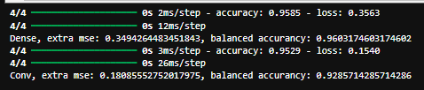

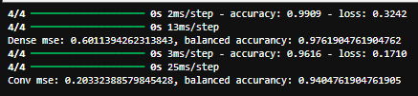

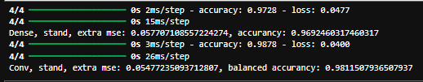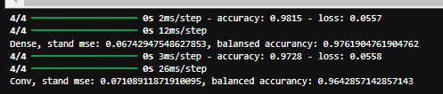

Лучший результат показала сверточная модель c масштабированием и с дополнительными признаками. Выполним Grid поиск гиперпараметров для неё

X_train, X_test, y_train, y_test = train_test_split(X_with_new_atribbute_scaled, Y_with_new_atribbute_scaled, test_size=0.4, random_state=42)

X_test, X_dev, y_test, y_dev = train_test_split(X_test, y_test, test_size=0.5, random_state=42)

Deg = [2,3,4,5,6,7]

res = []

res_r2 = []

names = []

for deg in Deg:

model = Sequential()

model.add(Input(shape=(1, X_train.shape[1])))

model.add(Conv1D(filters=2**deg, kernel_size=3, activation='relu', padding='same'))

model.add(MaxPooling1D(pool_size=1))

model.add(Conv1D(filters=2**(deg-1), kernel_size=3, activation='relu', padding='same'))

model.add(MaxPooling1D(pool_size=1))

model.add(Flatten())

model.add(Dense(64, activation='relu'))

model.add(Dense(1, activation='sigmoid'))

model.compile(optimizer='adam', loss='binary_crossentropy', metrics=['accuracy'])

history = model.fit(np.reshape(X_train, (X_train.shape[0], 1, X_train.shape[1])), Y_train, epochs=50, batch_size=32, verbose=0, validation_data=(np.reshape(X_dev, (X_dev.shape[0], 1, X_dev.shape[1])), Y_dev))

rmse = model.evaluate(np.reshape(X_test, (X_test.shape[0], 1, X_test.shape[1])), Y_test)

predicted = model.predict(np.reshape(X_test, (X_test.shape[0], 1, X_test.shape[1])))

predicted_classes = (predicted > 0.5).astype(int)

acc = balanced_accuracy_score(Y_test, predicted_classes)

res.append(rmse)

res_r2.append(acc)

names.append(deg)

print("Deg = ", deg)

print("CC = ", rmse)

print("Acc = ", acc, "\n-----------------")

print ("CCs: ", res)

print ("Names: ", names)

print ("Accs: ", res_r2)

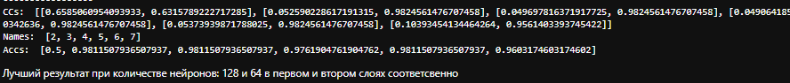

X_train, X_test, y_train, y_test = train_test_split(X_with_new_atribbute_scaled, Y_with_new_atribbute_scaled, test_size=0.4, random_state=42)

X_test, X_dev, y_test, y_dev = train_test_split(X_test, y_test, test_size=0.5, random_state=42)

Epohs = [10, 20, 30, 40, 50, 60, 70, 80, 90, 100]

res = []

res_r2 = []

names = []

for ep in Epohs:

model = Sequential()

model.add(Input(shape=(1, X_train.shape[1])))

model.add(Conv1D(filters=128, kernel_size=3, activation='relu', padding='same'))

model.add(MaxPooling1D(pool_size=1))

model.add(Conv1D(filters=64, kernel_size=3, activation='relu', padding='same'))

model.add(MaxPooling1D(pool_size=1))

model.add(Flatten())

model.add(Dense(64, activation='relu'))

model.add(Dense(1, activation='sigmoid'))

model.compile(optimizer='adam', loss='binary_crossentropy', metrics=['accuracy'])

history = model.fit(np.reshape(X_train, (X_train.shape[0], 1, X_train.shape[1])), Y_train, epochs=ep, batch_size=32, verbose=0, validation_data=(np.reshape(X_dev, (X_dev.shape[0], 1, X_dev.shape[1])), Y_dev))

rmse = model.evaluate(np.reshape(X_test, (X_test.shape[0], 1, X_test.shape[1])), Y_test)

predicted = model.predict(np.reshape(X_test, (X_test.shape[0], 1, X_test.shape[1])))

predicted_classes = (predicted > 0.5).astype(int)

acc = balanced_accuracy_score(Y_test, predicted_classes)

res.append(rmse)

res_r2.append(acc)

names.append(ep)

print("Epohs = ", ep)

print("CC = ", rmse)

print("Acc = ", acc, "\n-----------------")

print ("CCs: ", res)

print ("Names: ", names)

print ("Accs: ", res_r2)

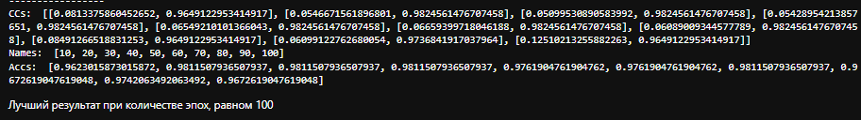

X_train, X_test, y_train, y_test = train_test_split(X_with_new_atribbute_scaled, Y_with_new_atribbute_scaled, test_size=0.4, random_state=42)

X_test, X_dev, y_test, y_dev = train_test_split(X_test, y_test, test_size=0.5, random_state=42)

Opts = ['adam', 'SGD', 'Adamax']

res = []

res_r2 = []

names = []

for op in Opts:

model = Sequential()

model.add(Input(shape=(1, X_train.shape[1])))

model.add(Conv1D(filters=128, kernel_size=3, activation='relu', padding='same'))

model.add(MaxPooling1D(pool_size=1))

model.add(Conv1D(filters=64, kernel_size=3, activation='relu', padding='same'))

model.add(MaxPooling1D(pool_size=1))

model.add(Flatten())

model.add(Dense(64, activation='relu'))

model.add(Dense(1, activation='sigmoid'))

model.compile(optimizer=op, loss='binary_crossentropy', metrics=['accuracy'])

history = model.fit(np.reshape(X_train, (X_train.shape[0], 1, X_train.shape[1])), Y_train, epochs=50, batch_size=32, verbose=0, validation_data=(np.reshape(X_dev, (X_dev.shape[0], 1, X_dev.shape[1])), Y_dev))

rmse = model.evaluate(np.reshape(X_test, (X_test.shape[0], 1, X_test.shape[1])), Y_test)

predicted = model.predict(np.reshape(X_test, (X_test.shape[0], 1, X_test.shape[1])))

predicted_classes = (predicted > 0.5).astype(int)

acc = balanced_accuracy_score(Y_test, predicted_classes)

res.append(rmse)

res_r2.append(acc)

names.append(op)

print("Ops = ", op)

print("CC = ", rmse)

print("Acc = ", acc, "\n-----------------")

print ("CCs: ", res)

print ("Names: ", names)

print ("Accs: ", res_r2)

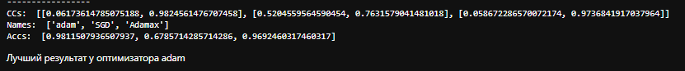

Итоговая сверточная модель без стандартизации и датасетом с дополнительным признаком и следующими гиперпараметрами:

- 128, 64 нейронов в первом и втором слоях соответсвенно

- Оптимизатор Adam

- Количество эпох 100

Выполним прогнозирования для модели с лучшими параметрами:

X_train, X_test, y_train, y_test = train_test_split(X_with_new_atribbute_scaled, Y_with_new_atribbute_scaled, test_size=0.4, random_state=42)

X_test, X_dev, y_test, y_dev = train_test_split(X_test, y_test, test_size=0.5, random_state=42)

model = Sequential()

model.add(Input(shape=(1, X_train.shape[1])))

model.add(Conv1D(filters=128, kernel_size=3, activation='relu', padding='same'))

model.add(MaxPooling1D(pool_size=1))

model.add(Conv1D(filters=64, kernel_size=3, activation='relu', padding='same'))

model.add(MaxPooling1D(pool_size=1))

model.add(Flatten())

model.add(Dense(64, activation='relu'))

model.add(Dense(1, activation='sigmoid'))

model.compile(optimizer=op, loss='binary_crossentropy', metrics=['accuracy'])

history = model.fit(np.reshape(X_train, (X_train.shape[0], 1, X_train.shape[1])), Y_train, epochs=100, batch_size=4, verbose=0, validation_data=(np.reshape(X_dev, (X_dev.shape[0], 1, X_dev.shape[1])), Y_dev))

rmse = model.evaluate(np.reshape(X_test, (X_test.shape[0], 1, X_test.shape[1])), Y_test)

predicted = model.predict(np.reshape(X_test, (X_test.shape[0], 1, X_test.shape[1])))

predicted_classes = (predicted > 0.5).astype(int)

acc = balanced_accuracy_score(Y_test, predicted_classes)

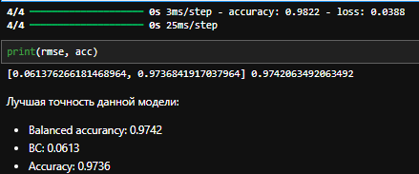

1. **Выводы**

В ходе лабораторной работы была выбрана модель, лучше всего классифицирующая данные на 2 класса.