Мой вариант:

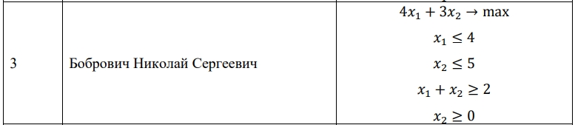

Решение в Excel:

|  |  |  |  |  |  |  |
| --- | --- | --- | --- | --- | --- | --- |
| БП | Базисный план | x1 | x2 | x3 | x4 | x5 |
| X3 | 4 | 1 | 0 | 1 | 0 | 0 |
| X4 | 5 | 0 | 1 | 0 | 1 | 0 |
| X5 | 2 | 1 | 0 | 0 | 1 | 0 |
| C | 4 | 3 | 0 | 0 | 0 | 0 |
|  |  |  |  |  |  |  |
| БП | Базисный план | x1 | x2 | x3 | x4 | x5 |
| x3 | 4 | 1 | 0 | 1 | 0 | 0 |
| X4 | 5 | 0 | 1 | 0 | 1 | 0 |
| x5 | 2 | 1 | 1 | 0 | 0 | 1 |
| z | 0 | -4 | -3 | 0 | 0 | 0 |
| C | 0 | 4 | 3 | 0 | 0 | 0 |
|  |  |  |  |  |  |  |
|  |  | Ответ: F(2;0) = -8 |  |  |  |  |

Код:

import numpy as np

from scipy.optimize import linprog

import matplotlib.pyplot as plt

# Целевая функция: 4x1 - 3x2

c = [4, 3]

# Левые части ограничений

A = [

[1, 0],

[0, 1],

[1, 1],

[0, 1]

]

# Правые части ограничений

b = [4, 5, 2, 2]

# Границы переменных

x0_bounds = (0, None) # x1 >= 0

x1_bounds = (0, None) # x2 >= 0

res = linprog(c, A_ub=A, b_ub=b, bounds=[x0_bounds, x1_bounds], method='simplex')

print("Результат оптимизации:")

print("x1 =", res.x[0])

print("x2 =", res.x[1])

print("Значение целевой функции:", -res.fun)

# Графическая интерпретация

x = np.linspace(0, 10, 400)

y1 = 0

y2 = 5

y3 = 2 - x

y4 = 0

plt.plot(x, y1, label=r'$x_1 \leq 4$')

plt.plot(x, y2, label=r'$x_2 \leq 5$')

plt.plot(x, y3, label=r'$x_1 + x_2 \geq 2$')

plt.plot(x, y4, label=r'$x_2 \geq 0$')

plt.xlim((0, 10))

plt.ylim((0, 10))

plt.xlabel(r'$x_1$')

plt.ylabel(r'$x_2$')

plt.fill_between(x, 0, y1, where=(y1 <= 0), interpolate=True, alpha=0.2)

plt.fill_between(x, 0, y2, where=(y2 >= 0), interpolate=True, alpha=0.2)

plt.fill_between(x, 0, y3, where=(y3 >= 0), interpolate=True, alpha=0.2)

plt.fill_between(x, 0, y4, where=(y4 <= 0), interpolate=True, alpha=0.2)

plt.legend(loc='upper right')

plt.scatter(res.x[0], res.x[1], color='red', marker='o', label='Оптимум')

plt.legend()

plt.show()

Результат:

Скриншот 21-10-2023 195004

Картинка:

