ГУАП

КАФЕДРА № 43

ОТЧЕТ   
ЗАЩИЩЕН С ОЦЕНКОЙ

ПРЕПОДАВАТЕЛЬ

|  |  |  |  |  |
| --- | --- | --- | --- | --- |
| доцент |  |  |  | Степанов П.А. |
| должность, уч.степень, звание |  | подпись, дата |  | инициалы, фамилия |

|  |
| --- |
| ОТЧЕТ О ЛАБОРАТОРНОЙ РАБОТЕ №7 |
| Недетерминированное программирование |
| по курсу: ФУНКЦИОНАЛЬНОЕ И ЛОГИЧЕСКОЕ ПРОГРАММИРОВАНИЕ |
|  |
|  |

РАБОТУ ВЫПОЛНИЛ

|  |  |  |  |  |  |
| --- | --- | --- | --- | --- | --- |
| СТУДЕНТ ГР. № | 4136 |  | 09.06.2023 |  | Н. С. Бобрович |
|  |  |  | подпись, дата |  | инициалы, фамилия |

Санкт-Петербург 2023

**Задание:   
  
На языке Prolog.**

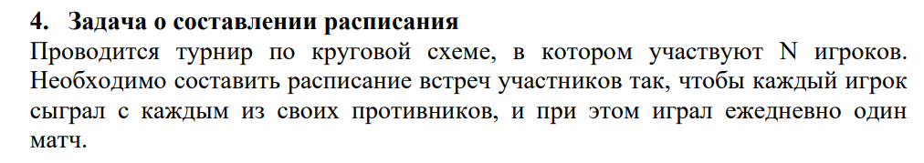

**Ход работы.**

**Листинг:**

get_set_games(N, Result) :-

get_set_games_helper(N, 1, [], Result).

get_set_games_helper(1, M, Acc, Result) :-

append(Acc, [[1, M]], Result).

get_set_games_helper(N, M, Acc, Result) :-

N > 1,

append(Acc, [[N, M]], Acc1),

M1 is M + 1,

N1 is N - 1,

get_set_games_helper(N1, M1, Acc1, Result).

get_set_players(N, Result) :-

numlist(1, N, Result).

delete_list1_from_list2([], List2, List2).

delete_list1_from_list2([X | Rest], List2, Result) :-

delete_list1_from_list2(Rest, List2, Result1),

select(X, Result1, Result).

get_day(_, [], []).

get_day(SetPlayers, [Game | Rest], [Game | Result]) :-

subset(Game, SetPlayers),

delete_list1_from_list2(Game, SetPlayers, NewSetPlayers),

get_day(NewSetPlayers, Rest, Result).

get_day(SetPlayers, [_ | Rest], Result) :-

get_day(SetPlayers, Rest, Result).

get_valid_day(SetPlayers, SetGames, Day) :-

get_day(SetPlayers, SetGames, Day),

length(Day, HalfLength),

length(SetPlayers, SetPlayersLength),

HalfLength is SetPlayersLength // 2.

get_schedule(SetPlayers, SetGames, Result) :-

get_schedule_helper(SetPlayers, SetGames, [], Result).

get_schedule_helper(_, [], Acc, Result) :-

reverse(Acc, Result).

get_schedule_helper(SetPlayers, SetGames, Acc, Result) :-

get_valid_day(SetPlayers, SetGames, Day),

delete_list1_from_list2(Day, SetGames, NewSetGames),

get_schedule_helper(SetPlayers, NewSetGames, [Day | Acc], Result).

start(N, Schedule) :-

N > 0,

N mod 2 =:= 0,

get_set_players(N, SetPlayers),

get_set_games(N, SetGames),

get_schedule(SetPlayers, SetGames, Schedule).

**Output:**

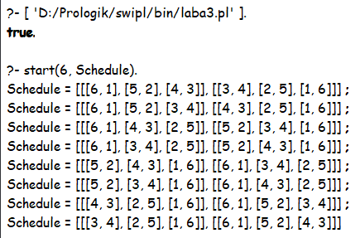

**Вывод:** Выполнил задание на языке Prolog.