COMP3850 PACE — Computing Industry Project
Deliverable 7 — Final Handover

Cybersecurity Project Documentation
Defensive Privacy-Preserving Record Linkage (PPRL)

Group: 74
Project stream: Cybersecurity (Defensive)
Sponsors: Dr Dinusha Vatsalan; Piyumi Seneviratne (Macquarie School of Computing)
Repository: github.com/Oslimy/group-74
Version: 1.0 (D7)
Date: 10 November 2026

Contents

1. Introduction and Scope
This document is the consolidated Cybersecurity Project Documentation for Group 74's defensive Privacy-Preserving Record Linkage (PPRL) prototype. It is written in response to the D3 and D4 marker feedback, which noted that the required Cybersecurity sections existed only as material scattered across the Scoping Document and the Prototype report rather than as dedicated, testable sections. The technical material is unchanged; it has been reorganised here under the required headings and linked to the evidence actually produced by the prototype.
The system is a two-party, defensive record-linkage pipeline. Two data custodians (referred to as "Alice" and "Bob", standing in for two hospitals) wish to discover which records refer to the same person without revealing the underlying personal data to each other or to any third party. Identifiers are encoded into Bloom filters, differential-privacy noise is applied, and a linkage model decides which encoded record pairs match. The cybersecurity objective is defensive: to preserve the privacy of individuals in the data while retaining enough utility for accurate linkage, and to make the privacy/utility trade-off measurable rather than assumed.
1.1 How this document maps to the marking criteria
Required section | Where it is addressed
Security/privacy user stories | §2 — testable user stories with attacker, target, action and security consequence
Detection of intrusions / vulnerabilities | §3 — executed findings with evidence, linked to test IDs
Defending Solutions Architecture | §4 — implemented architecture and trust-boundary view
Algorithms / Security Rules | §5 — implemented controls, inputs/outputs and configuration
Non-technical concerns / approaches | §6 — governance, authorised use, access and responsible reporting
Data Description / Feature Engineering | §7 — datasets and features used by the prototype
2. Security and Privacy User Stories
The following user stories frame the defensive requirements from the point of view of the actor involved. Each is written to be testable: it names the actor, the target component, the action, and the security or privacy consequence, and references the control that satisfies it (§5) and the test that verifies it (§3). "Attacker" stories describe what the system must resist; "custodian" stories describe what the system must guarantee to a legitimate party.
ID | User story (As a … I want … so that …) | Target component & action | Security consequence / control
US-01 | As a data custodian, I want personal identifiers to never leave my organisation in plaintext, so that a breach of the other party cannot expose my patients. | Encoding stage — only Bloom-filter bit vectors are exchanged. | Confidentiality preserved; plaintext never transmitted. Control SR-01; test TC03.
US-02 | As an honest-but-curious partner, I should not be able to reverse an encoded record back to the original name/DOB, so that linkage does not become a data-sharing back door. | Bloom-filter + DP noise — attempt dictionary/frequency inversion. | Hash collisions and added noise make inversion ambiguous. Control SR-02/SR-03; tests TC06, TC07.
US-03 | As a privacy officer, I want a tunable privacy budget, so that I can set a defensible privacy level before any data is linked. | DP noise stage — set ε per run. | Smaller ε = more bits flipped = stronger privacy. Control SR-03; test TC07.
US-04 | As an external eavesdropper, I should gain no usable identity information from intercepted filters, so that transport interception is not sufficient to re-identify a person. | Exchanged filters — observe set bits. | A set bit cannot be attributed to one q-gram (collisions). Control SR-02; §3 finding F-02.
US-05 | As a data custodian, I want the linkage decision to degrade gracefully as privacy increases, so that I am warned when a chosen privacy level makes results unreliable. | Linkage model — evaluate F1 across ε. | Measured privacy/utility curve; baseline failure is visible. Test TC10; §3 finding F-03.
US-06 | As an adversary submitting poisoned/corrupted records, I should not be able to silently force false matches, so that linkage quality cannot be degraded undetected. | Preprocessing + evaluation — inject corruption. | Corruption tests quantify robustness per model. §3 finding F-04.
US-07 | As a project sponsor, I want every privacy claim backed by evidence, so that the system is not represented as safer than it has been shown to be. | Reporting — tie claims to measured results. | No DP guarantee is asserted without validation. §5 note SR-03; §6.4.
3. Detection of Intrusions and Vulnerabilities
Because the prototype is an offline, two-party linkage system rather than a networked service, "detection" here means detecting privacy and linkage weaknesses in the pipeline itself, using controlled experiments that play the role of an adversary. Each finding below was produced by running the final code against the supplied datasets; the evidence is reproducible via the referenced test or experiment script.
ID | Vulnerability / threat examined | Detection method (executed) | Finding & evidence
F-01 | Weak perturbation — noise might not actually change the encoding. | Compare each filter before/after add_DP_noise (TC06). | 100/100 filters changed at ε=7; perturbation confirmed active.
F-02 | Re-identification by collision analysis of exchanged filters. | Measure Bloom-filter false-positive (collision) rate at k=10 (experiment exp_d4.py). | Collision rate ≈ 0.995 at the default configuration — an observed bit maps to many possible q-grams, so single-bit inversion is not feasible.
F-03 | Privacy level set too low makes linkage unreliable without warning. | Sweep ε = 1…10 and record F1 for every model (exp_d4.py; TC10). | The supplied fixed-0.8 threshold collapses to F1 = 0.000 at ε ≤ 5, while learned models hold ≈ 0.94 to ε = 3. The failure point is now visible and documented.
F-04 | Data-poisoning / corruption forcing degraded matching. | Re-run linkage at 0/25/50% record corruption (exp_d4.py, Figure 3). | Linear models retain the highest F1 under corruption; tree ensembles degrade fastest — informs the recommended model choice.
F-05 | Over-strong privacy silently destroys utility (denial-of-utility). | Observe F1 at ε = 1–2 across models. | At ε = 1 all models fall below F1 = 0.27; this is flagged as the lower bound of usable privacy for this dataset.
F-06 | Encoding of free-text clinical notes leaks or over-collides. | Counting-Bloom-filter text experiment at ε = ∞/7/3 (text_experiment.py). | Text F1 falls from 0.88 (no noise) to 0.70 (ε=3); a 1000-counter filter is lossy for a ~68k-token vocabulary, so collisions are high (privacy-favouring but utility-limiting).
Interpretation: the dominant residual vulnerability is operational, not cryptographic — choosing a privacy budget that is too low for the data at hand. §5 (SR-03) and the Recommendations/Monitoring Plan treat ε selection as a controlled, owned decision rather than a default.
4. Defending Solutions Architecture
The implemented architecture is a four-stage pipeline executed independently by each custodian up to the point of exchange. Only encoded, noised bit vectors cross the trust boundary between the two parties; raw identifiers never do. The diagram below shows the implemented components and the trust boundary.
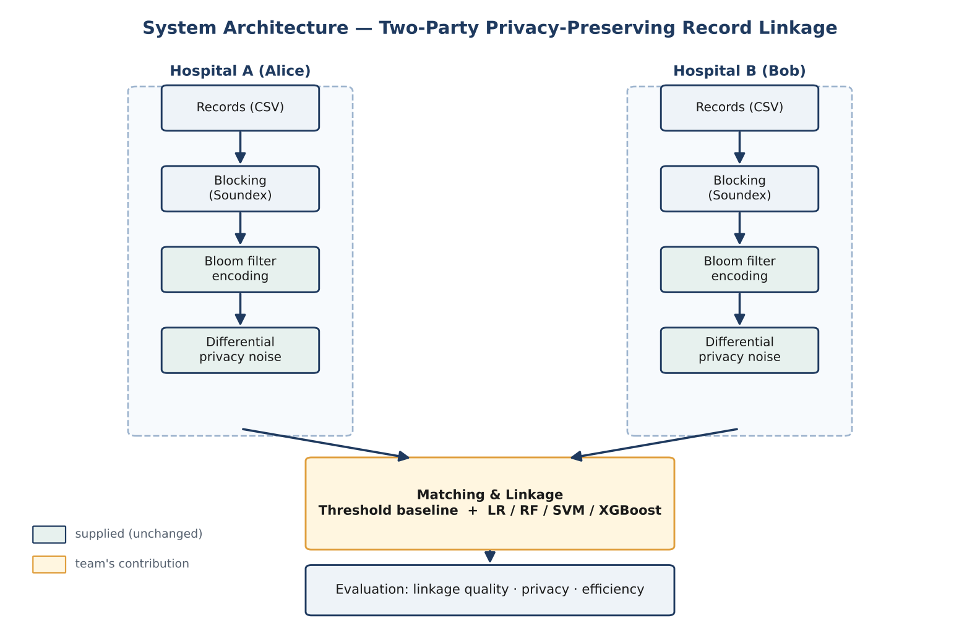
Figure 4.1 — Implemented PPRL architecture (components as built in BF.py, PPRL.py, ml_linkage.py).
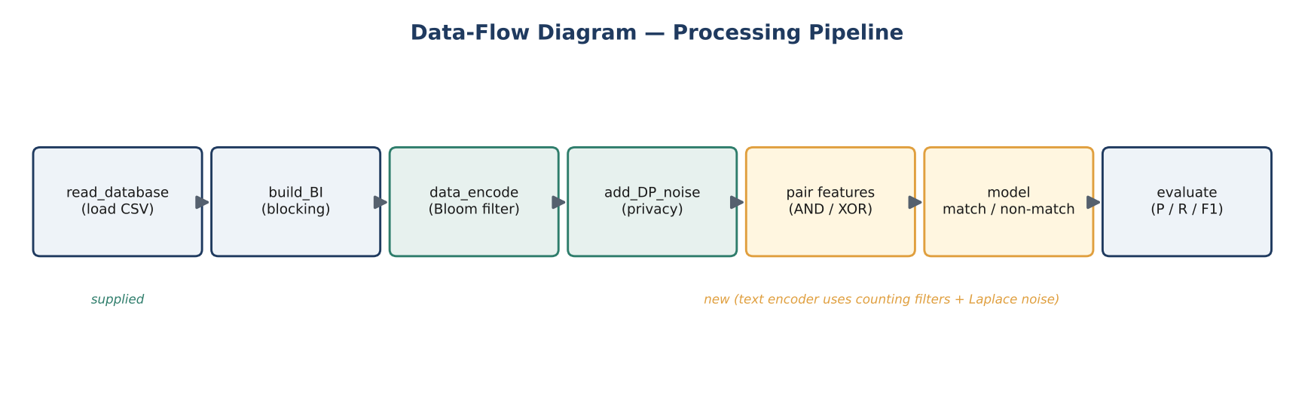
Figure 4.2 — Data flow and trust boundary. Plaintext stays inside each custodian; only perturbed Bloom filters are shared.
4.1 Components and trust boundary
- Preprocessing (inside each custodian): standardises identifier fields and splits each into q-grams. Plaintext never leaves this zone.
- Blocking (inside each custodian): Soundex-based block index groups candidate records to reduce comparisons without comparing raw values across parties.
- Bloom-filter encoding (inside each custodian): each q-gram sets k = 10 bits in a 1000-bit filter (q = 2). The filter is the only representation that may cross the boundary.
- Differential-privacy noise (at the boundary): randomised bit-flipping controlled by ε is applied before exchange, so even the encoded form is perturbed.
- Linkage / matching (neutral zone): similarity is computed on perturbed filters (Dice) and a model or threshold decides match / non-match. No stage receives plaintext.
Trust boundary: the dashed boundary in Figure 4.2 separates each custodian's private zone (plaintext, pre-noise filters) from the shared/neutral zone (perturbed filters, similarity scores, match decisions). A compromise of the shared zone exposes only perturbed, collision-ambiguous vectors — the property evidenced by finding F-02.
5. Algorithms and Security Rules
This section consolidates the implemented controls: the algorithm, its inputs and outputs, the configuration actually used, and the security rule it enforces. Configuration values are the defaults in the submitted code.
Rule | Algorithm / mechanism | Inputs → outputs (as implemented) | Configuration & security intent
SR-01 | Bloom-filter encoding (BF.py) | q-grams of an identifier → 1000-bit vector (k hashes). | len=1000, k=10, q=2. Replaces plaintext with a non-reversible set representation before any exchange.
SR-02 | Collision-based obfuscation | Shared bits → many possible source q-grams. | k=10 drives collision rate ≈ 0.995; a single bit cannot be attributed to one q-gram (F-02).
SR-03 | Differential-privacy bit-flip (add_DP_noise) | Encoded filter + ε → perturbed filter. | Flip probability p = 1/(1+e^(ε/2)); ε=7 ≈ 29 bits, ε=1 ≈ 377 bits of 1000. ε is an owned, logged decision — not asserted as a formal DP guarantee without validation.
SR-04 | Laplace noise on text counters (text_encode.py) | Counting filter + ε → noisy, clipped counters. | Scale 2k/ε; counters clipped ≥ 0 (TC15). Protects term-frequency signal in free-text notes.
SR-05 | Soundex blocking (PPRL.py) | Records → candidate blocks. | Limits comparisons to phonetically similar groups; avoids all-pairs comparison across parties.
SR-06 | Similarity + decision (ml_linkage.py) | Two perturbed filters → Dice similarity → match/non-match. | Learned model (Logistic Regression default) or threshold; entity-level cross-validation prevents leakage between train/test.
Security rationale: SR-01 and SR-02 provide confidentiality by construction; SR-03 and SR-04 add tunable, measurable privacy; SR-05 bounds exposure and cost; SR-06 keeps the evaluation honest (no identity appears in both training and test folds). The key standing rule for operators is that ε must be chosen per deployment and recorded, because finding F-03/F-05 show utility fails silently if ε is set too low.
6. Non-technical Concerns and Approaches
These concerns are specific to a PPRL deployment and to this academic project; they deliberately avoid generic login/network-security material, which the markers noted was not relevant to the prototype.
6.1 Privacy governance and authorised data use
The datasets are supplied synthetic hospital records provided for the unit; no real patient data is used. Any real deployment would require a data-sharing agreement between custodians, an approved purpose, and a named accountable owner for the privacy budget. Linkage output (match decisions) is itself sensitive and is treated as a controlled artefact.
6.2 Access and reproducibility
- Code and documentation are version-controlled in a single repository (github.com/Oslimy/group-74); the sponsor is given read access for the handover.
- Results are reproducible from the supplied datasets using the scripts in the repository (see the Scripts & Execution guide and Security Test Plan).
- Configuration (ε, k, filter length) is explicit in the code so a reviewer can re-run any reported privacy/utility point.
6.3 Responsible reporting
Absolute precision figures are treated as optimistic and are used only to compare models under identical conditions, not as deployment guarantees. The team reports the privacy/utility trade-off as a curve rather than a single headline number.
6.4 Honest privacy claims
Following the D2/D3 feedback, the bit-flipping mechanism is described as providing probable, collision- and noise-based privacy that is tunable via ε, k and filter length. It is not described as a proven differential-privacy guarantee, because a formal ε-DP proof for this specific construction has not been validated within the project scope. This is stated consistently across the Scoping Document, the Prototype report and this document.
7. Data Description and Feature Engineering
7.1 Datasets used by the prototype
Dataset | Size / form | Role in the prototype
Alice/Bob structured records | 100 and 500 records; non-corrupted, 25% and 50% corrupted variants | Main linkage experiments; corruption variants test robustness (F-04).
Hospital text records (train/test A & B) | Free-text clinical notes, ~68k-token vocabulary | Counting-Bloom-filter text pathway (F-06).
Ground-truth labels | Record-pair match labels | Entity-level train/test split and F1/precision/recall evaluation.
7.2 Feature engineering (as implemented)
- Structured pairs: for a candidate pair of perturbed 1000-bit filters, features are the element-wise AND and XOR of the two filters, giving a 2000-dimensional pair vector (TC11). AND captures shared bits (evidence of a match); XOR captures disagreement.
- Text pairs: counting Bloom filters are compared with element-wise minimum and absolute-difference features, scored with the min-sum Dice coefficient (TC14).
- Labelling & splitting: 5-fold cross-validation split by person (entity-level), so no individual appears in both training and test — preventing optimistic leakage.
- Class handling: matches are rare relative to non-matches, so models use balanced class weighting.
These features are deliberately simple and transparent so that the privacy/utility behaviour, not model complexity, explains the results. The recommended Logistic Regression model operates directly on these pair features.

