COMP3850 PACE · Group 74
Prototype / Final Results Document
Deliverable 4 · 24 October 2026
Robust Privacy-Preserving Record Linkage Models (Defensive Project)
Sponsor: Macquarie University School of Computing (Dr Dinusha Vatsalan, Piyumi Seneviratne)

Revision History
Version | Date | Author(s) | Summary of changes
3.0 | 01/10/2026 | [member] | D3: prototype with two models (LR, RF) on structured data.
4.0 | 24/10/2026 | [member] | D4: added SVM and XGBoost (all five models compared); implemented the counting-Bloom-filter text encoder and evaluated models on the hospital text dataset; added the final comparison and recommendation.

Contents

1. Summary
This document presents the final results of Group 74's defensive Privacy-Preserving Record Linkage (PPRL) project. All four required linkage models (Logistic Regression, Random Forest, SVM and XGBoost) have been implemented and compared against the supplied threshold-based baseline on the structured Alice/Bob datasets, across a full range of privacy settings. The counting-Bloom-filter text encoder has been implemented and at least two models evaluated on the unstructured hospital dataset, satisfying the final requirement. The headline finding from the MVP holds and strengthens: learned linkage models substantially outperform the fixed-threshold baseline under strong privacy noise, and Logistic Regression and linear SVM are the most robust and efficient choices.

2. Models and Method
The sponsor-supplied pipeline (read → block → Bloom-filter encode → differential-privacy noise → match) is reused unchanged; the team's work is confined to the matching-and-linkage step and, for D4, the text-encoding step. Each record pair is represented from the two differential-privacy-perturbed Bloom filters using the element-wise AND and XOR of their bit vectors (for the counting filters used on text, the element-wise minimum and absolute difference). Models are trained on labelled pairs using the ground-truth entity identifier for labels only, with entity-level cross-validation so that no individual appears in both training and test.
- Logistic Regression and linear SVM: linear classifiers that learn a single decision boundary; simple, fast and robust.
- Random Forest and XGBoost: tree ensembles that capture non-linear structure; stronger at low noise, more fragile under heavy perturbation.

3. Results on Structured Data (Alice/Bob)
Figure 1 shows how all five models and the baseline behave as privacy noise increases (ε decreasing). The supplied fixed-0.8 threshold collapses at ε = 5; every learned model and the tuned threshold remain strong far longer. Logistic Regression and SVM are the best, holding ≈ 0.94 F1 down to ε = 3.
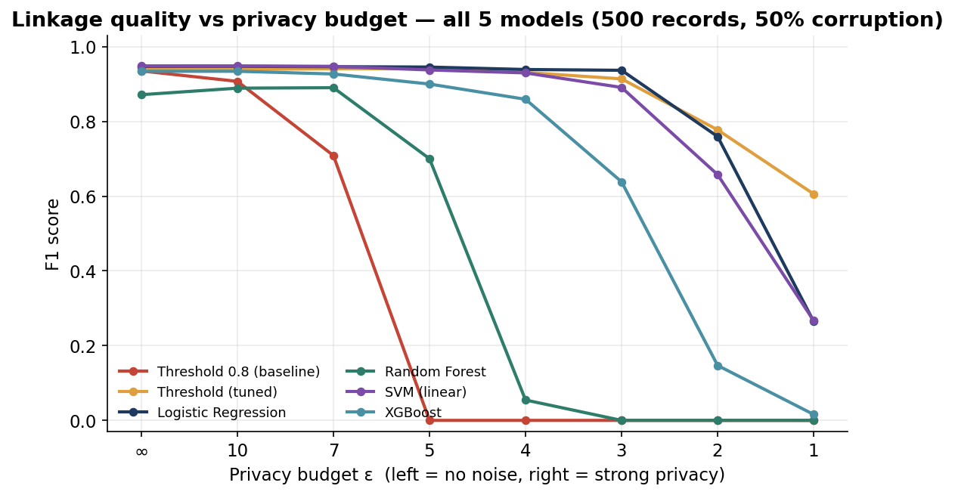
Figure 1. F1 vs privacy budget ε for all five models and both baselines (500 records, 50% corruption).
ε | Thr 0.8 | Thr tuned | LR | RF | SVM | XGB
∞ (no noise) | 0.935 | 0.941 | 0.948 | 0.872 | 0.949 | 0.934
10 | 0.907 | 0.939 | 0.948 | 0.889 | 0.949 | 0.934
7 | 0.709 | 0.941 | 0.947 | 0.890 | 0.948 | 0.927
5 | 0.000 | 0.941 | 0.946 | 0.700 | 0.938 | 0.900
4 | 0.000 | 0.931 | 0.939 | 0.054 | 0.930 | 0.859
3 | 0.000 | 0.914 | 0.937 | 0.000 | 0.891 | 0.639
2 | 0.000 | 0.778 | 0.760 | 0.000 | 0.658 | 0.147
1 | 0.000 | 0.606 | 0.265 | 0.000 | 0.267 | 0.016
Table 1. F1 at 500 records, 50% corruption. Best per row in green; 0.000 marks total failure of the fixed-threshold baseline.
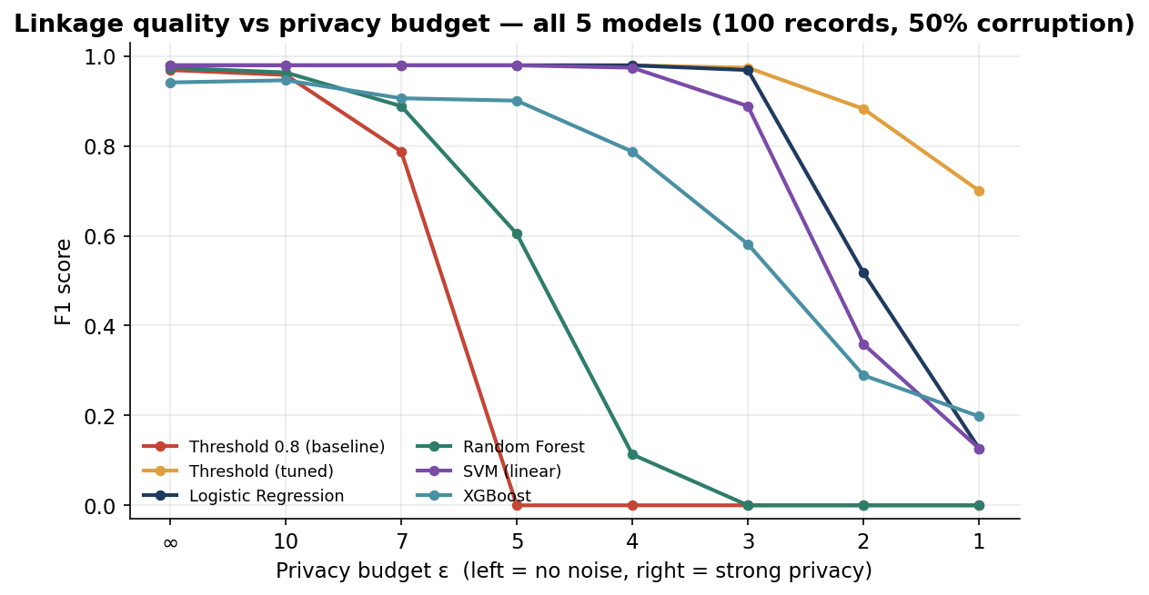
Figure 2. The same comparison at 100 records.
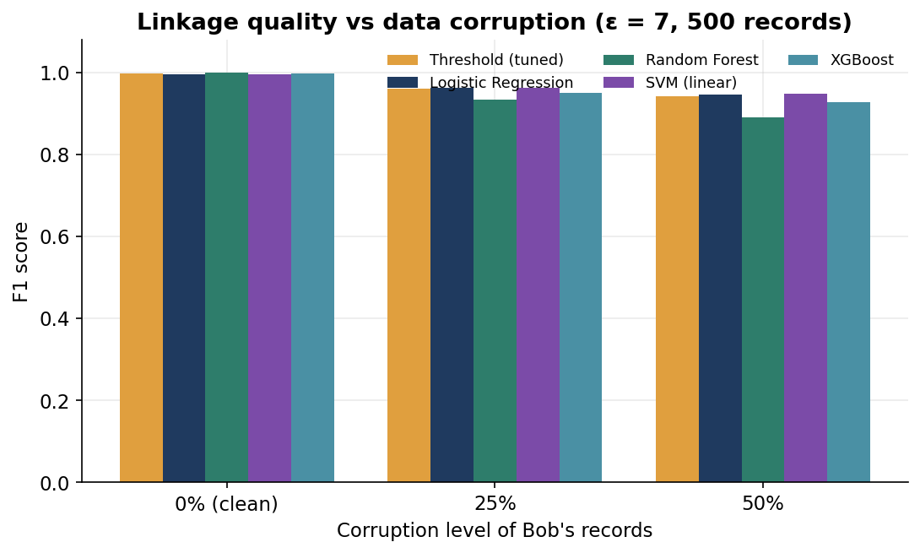
Figure 3. F1 vs data corruption level at ε = 7 (500 records).

4. Computational Efficiency
Runtime is measured inside the code (not across notebook cells). At 500 records all models are inexpensive; the linear models are markedly faster than the tree ensembles.
Model | Fit + predict time (500 rec, 5 folds) | Robustness under strong noise
Logistic Regression | 1.25 s | Best — holds ≈ 0.94 F1 down to ε = 3
SVM (linear) | 0.24 s (fastest) | Strong — close to LR to ε = 4
XGBoost | 3.19 s | Good at weak privacy; fades below ε = 4
Random Forest | 3.15 s | Weakest — breaks by ε = 4
Table 2. Efficiency and robustness summary (structured data, 500 records).

5. Effect of the Number of Hash Functions (k)
Carried forward from the MVP and confirmed: increasing k raises the Bloom-filter false-positive rate (stronger collision-based privacy) quickly toward 1.0 while linkage quality stays flat, so k = 10 remains a well-justified default.
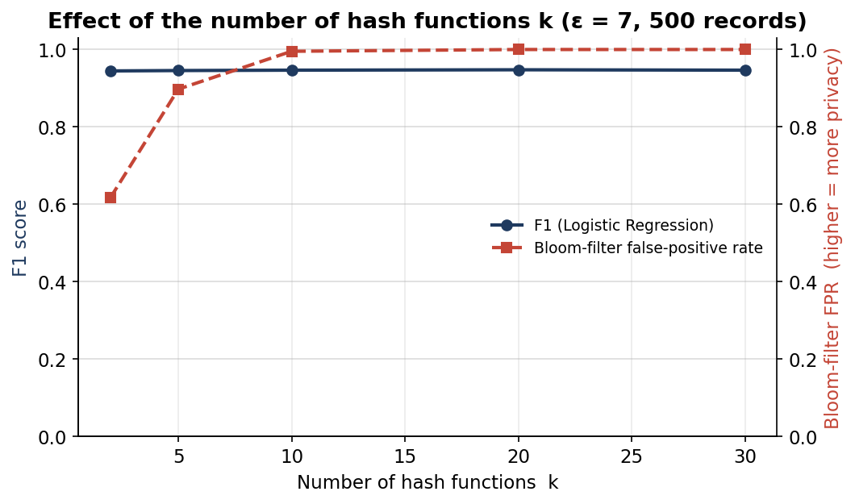
Figure 4. Effect of the number of hash functions k on F1 and the Bloom-filter false-positive rate (ε = 7, 500 records).

6. Results on Text Data (Counting Bloom Filters)
For the unstructured hospital dataset, a counting-Bloom-filter encoder was implemented following the sponsor specification: each clinical note is tokenised (stop-words removed, the trailing age/sex metadata stripped), a bag-of-words with term-frequency counts is formed, and each token increments k counters. Similarity uses the min-sum Dice coefficient. Differential privacy is applied with the Laplace mechanism (scale 2k/ε) on the counters. Models were trained and tested on a balanced sample (8,000 training and 4,000 test pairs).
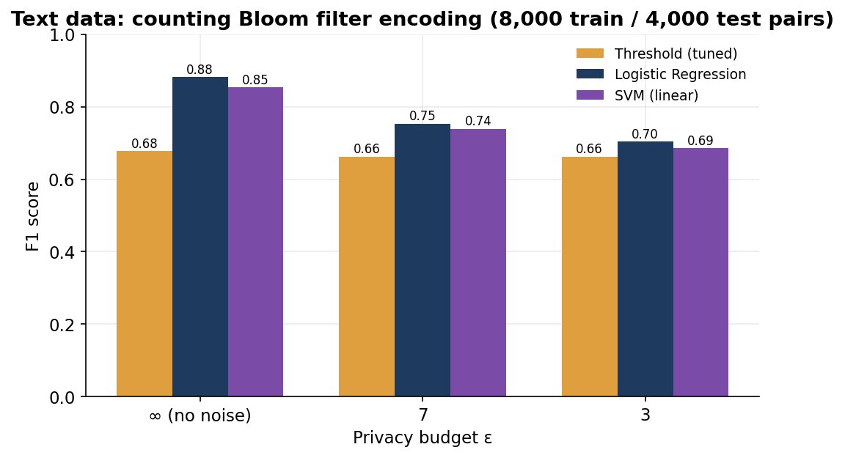
Figure 5. Text-data F1 by privacy budget: tuned threshold vs Logistic Regression vs SVM.
ε | Threshold (tuned) | Logistic Regression | SVM (linear)
∞ (no noise) | 0.677 | 0.882 | 0.854
7 | 0.663 | 0.754 | 0.739
3 | 0.663 | 0.704 | 0.685
Table 3. F1 on the hospital text data (counting Bloom filter, 1000 counters, k = 10).
Interpretation. On text the learned models beat the min-sum-Dice threshold by a wide margin (e.g. 0.88 vs 0.68 with no noise). The threshold is weak here because long clinical notes share a large common medical vocabulary, so a frequency-overlap score separates matches from non-matches poorly; the models instead learn which counter patterns are discriminative. A second observation is that a 1000-counter filter is very lossy for a vocabulary of ~68,000 tokens (heavy collisions), which caps absolute quality — a longer filter would be the first thing to try for text in future work.

7. Discussion and Recommendation
- Recommended model: Logistic Regression. It is the best or equal-best on both structured and text data, is robust down to strong privacy (ε = 3), and is cheap to train. Linear SVM is an almost-equivalent, even faster alternative.
- The baseline's failure is a threshold problem, not a data problem — a learned or tuned cut-off recovers the quality the fixed 0.8 threshold loses under noise.
- Tree ensembles (RF, XGBoost) are not recommended here: they are strong only at weak privacy and degrade sharply once the noise is high.
- Privacy is identical across models at a given setting (they all read the same perturbed filters); privacy is therefore reported as a curve over ε, filter length and k, not per model.

8. Limitations
- Evaluation is restricted to candidate pairs surviving blocking, so absolute precision is optimistic; results are used to compare models against each other.
- The text evaluation uses a balanced sample and a 1000-counter filter; scaling the filter length and the sample would likely raise absolute text F1.
- Notes repeat across the train/test split in the supplied text data, which can flatter ML models; a note-disjoint split is suggested for future validation.

9. Sponsor Feedback (D3 → D4)
Sponsor feedback (prototype demo) | Action taken for D4
Add plots and graphs. | All results are presented as figures (Figures 1–5) with supporting tables.
Justify k and explain training. | k justified by the sweep in Section 5; training method documented in Section 2 (entity-level cross-validation).
Complete the model set and the text work. | SVM and XGBoost added (five-model comparison); counting-Bloom-filter text encoder implemented and evaluated (Section 6).
[Team to add the D4 sponsor-demo date and any further feedback.]

