Household water-service priorities are not simple reflections of experienced service deficits
Aadhityaa Mohanavelu¹ and Khalid K. Osman¹,*
¹ Department of Civil and Environmental Engineering, Stanford University, Stanford, California, USA.
*Corresponding author: Khalid K. Osman; osmank@stanford.edu
Abstract
Household priorities increasingly inform water-service planning, but it remains unclear whether they simply reflect experienced service deficits. We analyzed reported impact ratings across eight domains spanning affordability, access, reliability, efficiency, acceptability, quality, quantity and customer service among 2,874 households using municipal water in Tamil Nadu, India. After separating overall rating intensity from within-household relative priorities, we found substantial heterogeneity in how strongly households differentiated among domains. A reproducible two-component mixture mainly reflected differentiation magnitude rather than distinct domain-priority configurations, and a flexible continuous model gave better held-out fit. Greater deficits in a domain did not correspond to greater relative priority for that domain overall, although domain-specific associations varied. Household context and service conditions were associated with fitted component probabilities, but provided little predictive information about observed differentiation magnitude or relative-priority direction. Service-performance measures alone did not recover how households rated the relative impact of different service dimensions. Water-service assessments should therefore measure these ratings directly rather than infer them from experienced deficits.
Introduction
Under the Millennium Development Goal framework, piped supply counted as an improved drinking-water source and progress was tracked through use of such sources [1]. The Sustainable Development Goal framework moved beyond source type by distinguishing improved-source access from the level of service households receive. Safely managed drinking water must be available when needed, accessible on the premises and meet standards for microbial and priority chemical contamination [1,2]. Across nationally representative surveys in 27 low- and middle-income countries, 84.3% of households used an improved source, while only 30.5% met all criteria for safely managed service [3]. Households served through comparable infrastructure can also differ in continuity, quantity, affordability and other experienced conditions [4, 5, 6]. Water service therefore cannot be characterized by access alone.
As service assessment has expanded across multiple dimensions, their relative importance matters for overall assessment and improvement decisions. Composite measures address this through weights derived from statistical structure, expert judgment or regulator preferences [7, 8, 9, 10]. These weights need not reflect how households themselves assess the importance of different dimensions of their water-service experience. Water studies have elicited rankings, choices among service improvements and willingness to pay for changes in service attributes [11,12], and preference structures can differ even within similar service settings [13,14,15]. Much of this evidence, however, concerns hypothetical service packages, proposed improvements or cost trade-offs rather than the importance households assign to dimensions of the service they currently experience. We use household priority for this reported importance, and relative priority for how a household positions one service dimension against the others in its own ratings.
The central unresolved question is whether these priorities can already be inferred from experienced service conditions. A household facing poor reliability, for example, might assign reliability greater priority than dimensions where its service is better. Importance-performance studies have measured current service and reported importance together, usually to identify areas for improvement [16,17,18]. We test whether comparatively worse service across matched dimensions within the same household corresponds to greater relative priority for the corresponding dimension. Stated-choice studies address a related but different question because respondents evaluate proposed changes rather than distribute importance across current service. Households also differ in how strongly they use rating scales across domains [19]. Without separating this respondent-wide rating intensity, apparent priority differences can reflect generally high or low ratings rather than differences in the relative position of individual domains. It therefore remains unclear whether relative household priorities contain structure beyond general rating intensity and whether that structure follows the deficits households experience.
Even if individual deficits do not align directly with their corresponding priorities, service experience may remain relevant through the combination of conditions households face. Households can buffer intermittent or inadequate supply through storage, supplementary sources, treatment or changes in water use, altering the burden produced by the original service condition [20,21]. The same provision may also be experienced differently across housing and household circumstances. Dwelling infrastructure can affect storage and management of intermittent supply, while tenure and household size can shape access and associated burdens [22,23,24]. Household priorities may therefore reflect broader service configurations and the circumstances in which they are experienced, even when no single deficit maps directly onto its corresponding priority. We therefore examine whether these broader service configurations and household circumstances are associated with relative-priority ratings within the same households.
To test these questions, we analyze 2,874 municipal-water households in Tamil Nadu, India, using matched measures of experienced service and reported priority across eight domains covering affordability, access, reliability, efficiency, acceptability, quality, quantity and customer service. H1 tests whether reproducible heterogeneity remains after separating household-wide rating intensity from relative-priority ratings. H2 tests whether households assign greater relative priority to dimensions in which they experience comparatively worse service. H3 tests whether broader service conditions and household context are associated with whether households differentiate among priorities and with fitted relative-priority components among those that do. Together, these analyses test whether household priorities can be inferred from experienced service conditions or whether direct priority measurement provides information that service-performance measures alone do not capture.
Results
Households show substantial differentiation in water-service priorities
Households generally assigned high ratings across the eight water-service domains, with substantial overlap in their marginal distributions (Fig. 1a,b). Medians clustered toward the upper end of the 0–10 scale, although every domain spanned a broad portion of the available range. At the sample level, the domains therefore appeared relatively similar. Household profiles showed considerably more differentiation (Fig. 1c). Of 2,874 households, 557 (19.4%) assigned the same rating to all eight domains, while 2,317 used at least two different ratings. A further 20.7% differed by only one point between their highest- and lowest-rated domains. Overall, 59.9% had a range of at least two points, and approximately one-quarter differed by four points or more. Equal ratings were therefore an important response pattern, but they did not characterize most households.
The highest- and lowest-rated domains also varied across households (Fig. 1d). Every domain appeared at both ends of the within-household profile. Affordability was more often among the lowest-rated domains and customer service among the highest, while reliability, quality and quantity occupied both positions for substantial shares of households. No single dimension consistently represented the highest or lowest priority. Thus, similar overall rating levels could conceal different within-household priority patterns, while equal ratings expressed no relative differentiation. We retained the 557 equal-rating households as an observed response pattern rather than assigning them to an inferred component. The 2,317 differentiating households provided the variation needed to test whether relative priorities retained reproducible structure after removing household-wide rating intensity.
Fig. 1. Household water-service priorities show substantial within-household differentiation
a, Distribution of 0–10 priority ratings across the eight service domains. Points show medians, dark bars interquartile ranges (25th–75th percentiles) and light bars 10th–90th percentile ranges. b, Full rating distributions by domain; cells show the percentage of households selecting each response. c, Within-household differentiation, measured as the range between the highest and lowest ratings across the eight domains. Of 2,874 households, 557 (19.4%) assigned the same rating to all domains. d, Relative positioning of each domain, shown as the share of households in which it occupied the highest- or lowest-rated position. Although absolute ratings were generally high, households differed substantially in how they positioned service dimensions relative to one another.
Relative priorities show reproducible structure beyond overall rating intensity
Most variation in the raw priority ratings reflected differences in how strongly households used the rating scale across domains. Respondent-wide rating intensity accounted for 75.2% of total variation, compared with 0.35% attributable to average differences between domains, leaving 24.4% as relative within-household variation (Fig. 2a). A complementary principal-component analysis showed the same dominance of a common rating direction. The first component explained 75.7% of variation in the raw ratings but 26.2% after household-mean centering. Removing household-wide rating intensity therefore reduced this dominant common direction without eliminating substantial variation in how individual domains were positioned relative to each household's mean.
We examined this relative variation among the 2,317 households that differentiated across domains. The continuous Gaussian benchmark retained multiple dimensions, indicating that a single relative-priority axis could not summarize the remaining variation. Three finite-mixture candidates advanced through the discovery stage. Both two-component models passed held-out predictive and structural validation. The spherical four-component model had the lowest full-sample BIC but failed the prespecified profile-reproducibility criterion and was rejected (Table 1).
We retained the full-covariance two-component model as the primary representation (Fig. 2b; Table 1). Its BIC was 48,396.7, improving on the continuous Gaussian comparator by 4,256.0. Across 50 repeated train-validation splits, the median held-out log-density gain was 0.987, and all 50 splits favored the mixture (Fig. 2d). Independently fitted validation samples recovered similar component profiles. The minimum median profile correlation was 0.883, and the maximum centroid RMSE was 0.128 rating points. The structure was also stable across 500 household bootstrap samples, with a minimum component-specific Jaccard similarity of 0.963 (Fig. 2e). The independently validated spherical two-component model likewise improved held-out fit in all 50 splits and had a minimum bootstrap Jaccard similarity of 0.974. Both fitted representations were reproducible under the original validation criteria.
The fitted components differed primarily in the magnitude of relative-priority differentiation, with smaller differences in their estimated domain means (Fig. 2b,c). Component A, with an estimated weight of 61%, showed smaller departures from the household mean. Affordability was 0.295 rating points below the mean, while acceptability, quality, quantity and customer service were above it. Component B, with an estimated weight of 39%, showed larger departures. Affordability, reliability and efficiency were below the household mean, while quantity and customer service occupied the strongest positive positions. The clearest between-component differences were for access, reliability and efficiency (Fig. 2c). Relative priority for access was 0.148 rating points higher in Component B than in Component A (95% bootstrap CI 0.014 to 0.289). Reliability was 0.124 points lower (95% CI −0.233 to −0.013), and efficiency was 0.178 points lower (95% CI −0.288 to −0.064). For affordability, acceptability, quality, quantity and customer service, the bootstrap confidence intervals crossed zero, providing no clear evidence of a between-component difference in those domains.
After removing overall rating intensity, the selected mixture captured reproducible differences in household ratings. Further diagnostics showed that the fitted components mainly reflected how strongly households differentiated among domains. Their assignments closely tracked within-household rating SD (AUC = 0.983), while a single multivariate Student-t distribution outperformed the selected mixture in all 50 held-out comparisons (Supplementary Tables S11 and S12). The components therefore do not establish distinct domain-priority types. We next tested whether experienced service deficits could explain this variation.
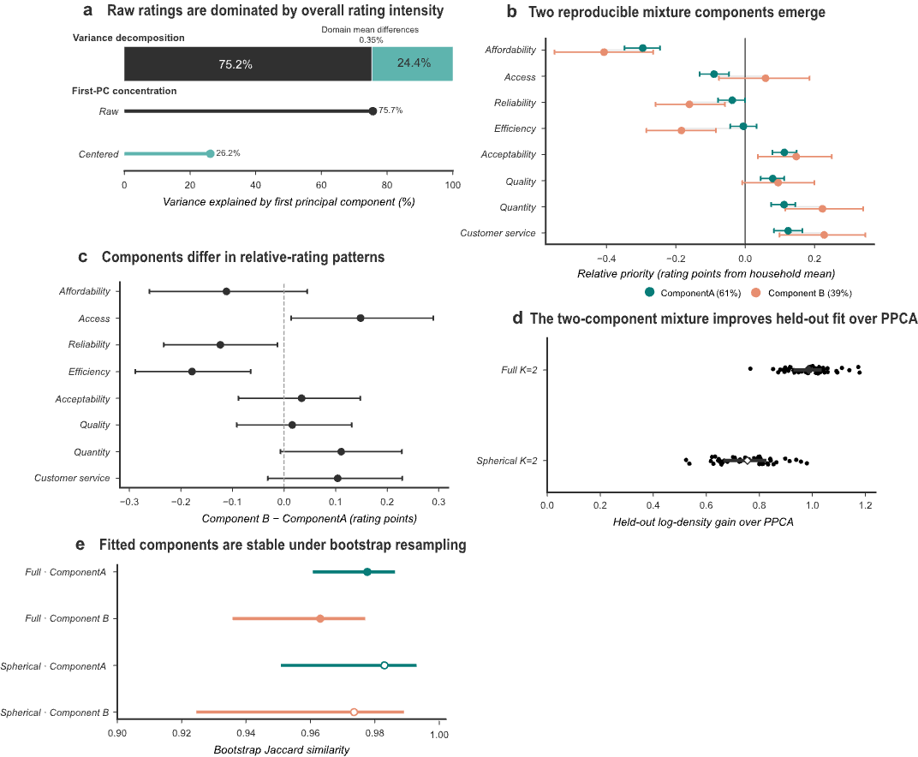
Fig. 2. Relative household water-service priorities retain reproducible structure beyond overall rating intensity
a, Decomposition of raw priority-rating variation across eight service domains. Respondent-level rating intensity accounts for 75.2% of variation, relative within-household variation for 24.4%, and between-domain mean differences for 0.35%. The first principal component explains 75.7% of variation in raw ratings and 26.2% after household-mean centering. b, Estimated relative-priority profiles for the primary two-component full-covariance Gaussian mixture among differentiating households (n = 2,317). Relative priority is expressed as rating points from each household's mean; estimated component weights are 61% and 39%. c, Domain-specific differences between Components B and A. d, Held-out log-density gain of the full- and spherical-covariance two-component mixtures relative to the training-selected probabilistic PCA comparator across 50 repeated train-validation splits. Positive values favor the mixture. e, Bootstrap reproducibility across 500 household resamples, summarized by matched-component Jaccard similarity. Filled symbols denote the primary full-covariance model and open symbols the spherical-covariance sensitivity model. Component labels are computational and do not imply ordered priority levels or fixed household types.
Table 1. Model discovery and validation of relative-priority structure
Model | BIC | ΔBIC vs continuous comparator | Held-out gain | Positive splits | Min. profile r | Max. RMSE | Bootstrap stability | Decision
Full-covariance K=2 | 48,396.7 | 4,256.0 | 0.987 | 50/50 | 0.883 | 0.128 | Min. Jaccard 0.963 | Primary
Spherical K=2 | 49,160.9 | 3,491.7 | 0.755 | 50/50 | 0.903 | 0.126 | Min. Jaccard 0.974 | Sensitivity
Spherical K=4 | 48,314.5 | 4,338.1 | 0.962 | 50/50 | 0.710 | 0.197 | Not evaluated after profile-reproducibility failure | Rejected
Experienced service deficits show little alignment with household priorities
H2 predicted that households would assign greater relative priority to service dimensions in which they experienced worse conditions. Using the prespecified matched deficit for each domain, standardized separately within domain, we found little evidence for this relationship (Fig. 3a). Across 2,870 service-complete households, a 1-s.d. worse deficit was associated with a −0.0045-point change in priority (95% CI −0.0274 to 0.0184, P = 0.702). After accounting for household-wide rating differences and average differences between domains, comparatively poorer service was therefore not associated with greater relative priority overall. In a post-review equivalence test, the 90% confidence interval (−0.0237 to 0.0148) fell within a ±0.025-point margin per 1-s.d. worse deficit (TOST P = 0.0396; Supplementary Table S18). We retained equal-rating households because the absence of differentiation was itself an observed response pattern. Repeating the analysis among the 2,313 service-complete differentiating households produced a similarly near-zero estimate of −0.0063 (95% CI −0.0343 to 0.0217, P = 0.659), showing that the pooled result was not driven by the 557 equal-rating households.
We next allowed the matched deficit–priority association to vary across domains (Fig. 3a). Seven of the eight estimates did not survive adjustment for the eight prespecified comparisons. Estimates were small and varied in direction, with positive coefficients for affordability and access, negative coefficients for reliability, acceptability, quality and customer service, and a near-zero estimate for quantity. Efficiency was the only domain to survive Holm correction. A 1-s.d. worse efficiency deficit was associated with a 0.0668-point lower priority rating (95% CI −0.1143 to −0.0194, Holm-adjusted P = 0.0462). This association ran opposite to H2, with comparatively worse efficiency corresponding to slightly lower rather than higher relative priority.
The near-zero pooled matched-domain relationship left open the possibility that poor conditions in one dimension corresponded to priorities assigned elsewhere. We therefore examined the full 8 × 8 pattern of relative deficit–priority associations (Fig. 3b). Positive and negative coefficients appeared across both matched and cross-domain pairs, but no consistent pattern emerged and none of the 64 associations survived Benjamini–Hochberg false-discovery-rate correction.
These results do not support H2. A worse standardized deficit in a domain did not consistently correspond to a higher relative priority rating for that domain. The pooled estimate remained near zero when equal-rating households were excluded, and none of the 64 cross-domain associations survived correction. Although service experience may relate to priorities in other ways, the matched deficit–priority relationship was not evident overall.
Fig. 3. Experienced service deficits show little alignment with household relative priorities
a, Estimated change in priority per 1-s.d. worse service deficit from the primary household- and domain-fixed-effects model (n = 2,870), the differentiators-only sensitivity (n = 2,313), and eight domain-specific matched tests. Points show coefficients and 95% confidence intervals. P values are unadjusted for the primary and sensitivity estimates and Holm-adjusted across the eight domain-specific tests. b, Cross-domain associations between relative standardized service deficits and relative priority. Cells show estimated coefficients; outlined diagonal cells denote same-domain deficit–priority pairs. None of the 64 associations survived Benjamini–Hochberg false-discovery-rate correction. Service deficits were standardized separately within each domain.
Household context and service configuration are associated with fitted priority components
H3 tested whether household context and broader service conditions were associated with priority patterns beyond the matched deficit–priority relationship examined under H2. We considered two outcomes separately. H3A tested whether households differentiated among the eight priority ratings at all, whereas H3B examined the fitted H1 mixture among households that did differentiate. The household- and service-block tests for H3A and H3B formed one prespecified four-test confirmatory family (Fig. 4a).
Neither predictor block passed the confirmatory threshold for H3A. Among 2,863 complete cases, the household-context block had a Wald χ² of 5.67 with 7 d.f. (raw P = 0.579, Holm-adjusted P = 0.579). The service-condition block had a Wald χ² of 15.82 with 8 d.f. (raw P = 0.0450) but did not survive correction across the four confirmatory tests (Holm-adjusted P = 0.090; Fig. 4a). Thus, neither measured household context nor service conditions provided confirmatory evidence distinguishing equal-rating households from those that differentiated across domains.
Among households that differentiated, H3B produced a different result. The analysis included 2,306 complete cases and retained uncertainty in component membership rather than treating component assignment as observed. Both predictor blocks passed the confirmatory threshold for association with fitted component probabilities. The household-context block had a Wald χ² of 22.53 with 7 d.f. (raw P = 0.00206, Holm-adjusted P = 0.0062), and the service-condition block had a Wald χ² of 30.47 with 8 d.f. (raw P = 0.000174, Holm-adjusted P = 0.0007; Fig. 4a). These associations concern the fitted mixture rather than independently established directional priority types.
We next localized the confirmed household-context association within the prespecified testing hierarchy (Fig. 4b). Dwelling type was the only household variable to survive the gated variable-level correction (Holm-adjusted P = 0.0177). Of the 2,306 H3B complete cases, 128 lived in apartments. Compared with households living in individual houses, those living in apartments had twice the adjusted odds of Component B rather than Component A (OR 2.00, 95% CI 1.32 to 3.03). This corresponded to a 16.62-percentage-point higher adjusted probability of Component B. Household size and housing tenure did not pass their corrected variable-level tests. Among the tested household variables, the association was therefore localized to dwelling type.
The service-condition association was similarly localized (Fig. 4c). Acceptability was the only one of the eight service domains to survive the gated domain-level correction (Holm-adjusted P = 4.37 × 10⁻⁵). A 1-s.d. worse acceptability deficit was associated with higher adjusted odds of Component B rather than Component A (OR 1.304, 95% CI 1.163 to 1.462), corresponding to a 6.25-percentage-point increase in the adjusted probability of Component B. The other seven service domains did not survive the prespecified correction. The confirmed service block therefore reflects a joint association across the service-condition predictors rather than evidence that every deficit was individually associated with relative-priority structure. Acceptability was the only individual domain localized after multiplicity correction. This coefficient concerns fitted component membership, not a higher acceptability priority rating in Component B.
We next tested whether the service-block association reflected overall service burden or the relative configuration of deficits across domains (Fig. 5a). The relative deficit-configuration block showed evidence of association with fitted component probabilities (raw P = 0.000327), whereas the overall-burden test did not (raw P = 0.0894; Supplementary Table S26). Because these tests concern different-dimensional predictor blocks, they do not establish which aspect of service experience is more important.
The block-level H3B findings persisted across the prespecified modeling checks (Fig. 5b). Both household-context and service-condition associations remained evident under alternative handling of component membership, the independently validated spherical two-component representation, flexible service-condition coding and an expanded household-context specification. Both blocks retained raw P < 0.05 across all sensitivity specifications. We also propagated uncertainty in the H1 mixture model through H3B (Fig. 5c). The conditional bootstrap closely reproduced the coefficient pattern under full first-stage uncertainty propagation. The apartment contrast and acceptability association retained the same direction, and their full H1–H3 bootstrap intervals excluded zero. The H3B coefficient structure therefore remained stable after propagating uncertainty within the selected H1 mixture model.
H3 showed different results depending on how relative-priority variation was represented. Neither block passed the confirmatory threshold for whether households differentiated their ratings at all, but both were associated with fitted component probabilities among those that did. Additional exploratory analyses found associations with differentiation magnitude, although the combined model explained little variation out of sample (held-out R² = 0.014). The same predictors did not improve held-out prediction of relative-priority direction (R² = −0.0046; Supplementary Tables S29 and S30). Together, these findings show that the measured household and service characteristics offer limited guidance about which domains households rated relatively higher.
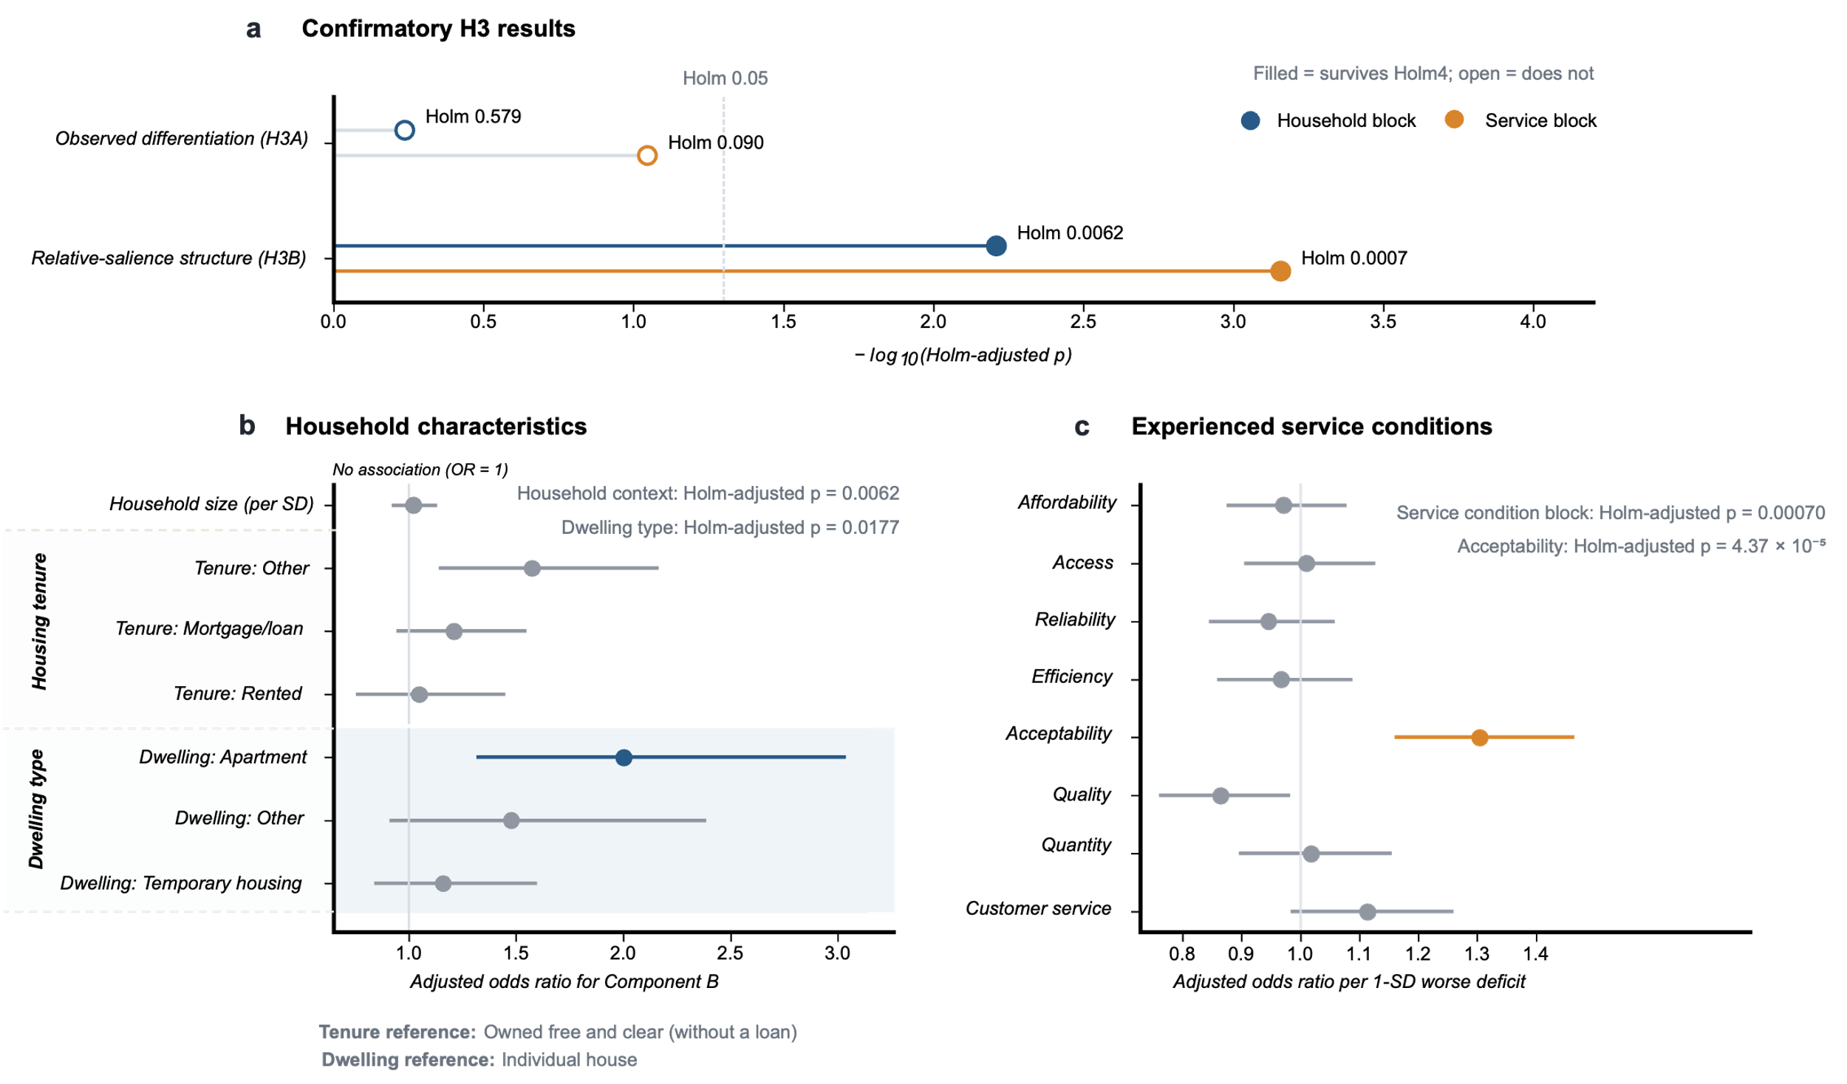
Fig. 4. Household context and experienced service conditions are associated with fitted priority components among households that differentiate.
a, Confirmatory tests of household-context and service-condition blocks for observed differentiation in priority ratings (H3A; n = 2,863) and fitted component probabilities among differentiating households (H3B; n = 2,306). Filled symbols indicate tests surviving Holm correction across the four prespecified confirmatory H3 tests. b, Adjusted odds ratios and 95% confidence intervals for household-context predictors in H3B. Household size is expressed per 1-s.d. increase; tenure and dwelling-type estimates are relative to the indicated reference categories. The household-context block survived Holm correction (P = 0.0062), with dwelling type also surviving the gated variable-level correction (P = 0.0177). c, Adjusted odds ratios and 95% confidence intervals for eight experienced-service deficits, each expressed per 1-s.d. worsening. The service-condition block survived Holm correction (P = 0.00070), and acceptability was the only domain surviving the gated domain-level correction (P = 4.37 × 10⁻⁵). The vertical line at OR = 1 indicates no association.
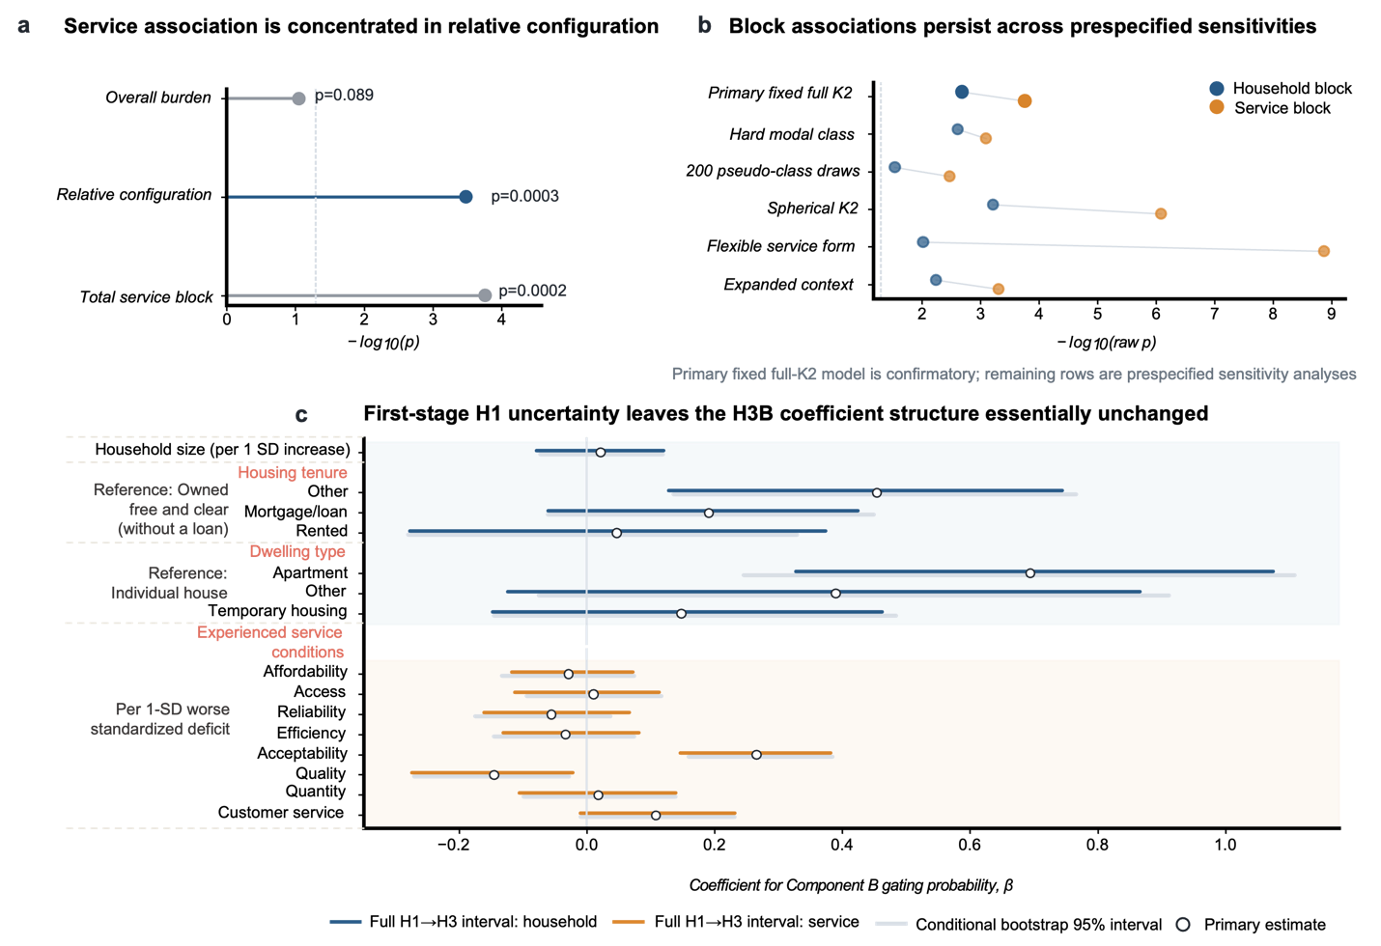
Fig. 5. Service-deficit configuration is associated with fitted priority components across modeling checks.
a, Decomposition of the H3B service association into overall standardized service burden and relative deficit configuration. The configuration block showed evidence of association with fitted component probabilities, whereas the overall-burden test did not (raw P = 0.000327 and 0.0894, respectively). These tests have different degrees of freedom and do not directly compare explanatory importance. b, Household- and service-block associations across the primary full-covariance two-component model and prespecified sensitivity analyses. Points show −log₁₀ raw P values, so values farther right indicate stronger evidence of association. The primary model is confirmatory; remaining rows assess sensitivity to alternative component handling, mixture specification, service functional form and expanded household-context adjustment. c, Primary H3B coefficient estimates with 95% bootstrap intervals from the conditional household bootstrap and full H1–H3 uncertainty propagation across 500 first-stage bootstrap models. The coefficient pattern is essentially unchanged after propagating first-stage uncertainty within the selected H1 mixture specification. Household size is expressed per 1-s.d. increase; tenure and dwelling estimates are relative to the indicated reference categories, and service-condition coefficients are expressed per 1-s.d. worse standardized deficit.
Discussion
Household water-service priorities retained reproducible structure after we separated overall rating intensity from the relative pattern expressed within each household. Comparatively worse service in a domain was not associated with greater relative priority for that same domain overall. Among households that differentiated across domains, broader service configuration and household context remained associated with the fitted mixture components, but did not reliably predict which domains households rated relatively higher. Service-performance measures therefore did not recover household relative-priority patterns from matched deficits alone.
The H1 result shows why separating general rating intensity from relative priority matters. Raw variation largely reflected a household-wide tendency to assign higher or lower ratings across domains, but substantial variation remained after removing that common level. A household assigning high ratings to every dimension conveys something different from one assigning similarly high ratings overall but differentiating sharply among domains, a distinction also recognized in person-centered analyses of multidimensional ratings [25]. The two mixture components should not be interpreted as fixed household types because finite-mixture models can represent recurring heterogeneity without naturally discrete groups [26]. Additional comparisons showed that the fitted components primarily reflected how strongly households differentiated among domains, rather than distinct domain-priority profiles.
The H2 results show the limits of inferring reported priorities from experienced service conditions. Comparatively worse conditions in a domain showed little pooled association with greater relative priority for that domain, including when equal-rating households were excluded, and the cross-domain analysis revealed no consistent alternative pattern. Stated-preference studies show that demand for improvements can vary with baseline conditions and the type or magnitude of improvement offered, but those choices do not directly measure the relative importance assigned to dimensions of current service [27,28]. Household responses may further weaken a direct deficit–priority correspondence. Storage, treatment, purchased water and changes in water use can redistribute burdens across cost, time and household activity [29,30]. In the original H3B model, the configuration of service deficits was associated with fitted component probabilities, while overall burden did not show clear evidence of association. Households with similar overall service difficulty may therefore face different combinations of problems. H2 and H3 together show that reported priorities do not follow a simple one-to-one correspondence with experienced service deficits.
The gated H3B analyses identified two more specific associations within the confirmed blocks. Dwelling type was the clearest household-context association, consistent with housing form shaping how municipal supply is stored and managed after reaching the property. Acceptability was the clearest service-domain association, and taste, odor and appearance are directly encountered at the point of use [31]. Neither association accounts for the broader H3 result on its own. Performance and priority also answer different questions. Performance measures characterize where service is deficient, while the ratings capture which dimensions households report as having greater impact on their water-service experience. This distinction matters when household priorities are used to weight multidimensional service measures. Replacing equal or expert-derived weights with a single sample-average household vector can still impose a common priority structure that many households do not share. In an exploratory comparison, the highest-severity decile showed 94.8% overlap under equal and household-specific impact weights (Supplementary Section S7 and Table S32).
Recruitment was non-probability based, so component proportions and regression estimates should not be interpreted as population-representative estimates for Tamil Nadu or the study cities. The cross-sectional design does not establish whether changing service conditions would change priorities or whether associated household characteristics precede those patterns. The same respondent reported service conditions and priorities, and because each priority item followed the corresponding service-condition questions, we cannot determine whether or how question order influenced reported evaluations [32]. We did not record whether this respondent managed household water decisions, and the impact questions did not specify whether respondents should consider favorable or unfavorable effects. Priority here captures reported impact on overall service evaluation, not willingness to pay, intervention choice or provider investment preference, and H3B applies only to households that differentiated across domains. Future work should combine repeated observations as service conditions change with independently measured utility performance and replication across provision systems. Outages, tariff changes, water-quality events or infrastructure improvements could reveal whether priorities change within an affected domain or reorganize more broadly.
Water-service measurement has evolved from simply assessing infrastructure access to considering multiple performance dimensions, but performance alone does not reveal how households rate the impact of each dimension. A poorly performing dimension need not receive greater relative priority, and households with similar overall service difficulty can express different priority patterns. Utilities should therefore measure performance and reported priority separately rather than infer priorities from the poorest-performing dimensions. Used together, service-performance measures and household impact ratings can identify where poor conditions coincide with high reported priority and where they do not. Multidimensional service assessment should therefore treat household priority as a separate measurement layer rather than use service conditions as a proxy for what matters to households.
Methods

Study design and sample
We analyzed household survey data collected in and around Karur, Salem and Namakkal, Tamil Nadu, India. The analysis was restricted to households selecting Municipality/Corporation as their primary domestic water source. The household was the unit of analysis, and respondents were adults aged 18 years or older reporting on household water-service conditions and experiences.
Households were recruited through non-probability convenience sampling with support from collaborating educational institutions in Karur, Salem and Namakkal. Recruitment and survey administration involved in-person coordination and supported sessions, while institutional partners also distributed access to the online questionnaire. Because household inclusion probabilities were unknown, the study was not designed to produce population-representative estimates, and statistical inference is conditional on the analytical sample [33,34]. We therefore assessed sample coverage and composition. Postal-reference locations showed broad geographic coverage across the focal study areas (Fig. 6), while comparison with the NSS benchmark indicated larger household sizes but similar housing tenure. Differentiating households were also compositionally similar to equal-rating households across measured household and service characteristics. Supplementary Section S1 reports the full sample-coverage and composition analyses.
The survey used a standardized questionnaire available in English and Tamil and was administered electronically through Qualtrics (an online survey tool). Respondents entered their own answers, with in-person coordination and administration support during field activities. Pilot testing was conducted before wider deployment to refine the questionnaire and administration procedures. The Stanford University Institutional Review Board approved the study protocol (no. 82168), and all participants provided electronic informed consent.
The survey generated 9,562 submissions. Data-quality screening combined automated indicators and manual review of survey completeness, response timing, potential duplicate submissions and reCAPTCHA scores. For the present study, eligibility was restricted to households reporting Municipality/Corporation as their primary domestic water source and providing valid responses to all eight domain-impact questions. Completeness was assessed for the specific questions required by the analyses, distinguishing structurally inapplicable items from unanswered questions. The resulting analytical cohort comprised 2,874 households. Screening procedures and further analysis-specific restrictions are described in Supplementary Sections S1 and S5.1.
Fig. 6. Geographic distribution of surveyed households and study areas.
a, Spatial distribution of 2,768 municipal-water households geocoded to 436 distinct postal-reference PIN locations, with focal survey areas in Karur, Namakkal and Salem, Tamil Nadu, indicated by crosses. Circles are scaled by the number of households assigned to each postal-reference location; household addresses are not shown. The inset shows 15 geocoded households at 13 PIN locations outside Tamil Nadu. b–d, Enlarged views of the spatial distribution around Salem, Namakkal and Karur, respectively. Administrative boundaries are shown for geographic context, and circle size indicates the number of surveyed households associated with each mapped PIN-code location.

Household priorities and service deficits
The questionnaire covered eight dimensions of household water service: affordability, access, reliability, efficiency, acceptability, quality, quantity and customer service. Within each section, respondents first reported their experienced service conditions and then rated, on a 0–10 scale, the dimension's impact on their overall water-service quality and experience.
We operationalized these ratings as household priority, using reported impact on overall water-service quality and experience as an indicator of perceived importance. They do not represent willingness to pay, a choice between interventions or a provider investment preference.
The eight priority measures were affordability (Q2.9), access (Q3.9), reliability (Q4.5), efficiency (Q5.4), acceptability (Q6.6), quality (Q7.5), quantity (Q8.6) and customer service (Q9.5). We paired each priority measure with a prespecified experienced-service deficit representing the same conceptual service domain. We selected candidate deficit measures using conceptual correspondence, response variation, missingness, and measurement coherence.
Affordability, access, reliability, efficiency and quality were represented by Q2.2, Q3.1, Q13.1, Q5.1 and Q7.1, respectively. The primary reliability measure (Q13.1) assessed unexpected outage frequency, while global perceived reliability (Q4.1) was evaluated as a sensitivity measure. Acceptability was calculated from appearance, taste and odor (Q6.2–Q6.4), quantity from sufficiency and peak-time shortages (Q8.1 and Q8.3), and customer service from complaint resolution and ease of provider contact (Q9.2 and Q9.3). For these multi-item domains, we harmonized component items in direction and combined them using their arithmetic mean. We coded all deficit measures so that larger values represented poorer service. Supplementary Section S2.2 and Supplementary Table S4 report exact response coding, missing-data rules, alternative candidate measures, and the measurement audit.
For analyses comparing deficits across domains, each deficit was standardized within its domain,
$$Z_{id}=\frac{D_{id}-{\overline{D}}_{d}}{s_{d}},$$
where $D_{id}$ is the deficit reported by household $i$ in domain $d$, and ${\overline{D}}_{d}$ and $s_{d}$ are the corresponding domain mean and standard deviation. Standardization placed the eight measures on a common statistical scale but does not imply that a one-standard-deviation change has the same substantive meaning across domains. It also does not establish which domain has the worst service for a household on its original response scale.

Because the service-condition questions preceded the corresponding priority item and both were reported by the same respondent, the study design cannot determine whether or how question sequence influenced reported evaluations [36]. H2 is therefore interpreted as within-instrument deficit–priority association rather than as a causal effect of experienced service on priority.

Relative priority
Following data-quality control, the municipal-water sample contained 2,874 households. Of these, 557 assigned the same priority rating to all eight domains and 2,317 used at least two distinct ratings. We refer to these groups as equal-rating and differentiating households, respectively. Equal rating was treated as an observed response pattern and not as evidence that a household was indifferent, disengaged or uncertain [37].
For household $i$, relative priority in domain $d$ was defined by person-centering,
$$P_{id}^{c}=P_{id}-{\overline{P}}_{i},$$
where $P_{id}$ is the observed priority rating and ${\overline{P}}_{i}$ is the household's mean rating across all eight domains. Positive values therefore identify domains rated above that household's own mean and negative values identify domains rated below it.
Person-centering removes between-household differences in overall rating intensity while preserving the configuration and magnitude of within-household differentiation. Because the eight centered values sum to zero, they occupy a seven-dimensional subspace. We represented this zero-sum space in a deterministic orthonormal Helmert basis, preserving Euclidean distances among household profiles [38,39]. Supplementary Sections S3.1–S3.2 report the full transformation and diagnostic procedures.

H1: structure of relative priority
H1 tested whether relative-priority patterns among differentiating households contained reproducible structure beyond general rating intensity and a prespecified continuous Gaussian benchmark.
We first fitted probabilistic principal-component analysis (PPCA) models as the continuous comparator [40]. We then fitted Gaussian mixture models with one to five components under spherical, tied-full and component-specific full covariance structures using expectation–maximization [41]. Models were compared using the Bayesian information criterion (BIC) [42]. Diagonal covariance models were excluded because their constraints depend on the orientation of the seven-dimensional basis.
Each mixture specification was derived from 200 initializations and evaluated for convergence, covariance stability, sufficient component support, and the recovery of similar optima. We then evaluated candidate models that passed these checks in 50 repeated household-level 80/20 train–validation splits. Predictive validation assessed held-out log density. Structural validation separately refitted the candidate model in validation data and evaluated whether the corresponding component profiles were recovered. We further evaluated models passing both validation stages across 500 household bootstrap resamples, including component-specific Jaccard stability [43].
Among models that met all prespecified validation criteria, we retained the model with the lowest full-sample BIC as the primary H1 representation. A separately validated covariance specification was retained as a sensitivity model. Exact numerical gates, component-matching procedures and bootstrap criteria are reported in Supplementary Sections S3.3–S3.5 and Supplementary Tables S7–S9.
We labeled components according to the Euclidean norm of their centered centroids. The component closer to the equal-priority origin was labeled A and the component farther from the origin B. These labels provide a reproducible computational ordering and do not imply low versus high priority, preference strength or fixed household types.
Equal-rating households map exactly to the origin of relative-priority space and were therefore excluded from the continuous H1 mixture analysis. Complete-sample mixture fits were examined separately as a diagnostic of the effect of the observed point mass at the origin.

H2: within-household deficit–priority alignment
H2 tested whether households assigned greater relative priority to domains in which they experienced comparatively worse service.
The primary analysis stacked the eight service domains within household and estimated
$$P_{id}=α_{i}+λ_{d}+βZ_{id}+ε_{id},$$
where $α_{i}$ denotes household fixed effects, $λ_{d}$ domain fixed effects and $Z_{id}$ the standardized deficit for the corresponding domain. Standard errors were clustered by household [44].
The coefficient $β$ therefore captures whether the cross-domain pattern of service deficits within a household aligns with its corresponding pattern of priority after removing between-household differences in overall rating intensity and average differences among service domains. We repeated the same model among differentiating households as a sensitivity analysis. Because deficits were standardized separately across households within each service domain, this comparison does not establish which domain was objectively worst for a given household on its native scale.
We then allowed the matched deficit–priority association to vary across domains by estimating eight domain-specific deficit coefficients. These eight tests formed one inferential family and were adjusted using Holm's procedure [45].
A secondary analysis examined the complete set of cross-domain relationships. For this analysis, standardized deficits were centered within household,
$$Z_{id}^{c}=Z_{id}-{\overline{Z}}_{i},$$
and associations were then estimated between each of the eight relative deficit measures and each of the eight relative-priority outcomes, producing an 8 × 8 coefficient matrix. We used HC3 standard errors [46] and adjusted the resulting 64 tests using the Benjamini–Hochberg false-discovery-rate procedure [47]. Because person-centered domain measures are structurally dependent, we treated this analysis as secondary. Off-diagonal coefficients were not interpreted as causal spillovers or substitutions between service domains. Supplementary Section S4.3 and Supplementary Tables S16–S17 report functional-form sensitivity analyses for the ordered single-item deficit measures.

H3: household and service correlates of priority structure
H3 examined two related outcomes. H3A tested whether measured household and service characteristics were associated with whether a household differentiated among its eight priority ratings at all. H3B tested whether the same characteristics were associated with fitted component probabilities under the selected H1 mixture among households that differentiated.
The household-context block included household size, housing tenure and dwelling type. We standardized household size before modeling and represented tenure and dwelling type categorically. The service-condition block contained the same eight standardized service deficits used in H2. Household-context and service-condition predictors were entered jointly in the confirmatory H3 models so that each block was evaluated conditional on the other. Analysis-specific complete-case sample sizes are reported with the corresponding results and in Supplementary Fig. S5.
For H3A, we fitted logistic regression models for any observed differentiation in priority ratings. We defined differentiation as any non-zero within-household range across the eight priority items. This outcome distinguishes exact equality from any observed differentiation and is not interpreted as a measure of engagement, certainty or preference strength.
For H3B, we retained the selected H1 measurement structure and modeled covariate associations with the relative probability of the two fitted components using a fixed-measurement concomitant mixture model [48],
$$L_{i}=\left(1-π_{i}\right)f_{A}\left(y_{i}\right)+π_{i}f_{B}\left(y_{i}\right),$$
with
$$logit⁡\left(π_{i}\right)=α+X_{i}^{⊤}γ.$$
Here, $f_{A}$ and $f_{B}$ are the fixed H1 component densities and $X_{i}$ contains the household-context and service-condition predictors. Covariates alter the relative probability of the two fitted components while the component means and covariance matrices remain fixed. This lets households with uncertain component membership contribute probabilistically to the likelihood, rather than assigning each household to a component and treating that classification as error-free [49].
H3B estimates are therefore interpreted as associations with the fitted probability of Component B relative to Component A among differentiating households. They do not identify separate household priority types or causal transitions between them.
For variables passing the prespecified inferential hierarchy, associations were additionally translated to the probability scale. Adjusted probability differences were calculated by predicting Component B probabilities under contrasting values of the focal variable while retaining all other covariates at their observed values, then averaging the household-level probability contrasts. Continuous standardized deficits were contrasted over a one-standard-deviation increase, while categorical variables were contrasted with their prespecified reference category.

Statistical inference and sensitivity analyses
H3 used a prespecified hierarchical testing procedure. Four block-level hypotheses formed the primary confirmatory family: household context for H3A, service conditions for H3A, household context for H3B and service conditions for H3B. These four P values were adjusted jointly using Holm's procedure [45].
Variable-level localization was undertaken only within a block that passed the corresponding block-level test. Household size, housing tenure and dwelling type formed a three-test Holm family, while the eight service domains formed an eight-test Holm family. For categorical predictors, category-specific contrasts were interpreted only after the corresponding variable-level omnibus test passed this stage.
We evaluated block- and variable-level hypotheses using joint Wald tests [50]. For a model-specific coefficient vector $\hat{θ}$ and restriction matrix $R$,
$$W={\left(R\hat{θ}\right)}^{⊤}{\left[R\hat{Var}\left(\hat{θ}\right)R^{⊤}\right]}^{-1}\left(R\hat{θ}\right),$$
with the statistic evaluated against a chi-square reference distribution with degrees of freedom given by the rank of R. The covariance estimator used for each H3 model is reported in Supplementary Section S5.2. We report 95% confidence intervals for estimation, but inferential conclusions follow the prespecified multiplicity hierarchy.
The original sensitivity analyses examined an alternative H1 covariance structure, alternative treatment of component-classification uncertainty, flexible functional forms for the service deficits, expanded household-context specifications and separation of overall service burden from the relative configuration of deficits. Additional post-review checks examined H1 distributional adequacy, H2 equivalence and measurement sensitivity, observed differentiation magnitude and direction, and an illustrative impact-weighted service assessment. These additional checks did not reopen the original H1 selection or H3 confirmatory testing hierarchy.
We further assessed whether uncertainty in the first-stage H1 structure materially affected H3B. A conditional household bootstrap held the validated H1 measurement parameters fixed across 500 resamples. A full H1–H3 bootstrap propagated the corresponding H1 bootstrap solution into H3B for each resample. The selected full-covariance two-component measurement specification was retained throughout rather than reselecting the number of components or covariance family within each bootstrap replicate. We report detailed procedures in Supplementary Sections S3.5 and S6.1.

Analytical reproducibility and scope of inference
We implemented data construction, variable definition, and H1–H3 analyses sequentially in a versioned analytical workflow. We froze the original analytical datasets and model-selection decisions before the subsequent diagnostic analyses, which were recorded separately.
The study is observational. H1 is interpreted as a reproducible statistical representation of relative-priority heterogeneity rather than evidence that households belong to intrinsically discrete types. H2 estimates within-household associations between reported service conditions and priority. H3A estimates associations with whether ratings differ at all, while H3B estimates associations with probabilities under the fitted H1 mixture. Neither H2 nor H3 identifies causal effects. The original H1 model was selected using held-out predictive performance, recovery of fitted component structure in independently fitted validation samples and bootstrap stability rather than in-sample mixture fit alone.

References
- World Health Organization & United Nations Children’s Fund. Progress on Drinking Water, Sanitation and Hygiene: 2017 Update and SDG Baselines (WHO and UNICEF, 2017).
- Dorea, C. C. et al. Safely managed drinking water services in the Democratic People’s Republic of Korea: findings from the 2017 Multiple Indicator Cluster Survey. npj Clean Water 3, 28 (2020).
- Bain, R., Johnston, R., Khan, S., Hancioglu, A. & Slaymaker, T. Monitoring drinking water quality in nationally representative household surveys in low- and middle-income countries: cross-sectional analysis of 27 Multiple Indicator Cluster Surveys 2014–2020. Environ. Health Perspect. 129, 097010 (2021).
- Kayser, G. L., Moriarty, P., Fonseca, C. & Bartram, J. Domestic water service delivery indicators and frameworks for monitoring, evaluation, policy and planning: a review. Int. J. Environ. Res. Public Health 10, 4812–4835 (2013).
- Subbaraman, R. et al. Multidimensional measurement of household water poverty in a Mumbai slum: looking beyond water quality. PLoS ONE 10, e0133241 (2015).
- Rawas, F., Bain, R. & Kumpel, E. Comparing utility-reported hours of piped water supply to households’ experiences. npj Clean Water 3, 6 (2020).
- OECD, European Union & European Commission Joint Research Centre. Handbook on Constructing Composite Indicators: Methodology and User Guide (OECD Publishing, 2008).
- Flores-Baquero, Ó., Gallego-Ayala, J., Giné-Garriga, R., Jiménez-Fdez de Palencia, A. & Pérez-Foguet, A. The influence of the Human Rights to Water and Sanitation normative content in measuring the level of service. Soc. Indic. Res. 133, 763–786 (2017).
- Vilarinho, H., Pereira, M. A., D’Inverno, G., Nóvoa, H. & Camanho, A. S. Water Utility Service Quality Index: a customer-centred approach for assessing the quality of service in the water sector. Socio-Econ. Plan. Sci. 92, 101797 (2024).
- Vilarinho, H., Pereira, M. A., D’Inverno, G. & Camanho, A. S. A composite indicator framework integrating regulator perspectives for assessing water service quality. Omega 138, 103435 (2026).
- Hensher, D. A., Shore, N. & Train, K. Households’ willingness to pay for water service attributes. Environ. Resour. Econ. 32, 509–531 (2005).
- Sayles, R., Smith, H. M. & Jeffrey, P. Customer priorities for water and wastewater services: a comparative evaluation of three elicitation methods. Water Environ. J. 35, 55–66 (2021).
- Hope, R. A. Evaluating water policy scenarios against the priorities of the rural poor. World Dev. 34, 167–179 (2006).
- Kloos, J. & Tsegai, D. W. Preferences for Domestic Water Services in the Middle Olifants Sub-Basin of South Africa. ZEF Discussion Papers on Development Policy No. 131 (Center for Development Research, University of Bonn, 2009).
- Price, J., Janmaat, J., Sugden, F. & Bharati, L. Water storage systems and preference heterogeneity in water-scarce environments: a choice experiment in Nepal’s Koshi River Basin. Water Resour. Econ. 13, 6–18 (2016).
- Speers, A. et al. Setting and Evaluating Customer Service Standards: Overarching Report. BCE Document No. 01/199 (CSIRO Urban Water, 2002).
- Salleh, A., Yusof, S. M. & Othman, N. An importance-performance analysis of sustainable service quality in water and sewerage companies. Ind. Eng. Manag. Syst. 18, 89–103 (2019).
- Preña, E. M., Labayo, C. P., Lorenzana, E. A., Poja, J. G. & Montas, M. M. P. Household perspectives on urban water service delivery: implications for policy and practice in the Philippines. Public Works Manag. Policy (2026).
- Cooper, B., Burton, M. & Crase, L. Exploring customer heterogeneity with a scale-extended latent class choice model: experimental evidence drawn from urban water users. Aust. J. Agric. Resour. Econ. 67, 176–197 (2023).
- Huberts, A., Palma, D., Bernal García, A. C., Cole, F. & Roberts, E. F. S. Making scarcity “enough”: the hidden household costs of adapting to water scarcity in Mexico City. PLOS Water 2, e0000056 (2023).
- Li, H. et al. Intermittent water supply management, household adaptation, and drinking water quality: a comparative study in two Chinese provinces. Water 12, 1361 (2020).
- Button, C. The co-production of a constant water supply in Mumbai’s middle-class apartments. Urban Res. Pract. 10, 102–119 (2017).
- Joshi, N. et al. Water insecurity, housing tenure, and the role of informal water services in Nairobi’s slum settlements. World Dev. 164, 106165 (2023).
- Beresford, M. et al. Safe, secure, and affordable? The state of household water insecurity in California. J. Am. Water Resour. Assoc. 62 (2026).
- Borg, I. & Bardi, A. Should ratings of the importance of personal values be centered? Journal of Research in Personality 63, 95–101 (2016).
- Bauer, D. J. & Curran, P. J. The integration of continuous and discrete latent variable models: potential problems and promising opportunities. Psychological Methods 9, 3–29 (2004).
- Soto Montes de Oca, G. & Bateman, I. J. Scope sensitivity in households’ willingness to pay for maintained and improved water supplies in a developing world urban area: investigating the influence of baseline supply quality and income distribution upon stated preferences in Mexico City. Water Resources Research 42, W07421 (2006).
- Van Houtven, G. L., Pattanayak, S. K., Usmani, F. & Yang, J.-C. What are households willing to pay for improved water access? Results from a meta-analysis. Ecological Economics 136, 126–135 (2017).
- Venkataramanan, V., Collins, S. M., Clark, K. A., Yeam, J., Nowakowski, V. G. & Young, S. L. Coping strategies for individual and household-level water insecurity: a systematic review. WIREs Water 7, e1477 (2020).
- Stoler, J., Jepson, W. E., Brewis, A. & Wutich, A. Frontiers of household water insecurity metrics: severity, adaptation and resilience. BMJ Global Health 8, e011756 (2023).
- Dietrich, A. M., Phetxumphou, K. & Gallagher, D. L. Systematic tracking, visualizing, and interpreting of consumer feedback for drinking water quality. Water Research 66, 63–74 (2014).
- Van de Walle, S. & Van Ryzin, G. G. The order of questions in a survey on citizen satisfaction with public services: lessons from a split-ballot experiment. Public Administration 89, 1436–1450 (2011).
- Baker, R. et al. Report of the AAPOR Task Force on non-probability sampling. J. Surv. Stat. Methodol. 1, 90–143 (2013).
- Cornesse, C. et al. A review of conceptual approaches and empirical evidence on probability and nonprobability sample survey research. J. Surv. Stat. Methodol. 8, 4–36 (2020).
- Mohanavelu, A. & Osman, K. K. Measuring and predicting household water service quality across heterogeneous provision systems. Research Square preprint, https://doi.org/10.21203/rs.3.rs-10888037/v1 (2026).
- Tourangeau, R. & Rasinski, K. A. Cognitive processes underlying context effects in attitude measurement. Psychol. Bull. 103, 299–314 (1988).
- Krosnick, J. A. Response strategies for coping with the cognitive demands of attitude measures in surveys. Appl. Cogn. Psychol. 5, 213–236 (1991).
- Lancaster, H. O. The Helmert matrices. Am. Math. Mon. 72, 4–12 (1965).
- Egozcue, J. J., Pawlowsky-Glahn, V., Mateu-Figueras, G. & Barceló-Vidal, C. Isometric logratio transformations for compositional data analysis. Math. Geol. 35, 279–300 (2003).
- Tipping, M. E. & Bishop, C. M. Probabilistic principal component analysis. J. R. Stat. Soc. B 61, 611–622 (1999).
- Dempster, A. P., Laird, N. M. & Rubin, D. B. Maximum likelihood from incomplete data via the EM algorithm. J. R. Stat. Soc. B 39, 1–38 (1977).
- Schwarz, G. Estimating the dimension of a model. Ann. Stat. 6, 461–464 (1978).
- Hennig, C. Cluster-wise assessment of cluster stability. Comput. Stat. Data Anal. 52, 258–271 (2007).
- Cameron, A. C. & Miller, D. L. A practitioner's guide to cluster-robust inference. J. Hum. Resour. 50, 317–372 (2015).
- Holm, S. A simple sequentially rejective multiple test procedure. Scand. J. Stat. 6, 65–70 (1979).
- MacKinnon, J. G. & White, H. Some heteroskedasticity-consistent covariance matrix estimators with improved finite sample properties. J. Econom. 29, 305–325 (1985).
- Benjamini, Y. & Hochberg, Y. Controlling the false discovery rate: a practical and powerful approach to multiple testing. J. R. Stat. Soc. B 57, 289–300 (1995).
- Dayton, C. M. & Macready, G. B. Concomitant-variable latent-class models. J. Am. Stat. Assoc. 83, 173–178 (1988).
- Vermunt, J. K. Latent class modeling with covariates: two improved three-step approaches. Polit. Anal. 18, 450–469 (2010).
- Wald, A. Tests of statistical hypotheses concerning several parameters when the number of observations is large. Trans. Am. Math. Soc. 54, 426–482 (1943).
Data availability
The household survey data are not publicly deposited with this manuscript. Requests for access to de-identified analytical data may be directed to the corresponding author and will be assessed subject to applicable participant-consent, confidentiality and institutional requirements. Aggregate results supporting the analyses are reported in the manuscript and Supplementary Information.
Code availability
The analysis was conducted using a versioned computational workflow. Requests for the analysis code and associated documentation may be directed to the corresponding author. Any public repository and permanent identifier will be added before publication, if released.
Acknowledgements
We thank Dr. Jenna Davis for discussions that helped shape the framing of this study and informed aspects of its development. We also thank the collaborating educational institutions in Karur, Salem and Namakkal for their support during survey administration, and the respondents for sharing their household water-service experiences. Fieldwork was supported by the Stanford King Center on Global Development.
Author contributions
A.M. and K.K.O. contributed to conceptualization. A.M. contributed to methodology, investigation, data curation, formal analysis, software, visualization and writing—original draft. K.K.O. contributed to methodology, supervision, interpretation of findings and writing—review and editing. Both authors reviewed the manuscript.
Competing interests
The authors declare no competing interests.

