Supplementary Information
This Supplementary Information documents the survey measures, sample coverage, numerical procedures, full secondary results and robustness analyses supporting the main manuscript.
S1. Sample coverage and composition
Recruitment used non-probability convenience sampling with support from local collaborating institutions. The analyses below characterize geographic coverage and observable household composition in the analytical sample; they were not used to construct survey weights, alter sample membership or calibrate subsequent models.
Sample screening and analytical eligibility
The household water-service survey was administered electronically through Qualtrics (an online survey tool) in English and Tamil, with in-person coordination and support from local collaborating institutions. The survey generated 9,562 submissions. Data screening combined automated quality indicators with manual review of respondent eligibility, survey completeness and response consistency. An initial completion screen considered records with at least 99% recorded survey progress. Survey metadata, including completion duration, duplicate-response indicators and reCAPTCHA scores, were examined to identify potentially unreliable submissions.
Automated indicators were used to flag records for further examination rather than treating every flag as sufficient evidence for exclusion. Particular attention was given to potential duplicate responses completed in under 300 seconds and reCAPTCHA scores below 0.5. Manual review considered survey timing, response completeness, internal consistency and the plausibility of reported information. Identical response patterns alone were not considered sufficient evidence of duplication. Identified pilot and early-testing records were excluded from the eligible survey data.
The present study applied additional eligibility criteria corresponding to its research questions. Households were required to report Municipality/Corporation as their primary domestic water source and provide valid responses to all eight questions assessing the reported impact of water-service dimensions on overall service experience. Completeness was assessed for the specific questionnaire items used in the analyses, rather than across the entire survey. Questions that were structurally inapplicable because of survey routing or household circumstances were distinguished from missing responses and did not independently lead to exclusion. After applying these screening and eligibility criteria, the canonical analytical sample comprised 2,874 households.
Subsequent restrictions reflected the requirements of individual analyses. Of the 2,874 households, 557 assigned identical impact ratings across all eight domains, while 2,317 differentiated among them. H2 included 2,870 households with the required experienced-service deficit measures, H3A included 2,863 households with complete model covariates, and H3B included 2,306 differentiating households with complete model variables. These analysis-specific samples are documented in Supplementary Figure S5.
S1.1 Geographic coverage
We matched reported PIN codes to postal-reference locations from the All India Pincode Directory maintained by the Department of Posts, Government of India. These coordinates represent postal-reference locations rather than household addresses or household-level GPS positions. The resulting distribution covered the main study areas around Salem, Namakkal, and Karur, as shown in Fig. 6 of the main manuscript. Exact state-classification and geocoding coverage and exclusion sensitivities are reported in Section S1.4.
S1.2 External population benchmark
We compared the study sample with the NSS 78th Round Multiple Indicator Survey, 2020–21 (National Sample Survey Office, 2023). The primary benchmark included urban households in Salem, Namakkal, and Karur whose principal drinking-water source was piped water or a public tap/standpipe. This yielded 587 households. NSS benchmark statistics were calculated using the survey multipliers supplied with the unit-level data. Accounting for unequal survey weights, the weight-based Kish effective sample size was 340.3, calculated as $n_{eff}={\left(\sum_{i}{w_{i}}\right)}^{2}/\sum_{i}{w_{i}^{2}}$(Kish, 1965).
The study defined eligibility using the reported primary domestic water-source category (Municipality/Corporation), whereas NSS records the principal drinking-water source. The NSS sample therefore provides the closest observable external benchmark rather than an exact reconstruction of the study population. We compared household size and housing tenure because we could harmonize them directly across the two surveys. Household size was top coded at eight to match the study instrument, and tenure was grouped as owned or non-owned. We summarized differences in household size using standardized mean differences (Austin, 2009) and categorical differences using percentage points.
The study contained larger households than the primary benchmark. Mean household size was 4.36 in the study and 3.32 in NSS (SMD = 0.75). One- and two-person households represented 3.9% of the study sample compared with 32.6% of NSS households, whereas households with five or more members represented 35.0% and 20.2%, respectively. Housing tenure was closely aligned, with ownership rates of 66.0% in the study and 66.3% in NSS.
We examined two alternative benchmark definitions. Including rural households from the same three districts produced a similar household-size difference (SMD = 0.72) but increased the NSS ownership rate to 77.5%. Restricting the primary urban benchmark to piped-water sources only produced nearly unchanged household-size differences (SMD = 0.75) and an ownership rate of 63.3%. The household-size difference was therefore stable across benchmark definitions, while the tenure comparison depended more strongly on whether we included non-urban, rural households.

Supplementary Table S1. External composition benchmark and benchmark-definition sensitivities
Characteristic | Study sample | Primary urban piped/public tap | Urban + rural piped/public tap | Urban piped only
NSS unweighted N | — | 587 | 1,259 | 420
Kish effective N | — | 340.3 | 636.2 | 233.0
Mean household size | 4.36 | 3.32 (SMD +0.75) | 3.35 (+0.72) | 3.33 (+0.75)
1–2 members | 3.9% | 32.6% (−28.6 pp) | 31.3% (−27.4 pp) | 30.7% (−26.8 pp)
3–4 members | 61.1% | 47.3% (+13.8 pp) | 49.1% (+11.9 pp) | 50.5% (+10.5 pp)
5+ members | 35.0% | 20.2% (+14.9 pp) | 19.6% (+15.4 pp) | 18.8% (+16.2 pp)
Owned dwelling | 66.0% | 66.3% (−0.3 pp) | 77.5% (−11.5 pp) | 63.3% (+2.7 pp)
Non-owned dwelling | 34.0% | 33.7% (+0.3 pp) | 22.5% (+11.5 pp) | 36.7% (−2.7 pp)
Note. Household-size comparisons use 2,866 study households with observed household size; tenure comparisons use all 2,874 households. Values in parentheses are study minus NSS. NSS estimates use the survey multipliers supplied with the NSS 78th Round unit-level data. The primary NSS benchmark includes urban households in Salem, Namakkal, and Karur with piped-water or public tap/standpipe sources. The first sensitivity additionally includes rural households, while the second restricts the urban benchmark to piped-water sources.

S1.3 Composition of equal-rating and differentiating households
The H1 mixture and H3B analyses are restricted to households assigning at least two different ratings across the eight domains. The primary H2 and H3A analyses retain equal-rating households where otherwise eligible. We examined whether the H1/H3B restriction produced a compositionally distinct analytical subgroup.
Of 2,874 households, 557 were equal-raters and 2,317 expressed differentiated priorities. We compared household size, housing tenure, dwelling type, and the eight primary service deficits between these groups. We summarized continuous differences using standardized mean differences (Austin, 2009) and categorical differences using percentage points.
Differences were small across the measured characteristics. Mean household size was 4.370 among equal-raters and 4.356 among differentiators (SMD = −0.011). Across the eight service deficits, the largest differences were observed for acceptability (SMD = +0.100) and reliability (+0.084); all remaining absolute SMDs were below 0.05. The largest categorical difference was 3.8 percentage points for mortgage or loan ownership, while dwelling-type differences did not exceed 2.6 percentage points. The restriction to differentiating households therefore produced limited observed compositional differences across the household and service characteristics examined here.

Supplementary Table S2. Composition of equal-raters and differentiating households
Characteristic | Equal raters | Differentiators | Difference
Household size | 4.370 | 4.356 | SMD −0.011
Affordability deficit | 2.348 | 2.314 | SMD −0.032
Access deficit | 2.022 | 1.996 | SMD −0.023
Reliability deficit | 2.183 | 2.264 | SMD +0.084
Efficiency deficit | 2.192 | 2.193 | SMD +0.001
Acceptability deficit | 2.253 | 2.339 | SMD +0.100
Quality deficit | 2.165 | 2.137 | SMD −0.032
Quantity deficit | 2.206 | 2.243 | SMD +0.043
Customer-service deficit | 2.540 | 2.533 | SMD −0.008
Owned free and clear | 45.1% | 42.9% | −2.1 pp
Owned with mortgage or loan | 19.6% | 23.4% | +3.8 pp
Rented | 24.6% | 22.1% | −2.5 pp
Other tenure | 10.8% | 11.6% | +0.8 pp
Individual house | 69.5% | 72.1% | +2.6 pp
Temporary housing | 20.3% | 18.3% | −2.0 pp
Apartment | 5.9% | 5.6% | −0.4 pp
Other dwelling type | 4.3% | 4.1% | −0.2 pp
Note. Equal raters $N=557$; differentiators $N=2,316$. Differences for continuous variables are standardized mean differences (differentiators minus equal raters). Categorical differences are percentage-point differences in the same direction. We observed household size for 557 equal-raters and 2,309 differentiators. Reliability and quality each had two missing observations; all other primary service deficits were complete. Higher deficit values indicate poorer experienced service.

S1.4 Geographic classification and exclusion sensitivity
We assessed geographic coverage using reported household PIN codes matched to postal-reference records. State classifications were established through exact-code matching against the study crosswalk and two India Post-derived reference directories. Of the 2,874 households, 2,788 (97.0%) had PIN codes associated with Tamil Nadu, 16 (0.6%) with other Indian states and 70 (2.4%) remained unresolved. Incomplete or unmatched PIN codes were not assigned locations through inferred corrections.
The 2,804 state-classified households represented 449 distinct PIN codes, including 435 in Tamil Nadu and 14 elsewhere. Postal-reference coordinates were available for 2,768 households (96.3% of the analytical sample), corresponding to 436 distinct PIN locations: 423 in Tamil Nadu and 13 outside the state (Fig. 6). The remaining 36 state-classified households had no matched coordinates. These locations represent postal-reference positions rather than independently verified household residences.
Restricting the primary H2 analysis to the 2,784 service-complete households with Tamil Nadu-classified PIN codes produced a pooled matched-deficit coefficient of −0.0058 (household-clustered SE = 0.0120; 95% CI −0.0293 to 0.0177), compared with −0.0045 (SE = 0.0117; 95% CI −0.0274 to 0.0184) in the full sample (N = 2,870). Among Tamil Nadu-classified households, 542 of 2,788 (19.4%) assigned equal ratings across all eight domains, and the median within-household rating SD among differentiating households was 0.916. In the exploratory differentiation-magnitude analysis described in Section S5.9, both household-context (P = 0.00424) and service-condition (P = 5.96 × 10⁻⁷) block associations remained detectable in the Tamil Nadu-classified subset (N = 2,236).
The geographic restriction produced little change in the pooled H2 association or the exploratory differentiation-magnitude findings.
S2. Measurement and analytical variable coding
Supplementary Tables S3–S5 document the survey items and analytical coding used for the priority measures, experienced-service deficits, and H3 household/context variables. Primary deficit definitions were fixed before H2 and H3 estimation, with alternative measures evaluated only in supporting and sensitivity analyses.
S2.1 Domain-priority measures
The eight 0–10 items asked respondents to rate each domain’s impact on their overall water-service quality and experience. We analyze these reported impact ratings as an operational measure of domain priority and preserve their original numerical values when examining relative differences within households. The items did not separately specify positive versus negative impact or ask respondents to rank potential improvements.
Supplementary Table S3. Exact survey items used to measure the eight domain priorities
Domain | QID | Administered question wording | Response scale | Analytical treatment
Affordability | Q2.9 | On a scale from 0 to 10, how would you rate the water source and questions discussed in this section in terms of their impact on your overall water service quality and experience? | 0–10 | Original scale retained
Access | Q3.9 | On a scale from 0 to 10, how would you rate the access and questions discussed in this section in terms of their impact on your overall water service quality and experience? | 0–10 | Original scale retained
Reliability | Q4.5 | On a scale from 0 to 10, how would you rate the reliability in terms of its impact on your overall water service quality and experience? | 0–10 | Original scale retained
Efficiency | Q5.4 | On a scale from 0 to 10, how would you rate the supply characteristics and questions discussed in this section in terms of their impact on your overall water service quality and experience? | 0–10 | Original scale retained
Acceptability | Q6.6 | On a scale from 0 to 10, how would you rate the acceptability and questions discussed in this section in terms of their impact on your overall water service quality and experience? | 0–10 | Original scale retained
Quality | Q7.5 | On a scale from 0 to 10, how would you rate quality and questions discussed in this section in terms of their impact on your overall water service quality and experience? | 0–10 | Original scale retained
Quantity | Q8.6 | On a scale from 0 to 10, how would you rate quantity and questions discussed in this section in terms of their impact on your overall water service quality and experience? | 0–10 | Original scale retained
Customer service | Q9.5 | On a scale from 0 to 10, how would you rate service/maintenance and questions discussed in this section in terms of their impact on your overall water service quality and experience? | 0–10 | Original scale retained
Note. Higher values indicate greater reported impact of the domain on overall water-service quality and experience. The instrument did not assign separate verbal anchors to individual numeric values.
S2.2 Experienced-service deficits
Five primary deficits were represented by single ordered items. We constructed acceptability, quantity, and customer service as arithmetic means of component items in the primary specification after harmonizing direction. Composite deficits required complete component responses. All eight measures were oriented so that larger values indicate poorer experienced service.
For cross-domain analysis, we standardized each deficit separately using the common N=2,870 service-complete sample. This placed the domains on comparable statistical scales while preserving their between-household variation. Differences of one standard deviation need not have equivalent substantive meanings across domains and do not establish the worst-performing domain on the original response scales. No pooled cross-domain standard deviation or additional within-household variance standardization was applied.
Supplementary Table S4. Exact construction and measurement audit for the eight experienced-service deficits
Domain | Source item(s) | Administered wording and response anchors | Final construction | Measurement rationale and alternatives
Affordability | Q2.2 | “How affordable do you find your drinking water to be, considering the cost of buying cans or treating water … if any?” Very affordable; Somewhat affordable; Neutral; Somewhat unaffordable; Very unaffordable | Retain 1–5 | The broader two-item candidate showed weak coherence (rho=0.288, alpha=0.447). Q2.2 was retained as the primary measure. Value for money and the two-item mean remained alternatives.
Access | Q3.1 | “How accessible is your primary drinking water supply …?” Very accessible; Accessible most of the time; Occasionally accessible; Rarely accessible; Not accessible | Retain 1–5 | The broader access family showed weak coherence (rho=0.203, alpha=0.433). Travel time, daily access time, and broader composites remained alternatives.
Reliability | Q13.1 | “How often does your water supply face unexpected outages?” Never; Rarely; Occasionally; Frequently; Always | Retain 1–5 | Outage frequency was selected as the direct continuity deficit. Global reliability, timing, supply frequency, and outage duration capture related but distinct aspects of reliability.
Efficiency | Q5.1 | “How do you rate the efficiency of your primary water system? Efficiency here means the water system's ability to deliver sufficient water with minimal effort from the user, delay, or energy required to access it.” Very efficient; Efficient; Neutral; Inefficient; Very inefficient | Retain 1–5 | The broader candidate pair showed weak coherence (ho=0.245, alpha=0.393). Infrastructure maintenance remained a sensitivity measure.
Acceptability | Q6.2–Q6.4 | Appearance, taste, and odor, each rated Completely acceptable; Somewhat acceptable; Neutral; Somewhat unacceptable; Completely unacceptable | Arithmetic mean of the three 1–5 items | The three-item set showed coherent measurement (rho=0.533, alpha=0.774). Individual items and leave-one-out composites remained supporting checks.
Quality | Q7.1 | “How would you rate the quality of water you receive? Good quality water is defined as water in pristine condition and free from any known pollutants.” Excellent; Good; Neutral; Poor; Very poor | Retain 1–5 | Q7.1 was retained as the direct perceived-quality measure. Q12.2 safety trust was conceptually broader and remained an alternative.
Quantity | Q8.1, Q8.3 | Sufficiency for daily needs, Always sufficient → Never sufficient; peak-time shortages, Never → Always | Arithmetic mean after harmonizing both to a 1–5 worse-service direction | Both items directly capture experienced quantity conditions (rho=0.356). Pressure and broader quantity composites remained alternatives.
Customer service | Q9.2, Q9.3 | Complaint resolution, Always → Never; ease of reaching provider, Very easy → Very difficult, plus “No known stream of communication” | Arithmetic mean of Q9.2 and harmonized Q9.3; raw Q9.3=6 mapped to harmonized 5 | The pair showed coherent measurement (rho=0.523, alpha=0.686). Global customer service, disruption notice, provider contact, and repair delay remained alternatives.
Note. For Q9.3, “No known stream of communication” was retained in the raw data and mapped to the worst harmonized contact category for the primary composite.
S2.3 H3 household and context variables
The primary H3 household block was restricted to household size, housing tenure, and dwelling type. We evaluated additional respondent and household characteristics only in supporting analyses.
Supplementary Table S5. H3 household and respondent-context variables
Role | QID | Variable | Coding | Reporting reference
Primary | Q15.10 | Household size | 1–8, with 8 representing 8+; standardized before modeling | Per 1-SD increase
Primary | Q15.15 | Housing tenure | Owned free and clear; owned with mortgage/loan; rented; other | Owned free and clear
Primary | Q15.14 | Dwelling type | Individual house; apartment; temporary housing; other | Individual house
Expanded-context sensitivity | Q15.2 | Respondent gender | Categorical; sparse categories retained unchanged | Male
Expanded-context sensitivity | Q15.5 | Upbringing area | Urban; sub-urban; rural | Rural
Secondary sensitivity | Q15.13 | Vehicle ownership | None=0; one=1; two=2; modeled categorically in robustness analysis | None
Note. We did not include household income, age, education, children, years in the dwelling, or years in the city/district in the final primary H3 model.
S3. H1 implementation and supporting diagnostics
S3.1 Pre-mixture structure
Raw ratings were largely structured by a common response-intensity dimension. Mean off-diagonal Spearman correlation across the eight ratings was 0.728, and the first raw principal component explained 75.68% of total variance. A two-way decomposition similarly attributed 75.24% of rating variation to respondent-wide response intensity, compared with 0.35% to average differences among domains and 24.41% to within-household relative differences.
This structure changed substantially after person-centering. The first principal component then explained 26.18% of relative variation, five components were required to reach 80% cumulative variance, and the participation-ratio effective dimension was 6.14. Relative priorities therefore did not collapse to a single dominant contrast after removing overall rating intensity. The sample retained 2,061 distinct raw rating vectors and 1,776 distinct shift-invariant relative vectors.
Among the 2,874 households, approximately 40% had an eight-domain rating range of no more than one point, approximately 60% differed by at least two points, and about one-quarter differed by at least four points. The median within-household rating SD was approximately 0.74. Substantial differentiation across domains therefore coexisted with a sizeable group expressing little or no differentiation.
Supplementary Table S6. Raw and person-centered priority-rating descriptives
Domain | Raw mean | Raw SD | Raw median | Raw IQR | Centered N | Centered mean | Centered SD
Affordability | 6.7136 | 2.2533 | 7.0 | 3.0 | 2,317 | −0.3387 | 1.4624
Access | 6.9607 | 2.1325 | 7.0 | 2.0 | 2,317 | −0.0323 | 1.2208
Reliability | 6.9179 | 2.1395 | 7.0 | 3.0 | 2,317 | −0.0853 | 1.1624
Efficiency | 6.9266 | 2.1744 | 7.0 | 4.0 | 2,317 | −0.0746 | 1.0916
Acceptability | 7.0884 | 2.1423 | 7.0 | 3.0 | 2,317 | +0.1261 | 1.0440
Quality | 7.0557 | 2.1299 | 7.0 | 3.0 | 2,317 | +0.0856 | 1.0906
Quantity | 7.1117 | 2.1077 | 7.0 | 3.0 | 2,317 | +0.1550 | 1.1324
Customer service | 7.1190 | 2.1530 | 7.0 | 3.0 | 2,317 | +0.1641 | 1.2300
Note. Centered statistics are reported among differentiating households; equal raters have centered values of zero in all eight domains.
S3.2 Relative-space implementation
The eight raw ratings were represented by one general response-intensity coordinate,
$$I_{i}=\sqrt{8} {\overline{P}}_{i},$$
and seven orthonormal Helmert relative-priority coordinates. The seven relative coordinates retain all information in the person-centered ratings while preserving Euclidean geometry. We applied no additional standardization before PPCA or mixture modeling.
The Helmert orientation provides a coordinate representation rather than a substantive domain ordering. Primary model families were therefore restricted to covariance structures whose likelihood is invariant to orthogonal rotation of the seven-dimensional relative space. We back-transformed component centroids to the original eight centered domain-rating axes before interpretation and matching.
We fitted a conventional diagonal-covariance profile analysis on the original eight domain axes solely as a raw-score diagnostic.
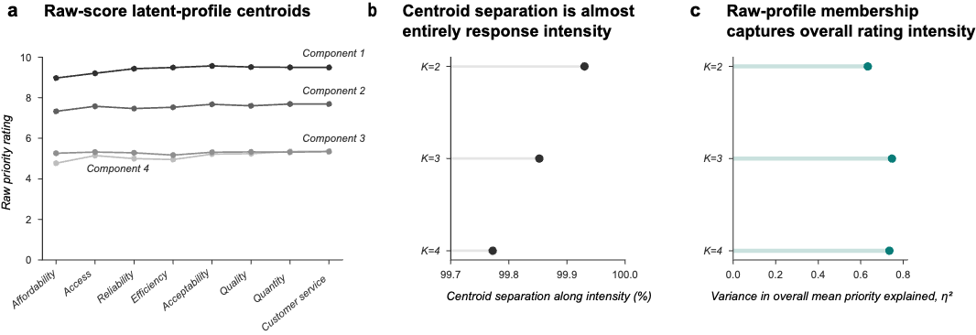
Supplementary Fig. S1. Conventional clustering of raw priority ratings primarily recovers response intensity
a, Raw-score component centroids for the diagnostic diagonal-covariance $K=4$solution. b, Percentage of between-centroid separation aligned with the all-domains response-intensity direction for numerically valid raw $K=2$, $K=3$, and $K=4$models. c, Proportion of variance in household mean priority associated with raw-profile membership. Nearly all between-profile separation lies along general response intensity, supporting removal of the household mean before substantive H1 mixture modeling.
S3.3 Continuous comparator and mixture-discovery gates
We fitted PPCA models with latent dimension $q=0,…,6$ as continuous comparators (Tipping and Bishop, 1999). Gaussian mixtures were evaluated $K=1,…,5$under spherical, tied-full, and component-specific full covariance structures within a model-based clustering framework (Fraley and Raftery, 2002).
Each Gaussian-mixture specification used 200 independent starts, a maximum of 2,000 EM iterations, a convergence tolerance of ${10}^{-6}$, and covariance regularization of ${10}^{-6}$.
A candidate was numerically acceptable only if its best solution converged, at least 95% of starts converged, at least 10 starts recovered an optimum within ${10}^{-4}$log-likelihood units per household of the best solution, and no fitted covariance variance or eigenvalue was $≤{10}^{-5}$. Each substantive component also had to include at least 5% of differentiating households by both fitted weight and modal assignment share.
Advancement from discovery also required a BIC improvement of at least 10 over $K=1$within the same covariance family and over the best PPCA comparator.
Supplementary Table S7. PPCA continuous-comparator grid
q | Log-likelihood | Parameters | BIC | Residual variance | Minimum covariance eigenvalue | Condition number
0 | −26,855.6 | 8 | 53,773.1 | 1.6060 | 1.6060 | 1.0000
1 | −26,356.5 | 15 | 52,829.2 | 1.3270 | 1.3270 | 2.4716
2 | −26,251.9 | 21 | 52,666.4 | 1.2140 | 1.2140 | 2.7017
3 | −26,225.6 | 26 | 52,652.6 | 1.1535 | 1.1535 | 2.8433
4 | −26,211.4 | 30 | 52,655.3 | 1.0999 | 1.0999 | 2.9818
5 | −26,207.7 | 33 | 52,671.0 | 1.0635 | 1.0635 | 3.0841
6 | −26,207.5 | 35 | 52,686.2 | 1.0503 | 1.0503 | 3.1227
Note. q denotes the PPCA latent dimension. Model estimates are otherwise unchanged from the frozen H1 run.
Supplementary Table S8. Complete relative-priority Gaussian-mixture discovery grid
Covariance | K | BIC | Equivalent-optimum starts | Minimum eigenvalue / variance | Minimum hard class share (%) | Discovery decision
spherical | 1 | 53,773.1 | 200 | 1.6060 | 100.00 | Do not advance
spherical | 2 | 49,160.9 | 200 | 0.4808 | 39.15 | Advance
spherical | 3 | 48,696.3 | 7 | 0.2807 | 21.45 | Fail numerical gate
spherical | 4 | 48,314.5 | 42 | 0.2924 | 18.56 | Advance
spherical | 5 | 45,191.9 | 1 | 0.0000 | 1.68 | Fail numerical gate
tied full | 1 | 52,686.2 | 200 | 1.0503 | 100.00 | Do not advance
tied full | 2 | 52,481.9 | 200 | 1.0478 | 4.01 | Fail component-size gate
tied full | 3 | 52,231.5 | 3 | 0.7463 | 3.45 | Fail numerical gate
tied full | 4 | 51,923.8 | 1 | 0.5509 | 2.33 | Fail numerical gate
tied full | 5 | 51,781.3 | 3 | 0.5681 | 1.90 | Fail numerical gate
full | 1 | 52,686.2 | 200 | 1.0503 | 100.00 | Do not advance
full | 2 | 48,396.7 | 200 | 0.2924 | 37.33 | Advance
full | 3 | 35,338.0 | 6 | 0.0000 | 26.28 | Fail numerical gate
full | 4 | 35,336.4 | 9 | 0.0000 | 18.86 | Fail numerical gate
full | 5 | 30,242.2 | 2 | 0.0000 | 9.15 | Fail numerical gate
Note. Several higher-$K$ models produced lower nominal BIC values but approached the covariance regularization boundary and failed the required recovery of equivalent optima. They therefore failed the numerical gate before substantive interpretation.
S3.4 Held-out predictive and structural validation
The three discovery survivors proceeded to 50 household-level 80/20 train–validation splits. PPCA was re-selected by BIC within each training partition.
Predictive validation required a positive median held-out per-household log-density gain over PPCA and positive gain in at least 75% of splits. Structural validation separately refitted each candidate in the corresponding validation partition. Every substantive component required a median Pearson correlation of at least 0.85 between matched eight-domain centroids and median centroid RMSE no greater than 0.50 priority-rating points.
The full-covariance $K=2$model had a median held-out gain of 0.987, minimum class-wise median centroid correlation of 0.883, and maximum class-wise median centroid RMSE of 0.128. The spherical $K=2$model had corresponding values of 0.755, 0.903, and 0.126. Both therefore passed the predictive and structural criteria. Spherical $K=4$showed positive held-out density gain but failed structural replication, with a minimum class-wise median centroid correlation of 0.710.
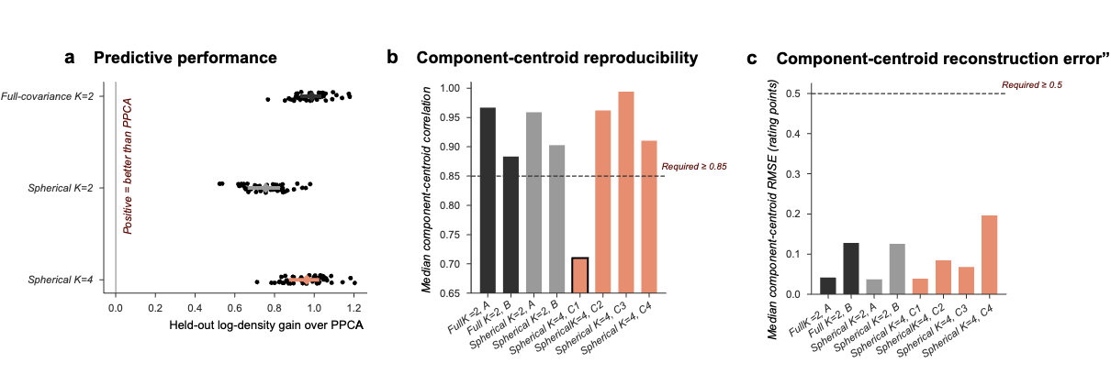
Supplementary Fig. S2. Held-out validation requires predictive improvement and reproducible component geometry.
a, Held-out per-household log-density gain over the training-selected PPCA comparator across 50 household-level 80/20 splits. b, Class-wise median matched-centroid correlation; the validation minimum was 0.85. c, Class-wise median centroid RMSE; the validation maximum was 0.50 priority-rating points. Both $K=2$specifications passed all held-out criteria, whereas spherical $K=4$failed the centroid-correlation requirement.
S3.5 Bootstrap stability and component matching
The two surviving $K=2$specifications underwent 500 household bootstrap resamples. We used the same resamples for both models, and each refit used the frozen 200-start mixture specification.
Bootstrap centroids were back-transformed to the eight centered domain axes and matched to the full-sample reference solution by minimum centroid RMSE using the Hungarian assignment algorithm (Kuhn, 1955). After matching, each bootstrap model predicted class membership for the original differentiating-household sample. We therefore calculated Jaccard similarity on a common population rather than on duplicated in-bag observations.
The original stability gate required median Jaccard similarity $≥0.75$for every substantive component. We assigned numerically invalid bootstrap fits a conservative Jaccard value of zero for gate calculation. All 500 refits were numerically valid for both retained $K=2$specifications.
Supplementary Table S9. Bootstrap stability of the validated H1 models
Model | Bootstrap replicates | Valid replicates | Median ARI | Median NMI | Median convergence rate | Minimum equivalent-optimum starts | Minimum eigenvalue / variance | Minimum class-wise median Jaccard | Gate result
Full-covariance $K=2$ | 500 | 500 | 0.9436 | 0.8935 | 1.0000 | 198 | 0.2359 | 0.963 | Pass
Spherical $K=2$ | 500 | 500 | 0.9589 | 0.9202 | 1.0000 | 199 | 0.4196 | 0.974 | Pass
Note. For the primary full-covariance $K=2$ solution, class-wise median Jaccard similarities were 0.978 and 0.963. ARI denotes the adjusted Rand index, and NMI denotes normalized mutual information.
Supplementary Table S10. Estimated relative-priority components in the primary H1 model
Domain | Component A (61%), estimate [95% bootstrap CI] | Component B (39%), estimate [95% bootstrap CI] | B − A [95% bootstrap CI]
Affordability | −0.295 [−0.348, −0.246] | −0.407 [−0.550, −0.266] | −0.112 [−0.261, +0.045]
Access | −0.090 [−0.131, −0.047] | +0.059 [−0.076, +0.185] | +0.148 [+0.014, +0.289]
Reliability | −0.037 [−0.079, −0.001] | −0.161 [−0.259, −0.059] | −0.124 [−0.233, −0.013]
Efficiency | −0.005 [−0.043, +0.033] | −0.184 [−0.285, −0.085] | −0.178 [−0.288, −0.064]
Acceptability | +0.113 [+0.078, +0.148] | +0.147 [+0.036, +0.249] | +0.034 [−0.088, +0.148]
Quality | +0.079 [+0.044, +0.112] | +0.095 [−0.009, +0.199] | +0.016 [−0.091, +0.131]
Quantity | +0.112 [+0.075, +0.144] | +0.223 [+0.116, +0.340] | +0.111 [−0.007, +0.228]
Customer service | +0.124 [+0.083, +0.165] | +0.228 [+0.099, +0.347] | +0.104 [−0.031, +0.229]
Notes. Estimates are relative-priority rating points from the household mean among differentiating households. Component labels are computational labels and do not imply ordered priority levels or fixed household types. Confidence intervals are based on 500 household bootstrap resamples.
S3.6 Exact equal-raters and full-sample sensitivity
For all 557 equal-rating households,
$$P_{i1}^{c}=⋯=P_{i8}^{c}=0.$$
They therefore form an exact point mass at the origin of relative-priority space rather than a diffuse Gaussian distribution. Full-sample Gaussian-mixture sensitivities assessed whether including this point mass within the same continuous mixture altered the differentiating-household structure.
All evaluated full-sample specifications captured the 557 equal-raters in a zero-like component. The relevant diagnostics were contamination by differentiating households, recovery of the validated non-zero components, and covariance behavior. The spherical $K=3$diagnostic isolated a 100%-pure zero-like component and preserved the two spherical $K=2$differentiating profiles, while its variance collapsed to the numerical boundary. This behavior is consistent with an exact point mass rather than an ordinary third Gaussian component and supports treating equal raters separately in the primary H1 analysis.
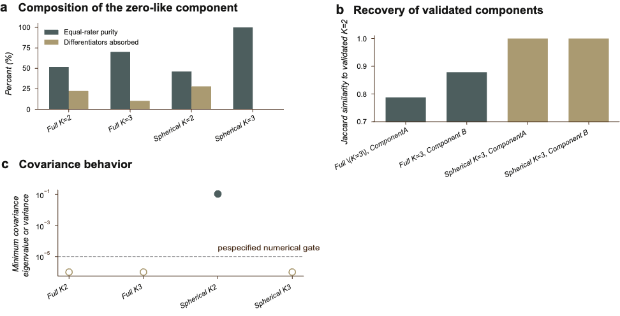
Supplementary Fig. S3. Equal-raters form an exact point mass in relative-priority space
a, Purity of the zero-like component and the proportion of differentiating households absorbed into it across full-sample mixture sensitivities. b, Jaccard recovery of the two validated differentiating-household components relative to the differentiator-only solution. c, Minimum covariance eigenvalue or spherical variance. All evaluated specifications assigned all 557 equal-raters to a zero-like component; the diagnostics assess contamination of the non-zero structure and behavior near the covariance boundary.

S3.7 Distributional adequacy and interpretation of the H1 components
The primary H1 analysis retained a full-covariance two-component Gaussian mixture based on the original discovery, validation and bootstrap criteria (Sections S3.3–S3.5). We conducted additional diagnostics to determine whether the fitted components primarily represented differences in the magnitude of priority differentiation or in the directions of relative-priority profiles, and whether alternative distributions described the observed variation more adequately.
Among the 2,317 differentiating households, within-household priority-rating SD was strongly associated with the original posterior probability of Component B (Pearson r = 0.826; Spearman ρ = 0.963). The SD distinguished the original modal component assignments with an AUC of 0.983. In paired held-out comparisons on the original seven-dimensional centered ratings, the full-covariance mixture provided only a small improvement over a two-component shared-mean scale mixture (+0.0063 median nats per household). A single multivariate Student-t distribution had a lower full-sample BIC and higher held-out log density than the original mixture in all 50 partitions (Supplementary Table S11).
We also examined relative-priority direction independently of differentiation magnitude by normalizing each nonzero centered profile to unit length. A two-component von Mises–Fisher (vMF) model outperformed a single vMF model, but was outperformed by both a flexible one-population angular-central Gaussian (ACG) distribution and the directional density induced by a single multivariate Student-t distribution (Supplementary Table S12). The original mixture assignments showed little correspondence with the independently fitted direction-only components: optimal modal agreement was 57.4%, the adjusted Rand index was 0.015 and the maximum absolute posterior-probability correlation was 0.092.
The originally selected two-component solution remains reproducible under its original validation criteria, but the fitted partition predominantly reflects differences in differentiation magnitude. The single Student-t and flexible directional benchmarks provided better held-out descriptions among the models tested. The components remain useful features of the fitted Gaussian-mixture representation; they do not independently establish two discrete domain-priority configurations.

Supplementary Table S11. Additional H1 distributional comparisons in centered-rating space
Model | BIC | Median held-out gain of full GMM K=2 over comparator (nats/household) | Splits favoring full GMM
Single Gaussian | 52,686.2 | +0.99336 | 50/50
K=2, shared mean and differing scales | 48,239.3 | +0.00630 | 35/50
K=2, shared mean and separate covariances | 48,368.7 | +0.00151 | 34/50
Full-covariance GMM, K=2 | 48,396.7 | Reference | —
Single multivariate Student-t | 47,910.3 | −0.06488 | 0/50
Note. Comparisons use N = 2,317 differentiating households and 50 paired household-level held-out splits. The gain is defined as the full-covariance K=2 Gaussian mixture minus the comparison model; positive values favor the full mixture. Lower BIC indicates better penalized in-sample fit. The Student-t degrees of freedom were estimated in training data (full-sample estimate: 3). Overlapping splits should not be considered independent tests.

Supplementary Table S12. H1 directional-distribution comparisons after magnitude normalization
Held-out comparison | Median difference (nats/household) | Splits favoring first model
Two vMF versus one vMF | +0.12756 | 50/50
Two vMF versus one ACG | −0.05516 | 0/50
Two vMF versus projected Student-t | −0.09402 | 0/50
ACG versus projected Student-t | −0.03914 | 0/50
Note. Comparisons use N = 2,317 differentiating households, with each nonzero centered priority vector normalized to unit length, over 50 paired held-out partitions. Positive values favor the first named model. The ACG model is antipodally symmetric (Tyler, 1987). Directional log densities cannot be compared numerically with the centered-rating densities in Supplementary Table S11. These are additional adequacy checks, not part of the original H1 selection.
S4. H2 complete secondary results and functional-form diagnostics
The main manuscript summarizes the primary pooled H2 estimate, differentiator-only sensitivity, and primary domain-specific matched slopes. Supplementary Tables S13 and S14 report the complete estimates.
Supplementary Table S13. Primary analysis and differentiator-only sensitivity
Analysis | N | β | SE | 95% CI | Raw P
All households, primary | 2,870 | −0.0045 | 0.0117 | −0.0274 to +0.0184 | 0.702
Differentiators only, sensitivity | 2,313 | −0.0063 | 0.0143 | −0.0343 to +0.0217 | 0.659
Supplementary Table S14. Domain-specific matched associations
Domain | N | β | SE | 95% CI | Raw P | Holm-adjusted P
Affordability | 2,870 | +0.0417 | 0.0302 | −0.0175 to +0.1010 | 0.167 | 1.000
Access | 2,870 | +0.0228 | 0.0256 | −0.0274 to +0.0729 | 0.374 | 1.000
Reliability | 2,870 | −0.0071 | 0.0247 | −0.0556 to +0.0413 | 0.773 | 1.000
Efficiency | 2,870 | −0.0668 | 0.0242 | −0.1143 to −0.0194 | 0.00578 | 0.0462
Acceptability | 2,870 | −0.0150 | 0.0221 | −0.0584 to +0.0284 | 0.497 | 1.000
Quality | 2,870 | −0.0095 | 0.0249 | −0.0585 to +0.0394 | 0.702 | 1.000
Quantity | 2,870 | +0.0121 | 0.0237 | −0.0345 to +0.0586 | 0.611 | 1.000
Customer service | 2,870 | −0.0270 | 0.0263 | −0.0786 to +0.0246 | 0.305 | 1.000
Coefficients in Table S13 are estimated changes in priority rating per 1-SD worse standardized service deficit. The primary and differentiator-only models include household and domain fixed effects with standard errors clustered by household. Table S14 allows the matched deficit–priority coefficient to vary across domains; we applied a Holm adjustment across the eight primary domain-specific tests. The following subsections report the complete cross-domain association map and supporting functional-form diagnostics.
S4.1 Exact collinearity of the contextual-deficit diagnostic
A planned diagnostic defined the mean standardized deficit across the seven domains other than $d$ as
$$G_{i,-d}=\frac{8G_{i}-Z_{id}}{7},$$
where $G_{i}$is the household mean across all eight standardized deficits. Because $G_{i}$is constant within household, it is absorbed by the household fixed effect. After within-household transformation,
$${\tilde{G}}_{i,-d}=-\frac{1}{7}{\tilde{Z}}_{id}.$$
The matched deficit and seven-domain contextual mean are therefore exactly collinear and cannot be estimated jointly in the household-fixed-effects model. The redundant diagnostic was not fitted.
S4.2 Complete 8×8 relative association map
Each cell estimates the association between one person-centered priority outcome and one person-centered standardized deficit predictor. We used HC3 standard errors, and all 64 tests formed one Benjamini–Hochberg FDR family. No association survived at $q=0.05$. Nominal associations were sparse and did not form a consistent cross-domain pattern.
Supplementary Table S15. Complete 8×8 relative deficit–priority association map
Priority outcome | Deficit predictor | β | 95% CI | Raw P | BH-FDR q | Same domain
Affordability | Affordability | +0.0003 | −0.060 to +0.060 | 0.9934 | 0.9934 | Yes
Affordability | Access | −0.0486 | −0.116 to +0.019 | 0.1573 | 0.9712 | No
Affordability | Reliability | −0.0677 | −0.133 to −0.002 | 0.0434 | 0.6598 | No
Affordability | Efficiency | +0.0774 | +0.005 to +0.149 | 0.0352 | 0.6598 | No
Affordability | Acceptability | −0.0262 | −0.101 to +0.049 | 0.4921 | 0.9712 | No
Affordability | Quality | +0.0372 | −0.044 to +0.118 | 0.3677 | 0.9712 | No
Affordability | Quantity | +0.0469 | −0.032 to +0.125 | 0.2413 | 0.9712 | No
Affordability | Customer service | +0.0145 | −0.067 to +0.096 | 0.7264 | 0.9712 | No
Access | Affordability | −0.0216 | −0.073 to +0.030 | 0.4134 | 0.9712 | No
Access | Access | +0.0012 | −0.048 to +0.051 | 0.9633 | 0.9786 | Yes
Access | Reliability | +0.0130 | −0.043 to +0.069 | 0.6501 | 0.9712 | No
Access | Efficiency | +0.0461 | −0.016 to +0.108 | 0.1465 | 0.9712 | No
Access | Acceptability | −0.0631 | −0.124 to −0.003 | 0.0408 | 0.6598 | No
Access | Quality | +0.0327 | −0.034 to +0.099 | 0.3349 | 0.9712 | No
Access | Quantity | −0.0238 | −0.087 to +0.039 | 0.4594 | 0.9712 | No
Access | Customer service | +0.0260 | −0.035 to +0.087 | 0.4028 | 0.9712 | No
Reliability | Affordability | −0.0151 | −0.067 to +0.036 | 0.5657 | 0.9712 | No
Reliability | Access | +0.0153 | −0.033 to +0.064 | 0.5390 | 0.9712 | No
Reliability | Reliability | +0.0196 | −0.033 to +0.072 | 0.4634 | 0.9712 | Yes
Reliability | Efficiency | −0.0098 | −0.069 to +0.049 | 0.7450 | 0.9712 | No
Reliability | Acceptability | +0.0143 | −0.041 to +0.069 | 0.6097 | 0.9712 | No
Reliability | Quality | −0.0419 | −0.108 to +0.024 | 0.2126 | 0.9712 | No
Reliability | Quantity | −0.0019 | −0.064 to +0.060 | 0.9507 | 0.9786 | No
Reliability | Customer service | +0.0136 | −0.047 to +0.074 | 0.6568 | 0.9712 | No
Efficiency | Affordability | −0.0071 | −0.052 to +0.038 | 0.7571 | 0.9712 | No
Efficiency | Access | −0.0025 | −0.049 to +0.044 | 0.9145 | 0.9786 | No
Efficiency | Reliability | −0.0039 | −0.058 to +0.050 | 0.8856 | 0.9786 | No
Efficiency | Efficiency | −0.0583 | −0.117 to +0.000 | 0.0516 | 0.6598 | Yes
Efficiency | Acceptability | +0.0593 | +0.006 to +0.112 | 0.0284 | 0.6598 | No
Efficiency | Quality | +0.0226 | −0.037 to +0.082 | 0.4557 | 0.9712 | No
Efficiency | Quantity | −0.0060 | −0.061 to +0.049 | 0.8297 | 0.9786 | No
Efficiency | Customer service | +0.0033 | −0.054 to +0.061 | 0.9114 | 0.9786 | No
Acceptability | Affordability | +0.0117 | −0.029 to +0.052 | 0.5686 | 0.9712 | No
Acceptability | Access | +0.0180 | −0.026 to +0.062 | 0.4190 | 0.9712 | No
Acceptability | Reliability | +0.0388 | −0.010 to +0.088 | 0.1209 | 0.9712 | No
Acceptability | Efficiency | −0.0316 | −0.085 to +0.022 | 0.2490 | 0.9712 | No
Acceptability | Acceptability | +0.0025 | −0.052 to +0.057 | 0.9278 | 0.9786 | Yes
Acceptability | Quality | −0.0158 | −0.073 to +0.041 | 0.5850 | 0.9712 | No
Acceptability | Quantity | −0.0081 | −0.064 to +0.047 | 0.7739 | 0.9712 | No
Acceptability | Customer service | −0.0366 | −0.090 to +0.017 | 0.1811 | 0.9712 | No
Quality | Affordability | +0.0237 | −0.022 to +0.070 | 0.3120 | 0.9712 | No
Quality | Access | −0.0050 | −0.049 to +0.039 | 0.8241 | 0.9786 | No
Quality | Reliability | −0.0350 | −0.088 to +0.018 | 0.1979 | 0.9712 | No
Quality | Efficiency | −0.0027 | −0.061 to +0.056 | 0.9289 | 0.9786 | No
Quality | Acceptability | −0.0103 | −0.064 to +0.043 | 0.7041 | 0.9712 | No
Quality | Quality | +0.0033 | −0.059 to +0.065 | 0.9173 | 0.9786 | Yes
Quality | Quantity | +0.0088 | −0.049 to +0.067 | 0.7663 | 0.9712 | No
Quality | Customer service | +0.0168 | −0.038 to +0.072 | 0.5484 | 0.9712 | No
Quantity | Affordability | +0.0097 | −0.034 to +0.053 | 0.6636 | 0.9712 | No
Quantity | Access | −0.0087 | −0.052 to +0.035 | 0.6983 | 0.9712 | No
Quantity | Reliability | −0.0092 | −0.065 to +0.047 | 0.7480 | 0.9712 | No
Quantity | Efficiency | −0.0091 | −0.069 to +0.051 | 0.7643 | 0.9712 | No
Quantity | Acceptability | +0.0116 | −0.045 to +0.068 | 0.6900 | 0.9712 | No
Quantity | Quality | −0.0167 | −0.078 to +0.045 | 0.5949 | 0.9712 | No
Quantity | Quantity | +0.0251 | −0.034 to +0.084 | 0.4013 | 0.9712 | Yes
Quantity | Customer service | −0.0028 | −0.061 to +0.056 | 0.9265 | 0.9786 | No
Customer service | Affordability | −0.0016 | −0.054 to +0.051 | 0.9515 | 0.9786 | No
Customer service | Access | +0.0303 | −0.017 to +0.077 | 0.2044 | 0.9712 | No
Customer service | Reliability | +0.0443 | −0.012 to +0.100 | 0.1205 | 0.9712 | No
Customer service | Efficiency | −0.0120 | −0.075 to +0.052 | 0.7114 | 0.9712 | No
Customer service | Acceptability | +0.0119 | −0.052 to +0.076 | 0.7165 | 0.9712 | No
Customer service | Quality | −0.0214 | −0.087 to +0.045 | 0.5266 | 0.9712 | No
Customer service | Quantity | −0.0408 | −0.107 to +0.025 | 0.2266 | 0.9712 | No
Customer service | Customer service | −0.0349 | −0.103 to +0.034 | 0.3175 | 0.9712 | Yes
Note. $N=2,870$ households in every row. Off-diagonal estimates represent cross-domain relative associations and are not interpreted as spillovers, substitutions, or causal effects.
S4.3 Ordered-item functional-form sensitivity
We re-estimated affordability, access, reliability, efficiency, and quality using categorical indicators rather than imposing equal spacing across their five ordered response levels. Category 1 was the reference.
The five domain-level association tests formed one Holm family, and the five tests of departure from linear equal spacing formed another. Acceptability, quantity, and customer service remained in their primary standardized composite form.
Supplementary Table S16. H2 functional-form tests for single-item deficits and supporting slopes for composite deficits
Domain | Encoding | Association test / slope | Raw P | Holm P | Nonlinearity test | Raw P | Holm P
Affordability | Ordinal categorical | $$F\left(4 , 2869\right)=1.662$$ | 0.1561 | 0.4682 | $$F\left(3 , 2869\right)=1.613$$ | 0.1843 | 0.7372
Access | Ordinal categorical | $$F\left(4 , 2869\right)=0.957$$ | 0.4298 | 0.8596 | $$F\left(3 , 2869\right)=0.811$$ | 0.4879 | 1.0000
Reliability | Ordinal categorical | $$F\left(4 , 2869\right)=3.157$$ | 0.0134 | 0.0669 | $$F\left(3 , 2869\right)=4.063$$ | 0.0068 | 0.0342
Efficiency | Ordinal categorical | $$F\left(4 , 2869\right)=2.239$$ | 0.0625 | 0.2500 | $$F\left(3 , 2869\right)=1.040$$ | 0.3738 | 1.0000
Quality | Ordinal categorical | $$F\left(4 , 2869\right)=0.911$$ | 0.4563 | 0.8596 | $$F\left(3 , 2869\right)=1.053$$ | 0.3680 | 1.0000
Acceptability | Composite continuous | $β=-0.0135$, 95% CI −0.0570 to +0.0299 | 0.5420 | — | — | — | —
Quantity | Composite continuous | $β=+0.0138$, 95% CI −0.0327 to +0.0604 | 0.5599 | — | — | — | —
Customer service | Composite continuous | $β=-0.0247$, 95% CI −0.0763 to +0.0268 | 0.3473 | — | — | — | —
Reliability was the only single-item deficit for which the categorical specification showed evidence of departure from equal linear spacing (Holm P=0.0342). However, the overall flexible association between reliability deficit and relative reliability priority did not meet the corrected significance threshold (Holm P = 0.0669). We found no evidence of nonlinearity for the other four single-item deficits.
Supplementary Table S17. Category support for the five single-item ordinal deficits
Domain | Category 1 | Category 2 | Category 3 | Category 4 | Category 5
Affordability | 783 (27.3%) | 735 (25.6%) | 1,108 (38.6%) | 135 (4.7%) | 109 (3.8%)
Access | 1,218 (42.4%) | 869 (30.3%) | 483 (16.8%) | 165 (5.7%) | 135 (4.7%)
Reliability | 735 (25.6%) | 973 (33.9%) | 936 (32.6%) | 166 (5.8%) | 60 (2.1%)
Efficiency | 771 (26.9%) | 961 (33.5%) | 1,009 (35.2%) | 71 (2.5%) | 58 (2.0%)
Quality | 754 (26.3%) | 1,135 (39.5%) | 842 (29.3%) | 98 (3.4%) | 41 (1.4%)
Note. Category 1 represents the best-service response and category 5 the worst-service response. The relatively small numbers in the poorest-service categories, particularly for efficiency and quality, warrant cautious interpretation of individual category coefficients.
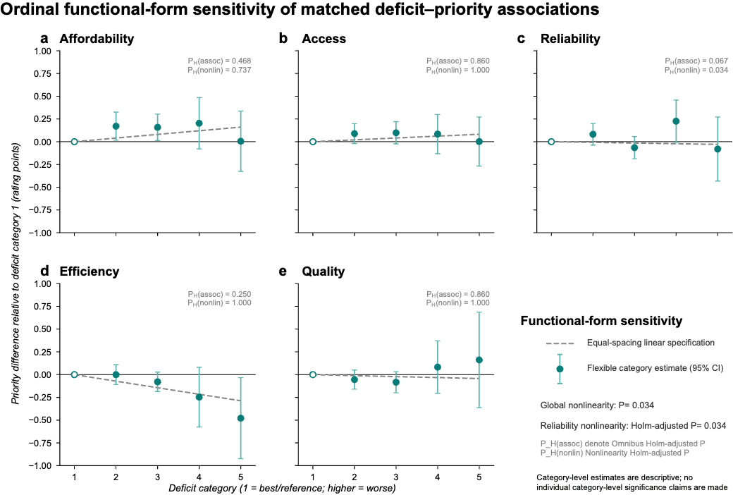
Supplementary Fig. S4. Ordinal functional-form sensitivity of H2 matched deficit–priority
The figure shows estimated category-specific priority differences and 95% confidence intervals for affordability, access, reliability, efficiency, and quality, using the best-service response as the reference. The figure also reports the original domain-level association and nonlinearity tests. Reliability was the only domain showing evidence of departure from linear equal spacing after Holm correction, while its flexible domain-level association did not pass the corresponding multiplicity correction.

S4.4 Equivalence and additional H2 interpretation checks
The primary H2 pooled matched-deficit coefficient was −0.00448 priority-rating points per one-standard-deviation worse deficit (household-clustered SE = 0.01169; N = 2,870). Its 95% CI was −0.02740 to 0.01844. We conducted two one-sided equivalence tests (TOST) to assess whether this coefficient was distinguishable from effects outside specified symmetric bounds (Schuirmann, 1987; Lakens, 2017).
The 90% CI was −0.02371 to 0.01475 and fell within all four evaluated equivalence margins (Supplementary Table S18). The ±0.10-point margin corresponds to 1% of the 0–10 rating scale; it is an illustrative reference rather than an established threshold of practical importance. The margins were introduced after the original analysis and are not prespecified thresholds. The equivalence results apply to the pooled linear association, not to each domain-specific or nonlinear relationship.
Replacing the primary unexpected-outage measure (Q13.1) with global perceived reliability (Q4.1) produced a similarly near-zero pooled estimate (Supplementary Table S19). The original categorical analysis of Q13.1 showed evidence of departure from equal linear spacing (Holm-adjusted P = 0.0342), while its flexible domain-level association did not pass correction (Holm-adjusted P = 0.0669; Supplementary Table S16). The Q4.1 alternative did not provide corresponding evidence of a flexible domain-level association.
The pooled estimate also contained partly offsetting domain contributions. Efficiency (−0.00688) and customer service (−0.00372) contributed negatively to the pooled coefficient, while reliability (+0.00259) and quantity (+0.00269) contributed positively. These are algebraic contributions rather than the separately estimated matched-domain slopes reported in Supplementary Table S14. Neither an interaction with overall standardized service burden (P = 0.353) nor an exploratory interaction with original posterior Component B probability (P = 0.785) provided evidence of differing matched-deficit slopes. The latter comparison is outcome-dependent and cannot determine how respondents interpreted the administered impact questions.

Supplementary Table S18. Equivalence tests for the primary pooled H2 coefficient
Symmetric equivalence margin (priority-rating points per 1-SD deficit) | TOST P | Equivalence at α = 0.05
±0.025 | 0.0396 | Yes
±0.050 | 5.03 × 10⁻⁵ | Yes
±0.100 | 2.24 × 10⁻¹⁶ | Yes
±0.200 | 2.59 × 10⁻⁶⁰ | Yes
Note. Primary H2 uses N = 2,870 households, household and domain fixed effects, and household-clustered SE = 0.01169 (2,869 degrees of freedom). The pooled coefficient is −0.00448 and its 90% CI is [−0.02371, 0.01475]. The equivalence margins were introduced as post-review sensitivities rather than original thresholds.

Supplementary Table S19. Alternative reliability measure and exploratory H2 interactions
Analysis | β | Clustered SE | Raw P
Primary pooled H2, Q13.1 | −0.00448 | 0.01169 | 0.702
Alternative pooled H2, Q4.1 | −0.00166 | 0.01147 | 0.885
Matched deficit × overall service burden | +0.01826 | 0.01964 | 0.353
Matched deficit × posterior P(B) | +0.00940 | 0.03450 | 0.785
Note. Q13.1 is the primary unexpected-outage measure; Q4.1 is global perceived reliability. The outcome remains the original priority rating. The Component B probability interaction uses N = 2,313 differentiating service-complete households and is exploratory because posterior probabilities are derived from the priority ratings.
S5. H3 implementation, complete estimates and robustness
S5.1 Analysis-specific samples
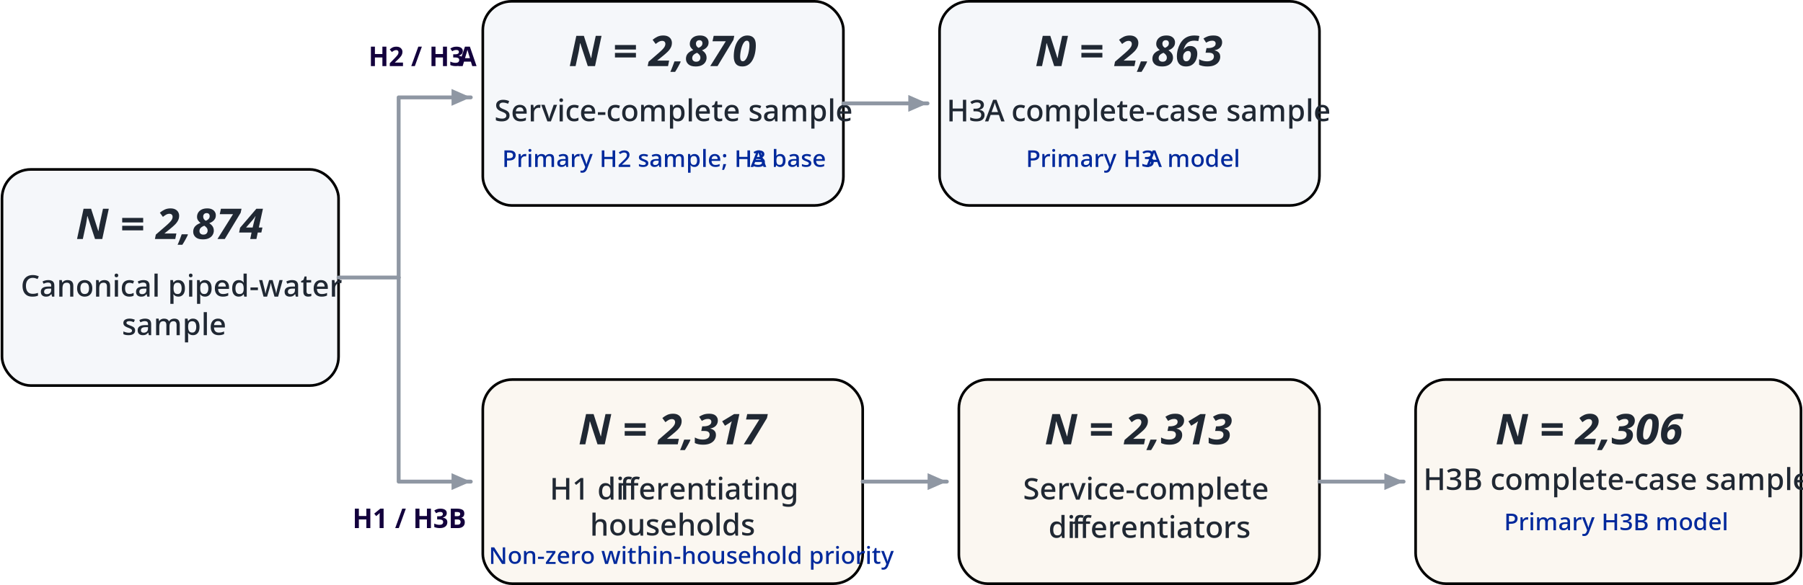
Supplementary Fig. S5. Analysis-specific sample construction
The canonical sample contains 2,874 households.$N=2,873$ The H2/H3A branch contains $N=2,870$service-complete households and $N=2,863$H3A complete cases. The H1/H3B branch contains $N=2,316$differentiating households, $N=2,313$service-complete differentiators, and $N=2,306$H3B complete cases. The branches reflect distinct outcome and complete-case requirements rather than result-dependent exclusions.
S5.2 Covariance and implementation details
H3A used HC3 covariance for coefficient uncertainty and Wald testing (MacKinnon and White, 1985). H3B used the Huber–White sandwich covariance from the fixed-measurement likelihood (Huber, 1967; White, 1980). The main Methods section defines the joint Wald tests, degrees of freedom, and gated multiplicity procedure.
S5.3 Confirmatory H3 tests and gated localization
Four block-level hypotheses formed the prespecified confirmatory H3 family. We opened variable-level localization only within H3B blocks that passed the Holm-adjusted block-level family. Supplementary Tables S20–S22 report the confirmatory block tests, variable-level localization within the confirmed H3B blocks, and effect estimates for the associations that passed the gated hierarchy.
Supplementary Table S20. Confirmatory H3 block-level tests
Outcome | Predictor block | N | df | Wald χ² | Raw P | Holm-adjusted P | Result
H3A: observed differentiation | Household context | 2,863 | 7 | 5.67 | 0.579 | 0.579 | Does not pass
H3A: observed differentiation | Service conditions | 2,863 | 8 | 15.82 | 0.0450 | 0.0900 | Does not pass
H3B: fitted mixture components | Household context | 2,306 | 7 | 22.53 | 0.00206 | 0.00617 | Pass
H3B: fitted mixture components | Service conditions | 2,306 | 8 | 30.47 | 0.000174 | 0.000697 | Pass
Note. The four block-level tests formed the prespecified confirmatory H3 family and were adjusted jointly using Holm's procedure. Variable-level localization was opened only within blocks that passed this family.
Supplementary Table S21. Variable-level localization within the confirmed H3B blocks
Block | Variable/domain | df | Wald χ² | Raw P | Within-block Holm P
Household context | Household size | 1 | 0.187 | 0.6653 | 0.6653
Household context | Housing tenure | 3 | 9.086 | 0.0282 | 0.0563
Household context | Dwelling type | 3 | 12.479 | 0.0059 | 0.0177
Service conditions | Affordability | 1 | 0.316 | 0.5742 | 1.0000
Service conditions | Access | 1 | 0.034 | 0.8538 | 1.0000
Service conditions | Reliability | 1 | 1.000 | 0.3174 | 1.0000
Service conditions | Efficiency | 1 | 0.330 | 0.5656 | 1.0000
Service conditions | Acceptability | 1 | 20.666 | 5.47 × 10⁻⁶ | 4.37 × 10⁻⁵
Service conditions | Quality | 1 | 5.186 | 0.0228 | 0.1594
Service conditions | Quantity | 1 | 0.077 | 0.7818 | 1.0000
Service conditions | Customer service | 1 | 3.048 | 0.0808 | 0.4850
Notes. Variable-level testing was conducted solely for the two H3B blocks that cleared the confirmatory family. Household size, housing tenure, and dwelling type constitute the household-context Holm3 family. The eight service domains form the service-condition Holm8 family. Category-specific contrasts were interpreted only if the associated categorical-variable omnibus test was significant.
Supplementary Table S22. Effect estimates for localized H3B associations
Variable / contrast | Test | Raw P | Multiplicity treatment | Effect estimate
Apartment vs individual house | Subordinate contrast within dwelling type | 0.00102 | Not separately adjusted after significant dwelling-type omnibus test | OR 2.00 [1.32, 3.03]; +16.62 pp
Acceptability, per 1-SD worse deficit | Prespecified domain-level test | 5.47 × 10⁻⁶ | Holm8-adjusted P = 4.37 × 10⁻⁵ | OR 1.304 [1.163, 1.462]; +6.25 pp
Note. We interpreted the apartment contrast only after the dwelling-type omnibus test passed the household-context Holm3 correction. The acceptability estimate corresponds to the domain-level test that passed the service-condition Holm8 correction. Probability differences are average adjusted probability contrasts.
S5.4 H3B numerical verification
Primary H3B household-only, service-only, and combined models each used 100 optimization starts. We considered a solution converged when its log-likelihood was within ${10}^{-6}$per household of the best solution. All starts converged for all three models, and all 100 recovered equivalent optima.
The maximum reconstruction error for the fixed H1 posterior probabilities was $1.78×{10}^{-15}$. Exact posterior values equal to 1 were retained without clipping, epsilon adjustment, or renormalization.
Numerical verification additionally required a finite full-rank solution, agreement between analytic and finite-difference gradients, analytic-Hessian verification, and independent reconstruction of the sandwich covariance. Maximum absolute discrepancies were $1.33×{10}^{-6 }$for the gradient, $1.78×{10}^{-8}$for the Hessian, and $3.47×{10}^{-17}$for sandwich covariance reconstruction.
Supplementary Table S23. Complete coefficient estimates from the primary H3A and H3B models
Outcome | Predictor | β | SE | 95% CI | OR | OR 95% CI
H3A | Intercept | +1.3978 | 0.0729 | +1.255 to +1.541 | 4.046 | 3.508 to 4.667
H3A | Household size, per SD | −0.0109 | 0.0472 | −0.103 to +0.082 | 0.989 | 0.902 to 1.085
H3A | Tenure: Other | +0.1212 | 0.1641 | −0.200 to +0.443 | 1.129 | 0.818 to 1.557
H3A | Tenure: Mortgage/loan | +0.2370 | 0.1281 | −0.014 to +0.488 | 1.267 | 0.986 to 1.629
H3A | Tenure: Rented | +0.0194 | 0.1554 | −0.285 to +0.324 | 1.020 | 0.752 to 1.383
H3A | Dwelling: Apartment | −0.1019 | 0.2156 | −0.525 to +0.321 | 0.903 | 0.592 to 1.378
H3A | Dwelling: Other | −0.1061 | 0.2470 | −0.590 to +0.378 | 0.899 | 0.554 to 1.459
H3A | Dwelling: Temporary housing | −0.1337 | 0.1562 | −0.440 to +0.172 | 0.875 | 0.644 to 1.188
H3A | Affordability deficit | −0.0337 | 0.0508 | −0.133 to +0.066 | 0.967 | 0.875 to 1.068
H3A | Access deficit | −0.0319 | 0.0519 | −0.134 to +0.070 | 0.969 | 0.875 to 1.072
H3A | Reliability deficit | +0.1084 | 0.0531 | +0.004 to +0.212 | 1.115 | 1.004 to 1.237
H3A | Efficiency deficit | −0.0043 | 0.0565 | −0.115 to +0.106 | 0.996 | 0.891 to 1.112
H3A | Acceptability deficit | +0.1604 | 0.0573 | +0.048 to +0.273 | 1.174 | 1.049 to 1.313
H3A | Quality deficit | −0.1076 | 0.0564 | −0.218 to +0.003 | 0.898 | 0.804 to 1.003
H3A | Quantity deficit | +0.0250 | 0.0611 | −0.095 to +0.145 | 1.025 | 0.909 to 1.156
H3A | Customer-service deficit | −0.0496 | 0.0569 | −0.161 to +0.062 | 0.952 | 0.851 to 1.064
H3B | Intercept | −0.6646 | 0.0766 | −0.815 to −0.514 | 0.515 | 0.443 to 0.598
H3B | Household size, per SD | +0.0211 | 0.0489 | −0.075 to +0.117 | 1.021 | 0.928 to 1.124
H3B | Tenure: Other | +0.4537 | 0.1607 | +0.139 to +0.769 | 1.574 | 1.149 to 2.157
H3B | Tenure: Mortgage/loan | +0.1910 | 0.1228 | −0.050 to +0.432 | 1.211 | 0.952 to 1.540
H3B | Tenure: Rented | +0.0465 | 0.1624 | −0.272 to +0.365 | 1.048 | 0.762 to 1.440
H3B | Dwelling: Apartment | +0.6940 | 0.2113 | +0.280 to +1.108 | 2.002 | 1.323 to 3.029
H3B | Dwelling: Other | +0.3896 | 0.2431 | −0.087 to +0.866 | 1.476 | 0.917 to 2.378
H3B | Dwelling: Temporary housing | +0.1477 | 0.1608 | −0.167 to +0.463 | 1.159 | 0.846 to 1.589
H3B | Affordability deficit | −0.0291 | 0.0518 | −0.131 to +0.072 | 0.971 | 0.878 to 1.075
H3B | Access deficit | +0.0101 | 0.0547 | −0.097 to +0.117 | 1.010 | 0.907 to 1.125
H3B | Reliability deficit | −0.0558 | 0.0558 | −0.165 to +0.054 | 0.946 | 0.848 to 1.055
H3B | Efficiency deficit | −0.0338 | 0.0589 | −0.149 to +0.082 | 0.967 | 0.861 to 1.085
H3B | Acceptability deficit | +0.2655 | 0.0584 | +0.151 to +0.380 | 1.304 | 1.163 to 1.462
H3B | Quality deficit | −0.1454 | 0.0639 | −0.271 to −0.020 | 0.865 | 0.763 to 0.980
H3B | Quantity deficit | +0.0175 | 0.0633 | −0.107 to +0.142 | 1.018 | 0.899 to 1.152
H3B | Customer-service deficit | +0.1075 | 0.0616 | −0.013 to +0.228 | 1.114 | 0.987 to 1.256
Note. H3A uses HC3 covariance; H3B uses Huber–White sandwich covariance. Tenure coefficients are relative to ownership free and clear, and dwelling coefficients relative to an individual house. Service coefficients are per 1-SD worse deficit. H3A coefficients are reported for completeness; variable-level H3A localization was not opened.
S5.5 Classification handling and alternative validated H1 structure
We compared the primary H3B result with three original sensitivity specifications. A hard-assignment diagnostic used the frozen modal H1 component as a binary outcome. A pseudo-class analysis used 200 draws from each household's frozen H1 posterior membership probabilities and pooled the resulting estimates. A third analysis repeated the fixed-measurement model using the independently validated spherical $K=2$ H1 representation. The hard-assignment and pseudo-class analyses assess sensitivity to classification handling, while the spherical model assesses dependence on the validated H1 covariance structure.
Supplementary Table S24. Robustness of H3B associations to class handling and H1 mixture specification
H3B specification | Household block χ² / P | Service block χ² / P | Dwelling-type χ² / P | Apartment β / OR | Acceptability β / OR
Primary fixed-measurement full $K=2$ | 22.532 / 0.00206 | 30.475 / 0.000174 | 12.479 / 0.0059 | +0.694 / 2.002 | +0.266 / 1.304
Hard modal assignment | 22.110 / 0.00243 | 26.684 / 0.00080 | 10.337 / 0.0159 | +0.588 / 1.801 | +0.235 / 1.265
200-draw pseudo-class pooled | 15.612 / 0.0289 | 23.025 / 0.0033 | 8.624 / 0.0347 | +0.564 / 1.758 | +0.222 / 1.249
Validated spherical $K=2$ | 25.562 / 0.00060 | 43.171 / $8.16×{10}^{-7}$ | 14.119 / 0.00275 | +0.646 / 1.909 | +0.360 / 1.433
Notes. The primary fixed-measurement analysis retains H1 membership uncertainty in the likelihood. Hard assignment is diagnostic only. The spherical $K=2$ specification is the independently validated H1 covariance sensitivity; we performed no new choice of $K$.
The household and service block associations persisted across all three alternatives, as did the direction of the apartment and acceptability coefficients.
S5.6 Flexible service-deficit coding
The five single-item deficits were represented categorically while the three composite deficits remained standardized continuous predictors. The full service block was retained, and the specification was not selected according to primary-model coefficients.
Supplementary Table S25. Domain-level tests under flexible H3B service coding
Domain | Holm8-adjusted P
Affordability | 1.000
Access | 1.000
Reliability | 0.0268
Efficiency | 0.00515
Acceptability | 0.000283
Quality | 0.354
Quantity | 1.000
Customer service | 0.649
Flexible coding produced supporting signals for reliability, efficiency, and acceptability. These results assess functional form and do not replace the primary linear-deficit localization, in which acceptability was the only service domain surviving the gated eight-domain correction.
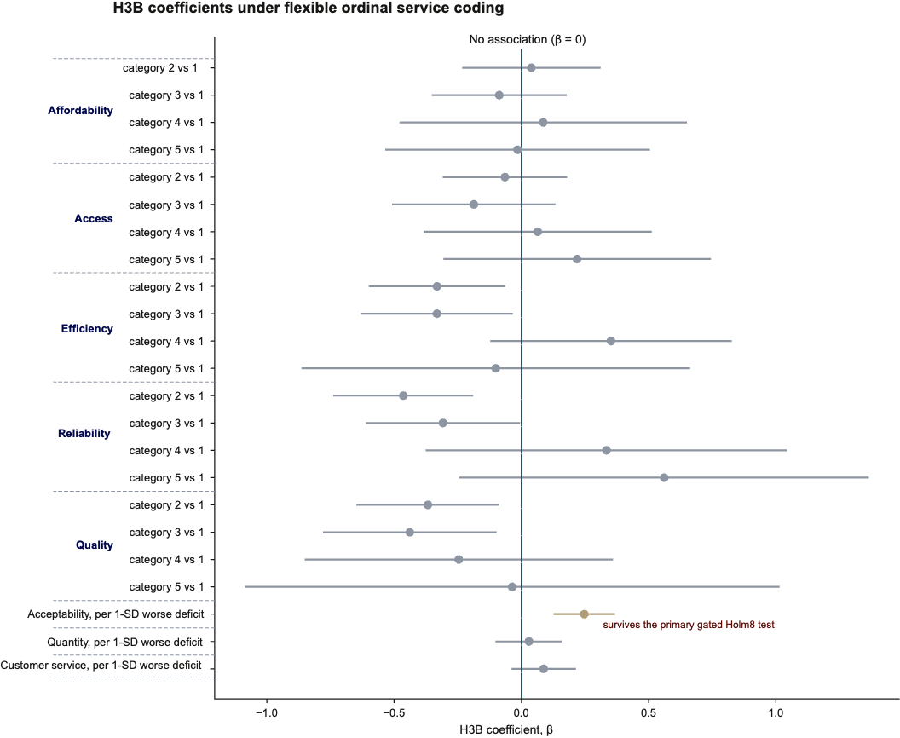
Supplementary Fig. S6. H3B coefficients under flexible service-deficit coding
Coefficient estimates and 95% confidence intervals are shown for the supporting H3B model in which affordability, access, reliability, efficiency, and quality are represented categorically. Acceptability, quantity, and customer service retain their continuous standardized composite specification. Acceptability is highlighted because that domain also passed the primary H3B gated Holm8 test. The highlighted coefficient shown here nevertheless comes from the supporting flexible specification, which does not replace the primary linear-deficit model.
S5.7 Overall service burden and relative deficit configuration
We re-expressed the eight standardized service deficits as one overall-burden coordinate and seven orthonormal coordinates describing the within-household relative configuration of deficits. No second standardization was applied. This is an exact invertible reparameterization of the same linear predictor space. It adds no service variables and leaves model fit unchanged.
Supplementary Table S26. Decomposition of service conditions into overall burden and relative deficit configuration
Outcome | Service component | df | Wald χ² | Raw P
H3A | Overall standardized service burden | 1 | 0.660 | 0.4166
H3A | Relative deficit configuration | 7 | 15.54 | 0.0296
H3A | Joint service block | 8 | 15.82 | 0.0450
H3B | Overall standardized service burden | 1 | 2.885 | 0.0894
H3B | Relative deficit configuration | 7 | 27.05 | 0.000327
H3B | Joint service block | 8 | 30.47 | 0.000174
In the original H3B model, the relative deficit-configuration block showed evidence of association with fitted component probabilities (Wald χ²(7) = 27.05, raw P = 0.000327), whereas the overall standardized burden test did not (Wald χ²(1) = 2.885, raw P = 0.0894; Supplementary Table S26). The blocks have different degrees of freedom, so these tests do not establish which aspect of service experience is more important. This decomposition concerns the selected mixture model and does not establish directional priority prediction. The corresponding H3A decomposition is supporting evidence only because its parent service block did not pass the confirmatory correction.
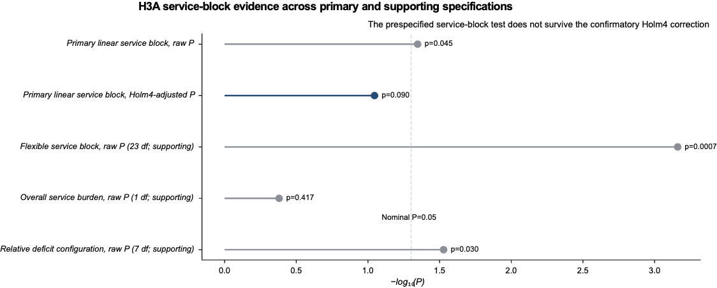
Supplementary Fig. S7. H3A service evidence varies across prespecified service representations
The figure compares the raw and Holm-adjusted primary H3A service-block evidence with the supporting flexible service specification and the burden/configuration decomposition. The primary H3A service block does not pass the confirmatory family; alternative specifications are therefore interpreted as supporting functional-form or configuration sensitivities rather than confirmatory H3A findings.
S5.8 Expanded-context robustness
We added respondent gender and upbringing area jointly to the complete primary predictor set. A second sensitivity additionally included vehicle ownership. Both models retained all primary household and service predictors.
The primary H3B household and service associations remained present after expanded-context adjustment. The added respondent-context association in H3B was concentrated in respondent gender rather than upbringing area. These variables were outside the primary H3 predictor family and are therefore treated as supporting results.
Supplementary Table S27. Robustness of the primary H3 blocks to expanded-context adjustment
Outcome | Expanded specification | N | Primary block | df | Wald χ² | Raw P
H3A | Gender + upbringing | 2,863 | Household context | 7 | 5.253 | 0.629
H3A | Gender + upbringing | 2,863 | Service conditions | 8 | 16.091 | 0.041
H3B | Gender + upbringing | 2,306 | Household context | 7 | 19.923 | 0.0057
H3B | Gender + upbringing | 2,306 | Service conditions | 8 | 27.908 | 0.00049
H3A | Gender + upbringing + vehicle | 2,863 | Household context | 7 | 6.223 | 0.514
H3A | Gender + upbringing + vehicle | 2,863 | Service conditions | 8 | 15.671 | 0.047
H3B | Gender + upbringing + vehicle | 2,306 | Household context | 7 | 18.500 | 0.0099
H3B | Gender + upbringing + vehicle | 2,306 | Service conditions | 8 | 27.658 | 0.00052
Notes. Expanded specifications retain all predictors from the corresponding primary H3 model. These analyses assess robustness of the primary household and service associations to additional respondent-context adjustment.
Supplementary Table S28. Associations of added respondent-context variables in expanded H3 models
Outcome | Expanded specification | Added variable | df | Wald χ² | Raw P | Supporting Holm P
H3A | Gender + upbringing | Respondent gender | 3 | 1.206 | 0.752 | 0.777
H3A | Gender + upbringing | Upbringing area | 2 | 1.890 | 0.389 | 0.777
H3B | Gender + upbringing | Respondent gender | 3 | 42.264 | $$3.53×{10}^{-9}$$ | $$7.05×{10}^{-9}$$
H3B | Gender + upbringing | Upbringing area | 2 | 0.051 | 0.975 | 0.975
H3A | Gender + upbringing + vehicle | Vehicle ownership | 2 | 7.728 | 0.021 | —
H3B | Gender + upbringing + vehicle | Vehicle ownership | 2 | 5.058 | 0.080 | —
Notes. Added variables were outside the primary H3 predictor family. Sparse respondent-gender categories were retained unchanged, and individual rare-category coefficients were not substantively interpreted. Supporting Holm adjustment was applied to the gender and upbringing tests within each outcome.

S5.9 Predictor dependence and continuous H3 interpretation checks
The original H3B analysis modeled associations with component probabilities under the selected H1 mixture (Sections S5.3–S5.8). We conducted additional analyses to examine predictor dependence and distinguish associations with the magnitude and direction of observed priority differentiation. These checks used the original 2,306 H3B-eligible households and the same household-context and service-condition predictor blocks.
Acceptability and perceived-quality deficits were moderately correlated (Pearson r = 0.420; Spearman ρ = 0.409), with a partial correlation of 0.192 after adjustment for the other predictors. Their variance inflation factors (VIFs) in the full H3 design were 1.397 and 1.577, respectively; the maximum VIF across the complete design was 1.880. No primary household-context category had fewer than 30 observations, and the apartment category included 128 households. These diagnostics did not indicate substantial linear predictor dependence or insufficient support for the apartment category. The acceptability coefficient concerns fitted-component probability, not relative acceptability priority.
We then modeled the logarithm of within-household priority-rating SD as an observable measure of differentiation magnitude. Both predictor blocks showed exploratory joint associations (household-context Wald χ²(7) = 16.67, P = 0.0196; service-condition Wald χ²(8) = 42.21, P = 1.24 × 10⁻⁶). The combined model explained little variation, however, with in-sample R² = 0.0292 and five-fold held-out R² = 0.0141. Associations remained detectable when untransformed SD was used instead of log SD.
To examine relative-priority direction independently of magnitude, we modeled each household's unit-normalized seven-dimensional centered profile while adjusting for log differentiation SD. The household-context block had partial R² = 0.0030 (wild-sign P = 0.521), and the service-condition block had partial R² = 0.0049 (raw P = 0.031; exploratory Holm-adjusted P = 0.062). The combined model did not improve held-out directional prediction (R² = −0.0046). The service-block association was sensitive to specification, with raw P = 0.006 among households whose rating range was at least two points, but P = 0.159 after additional adjustment for mean priority rating.
Adding respondent gender and upbringing to the differentiation-magnitude model produced a gender-block association (Wald χ²(3) = 36.82; raw P = 5.01 × 10⁻⁸; supporting Holm-adjusted P = 1.00 × 10⁻⁷), whereas upbringing was not associated with the outcome (P = 0.263). One gender category contained fewer than 30 observations. Excluding under-supported categories retained the gender-block association (Wald χ²(2) = 36.99; P = 9.28 × 10⁻⁹), but adding respondent characteristics improved held-out R² only from 0.0141 to 0.0242. Respondent gender was not a measure of household water-management responsibility, which the survey did not record.
Household and service characteristics showed detectable but weak associations with differentiation magnitude. Associations with relative-priority direction were less robust and did not improve combined-model held-out prediction. These exploratory analyses qualify the interpretation of H3B without changing its original confirmatory tests.

Supplementary Table S29. H3 exploratory predictor-block tests for differentiation magnitude and direction
Outcome | Predictor block | Statistic | Raw P | Exploratory Holm P | Partial R²
Log differentiation SD | Household context | HC3 Wald χ²(7) = 16.67 | 0.0196 | — | —
Log differentiation SD | Service conditions | HC3 Wald χ²(8) = 42.21 | 1.24 × 10⁻⁶ | — | —
Relative-priority direction | Household context | Wild-sign test | 0.521 | 0.521 | 0.00296
Relative-priority direction | Service conditions | Wild-sign test | 0.031 | 0.062 | 0.00490
Note. Both exploratory outcomes use N = 2,306 households. Magnitude is the log within-household rating SD (HC3 Wald tests). Direction is the seven-dimensional normalized centered vector (wild-sign tests). The directional Holm adjustment covers only the two exploratory directional block tests; it is not the original confirmatory H3 correction. Dashes indicate quantities not reported for these analyses.

Supplementary Table S30. Five-fold held-out prediction for H3 differentiation magnitude and direction
Outcome | Predictors | Held-out R² | RMSE
Log differentiation SD | Intercept only | −0.00152 | 0.58294
Log differentiation SD | Household context | 0.00163 | 0.58202
Log differentiation SD | Service conditions | 0.01333 | 0.57860
Log differentiation SD | Household context + service conditions | 0.01411 | 0.57837
Relative-priority direction | Intercept only | −0.00067 | 0.37432
Relative-priority direction | Magnitude only | −0.00043 | 0.37428
Relative-priority direction | Magnitude + household context + service conditions | −0.00461 | 0.37506
Note. N = 2,306. The magnitude outcome is log rating SD, and the directional outcome is the unit-normalized centered seven-vector. RMSE is on the log-SD scale for magnitude and per directional coordinate for direction. Held-out R² values measure predictive performance and differ from the partial R² values in Supplementary Table S29.
S6. First-stage uncertainty propagation
S6.1 Conditional and full H1→H3 uncertainty propagation
The conditional H3B bootstrap used 500 household resamples while holding the validated full covariance $K=2$H1 measurement densities fixed. This assesses H3B sampling uncertainty conditional on the selected H1 measurement model.
The full first-stage analysis propagated H1 uncertainty by reusing the same 500 household bootstrap samples, fitted full-covariance $K=2$ models, and component matches generated during H1 stability analysis. For each replicate, we retained H3B-eligible observations from the corresponding H1 resample with their bootstrap multiplicity and analyzed them using that replicate's matched H1 component densities. No independent second resample was drawn, and H1 model selection was not reopened.
All 500 full-pipeline replicates produced valid H3B fits. Coefficient medians and percentile intervals were closely aligned between the conditional and full first-stage procedures, with no material coefficient reversals. The primary dwelling-type and acceptability associations were stable under both procedures.
Supplementary Table S31. Conditional and full first-stage bootstrap uncertainty for the H3B coefficient vector
Predictor | Primary β | Conditional median [95% CI] | Conditional sign stability | Full H1→H3 median [95% CI] | Full sign stability
Intercept | −0.665 | −0.665 [−0.822, −0.509] | 1.000 | −0.670 [−0.857, −0.477] | 1.000
Household size | +0.021 | +0.028 [−0.073, +0.119] | 0.698 | +0.020 [−0.079, +0.120] | 0.680
Tenure: Other | +0.454 | +0.464 [+0.136, +0.766] | 0.994 | +0.461 [+0.128, +0.744] | 0.996
Tenure: Mortgage/loan | +0.191 | +0.182 [−0.061, +0.449] | 0.948 | +0.190 [−0.061, +0.424] | 0.936
Tenure: Rented | +0.046 | +0.045 [−0.280, +0.330] | 0.602 | +0.056 [−0.277, +0.374] | 0.600
Dwelling: Apartment | +0.694 | +0.688 [+0.246, +1.109] | 0.998 | +0.699 [+0.327, +1.074] | 1.000
Dwelling: Other | +0.390 | +0.371 [−0.075, +0.911] | 0.932 | +0.380 [−0.124, +0.866] | 0.926
Dwelling: Temporary housing | +0.148 | +0.167 [−0.145, +0.484] | 0.832 | +0.164 [−0.148, +0.462] | 0.846
Affordability | −0.029 | −0.029 [−0.133, +0.075] | 0.710 | −0.027 [−0.118, +0.072] | 0.684
Access | +0.010 | +0.011 [−0.094, +0.117] | 0.582 | +0.004 [−0.113, +0.113] | 0.530
Reliability | −0.056 | −0.058 [−0.175, +0.037] | 0.862 | −0.055 [−0.161, +0.066] | 0.828
Efficiency | −0.034 | −0.031 [−0.146, +0.074] | 0.720 | −0.032 [−0.131, +0.081] | 0.728
Acceptability | +0.266 | +0.272 [+0.160, +0.385] | 1.000 | +0.267 [+0.146, +0.381] | 1.000
Quality | −0.145 | −0.147 [−0.270, −0.028] | 0.988 | −0.151 [−0.274, −0.022] | 0.990
Quantity | +0.018 | +0.011 [−0.099, +0.139] | 0.566 | +0.014 [−0.106, +0.139] | 0.596
Customer service | +0.108 | +0.110 [−0.009, +0.232] | 0.960 | +0.108 [−0.011, +0.231] | 0.958
Notes. Both procedures used 500 valid replicates. Bootstrap intervals are percentile intervals. Sign stability is the proportion of replicates with the same sign as the primary estimate. The conditional bootstrap holds the selected H1 measurement model fixed, whereas the full H1→H3 procedure propagates the corresponding H1 bootstrap fit and component match into H3B. These analyses provide supporting uncertainty evidence and do not replace the original confirmatory H3 multiplicity hierarchy.

S7. Exploratory impact-weighted service assessment
We examined how household-specific weights derived from the eight reported impact ratings changed an illustrative assessment of experienced service severity. This analysis used the eight deficit measures defined in Section S2.2 and did not reconstruct or revalidate the separately developed Water Service Quality Score (WSQS). Each worse-service-oriented deficit on the native 1–5 scale was transformed to (D − 1)/4, yielding a severity score between zero and one. We compared the equally weighted mean of these eight severities with a weighted mean using each household's eight 0–10 impact ratings normalized to sum to one. A sensitivity used weights proportional to P + 1, preserving positive influence for every domain.
Of the 2,870 service-complete households, 13 had zero ratings across all eight impact items and therefore lacked defined raw weights. Among the remaining 2,857 households, equal-weight and impact-weighted severity rankings were highly correlated (Spearman ρ = 0.9935). The median absolute severity-score difference was 0.00357 on the 0–1 scale, and the 95th percentile was 0.03433. The median absolute percentile-rank change was 0.665 percentage points.
The highest-severity 5%, 10% and 20% groups retained 93.7%, 94.8% and 95.8% of their members, respectively, under impact weighting (Supplementary Table S32). For the highest-severity decile, 15 of 286 households were replaced in each direction. Rankings were still more similar under the conservative P + 1 weighting scheme. Repeating the fixed-size selections using 100 shared deterministic tie-breaking assignments produced comparable overlaps.
Household-specific impact weighting therefore changed the relative classification of some households but produced modest differences in the severity rankings under this construction. The comparison assumes equally spaced and comparable levels across the original ordered deficit measures. It does not establish improved allocation, service outcomes or equity; its within-sample severity thresholds are not externally validated service standards.

Supplementary Table S32. Highest-severity selection under equal and household-specific impact weights
Highest-severity group | Selected N | Equal versus impact-weighted overlap | Households replaced in each direction | Tie-sensitivity overlap range | Equal versus P+1 overlap
5% | 143 | 93.7% | 9 | 92.3–94.4% | 95.1%
10% | 286 | 94.8% | 15 | 93.4–95.5% | 95.8%
20% | 572 | 95.8% | 24 | 95.5–96.2% | 96.5%
Note. N = 2,857 with service-complete deficits and positive impact-rating sums. P+1 denotes weights proportional to observed ratings plus one. Fixed-cardinality groups use shared deterministic tie-breaking. The displayed overlap ranges reflect 100 deterministic repetitions, not confidence intervals; reclassification is descriptive rather than a measured allocation outcome.
Reference used in supplementary information
- Baker, R., Brick, J. M., Bates, N. A., Battaglia, M., Couper, M. P., Dever, J. A., Gile, K. J. & Tourangeau, R. (2013). Summary report of the AAPOR Task Force on non-probability sampling. Journal of Survey Statistics and Methodology, 1(2), 90–143. https://doi.org/10.1093/jssam/smt008.
- Cornesse, C., Blom, A. G., Dutwin, D., Krosnick, J. A., de Leeuw, E. D., Legleye, S., Pasek, J., Pennay, D., Phillips, B., Sakshaug, J. W., Struminskaya, B. & Wenz, A. (2020). A review of conceptual approaches and empirical evidence on probability and nonprobability sample survey research. Journal of Survey Statistics and Methodology, 8(1), 4–36. https://doi.org/10.1093/jssam/smz041.
- Department of Posts, Ministry of Communications, Government of India (2026). All India Pincode Directory. Open Government Data Platform India.
- National Sample Survey Office (2023). Multiple Indicator Survey in India, NSS 78th Round (2020–21). NSS Report No. 589 (78/5.1/1). Ministry of Statistics and Programme Implementation, Government of India.
- Kish, L. (1965). Survey Sampling. New York: John Wiley & Sons.
- Austin, P. C. (2009). Balance diagnostics for comparing the distribution of baseline covariates between treatment groups in propensity-score matched samples. Statistics in Medicine, 28(25), 3083–3107. https://doi.org/10.1002/sim.3697.
- Tipping, M. E., and Bishop, C. M. (1999). Probabilistic principal component analysis. Journal of the Royal Statistical Society: Series B, 61, 611–622.
- Fraley, C., and Raftery, A. E. (2002). Model-based clustering, discriminant analysis, and density estimation. Journal of the American Statistical Association, 97, 611–631.
- Kuhn, H. W. (1955). The Hungarian method for the assignment problem. Naval Research Logistics Quarterly, 2, 83–97.
- MacKinnon, J. G., and White, H. (1985). Some heteroskedasticity-consistent covariance matrix estimators with improved finite sample properties. Journal of Econometrics, 29, 305–325.
- Huber, P. J. (1967). The behavior of maximum likelihood estimates under nonstandard conditions. Proceedings of the Fifth Berkeley Symposium on Mathematical Statistics and Probability, 1, 221–233.
- White, H. (1980). A heteroskedasticity-consistent covariance matrix estimator and a direct test for heteroskedasticity. Econometrica, 48, 817–838.
- Lakens, D. (2017). Equivalence tests: a practical primer for t tests, correlations, and meta-analyses. Social Psychological and Personality Science, 8, 355–362. https://doi.org/10.1177/1948550617697177.
- Schuirmann, D. J. (1987). A comparison of the two one-sided tests procedure and the power approach for assessing the equivalence of average bioavailability. Journal of Pharmacokinetics and Biopharmaceutics, 15, 657–680. https://doi.org/10.1007/BF01068419.
- Tyler, D. E. (1987). Statistical analysis for the angular central Gaussian distribution on the sphere. Biometrika, 74, 579–589. https://doi.org/10.1093/biomet/74.3.579.

