Connection Close and Fault Scope in Acknowledged Write Recovery from Chromium SQLite IndexedDB
Osman Bin Nasir, Saif Ali Baig, Mohammed Abdul Lateef, Abdul Razzaq, Mohd Abdul Hafeez, Syed Hameduddin, Tasneem Bano Rehman
Muffakham Jah College of Engineering and Technology, Hyderabad, India
Corresponding author: Osman Bin Nasir; osmanbinnasir18@gmail.com

Abstract
Transaction completion alone does not establish recovery after a crash. We examined how connection closure and fault scope relate to acknowledged writes in Chromium’s explicitly enabled SQLite IndexedDB backend. A prospectively registered campaign ran in an ARM64 Ubuntu guest on an Apple Silicon Mac mini. Recovery varied with connection handling even when the delayed-close condition had the later ACK-relative fault deadline. The close-aligned comparison and the immediate-versus-delayed close comparison passed the prespecified Holm correction; the held-duration comparison did not. In the selected fault-scope conditions, browser-process termination preserved relaxed writes that were lost after guest reboot. Retaining additional database connections and silently dropping writes after ACK also removed recovery in the immediate-close condition. File-level records and available traces were consistent with later synchronization after connection release, but did not identify the causal callback or fully explain recovery while connections remained open. These findings apply to the tested host, guest, and forced backend. Physical power loss was not tested, and no safe waiting time or portability guarantee is established.
Keywords: IndexedDB; Chromium; SQLite; crash consistency; connection lifetime; storage durability

1 Introduction

1.1 Background
IndexedDB lets browser applications store structured data in transactions. An application can observe transaction completion, close its database handle and later reopen the database. That sequence spans the browser, database engine, operating-system cache, filesystem and storage. Completion at one layer does not establish the state of every lower layer. We define an acknowledged write as a completed transaction that emitted the registered application acknowledgment (ACK). Recovery means that a separate reader found the entire expected transaction after the specified fault.
The IndexedDB specification defines strict, relaxed and default durability hints. Strict requests verification that changes reached persistent storage; relaxed allows completion without that verification; default follows the storage bucket’s policy [1]. The hints do not guarantee survival of every physical fault. We use recovery for our measured outcome and reserve durability for API hints and cited engine guarantees.
SQLite’s write-ahead log (WAL) separates transaction records from checkpointing into the main database. Its NORMAL and FULL synchronization settings differ in when synchronization is requested [2,3,4]. Connection shutdown, checkpoint completion and WAL removal are distinct events. A browser may retain its engine connection after the application closes an IndexedDB handle, delaying when engine cleanup becomes possible.

1.2 Existing evidence
Crash-consistency research shows why application-visible completion must be interpreted across storage layers. Pillai et al. used ALICE to analyze filesystem-dependent persistence requirements [5]. Bornholt et al. specified and checked filesystem crash-consistency models [6]; Mohan et al. developed bounded black-box testing with CrashMonkey and ACE [7]. These studies provide persistence models and testing methods, rather than measurements of IndexedDB connection lifetime.
Zheng et al. tested databases using fault injection [8] and separately studied SSDs under physical power faults [9]. Their device-level fault model differs from the guest resets and process termination examined here.
Nightingale et al. studied synchronization and externally observable dependencies [10]; Rebello et al. examined application responses to fsync failures [11]. Our silent write-dropping intervention acknowledges discarded writes, so it does not establish browser responses to reported synchronization errors.
Smartphone studies examined storage performance, SQLite I/O and database/filesystem journaling [12,13]. They do not determine the close-relative recovery pattern in this browser configuration.
SQLite documents that NORMAL-mode WAL transactions can be rolled back after a system failure, while FULL adds WAL synchronization after commit. NORMAL instead concentrates synchronization around checkpointing and WAL reuse. Closing the last connection normally checkpoints and removes WAL-related files, subject to documented exceptions; an ordinary checkpoint need not remove the WAL [2,3,4]. These behaviors suggest a possible connection-lifetime effect without identifying which operation executed in a trial.
LevelDB also distinguishes asynchronous writes to operating-system buffers from synchronous writes [14]. This does not imply equivalent timing across backends. Likewise, QEMU cache=none requests direct host I/O while retaining guest-visible writeback and flush handling [15]; it neither removes guest caches nor reproduces physical power loss.
Chromium’s pinned source exposes a SQLite connection-release path [16,17,18,19,20]. Rollout records distinguish incognito storage from new on-disk stores [21,22,23,24]. Our explicitly forced backend therefore characterizes the tested package, not every default Chromium installation.
For applications storing user data locally, losing a completed edit matters even when the requested relaxed semantics permit that loss. Chromium’s transition from LevelDB and flat files to SQLite makes backend-specific recovery behavior relevant [23,24]. The practical question is which application-visible events and failure conditions a recovery test must record.

1.3 Research gap
Documented synchronization and last-connection shutdown do not quantify how IndexedDB close time orders recovery in this stack. We measure that relationship using close-relative faults, different ACK-based deadlines and retained connections. The contribution is the controlled comparison of these conditions, supported by file-level and trace observations, rather than a claim that relaxed completion must survive a system fault.
Earlier exploratory observations informed the timing windows but remain outside every campaign denominator. The prospective, hash-frozen plan separated three primary comparisons from the descriptive grid and four secondary test families. Interesting differences were not promoted retrospectively into confirmatory tests.

1.4 Objective
This study aimed to determine how connection lifetime and fault scope affect recovery of acknowledged relaxed writes in Chromium’s explicitly enabled SQLite IndexedDB backend, with particular attention to whether elapsed time from acknowledgment alone orders recovery. Three prespecified two-sided primary comparisons tested close-aligned gap endpoints, immediate versus delayed close at their registered ACK deadlines, and held 15 versus 5 s. Secondary families examined fault scope, block state, environment and workload. Byte capture and tracing supplied descriptive evidence for interpreting the observed recovery patterns.

1.5 Scope
The campaign used one Apple Silicon Mac mini and an ARM64 guest accelerated by Apple’s Hypervisor Framework (HVF), with packaged Chromium and SQLite explicitly forced. Most cells wrote one 256-byte record with relaxed durability. Physical power loss, x86, cloud execution, source-built Chromium, stable-version comparison, a writeback-sysctl matrix and second-host confirmatory replication were not performed. The optional transaction-cost tier was not activated.
The paper makes three contributions: a close-relative recovery pattern and ACK-age ordering reversal; matched evidence distinguishing browser termination from guest reboot; and target-byte and trace observations consistent with deferred cleanup. The mechanism evidence supports an interpretation, without identifying the causal callback.

2 Materials and Methods

2.1 Prospective protocol, experimental units, and randomization
The prospective v2 design fixed 930 assignments across nine mandatory families and 95 cells: 370 Tier 1 and 560 Tier 2 assignments. Ordinary families contained ten randomized complete blocks, one assignment per cell per block; the trace family contained five blocks. Each unit used a fresh guest overlay and browser profile. Repeated conditions in different families remained separate units and were never pooled.
Assignments used the fixed seed indexeddb-connection-lifetime-mac-20261003-v2 and deterministic SHA-256 ranking of canonical conditions within blocks. Qualification and scientific roles had separate identities. Verification reproduced the order, all ten design-file hashes and all 930 frozen assignments. Exact ranking and seeded-uptime rules are retained in the Supporting Information.
OSF registration (DOI 10.17605/OSF.IO/B3XPE) occurred on 3 October 2026 at 18:48:13 UTC [25]. Scientific acquisition began on 4 October 2026 at 14:03:18 UTC and concluded on 6 October 2026 at 10:57:40 UTC, bounded by the first start and final integration-completion receipts [26]. The initial immutable OSF snapshot omitted the complete hashed protocol package; its later deposit was verified against the frozen repository tag [27]. The Supporting Information retains the distinct registration, repository and upload chronology.
Qualification and technical repairs were excluded. Every scientific slot was consumed once started, including the premeasurement failure; no missing endpoint was rerun or replaced. Later operator authorization permitted continuation after terminal failures, an operational deviation from stopping the sequence at a failed slot. Conditions, assignment counts and endpoint rules were unchanged; original failures remain preserved.

2.2 Platform and backend identification
The host ran macOS 15.7.4, build 24G517, with 16 GiB RAM and QEMU 11.1.1. The Ubuntu 24.04 ARM64 guest used kernel 6.8.0-142-generic, four virtual CPUs, 6144 MiB RAM, virtio storage, HVF and cache=none. Headed Chrome for Testing 153.0.8010.12 ran under Xvfb through Playwright 1.63.0. The application and executable were hash bound; background networking and updates were disabled. Full platform settings accompany the supplement.
Launch records consistently enabled --enable-features=IdbSqliteBackingStore, and database extracts confirmed SQLite. The pinned source selects this explicit override before the rollout policy [19,20]. A default feature setting or rollout announcement alone would not identify an arbitrary installation’s backend.
Unless stated otherwise, principal families used the guest-root ext4 browser-data filesystem mounted with commit=30,discard. Block-state and environment families used separate browser-data volumes at /var/lib/idbv2. Table 1 distinguishes their acquisition volumes and policies; the root mount did not define a separate data volume’s configuration.
Family / arms | Browser-data filesystem | Acquisition volume
Close-aligned grid | ext4; commit=30,discard | Root /dev/vda1
Held sweep and close controls | ext4; commit=30,discard | Root /dev/vda1
Six key conditions | ext4; commit=30,discard | Root /dev/vda1
Byte capture and forensics | ext4; commit=30,discard | Root /dev/vda1
Trace-category timelines | ext4; commit=30,discard | Root /dev/vda1
Fault scope: QMP, SysRq, SIGKILL | ext4; commit=30,discard | Root /dev/vda1
Block state: linear, logging, drop writes | ext4 defaults; ordinary 5 s commit interval | /dev/mapper/idbv2-browser; /var/lib/idbv2
Environment: custom ext4, fixed uptime | ext4; commit=30,discard | /dev/vdc; /var/lib/idbv2
Environment: default ext4, fixed/random uptime | ext4 defaults; ordinary 5 s commit interval | /dev/vdc; /var/lib/idbv2
Environment: XFS, fixed uptime | XFS defaults | /dev/vdc; /var/lib/idbv2
Workload: quiet, fsync, ten records, four connections | ext4; commit=30,discard | Root /dev/vda1
Table 1. Browser-data filesystem and volume by experiment family. Recovery and helper attachments are not acquisition devices. The unmeasured trace slot had no mount observation; its assigned configuration was unchanged.

2.3 Transactions, acknowledgment, and recovery oracle
The ordinary transaction wrote a deterministic 256-byte ASCII payload containing trial and record identity plus checksum metadata. The ten-record workload committed ten such records atomically. Target transactions requested relaxed durability except for the registered strict control. ACK required transaction completion; requested and API-observed durability hints were recorded. Exact payload construction is retained in the supplement.
A strict sentinel was created, closed and verified, and target absence was confirmed before acquisition. After the fault, a separate reader opened the existing database/profile without creation or upgrade. It checked identity, version, stores, direct/indexed lookup, multiplicity, metadata and checksums. A complete valid target transaction with a valid sentinel was recovered; complete target absence with a valid sentinel was lost. Partial transactions, checksum/metadata errors, unexpected multiplicity or sentinel loss were integrity failures. Missing or unreadable observations remained unknown. The sentinel distinguished target loss from a wrong database or failed recovery measurement. Neither an ACK record nor surviving payload bytes alone counted as successful recovery. The complete expected transaction had to be accessible through the original browser oracle.
Technical eligibility was assessed without reference to target recovery, using condition, package/backend, preconditions, ACK, connection telemetry, timing, fault identity and required capture. Eligible recovered/lost observations supplied each cell’s binary denominator. Assigned and acknowledged counts were retained alongside it; a result file alone did not establish an interpretable endpoint. This separation matters when a fault interrupts telemetry or extraction: missing evidence is a failed measurement, not evidence of target absence. Unknown endpoints therefore could not increase either the recovery or loss count. Their possible influence was described through bounds.

2.4 Timing and connection policies
The grid requested close at 0 or 1 s from page ACK, then scheduled fault dispatch 1.6–2.4 s after estimated observed close return. Nine guest/host monotonic-clock samples mapped the page diagnostic to host time using the lowest-round-trip sample’s midpoint. Half its round-trip duration was the mapping diagnostic. The gap was close-relative, not ACK plus nominal close delay; recomputation reproduced all 180 mapped deadlines.
Key, held and close-control deadlines instead began at host ACK receipt. The four relaxed keys were immediate close/2.50 s, close at 1 s/2.75 s, held 5 s and held 15 s. Close delay remained page-ACK-relative. Held telemetry had to exclude unsolicited closure. In the four-connection workload, three additional connections remained open through the deadline even when the target connection closed (Table 2).
Cell family | Timing anchor | Why this anchor is used
Close-aligned grid | Estimated observed close return, mapped to host time | Assigned 1.6–2.4 s gaps isolate time after observed close. Close itself is assigned at 0 or 1 s from page ACK.
Four relaxed key conditions and crossed families | Host receipt of target ACK | Assigned 2.50, 2.75, 5 or 15 s deadlines compare connection policies at ACK-relative fault times.
Held sweep, close controls and added six-key controls | Host receipt of target ACK | Held/control deadlines remain ACK-relative, including held 30 s and strict immediate close at 0.50 s. Held cells have no close anchor.
Table 2. Timing anchors for the registered families. ACK-based deadlines use host receipt, while assigned close delays use page ACK. These are dispatch anchors, not calibrated physical-fault times.

Dispatch could not precede its deadline; overshoot above 25 ms excluded narrow timing analysis. Dispatch, QMP write, observed reset and close diagnostics were separately recorded. These anchors did not calibrate physical fault occurrence. Achieved intervals and uncertainty were reported, with nearest-rank p95 timing summaries; the 0.1 s grid did not imply device-level resolution.

2.5 Registered families
Table 3 inventories the nine families. The grid crossed two close times and nine gaps (180 assignments). The held sweep included five deadlines and close controls at 5 and 15 s (70). Six-key conditions added relaxed held 30 s and strict immediate close/0.50 s to the four relaxed keys (60). These families used QMP reset. Within the grid, only the registered endpoint contrast was confirmatory.
Byte capture repeated the four relaxed keys in 40 assignments, recording write bytes, offsets, return status, syncs and file identity on the unmodified packaged binary. A separate 20-assignment trace family enabled the registered categories. Both were descriptive; neither included a formal mechanism test or randomized capture-disabled comparison.
Retrospective decoding matched complete target objects and validated committed SQLite views against the original oracles, using the SQLite file format [28] and pinned IndexedDB/Blink/V8 encodings [16,29,30,31]. It added no trials, tests or endpoints. Detailed parsing and validation accompany Supplementary Tables S9–S10.
Retrospective trace analysis measured native close-to-task intervals and separately retained intact events from malformed envelopes. It did not repair raw traces or reclassify unknown endpoints. The executed worker/controller matched the final lock; posting metadata were interpreted using pinned TaskAnnotator source [32,33].
Fault scope crossed the four keys with QMP system reset, SysRq immediate reboot and browser-tree SIGKILL (120 assignments). Reboots required changed boot identity and reset evidence; SIGKILL required process-tree identity/exit evidence with unchanged boot identity. The guest kernel survived SIGKILL. None represented physical power loss.
Block state crossed the four keys with linear, dm-log-writes and dm-flakey drop_writes mappings on matched ext4-default volumes (120). Flakey was healthy through ACK, then silently discarded writes during continued guest execution [34]. At the registered boundary, execution was paused and immutable multi-disk state captured; a fresh derivative supplied recovery after discarding guest volatile state. Mapper-transition, flush/FUA and pause evidence were retained.
Logging supplied dependent prefixes before ACK, at ACK and at the final event; retrospective replay separately read the last literal FLUSH prefix [35]. These views added no units. The logs preserved completion ordering without completion timestamps or a model of instantaneous volatile-cache loss. Exact replay and mapper procedures remain in the supplement.
Environment crossed the keys with custom ext4 (commit=30,discard), fixed-uptime default ext4, seeded-random-uptime default ext4 and fixed-uptime XFS (160). Fixed launch uptime was 60 s; random draws spanned 45–180 s. Workload crossed the keys with quiet reference, same-filesystem background fsync, a ten-record transaction and four retained connections (160). Detailed workload parameters and observed uptime distributions remain in the supplement.

2.6 Preservation, verification, and incidents
Disk views preceded the recovery oracle but could follow boot/filesystem activity; they were not fault-instant snapshots. Hashed DB/WAL extracts, forensic interpretations and separate recovery derivatives were retained. Full overlays were preserved for anomalies and a seeded sample, with the registered compression/offload workflow for normal overlays.
Supplementary Table S12 records incidents, preserved failures and the append-only validator correction. Analysis used the machine-readable ledger, not the stale dashboard. Verification matched 11,140 original manifest hashes on the retained statistical core; it did not establish verification of every full image or remote archive.

2.7 Statistical analysis
Eligible cell proportions used exact two-sided 95% Clopper–Pearson intervals [36]. These were pointwise: with ten observations, 0/10 spans 0–30.85% and 10/10 spans 69.15–100%. Acknowledged denominators and pessimistic/optimistic missing-endpoint bounds were also retained.
Three two-sided exact paired tests formed one Holm family at α = 0.05 [37]: grid gap 2.4 versus 1.6 s within block/close-time strata (20 pairs); immediate close/2.50 s versus delayed close/2.75 s within six-key blocks (ten); and held 15 versus 5 s within sweep blocks (ten). All within-pair sign assignments were enumerated and checked against the conditional binomial tail on discordant pairs. Missing endpoints removed pairs, not multiplicity-family members.
Secondary comparisons used fixed Holm families: eight fault-scope, eight block-state, twelve environment and twelve workload tests, comparing registered alternatives with their within-block references. No trace or byte-capture test was added. Family definitions and attainable p-values for ten blocks are retained in the supplementary statistical details.
Risk differences were alternative minus reference. Pointwise Newcombe method 10 intervals combined marginal Wilson-score intervals [38]; they did not adjust for pairing or multiplicity. Paired exact tests supplied inference. Supplementary Table S7 retains primary intervals. The remaining grid was descriptive; nonsignificance was not evidence of equivalence. A post hoc 2.0 s rank analysis stayed supplementary and did not fit a threshold or alter registered tests. Inventory totals were not pooled recovery rates.
Thirty-two earlier supporting syscall observations preceded registration [26]. Their payloads, checksums and raw strace records were verified, but they remained outside campaign denominators. Their historical clock reconstruction and lack of per-trial executable hashes are disclosed separately.

3 Results and Discussion

3.1 Inventory and Primary Tests
All 930 assignments were consumed; 925 yielded eligible binary endpoints. Table 3 retains 340 recovered and 585 lost outcomes, four unknown result endpoints and one premeasurement slot. These inventory totals combine deliberately different conditions and are not a population recovery rate. Supplementary Tables A1–A9 retain all 95 cells, denominators, intervals and achieved timings.
Family | Cells × blocks | A | ACK | n | R / L | U / P
Close-aligned grid | 18 × 10 | 180 | 180 | 180 | 83 / 97 | 0 / 0
Held sweep and close controls | 7 × 10 | 70 | 70 | 70 | 22 / 48 | 0 / 0
Six key conditions | 6 × 10 | 60 | 60 | 60 | 30 / 30 | 0 / 0
Byte capture and forensics | 4 × 10 | 40 | 40 | 40 | 12 / 28 | 0 / 0
Trace-category timelines | 4 × 5 | 20 | 19 | 16 | 5 / 11 | 3 / 1
Fault scope | 12 × 10 | 120 | 120 | 119 | 62 / 57 | 1 / 0
Block state | 12 × 10 | 120 | 120 | 120 | 24 / 96 | 0 / 0
Environment | 16 × 10 | 160 | 160 | 160 | 60 / 100 | 0 / 0
Workload | 16 × 10 | 160 | 160 | 160 | 42 / 118 | 0 / 0
Inventory total | 95 cells | 930 | 929 | 925 | 340 / 585 | 4 / 1
Table 3. Registered experiment families and observed endpoints. A = assigned; ACK = acknowledged; n = eligible; R/L = recovered/lost; U/P = unknown/premeasurement. Inventory totals combine different conditions and are not a pooled recovery rate.

Two of the three primary comparisons passed Holm correction (Table 4). All their cells had ten eligible observations. The held comparison used the sweep’s 1/10 versus 0/10, not the separate six-key cells, which were both 0/10.
Contrast | Recovered | Pairs | Risk difference | Exact p | Holm p
Grid: 2.4 minus 1.6 s, stratified by close time | 20/20 vs 0/20 | 20 | 1.000 | 1.9073e-06 | 5.722e-06
Immediate 2.50 s minus delayed-close 2.75 s | 10/10 vs 0/10 | 10 | 1.000 | 0.001953125 | 0.00390625
Held sweep: 15 minus 5 s | 1/10 vs 0/10 | 10 | 0.100 | 1 | 1
Table 4. Prespecified primary comparisons. Tests are exact, paired and two-sided. Risk differences are descriptive marginal estimates; pointwise intervals appear in Supplementary Table S7.

The prespecified grid contrast compared 20/20 at 2.4 s with 0/20 at 1.6 s across two close-time strata. Each stratum separately was 10/10 versus 0/10, with pointwise marginal difference interval [0.608, 1.000]. This combines the registered endpoint strata, not the entire grid.
Immediate close recovered 10/10 at the earlier 2.50 s ACK deadline, while delayed close recovered 0/10 at the later 2.75 s deadline. All ten pairs differed (Holm p = 0.00390625). A longer ACK-based wait therefore did not order recovery across these policies. Nominally, close at 1 s leaves about 1.75 s before the 2.75 s deadline, consistent with a grace-period account of the loss. Because close uses page ACK and dispatch uses host ACK, this subtraction is nominal arithmetic, not a measured common-clock interval. The two-sided test established a difference without prespecifying its direction. The contrast compares two registered policies, changing connection policy and ACK deadline jointly. Its close-related interpretation also relies on the grid and retained-connection comparison. It does not isolate the effect of close at a common ACK age.
Contrast | Recovered | Pairs | Difference [95% CI] | Exact p | Holm p
SIGKILL minus QMP; Close at 1 s; 2.75 s | 10/10 vs 0/10 | 10 | 1.000 [0.608, 1.000] | 0.001953125 | 0.015625
SIGKILL minus QMP; Held 5 s | 10/10 vs 0/10 | 10 | 1.000 [0.608, 1.000] | 0.001953125 | 0.015625
SIGKILL minus QMP; Held 15 s | 9/9 vs 0/10 | 9 | 1.000 [0.592, 1.000] | 0.00390625 | 0.0234375
Drop writes minus linear; Immediate close; 2.50 s | 0/10 vs 10/10 | 10 | -1.000 [-1.000, -0.608] | 0.001953125 | 0.015625
Four connections minus quiet; Immediate close; 2.50 s | 0/10 vs 10/10 | 10 | -1.000 [-1.000, -0.608] | 0.001953125 | 0.0234375
Table 5. Secondary comparisons significant after correction within their registered Holm families.

Table 5 lists secondary contrasts passing their registered family corrections; all others did not. The held-15-s SIGKILL test used nine complete pairs, while its descriptive marginal difference used 9/9 versus 0/10. Its missing observation was not imputed.

3.2 Close Aligned Recovery
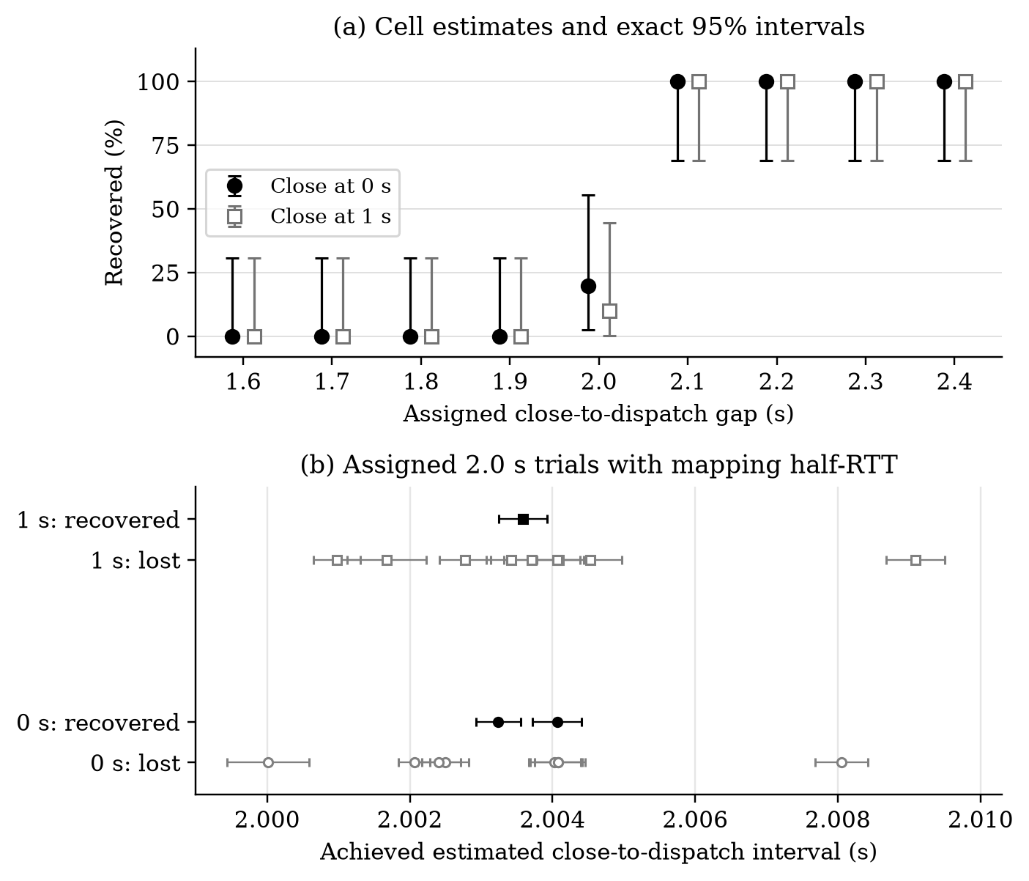
Figure 1. Recovery after connection close under QMP reset. Panel (a) shows per-cell proportions with exact pointwise 95% intervals; each cell had ten trials; counts are listed in Supplementary Table A1. Small horizontal offsets separate the two close-time estimates for display only. Panel (b) shows the twenty assigned-2.0-s outcomes at their achieved estimates, with horizontal bars for the recorded mapping half-RTT. Bars are not calibrated total-error confidence intervals; overlapping points are retained. Supplementary Table S4 lists the observations. The full grid and the post hoc timing association are descriptive except for the original endpoint contrast. No continuous threshold was fitted.
Recovery aligned with time since close in both grid strata (Figure 1). Each recovered 0/10 at assigned gaps 1.6–1.9 s and 10/10 at 2.1–2.4 s. At 2.0 s, immediate and delayed close recovered 2/10 and 1/10. The transition followed close alignment despite the one-second difference in assigned close time. Only the endpoint contrast was confirmatory (Holm p = 0.000005722).
Eligible dispatches met the deadline/25 ms gate. Grid mapping half-RTT ranged from 0.225 to 0.703 ms. The mixed 2.0 s cells overlapped in achieved timing; their post hoc rank analysis did not establish a threshold (Supplementary Table S4). Displayed estimates locate observations without calibrating total fault-time error or exact callback execution. Achieved estimates in the immediate-close 2.0 s cell ranged from 2.000014 to 2.008054 s; delayed-close estimates ranged from 2.000979 to 2.009087 s. Their medians were 2.003633 and 2.003646 s. The overlap, including shorter recovered estimates than some lost estimates, prevents reading the grid as a deterministic two-second boundary.

3.3 Held Connections and Strict Control
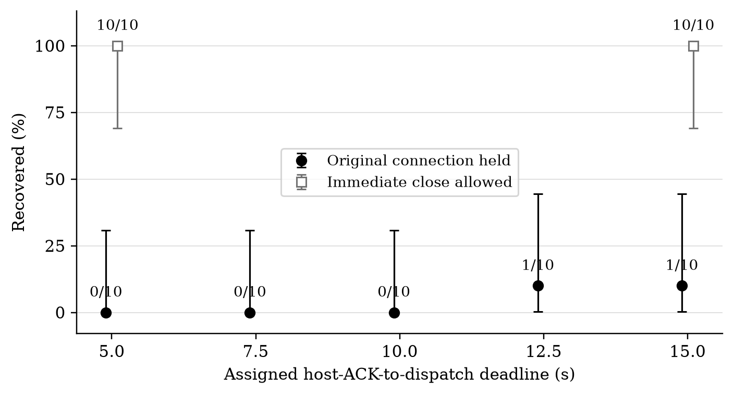
Figure 2. Held connections and immediate-close controls under QMP reset. Every cell had ten trials; labels show recovered/eligible counts and bars give exact pointwise 95% intervals. The original connection remained open in held cells. Controls existed only at 5 and 15 s. Small horizontal offsets distinguish markers, without changing assigned deadlines. Held 15 s versus held 5 s was the primary sweep comparison and did not pass Holm correction.
Held connections recovered 0/10 at 5, 7.5 and 10 s, and 1/10 at 12.5 and 15 s; immediate-close controls recovered 10/10 at 5 and 15 s (Figure 2). Nevertheless, held 15 versus 5 s was nonsignificant (raw/Holm p = 1; difference 0.100, interval [−0.189, 0.404]). The separate six-key family recovered 0/10 at held 5 and 15 s, and 10/10 at held 30 s. These distinct families were not pooled.
The strict immediate-close control recovered 10/10 at its assigned 0.50 s host-ACK deadline. All ACKs reported strict through IDBTransaction.durability. Achieved dispatch ranged from 0.502861 to 0.509103 s, median 0.504082 s. This single descriptive cell verifies recovery under QMP reset, not hardware synchronization or physical-power survival. Held-30-s recovery on commit=30,discard is consistent with a filesystem commit explanation, but that hypothesis was not causally tested. Neither observation establishes a safe waiting time. The contrast with relaxed conditions is useful context, but their different deadlines and lack of a registered direct strict-versus-relaxed test preclude treating this observation as a prespecified comparative effect. The optional transaction-cost tier was not activated, so this study supplies no strict-durability latency or energy estimate.

3.4 Fault Scope
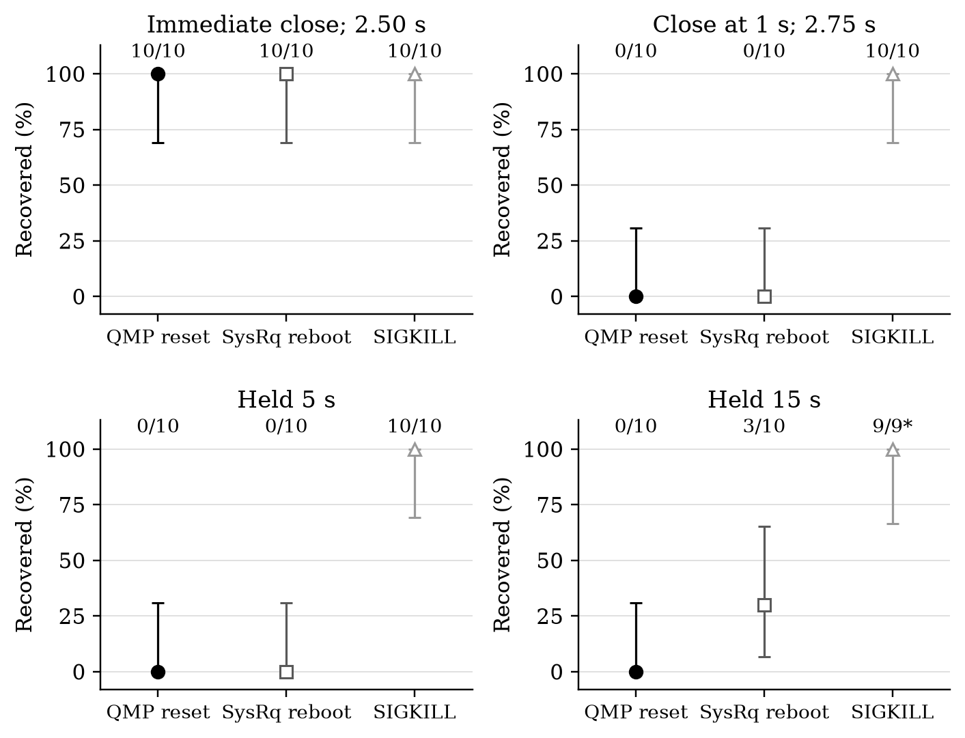
Figure 3. Recovery across fault scopes by key condition. Labels show recovered/eligible counts and bars give exact pointwise 95% intervals. The asterisk marks the held-15-s SIGKILL cell with one unknown endpoint, giving 9/9 interpretable outcomes from ten assignments. QMP reset and SysRq reboot changed boot identity; SIGKILL left the guest boot identity unchanged. Conditions are separate panels, not pooled fault rates.
Browser termination and guest reboot produced different outcomes (Figure 3). Immediate close recovered 10/10 under all three faults. Delayed close and held 5 s recovered 0/10 under QMP/SysRq but 10/10 under SIGKILL. Held 15 s recovered 0/10 under QMP, 3/10 under SysRq and 9/9 interpretable SIGKILL endpoints, with one unknown. The SIGKILL contrasts passed Holm correction for delayed close/held 5 s (p = 0.015625) and held 15 s (p = 0.0234375); SysRq contrasts did not.
All 39 interpretable SIGKILL endpoints recovered across its four cells, out of 40 assignments. For the incomplete cell, recovered/ACK was 9/10, with missing-endpoint bounds 90–100%. Treating its unknown as lost in sensitivity analysis still gave nine positive discordant pairs and one tie against QMP (exact p = 0.00390625), without reclassifying the actual endpoint.
SIGKILL retained the guest kernel, whereas QMP/SysRq changed boot identity. These differences explain why process termination is an incomplete recovery test for guest reboot. They do not establish future process-crash recovery or physical power-loss behavior.

3.5 Block State
The block intervention separated acknowledged write acceptance from recoverable captured state (Supplementary Figure S1). Immediate-close linear/logging cells recovered 10/10, while post-ACK drop_writes recovered 0/10 (Holm p = 0.015625 versus linear). Delayed-close cells were all 0/10. Held-5-s counts were 1/10, 0/10 and 0/10 for linear, logging and flakey; held-15-s counts were 1/10, 2/10 and 0/10. No other block contrast passed correction.
Flakey activation was bracketed at 69.38–93.42 ms after host ACK, with verification complete at 75.89–94.02 ms. The guest then continued running until capture. Thus this was an early write cutoff, not a drop switch at capture or an early reset. Mapped writes and PREFLUSH/FUA submissions followed activation; no definitely post-ACK/pre-dispatch backing-device write/flush was observed. Payload-free submission traces did not identify target sectors or completion times (Supplementary Table S5).
None of 40 dependent logging prefixes at ACK contained the target (0/40); pre-ACK prefixes also lacked it. Final-prefix and separately read literal last-FLUSH recoveries were 10/10, 0/10, 0/10 and 2/10 across the four keys (Supplementary Table S6). These are dependent views of the original trials, not new observations or physical-cache-loss frontiers. Thirty-nine literal prefixes omitted a trailing 4096-byte FUA metadata record. Detailed timing, overlap uncertainty and replay semantics remain in the supplement.

3.6 Environment and Workload
Environment cells recovered 10/10 after immediate close and 0/10 after delayed close or held 5 s (Supplementary Figure S2). Held-15-s counts were 1/10 for custom ext4, 8/10 for fixed default ext4, 6/10 for random-uptime default ext4 and 5/10 for XFS. None of twelve contrasts passed Holm correction; fixed default versus custom ext4 had raw p = 0.015625 and Holm p = 0.1875. The variation is descriptive, without adjusted evidence of an environment effect.
Assigned launch uptime and observed ACK uptime were distinguished. Fixed-profile median ACK uptimes were approximately 60 s; random-profile observations ranged from 50.452 to 178.837 s. Full distributions appear in Supplementary Table S3.
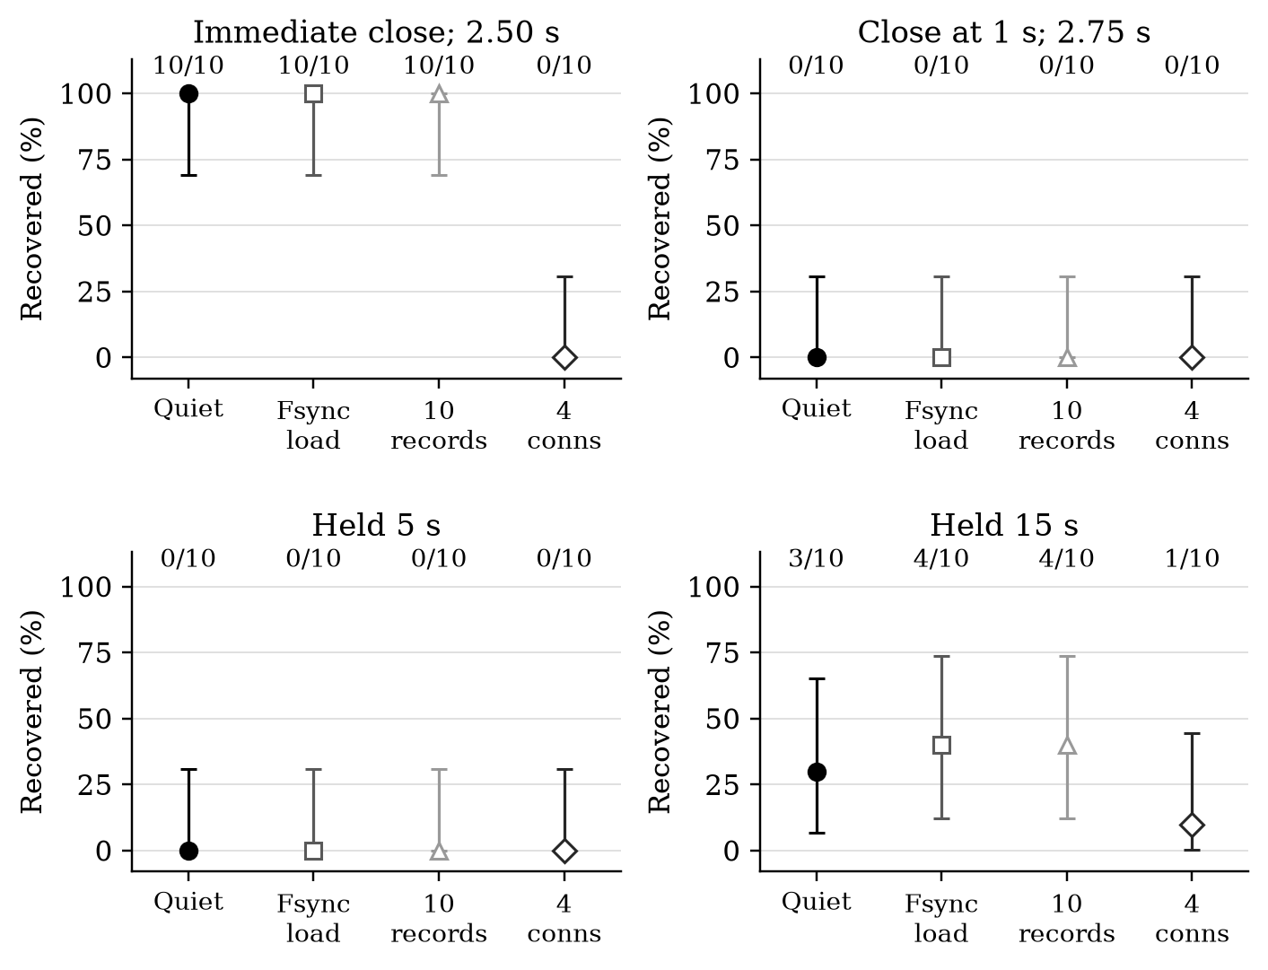
Figure 4. Workload and retained connections with exact pointwise 95% intervals and ten trials per cell. Background fsync used a separate file on the same filesystem. Ten records were committed in one target transaction. Four connections retained three additional connections through the fault deadline. The immediate-close four-connection contrast with quiet reference passed the twelve-test Holm family; other workload comparisons did not.
Retaining three additional connections removed immediate-close recovery: 0/10 versus 10/10 for quiet reference (Figure 4; Holm p = 0.0234375). Background-fsync and ten-record immediate-close cells also recovered 10/10. Delayed-close/held-5-s cells were all 0/10. Held-15-s counts were 3/10, 4/10, 4/10 and 1/10 for quiet, fsync, ten records and four connections; these contrasts did not pass correction. No eligible ten-record endpoint was partial. With three connections retained, closing the target handle did not release the last usable connection. This supports the cleanup account without identifying a causal callback.

3.7 Mechanism Evidence
File observations and traces support a deferred-cleanup interpretation of the close-relative pattern. Figure 5 separates their measured intervals because they come from different families and clock anchors. Similar timing across panels is supporting consistency, not a same-trial causal sequence.
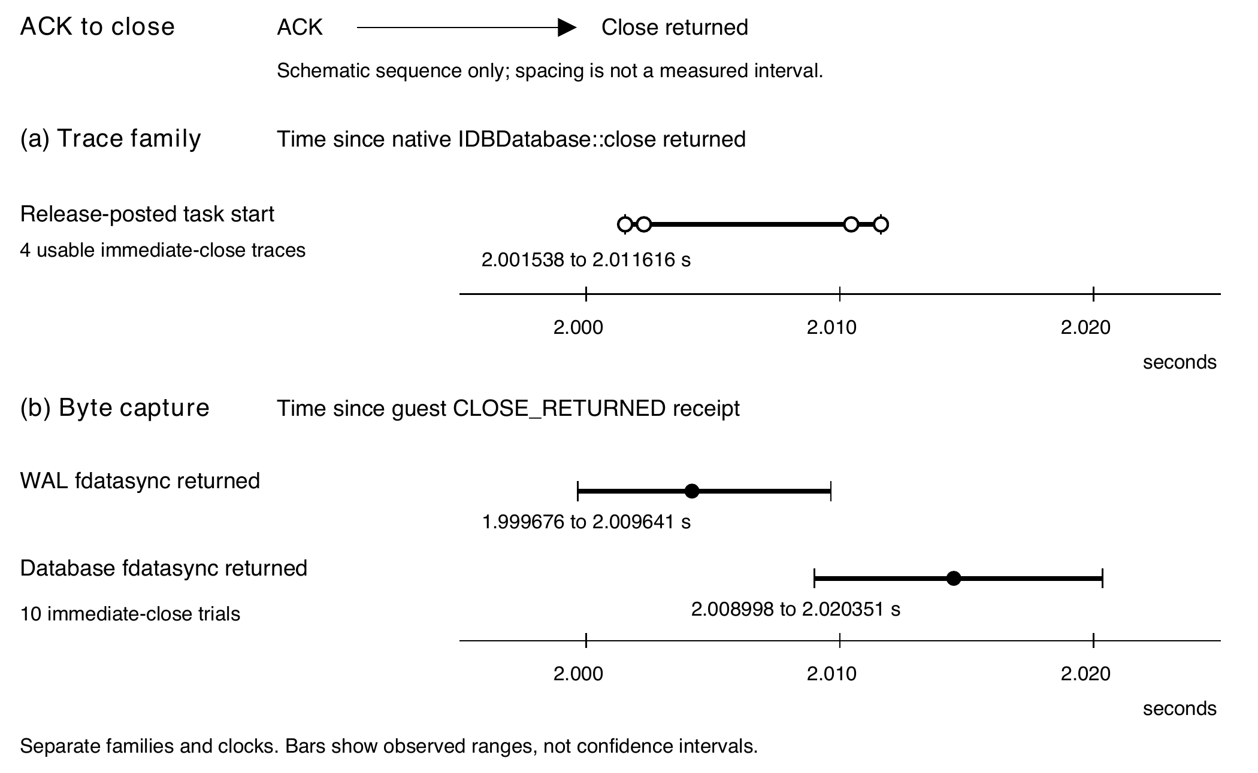
Figure 5. Close-relative observations supporting the cleanup hypothesis. The ACK-to-close sequence is schematic. Panel (a) shows the four late Release-posted task starts on the native trace clock. Panel (b) shows successful sync-return ranges and median dots in ten different byte-capture trials, anchored to guest close telemetry receipt. The panels have separate origins and are zoomed around two seconds; they are not a common-clock or same-trial sequence. Bars are observed ranges, not confidence intervals. The overlapping ranges do not establish a causal task-to-sync sequence.
At the pinned source revision, releasing a healthy SQLite connection scheduled MaybeSelfDestruct after a two-second grace period, subject to remaining-reference checks. Backing-store cleanup subsequently posted SQL connection close [16,17,18]. Strict transactions selected FULL and non-strict transactions NORMAL. The same grace constant appeared in a separately inspected revision [39], but no newer browser was tested. Source reading identifies a candidate path; callback attribution remains not established.
Earlier supporting syscall cells supplied a separate discriminator: closed targets lost at a 2.00 s reset deadline and recovered at 2.25 s, where completed WAL fdatasync appeared. In a separate close-versus-held comparison at 2.25 s, closed trials recovered with delayed WAL sync and unlinkat, while held trials lost with neither observed event. Each of the four cells had eight trials. Their separate counts, historical clocks and provenance remain in Supplementary Table S8; none entered the 930 campaign denominator.
A post hoc two-path hypothesis is consistent with these observations. Last-connection release may permit deferred SQLite shutdown and synchronization/checkpointing. Held-open recovery may instead depend more strongly on filesystem/kernel writeback. Held recoveries and filesystem variation fit that possibility, but environment tests were nonsignificant after correction and neither path was established causally.
Retrospective decoding identified the complete target in submitted WAL histories of all 40 byte-capture trials: records-table page 5, row ID 2, frame 26, with frame 29 committing the four-frame transaction. Recovery remained 10/10 after immediate close, 0/10 after delayed close, 0/10 when held 5 s and 2/10 when held 15 s (Supplementary Tables S9–S10). Successful writes and valid submitted checksums establish file-level history, not physical persistence. Matching required the complete identifier, payload, metadata and checksum, not a substring search. WAL salts, chained checksums and the transaction commit marker determined which bytes belonged to a valid committed view. The reconstructed views were checked against the original recovery oracles; no forensic match replaced an original endpoint.
All ten immediate-close trials subsequently showed target-covering WAL fdatasync, a byte-identical target-page write to the main database and database fdatasync. Their main databases alone contained the target. Neither delayed-close nor held-5-s captures showed those later completed sync/page-write events. The two held-15-s recoveries instead preserved committed targets in WAL, without the observed main-database path. The sync-return ranges in Figure 5 use guest CLOSE_RETURNED receipt, distinct from native trace close time.
One held-15-s LOST trial retained the full target value in an incomplete, uncommitted WAL tail. Its valid committed view and original browser oracle exposed only the sentinel. The other 27 LOST extracts lacked a target-payload match. Surviving bytes alone therefore did not establish record recovery.
Reconstructed committed views agreed with all 40 original endpoints. Extracts followed reset and guest boot activity, before the reader, so they were not fault-instant snapshots. Page/guest brackets left exact commit-write ordering relative to page transaction completion unresolved. The filter omitted unlink. Decoder, checksum, clock and source checks remain in the supplement.
All four usable immediate-close traces recorded a Release-posted task beginning 2.001538–2.011616 s after native IDBDatabase::close return, followed by a task at the DestroyConnection posting site (Supplementary Table S11). Posting metadata bind source locations, not direct callback entry or target-database identity [16,32,33]. The trace family retained 16 eligible endpoints, three unknown and one premeasurement slot. Its four immediate-close extracts contained the target in the main database; its held-15-s recovery retained it in WAL.
Despite producer no-loss flags, 15 of 16 eligible streams preserved transport failures and malformed envelopes. Missing events therefore did not establish absent execution. Delayed-close end requests preceded the candidate two-second interval, and the final pre-fault interval lay outside declared coverage. Positive events support the interpretation; incomplete delivery limits negative and causal claims.
For developers, the findings identify what recovery tests must record: durability hint, the lifetime of every usable connection and the fault scope. A longer ACK-based deadline did not compensate for delaying close, and closing one handle did not reproduce the quiet reference when others remained open. Browser-only termination tests would have missed guest-reset losses. These are testing implications, not instructions to sleep for two seconds or treat close as a durability operation.

3.8 Limitations
Relaxed semantics permit loss after a system fault [1]; the observations characterize behavior, not an API defect. The tested guest resets/reboots, process termination and block interventions did not reproduce physical power loss. Dispatch/QMP timing and block pause brackets did not calibrate the physical instant of volatile-state loss. Post-reboot extracts could include filesystem recovery activity.
Most cells contained only ten fresh-overlay trials, giving wide exact intervals and coarse attainable p-values. Trace cells were smaller and incomplete. Four unknown endpoints and one unmeasured slot remained separate; missing-endpoint bounds did not replace them. Newcombe intervals were marginal, not paired or multiplicity-adjusted. Paired tests relied on the registered within-block exchangeability and the chosen cells; the heterogeneous inventory was not a population recovery rate.
Generalization is limited by one host, an ARM64 guest, one forced backend/build, a custom ext4 reference and mostly single-record transactions. The registered default-ext4/XFS and workload arms extend conditions within that stack, without establishing portability to default browser populations, arbitrary databases or devices. There was no capture-disabled mechanism comparison. Callback causality, target-sector completion and a universal waiting threshold remain unestablished.
The retained statistical core passed its scoped verification, while some full remote archives remain without returned-byte verification. Several mechanism analyses require original inputs absent from the compact public package. The guide distinguishes these reproduction boundaries. Supplementary Table S12 preserves operational deviations and incidents without adding recovery observations; the later protocol-package deposit is separately disclosed in Section 2.1.

4 Conclusion
Connection lifetime and fault scope were associated with recovery of acknowledged relaxed writes in this pinned Chromium SQLite stack. Immediate close recovered at an earlier ACK deadline while delayed close failed at a later one; retaining other connections removed the quiet immediate-close recovery. Browser termination and guest reboot also produced different outcomes. The campaign consumed 930 assignments and yielded 925 eligible endpoints without replacing failures. Two of three primary comparisons passed Holm correction; held 15 s versus held 5 s did not. Source, syscall, target-byte and positive trace observations support deferred cleanup, while the causal callback and full block-sector completion sequence remain unestablished.
Applications storing critical data should evaluate explicit strict durability and test their required fault scope. The strict immediate-close control recovered 10/10 at a 0.50 s host-ACK deadline under QMP reset, but it was one descriptive cell, not a comparative strict-versus-relaxed test or a physical-power guarantee. All 39 interpretable SIGKILL endpoints recovered, with one unknown among 40 assignments; this did not predict reset behavior. Recovery tests should therefore record connection lifetime and durability policy alongside transaction completion. Neither elapsed time nor closing a connection supplies a verified recovery contract, and no safe waiting time or portability claim follows.

Declarations
Data availability: The registered campaign records, frozen design and analysis code are available in artifact release v1.0.0 [27]. Release v1.1.0 adds the separately identified supporting syscall records and reproduction scripts [26]. The accompanying reproducibility supplement contains the retrospective target-record and trace analyses. Full VM images and credentials are excluded. Verification of separately offloaded full archives remains incomplete; this limitation is distinct from the verified statistical records.
Funding: No external funding was received for this research.
Competing interests: The authors declare no financial or non-financial competing interests.

References
[1] W3C. Indexed Database API 3.0. Editor’s Draft, durability-hint definitions. Accessed 7 October 2026. https://w3c.github.io/IndexedDB/
[2] SQLite. PRAGMA synchronous. Documentation, accessed 7 October 2026. https://www.sqlite.org/pragma.html#pragma_synchronous
[3] SQLite. Write-Ahead Logging. Documentation, accessed 7 October 2026. https://www.sqlite.org/wal.html
[4] SQLite. Checkpoint a database: sqlite3_wal_checkpoint_v2. Documentation, accessed 7 October 2026. https://www.sqlite.org/c3ref/wal_checkpoint_v2.html
[5] Pillai, T. S., Chidambaram, V., Alagappan, R., Al-Kiswany, S., Arpaci-Dusseau, A. C., and Arpaci-Dusseau, R. H. All File Systems Are Not Created Equal: On the Complexity of Crafting Crash-Consistent Applications. OSDI, 2014, pp. 433–448. https://www.usenix.org/conference/osdi14/technical-sessions/presentation/pillai
[6] Bornholt, J., Kaufmann, A., Li, J., Krishnamurthy, A., Torlak, E., and Wang, X. Specifying and Checking File System Crash-Consistency Models. ASPLOS, 2016, pp. 83–98. DOI: 10.1145/2872362.2872406. https://doi.org/10.1145/2872362.2872406
[7] Mohan, J., Martinez, A., Ponnapalli, S., Raju, P., and Chidambaram, V. Finding Crash-Consistency Bugs with Bounded Black-Box Crash Testing. OSDI, 2018, pp. 33–50. https://www.usenix.org/conference/osdi18/presentation/mohan
[8] Zheng, M., Tucek, J., Huang, D., Qin, F., Lillibridge, M., Yang, E. S., Zhao, B. W., and Singh, S. Torturing Databases for Fun and Profit. OSDI, 2014, pp. 449–464. https://www.usenix.org/conference/osdi14/technical-sessions/presentation/zheng_mai
[9] Zheng, M., Tucek, J., Qin, F., and Lillibridge, M. Understanding the Robustness of SSDs under Power Fault. FAST, 2013, pp. 271–284. https://www.usenix.org/conference/fast13/technical-sessions/presentation/zheng
[10] Nightingale, E. B., Veeraraghavan, K., Chen, P. M., and Flinn, J. Rethink the Sync. OSDI, 2006. https://www.usenix.org/conference/osdi-06/rethink-sync
[11] Rebello, A., Patel, Y., Alagappan, R., Arpaci-Dusseau, A. C., and Arpaci-Dusseau, R. H. Can Applications Recover from fsync Failures? USENIX ATC, 2020, pp. 753–767. https://www.usenix.org/conference/atc20/presentation/rebello
[12] Kim, H., Agrawal, N., and Ungureanu, C. Revisiting Storage for Smartphones. FAST, 2012, pp. 209–222. https://www.usenix.org/conference/fast12/revisiting-storage-smartphones-0
[13] Jeong, S., Lee, K., Lee, S., Son, S., and Won, Y. I/O Stack Optimization for Smartphones. USENIX ATC, 2013, pp. 309–320. https://www.usenix.org/conference/atc13/technical-sessions/presentation/jeong
[14] LevelDB authors. LevelDB documentation: synchronous and asynchronous writes. Accessed 7 October 2026. https://github.com/google/leveldb/blob/main/doc/index.md
[15] QEMU Project. QEMU system invocation: drive cache options. Documentation, accessed 7 October 2026. https://www.qemu.org/docs/master/system/invocation.html
[16] Chromium authors. SQLite IndexedDB database connection implementation. Chromium 153.0.8010.12, revision 971a7443b0c9b0a9b2860529b33331b76077ec62. Source inspected 7 October 2026. https://github.com/chromium/chromium/blob/971a7443b0c9b0a9b2860529b33331b76077ec62/content/browser/indexed_db/instance/sqlite/database_connection.cc
[17] Chromium authors. SQLite backing-store and database-wrapper cleanup implementations. Revision 971a7443b0c9b0a9b2860529b33331b76077ec62, inspected 7 October 2026. https://github.com/chromium/chromium/blob/971a7443b0c9b0a9b2860529b33331b76077ec62/content/browser/indexed_db/instance/sqlite/backing_store_impl.cc Database-wrapper destructor: https://github.com/chromium/chromium/blob/971a7443b0c9b0a9b2860529b33331b76077ec62/content/browser/indexed_db/instance/sqlite/backing_store_database_impl.cc
[18] Chromium authors. SQL database close implementation. Same pinned revision, inspected 7 October 2026. https://github.com/chromium/chromium/blob/971a7443b0c9b0a9b2860529b33331b76077ec62/sql/database.cc
[19] Chromium authors. IndexedDB bucket context and SQLite selection policy. Same pinned revision, inspected 7 October 2026. https://github.com/chromium/chromium/blob/971a7443b0c9b0a9b2860529b33331b76077ec62/content/browser/indexed_db/instance/bucket_context.cc
[20] Chromium authors. Public feature definitions. Same pinned revision, inspected 7 October 2026. https://github.com/chromium/chromium/blob/971a7443b0c9b0a9b2860529b33331b76077ec62/content/public/common/content_features.cc
[21] Chrome Platform Status. SQLite backend for IndexedDB (step 1: in-memory data stores). Feature 5126896685809664, accessed 7 October 2026. https://chromestatus.com/feature/5126896685809664
[22] Chrome Platform Status. SQLite backend for IndexedDB (step 2: new on-disk data stores). Feature 5161589557821440, accessed 7 October 2026. https://chromestatus.com/feature/5161589557821440
[23] Stade, E. Web-Facing Change PSA: IndexedDB: SQLite backend. blink-dev announcement, 24 April 2026. https://groups.google.com/a/chromium.org/g/blink-dev/c/jS0khnC5IWA/m/JfLnx8U-BgAJ
[24] Chrome Platform Status. Chrome 156 release notes: SQLite backend for IndexedDB, step 2. Accessed 7 October 2026; preview information. https://chromestatus.com/release-notes/156
[25] OSF. Prospective registration: connection lifetime and acknowledged IndexedDB write recovery. Registration timestamp 3 October 2026; DOI: 10.17605/OSF.IO/B3XPE. Registration API and identifier inspected 7 October 2026. Exact-package upload chronology is distinguished in Methods. https://doi.org/10.17605/OSF.IO/B3XPE
[26] Osman-bin-nasir. Verified syscall supplement and manuscript revision artifacts. Version 1.1.0, 7 October 2026. https://github.com/Osman-bin-nasir/indexeddb-connection-lifetime-artifacts/releases/tag/v1.1.0 OSF artifact component: https://osf.io/svrjy/
[27] Osman-bin-nasir. Connection lifetime and acknowledged IndexedDB write recovery data and code. Version 1.0.0. GitHub artifact release, 7 October 2026. https://github.com/Osman-bin-nasir/indexeddb-connection-lifetime-artifacts/releases/tag/v1.0.0
[28] SQLite. Database File Format. SQLite database and write-ahead-log specifications. Accessed 11 October 2026. https://www.sqlite.org/fileformat.html
[29] Chromium. IndexedDB sortable key coding. Revision 971a7443b0c9b0a9b2860529b33331b76077ec62. https://github.com/chromium/chromium/blob/971a7443b0c9b0a9b2860529b33331b76077ec62/content/browser/indexed_db/indexed_db_leveldb_coding.cc
[30] Chromium. Blink V8 script-value serializer. Revision 971a7443b0c9b0a9b2860529b33331b76077ec62. https://github.com/chromium/chromium/blob/971a7443b0c9b0a9b2860529b33331b76077ec62/third_party/blink/renderer/bindings/core/v8/serialization/v8_script_value_serializer.cc
[31] V8. Value serializer. Dependency revision 0b60d2b01800d7ba2c6eeb5e51ecd95f6dab44c7, pinned by the inspected Chromium DEPS. https://github.com/v8/v8/blob/0b60d2b01800d7ba2c6eeb5e51ecd95f6dab44c7/src/objects/value-serializer.cc
[32] Chromium. TaskAnnotator task execution wrapper. Revision 971a7443b0c9b0a9b2860529b33331b76077ec62. https://github.com/chromium/chromium/blob/971a7443b0c9b0a9b2860529b33331b76077ec62/base/task/common/task_annotator.h
[33] Chromium. TaskAnnotator posted-from location and task-delay metadata. Revision 971a7443b0c9b0a9b2860529b33331b76077ec62. https://github.com/chromium/chromium/blob/971a7443b0c9b0a9b2860529b33331b76077ec62/base/task/common/task_annotator.cc
[34] Linux kernel documentation. dm-flakey. Accessed 7 October 2026. https://docs.kernel.org/admin-guide/device-mapper/dm-flakey.html
[35] Linux kernel documentation. dm-log-writes. Accessed 7 October 2026. https://docs.kernel.org/admin-guide/device-mapper/log-writes.html
[36] Clopper, C. J., and Pearson, E. S. The use of confidence or fiducial limits illustrated in the case of the binomial. Biometrika, 1934, 26(4), 404–413. DOI: 10.1093/biomet/26.4.404. https://doi.org/10.1093/biomet/26.4.404
[37] Holm, S. A Simple Sequentially Rejective Multiple Test Procedure. Scandinavian Journal of Statistics, 1979, 6(2), 65–70. https://www.jstor.org/stable/4615733
[38] Newcombe, R. G. Interval estimation for the difference between independent proportions: comparison of eleven methods. Statistics in Medicine, 1998, 17(8), 873–890. DOI: 10.1002/(SICI)1097-0258(19980430)17:8<873::AID-SIM779>3.0.CO;2-I. https://onlinelibrary.wiley.com/doi/10.1002/%28SICI%291097-0258%2819980430%2917%3A8%3C873%3A%3AAID-SIM779%3E3.0.CO%3B2-I
[39] Chromium authors. SQLite IndexedDB database connection implementation, main revision ea88d34fb15f5f329a0d104b11827ff1e327f98b, committed 6 October 2026. Source inspected 7 October 2026. https://github.com/chromium/chromium/blob/ea88d34fb15f5f329a0d104b11827ff1e327f98b/content/browser/indexed_db/instance/sqlite/database_connection.cc

