**Name: Usman Ijaz**

**Reg# SP22-BSE-051**

**Class: Devops**

List of process:

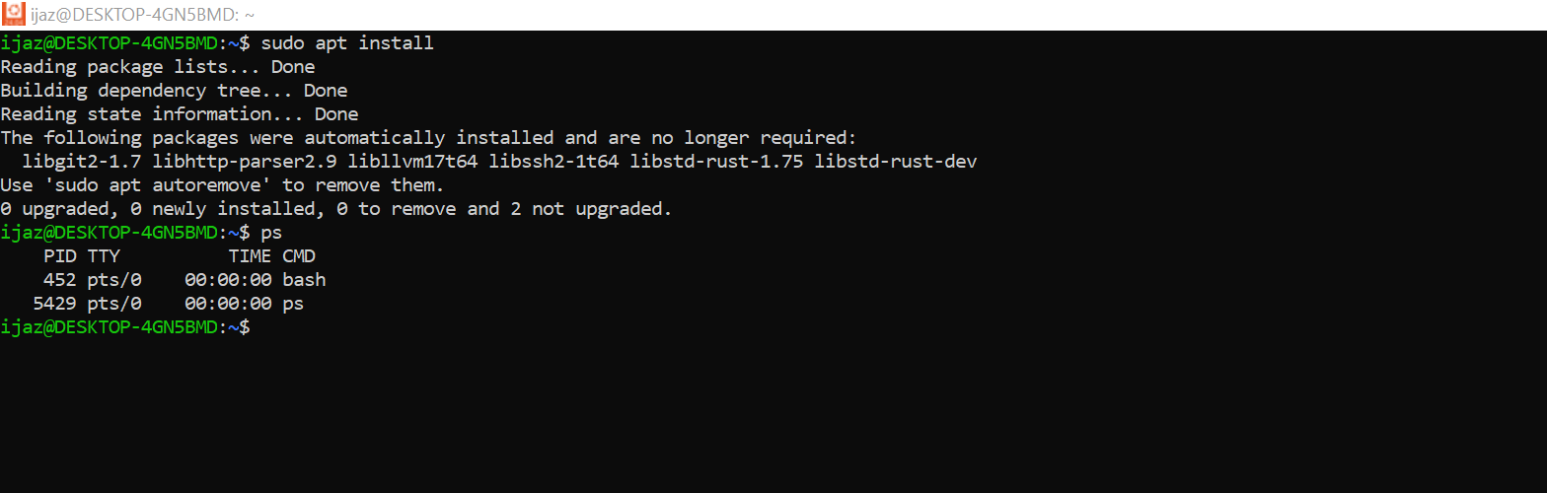

View process:

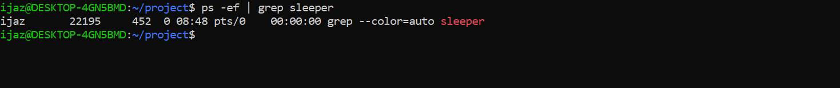

Adjust process priority:



Check memory usages:

Check process usages:

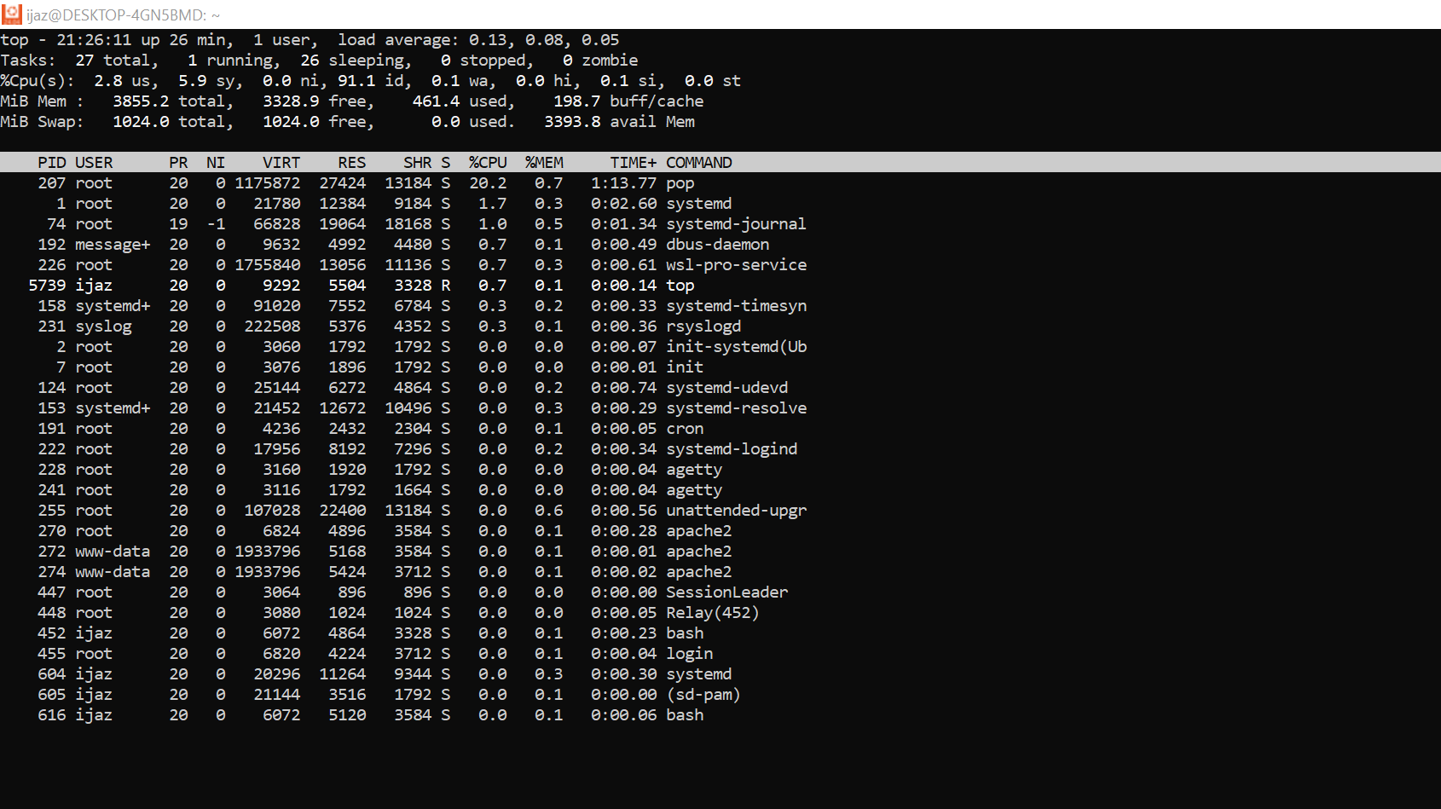

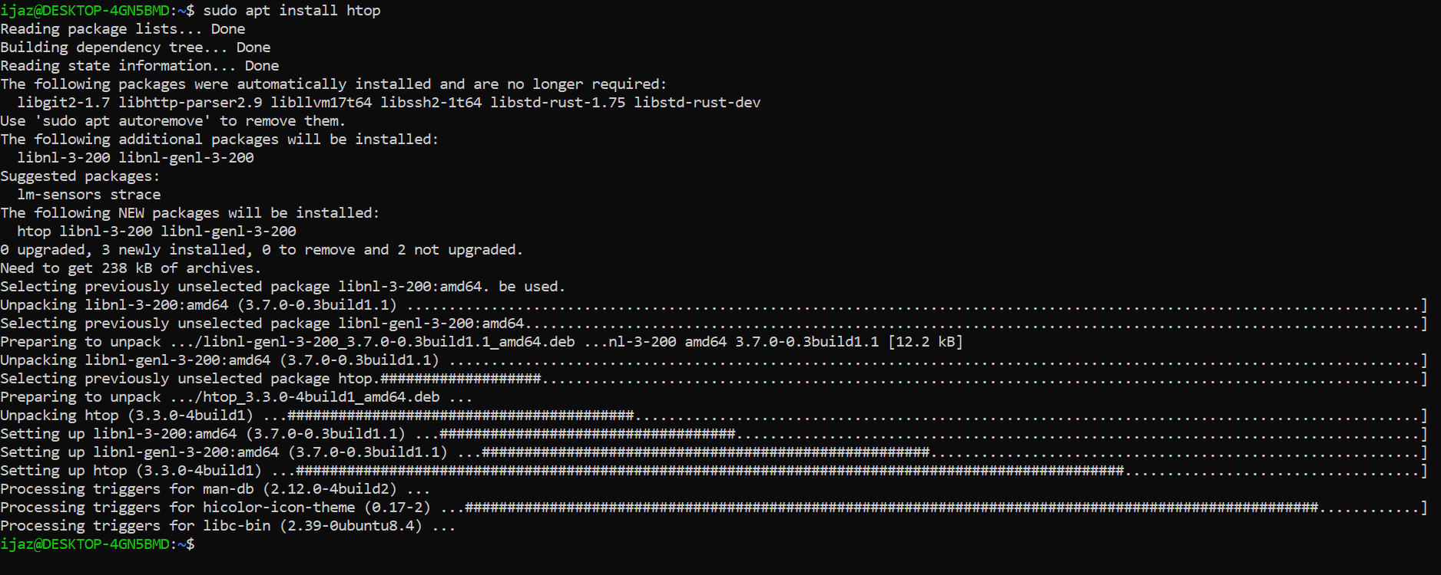

Create file:

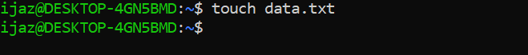

View File:

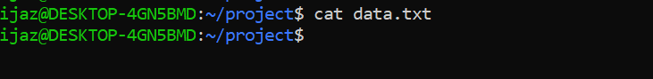

Create file:

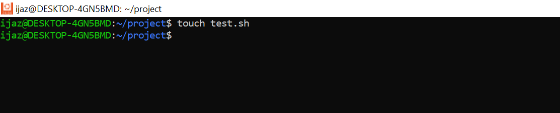

Only Permission to owner:



Make executable:

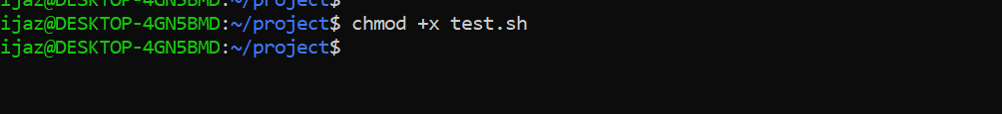

Add User:

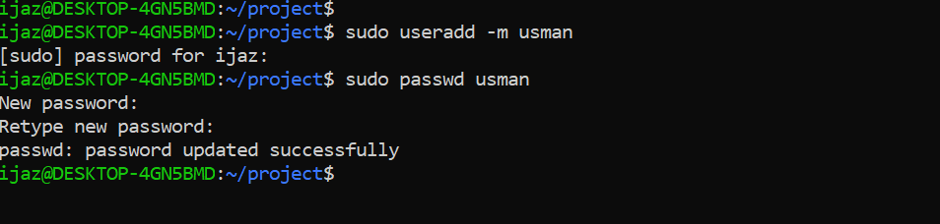

User Information:

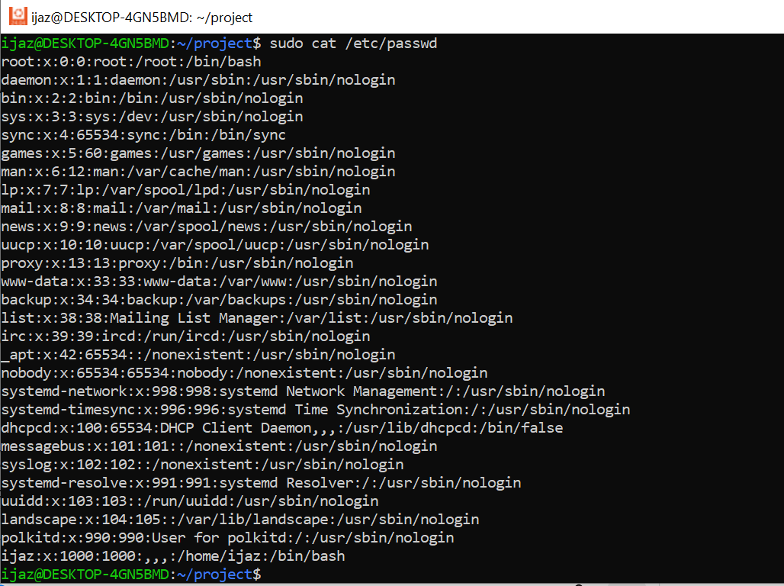

Lock user:

Install docker:

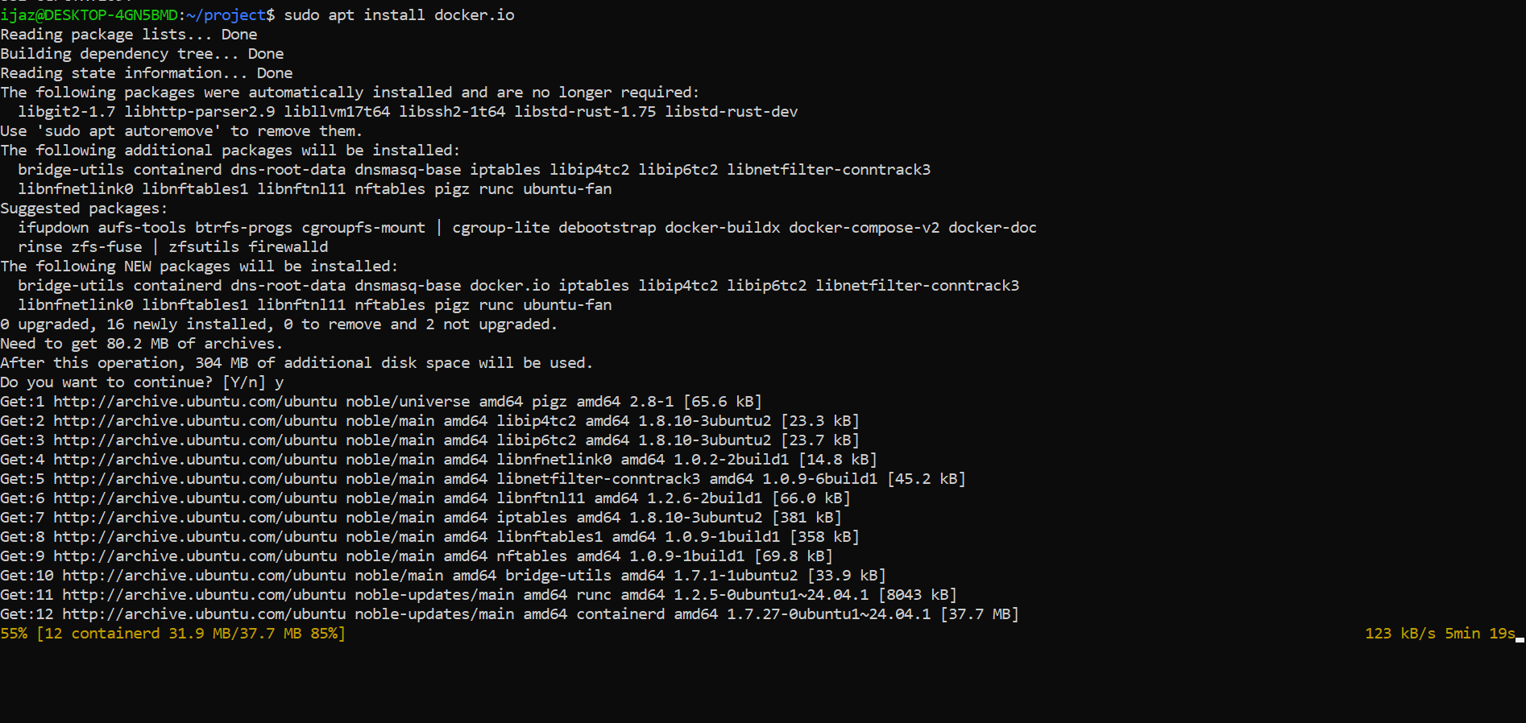

Check htop version:

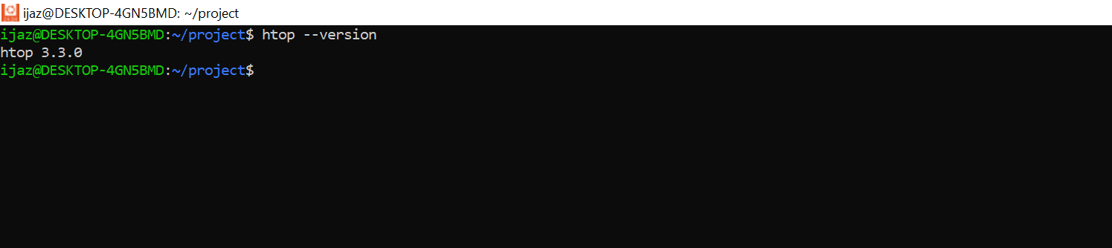

Check ip:

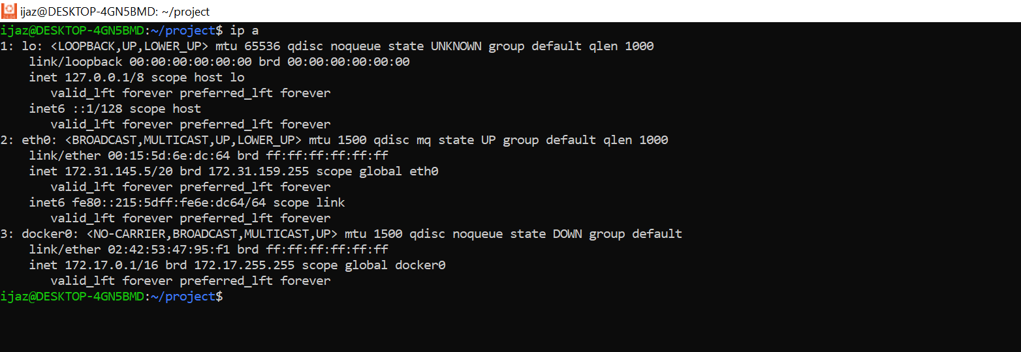

Check ip route:

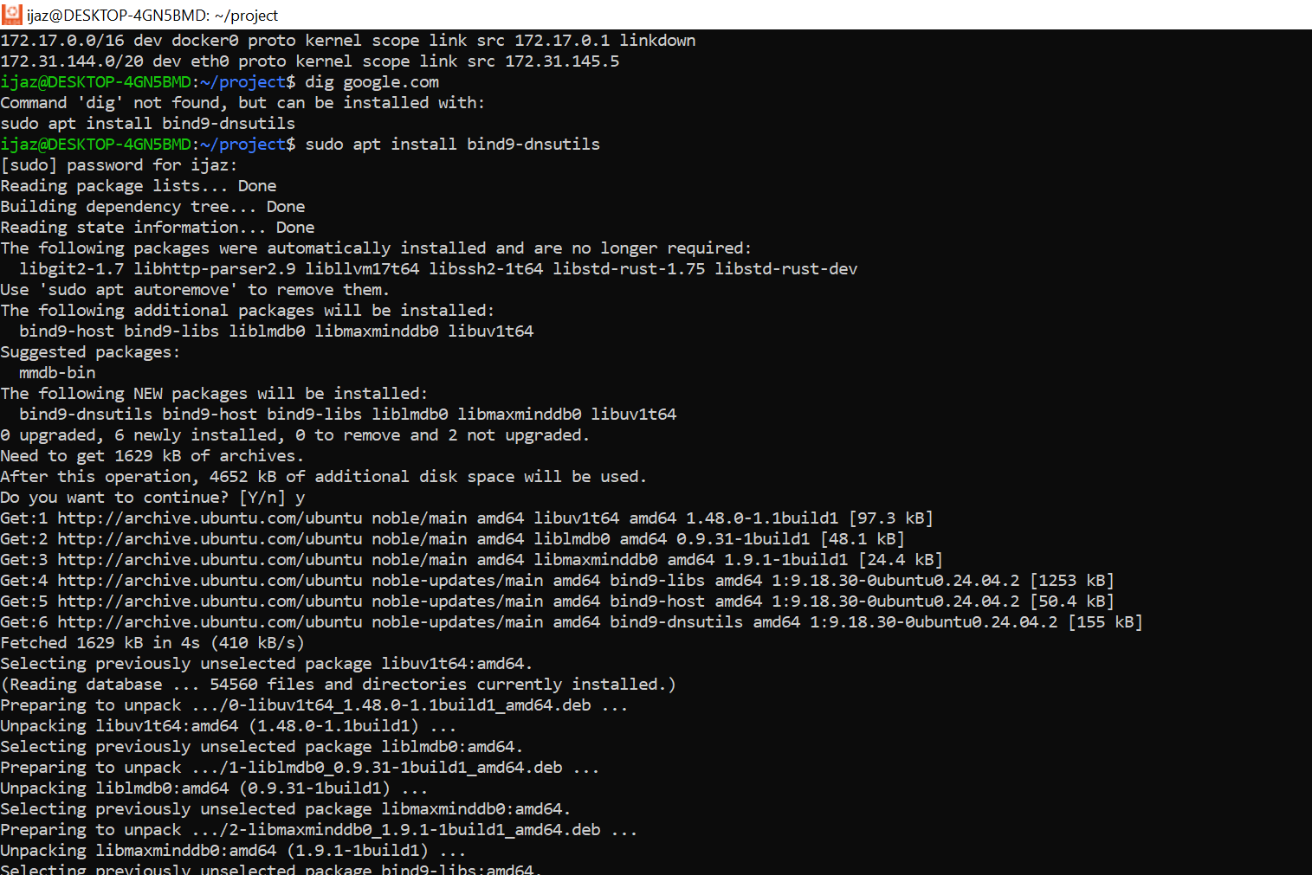

Dig google.com:

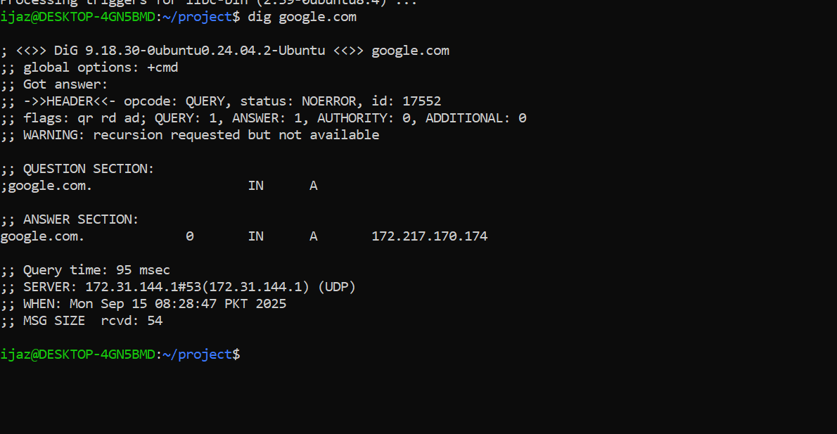

Install nmap:

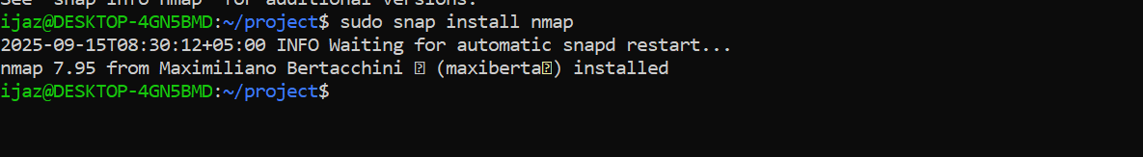

Scan open ports:

Check memory:

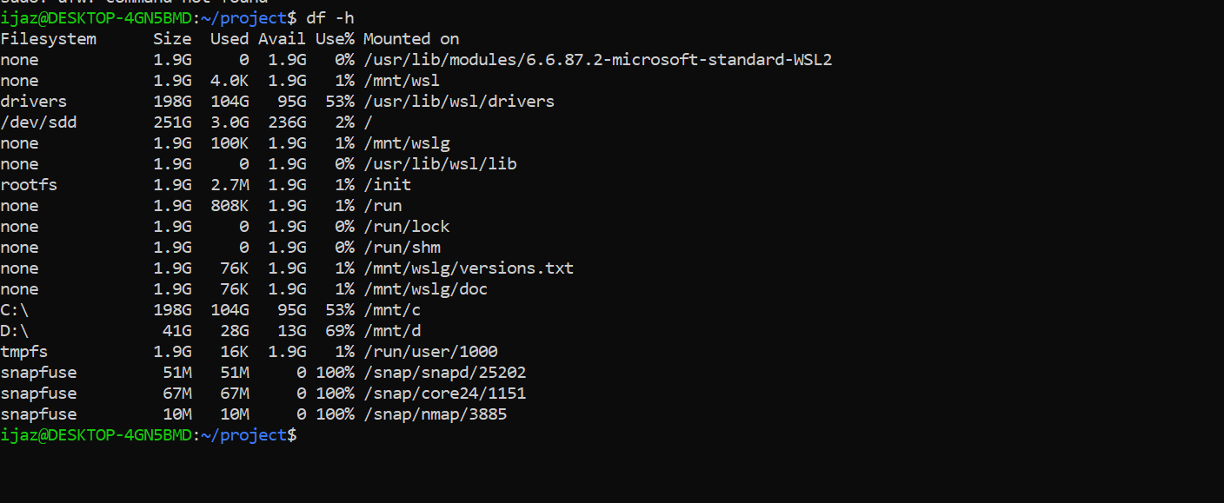

Check size of subdirectories:

List block devices:

