SRS

for

Undergraduate Transfer Management System
Prepared by
Tan Aksu 290201060
Seda Güven 300201064
Buse Toklu 300201009
Mert Güden 300201012
Vepa Altyyev 310201120
Furkan Uğurlu 300201063
Berzan Tan 300201008
Osman Altunbağ 300201015

<organization>
22.11.2025
Revision History

Name | Date | Reason For Changes | Version

Introduction

Purpose
The purpose of this Software Requirements Specification (SRS) is to describe the functional and non-functional requirements for the Undergraduate Transfer Management System (UTMS) for İzmir Institute of Technology (IZTECH). This document is intended for the development team, project stakeholders (Student Affairs, Dean’s Office, Transfer Commission, YDYO), and the client to ensure a shared understanding of the system.

Scope
The UTMS is a web-based platform designed to automate and streamline the horizontal transfer (yatay geçiş) process. The scope includes:
- All system users (Applicant, Transfer Commission, Student Affairs, Dean’s Office, YDYO) can securely log in with email & password, supporting password validation and session management.
- Users can reset forgotten passwords
- Online application submission and document upload for students.
- Applicants can view the real-time status, stages, and results of their transfer applications.
- Automated data retrieval from UBYS, ÖSYM, and YÖKSİS.
- Automated eligibility checks (GPA, Exam Scores) and rule-based validation.
- Approval of document verification for Student Affairs
- Check and manage the verified documents if needed for Student Affairs
- Students can ask their questions to Students Affairs and students affairs can reply to them
- Notification of the status of the student’s application
- Registration and assignment of the roles to the staff for IT
- Integration of the application date and deadline into the system for IT
- Approvement of English proficiency for YDYO
- Announce the English proficiency exam results for YDYO
- Conversion of GPA for Transfer Commision
- Verifying the yks scores for Transfer Commision
- Ability to check the department specific requirements and approving the ranking generated by the system for Transfer Commision
- Digital routing of applications between Student Affairs, Dean’s Offices, and Departments.
- Semi-automated course equivalency (Intibak) mapping interface.
- Automated scoring, ranking, and result announcement with notifications.

Definitions, Acronyms, and Abbreviations
- UTMS: Undergraduate Transfer Management System.
- IZTECH (İYTE): İzmir Institute of Technology.
- ÖİDB (Student Affairs): The administrative unit responsible for student records and initial application processing.
- YGK (Transfer Commission): Departmental committee responsible for academic evaluation and course mapping.
- Intibak: The process of mapping courses from the applicant's previous institution to the IZTECH curriculum.
- YDYO (School of foreign languages): University unit responsible for foreign-language education and proficiency exams.
- GPA (Grade point average): Numeric measure of a student’s overall academic performance.
- YÖK: Higher Education administration.
- YÖKSİS: Higher Education Information System (National Database).
- UBYS: University Information Management System (Internal).
- EBYS: Electronic Document Management System used for official correspondence.

References
İYTE (Izmir Institute of Technology) Regulations
- İzmir Institute of Technology Undergraduate Transfer Procedures and Senate-approved academic policies.
- IZTECH Student Affairs internal guidelines for transfer applications.
YÖK (Council of Higher Education) Regulations
- YÖK Lisans Geçiş (Undergraduate Transfer) Framework.
- Official YÖK regulation on GPA conversion to the 4.0 grading scale.
- YÖK Academic Mobility and Transfer circulars.
YÖKSİS (Higher Education Information System)
- Identity verification and academic record data retrieved from YÖKSİS Web Services.
- Official API specifications and constraints.
ÖSYM (Student Selection and Placement Center)
- YKS (University Entrance Exam) score calculation rules and verification standards.
- ÖSYM documentation regarding score validity and candidate data security.
KVKK (Personal Data Protection Law – Turkey)
- Law No. 6698 on the Protection of Personal Data, especially regarding:
  - Secure storage of personal information
  - Explicit consent and access control
  - Data processing and retention policies

Overview
The rest of this document presents the overall product perspective, user characteristics, functional requirements, and interface specifications for the UTMS system. While this SRS is based on the TO-BE system described in the Problem Analysis Report, it also extends beyond it by including additional requirements and clarifications necessary for the full implementation of the system.

Overall Description

Product Perspective
UTMS is a new, standalone web-based system that replaces the manual, paper-based workflow. It operates within the university's digital ecosystem and interacts with the following entities as shown in the Context Diagram:

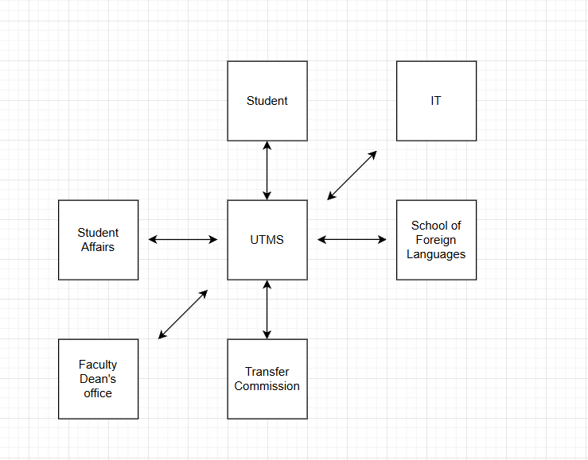
- External Systems: Integrates with YÖKSİS (Academic History), ÖSYM (Exam Scores).
- Internal Systems: Connects with UBYS for transcript data and EBYS for official document routing.

Product Functions
Based on the High-Level Functional Requirements, the major functions are:
1. Applicant Portal
- User registration
- Login & authentication
- Submit transfer application
- Upload missing documents
- Track application status (real-time)
- View results
- Ask questions via system
2. Automation Engine
- Automatic document validation
- GPA conversion using YÖK scale
- Eligibility checks (GPA thresholds, YKS scores, dept. requirements)
- Automated ranking generation
3. Administrative Dashboard (For Student Affairs, Dean’s Office, YDYO, Transfer Commission, IT)
3.1 Student Affairs
- Approve / oversee document verification
- Assign roles to administrative staff
- Manage applicant records
- Q&A support for applicants
- Notify applicants if necessary
3.2 Dean’s Office
- Approve final decisions
- Forward applications to relevant units
3.3 YDYO (School of Foreign Languages)
- Approve English proficiency status
- Announce English proficiency exam results
3.4 Transfer Commission
- Verify YKS scores
- Check department-specific requirements
- Approve ranking generated by the system
- Prepare and approve course equivalency (intibak) tables
3.5 IT Department
- Register and assign roles to staff
- Integrate application dates & deadlines into the system
- Manage system-level configurations

4. Evaluation Module
- Course equivalency (intibak) mapping
- Automated scoring / ranking
- Eligibility decision assistance
- Final decision support for commissions

5. Notification Service
- Email notifications for application updates
- Password reset emails
- Result announcements

User Characteristics
- Applicant (Student): University students capable of using web interfaces; familiar with basic academic terminology, able to understand English.
- Student Affairs Staff: Administrative personnel; require efficient tools for batch processing, document checks notifying results.
- Faculty Dean’s Office: Academic administrators responsible for approving, forwarding, and finalizing transfer-related decisions.
- Transfer Commission (Academic Staff): Faculty members needing detailed transcript views, GPA/YKS data, and tools for course equivalency (intibak) evaluation.
- YDYO (School of Foreign Languages) Staff: Personnel responsible for English proficiency validation, requiring interfaces for exam result entry and student status approval.
- IT Department Staff: Technical staff responsible for role assignment, configuration, system dates, and maintaining platform operability.

Constraints
• Regulatory Compliance:
The system must comply with YÖK regulations (e.g., 4.0 GPA scale conversion), ÖSYM policies, and University Senate rules.
• Deadline Dependency:
The application process is strictly time sensitive. System downtime during the application window is unacceptable.
• File Format Restrictions:
Uploaded documents must follow predefined formats (PDF only) to ensure readability and secure processing.
• Identity Verification Constraint:
System must rely on external identity services (e-Devlet, YÖKSİS). Any downtime in these services directly affects registration and data validation.
• Data Integrity Constraint:
Automated eligibility and ranking calculations must follow deterministic, non-manipulable rules defined by academic regulations.
• Security & Privacy Constraint:
The system must operate over encrypted channels (HTTPS) and comply with KVKK / GDPR-like standards for storing personal data.
• Role-Based Access Constraint:
Only authorized university staff may access applicant data, perform approvals, or view sensitive documents.
• Performance Constraint:
Login, document validation, and status retrieval operations must return results within acceptable time limits (<5 seconds for login, <2 min latency for status updates with 5mbps internet connection).
• System Integration Constraint:
The system depends on real-time or scheduled integrations with UBYS, EBYS, YÖKSİS, and ÖSYM. Their schema and API limitations constrain UTMS functionality.

Assumptions and Dependencies
- Internet Connectivity: All users are assumed to have a stable internet connection with a minimum speed of 5 Mbps, required for login, document uploads, and accessing real-time application status.
- External API Availability: The system depends on uninterrupted access to YÖKSİS, ÖSYM, e-Devlet, and UBYS services. These third-party APIs are assumed to be operational, reachable, and within their normal rate limits during the application period.
- Identity: Applicants possess a valid National ID.
- Compliance With Deadlines: It is assumed that all academic units (Student Affairs, YDYO, Dean’s Office, Commission) will perform reviews within the official university deadlines configured in the system.
- Email Service Reliability: The university SMTP/Email service is assumed to be operational for password resets, notifications.

Apportioning of Requirements
- Must-Have (Release 1 – Critical Requirements)
These features are essential for the transfer process to function and must be delivered in the first release:
- Applicant registration, login, document upload, and application submission
- Real-time status tracking and viewing results
- Automatic document validation, GPA conversion, eligibility checks, and ranking
- Administrative verification tools (Student Affairs, Dean’s Office, Commission)
- Final decision support and publication of results
- Integration with external systems (YÖKSİS, ÖSYM, e-Devlet, UBYS)
- Mandatory constraints: role-based access, HTTPS security, PDF-only uploads, deterministic scoring rules, performance limits

2. Should-Have (Release 2 – Important but Not Critical)
These improve administrative efficiency but are not required for the core transfer flow:
- Staff role assignment and configuration features
- Batch processing tools
- YDYO module for proficiency result entry
- Course equivalency (intibak) preparation tools
- Additional notification types (password reset, clarification messages)

3. Could-Have (Future Releases – Enhancements)
These features enhance usability and long-term maintainability:
- In-system Q&A messaging for applicants
- Analytics dashboards and exportable reports
- Automated reminders and extended configuration options
- Performance optimizations for large applicant pools

Specific Requirements
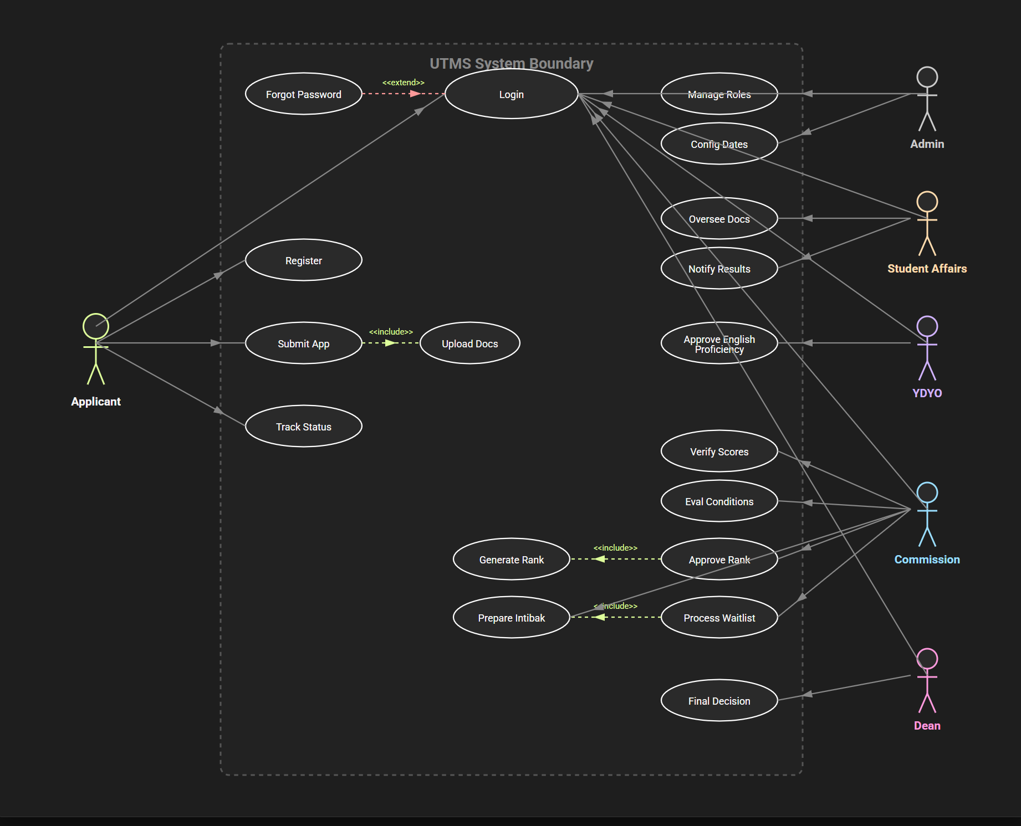

Use Cases

Use Cases for all users (general)

Use Case LOGIN for all users

Use Case template LOGIN
Use Case ID: | UC-01-01(all ids are highlighted)
Use Case Name: | LOGIN
Created By: | Group-6 | Last Updated By:
Date Created: | 13.11.2025 | Date Last Updated: | 13.11.2025

Actor: | Applicant, Transfer Commission, Student Affairs, Dean’s Office
Description: | Login system for everyone uses the system into UTMS system by registered account.
Preconditions: | PRE1. The user has a registered account.  PRE2. Transfer period has started.  PRE3. User has a stable internet connection at least 5Mbps.
Postconditions: | POST1. User is successfully authenticated.  POST2. Directed to related User-Interface.
Priority: | High Priority
Frequency of Use: | Very Frequent
Normal Course of Events: | 1- User navigates to UTMS login page.  2- User chooses login via registered e-mail and password combination.  3- User enters registered e-mail.  4- User enters password.  5- User clicks “Login”.  6- System validates the credentials.  7- System logs the user in.  8- System redirects the user to related User-Interface.
Alternative Courses: | UC-01-01.AC-01: Forgot Password Flow  2A:  At Step 2, user selects “Forgot Password.”  System asks for user’s registered email.  User enters email.  System sends a password reset link to the email.  User resets the password and returns to login page.  UC-01-01.AC-02: Incorrect Credentials  6A:  User tries to login with wrong e-mail password combination.  credentials do not match.  System displays “Incorrect email or password” error.  System returns user to login page.  User attempts login again.
Exceptions: | UC-01-01.EX-01 System shutdown.  During any step, if the system becomes unavailable,  1. System shows maintenance / unavailable message  2. Login process terminates.  UC-01-01.EX-02 Transfer period has ended.  At Step 1 or Step 2, if the transfer period has ended,  1. System blocks login for Applicant role  2. Displays “Transfer Period Has Ended.”  3. Commission and administrative actors may still proceed.  UC-01-01.EX-03 User loses network connection.  During any step requiring network verification,  1. System displays “Network Error. Please check your connection.”  2. Process returns to Step 1.
Includes: | INC1. User validation.  INC2. UC-02-04 Forget Password
Special Requirements: | SR1. Authentication Protocol Requirement  The system shall authenticate all actors through OAuth 2.0 Authorization Code Flow.  SR2. Secure Transmission Requirement  All login credentials shall be transmitted via HTTPS secured with TLS 1.2 or higher.  SR3. Password Storage Requirement  Passwords shall be stored only in hashed and salted form using a cryptographic one-way hashing algorithm (e.g., bcrypt/Argon2).  SR4. Session Security Requirement  After successful login, the system shall issue a Secure, HttpOnly session token to prevent client-side access or script injection.  SR5. Account Protection Requirement  After 5 failed login attempts, the system shall temporarily lock the account and prevent additional attempts for a defined security timeout period.  SR6. Privacy Requirement  Error messages shall be generic and shall not reveal whether the entered email exists in the system.
Assumptions: | 1- Applicant has a network connection at least 5 Mbps which is stable.
Notes and Issues: | Multi-factor authentication could be added. Forgot the password could have SMS reset option.

User Interface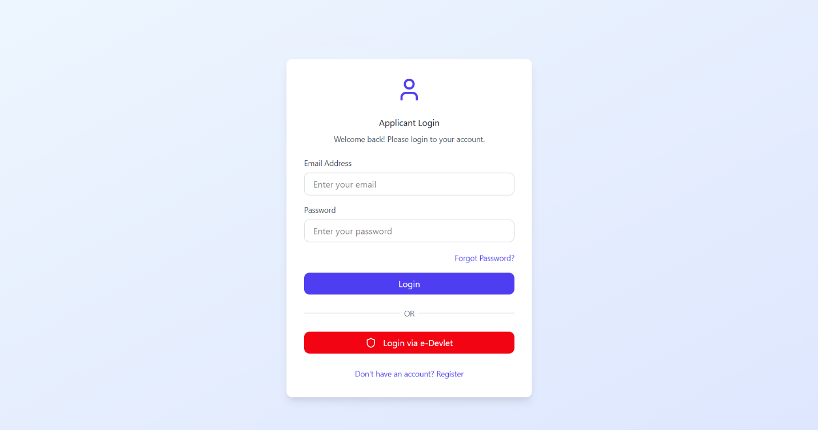

Performance/Software quality requirements
• The system shall process 95% of all login requests within 5 seconds under normal load.
• The system shall display incorrect credential error messages within 2 seconds.
• The authentication subsystem shall support at least 1,000 concurrent login requests without degradation.
• During peak load (e.g., start of transfer period), the system shall handle up to 5,000 login attempts per minute with a maximum response time of 8 seconds.
• The login service shall maintain at least 99.5% availability during the transfer period.
• The system shall operate correctly for users with a minimum stable internet connection of 5 Mbps.
• The system shall ensure that authentication logs are written and stored without causing delays in login processing.
• The backend infrastructure shall scale automatically or elastically during periods of increased traffic to maintain required response times.
• The system shall ensure that session creation and token issuance do not exceed 1 second of processing time.
• The system shall be able to recover from a partial service interruption and resume authentication functionality within 30 seconds after restoration.

Use Case Forget Password for Applicant

Use Case template Forget Password
Use Case ID: | UC-01-02
Use Case Name: | Forget Password
Created By: | Team-6 | Last Updated By:
Date Created: | 18.11.2025 | Date Last Updated: | 18.11.2025

Actor: | Applicant, Transfer Commission, Student Affairs, Dean’s Office
Description: | Allows users who have forgotten their password to reset it via email verification.
Preconditions: | PRE1. User must have a registered account with a valid email address.
Postconditions: | PRE2. User's password is updated, and they can log in with the new credentials.
Priority: | High
Frequency of Use: | Low
Normal Course of Events: | 1. User clicks "Forgot Password" on the login screen.  2. System requests the registered email address.  3. User enters the registered email address.  4. System checks database; if valid, sends a reset link with a time-limited token.  5. User clicks the link in the email.  6. System validates the token and displays the "New Password" screen.  7. User enters a new password and confirms it.  8. System updates the password and redirects to Login.
Alternative Courses: | UC-01-02.AC-01: Registered Email Not Found  3A. At Step 3, the user enters an email address that is not registered in the system.  4A. The system displays a generic message:  “If this email is registered, a password reset link has been sent.”  (to avoid user enumeration)  5A. The user is returned to the Login Page.  6A. Flow terminates.  5A: Expired Reset Link (Süresi Dolmuş Link)  UC-01-02.AC-02: Expired Reset Link  5A. At Step 5, the user clicks the password reset link after the token validity period (e.g., 30 minutes) has expired.  6A. The system displays an error message: “This link has expired.”  7A. The system redirects the user back to the Forgot Password page to request a new link.  8A. Flow continues at Normal Flow Step 1.
Exceptions: | UC-01-02.EX-01: Email Not Registered  The entered email does not match any user account.  The system displays a generic message to prevent account enumeration.  The user returns to the Forgot Password page.  Flow terminates.  UC-01-02.EX-02: Expired Token  The password reset token is expired.  The system prompts the user to request a new reset link.  Flow returns to Normal Flow Step 1.
Includes:
Special Requirements: | SR1. Token Validity: The password reset link must contain a unique, one-time-use token that expires after a specific time (e.g., 15 or 30 minutes).  SR2. Password Complexity: The new password must meet the system's security policies (min. 8 characters, alphanumeric, special char) as defined in UC-01.  SR3. Secure Transmission: All data (email, new password) must be transmitted over an encrypted connection (HTTPS).
Assumptions: | 1. Access to Email: The applicant has access to the email address currently registered in the system.  2. Email Service Availability: The university's email server (SMTP) is operational and capable of sending external emails without delay.
Notes and Issues: | 1. SMS Option: As noted in the Login analysis, a multi-factor option could be added. "Forgot the password could have SMS reset option" for users who lost email access.

User Interface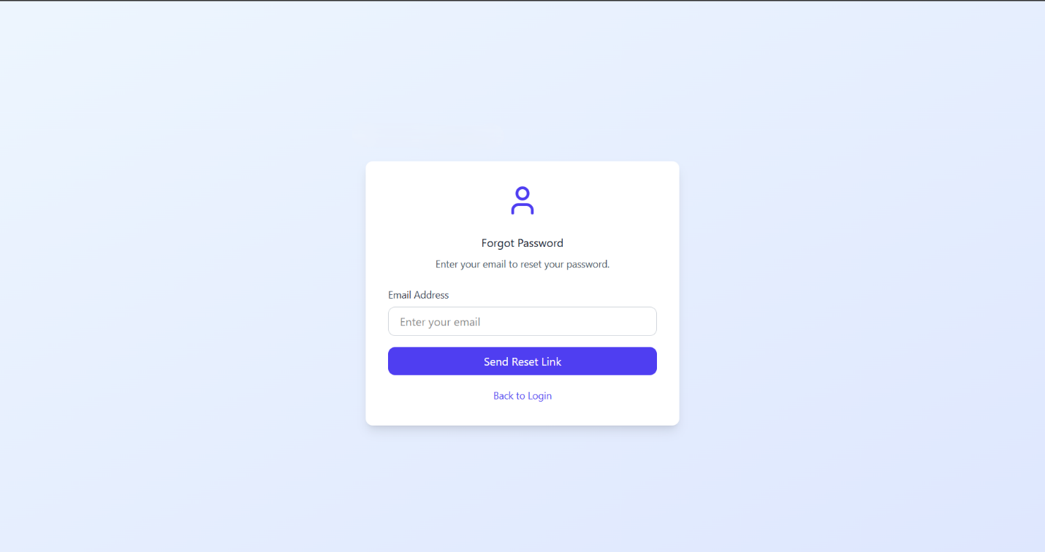

Performance / Software Quality requirements
• The system must send the password reset email within 10 seconds after the user submits their email.
• Token validation (checking if the reset link is valid or expired) must complete within 2 seconds.
• The “New Password” screen must load within 3 seconds after the user clicks the reset link.
• The system must support at least 200 concurrent password reset requests without performance degradation.
• The password update process must complete within 2 seconds after the user submits the new password.
- User must at least have 5Mbps stable internet connection for above requirements

Use Cases for Applicant

Use Case Register for user Applicant

Use case template Register
Use Case ID: | UC-02-01
Use Case Name: | Register to System
Created By: | Team-06 | Last Updated By:
Date Created: | 17.11.2025 | Date Last Updated: | 18.11.2025

Actor: | Applicant
Description: | The applicant creates a new account in the online portal to initiate the transfer process. After verifying identity, the applicant completes the registration form and activates their account via email verification to become eligible to initiate a transfer application.
Preconditions: | PRE1. The applicant must not have an existing active account.  PRE2. The applicant must have a valid National or Foreign ID.
Postconditions: | POST1. Applicant account is created and activated.  POST2. A unique user profile is created in the database.  POST3. Applicant can log in to the system.
Priority: | High
Frequency of Use: | Once per applicant.
Normal Course of Events: | 1. Applicant selects “Register” on the portal login page.  2. System prompts for National ID, Date of Birth, and University Email.  3. Applicant enters National ID.  4. Applicant enters Date of Birth.  5. Applicant enters University Email address.  7. Applicant enters password and confirms it.  8. System validates the inputs and checks for duplicate accounts.  9. System creates the account.  10. System sends a verification email.  11. Applicant verifies the email.  12. System logs the applicant in.  13. System redirects the applicant to the Applicant Dashboard.
Alternative Courses: | UC-02-01.AC-01: Duplicate Account Found  9A. At Step 9, system detects that an account already exists with the same National ID or University Email.  10A. System displays “An account with this information already exists.”  11A. System redirects applicant to Login page.
Exceptions: | UC-02-01.EX.1: Existing User  If the entered National ID or Email is already registered, the system displays "Account already exists" and redirects to the login page.
Includes: | INC1. email verification
Special Requirements: | SR1. Unique Account Constraint  The system must ensure that each National ID and University Email is associated with at most one active applicant account.  SR2. Password Complexity  The password created during registration must comply with the system’s password policy:  - Minimum 8 characters  - Must contain at least one uppercase letter, one digit, and one special character.
Assumptions: | A1. The applicant has uninterrupted internet access while completing the registration steps, especially during external identity verification and email activation.
Notes and Issues:

User Interface
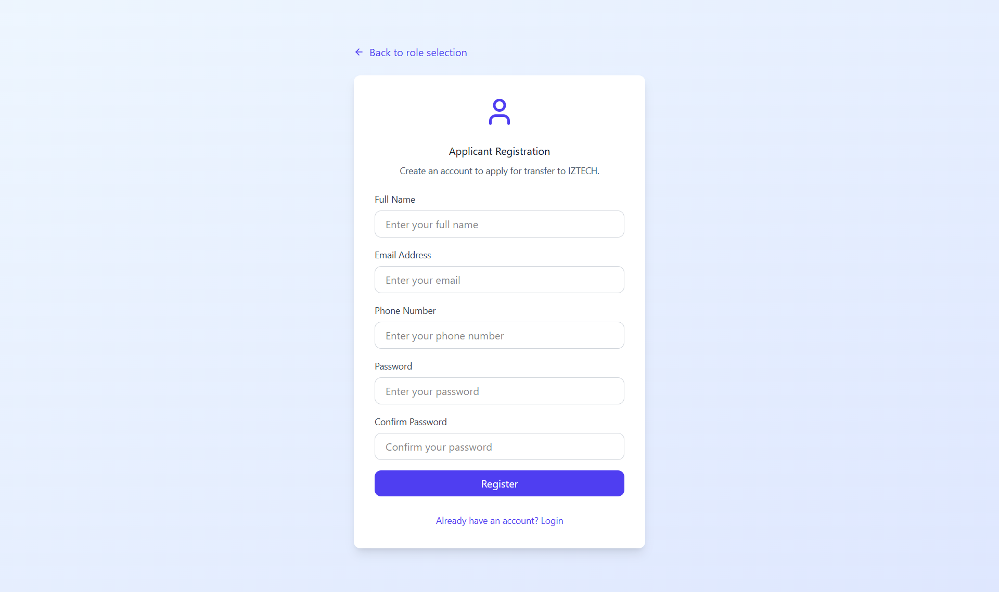

Performance / Software Quality Requirements
• The registration process (form submission → account creation) must complete within 5 seconds.
• Duplicate account check (National ID / University Email) must finish within 2 seconds.
• The verification email must be sent within 10 seconds after the account is created.
• The system must support at least 300 concurrent registration requests without performance degradation.
- The user must have at least 5Mbps for the requirements above

Use case Submit Transfer Application for Applicant

Use case template submit transfer application
Use Case ID: | UC-02-02
Use Case Name: | Submit Transfer Application
Created By: | Team-06 | Last Updated By:
Date Created: | 17.11.2025 | Date Last Updated: | 18.11.2025

Actor: | Applicant
Description: | The applicant submits a transfer application by validating automatically retrieved data and uploading any missing required documents.
Preconditions: | PRE1. Applicant is logged in.  PRE2. Application window is open.
Postconditions: | POST1. Application status is updated to "Under Review”  POST2. System initiates automated eligibility checks
Priority: | Critical
Frequency of Use: | Once per cycle per student
Normal Course of Events: | 1. Applicant clicks "New Application" and selects the target program.  2. System connects to external APIs (UBYS, ÖSYM, YÖKSİS) to fetch academic records.  3. Applicant reviews the data automatically retrieved by the system (YKS score, Transcript).  4. System performs automated document validation (format, completeness) and prompts applicant to upload missing mandatory documents.  5. Applicant uploads missing documents (e.g., Language Certificate) if not retrieved automatically.  6. System validates the files and confirms completeness.  7. Applicant confirms and submits the application.  8. System records the application and provides a tracking reference number.
Alternative Courses:
Exceptions: | UC-02-02.EX.1: Eligibility Failure (Automated Check)  If the system detects that the applicant's GPA or exam score does not meet the defined rules/thresholds, it prevents submission and displays the specific reason for ineligibility immediately.  UC-02-02.EX.2: Invalid Document Format  If the applicant attempts to upload a document in an unsupported format (e.g., uploading a .exe or .jpg file when .pdf is required), the system detects the format mismatch during validation. The system rejects the upload, displays an error message (e.g., "Invalid file format. Please upload a PDF file.") and prevents the application from proceeding until a valid file is provided.
Includes:
Special Requirements: | System must support file formats.
Assumptions:
Notes and Issues:

User interface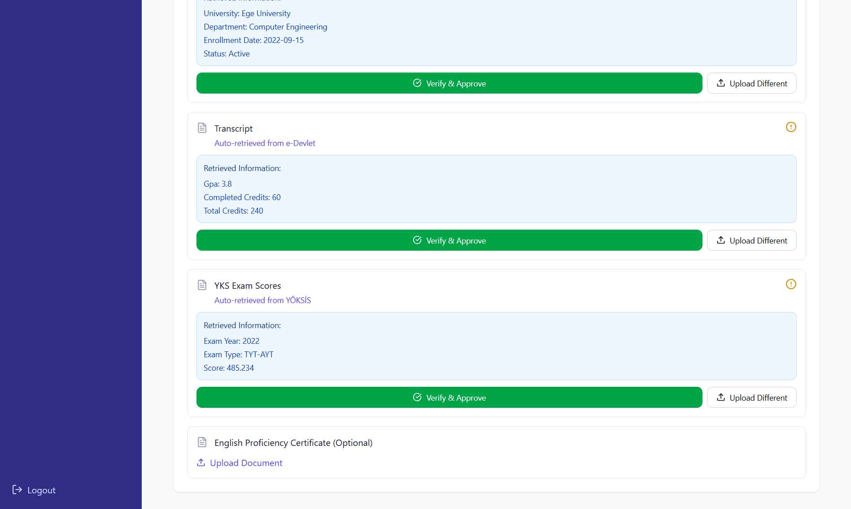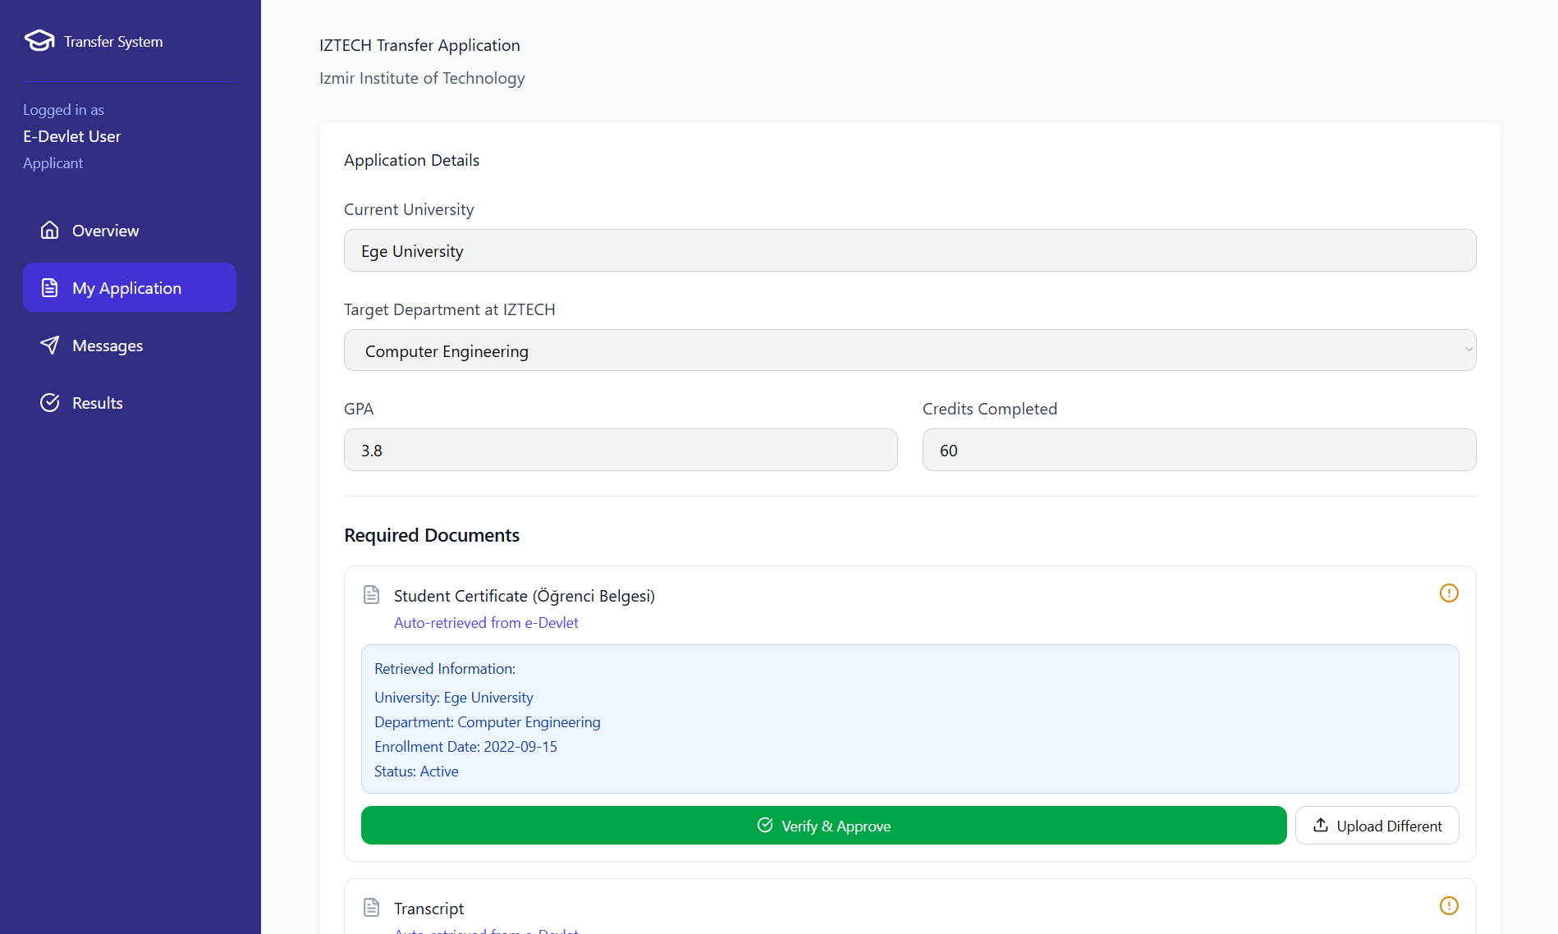

Performance / Software Quality requirements
• External API data retrieval (UBYS, ÖSYM, YÖKSİS) must complete within 10 seconds under normal load.
• Document upload and validation (format + completeness) must finish within 5 seconds per file.
• Automated eligibility checks (GPA, exam score rules) must execute within 3 seconds after submission.
• The system must handle at least 200 concurrent application submissions without performance degradation.
• The application record must be stored in the database and a tracking number generated within 2 seconds after submission.
  - The user must have at least 5Mbps for the requirements above

Use Case Track Application Status for Applicant

Use case template track application status
Use Case ID: | UC-02-03
Use Case Name: | Track Application Status
Created By: | Team-6 | Last Updated By:
Date Created: | 18.11.2025 | Date Last Updated: | 18.11.2025

Actor: | Applicant
Description: | To allow the applicant to log in and view the real-time status, current stage (e.g., Document Verification, English Proficiency Check, Evaluation, Result Announcement), and the final outcome (Primary/Waitlisted/Rejected) of their transfer application.
Preconditions: | PRE1. The student must be registered in the system and have submitted at least one application.  PRE2. The student must be successfully logged into the system.
Postconditions: | POST1. The student is informed about the up-to-date status of their application.
Priority: | High
Frequency of Use: | Frequent
Normal Course of Events: | 1. The student clicks on the "My Applications" tab on the main dashboard.  2. The system lists all current and past applications of the student.  3. The student finds the relevant application and clicks the "View Status" button.  4. The system displays the application details page.  5. The system shows a dynamic progress bar indicating the current status (e.g., "Under Evaluation") and highlights completed stages. 6. If the process is finalized, the system displays the final result (Accepted/Waitlisted/Rejected).
Alternative Courses: | UC-02-03.AC-01: Viewing an Archived Application  3A. At Step 3, the applicant selects an Archived or Past Semester application instead of an active one.  4A. The system opens the application details page in read-only mode.  5A. The system displays completed stages but disables modification options.  6A. Flow continues at Normal Flow Step 4.  UC-02-03.AC-02: Application Status = Rejected  6A. At Step 6, if the application status is Rejected, the system displays the rejection reason in red text.  7A. No further actions are allowed for this application.  8A. Flow terminates.  UC-02-03.AC-03: Application Status = Missing Documents  6B. At Step 6, if the application status is Missing Documents, the system displays a warning.  7B. The system provides a button for uploading missing files.  8B. After the upload, the system updates the status and flow continues at Normal Flow Step 5.
Exceptions: | UC-02-03.EX-01: Database Connection Error  Triggered at Step 2 or Step 4.  The system cannot retrieve application data due to database connection failure.  The system displays: "Unable to retrieve application information. Please try again later."  Flow terminates.  UC-02-03.EX-02: Network Connection Lost  Triggered at any step requiring a server response.  The system displays: "Network error. Please check your internet connection."  User is returned to Normal Flow Step 1.  UC-02-03.EX-03: Session Timeout  Triggered after prolonged inactivity.  The system redirects the applicant to the Login Page with the message:"Session expired. Please log in again."  Flow terminates.
Includes:
Special Requirements: | SR1. Real Time status refresh: Status updates must be reflected in real-time (under 2 minutes latency).
Assumptions: | 1. Operational Backend Services: The backend services (ÖİDB interface) are operational to fetch the latest status.  2. Stable Connectivity: Applicant has a stable internet connection.
Notes and Issues: | Future Enhancement: Download Result Document button directly on the result screen can be added.

User Interface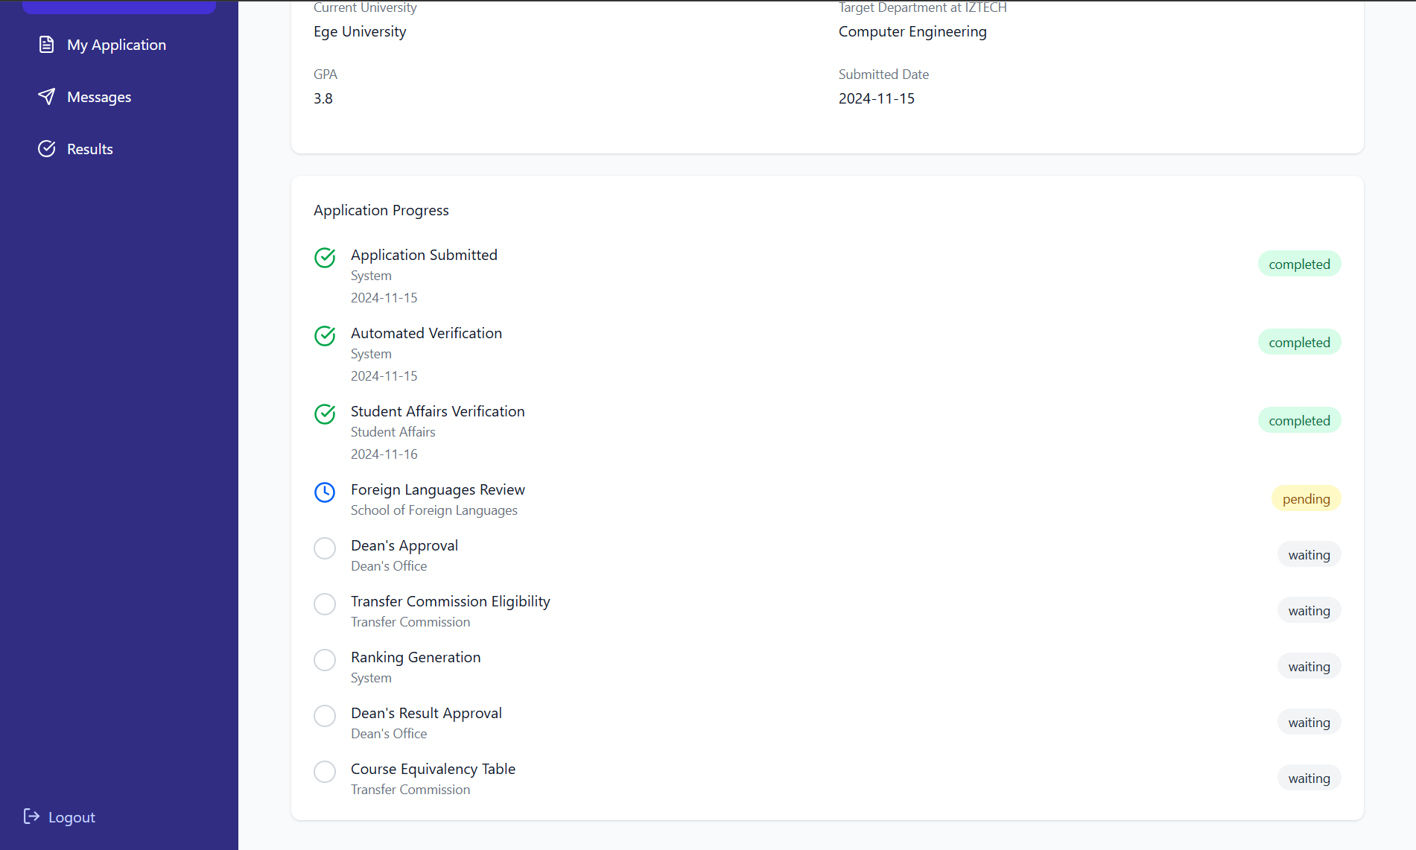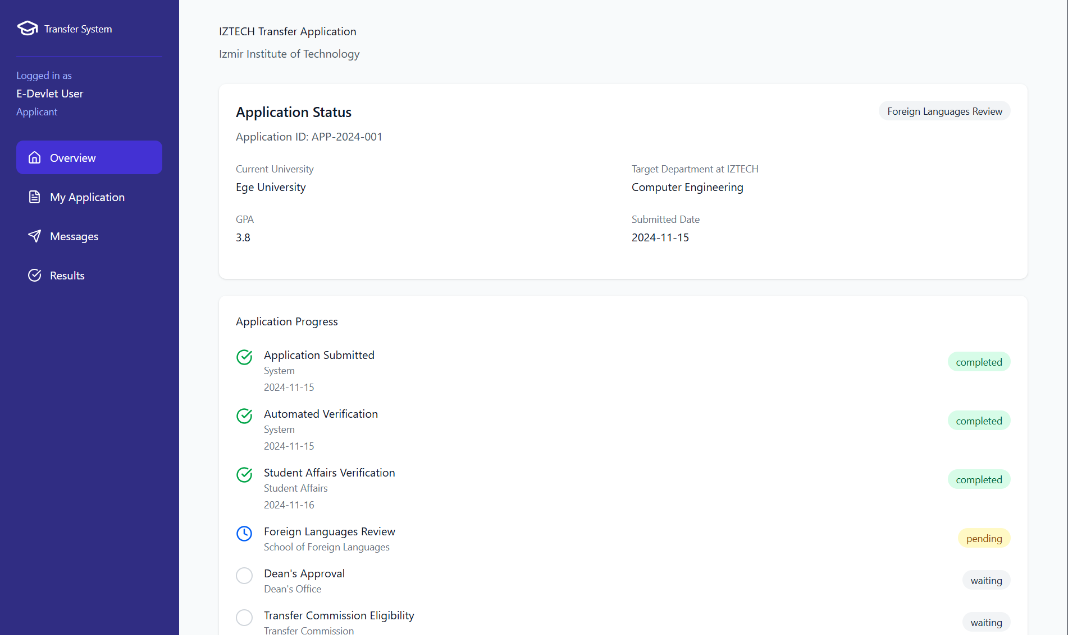

Performance/Software Quality requirements
• Loading the “My Applications” list must complete within 3 seconds under normal load.
• Loading the application details page and progress bar must complete within 3 seconds.
• Status changes in the backend must be reflected on the UI within 2 minutes (real-time update latency).
• The system must support at least 500 concurrent status view requests without performance degradation.
• The status tracking feature must maintain at least 99.5% availability during the active evaluation/decision period.

Use Case for Student Affairs

Use Case Oversee Application Documents for Student affairs

Use Case template Oversee Application Documents
Use Case ID: | UC-03-01
Use Case Name: | Oversee Application Documents
Created By: | Team-6 | Last Updated By:
Date Created: | 22.11.2025 | Date Last Updated: | 22.11.2025

Actor: | Student Affairs Officer (ÖİDB)
Description: | The officer reviews applications processed by the system's automated validation, either approving them for the next stage or requesting corrections from the student for issues like blurred or incorrect documents.
Preconditions: | PRE1. Applications have been submitted by students.  PRE2. Automated validation has been performed.
Postconditions: | POST1. The application status is updated to "Verified", "Rejected", or "Correction Requested".
Priority: | High
Frequency of Use: | Daily during application period
Normal Course of Events: | 1- User navigates to the "Applications Management" dashboard.  2- User displays applications.  3- User selects a specific application to view details.  4- System displays the applicant's data and uploaded documents alongside the automated validation results.  5- User reviews the documents and confirms they meet the criteria.  6- User clicks "Approve Verification".  7- System updates the application status to "Verified" and routes it to the relevant Faculty/Department.  8- System notifies the applicant of successful verification.
Alternative Courses: | UC-03-01.AC-01: Request Correction  6A: At Step 6 in the Normal Course, instead of clicking “Approve Verification”:  6A.1 User identifies an issue in the document (e.g., blurred transcript, missing page, wrong file).  6A.2 User clicks “Request Correction.”  6A.3 User writes a note explaining the issue (e.g., “Please upload a clearer scan of your transcript.”).  6A.4 System updates the application status to Correction Requested.  6A.5 System sends a notification to the student to re-upload the corrected document within the specified timeframe.  UC-03-01.AC-02: Reject Application  6B: At Step 6 in the Normal Course, if the issue is critical or the correction deadline has passed:  6B.1 User clicks “Reject Application.”  6B.2 User selects a rejection reason code from the predefined list.  6B.3 System updates the application status to Rejected.  6B.4 System notifies the student that the application has been rejected.
Exceptions: | UC-03-01.EX-01: Corrupted Document File  If the uploaded file cannot be opened or displayed:  - System displays “Document Cannot Be Viewed – File May Be Corrupted.”  - User returns to the previous step or requests the student to re-upload the document.
Includes: | None
Special Requirements: | SR1. In-Browser Preview: The system must provide a built-in document viewer (PDF/Image) to allow staff to review files without downloading them to the local machine.  SR2. Audit Logging: Every action taken by the staff (Verify, Reject, Request Correction) must be logged with a timestamp and user ID for security auditing.  SR3. Data Privacy: Access to student documents must be restricted strictly to authorized personnel in compliance with KVKK.
Assumptions: | 1. Trained Verification Staff: The staff member has received training on the document verification criteria.  2. Functional Automated Validation: The automated validation system is functioning correctly and filtering out clearly invalid file types before this stage.
Notes and Issues: | Future Enhancement: OCR (Optical Character Recognition) could be integrated to automatically highlight GPA and University Name on the transcripts to speed up the manual review.

User Interface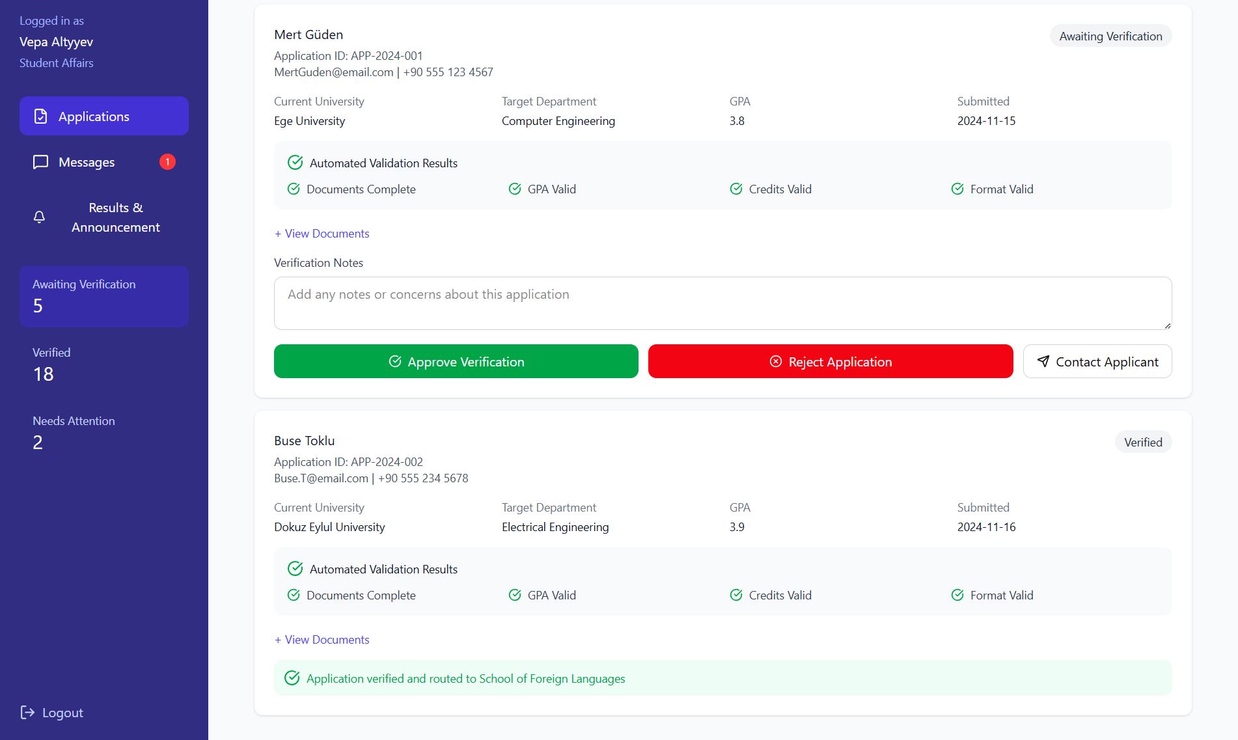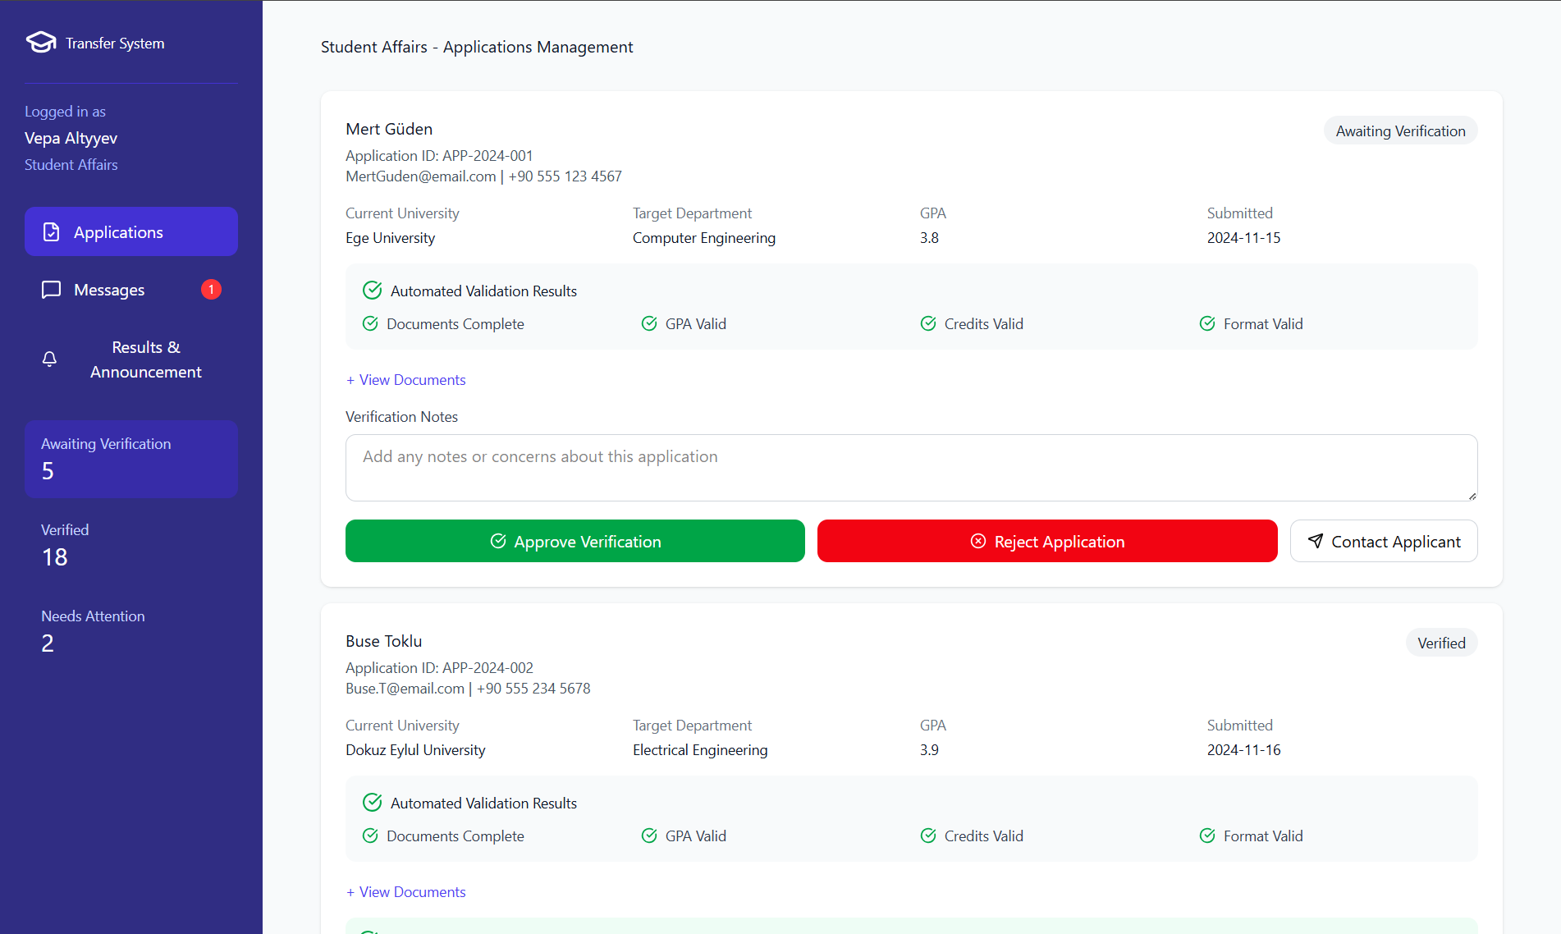

Performance / Software Quality requirements
• Document preview (PDF/Image viewer) must load within 3 seconds after the officer opens the application.
• Automated validation results must be fetched and displayed within 2 seconds when opening the application details.
• Status updates (Verified / Rejected / Correction Requested) must be processed and saved within 2 seconds after the officer takes an action.
• The system must support at least 200 concurrent document review operations without performance degradation.
• Notifications to students (verification, rejection, correction request) must be sent within 5 seconds after the status change is saved.
- User must have at least 5 Mbps stable internet connection

Use Case notify transfer results for Student affairs

Use case template notify transfer results
Use Case ID: | UC-03-02
Use Case Name: | Notify Transfer Results
Created By: | Team-6 | Last Updated By:
Date Created: | 22.11.2025 | Date Last Updated: | 22.11.2025

Actor: | Student Affairs Officer (ÖİDB)
Description: | The officer formally announces the final transfer results after they have been approved by the Faculty Dean's Office, making them visible to students and triggering notifications.
Preconditions: | PRE1. Final decisions have been recorded by the Dean's Office.  PRE2. Results are in "Pending Publication" status.
Postconditions: | POST1. Results are public, students are notified, and the process is closed.
Priority: | Critical
Frequency of Use: | Once per semester (at the end of the process)
Normal Course of Events: | 1- User navigates to the "Results & Announcement" tab.  2- User reviews the finalized lists of Primary (Asil) and Waitlisted (Yedek) candidates received from Faculties.  3- User clicks the "Notify Results" button.  4- System asks for final confirmation.  5- User confirms the action.  6- System updates the status of all applications to "Announced".  7- System sends automated Email notifications to all applicants regarding their result.  8- System makes the lists visible on the applicant’s page.
Alternative Courses: | None
Exceptions: | UC-03-02.EX-01 – Notification Service Failure  At Step 7, if the Email service fails, the system retries sending notifications automatically.
Includes: | None
Special Requirements: | SR1.Bulk Notification Performance: The system must be capable of sending notification emails to all applicants (approx. 500-1000 users) within 5 minutes of publication.  SR2.Audit Logging: The exact timestamp and the User ID of the officer who clicked "Publish" must be irrevertibly recorded for legal accountability.  SR3.Data Consistency: The published list must exactly match the "Asil/Yedek" lists approved by the Faculty Board; no manual edits should be allowed at this stage.
Assumptions: | 1. Finalized Faculty Board Decisions: All Faculty Board decisions have been correctly entered and finalized in the system by the Dean's Office.  2. Operational Notification Services: The university's Email (SMTP) and gateway services are operational.
Notes and Issues: | Future Enhancement: Integration with e-Devlet could be added to allow students to query their results directly through the national gateway.

User Interface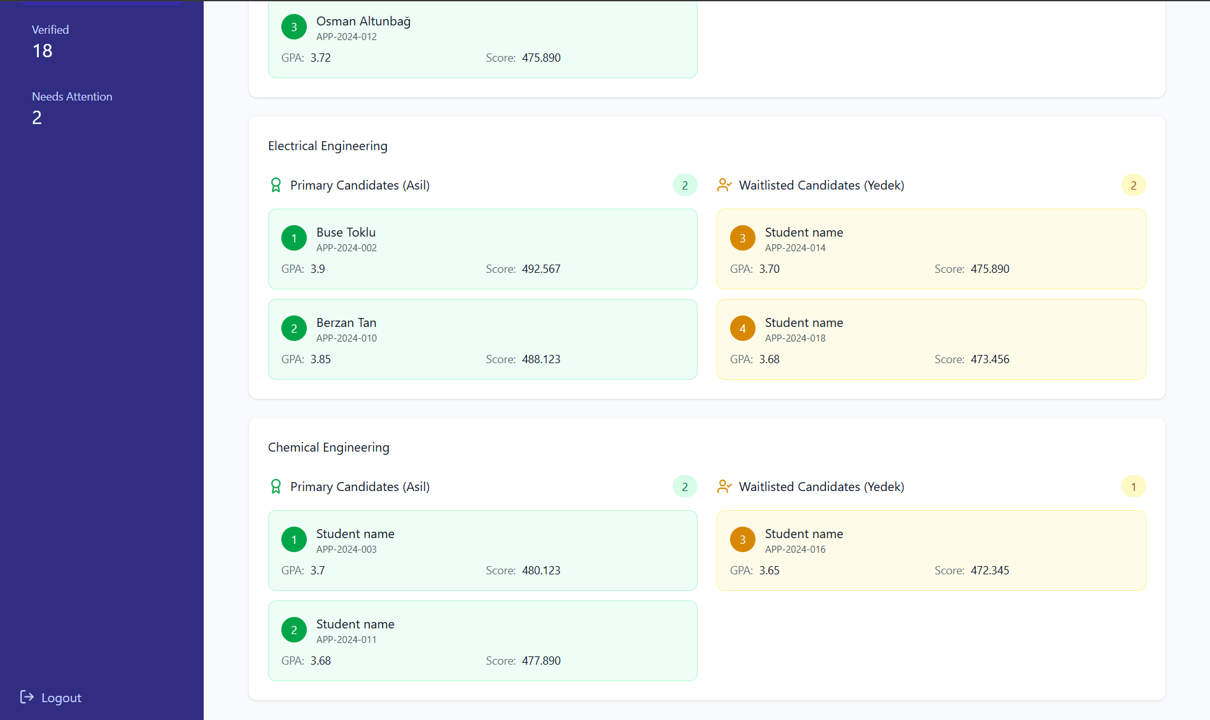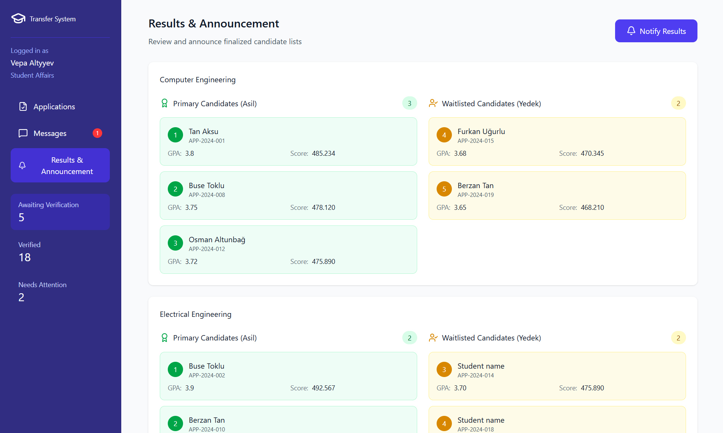

Performance / software Quality requirements
• Bulk result publication (updating all application statuses to “Announced”) must complete within 10 seconds after the officer confirms.
• Email notifications must be triggered and queued for delivery within 5 seconds after publication begins.
• The system must support publishing results for up to 1,000 applicants concurrently without performance degradation.
• Applicant result pages must reflect updated statuses within 30 seconds of publication.
• The “Results & Announcement” interface must load finalized lists within 3 seconds when accessed by the officer.
- User must have atleast 5Mbps stable internet connection

Use cases for Transfer Committee (YGK)

3.1.4.1 Use Case for Verify Entrance Scores and Convert GPA

3.1.4.1.1Use case template Verify Entrance Scores and Convert GPA
Use Case ID: | UC-04-01
Use Case Name: | Verify Entrance Scores and Convert GPA
Created By: | Team-6 | Last Updated By:
Date Created: | 22.11.2025 | Date Last Updated:

Actor: | Transfer Committee (YGK)
Description: | The YGK member retrieves the applicant’s ÖSYS/YKS entrance exam scores to verify eligibility against national thresholds and validates the automated GPA conversion (YÖK scale) to determine the final ranking score.
Preconditions: | PRE1. The applicant has uploaded the required "ÖSYS/YKS Result Document" and "Transcript" via the portal.  PRE2. The Student Affairs Office (ÖİDB) has validated the transcript and routed the application to the Faculty.  PRE3. The Faculty Dean’s Office has assigned the application to the specific Department (YGK).  PRE4. The YÖK GPA conversion table and Department Base Scores (Taban Puanları) are loaded and active in the system.
Postconditions: | POST1. The applicant’s entrance exam score and GPA are verified, converted to the 100-point scale, and locked in the system.  POST2. The entrance exam score and converted GPA is validated and electronically submitted to the Dean’s Office.
Priority: | High
Frequency of Use: | Once per application period
Normal Course of Events: | - The Transfer Committee (YGK) member selects an application from the "Pending Evaluation" list.  - The System retrieves the applicant's data and displays the Evaluation Dashboard, showing the uploaded transcript alongside the automated data fields.  - The System automatically identifies the applicant's declared GPA and applies the YÖK 4.0–100 conversion scale rules to calculate the standardized score.  - The Actor views the uploaded "Transcript" and "ÖSYS/YKS Result Document" to visually confirm the GPA matches the document and the declared score matches the official document.  - If both the Entrance Score and GPA match the documents, the Actor clicks the "Verify & Confirm" button.  - The System locks the values, marks the application as "Verified," and updates the status to "Ready for Ranking."
Alternative Courses: | UC.AC01: Data Discrepancy (Correction)  4A/6A. If the Actor sees a mismatch between the declared data and the uploaded PDF (e.g., typo or false declaration):  1. Actor selects "Edit Score/GPA".  2. Actor manually enters the correct value shown on the PDF.  3. Actor adds a "Correction Note".  4. System updates the value and re-calculates eligibility.  UC.AC02: Applicant Ineligible (Score Below Threshold)  3A. If the verified score is lower than the department's minimum base score:  3A.1 System flags the application as "Ineligible".  3A.2 Actor confirms the rejection.  3A.3 System updates status to "Rejected".
Exceptions: | UC-3.2.EX.1: Unrecognized Grading Scale  Condition: The applicant's transcript uses a non-standard scale not defined in the YÖK table.  Response: System flags the GPA as "Requires Manual Calculation" and alerts the Actor to perform a manual conversion based on YÖK rules.
Includes: | None
Special Requirements: | SR1. Year Check: The Actor must ensure the uploaded Exam Result Document belongs to the correct placement year declared by the student.  SR2. Audit Trail: Any manual correction made by the Actor (changing the student's declared score) must be logged with the Actor's ID and timestamp.
Assumptions: | 1. Legible & Authentic Transcript: The uploaded transcript is legible and authentic.  2. Unchanged YÖK Conversion Rules: YÖK regulations regarding GPA conversion have not changed since the system configuration.
Notes and Issues: | None

User Interface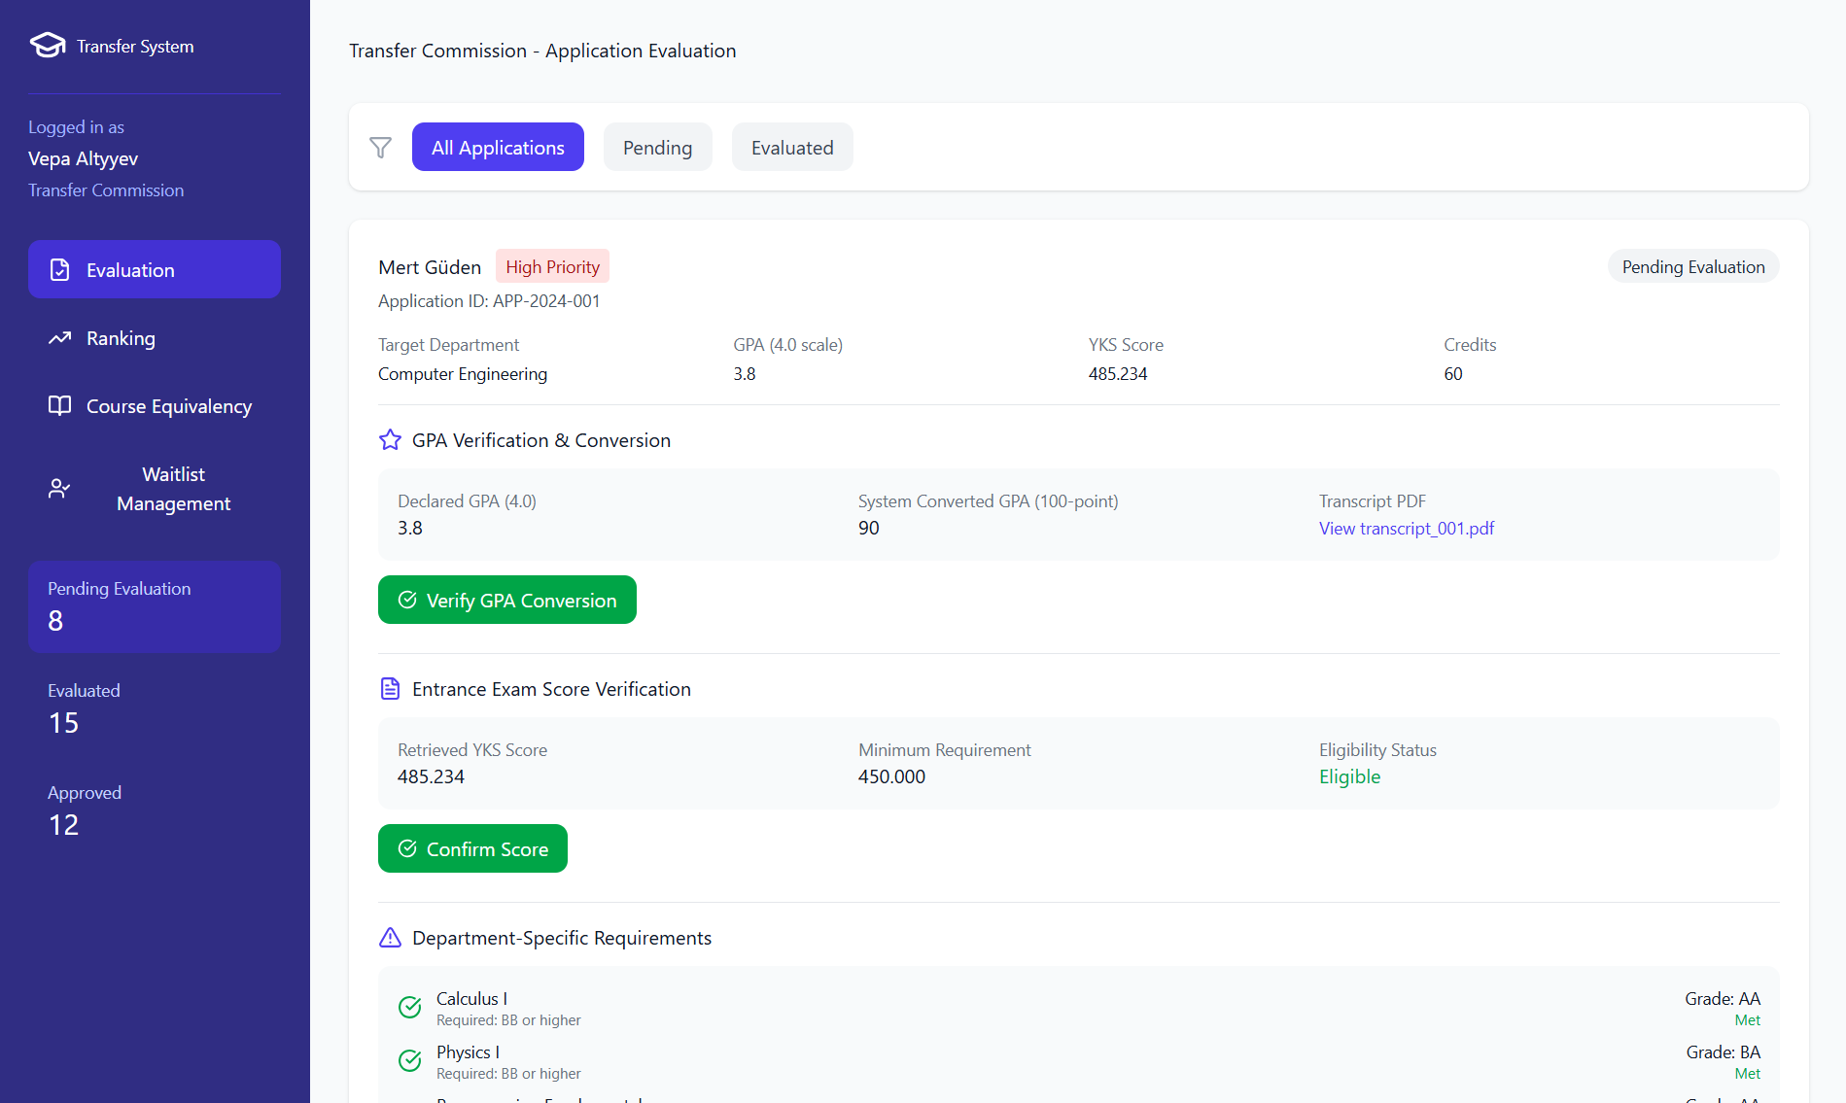

Performance / Software Quality requirements
• GPA conversion must be completed in ≤ 2 seconds after the dashboard loads.
• Transcript PDF must render and become viewable in ≤ 3 seconds.
• Manual override logging must occur in ≤ 1 second after user submission.
• The system must handle GPA verification for up to 200 concurrent applicants without degradation.
• Eligibility status ("Eligible" / "Ineligible") must be computed and displayed in ≤ 1 second after score retrieval.
• Manual score entry must be processed and saved in ≤ 2 seconds, including creation of the "Manually Verified" flag.
• The system must support at least 200 concurrent exam score retrieval requests without timeout or performance degradation.
• The actor must have at least a 5 Mbps stable internet connection to support PDF loading and real-time score verification.
• All verification actions (Confirm Score, Manual Entry, Rejection) must be audit-logged within ≤ 1 second of submission.
• User must have at least a 5 Mbps stable internet connection for proper dashboard and transcript loading.

Use case Evaluating department specific conditions for transfer committee

Use case template evaluating department specific conditions

Use Case ID: | UC-04-02
Use Case Name: | Evaluating Department Specific Conditions
Created By: | Team-6 | Last Updated By:
Date Created: | 22.11.2025 | Date Last Updated:

Actor: | Transfer Committee (YGK)
Description: | The system automatically validates rule-based department-specific requirements (e.g., minimum grades in specific core courses). The YGK member reviews these automated checks and manually evaluates qualitative requirements (e.g., design portfolios or interviews) to determine if the applicant meets the specialized criteria for the department.
Preconditions: | PRE1.The applicant has submitted a complete application via the online portal.  PRE2. The Faculty Dean’s Office has assigned the application to the Departmental Transfer Committee.
Postconditions: | POST1.The applicant's entrance exam score is verified and locked in the system.  POST2.The system has calculated the "Eligibility Status" (Eligible/Ineligible) regarding entrance scores.  POST3.The verified score is ready to be used in the automatic composite score calculation (ranking).
Priority: | High
Frequency of Use: | Executed for specific departments (Civil Engineering, Architecture, Industrial Design)
Normal Course of Events: | 1- The Transfer Committee (YGK) member selects an application from the "Pending Evaluation" list.  2- The System displays the Evaluation Dashboard, highlighting the "Department Specific Requirements" section.  3- The System automatically scans the applicant's digitized transcript data to identify required core courses (e.g., Calculus, Physics).  4- The System compares the applicant's grades against the defined rule-based criteria (e.g. Grade must be at least BB for all Physics and Mathematics courses).  5- The System displays a status for each condition: "Met" or "Not Met".  6- The Actor reviews the automated checks.  7- If the department requires a Portfolio/Interview (e.g., Architecture or Design), the Actor reviews the uploaded digital portfolio file via the system interface.  8- The Actor inputs the result of the portfolio review and clicks "Confirm All Conditions."
Alternative Courses: | UC-04-07.AC-01: Manual Course Mapping  3A: At Step 3, if the system cannot automatically identify a required course because the transcript course name does not match the expected rule (e.g., “Math 101” vs. “Calculus I”):  3A.1 Actor manually selects the equivalent course from the transcript viewer.  3A.2 Actor assigns the grade to the correct requirement rule category.  3A.3 System updates the condition result to “Met” based on the mapped grade.  3A.4 System logs the manual intervention for audit purposes.  3A.5 Flow continues at Step 4 of the main flow.  UC-04-07.AC-02: Conditional Rejection  5A: At Step 5, if one or more conditions evaluate as “Not Met” (e.g., missing core course, insufficient grade, failed portfolio review):  5A.1 Actor selects the specific unmet condition.  5A.2 Actor marks the condition as “Failed” and enters a rejection justification note.  5A.3 System sets overall eligibility status to “Ineligible.”  5A.4 System prevents the applicant from entering the ranking list.  5A.5 System triggers the rejection notification workflow.
Exceptions: | UC-04-07.EX-01: Corrupted Portfolio/Document File  Condition: The system attempts to open a specific required file (e.g., Portfolio PDF), but the file is corrupted or unreadable despite passing initial upload checks.  Response: The System displays a "File Error" alert. It prompts the Actor to either request a re-upload from the applicant (if the administrative timeline permits) or mark the condition as "Unverifiable/Failed"  UC-04-07.EX-02: Automated Rule Engine Failure  Condition: The system fails to load the specific configuration rules for the department (e.g., the database connection for retrieving "Minimum Grade" criteria drops).  Response: The System displays a "Configuration Load Error" message. It disables the automated "Met/Not Met" indicators and forces the Actor to perform a fully manual review of the transcript against the department's written regulations until the system is restored.
Includes: | None
Special Requirements: | SR1. Department-Specific Rule Flexibility: Flexibility: The system must allow different rules for different departments (e.g., Architecture needs a portfolio; Engineering needs specific Physics grades).  SR2. Decision Traceability: Traceability: All manual decisions (especially portfolio scores) must be recorded with the evaluator's ID for transparency.
Assumptions: | 1. Digitized Transcript Data: The applicant's transcript data has been successfully digitized to allow for rule-based checking.  2. Defined Department Prerequisites: The department has clearly defined its specific prerequisites in the system configuration prior to the application period.
Notes and Issues: | Issue: Subjectivity in portfolio reviews.  Resolution: The system should ideally allow multiple YGK members to score a portfolio and average the result to reduce bias, though the current scope implies a single committee decision

User Interface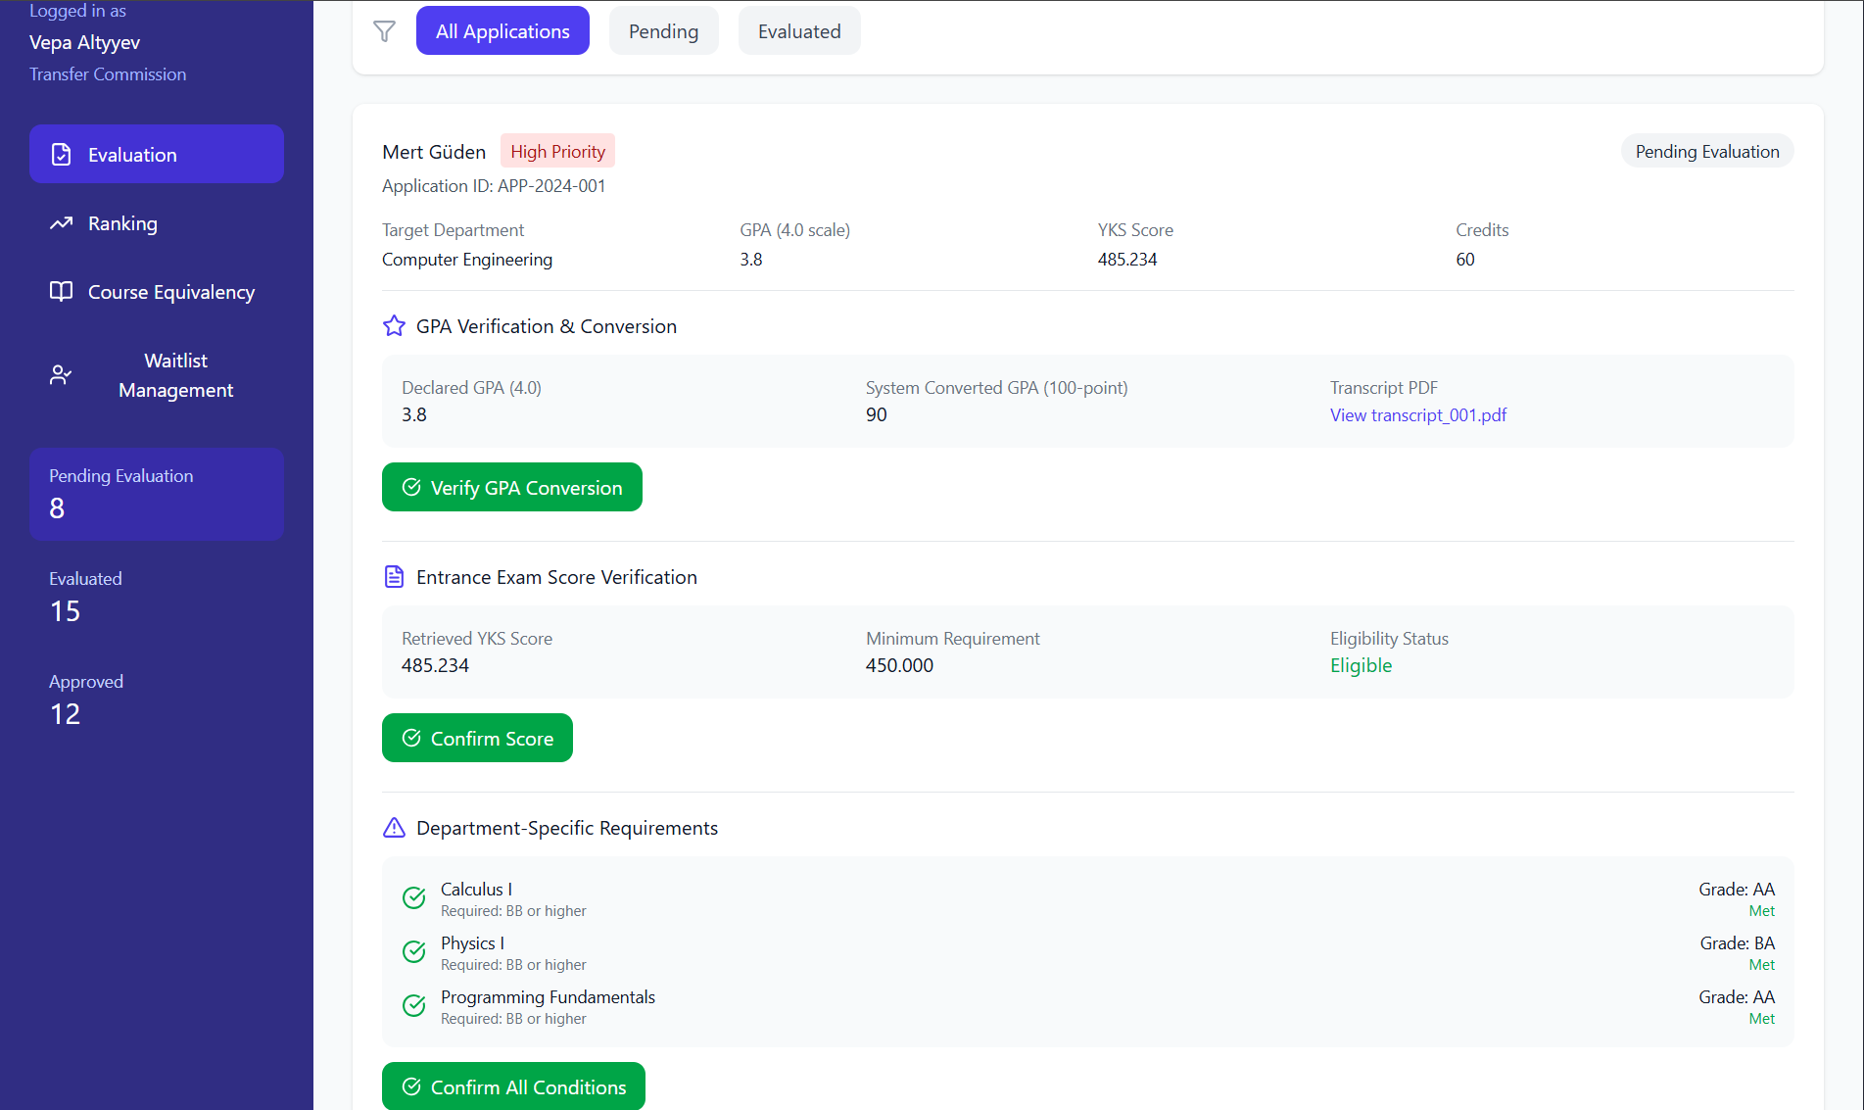

Performance / Software Quality requirements
• The Evaluation Dashboard must load all rule-based requirement fields within ≤ 3 seconds.
• Automated rule-checking (comparing transcript courses & grades) must complete in ≤ 2 seconds after transcript data loads.
• Portfolio file preview (PDF/Image) must open and render in ≤ 3 seconds.
• Manual course mapping updates must reflect in rule status (“Met/Not Met”) within ≤ 1 second.
• The system must support evaluation of up to 150 concurrent users without rule-check delays.
• All verification and rejection events must be audit-logged within ≤ 1 second.
• The actor must have at least a 5 Mbps stable internet connection to ensure transcript and portfolio loading

Use case generate ranking automatically for transfer committee

Use case template generate ranking automatically
Use Case ID: | UC-04-03
Use Case Name: | Generate Ranking Automatically
Created By: | Team-6 | Last Updated By:
Date Created: | 22.11.2025 | Date Last Updated:

Actor: | Transfer Committee (YGK)
Description: | The system automatically calculates each applicant’s standardized transfer score using the official weighting formula (90% exam score + 10% converted GPA) and produces the primary and waitlisted ranking lists.
Preconditions: | PRE1. All applicant documents and data have already been validated.  PRE2. GPA values have been converted to the 4-scale using the YÖK conversion table.  PRE3. Exam score (ÖSYS/YKS) and program base score are available.
Postconditions: | POST1. Transfer scores are calculated for all valid applicants.  POST2. Asil (primary) list and yedek (waitlist) are generated.  POST3. Ranking becomes available for review by the Transfer Commission
Priority: | High
Frequency of Use: | Once per application period
Normal Course of Events: | - YGK member selects the “Generate Ranking” option from the evaluation dashboard.  - The system collects all validated applicant data.  - The system converts each applicant’s GPA to a 100-point scale using the official conversion table.  - The system retrieves each applicant’s exam score (x) and the program’s base score (y).  - The system calculates the standardized exam component using:  Exam Component = (x / y) × 100 × 0.90  - The system calculates the GPA component using:  GPA Component = (Converted_GPA) × 0.10  - The system calculates the final transfer score as:  Transfer Score = Exam Component + GPA Component  - The system sorts applicants from highest to lowest transfer score.  - The system assigns the top/Quota candidates as Primary (Asil).  - The remaining candidates are assigned as Waitlisted (Yedek).  - The YGK member accesses the generated ranking report for review.
Alternative Courses: | UC-04-03.AC-01 — Missing Data (Alternative to Step 4)  4A. At Step 4, if the system detects that the exam score (x) or program base score (y) is missing for a candidate:  4A.1 The system flags the candidate as “Excluded – Missing Score Data.”  4A.2 The system skips calculation steps (5–7) for this candidate and does not include them in the ranking list.  4A.3 The candidate is listed separately in the report under “Excluded Candidates (Missing Data)” for transparency.  4A.4 Flow continues at Normal Flow Step 8 for the remaining candidates.
Exceptions: | UC-04-03.EX-01 — Ranking Calculation Fails  The system displays an error and stops processing.
Includes: | INC.1: Retrieve Applicant Data  INC.2: Convert GPA to 4-Scale
Special Requirements: | SR1. Auditable Calculations: All calculations must be auditable and reproducible.  SR2. Deterministic Sorting: Sorting must be strictly deterministic.
Assumptions: | 1. Reliable External Score Data: External score data is consistent and accurate.
Notes and Issues: | None

User Interface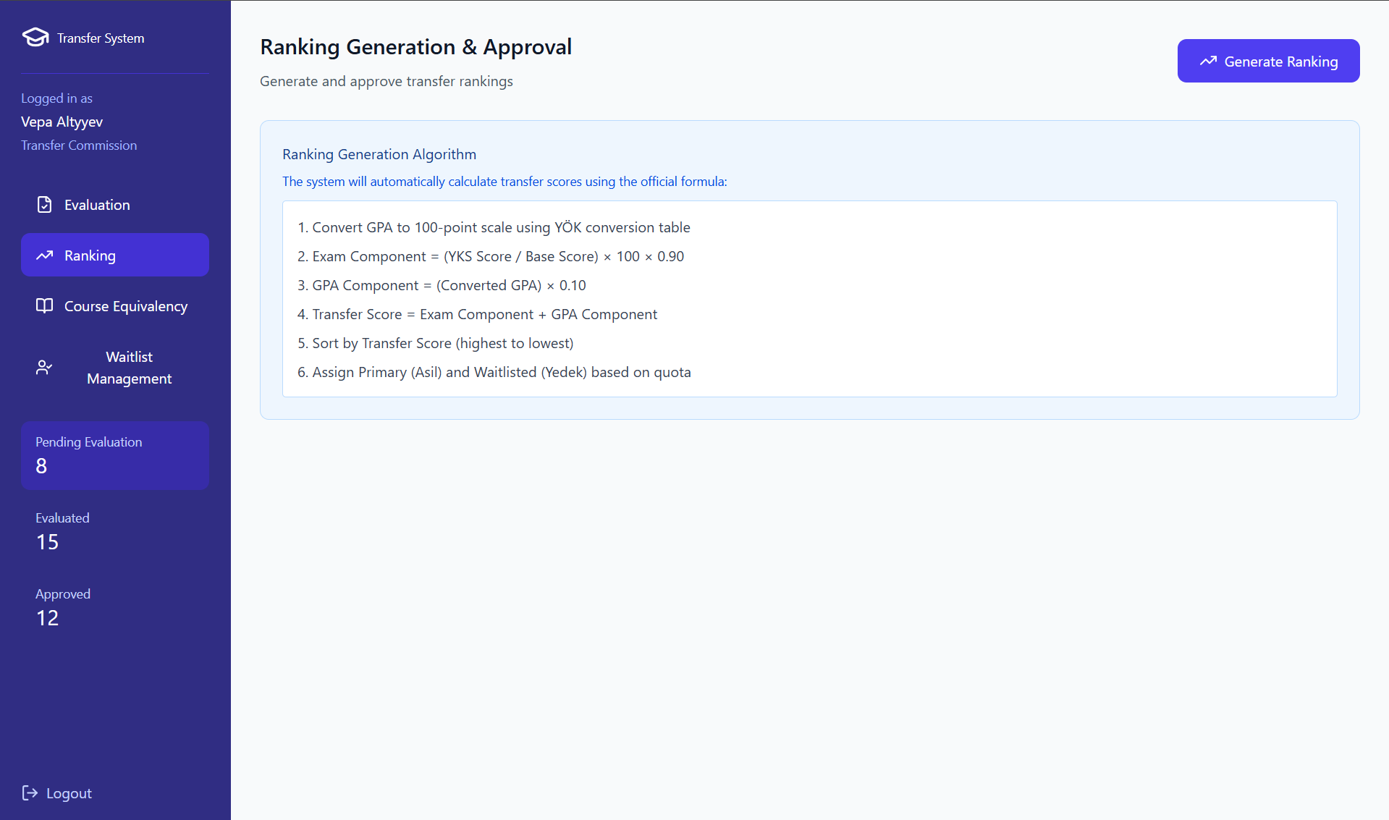

Performance / Software Quality requirements
• The ranking generation process (data retrieval → calculation → sorting) must complete within 10 seconds for up to 1,000 applicants.
• GPA conversion and exam-score normalization steps must each execute within 2 seconds.
• Sorting applicants by transfer score must complete within 1 second.
• The generated ranking report must load and become viewable within 3 seconds after processing.
• The system must support simultaneous ranking generation requests by at least 20 YGK members without performance degradation.
• Users must have at least a 5 Mbps stable internet connection for proper system performance.
.

Use case approve system-generated ranking for transfer committee

Use case template approve system-generated ranking
Use Case ID: | UC-04-04
Use Case Name: | Approve System-Generated Ranking
Created By: | Team-6 | Last Updated By:
Date Created: | 22.11.2025 | Date Last Updated:

Actor: | Transfer Committee (YGK)
Description: | The Transfer Commission reviews the automatically generated composite scores and applicant ranking created by the Undergraduate Transfer Management System (UTMS). After validating the system-generated rankings for accuracy and compliance with YÖK and university rules, the Commission approves the ranking list so it can be forwarded to the Faculty Dean’s Office for final decision steps.
Preconditions: | PRE1. All applications assigned to the department have been evaluated by the system.  PRE2. GPA conversion, exam score validation, language proficiency checks, and department-specific checks have already been performed automatically by the system.  PRE3. The system has produced a preliminary ranking report (asil/yedek lists).  PRE4. YGK members are authenticated and authorized to access the evaluation dashboard.
Postconditions: | POST1. The ranking list is marked as “Approved” by the YGK.  POST2. The approved ranking is electronically submitted to the Faculty Dean’s Office.  POST3. Ranking becomes locked and cannot be modified unless the Commission revokes approval.
Priority: | High
Frequency of Use: | Once per transfer application period
Normal Course of Events: | 1- YGK actor logs into the UTMS.  2- System displays all applications assigned to the department.  3- Actor selects “View Ranking Report.”  4- System presents system-generated composite scores and ranking (asil/yedek).  5- Actor reviews each candidate’s details (GPA, YKS score, English proficiency, core-course criteria, etc.).  6- Actor verifies that system-generated rankings comply with department and YÖK rules.  7- Actor clicks “Approve Ranking.”  8- System requests confirmation.  9- Actor confirms approval.  10- System locks the ranking report and records timestamp + actor identity.  11- System forwards the approved ranking electronically to the Faculty Dean’s Office.
Alternative Courses: | UC-04-01.AC-01 — Request Manual Correction Before Approval  6A: At step 6, actor finds a data inconsistency (e.g., missing portfolio score).  6A.1 Actor selects “Return for Correction.”  6A.2 System returns applications to correction queue for designated staff.  6A.3 After correction, the system regenerates the ranking, returning to step 3 of the main flow.
Exceptions: | UC-04-01.EX-01 — System Data Error  If ranking cannot be generated due to missing external data (YÖKSİS/ÖSYM), the system displays an error message and prevents approval.  UC-04-02.EX-01 — Authorization Failure  If a user without YGK privileges attempts to approve rankings, the system denies access.
Includes: | INC.01: Use Case: “Generate Ranking Automatically”
Special Requirements: | SR1. Sortable Ranking Columns: Ranking must be viewable with sortable columns (score, GPA, exam score, name).  SR2. Automated Approval Logging: Approval action must be automatically logged for auditing.  SR3. Post-Approval Immutability: System must ensure immutability of ranking post-approval.
Assumptions: | 1. Correct Evaluation Logic: All evaluation rules have been correctly encoded in the system.  2. Designated YGK Approver: YGK operates as a group but gives approval via a designated member account.
Notes and Issues: | Question: Should the system support “multi-signature approval” (multiple YGK members)? (TBD with project owner)

User Interface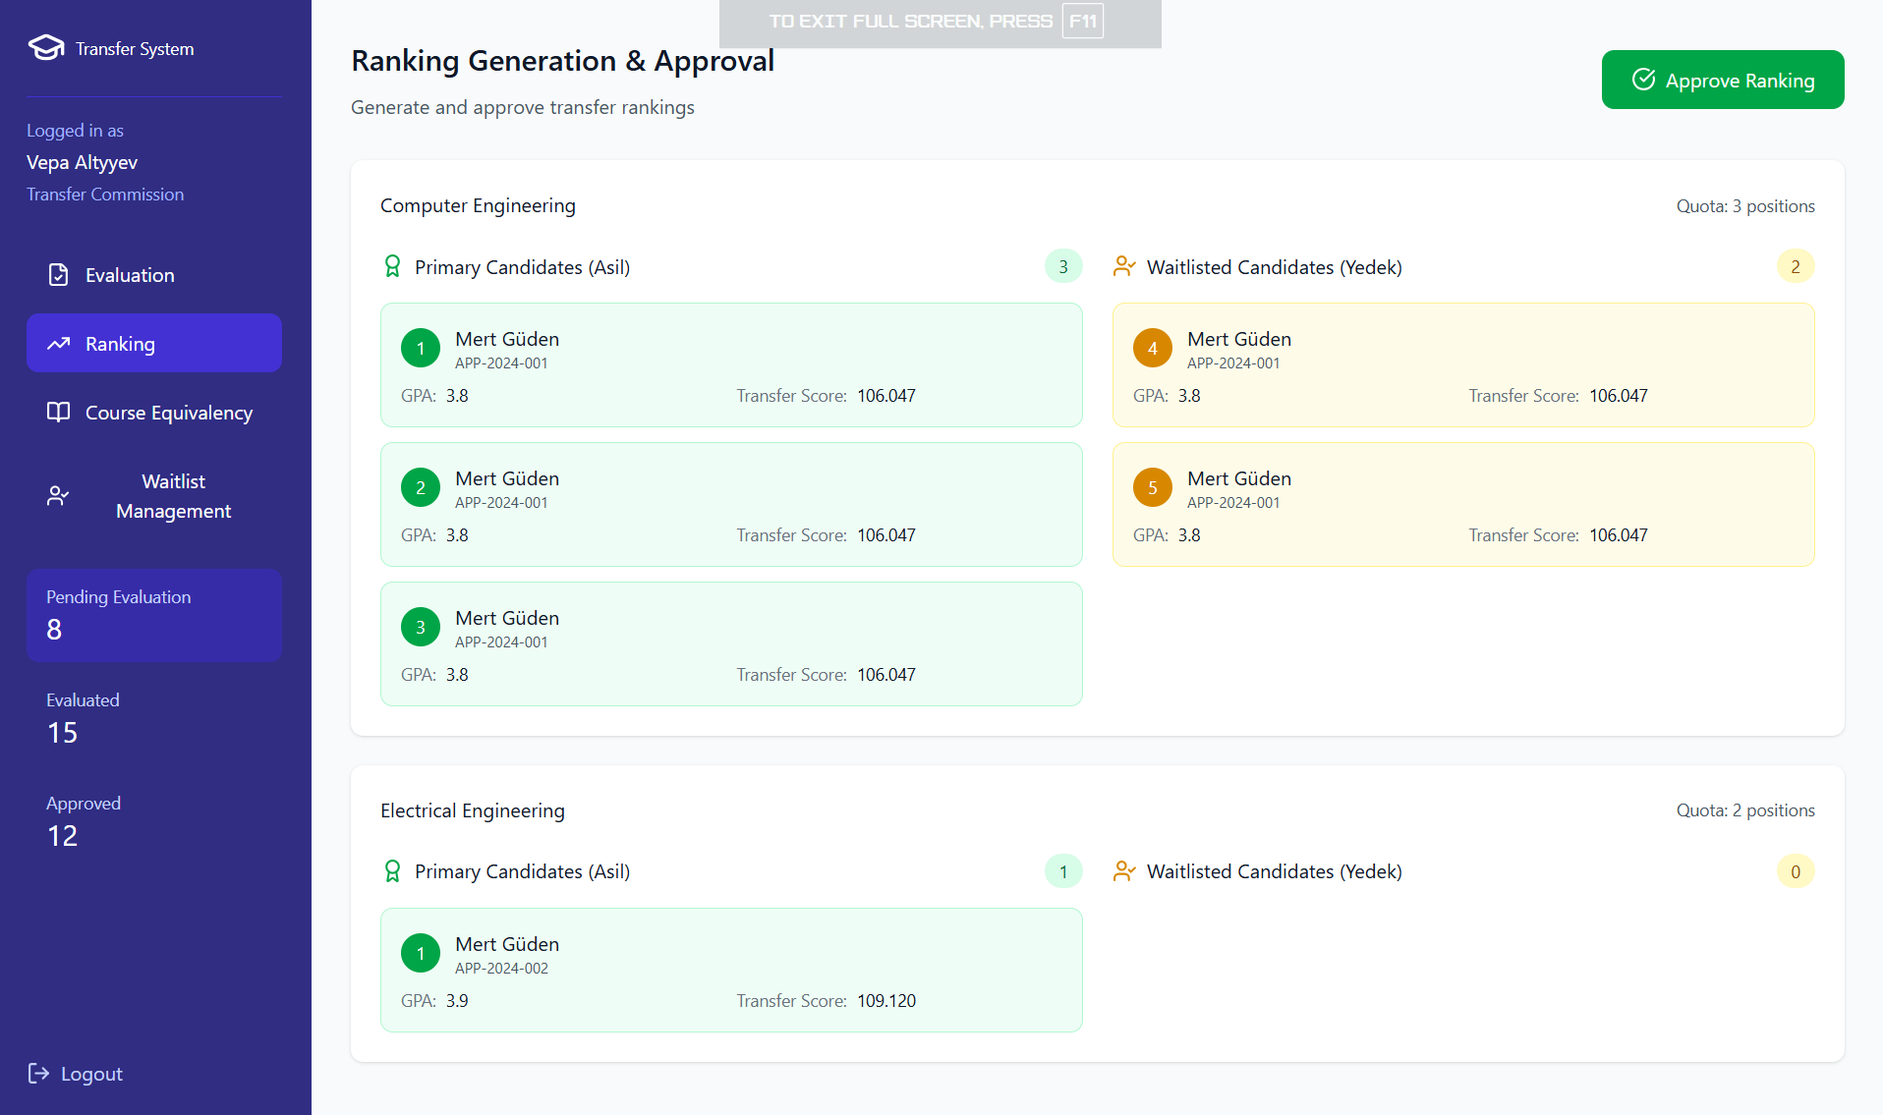

Performance / Software Quality requirements
• The ranking report must load within 5 seconds when accessed by the Transfer Committee.
• Sorting and filtering operations on the ranking table must execute within 2 seconds.
• Approval confirmation (locking the ranking + recording timestamp + forwarding to Dean’s Office) must complete within 5 seconds.
• The system must support at least 200 concurrent ranking review sessions without performance degradation.
• The system must guarantee that ranking immutability checks (preventing post-approval changes) execute within 1 second.
• Users must have at least a 5 Mbps stable internet connection for proper system performance.

Use case prepare course equivalence table for transfer committee

Use Case template Prepare Course Equivalence Table
Use Case ID: | UC-04-05
Use Case Name: | Prepare Course Equivalence Table
Created By: | Team-6 | Last Updated By:
Date Created: | 22.11.2025 | Date Last Updated:

Actor: | Transfer Commission (YGK)
Description: | The Transfer Commission prepares an intibak (course equivalence) table for each accepted applicant using the system's digital interface. The system provides structured fields for selecting external institution courses and mapping them to IZTECH courses. The process is partially manual due to academic judgment requirements but supported digitally for consistency, storage, and transfer.
Preconditions: | PRE1. Applicant must appear on the approved ranking list of the department.  PRE2. Actor is authenticated and authorized as a YGK member.  PRE3. System has imported course data from the applicant’s transcript and external institution.  PRE4. No pending corrections exist for the applicant’s application data.
Postconditions: | POST1. A completed intibak table is generated and stored in the system.  POST2. The table is electronically submitted to the Faculty Dean’s Office for approval.  POST3. The table becomes part of the student’s future curriculum path if the transfer is finalized.
Priority: | High
Frequency of Use: | For each accepted (asil) student — typically once per academic year.
Normal Course of Events: | 1- Actor logs into UTMS and selects “Prepare Intibak Table.”  2- System displays applicant information, transcript, and list of completed courses.  3- Actor selects a course from the applicant’s previous institution.  4- System displays potential matching IZTECH courses (based on keywords or credits).  5- Actor reviews syllabus/credit details.  6- Actor selects the equivalent IZTECH course or marks “No Equivalence.”  7- Actor repeats steps 3–6 until all relevant courses are evaluated.  8- Actor reviews the completed intibak table.  9- Actor clicks “Submit Intibak Table.”  10- System stores the table, locks it, and sends it to the Faculty Dean’s Office.
Alternative Courses: | UC-04-02.AC-01 — Add Custom Equivalence  4A: At step 4, system finds no match.  Actor selects “Add Custom Mapping.”  Actor manually enters course details for review.  Process returns to step 6.  UC-04-02.AC-02 — Save as Draft  8A: At step 8, actor chooses “Save Draft.”  System stores progress without submission.  Actor may return later to complete the table.
Exceptions: | UC-04-02.EX-01 — Missing Transcript Data  System cannot retrieve course information → user receives error, and intibak creation is blocked.  UC-04-02.EX-02 — Unauthorized Attempt to Edit After Submission  If actor tries to modify a submitted table, system prevents changes.
Includes: | None
Special Requirements: | SR1. PDF Attachment Support: System must support attaching PDFs (syllabi) for academic verification.  SR2. Credit & Grade Comparison Interface: The interface must allow credit, ECTS, and grade comparisons.  SR3. Structured Mapping Storage: All mappings must be stored in a reusable structured database for consistency across years.
Assumptions: | 1. Human Judgment Required: Not all equivalence decisions can be automated—human judgment is required.  2. Department-Specific Policies: Departments may have different policies for minimum passing grades.
Notes and Issues: | Issue: Should the system allow multiple YGK members to collaborate on the same intibak table simultaneously? (TBD)  Note: Storing mappings in a shared database could allow future automation but is outside current scope.

User Interface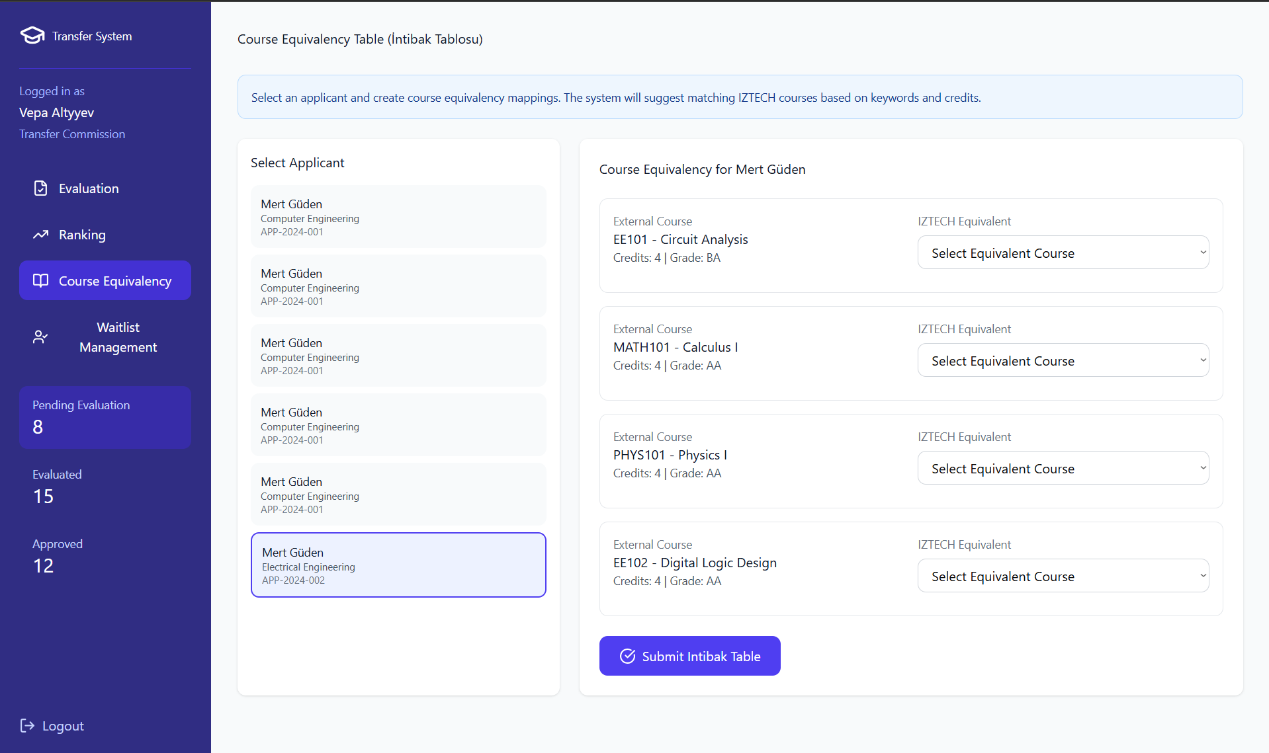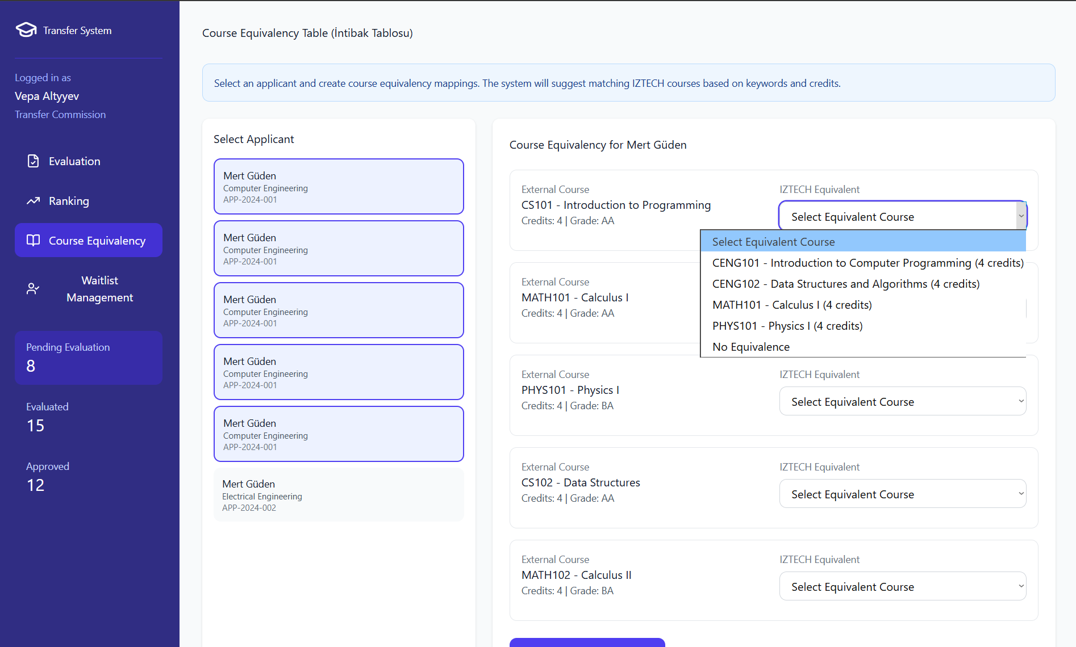

Performance / Software Quality requirements
- Applicant transcript and course list must load within 5 seconds after the actor selects “Prepare Intibak Table.”
- Automatic course matching suggestions (based on keywords/credits) must display within 2 seconds after the actor selects an external course.
- Saving the completed or draft intibak table must finish within 3 seconds.
- Submitting the intibak table to the Dean’s Office must complete within 5 seconds.
- The system must support at least 100 concurrent intibak table preparation sessions without performance degradation.
- Users must have at least a 5 Mbps stable internet connection for proper system operation.

User Interface

Use case process waitlisted applicants for transfer committee

Use case template process waitlisted applicants
Use Case ID: | UC-04-06
Use Case Name: | Process Waitlisted Applicants
Created By: | Team-6 | Last Updated By:
Date Created: | 22.11.2025 | Date Last Updated:

Actor: | Transfer Committee (YGK)
Description: | If a primary candidate withdraws or does not register, the system automatically promotes the next candidate in the waitlist. The Transfer Commission then prepares an intibak (course equivalence) table for the promoted candidate to finalize their eligibility.
Preconditions: | PRE1. At least one primary candidate seat becomes vacant.  PRE2. There is a remaining waitlisted candidate.  PRE3. The ranking list has already been finalized and approved.
Postconditions: | POST1. Next waitlisted candidate is promoted to primary status.  POST2. Intibak table for this candidate is completed.  POST3. Updated official lists are forwarded to the Dean’s Office and Student Affairs.
Priority: | High
Frequency of Use: | Triggered whenever an asil applicant does not complete enrollment.
Normal Course of Events: | 1- The YGK member opens the “Waitlist Management” interface.  2- The system shows vacant quota slots due to withdrawal or non-enrollment.  3- The YGK member selects “Promote Next Candidate.”  4- The system promotes the highest-ranked waitlist candidate to primary status.  5- The YGK member reviews the candidate’s transcript and application data.  6- The YGK member opens the “Create Intibak Table” interface.  7- The YGK member selects each completed external course and matches it to the correct internal course (or marks “No Equivalence”).  8- The YGK member finalizes and submits the intibak table.  9- The system records the update, locks the table, and sends the updated list to the Dean’s Office and Student Affairs.  10- The system updates the remaining waitlist to reflect the new position order.
Alternative Courses: | UC-04-04.AC-01 — Promoted Candidate Withdraws Immediately  4A. At Step 4, immediately after being promoted to primary status, the promoted candidate withdraws or declines the offer.  4A.1 YGK member marks the candidate as “Withdrawn”.  4A.2 The system automatically selects and promotes the next highest-ranked waitlisted candidate.  4A.3 Process resumes at Step 5 of the main flow.
Exceptions: | UC-04-04.EX-01 — No Remaining Waitlist Candidates  System indicates no candidates remain to promote.
Includes: | INC1. Prepare Intibak Table  INC2. Update Applicant Status
Special Requirements: | SR1. Ranking-Based Promotion: Promotion must strictly follow ranking order.
Assumptions: | 1. Timely Withdrawal Updates: Student Affairs updates withdrawal information promptly.
Notes and Issues:

User Interface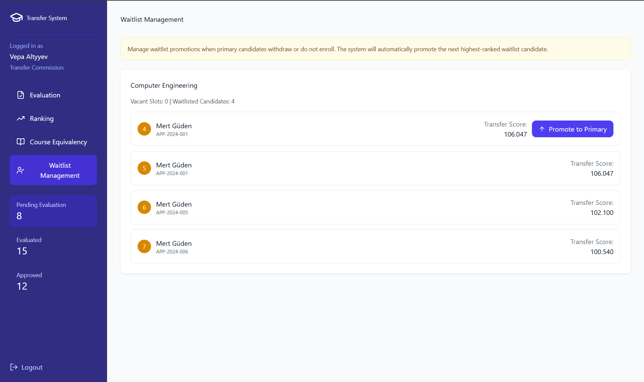

Performance / Software Quality requirements
• Loading the Waitlist Management interface and vacant quota information must complete within 3 seconds.
• Promoting the next waitlisted candidate to primary status and updating their status must complete within 3 seconds after the YGK member selects “Promote Next Candidate.”
• Creating, saving, and locking the intibak table for the promoted candidate must complete within 5 seconds after submission.
• Updating and reordering the remaining waitlist (after promotion) must complete within 2 seconds.
• The system must support at least 100 concurrent waitlist processing sessions without performance degradation.
• Users must have at least a 5 Mbps stable internet connection for proper system operation.

Use cases for YDYO (School of Foreign Languages)

Use case approve English proficiency for School of foreign languages

Use case template approve English proficiency
Use Case ID: | UC-05-01
Use Case Name: | Approve English Proficiency
Created By: | Team-6 | Last Updated By:
Date Created: | 22.11.2025 | Date Last Updated: | 22.11.2025

Actor: | YDYO English Proficiency Officer / Commission
Description: | The officer evaluates the English proficiency requirement for each transfer applicant by reviewing certificates or retrieved official exam results. The officer either confirms that the applicant meets the English requirement or does not meet it.
Preconditions: | PRE1. The applicant has submitted a transfer application.  PRE2. The system has retrieved or received the applicant’s English certificate or English score.  PRE3. The application is currently in the stage: “English Proficiency Review (YDYO)”.
Postconditions: | POST1. If Approved:  - English proficiency status becomes “Satisfied”.  - Application automatically moves to Dean’s Office / Faculty Evaluation Stage.  - Applicant receives a notification.  POST2. If Rejected:  - English proficiency status becomes “Not Satisfied”.  - Application status becomes “Eliminated – English Requirement Not Met”.  - Applicant receives a notification and cannot continue in the process.
Priority: | High
Frequency of Use: | During every transfer cycle until all applicants are reviewed.
Normal Course of Events: | 1- Officer opens English Proficiency Review screen.  2- Officer selects an applicant.  3- Officer reviews certificate/results and checks validity against YDYO criteria.  4- Officer clicks “Approve English Proficiency”.  5- System updates status to “English Requirement Satisfied”.  6- System routes the application to Dean’s Office / Faculty Evaluation stage.  7- System sends approval notification to the applicant.
Alternative Courses: | UC-05-01.AC-01: Reject English Requirement  4A: At Step 4, if the officer decides the applicant does not satisfy the English proficiency requirement:  4A.1 Officer clicks “Reject English Proficiency.”  4A.2 System displays a list of predefined rejection reasons (e.g., expired exam, insufficient score, unverifiable document).  4A.3 Officer selects the rejection reason and confirms.  4A.4 System updates the application status to “Eliminated — English Requirement Not Met.”  4A.5 System sends an elimination notification to the applicant.  4A.6 Process ends; the application does not proceed to Faculty Evaluation.
Exceptions: | UC-05-01.EX-01: Certificate unreadable or corrupted  The system prevents approval and requires the officer to choose Reject.  UC-05-01.EX-02: Missing document  Application remains automatically blocked until document is re-uploaded.
Includes: | None
Special Requirements: | SR1. Comprehensive Audit Logging: Full audit logging (officer ID + timestamp + decision).  SR2. Mandatory In-Browser Document Preview: In-browser preview for PDF/Images is mandatory for document validation.
Assumptions: | 1. Proficiency Criteria Awareness: YDYO officer is fully aware of the proficiency criteria.
Notes and Issues: | None

User Interface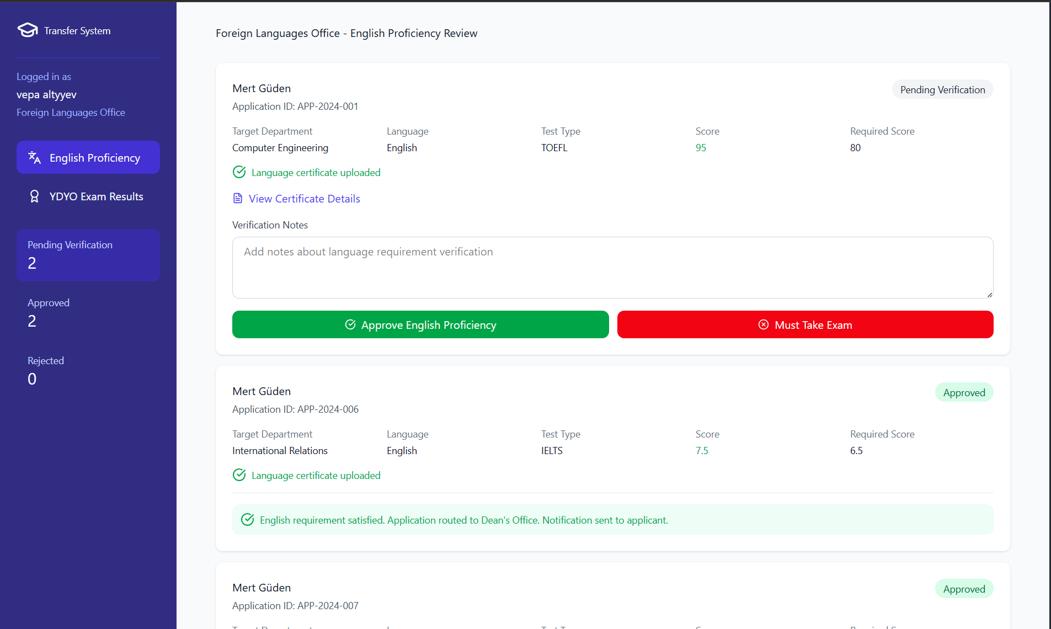

Performance / Software Quality requirements
• The English Proficiency Review screen must load in ≤ 3 seconds.
• Document preview (certificate / exam PDF) must render in ≤ 2 seconds.
• Approval or rejection action must be processed and saved in ≤ 1 second.
• Notification to the applicant must be triggered within ≤ 30 seconds after status change.
• The system must support at least 150 concurrent English review operations without slowdown.
• All officer actions (Approve / Reject / Reason selection) must be audit-logged in ≤ 1 second.
• Officer must have at least 5 Mbps stable internet for certificate loading and verification.

Use case announce English proficiency exam results for school of foreign languages

Use case template announce English proficiency exam results
Use Case ID: | UC-05-02
Use Case Name: | Announce English Proficiency Exam Results
Created By: | Team-6 | Last Updated By:
Date Created: | 22.11.2025 | Date Last Updated: | 22.11.2025

Actor: | YDYO English Proficiency Officer / Commission
Description: | The officer publishes the results of the YDYO English Proficiency Exam taken by transfer applicants. Once announced, each applicant’s transfer status is updated based on exam success or failure.
Preconditions: | PRE1. Exam scoring has been finalized and internally approved by YDYO.  PRE2. The results exist in the system in state “Pending Publication”.
Postconditions: | POST1. If applicant Passed:  - English proficiency status becomes “Satisfied”.  - Application automatically routes to Dean’s Office / Faculty Evaluation.  - Applicant receives a Pass notification.  POST2. If applicant Failed:  - English proficiency status becomes “Not Satisfied”.  - Application becomes “Eliminated – Failed English Exam” and cannot continue.  - Applicant receives a Fail notification.
Priority: | High
Frequency of Use: | Once per English Proficiency Exam cycle
Normal Course of Events: | 1- Officer navigates to “YDYO Exam Results” screen.  2- Officer previews result list (Pass / Fail).  3- Officer clicks “Publish Results”.  5.- System permanently publishes results.  6- System updates each applicant status based on Pass or Fail.  7- System automatically triggers notifications (email + SMS if available).  8- Applicants can view results on their dashboard.
Alternative Courses: | None — publication is irreversible.
Exceptions: | Notification service failure → System still publishes results but retries sending notifications until successful.
Includes: | None
Special Requirements: | SR1. Irreversible Publication: Publishing must be irreversible to satisfy legal accountability.  SR2. Permanent Publication Metadata: Publication timestamp + officer ID must be stored permanently.  SR3. Performance-Compliant Bulk Processing: Bulk result processing and notification distribution must finish within required performance limits.
Assumptions: | 1. Finalized Scoring Data: The scoring data has been accurately and finally recorded in the system before publication.
Notes and Issues: | Notification: The publication action will be announced to all existing applicants in the system.

User Interface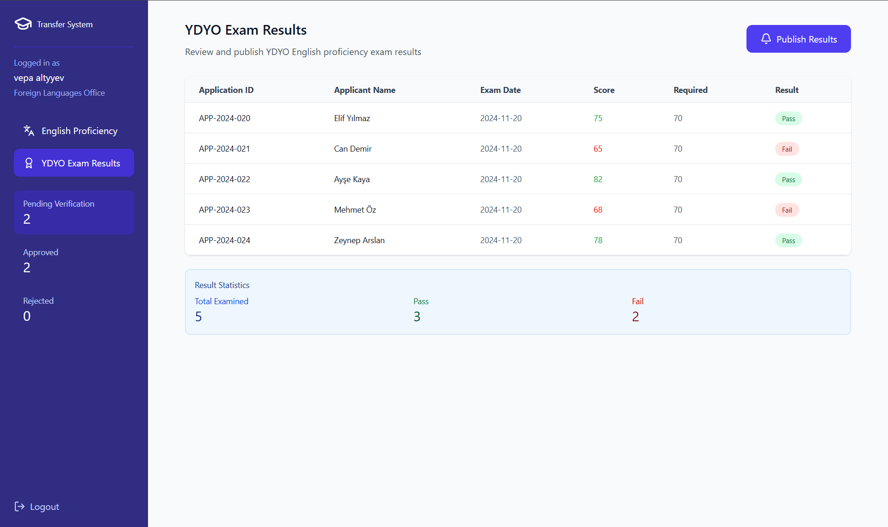

Performance / Software Quality requirements
• The “YDYO Exam Results” screen must load in ≤ 3 seconds under normal load.
• Bulk publication of all exam results (typically 300–800 applicants) must complete in ≤ 10 seconds.
• Status updates for each applicant (Pass/Fail) must be processed at a rate of at least 100 applications per second.
• Notification triggers (email + SMS) must start within ≤ 30 seconds after results are published.
• The system must tolerate at least 200 concurrent publication-related read operations without performance degradation.
• Audit logging of publish action (timestamp + officer ID) must be stored in ≤ 1 second.
• The officer must have at least 5 Mbps stable internet for accurate dashboard and result list loading.

Use cases for faculty dean’s office

Use case Approve transfer application for dean’s Office

Use case template Approve transfer application
Use Case ID: | UC-06-01
Use Case Name: | Approve Transfer Application (Dean’s Office Final Decision)
Created By: | Team-6 | Last Updated By:
Date Created: | 22.11.2025 | Date Last Updated: | 22.11.2025

Actor: | Dean’s Office Officer / Faculty Dean
Description: | After YDYO confirms English proficiency and the Faculty Commission completes academic evaluation/course equivalency, the application is transferred to the Dean’s Office for the final approval.  The Dean must either approve the transfer or reject it.  This decision is legally binding and determines whether the transfer will occur.
Preconditions: | PRE1. Application stage = “Pending Dean’s Office Final Decision”.  PRE2. All earlier evaluations are completed:  - English Requirement Satisfied (YDYO)  - Academic Evaluation Completed (Faculty Commission)  PRE3. All supporting documents and equivalency reports are available in the system.  PRE4. Dean is authenticated and authorized.
Postconditions: | POST1. If the Dean approves the application, the final status becomes “Transfer Accepted”, and the system automatically forwards the student to the Student Affairs (ÖİDB) registration stage.  POST2. If the Dean rejects the application, the final status becomes “Transfer Rejected – Dean’s Decision”, and the transfer process is permanently closed for that cycle.  POST3. In both cases, the applicant is notified instantly and can view the final outcome on their dashboard.
Priority: | High
Frequency of Use: | Low
Normal Course of Events: | 1- Dean logs into the UTMS system and opens the Approval Dashboard.  2- Dean selects an application that is pending final decision.  3- Dean reviews:  - Faculty Commission evaluation and score  - Course equivalency mapping (Intibak Table)  - Applicant’s transcript and academic history  4- Dean clicks “Approve Final Transfer Decision”.  5- System sets the final status to “Transfer Accepted”.  6- System locks all evaluation data for legal archival (cannot be modified after approval).  7- System forwards the application to ÖİDB – Registration Workflow.  8- The applicant receives an official notification with next steps (registration dates, required documents).  9- System stores a permanent audit record (Dean’s ID, timestamp, IP).
Alternative Courses: | UC-05-03.AC-01 — Reject Application  (Occurs at Step 4 of the Main Flow)  Condition:  At Step 4, instead of approving the final decision, the Dean decides that the applicant should not be accepted.  Steps:  4A: Dean clicks “Reject Application”.  4A.1. System displays a list of standardized  rejection codes (e.g., “Insufficient Academic Standing”, “Quota Limit Reached”, “Disciplinary Record”, “Unsuitable Program Match”).  4A.2. Dean selects a rejection reason and optionally adds an explanatory note.  4A.3. System updates the final status to:  Final Application Status: “Transfer Rejected – Dean’s Decision”  Status is marked Final and Irreversible  4A.4. System prevents the application from entering the Registration Workflow.  4A.5. System sends the applicant an instant rejection notification on the portal (and email/SMS if enabled).  4A.6. System records the decision in audit logs (Dean ID, timestamp, IP, rejection reason).  Rejoins:  Process terminates. No return to main flow.
Exceptions: | None
Includes: | None
Special Requirements: | SR1. Dean-Level Digital Signature: All approval/rejection actions must be digitally signed with Dean’s account to satisfy legal and Senate accountability requirements.  SR2. Immutable Final Decisions: The system must not allow post-decision modifications (immutability).  SR3. Restricted Decision Authority: Only accounts with Dean / Vice-Dean privileges can approve or reject at this stage.  SR4. Official Decision Logging: Decision must appear in the official decision log and exportable for senate archive.
Assumptions: | 1. Completed Equivalency Processing: Course equivalency decisions and scoring performed by the Faculty Commission are already finalized and require no further review at this stage.  2. Accurate Quota & Capacity Data: Quotas and enrolment capacity information shown to the Dean are accurate and up to date.
Notes and Issues: | None

User Interface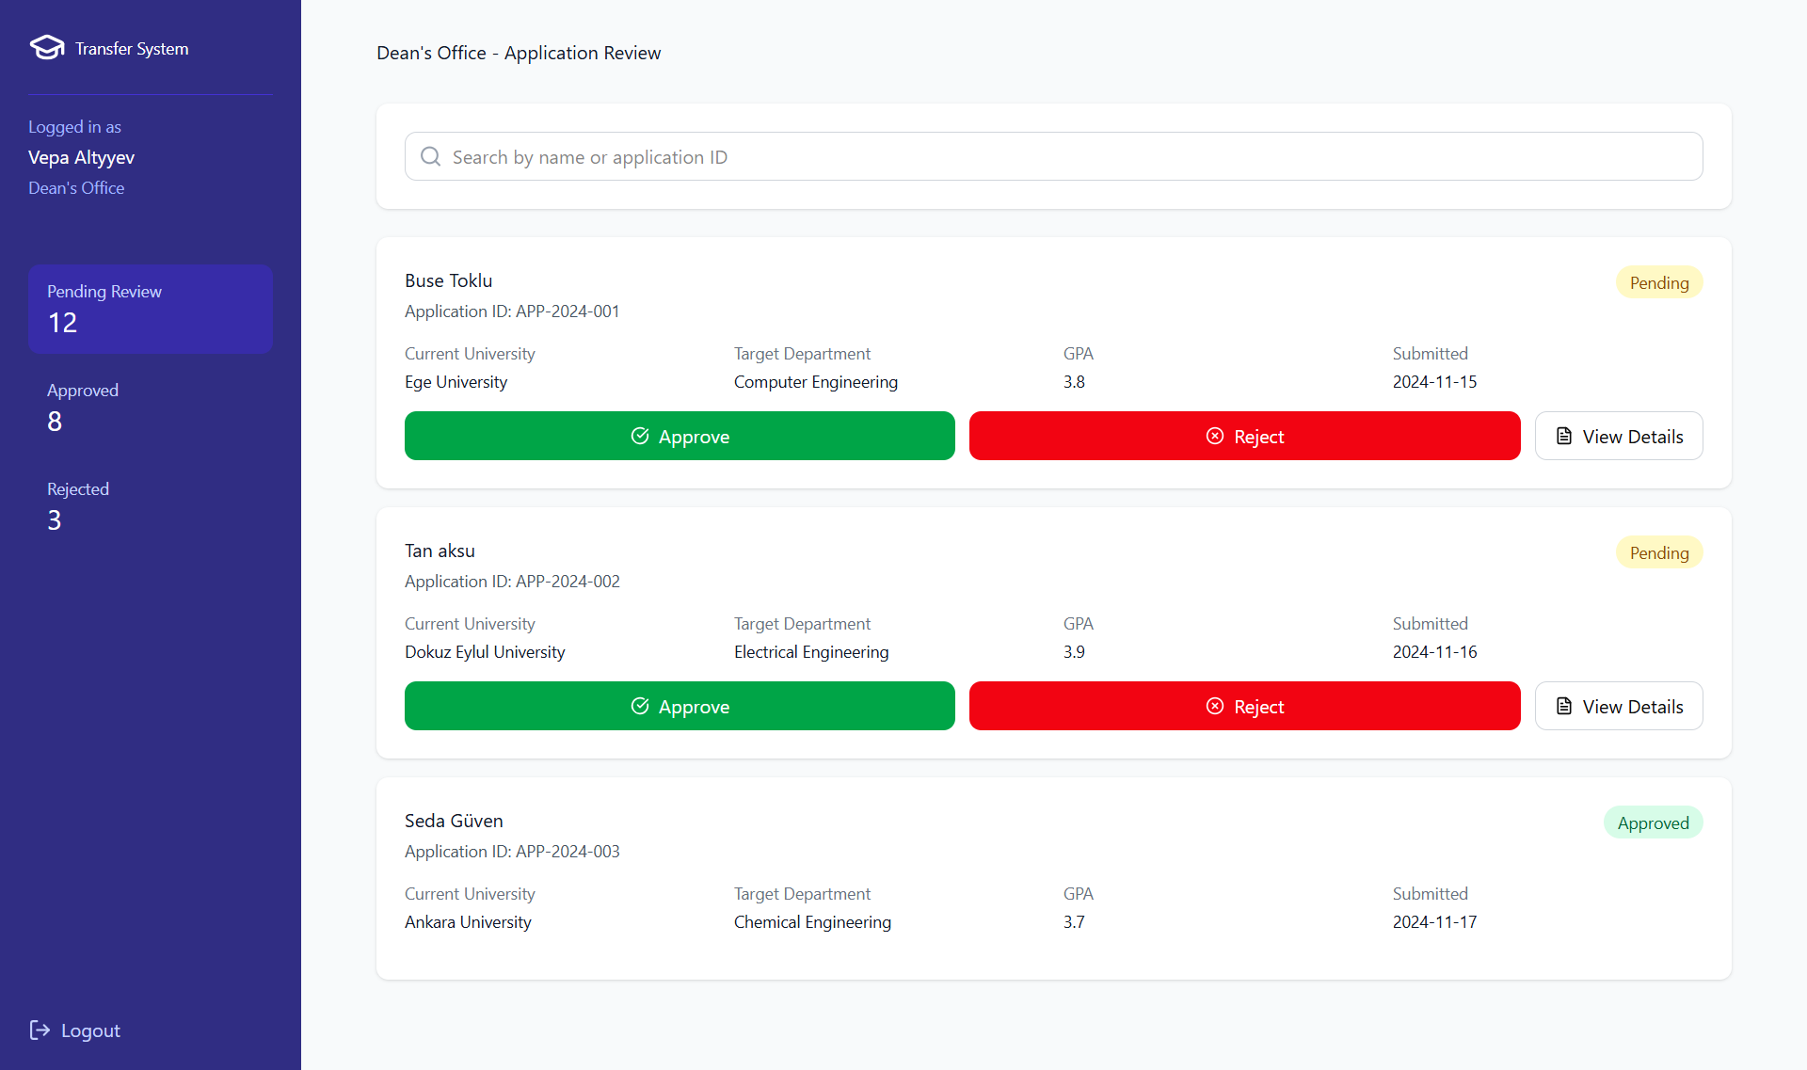

Performance / Software Quality requirements
- Approval Dashboard must load within ≤ 3 seconds under normal system load.
- Loading applicant details (transcript, intibak table, evaluation report) must complete within ≤ 5 seconds.
- Final decision action (“Approve” or “Reject”) must be processed and saved within ≤ 2 seconds.
- Locking all evaluation data and archiving it must complete within ≤ 3 seconds after final decision.
- Audit logging (Dean ID, timestamp, IP, decision) must be stored in ≤ 1 second.
- The system must support at least 50 concurrent Dean operations without performance degradation.
- Notification to the applicant (approval or rejection) must be triggered within ≤ 10 seconds after the decision.
- User must have at least 5 Mbps stable internet connection to properly load applicant details and documents.

Use cases for System administrator (IT/BIDB)

Use case Register and assign roles to staff for system administrator

Use case template register and assign roles to staff
Use Case ID: | UC-07-01
Use Case Name: | Register and Assign Roles to Staff
Created By: | Team-6
Date Created: | 23.11.2025 | Last Updated By:
Actor: | System Administrator (IT/BIDB) | Date Last Updated: 23.11.2025
Description: | The System Administrator registers administrative staff members (Student Affairs, Faculty Dean’s Office, Transfer Commission) into the UTMS and assigns them specific roles (RBAC). This ensures that only authorized personnel can access sensitive dashboards and data relevant to their function.
Preconditions: | PRE1. The Administrator is logged in with super-user privileges.  PRE2. The staff member has a valid university employment record.  PRE3. The organizational units (Faculties, Departments) are already defined in the system.
Postconditions: | POST1. A new user account is created in the database.  POST2. The user is assigned a specific role (e.g., "YGK Member").  POST3. An activation email with temporary credentials is sent to the staff member.
Priority: | High
Frequency of Use: | Low (At the beginning of semesters or upon personnel changes)
Normal Course of Events: | 1- User navigates to the "User Management" module.  2- User selects "Add New User".  3- User enters staff details (Name, University ID, Official Email).  4- User selects the specific Role from the system list (e.g., Student Affairs, Dean's Office, Transfer Commission).  5- User associates the account with a specific Faculty or Department if required.  6- User clicks "Save".  7- System validates that the email is unique and belongs to the official domain.  8- System saves the user account and logs the action.  9- System triggers an automated email with login instructions to the staff member.
Alternative Courses: | UC-07-01.AC-01: Update Existing Role  2A: If the staff member already exists but needs a permission change:  1. User searches for the existing staff record.  2. User selects "Edit Role".  3. User updates the permissions (e.g., promoting a user to Commission Head).  4. System updates the record without sending a new password.  UC-07-01.AC-02: Deactivate User  2B: If a staff member leaves the university:  1. User selects the staff record.  2. User changes status to "Inactive".  3. System revokes access immediately but preserves audit logs.
Exceptions: | UC-07-01.EX-01: Duplicate User:  If the email is already registered, the system displays "User already exists" and prompts the Admin to edit the existing profile.  UC-07-01.EX-02: Invalid Domain:  If the email is not an @iyte.edu.tr address, the system blocks the registration to ensure security.
Includes: | None
Special Requirements: | SR1. RBAC Enforcement: Role-Based Access Control (RBAC): The system must enforce strict separation; a "YGK" role must not access "System Admin" settings.  SR2. Administrator Audit Logging: Audit Logging: The system must record the ID of the Administrator who created/modified the account and the timestamp for security accountability.  SR3. Secure Credential Transmission: Secure Transmission: Account credentials sent via email must be temporary tokens that force a password change on first login.
Assumptions: | 1. Authorized Personnel List Provided: The IT Staff has received the official list of authorized personnel from HR or the Rectorship.  2. Operational Email Delivery System: The email server is operational to deliver activation links.
Notes and Issues: | Future Enhancement: Integration with the university's central LDAP/Active Directory could automate this process, removing the need for manual registration.

User Interface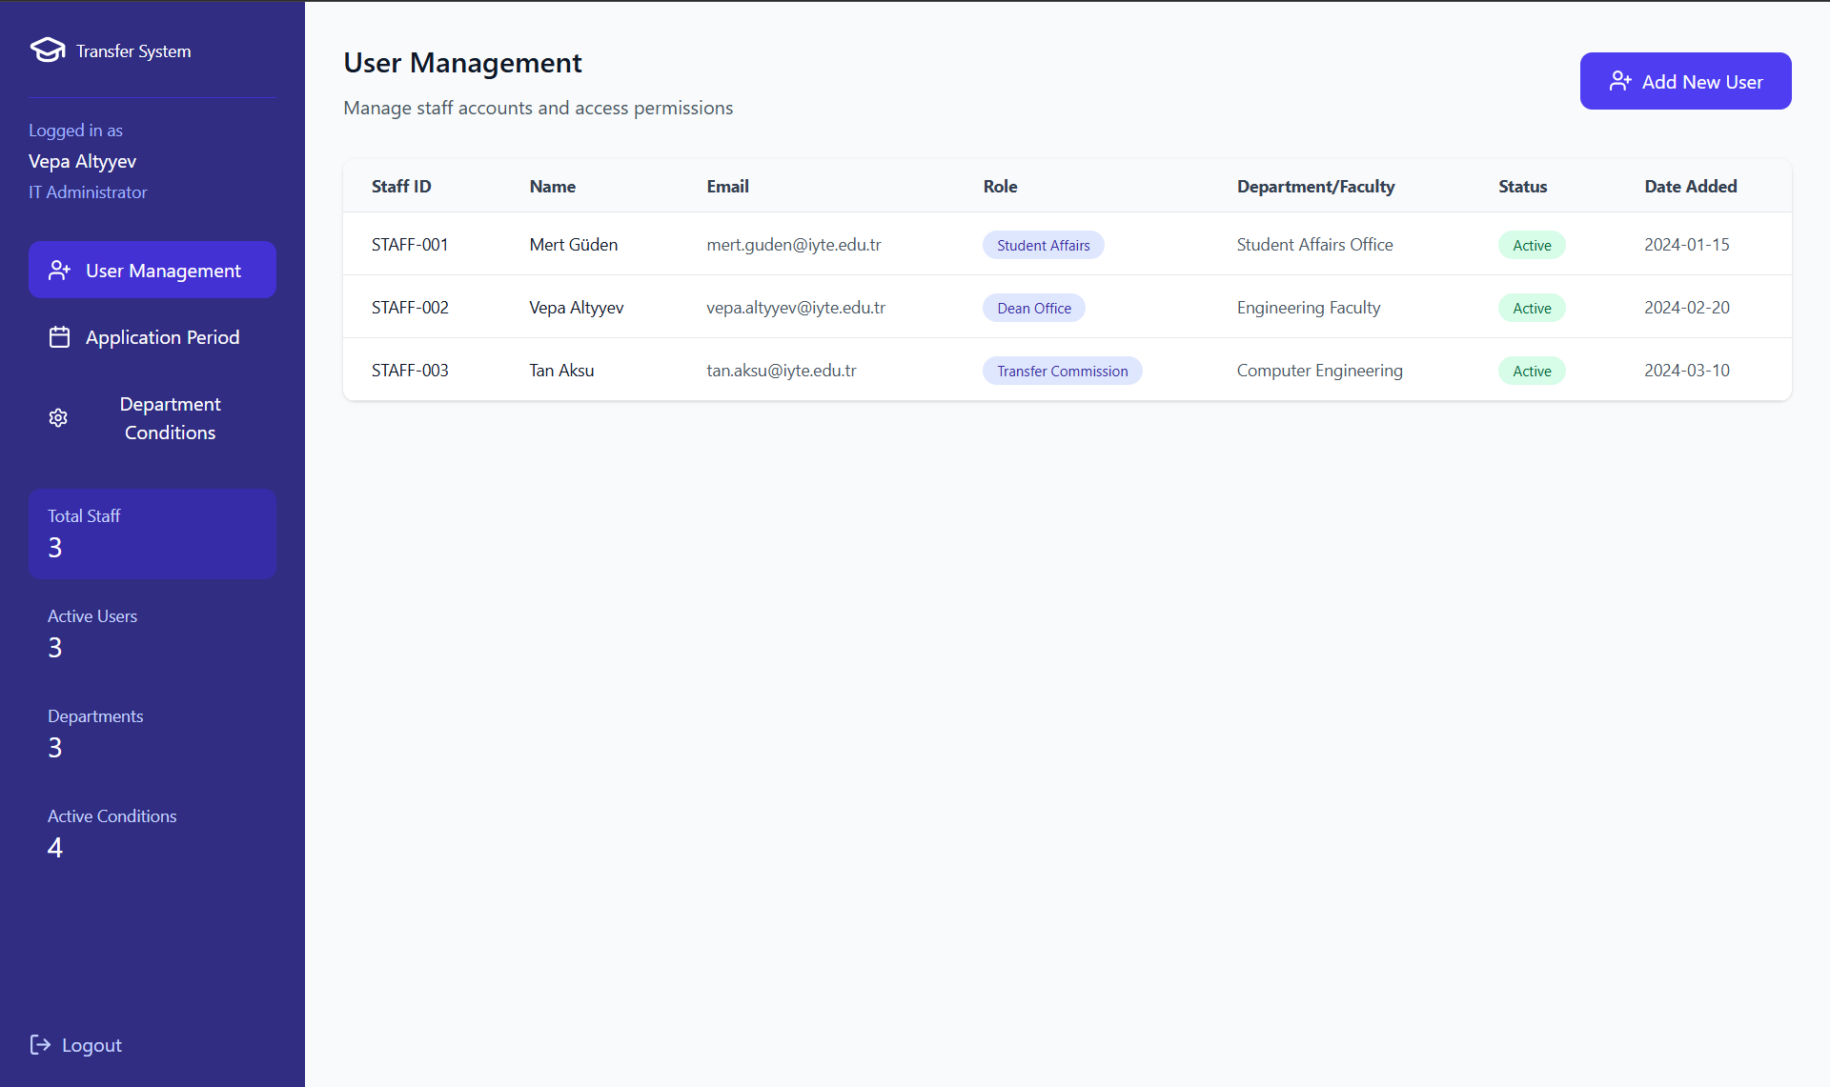

Performance / Software Quality requirements
• The User Management module must load within 3 seconds under normal load.
• Creating a new staff account (form submit → save → audit log) must complete within 5 seconds.
• Updating an existing user’s role or deactivating a user must complete within 3 seconds.
• Duplicate email / invalid domain checks must be performed and shown to the administrator within 2 seconds.
• The system must support at least 100 concurrent admin user-management operations without performance degradation.
• Audit logging for create / update / deactivate actions must be stored within 1 second after the action.
• The administrator must have at least a 5 Mbps stable internet connection for proper dashboard and form loading.

Use case configure application dates for System administrator (IT/BIDB)

Use case template configure application dates
Use Case ID: | UC-07-02
Use Case Name: | Configure Application Dates
Created By: | Team-6
Date Created: | 23.11.2025 | Last Updated By:
Actor: | System Administrator (IT/BIDB) | Date Last Updated: 23.11.2025
Description: | The System Administrator configures the "Application Window" (Start Date and Deadline). The system uses these parameters to automatically open the portal for submissions and strictly close it at the deadline to ensure fair process compliance.
Preconditions: | PRE1. The System Administrator is logged into the system.  PRE2. The academic calendar and transfer quotas have been approved by the University Senate.
Postconditions: | POST1. The application period is scheduled. The system will automatically reject applications attempted after the deadline.
Priority: | Critical
Frequency of Use: | Low (Once per semester)
Normal Course of Events: | 1- User navigates to the "Application Period Configuration" dashboard.  2- User inputs the Start Date/Time.  3- User inputs the Deadline Date/Time.  4- System validates that the Deadline is chronologically after the Start Date.  5- User clicks "Activate Schedule".  6- System records the schedule and displays a confirmation message.  7- (Automatic) When Start Date arrives, System enables the "Apply" button on the student portal.  8- (Automatic) When Deadline arrives, System disables document upload features and locks draft applications.  9- System displays "Application Period Closed" to any visitors.
Alternative Courses: | UC-07-02.AC-01: Deadline Extension  5A: If the Senate extends the period while it is active:  1. User logs in and updates the "Deadline Date/Time".  2. System immediately extends the active window and updates the countdown on the student portal.  UC-07-02.AC-02: Emergency Closure  5B: If a critical issue occurs:  1. User clicks "Suspend Application Period".  2. System immediately closes access regardless of the time.
Exceptions: | UC-07-02.EX-01: Invalid Date Range:  If the User enters a deadline earlier than the start date, the System displays "End date cannot be before start date" and prevents saving.  UC-07-02.EX-02: Active Upload Interruption: If a student is uploading a file exactly when the deadline hits, the System allows the current upload to finish but blocks the final "Submit" button.
Includes: | None
Special Requirements: | SR1. Server-Based Time Enforcement: Time Synchronization: The system shall use the server's local time for all open/close logic, not the user's local computer time, to prevent manipulation.  SR2. Deadline Immutability: Immutability: Once the deadline has passed, no new applications shall be accepted unless a formal "Extension" flow is executed by an authorized administrator.
Assumptions: | 1. Finalized Transfer Timeline: The University Senate has provided clear and final dates for the transfer period.
Notes and Issues: | Future Enhancement: A "Countdown Timer" widget could be added to the student dashboard to visibly show the remaining time for submission.

User Interface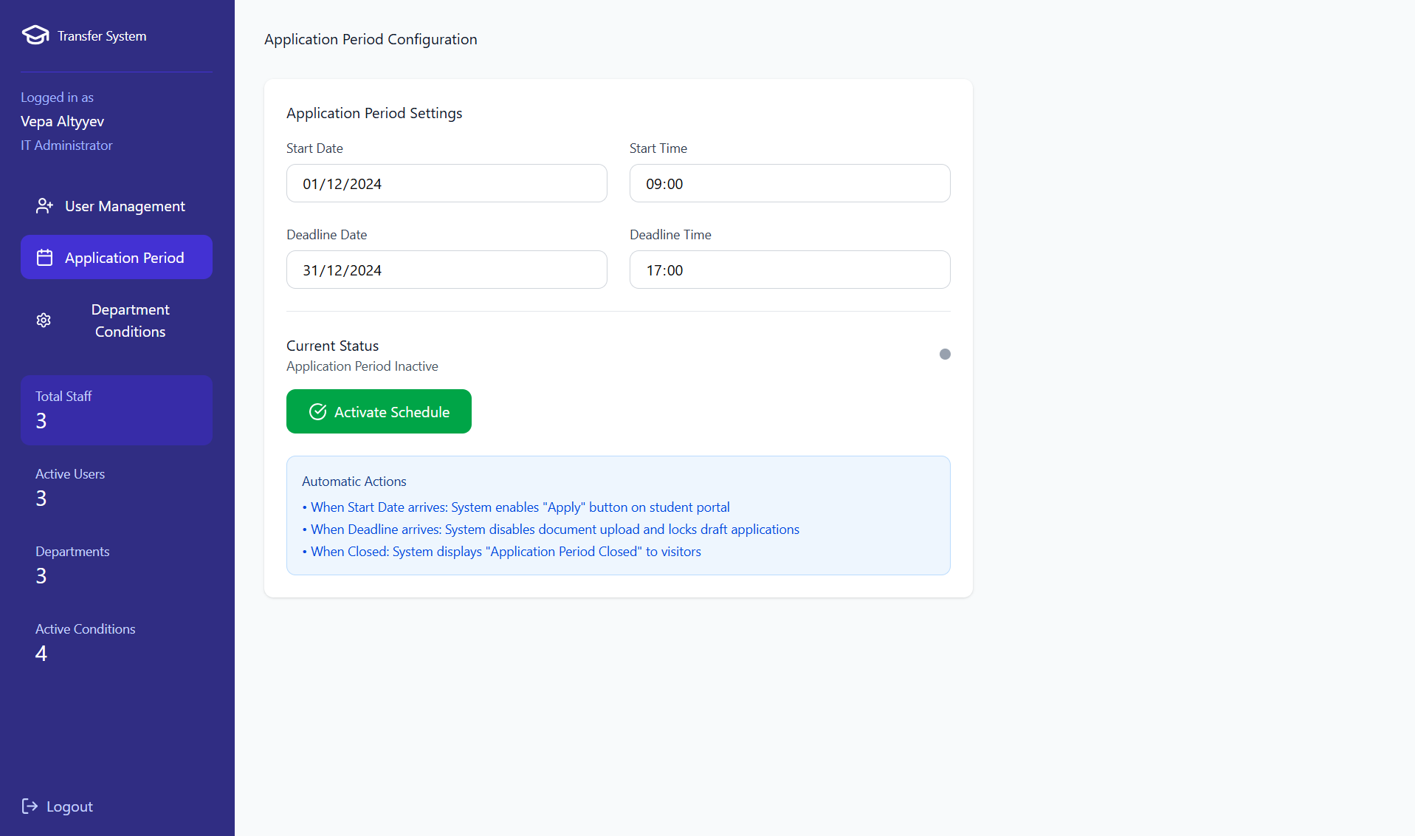

Performance / Software Quality requirements
- The “Application Period Configuration” dashboard must load within ≤ 3 seconds.
- Validation of Start/End dates must be performed and displayed to the administrator within ≤ 2 seconds.
- Saving or updating the schedule (Start/Deadline or Extension) must complete within ≤ 3 seconds.
- Automatic open/close operations executed at Start/Deadline timestamps must complete within ≤ 1 second to ensure strict cut-off.
- The system must be able to handle at least 50 simultaneous student submissions at the exact moment the application window opens.
- Locking active applications at the deadline must occur without delays and must guarantee zero acceptance of submissions after the official timestamp.
- The system must maintain accurate time synchronization within ± 1 second of the server’s clock to ensure fairness.
- The administrator must have at least 5 Mbps stable internet for reliable configuration operations.

Use case configure department specific conditions for System administrator (IT/BIDB)

Use case template configure department specific conditions
Use Case ID: | UC-07-03
Use Case Name: | Configure department specific conditions
Created By: | Team-6
Date Created: | 23.11.2025 | Last Updated By:
Actor: | System Administrator (IT/BIDB) | Date Last Updated: 23.11.2025
Description: | The System Administrator defines and configures specific academic criteria (e.g., Minimum GPA, Core Course Grades, Portfolio Requirements) for each department. These rules are used by the automation engine to filter applicants and by the Transfer Commission during evaluation.
Preconditions: | PRE1. The Administrator is logged in with super-user privileges.  PRE2. The Departments (e.g., Computer Eng., Architecture) are already defined in the system.  PRE3. The application period has not yet started (to prevent changing rules for active applicants).
Postconditions: | POST1. Specific validation rules are active for the selected department.  POST2. The system's automated eligibility check engine is updated with the new parameters.
Priority: | High
Frequency of Use: | Once per semester (Prior to application announcements)
Normal Course of Events: | 1- User navigates to the "Department Conditions" settings page.  2- System displays a list of departments and their currently active conditions.  3- User selects a specific department (e.g., Computer Engineering).  4- User clicks the "Add Condition" button.  5- User selects the Condition Type from a dropdown (e.g., "Minimum GPA", "Core Course Grade", "Portfolio Required", "Minimum Credits").  6- User enters the required value (e.g., "3.00" for GPA, "BB" for Grade, "Yes" for Portfolio).  7- User saves the condition.  8- System validates the input format.  9- System activates the rule and displays it in the list with an "Active" tag.
Alternative Courses: | UC-07-03.AC-01: Deactivate a Condition  2A: If a rule is no longer valid:  1. User locates the existing condition in the list.  2. User clicks the "Deactivate" button (or Toggle Switch).  3. System marks the condition as "Inactive" and stops applying it to new applications.  UC-07-03.AC-02: Delete a Condition  2B: If a rule was entered by mistake:  1. User clicks the "Delete" (Trash icon) button.  2. System asks for confirmation.  3. User confirms.  4. System permanently removes the rule from the configuration.
Exceptions: | UC-07-03.EX-01: Invalid Value Type  If User enters text into a numeric field (e.g., "Three" for GPA), System displays "Invalid Format" error and prevents saving.  UC-07-03.EX-02: Duplicate Condition  If User tries to add a second "Minimum GPA" rule for the same department, System displays "Condition already exists" and prompts User to edit the existing one instead.
Includes: | None
Special Requirements: | SR1. Dynamic Form Behavior: Dynamic Form Fields: The input interface must change based on the Condition Type (e.g., simple text box for Credits, boolean toggle for Portfolio, Course selector for Core Grades).
Assumptions: | 1. Senate-Approved Criteria Provided: The academic senate has provided the IT department with the official list of criteria for the upcoming semester.
Notes and Issues: | Note: This configuration directly impacts UC-04-07 (Evaluating Department Specific Conditions).

User Interface
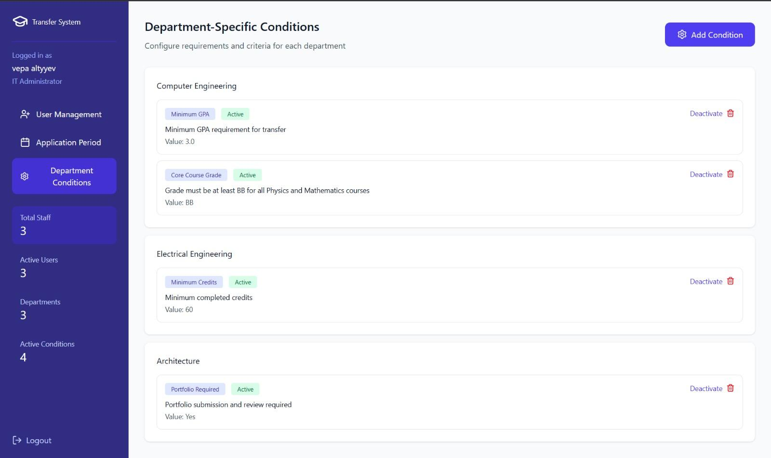

Performance / Software Quality requirements
- The "Department Conditions" dashboard must load within ≤ 3 seconds.
- Adding or updating a condition rule must be processed and reflected in the database within ≤ 2 seconds.
- The system must prevent the configuration of "Logically Impossible" conditions (e.g., Minimum GPA > 4.00) via input validation masks.
- The administrator must have at least 5 Mbps stable internet connection for reliable configuration.

External Interfaces
The UTMS shall communicate with existing external and internal software systems to automate data retrieval and validation as defined in the TO-BE model.
- YÖKSİS (Higher Education Information System):
  - Purpose: To automatically retrieve and validate the applicant's academic history, current enrolment status, and disciplinary records.
  - Interface: YÖK Web Services.
- ÖSYM (Student Selection and Placement Centre):
  - Purpose: To verify national university entrance exam scores (YKS/ÖSYS) required for eligibility calculations.
  - Interface: ÖSYM Data Verification Service.
- UBYS (University Information Management System):
  - Purpose: To retrieve transcripts for intra-institutional transfer applicants and to push final accepted student data into the university's main registry.
  - Interface: Internal University Database API.

User Interfaces
- The system shall provide a responsive web interface accessible via most used 7 browsers worldwide (Chrome, Firefox, Edge).
- The interface shall differentiate views based on user roles (Applicant vs. Admin).

Software Interfaces
- Academic Record Interface: The system shall interface with YÖKSİS and UBYS to retrieve transcript data and student status automatically.
- Exam Score Interface: The system shall connect to ÖSYM services to fetch YKS/ÖSYS placement scores.

Generic Performance / Software Quality Requirements
3.3.1 API and System Performance
- PER-01: The system shall process 95% of all login requests within 5 seconds, including credential validation and session creation.
- PER-02: Retrieval of external data (UBYS, YÖKSİS, ÖSYM) shall complete within 10 seconds under normal load.
- PER-03: Uploading and validating a PDF document up to 5MB shall complete within 5 seconds.
- PER-04: Critical dashboards (Application Details, Evaluation Dashboard, Ranking Dashboard, YDYO Review Pages) must load within 3–5 seconds.
- PER-05: Automated evaluation operations (GPA conversion, score validation, rule-checking) must complete within 3 seconds.

3.3.2 Concurrency and Scalability
- SCA-01: The system shall support at least 1,000 concurrent login sessions without degraded performance.
- SCA-02: The system must support concurrent academic evaluation operations, including:
• 200 simultaneous document reviews
• 200 simultaneous exam score verification sessions
• 150 simultaneous English proficiency reviews
• 100 simultaneous intibak table preparations
- SCA-03: During result publication, the system shall update up to 1,000 applicant records within 10 seconds.

3.3.3 Availability and Reliability
- AVL-01: The system must maintain at least 99.5% availability during the application window.
- AVL-02: User sessions must remain stable throughout the configured session duration unless explicitly terminated or interrupted.
- AVL-03: After partial service interruptions, authentication and core services must resume within 30 seconds.

3.3.4 Security and Privacy Performance
- SEC-01: All credentials and sensitive data must be transmitted over HTTPS/TLS 1.2+ and stored securely using hashed and salted methods (bcrypt/Argon2).
- SEC-02: User accounts shall lock temporarily after 5 consecutive failed login attempts.
- SEC-03: Role-based authorization checks must execute within 100 milliseconds per request.

Logical Database Requirements
3.4.1. User & Actor Management
- User: (UserID, Email, PasswordHash, Role, FirstName, LastName, IsActive, CreatedAt)
- Applicant: (ApplicantID [FK to User], NationalID, DateOfBirth, Phone, YKSScore)
- Staff: (StaffID [FK to User], DepartmentID [FK], Title)
- SystemLog: (LogID, UserID [FK], ActionType, Timestamp, Details)
3.4.2. Academic Structure
- Faculty: (FacultyID, Name, DeanName)
- Department: (DepartmentID, FacultyID [FK], Name, Quota, MinScoreRequirement)
- DepartmentCondition: (ConditionID, DepartmentID [FK], ConditionType, RequiredValue, IsActive)
- Course: (CourseID, DepartmentID [FK], CourseCode, CourseName, Credit, ECTS)
3.4.3. Application Process
- Application: (ApplicationID, ApplicantID [FK], TargetDepartmentID [FK], ApplicationDate, Status, ConvertedGPA, ExamScore, OverallScore, RankStatus)
- Document: (DocumentID, ApplicationID [FK], DocumentType, FilePath, VerificationStatus, RejectionReason)
3.4.4. Evaluation & Intibak
- IntibakTable: (IntibakID, ApplicationID [FK], InternalCourseID [FK], ExternalCourseName, ExternalCourseCredit, ExternalCourseGrade, Decision)
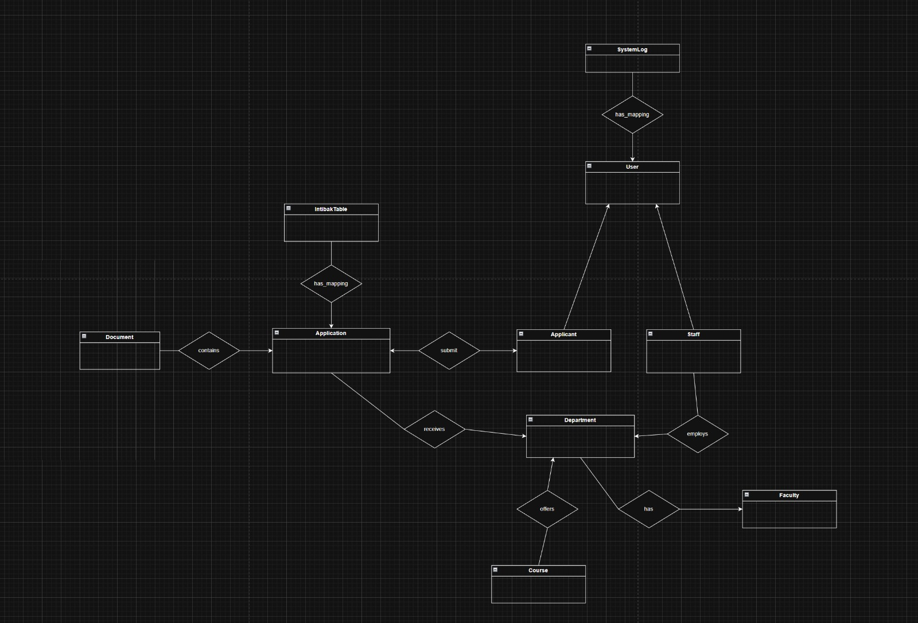

Design Constraints
- The system shall be developed as a web-based application.
- The user interface language shall support Turkish and English.
- The system must prevent multiple active sessions for the same user for security.

Other Requirements

1. Administrator Manual Requirement
- The system shall include a comprehensive Administrator Manual that provides detailed instructions for all administrative operations.
2. Database ACID Compliance Requirement
- The UTMS database shall adhere to ACID properties to guarantee the reliability and consistency of all transactions:
- Atomicity:
Each transaction must be processed as an indivisible unit. Partial updates are not allowed; operations either fully complete or are fully rolled back.
- Consistency:
All transactions must transition the database from one valid state to another, ensuring that constraints, rules, and validation policies are preserved.
- Isolation:
Concurrent operations must not interfere with each other. The system shall ensure that simultaneous transactions execute as if they were executed sequentially.
- Durability:
Once a transaction is committed, its results must be permanently stored and remain intact even in the event of system crashes or failures.
These ACID standards ensure integrity for critical operations such as identity verification, application submission, document handling, ranking generation, and inter-departmental processing.

