***SE 3360 FINAL PROJECT’S REPORT***

WHAT IS IT?

Main purpose of this model is showing the certain elements that can increase and decrease the effects of an earthquake. To do that, I designed an environment that is like Izmir, Turkey which includes a sea, seashore, and a mountain. First element I want to show is properly deciding where to construct a building, choosing the suitable ground for foundations , and avoiding fault rupture zones. Next one is following the construction regulations and building a proper structure. Third, doing urban renewals and choosing to live in newer buildings to avoid decaying buildings. Last one is doing periodical restorations to the buildings. Those are the parameters that I came across with.

I will start informing by explaining the **World** then, I move on to **Variables** that I used and **Parameters**. Next, I will continue with **Procedures** and **Calculations** that I made to obtain these results. Finally, I will talk about **Main Cases**.

The Houses initially will be white and shapes as house, but if they collapse their shape will be a black cross.

WORLD

Initially, I draw a black frame only on the edges of the world. This way I can see environment and turtles from an outer look. Then I divided the world into three parts.

1. *Sea* 
   1. I painted the left side of the world (-24 to -10) as “**pxcor”**, and (-24 to 24) as **“pycor”** to **blue**. This part represents the sea. There cannot be any buildings on the sea, that is why it does not affect the **durability-ground** or **soil-type** attributes of the buildings(turtles).
2. *Beach*
   1. This is the middle part of the world (-10 to 0) as “**pxcor”**, and (-24 to 24) as **“pycor”** to **yellow (47)**. This part represents the beach. There can be buildings on the beach. Since sand is not a well ground for foundation, for the turtles that spawned on sand, their **durability-ground** will be set as **2** and **soil-type** will be set as **sandy**.
3. *Mountain*
   1. This is the right side of the world (0 to 24) as “**pxcor”**, and (-24 to 24) as **“pycor”** to **grey (3)**. This part represents the mountain. There can be buildings on the mountain. Since mountain is a rocky ground and which is good for foundation, for the turtles that spawned on mountain their **durability-ground** will be set as **8** and **soil-type** will be set as **rocky**.

MONITOR

1. *Destroyed Buildings:* This shows the count of the **destroyed-count.**

VARIABLES

* *globals:*
  + destroyed-count
  + total-magnitude
  + destructive-aftershock
  + fault-rupture-affect
* turtles-own:
  + total-durability
  + durability-ground
  + durability-age
  + durability-estate
  + durability-restoration
  + is-on-fault-rupture
  + is-restored
  + soil-type

PARAMETERS

1. *Number-of-buildings*
   1. It determines the number of the building before creating turtles.
   2. Its **minimum value** is **20** and the **maximum value** is **60**.
   3. **Initial value** is **30**.
2. *Housing-Estate* 
   1. If the buildings are an estate, the buildings will be **spawned in a certain area**. Furthermore, since they are built as an estate, we can assume that they were build according to the construction regulations. This will set **durability-estate** attribute of the turtles as **5**.
   2. If they are not part of an estate, they will **spawn randomly** and they are built by different people, and this sets **durability-estate** attribute of the turtles as **0**.
3. *Age*
   1. There are three types of age.
      1. First one is “**New Build”**, this sets **durability-age** attribute as **8**.
      2. Second one is “**Mid Life”**, this sets **durability-age** attribute as **5**.
      3. Third one is “**Decayed”**, this sets **durability-age** attribute as **2**.
4. *Random-Age*
   1. If it is true, the **durability-age** attribute of the buildings will be assigned **randomly**.
   2. If it is false, the **selected option** from Age selector **will be applying to all**.
5. *Random-Restoration*
   1. If it is true, some buildings will be randomly restored, and some will not. The **durability-restoration** attribute of buildings will be set as **5** and **is-restored** attribute as **Yes**.
   2. The ones that are not restored will be set as **0** for the **durability-restoration** attribute and **No** for the **is-restored** attribute.
6. *Magnitude*
   1. This parameter represents the magnitude of the earthquake.
   2. Its **minimum value** is **1.0** and the **maximum value** is **10.0**.
   3. **Initial value** is **4.0**.
7. *Aftershock*
   1. There are two categories for aftershock.
      1. First one is “**Weak”**, this sets **destructive-aftershock** attribute as magnitude * **0.1**.
      2. Second one is “**Strong”**, this sets **destructive-aftershock** attribute as magnitude * **0.3**.
8. *Frequency-of-Aftershock*
   1. This specifies the count of aftershocks.
   2. Its **minimum value** is **2** and the **maximum value** is **10**.
   3. **Initial value** is **5**.
9. *Fault-Rupture*
   1. If it is true, there will be a fault-rupture on the map and the patches on it will be affected more from the earthquake. The **is-on-fault-rupture** is a global variable, and it will be set as **“yes”** and
   2. The ones that are not on the fault-rupture will have **“no”** as their **is-on-fault-rupture**.

PROCEDURES

* *setup-world:* It sets up the frame around the world and paints the world as sea, beach, and mountain.
* *setup-buildings:* This procedure spawn buildings according to go **housing-estate** parameter and sets the turtle’s **color**, **shape**, and **size** attributes. Then, makes sure that buildings do not overlap by calling **separate-buildings** procedure. Finally, calculates **total-durability** of buildings by calling **calculate-durability**.
* *separate-buildings:* If any buildings are overlapping it moves the turtle to south by 1 unit. It calls itself recursively till the turtle does not overlap with any other turtle.
* *calculate-durability:* It is a very important procedure because it calculates **the total-durability** of the buildings by calling **check-age**, **check-soil**, **check-estate**, **check-restoration**. After all these procedures that set the attributes of building, it calculates the **total-durability** of the building.
* *check-age:* It reads the **age** and **random-age** parameters and assigns the age of the building accordingly.
* *check-soil:* It checks the patch color **“pcolor”** of the building that it is standing on and if it is on beach/yellowish color (47), it will assign a weaker **durability-ground** value as **2** and as **soil-type** it will set **“sandy”.** If it is on the mountain/greyish color (3), it will assign a stronger **durability-ground** value as **8** and as **soil-type** it will set **“rocky”.**
* *check-estate:* It reads the parameter **housing-estate** and if its in an estate then, it will set **durability-estate** as **5** because of the better and more controlled construction. If it is not, it will set **durability-estate** as **0** because the constructions are done by separate people.
* *check-restoration:* It checks the **random-restoration** parameter. If it is true, some house will be restored, and their **durability-restoration** attribute will be **5** and **is-restored** attribute will be **“yes”**. If it is false, their **durability-restoration** attribute will be **0** and **is-restored** attribute will be **“no”**.
* *setup-fault-rupture:* This is where I set up a fault rupture. If the **fault-rupture** parameter is true, I create a **diagonal fault rupture,** paint the patches on it to **red** and set the global **is-on-fault-rupture** to **“yes”**. If it is false, set the global **is-on-fault-rupture** to **“no”.**
* *calculate-destructivity:* It calculates the destructivity of the earthquake by calling **handle-aftershock** and **check-fault-rupture**. After calling those procedures, it calculates the **total-magnitude** of the earthquake by using global variables.
* *handle-aftershock:*It reads the selected value from **aftershock** selector. If it is **“Weak”**, it sets the global **destructive-aftershock** variable to magnitude times **0.1**. If it is **“Strong”**, it sets the global **destructive-aftershock** variable to magnitude times **0.3**. Finally, it set the **destructive-aftershock** variable to multiplication of **destructive-aftershock** and **frequency-of-aftershock** parameter.
* *check-fault-rupture:* This is where I check fault rupture. If the color of current patch that the building is standing on is **red**, then this procedure sets the global **fault-rupture-affect** variable to multiplication of constant 3 and **half of the magnitude**.
* *shake-it:* This is where I simulate the earthquake. I compare the calculated **total-durability** attribute of building with *global* variable **total-magnitude**. If the **total-durability** is smaller or equal to **total-magnitude**, the building collapses. To represent this, I set the **shape** of the turtle to a **“X”**, its **color** to **black** and increase the global variable **destroyed-count**.
* *setup:* Initially it resets the world by calling **clear-all**. It asks patches to call **setup-world** procedure then it calls **setup-buildings** procedure. Then, it again asks patches to call **setup-fault-rupture**. Finally, it calls **calculate-destructivity** procedure, and it also shows the **count of turtles** before **reset-ticks**.
* *go:*  This procedure asks turtles to call **shake-it** procedure and it shows **total-magnitude**.

CALCULATIONS

* total-durability:

( ( **durability-ground** * **durability-age** ) + **durability-estate** + **durability-restoration )**

* total-magnitude:

( ( **magnitude** * **1.5** ) + **destructive-aftershock** + **fault-rupture-affect )**

* destructive-aftershock:

( **destructive-aftershock** *  **frequency-of-aftershock )**

* fault-rupture-affect:

( ( **magnitude / 2** ) * **3 )**

MAIN CASES

1-) Difference of Foundation Ground

For this case, we have **30 houses**. They are all in **midlife**, **not a part of estate**, **no restoration** , **no fault rupture** , and **magnitude of earthquake 5.0** with **small 5x aftershocks**(power of earthquake is **10**). The houses on the beach are collapsed because of the sandy ground(*turtle13*) but rocky did not(*turtle14*). 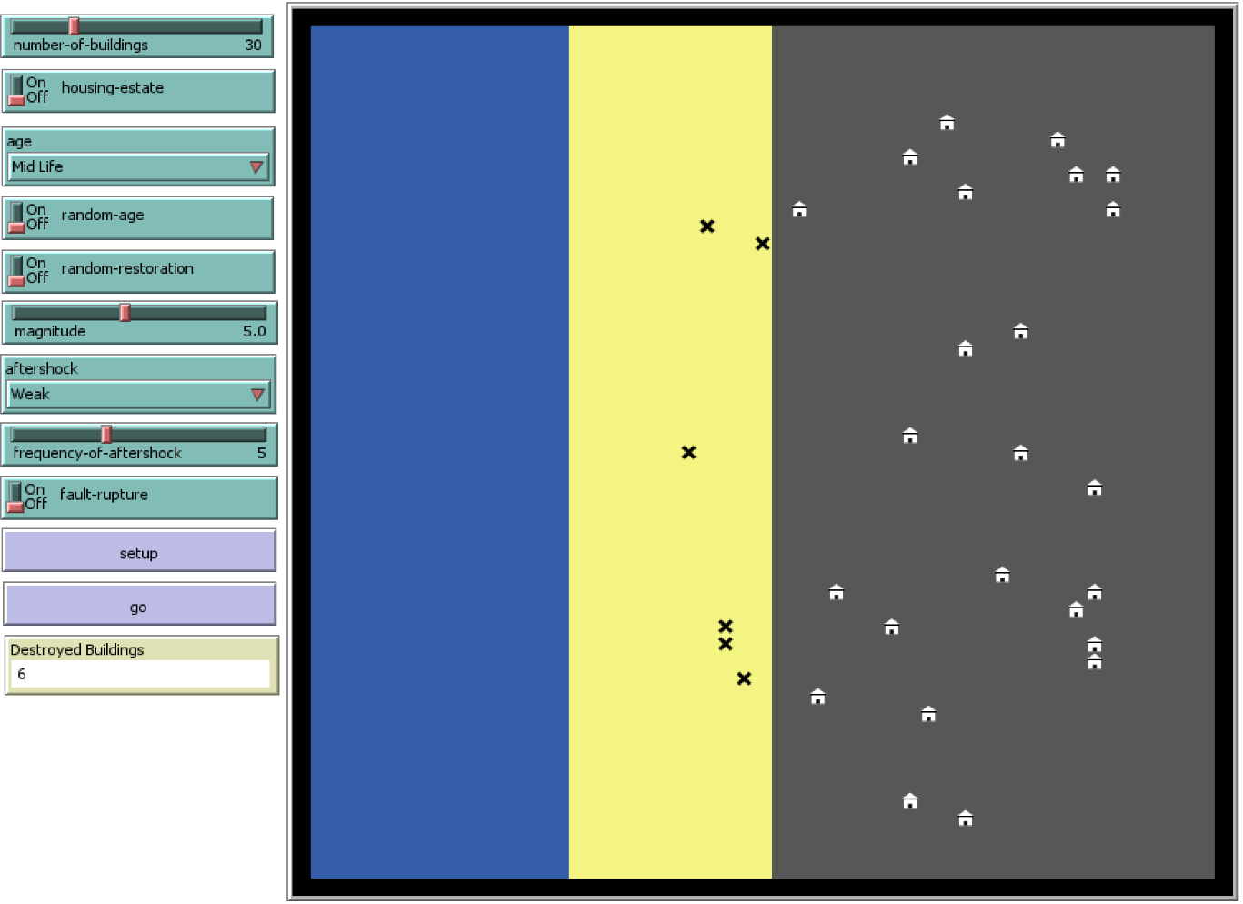

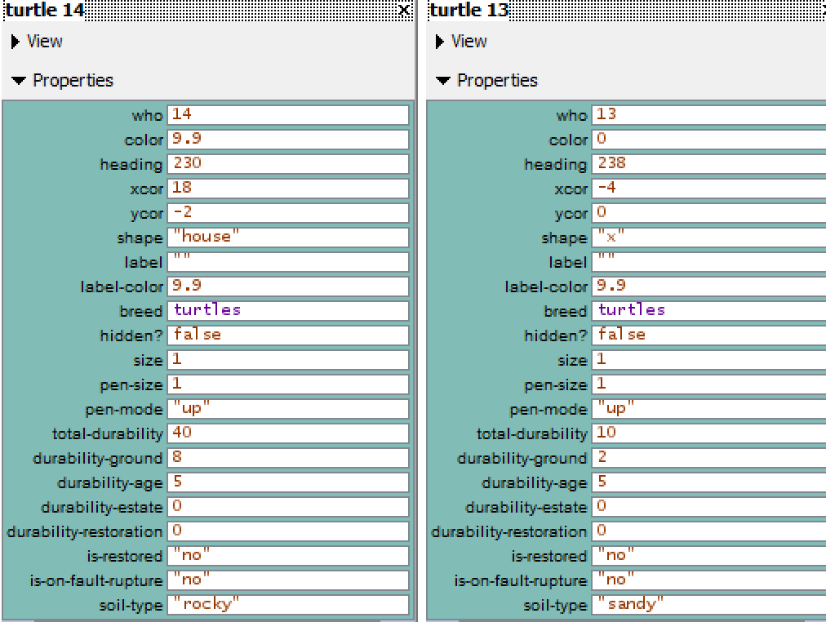

2-) Difference of Being in an Estate(Proper Construction)

For this case, we have **30 houses**. They are all in **midlife**,  **part of an estate**, **no restoration** , **no fault rupture** , and **magnitude of earthquake 5.0** with **small 5x aftershocks**(power of earthquake is **10**). This time, the houses on the beach did not collapsed because proper construction(*turtle22*) . Rocky(*turtle25*)

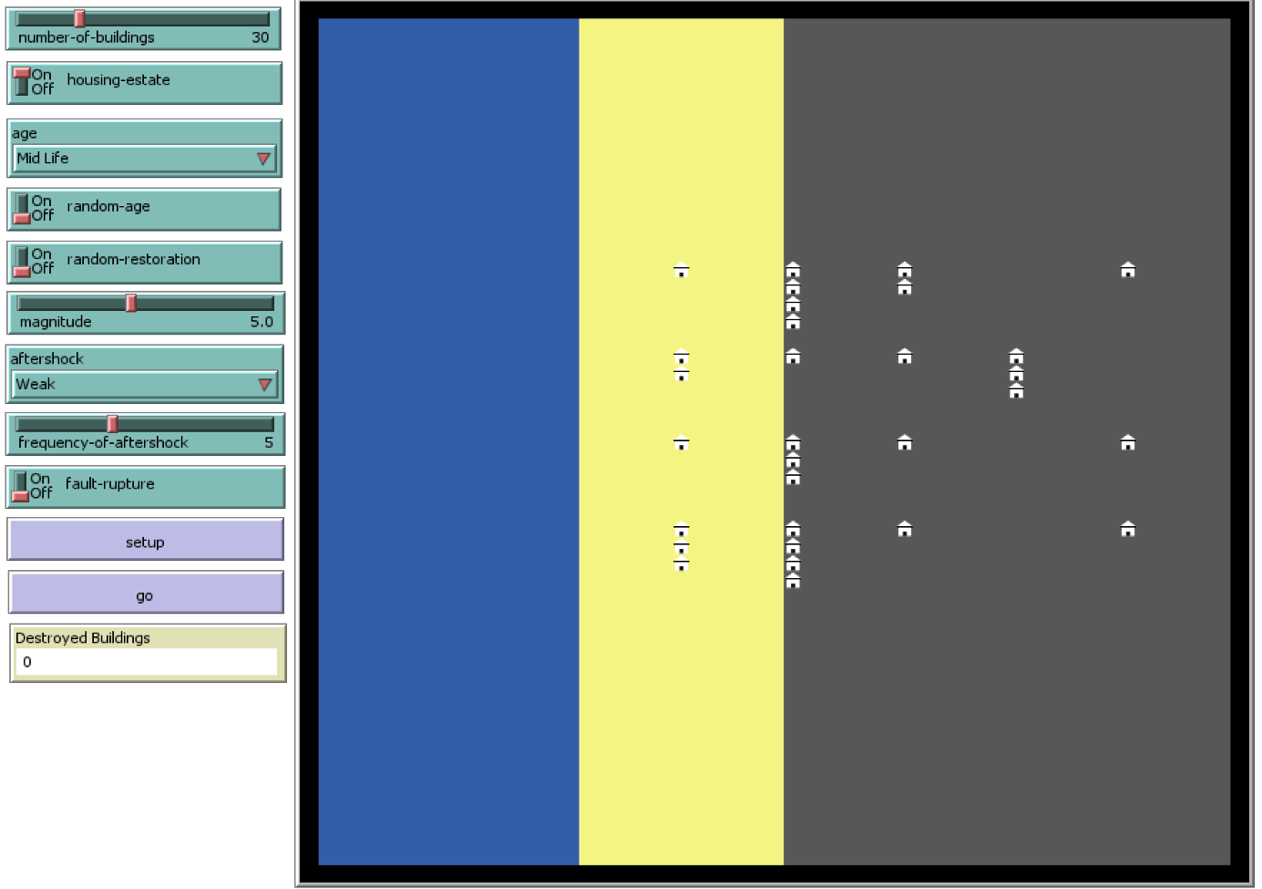

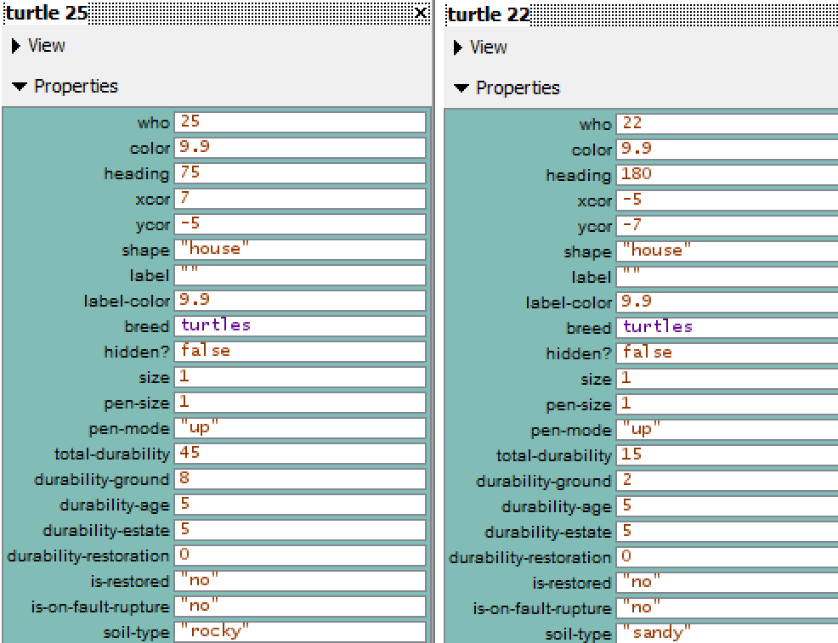

3-) Difference of Doing Restorations and Living in a Newly Build Building

For this case, we have **50 houses**. They are all in **new build**,  **part of an estate**, **random restoration** , **no fault rupture** , and **magnitude of earthquake 7.0** with **Strong 7x aftershocks**(power of earthquake is **25.2**). This time, some of the houses on the beach did collapsed (*turtle6*) but some survived (*turtle12*) thanks to being newly build and doing restorations even though the earthquake’s effect is stronger. Rock ground is (*turtle16)*.

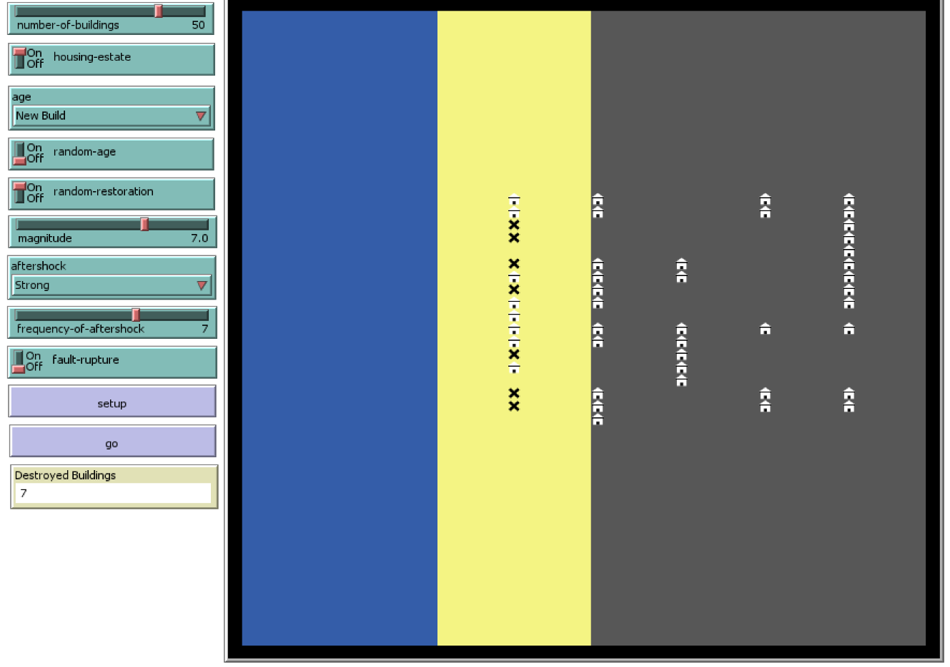

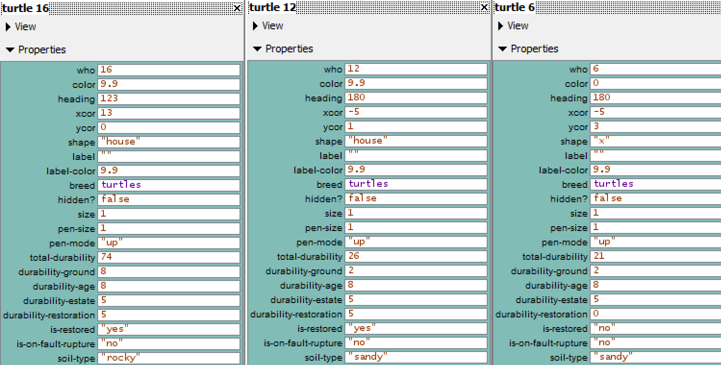

4-) Difference of Random Ages, Random Restorations and Not Being in an Estate

For this case, we have **50 houses**. They are all **randomly aged**, **not a part of estate**, **random restoration** , **no fault rupture** , and **magnitude of earthquake 7.0** with **Strong 7x aftershocks**(power of earthquake is **25.2**). This time, houses on the beach collapsed (*turtle43*) and some of the houses on the mountain collapsed as well(*turtle11*) but some of the houses on the mountain survived(*turtle46)*.

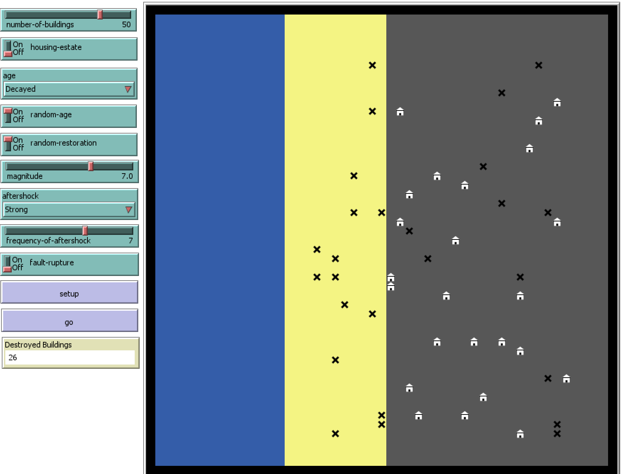

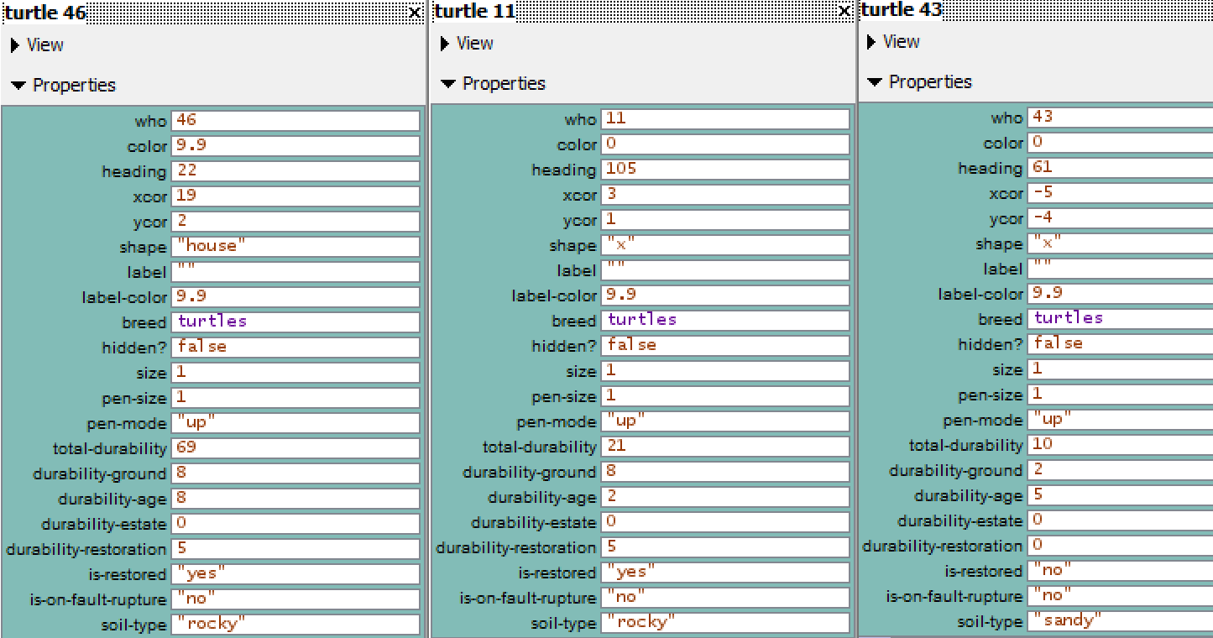

5-) Difference of Fault Rupture and Random Age

For this case, we have **50 houses**. They are all **randomly aged**, **not a part of estate**, **random restoration** , there is a **fault rupture** , and **magnitude of earthquake 7.0** with **Strong 7x aftershocks**(power of earthquake is **35.7**). There are two houses on fault line and one of them collapsed(*turtle32*) and other did not(*turtle48*).

